

[](https://www.tutorialr.com/tutorials/)

Windows App SDK

Four in Row





# Four in Row

**Four in Row** shows how you can create simple a two-player game where the objective is to get four items

in a horizontal, vertical or diagonal row displayed with emoji and with a toolkit from **NuGet** using the

**Windows App SDK**.

## Step 1

Follow **Setup and Start** on how to get **Setup** and **Install** what you need for **Visual Studio 2022** and **Windows App SDK**.

|  |  |
| --- | --- |
| In **Windows 11** choose **Start** and then find or search for **Visual Studio 2022** and then select it. |  |
| Once **Visual Studio 2022** has started select **Create a new project**. |  |
| Then choose the **Blank App, Packages (WinUI in Desktop)** and then select **Next**. |  |
| After that in **Configure your new project** type in the **Project name** as *FourInRow*, then select a Location and then select **Create** to start a new **Solution**. |  |

## Step 2

Then in **Visual Studio** within **Solution** **Explorer** for the **Solution**, right click on the **Project** shown below the **Solution** and then select **Manage NuGet Packages…**

## Step 3

Then in the **NuGet Package Manager** from the **Browse** tab search for **Comentsys.Toolkit.WindowsAppSdk** and then select **Comentsys.Toolkit.WindowsAppSdk by Comentsys** as indicated and select **Install**

This will add the package for **Comentsys.Toolkit.WindowsAppSdk** to your **Project**. If you get the **Preview Changes** screen saying **Visual Studio is about to make changes to this solution. Click OK to proceed with the changes listed below.** You can read the message and then select **OK** to **Install** the package.

## Step 4

Then while still in the **NuGet Package Manager** from the **Browse** tab search for **Comentsys.Assets.FluentEmoji** and then select **Comentsys.Assets.FluentEmoji by Comentsys** as indicated and select **Install**

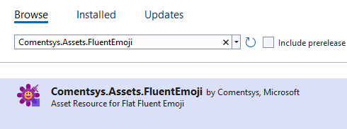

This will add the package for **Comentsys.Assets.FluentEmoji** to your **Project**. If you get the **Preview Changes** screen saying **Visual Studio is about to make changes to this solution. Click OK to proceed with the changes listed below.** You can read the message and then select **OK** to **Install** the package, then you can close the **tab** for **Nuget: FourInRow** by selecting the **x** next to it.

## Step 5

Then in **Visual Studio** within **Solution** **Explorer** for the **Solution**, right click on the **Project** shown below the **Solution** and then select **Add** then **New Item…**

## Step 6

Then in **Add New Item** from the **C# Items** list, select **Code** and then select **Code File** from the list next to this, then type in the name of *Library.cs* and then **Click** on **Add**.

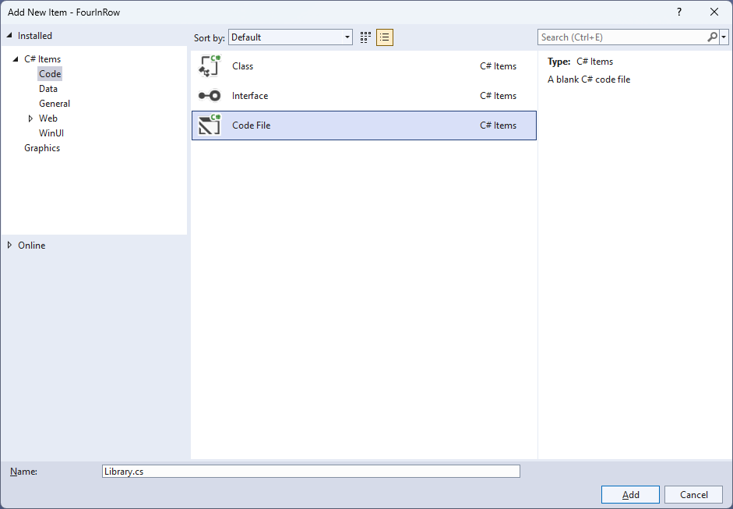

## Step 7

You will now be in the **View** for the **Code** of *Library.cs*, within this first type the following **Code**:

using Comentsys.Assets.FluentEmoji;

using Comentsys.Toolkit.WindowsAppSdk;

using Microsoft.UI.Xaml;

using Microsoft.UI.Xaml.Controls;

using System.Linq;

public class Library

{

private const string title = "Four In Row";

private const int total = 3;

private const int size = 7;

private readonly string[] _players = { string.Empty, "Yellow", "Red" };

private readonly int[,] _board = new int[size, size];

private int _value = 0;

private int _amend = 0;

private int _player = 0;

private bool _won = false;

private Dialog _dialog;

// Check Vertical & Check Horizontal

// Check Diagonal Top Left & Check Diagonal Top Right

// Winner, Full & Asset

// Set & Add

// Layout & New

}

The **Class** that has been defined in so far *Library.cs* has **using** for the packages that were addedof **Comentsys.Assets.FluentEmoji** and **Comentsys.Toolkit.WindowsAppSdk** amongst others needed. There are also some **const** and **readonly** values for parts of the game and to represent the board along with a **Dialog** that will be used to display messages in the game.

## Step 8

Still in the **Class** for *Library.cs* after the **Comment** of **// Check Vertical & Check Horizontal** type the following **Methods**:

private bool CheckVertical(int row, int column)

{

_value = 0;

do

{

_value++;

}

while (row + _value < size &&

_board[column, row + _value] == _player);

return _value > total;

}

private bool CheckHorizontal(int row, int column)

{

_value = 0;

_amend = 0;

// From Left

do

{

_value++;

}

while (column - _value >= 0 &&

_board[column - _value, row] == _player);

if (_value > total)

return true;

// Deduct Middle - Prevent double count

_value -= 1;

// Then Right

do

{

_value++;

_amend++;

}

while (column + _amend < size &&

_board[column + _amend, row] == _player);

return _value > total;

}

**CheckVertical** will check to see if there is a vertical set of four items for the current player or for a horizontal set of four items then will use **CheckHorizontal**.

## Step 9

While still in the **Class** for *Library.cs* after the **Comment** of **// Check Diagonal Top Left & Check Diagonal Top Right** type in the following **Methods** to check for a set of four diagonal items for a player:

private bool CheckDiagonalTopLeft(int row, int column)

{

_value = 0;

_amend = 0;

// From Top Left

do

{

_value++;

}

while (column - _value >= 0 && row - _value >= 0 &&

_board[column - _value, row - _value] == _player);

if (_value > total)

return true;

_value -= 1; // Deduct Middle - Prevent double count

// To Bottom Right

do

{

_value++;

_amend++;

}

while (column + _amend < size && row + _amend < size &&

_board[column + _amend, row + _amend] == _player);

return _value > total;

}

private bool CheckDiagonalTopRight(int row, int column)

{

_value = 0;

_amend = 0;

// From Top Right

do

{

_value++;

}

while (column + _value < size && row - _value >= 0 &&

_board[column + _value, row - _value] == _player);

if (_value > total)

return true;

_value -= 1; // Deduct Middle - Prevent double count

// To Bottom Left

do

{

_value++;

_amend++;

}

while (column - _amend >= 0 &&

row + _amend < size &&

_board[column - _amend,

row + _amend] == _player);

return _value > total;

}

## Step 10

While still in the **Class** for *Library.cs* after the **Comment** of **// Winner, Full & Asset** type in the following **Methods**:

private bool Winner(int row, int column)

{

bool vertical = CheckVertical(row, column);

bool horizontal = CheckHorizontal(row, column);

bool diagonalTopLeft = CheckDiagonalTopLeft(row, column);

bool diagonalTopRight = CheckDiagonalTopRight(row, column);

return vertical || horizontal ||

diagonalTopLeft || diagonalTopRight;

}

private bool Full()

{

for (int row = 0; row < size; row++)

{

for (int column = 0; column < size; column++)

{

if (_board[column, row] == 0)

{

return false;

}

}

}

return true;

}

private Viewbox Asset(int player) => new()

{

Child = new Asset()

{

AssetResource = FlatFluentEmoji.Get(

player == 1 ? FluentEmojiType.YellowCircle :

FluentEmojiType.RedCircle)

}

};

**Winner** will use the previous **Methods** to check if the current player is the winner to see if there is a vertical, horizontal or diagonal set of items. **Full** will be used to check if the board is full and **Asset** will be used to create the **Emoji** to represent the players with a *Yellow Circle* and a *Red Circle*.

## Step 11

While still in the **Class** for *Library.cs* after the **Comment** of **// Set & Add** type in the following **Methods** which are **Set** to place an item for a player and **Add** for the **Button** and **Events** which form the game board.

private void Set(Grid grid, int row, int column)

{

for (int i = size - 1; i > -1; i--)

{

if (_board[column, i] == 0)

{

_board[column, i] = _player;

Button button = (Button)grid.Children.Single(

w => Grid.GetRow((Button)w) == i

&& Grid.GetColumn((Button)w) == column);

button.Content = Asset(_player);

row = i;

break;

}

}

if (Winner(row, column))

{

_won = true;

_dialog.Show($"{_players[_player]} has won!");

}

else if (Full())

_dialog.Show("Board Full!");

_player = _player == 1 ? 2 : 1; // Set Player

}

private void Add(Grid grid, int row, int column)

{

Button button = new()

{

Width = 100,

Height = 100,

Name = $"{row}:{column}"

};

button.Click += (object sender, RoutedEventArgs e) =>

{

if (!_won)

{

button = (Button)sender;

row = (int)button.GetValue(Grid.RowProperty);

column = (int)button.GetValue(Grid.ColumnProperty);

if (_board[column, 0] == 0) // Check Free Row

Set(grid, row, column);

}

else

_dialog.Show("Game Over!");

};

button.SetValue(Grid.ColumnProperty, column);

button.SetValue(Grid.RowProperty, row);

grid.Children.Add(button);

}

## Step 12

While still in the **Class** for *Library.cs* after the **Comment** of **// Layout & New** type in the following **Methods**:

private void Layout(Grid grid)

{

grid.Children.Clear();

grid.ColumnDefinitions.Clear();

grid.RowDefinitions.Clear();

// Setup Grid

for (int index = 0; index < size; index++)

{

grid.RowDefinitions.Add(new RowDefinition());

grid.ColumnDefinitions.Add(new ColumnDefinition());

}

// Setup Board

for (int column = 0; column < size; column++)

{

for (int row = 0; row < size; row++)

{

Add(grid, row, column);

_board[row, column] = 0;

}

}

}

public async void New(Grid grid)

{

_won = false;

_dialog = new Dialog(grid.XamlRoot, title);

_player = await _dialog.ConfirmAsync("Who goes First?",

_players[1], _players[2]) ? 1 : 2;

Layout(grid);

}

**Layout** creates the look-and-feel of the game by setting out the game board and **New** will start a new game and ask which player should go first as either *Yellow*or *Red*.

## Step 13

|  |  |
| --- | --- |
| Then from **Solution** **Explorer** for the **Solution** double-click on **MainWindow.xaml** to see the **XAML** for the **Main Window**. |  |

## Step 14

In the **XAML** for **MainWindow.xaml** there be some **XAML** for a **StackPanel**, this should be **Removed** by removing the following:

<StackPanel Orientation="Horizontal"

HorizontalAlignment="Center" VerticalAlignment="Center">

<Button x:Name="myButton" Click="myButton_Click">Click Me</Button>

</StackPanel>

## Step 15

While still in the **XAML** for **MainWindow.xaml** above **</Window>**, type in the following **XAML**:

<Grid>

<Viewbox>

<Grid Margin="50" Name="Display"

HorizontalAlignment="Center"

VerticalAlignment="Center" Loaded="New"/>

</Viewbox>

<CommandBar VerticalAlignment="Bottom">

<AppBarButton Icon="Page2" Label="New" Click="New"/>

</CommandBar>

</Grid>

This **XAML** contains a **Grid** with a **Viewbox** which will scale a **Grid**. It has a **Loaded** event handler for **New** which is also shared by the **AppBarButton**.

## Step 16

|  |  |
| --- | --- |
| Then, within **Solution** **Explorer** for the **Solution** select the arrow next to **MainWindow.xaml** then double-click on **MainWindow.xaml.cs** to see the **Code** for the **Main Window**. |  |

## Step 17

In the **Code** for **MainWindow.xaml.cs** there be a **Method** of **myButton_Click(...)** this should be **Removed** by removing the following:

private void myButton_Click(object sender, RoutedEventArgs e)

{

myButton.Content = "Clicked";

}

## Step 18

Once **myButton_Click(...)** has been removed, type in the following **Code** below the end of the **Constructor** of **public MainWindow() { ... }**:

private readonly Library _library = new();

private void New(object sender, RoutedEventArgs e) =>

_library.New(Display);

Here an **Instance** of the **Class** of **Library** is created then below this is the **Method** of **New** that will be used with **Event Handler** from the **XAML**, this **Method** uses Arrow Syntax with the **=>** for an Expression Bodywhich is useful when a **Method** only has one line.

## Step 19

|  |  |
| --- | --- |
| That completes the **Windows App SDK** application. In **Visual Studio 2022** from the **Toolbar** select **FourInRow (Package)** to **Start** the application. |  |

## Step 20

Once running you can choose to play as *Yellow* or *Red* then the first player to get a horizontal, vertical or diagonal set of items wins the game or you can restart the game by selecting *New*.

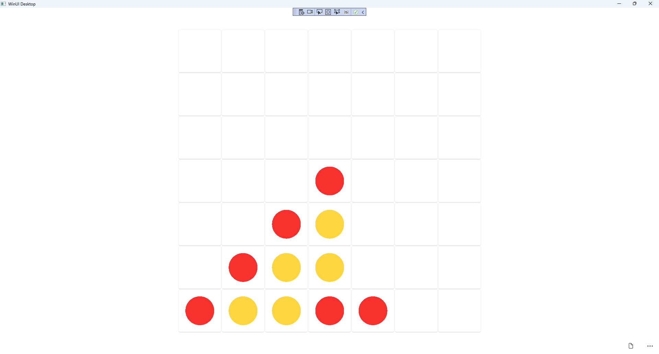

## Step 21

|  |  |
| --- | --- |
| To **Exit** the **Windows App SDK** application, select the **Close** button from the top right of the application as that concludes this **Tutorial** for **Windows App SDK** from [tutorialr.com](https://tutorialr.com)! |  |