

[](https://www.tutorialr.com/tutorials/)

Windows App SDK

Gauge Control





# Gauge Control

**Gauge Control** shows how to create a **Control** that can be used as a **Gauge** using **Windows App SDK**

## Step 1

Follow **Setup and Start** on how to get **Setup** and **Install** what you need for **Visual Studio 2022** and **Windows App SDK**.

|  |  |
| --- | --- |
| In **Windows 11** choose **Start** and then find or search for **Visual Studio 2022** and then select it. |  |
| Once **Visual Studio 2022** has started select **Create a new project**. |  |
| Then choose the **Blank App, Packages (WinUI in Desktop)** and then select **Next**. |  |
| After that in **Configure your new project** type in the **Project name** as *GaugeControl*, then select a Location and then select **Create** to start a new **Solution**. |  |

## Step 2

Then in **Visual Studio** within **Solution** **Explorer** for the **Solution**, right click on the **Project** shown below the **Solution** and then select **Add** then **New Item…**

## Step 3

Then in **Add New Item** from the **C# Items** list, select **WinUI** and then select **User Control (WinUI 3)** from the list next to this, then type in the name of *Gauge.xaml* and then **Click** on **Add**.

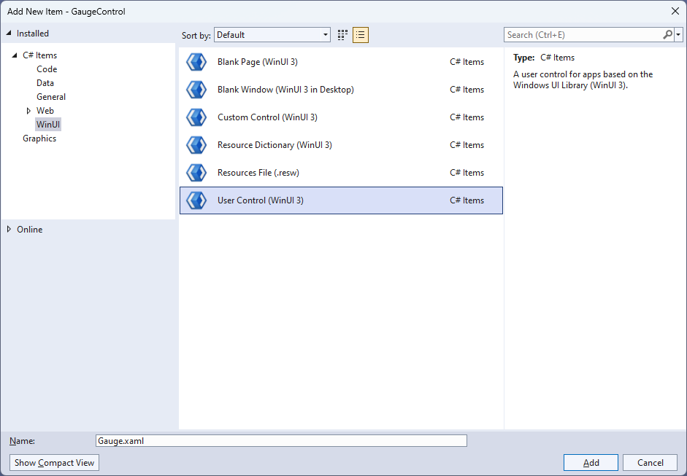

## Step 4

|  |  |
| --- | --- |
| Then from **Solution** **Explorer** for the **Solution** double-click on **Gauge.xaml** to see the **XAML** for the **User Control**. |  |

## Step 5

In the **XAML** for *Gauge.xaml* there be some **XAML** for a **Grid**, above **</Grid>**, type in the following **XAML**:

<Viewbox>

<Canvas Name="Display" Height="300" Width="300" Loaded="Load"/>

</Viewbox>

This **XAML** contains a **Viewbox** which will **Scale** a **Canvas** with a **Loaded** event handler of **Load**.

## Step 6

|  |  |
| --- | --- |
| Then, within **Solution** **Explorer** for the **Solution** select the arrow next to **Gauge.xaml** then double-click on **Gauge.xaml.cs** to see the **Code** for the **User Control**. |  |

## Step 7

You will now be in the **View** for the **Code** of *Gauge.xaml.cs*, near the top of the **Code**, below the final **using** statement you will need to type the following **using** statement:

using Microsoft.UI.Xaml.Shapes;

## Step 8

Then, while still in the **View** for the **Code** of *Gauge.xaml.cs* type in the following **Code** below the end of the **Constructor** of **public Gauge() { ... }**:

private Rectangle _needle;

private double _diameter = 0;

// Transform Method

// Markers Method

// Layout, Indicator & Load Methods

// Dependency Properties

// Properties

The **class** for **Gauge** represents the **User Control** for the **Gauge** and includes a **Rectangle** that will be used to represent the needle of the **Gauge** along with a **double** for the diameter of the **Gauge**.

## Step 9

While still in the **class** of **Gauge** after the **Comment** of **// Transform Method** type the following **Method**:

private TransformGroup Transform(double angle, double x, double y)

{

var transformGroup = new TransformGroup();

var firstTranslate = new TranslateTransform()

{

X = x,

Y = y

};

transformGroup.Children.Add(firstTranslate);

var rotateTransform = new RotateTransform()

{

Angle = angle

};

transformGroup.Children.Add(rotateTransform);

var secondTranslate = new TranslateTransform()

{

X = _diameter / 2,

Y = _diameter / 2

};

transformGroup.Children.Add(secondTranslate);

return transformGroup;

}

This **Method** will create a **TransformGroup** to rotate elements to be used for the **Gauge**.

## Step 10

While still in the **class** of **Gauge** after the **Comment** of **// Markers Method** type the following **Method**:

private void Markers(Canvas canvas, double thickness)

{

var inner = _diameter;

var markers = new Canvas()

{

Width = inner,

Height = inner

};

for (int i = 0; i < 51; i++)

{

var marker = new Rectangle()

{

Fill = Foreground

};

if ((i % 5) == 0)

{

marker.Width = 4;

marker.Height = 16;

marker.RenderTransform = Transform(i * 6, -(marker.Width / 2),

-(marker.Height * 2 + 4.5 - thickness / 2 - inner / 2 - 16));

}

else

{

marker.Width = 2;

marker.Height = 8;

marker.RenderTransform = Transform(i * 6, -(marker.Width / 2),

-(marker.Height * 2 + 12.75 - thickness / 2 - inner / 2 - 16));

}

markers.Children.Add(marker);

}

markers.RenderTransform = new RotateTransform()

{

Angle = 30,

CenterX = _diameter / 2,

CenterY = _diameter / 2

};

canvas.Children.Add(markers);

}

This **Method** will create the set of small and large markers to be displayed on the **Gauge**.

## Step 11

While still in the **class** of **Gauge** after the **Comment** of **// Layout, Indicator & Load Methods** type the following **Methods**:

private void Layout(Canvas canvas)

{

canvas.Children.Clear();

_diameter = canvas.Width;

var face = new Ellipse()

{

Height = _diameter,

Width = _diameter,

Fill = Fill

};

canvas.Children.Add(face);

Markers(canvas, face.StrokeThickness);

_needle = new Rectangle()

{

Width = Needle,

Height = (int)_diameter / 2 - 30,

Fill = Foreground

};

canvas.Children.Add(_needle);

var middle = new Ellipse()

{

Height = _diameter / 10,

Width = _diameter / 10,

Fill = Foreground

};

Canvas.SetLeft(middle, (_diameter - middle.ActualWidth) / 2);

Canvas.SetTop(middle, (_diameter - middle.ActualHeight) / 2);

canvas.Children.Add(middle);

}

private void Indicator(int value)

{

Layout(Display);

var percentage = value / (double)Maximum * 100;

var position = (percentage / 2) + 5;

_needle.RenderTransform = Transform(position * 6,

-Needle / 2, 4.25);

}

private void Load(object sender, RoutedEventArgs e) =>

Indicator(Value);

There will also be some **Errors** as these refer to **Properties** that will be added in the next few steps.

**Layout** will create the look-and-feel of the **Gauge** and uses the **Method** for **Markers** along with creating the centre point and needle for the **Gauge**. The **Method** of **Indicator** will use **Layout** along with calculating the position of the needle for the **Gauge** and **Load** will be used when the **Canvas** of the **User Control** is loaded and will call the **Method** of **Indicator**.

## Step 12

While still in the **class** of **Gauge** after the **Comment** of **// Dependency Properties** type the following **Dependency Properties**:

public static readonly DependencyProperty FillProperty =

DependencyProperty.Register(nameof(Fill), typeof(Brush),

typeof(Gauge), null);

public static readonly DependencyProperty NeedleProperty =

DependencyProperty.Register(nameof(Needle), typeof(int), typeof(Gauge),

new PropertyMetadata(2));

public static readonly DependencyProperty ValueProperty =

DependencyProperty.Register(nameof(Value), typeof(double), typeof(Gauge),

new PropertyMetadata(25));

public static readonly DependencyProperty MinimumProperty =

DependencyProperty.Register(nameof(Minimum), typeof(int), typeof(Gauge),

new PropertyMetadata(0));

public static readonly DependencyProperty MaximumProperty =

DependencyProperty.Register(nameof(Maximum), typeof(int), typeof(Gauge),

new PropertyMetadata(100));

There will still also be some **Errors** as these refer to **Properties** that will be added in the next step.

These **Dependency Properties** refer to various **Properties** of the **Gauge** that can be customised for the **User Control**.

## Step 13

While still in the **class** of **Gauge** after the **Comment** of **// Properties** type the following **Properties**:

public Brush Fill

{

get { return (Brush)GetValue(FillProperty); }

set { SetValue(FillProperty, value); }

}

public int Needle

{

get { return (int)GetValue(NeedleProperty); }

set

{

SetValue(NeedleProperty, value);

Indicator(Value);

}

}

public int Value

{

get { return (int)GetValue(ValueProperty); }

set

{

if (value >= Minimum && value <= Maximum)

{

SetValue(ValueProperty, value);

Indicator(value);

}

}

}

public int Minimum

{

get { return (int)GetValue(MinimumProperty); }

set { SetValue(MinimumProperty, value); }

}

public int Maximum

{

get { return (int)GetValue(MaximumProperty); }

set { SetValue(MaximumProperty, value); }

}

Any **Errors** should now be resolved, if you continue to get them check all previous steps to see if you have missed anything.

These **Properties** are for values for the **User Control** such as the **Minimum** or **Maximum** values for the **Gauge**.

## Step 14

|  |  |
| --- | --- |
| Within **Solution** **Explorer** for the **Solution** double-click on **MainWindow.xaml** to see the **XAML** for the **Main Window**. |  |

## Step 15

In the **XAML** for **MainWindow.xaml** there be some **XAML** for a **StackPanel**, this should be **Removed** by removing the following:

<StackPanel Orientation="Horizontal"

HorizontalAlignment="Center" VerticalAlignment="Center">

<Button x:Name="myButton" Click="myButton_Click">Click Me</Button>

</StackPanel>

## Step 16

While still in the **XAML** for **MainWindow.xaml** above **</Window>**, type in the following **XAML**:

<local:Gauge Margin="50" Value="25" Foreground="WhiteSmoke" Needle="4"

Fill="{ThemeResource SystemControlHighlightAccentBrush}"/>

This **XAML** contains the **User Control** of **Gauge** with various **Properties** including **Value** and **Needle**.

## Step 17

|  |  |
| --- | --- |
| Then, within **Solution** **Explorer** for the **Solution** select the arrow next to **MainWindow.xaml** then double-click on **MainWindow.xaml.cs** to see the **Code** for the **Main Window**. |  |

## Step 18

In the **Code** for **MainWindow.xaml.cs** there be a **Method** of **myButton_Click(...)** this should be **Removed** by removing the following:

private void myButton_Click(object sender, RoutedEventArgs e)

{

myButton.Content = "Clicked";

}

## Step 19

|  |  |
| --- | --- |
| That completes the **Windows App SDK** application. In **Visual Studio 2022** from the **Toolbar** select **GaugeControl (Package)** to **Start** the application. |  |

## Step 20

Once running you will see the **Gauge Control** displayed, with a *Value* which can be changed in the **XAML** to show the *Needle*in a different position.

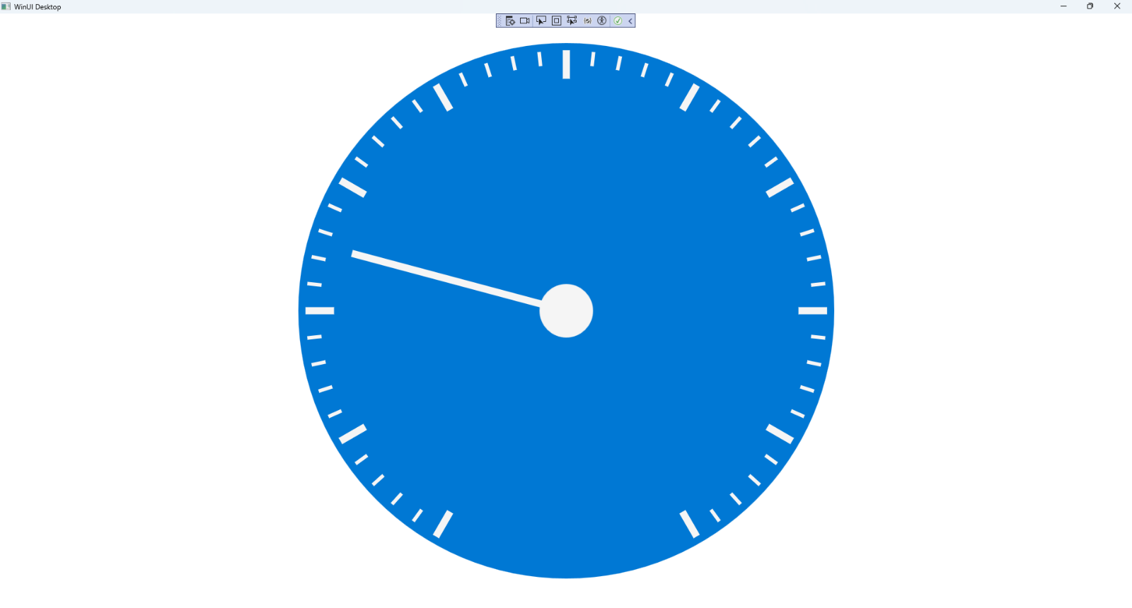

## Step 21

|  |  |
| --- | --- |
| To **Exit** the **Windows App SDK** application, select the **Close** button from the top right of the application as that concludes this **Tutorial** for **Windows App SDK** from [tutorialr.com](https://tutorialr.com)! |  |