

[](https://www.tutorialr.com/tutorials/)

Windows App SDK

Light Control





# Light Control

**Light Control** shows how to create a **Control** that can be used as an indicator like a **Light** using a toolkit

from **NuGet** using the **Windows App SDK**.

## Step 1

Follow **Setup and Start** on how to get **Setup** and **Install** what you need for **Visual Studio 2022** and **Windows App SDK**.

|  |  |
| --- | --- |
| In **Windows 11** choose **Start** and then find or search for **Visual Studio 2022** and then select it. |  |
| Once **Visual Studio 2022** has started select **Create a new project**. |  |
| Then choose the **Blank App, Packages (WinUI in Desktop)** and then select **Next**. |  |
| After that in **Configure your new project** type in the **Project name** as *LightControl*, then select a Location and then select **Create** to start a new **Solution**. |  |

## Step 2

Then in **Visual Studio** within **Solution** **Explorer** for the **Solution**, right click on the **Project** shown below the **Solution** and then select **Manage NuGet Packages…**

## Step 3

Then in the **NuGet Package Manager** from the **Browse** tab search for **Comentsys.Toolkit.WindowsAppSdk** and then select **Comentsys.Toolkit.WindowsAppSdk by Comentsys** as indicated and select **Install**

This will add the package for **Comentsys.Toolkit.WindowsAppSdk** to your **Project**. If you get the **Preview Changes** screen saying **Visual Studio is about to make changes to this solution. Click OK to proceed with the changes listed below.** You can read the message and then select **OK** to **Install** the package, then you can close the **tab** for **Nuget: LightControl** by selecting the **x** next to it.

## Step 4

Then in **Visual Studio** within **Solution** **Explorer** for the **Solution**, right click on the **Project** shown below the **Solution** and then select **Add** then **New Item…**

## Step 5

Then in **Add New Item** from the **C# Items** list, select **Code** and then select **Code File** from the list next to this, then type in the name of *Library.cs* and then **Click** on **Add**.

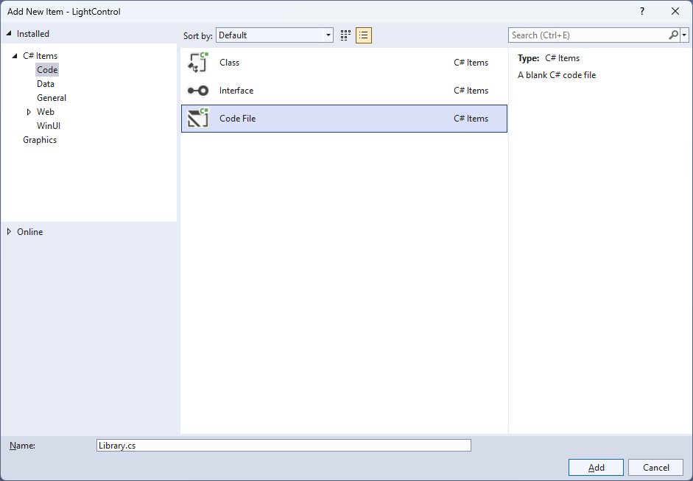

## Step 6

You will now be in the **View** for the **Code** of *Library.cs* and then you need to type the following **Code**:

using Comentsys.Toolkit.WindowsAppSdk;

using Microsoft.UI;

using Microsoft.UI.Xaml;

using Microsoft.UI.Xaml.Controls;

using Microsoft.UI.Xaml.Data;

using Microsoft.UI.Xaml.Media;

using System.ComponentModel;

using System.Runtime.CompilerServices;

using System.Threading.Tasks;

namespace LightControl;

public class Light : Grid, INotifyPropertyChanged

{

public event PropertyChangedEventHandler PropertyChanged;

public void OnPropertyChanged([CallerMemberName] string propertyName = null) =>

PropertyChanged?.Invoke(this, new PropertyChangedEventArgs(propertyName));

// Light Properties

// Light Constructor

}

public class Library

{

// Library Members and Delay, Toggle & Load Methods

// Library Traffic & Reset Methods

}

*Library.cs* defines a **namespace** which allows classes to be defined together, usually each is separate but will be defined in *Library.cs* along with adding **using** statements such as for the package of **Comentsys.Toolkit.WindowsAppSdk**.

## Step 7

While still in the **class** of **Light** after **Comment** of **// Light Properties** type the following **Properties**:

public static readonly DependencyProperty ForegroundProperty =

DependencyProperty.Register("Foreground", typeof(Brush),

typeof(Light), new PropertyMetadata(new SolidColorBrush(Colors.Black)));

public static readonly DependencyProperty OffProperty =

DependencyProperty.Register("Off", typeof(Visibility),

typeof(Light), new PropertyMetadata(Visibility.Collapsed));

public Brush Foreground

{

get { return (Brush)GetValue(ForegroundProperty); }

set

{

SetValue(ForegroundProperty, value);

OnPropertyChanged();

}

}

public Visibility Off

{

get { return (Visibility)GetValue(OffProperty); }

set

{

SetValue(OffProperty, value);

OnPropertyChanged();

}

}

public bool IsOn

{

get { return Off == Visibility.Collapsed; }

set

{

Off = value ? Visibility.Collapsed : Visibility.Visible;

OnPropertyChanged();

}

}

**Foreground** and **Off** are **Dependency Properties** which are used for **Data Binding** and **IsOn** will set the **Property** of **Off** accordingly.

## Step 8

While still in the **namespace** of **LightControl** in *Library.cs* and in the **class** of **Light** after the **Comment** of **// Light Constructor** type the following **Constructor**:

public Light()

{

Margin = new Thickness(5);

Piece element = new()

{

Stroke = new SolidColorBrush(Colors.Black)

};

element.SetBinding(Piece.FillProperty, new Binding()

{

Path = new PropertyPath(nameof(Foreground)),

Mode = BindingMode.TwoWay,

Source = this,

});

Piece overlay = new()

{

Stroke = new SolidColorBrush(Colors.Black),

Fill = new SolidColorBrush(Colors.Black),

Opacity = 0.75

};

overlay.SetBinding(VisibilityProperty, new Binding()

{

Path = new PropertyPath(nameof(Off)),

Mode = BindingMode.TwoWay,

Source = this

});

Children.Add(element);

Children.Add(overlay);

}

The **Constructor** will create the look-and-feel for the **Control** with the **Properties** for **Data Binding** with **Piece** from **Comentsys.Toolkit.WindowsAppSdk.**

## Step 9

While still in the **namespace** of **LightControl** in *Library.cs* and in the **class** of **Library** after the **Comment** of **// Library Members and Delay, Toggle & Load Methods** type the following **Members** and **Methods**:

private readonly Light _red = new()

{

Foreground = new SolidColorBrush(Colors.Red)

};

private readonly Light _orange = new()

{

Foreground = new SolidColorBrush(Colors.Orange)

};

private readonly Light _green = new()

{

Foreground = new SolidColorBrush(Colors.Green)

};

private static async Task Delay(int seconds = 2) =>

await Task.Delay(seconds * 1000);

private void Toggle(bool red, bool orange, bool green) =>

(_red.IsOn, _orange.IsOn, _green.IsOn) = (red, orange, green);

public void Load(StackPanel panel)

{

panel.Children.Add(_red);

panel.Children.Add(_orange);

panel.Children.Add(_green);

}

**Members** will represent the three **Light Controls** along with a **Method** for **Delay** which will create a short pause and **Toggle** which will be used to set the **Property** of **IsOn** for each **Light** and **Load** which will add the **Light Controls** to a **StackPanel**.

## Step 10

While still in the **namespace** of **LightControl** in *Library.cs* and in the **class** of **Library** after the **Comment** of **// Library Traffic & Reset Methods** type the following **Methods**:

public async void Traffic()

{

Toggle(false, false, true);

await Delay();

Toggle(false, false, false);

await Delay();

Toggle(false, true, false);

await Delay();

Toggle(false, false, false);

await Delay();

Toggle(true, false, false);

await Delay();

Toggle(true, false, false);

await Delay();

Toggle(true, true, false);

await Delay();

Toggle(false, false, true);

await Delay();

}

public void Reset() =>

Toggle(true, true, true);

**Traffic** will go through the sequence of a UK *Traffic Light* for each of the **Light Controls** and **Reset** will return them to their original state.

## Step 11

|  |  |
| --- | --- |
| Then from **Solution** **Explorer** for the **Solution** double-click on **MainWindow.xaml** to see the **XAML** for the **Main Window**. |  |

## Step 12

In the **XAML** for **MainWindow.xaml** there be some **XAML** for a **StackPanel**, this should be **Removed** by removing the following:

<StackPanel Orientation="Horizontal"

HorizontalAlignment="Center" VerticalAlignment="Center">

<Button x:Name="myButton" Click="myButton_Click">Click Me</Button>

</StackPanel>

## Step 13

While still in the **XAML** for **MainWindow.xaml** above **</Window>**, type in the following **XAML**:

<Grid>

<Viewbox>

<StackPanel Margin="50" Name="Display" Orientation="Vertical"

HorizontalAlignment="Center" VerticalAlignment="Center" Loaded="Load"/>

</Viewbox>

<CommandBar VerticalAlignment="Bottom">

<AppBarButton Icon="Play" Label="Play" Click="Play"/>

<AppBarButton Icon="Page2" Label="New" Click="New"/>

</CommandBar>

</Grid>

This **XAML** contains a **Grid** with a **Viewbox** which will **Scale** a **StackPanel**. It has a **Loaded** event handler for **Load** and there is an **AppBarButton** *Play* using the **Method** of **Play** and *New* using the **Method** of **New**.

## Step 14

|  |  |
| --- | --- |
| Then, within **Solution** **Explorer** for the **Solution** select the arrow next to **MainWindow.xaml** then double-click on **MainWindow.xaml.cs** to see the **Code** for the **Main Window**. |  |

## Step 15

In the **Code** for **MainWindow.xaml.cs** there be a **Method** of **myButton_Click(...)** this should be **Removed** by removing the following:

private void myButton_Click(object sender, RoutedEventArgs e)

{

myButton.Content = "Clicked";

}

## Step 16

Once **myButton_Click(...)** has been removed, type in the following **Code** below the end of the **Constructor** of **public MainWindow() { ... }**:

private readonly Library _library = new();

private void Load(object sender, RoutedEventArgs e) =>

_library.Load(Display);

private void Play(object sender, RoutedEventArgs e) =>

_library.Traffic();

private void New(object sender, RoutedEventArgs e) =>

_library.Reset();

Here an **Instance** of the **Class** of **Library** is created then below this are the **Methods** of **Load**, **Play** and **New** that will be used with the **Event Handler** from the **XAML**, these **Methods** use Arrow Syntax with the **=>** for an Expression Bodywhich is useful when a **Method** only has one line.

## Step 17

|  |  |
| --- | --- |
| That completes the **Windows App SDK** application. In **Visual Studio 2022** from the **Toolbar** select **LightControl (Package)** to **Start** the application. |  |

## Step 18

Once running you will see the **Light Control** displayed, then you can select *Play* to cycle through the UK *Traffic Light* sequence or select *New* to start again.

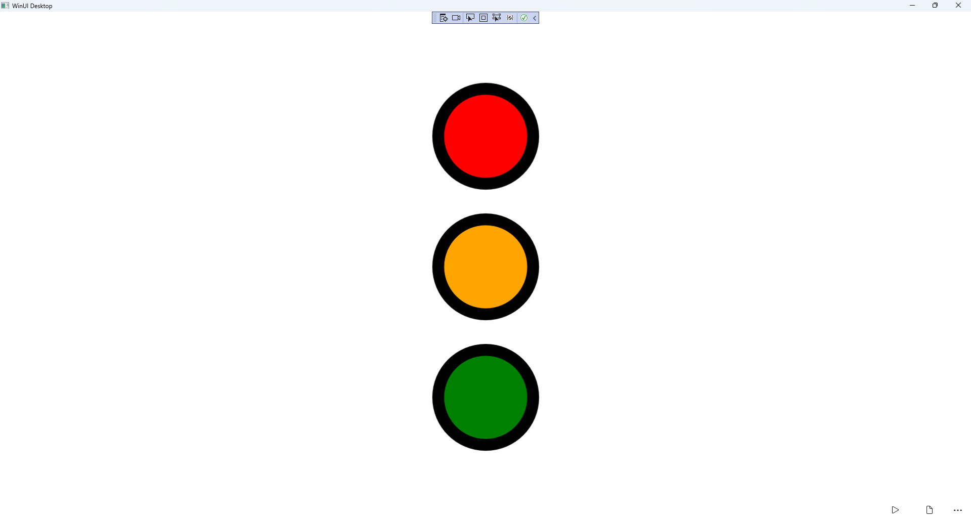

## Step 19

|  |  |
| --- | --- |
| To **Exit** the **Windows App SDK** application, select the **Close** button from the top right of the application as that concludes this **Tutorial** for **Windows App SDK** from [tutorialr.com](https://tutorialr.com)! |  |