

[](https://www.tutorialr.com/tutorials/)

Windows App SDK

Lucky Bunny





# Lucky Bunny

**Lucky Bunny** shows how you can create a simple game where the aim is to select the **Carrot** but if you

miss then you lose a **Bunny** but if you lose three you lose the game but if you get them all you win the

game, using emoji and a toolkit from **NuGet** using the **Windows App SDK**.

## Step 1

Follow **Setup and Start** on how to get **Setup** and **Install** what you need for **Visual Studio 2022** and **Windows App SDK**.

|  |  |
| --- | --- |
| In **Windows 11** choose **Start** and then find or search for **Visual Studio 2022** and then select it. |  |
| Once **Visual Studio 2022** has started select **Create a new project**. |  |
| Then choose the **Blank App, Packages (WinUI in Desktop)** and then select **Next**. |  |
| After that in **Configure your new project** type in the **Project name** as *LuckyBunny*, then select a Location and then select **Create** to start a new **Solution**. |  |

## Step 2

Then in **Visual Studio** within **Solution** **Explorer** for the **Solution**, right click on the **Project** shown below the **Solution** and then select **Manage NuGet Packages…**

## Step 3

Then in the **NuGet Package Manager** from the **Browse** tab search for **Comentsys.Toolkit.WindowsAppSdk** and then select **Comentsys.Toolkit.WindowsAppSdk by Comentsys** as indicated and select **Install**

This will add the package for **Comentsys.Toolkit.WindowsAppSdk** to your **Project**. If you get the **Preview Changes** screen saying **Visual Studio is about to make changes to this solution. Click OK to proceed with the changes listed below.** You can read the message and then select **OK** to **Install** the package.

## Step 4

Then while still in the **NuGet Package Manager** from the **Browse** tab search for **Comentsys.Assets.FluentEmoji** and then select **Comentsys.Assets.FluentEmoji by Comentsys** as indicated and select **Install**

This will add the package for **Comentsys.Assets.FluentEmoji** to your **Project**. If you get the **Preview Changes** screen saying **Visual Studio is about to make changes to this solution. Click OK to proceed with the changes listed below.** You can read the message and then select **OK** to **Install** the package, then you can close the **tab** for **Nuget: LuckyBunny** by selecting the **x** next to it.

## Step 5

Then in **Visual Studio** within **Solution** **Explorer** for the **Solution**, right click on the **Project** shown below the **Solution** and then select **Add** then **New Item…**

## Step 6

Then in **Add New Item** from the **C# Items** list, select **Code** and then select **Code File** from the list next to this, then type in the name of *Library.cs* and then **Click** on **Add**.

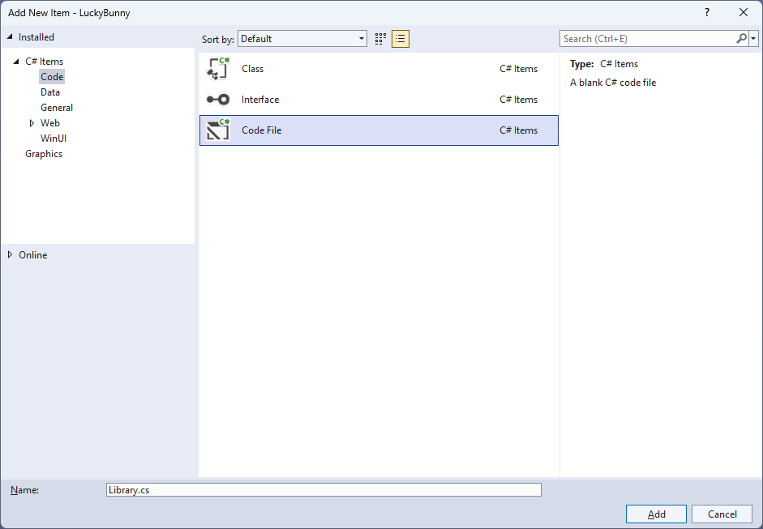

## Step 7

You will now be in the **View** for the **Code** of *Library.cs*, within this first type the following **Code**:

using Comentsys.Assets.FluentEmoji;

using Comentsys.Toolkit.WindowsAppSdk;

using Microsoft.UI.Xaml;

using Microsoft.UI.Xaml.Controls;

using System;

using System.Collections.Generic;

using System.Linq;

public class Library

{

private const string title = "Lucky Bunny";

private const int size = 5;

private const int bunnies = 3;

private const int maximum = 25;

private const double timer = 1;

private const bool bunny = true;

private const bool carrot = false;

private readonly Random _random = new((int)DateTime.UtcNow.Ticks);

private DispatcherTimer _timer;

private Dialog _dialog;

private Panel _panel;

private Grid _grid;

private List<int> _numbers;

private int _current;

private int _missed;

private bool _over;

private List<int> Choose(int minimum, int maximum, int total) =>

Enumerable.Range(minimum, maximum)

.OrderBy(r => _random.Next(minimum, maximum))

.Take(total).ToList();

// Get Asset, Get Content, Set Content, Over & Miss

// Add

// Layout & New

}

**Class** defined so far *Library.cs* has **using** for packageof **Comentsys.Toolkit.WindowsAppSdk** and others. It also has **Constants** to represent things needed in the game you can even change the values to make the game more difficult or easier if needed. There are **Variables** to keep track of values used in the game and elements for the look-and-feel of the game as well as a **Method** for **Choose** which is used to select a list of randomised numbers

## Step 8

Still in the **Class** for *Library.cs* after the **Comment** of **// Get Asset, Get Content, Set Content, Over & Miss** type the following **Methods**:

private Asset GetAsset(bool? isBunny = null) =>

new()

{

AssetResource = FlatFluentEmoji.Get(

isBunny switch

{

bunny => FluentEmojiType.RabbitFace,

carrot => FluentEmojiType.Carrot,

_ => FluentEmojiType.None

})

};

private Asset GetContent(int counter) =>

_numbers[_current] == counter ? GetAsset(false) : GetAsset();

private void SetContent()

{

foreach (var button in _grid.Children.Cast<Button>())

{

button.Content = GetContent((int)button.Tag);

}

}

private void Over()

{

if (_over)

_dialog.Show("Game Over!");

}

private void Miss()

{

if (!_over)

{

_panel.Children.Remove(_panel.Children.FirstOrDefault());

_panel.Children.Add(GetAsset());

_missed++;

if (_missed >= bunnies)

{

_timer.Stop();

_over = true;

}

}

Over();

}

**GetAsset** is used to get an asset for the emoji used in the game and **GetContent** is used to get the correct **Asset** based on the value passed in and is used by **SetContent** to update the **Content** for a **Button**. **Over** is used to display when the game is over and **Miss** is used to indicate when a carrot has been missed.

## Step 9

While still in the **Class** for *Library.cs* after the **Comment** of **// Add** type in the following **Method**:

private void Add(Grid grid, int row, int column, int index)

{

Button button = new()

{

Width = 50,

Height = 50,

Tag = index,

Content = GetContent(index)

};

button.Click += (object sender, RoutedEventArgs e) =>

{

if (!_over)

{

if (_current < maximum - 1)

{

var value = (int)button.Tag;

if (_numbers[_current] == value)

{

_current++;

SetContent();

_timer.Start();

}

else

{

Miss();

}

}

else

{

_dialog.Show($"You Won with {_missed} missed!");

_timer.Stop();

}

}

Over();

};

button.SetValue(Grid.ColumnProperty, column);

button.SetValue(Grid.RowProperty, row);

grid.Children.Add(button);

}

**Add** will be used to create a **Button** and then set the **Content** using **GetContent** then it will check if the game is not complete, if it is then a message will be displayed to indicate this then there is checked to see whether the correct selection has been made then it will select the next position and start the timer.

## Step 10

While still in the **Class** for *Library.cs* after the **Comment** of **// Layout & New** type the following **Methods** of **Layout** which creates the look-and-feel of the game and **New** which begins a game.

private void Layout(Grid grid)

{

int index = 0;

grid.Children.Clear();

var panel = new StackPanel()

{

Orientation = Orientation.Vertical

};

_grid = new Grid();

for (int row = 0; row < size; row++)

{

_grid.RowDefinitions.Add(new RowDefinition());

for (int column = 0; column < size; column++)

{

if (row == 0)

_grid.ColumnDefinitions.Add(new ColumnDefinition());

Add(_grid, row, column, index);

index++;

}

}

panel.Children.Add(_grid);

_panel = new StackPanel()

{

Orientation = Orientation.Horizontal,

HorizontalAlignment = HorizontalAlignment.Center

};

for (int counter = 0; counter < bunnies; counter++)

{

_panel.Children.Add(GetAsset(true));

}

panel.Children.Add(_panel);

grid.Children.Add(panel);

}

public void New(Grid grid)

{

_dialog = new Dialog(grid.XamlRoot, title);

_numbers = Choose(0, size * size, maximum);

_timer = new()

{

Interval = TimeSpan.FromSeconds(timer)

};

_timer.Tick += (object sender, object e) =>

Miss();

_over = false;

_current = 0;

_missed = 0;

Layout(grid);

}

## Step 11

|  |  |
| --- | --- |
| Then from **Solution** **Explorer** for the **Solution** double-click on **MainWindow.xaml** to see the **XAML** for the **Main Window**. |  |

## Step 12

In the **XAML** for **MainWindow.xaml** there be some **XAML** for a **StackPanel**, this should be **Removed** by removing the following:

<StackPanel Orientation="Horizontal"

HorizontalAlignment="Center" VerticalAlignment="Center">

<Button x:Name="myButton" Click="myButton_Click">Click Me</Button>

</StackPanel>

## Step 13

While still in the **XAML** for **MainWindow.xaml** above **</Window>**, type in the following **XAML**:

<Grid>

<Viewbox>

<Grid Margin="50" Name="Display"

HorizontalAlignment="Center"

VerticalAlignment="Center" Loaded="New"/>

</Viewbox>

<CommandBar VerticalAlignment="Bottom">

<AppBarButton Icon="Page2" Label="New" Click="New"/>

</CommandBar>

</Grid>

This **XAML** contains a **Grid** with a **Viewbox** which will scale a **Grid**. It has a **Loaded** event handler for **New** which is also shared by the **AppBarButton**.

## Step 14

|  |  |
| --- | --- |
| Then, within **Solution** **Explorer** for the **Solution** select the arrow next to **MainWindow.xaml** then double-click on **MainWindow.xaml.cs** to see the **Code** for the **Main Window**. |  |

## Step 15

In the **Code** for **MainWindow.xaml.cs** there be a **Method** of **myButton_Click(...)** this should be **Removed** by removing the following:

private void myButton_Click(object sender, RoutedEventArgs e)

{

myButton.Content = "Clicked";

}

## Step 16

Once **myButton_Click(...)** has been removed, type in the following **Code** below the end of the **Constructor** of **public MainWindow() { ... }**:

private readonly Library _library = new();

private void New(object sender, RoutedEventArgs e) =>

_library.New(Display);

Here an **Instance** of the **Class** of **Library** is created then below this is the **Method** of **New** that will be used with **Event Handler** from the **XAML**, this **Method** uses Arrow Syntax with the **=>** for an Expression Bodywhich is useful when a **Method** only has one line.

## Step 17

|  |  |
| --- | --- |
| That completes the **Windows App SDK** application. In **Visual Studio 2022** from the **Toolbar** select **LuckyBunny (Package)** to **Start** the application. |  |

## Step 18

Once running you can then select a **Carrot** then you must be quick to select the next **Carrot** and so on until you win, if you’re too slow or you miss you lose one **Bunny** and if you lose them all you lose the game, or you can select *New*to start a new game.

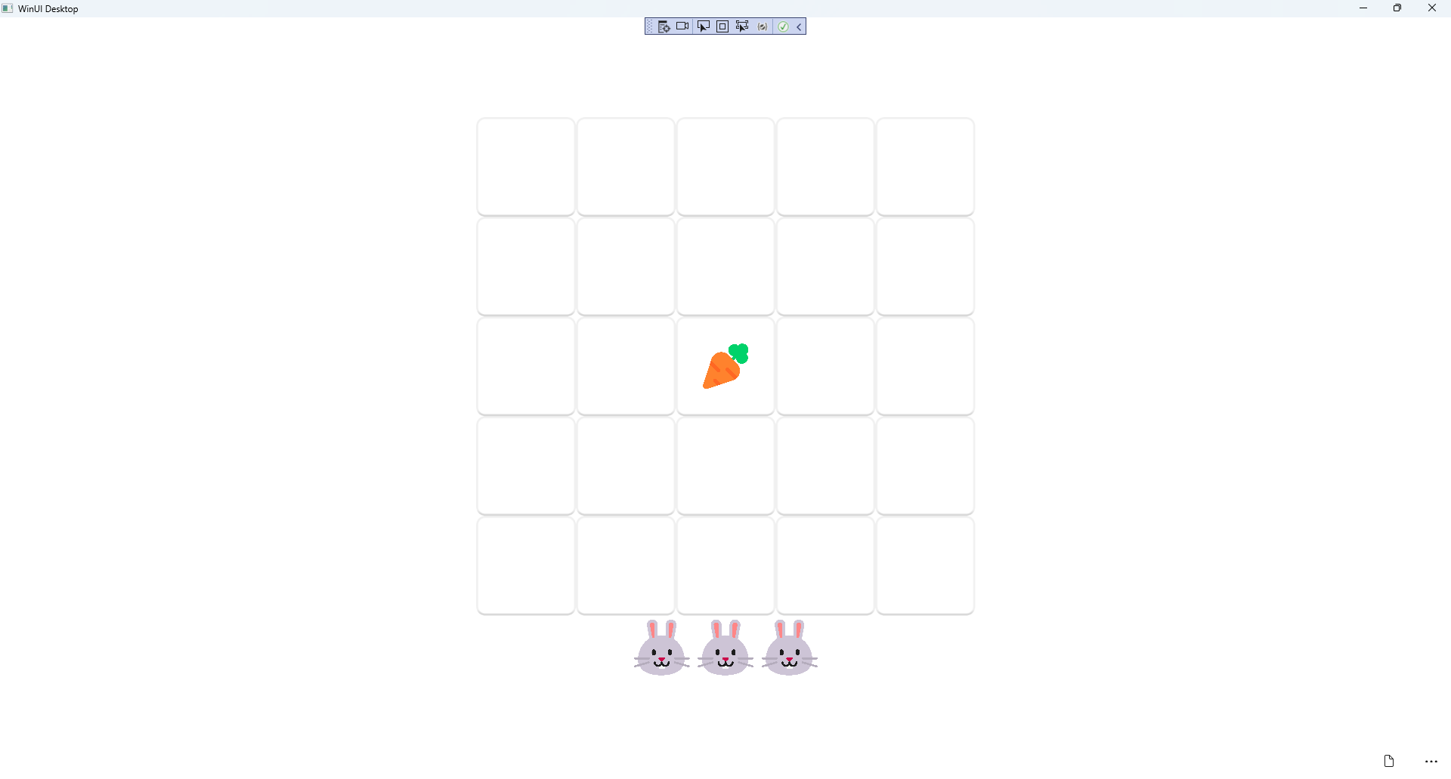

## Step 19

|  |  |
| --- | --- |
| To **Exit** the **Windows App SDK** application, select the **Close** button from the top right of the application as that concludes this **Tutorial** for **Windows App SDK** from [tutorialr.com](https://tutorialr.com)! |  |