

[](https://www.tutorialr.com/tutorials/)

Windows App SDK

Lucky Darts





# Lucky Darts

**Lucky Darts** shows how you can create a darts game with a random chance of hitting the right spot on the

dartboard using a control in a toolkit from **NuGet** using the **Windows App SDK**.

## Step 1

Follow **Setup and Start** on how to get **Setup** and **Install** what you need for **Visual Studio 2022** and **Windows App SDK**.

|  |  |
| --- | --- |
| In **Windows 11** choose **Start** and then find or search for **Visual Studio 2022** and then select it. |  |
| Once **Visual Studio 2022** has started select **Create a new project**. |  |
| Then choose the **Blank App, Packages (WinUI in Desktop)** and then select **Next**. |  |
| After that in **Configure your new project** type in the **Project name** as *LuckyDarts*, then select a Location and then select **Create** to start a new **Solution**. |  |

## Step 2

Then in **Visual Studio** within **Solution** **Explorer** for the **Solution**, right click on the **Project** shown below the **Solution** and then select **Manage NuGet Packages…**

## Step 3

Then in the **NuGet Package Manager** from the **Browse** tab search for **Comentsys.Toolkit.WindowsAppSdk** and then select **Comentsys.Toolkit.WindowsAppSdk by Comentsys** as indicated and select **Install**

This will add the package for **Comentsys.Toolkit.WindowsAppSdk** to your **Project**. If you get the **Preview Changes** screen saying **Visual Studio is about to make changes to this solution. Click OK to proceed with the changes listed below.** You can read the message and then select **OK** to **Install** the package,, then you can close the **tab** for **Nuget: LuckyDarts** by selecting the **x** next to it.

## Step 4

Then in **Visual Studio** within **Solution** **Explorer** for the **Solution**, right click on the **Project** shown below the **Solution** and then select **Add** then **New Item…**

## Step 5

Then in **Add New Item** from the **C# Items** list, select **Code** and then select **Code File** from the list next to this, then type in the name of *Library.cs* and then **Click** on **Add**.

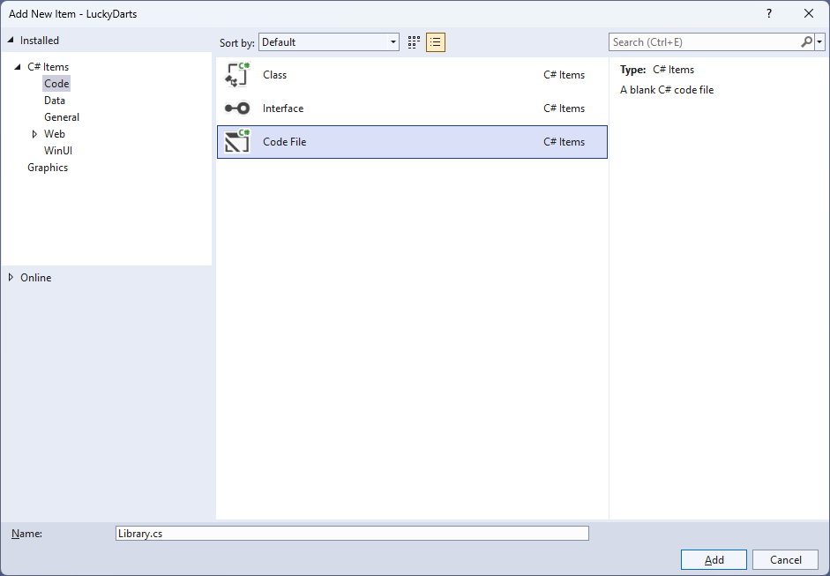

## Step 6

You will now be in the **View** for the **Code** of *Library.cs*, within this first type the following **Code**:

using Comentsys.Toolkit.WindowsAppSdk;

using Microsoft.UI;

using Microsoft.UI.Xaml;

using Microsoft.UI.Xaml.Controls;

using Microsoft.UI.Xaml.Input;

using Microsoft.UI.Xaml.Media;

using Microsoft.UI.Xaml.Shapes;

using System;

using Windows.Foundation;

using Windows.UI;

public class Library

{

private const string title = "Lucky Darts";

private const int radius = 200;

private const int circle = 360;

private const int triple = 250;

private const int offset = 40;

private const int chance = 5;

private const int size = 500;

private const int dart = 10;

private const int bull = 20;

private const int ring = 10;

private const int font = 25;

private const int line = 2;

private static readonly int[] numbers =

{

20, 1, 18, 4, 13, 6, 10, 15, 2, 17,

3, 19, 7, 16, 8, 11, 14, 9, 12, 5

};

private static readonly double section =

circle / numbers.Length;

private readonly Random _random = new((int)DateTime.UtcNow.Ticks);

private int _score = 0;

private Dialog _dialog;

private Canvas _canvas;

private Piece _dart;

// Is Odd, Get Ellipse, Add Circle & Get Sector

// Add Section, Get Text & Add Text

// Add Dart & Get Number

// Get Score, Play & Add Board

// Layout & New

}

**Class** defined so far *Library.cs* has **using** for packageof **Comentsys.Toolkit.WindowsAppSdk** and others.

## Step 7

Still in the **Class** for *Library.cs* after the **Comment** of **// Is Odd, Get Ellipse, Add Circle & Get Sector** type the following **Methods**:

private bool IsOdd(int value) =>

value % 2 != 0;

private Ellipse GetEllipse(double diameter, Color fill) => new()

{

Width = diameter,

Height = diameter,

StrokeThickness = line,

Fill = new SolidColorBrush(fill),

Stroke = new SolidColorBrush(Colors.WhiteSmoke)

};

private void AddCircle(Canvas canvas, double diameter, Color fill)

{

var circle = GetEllipse(diameter, fill);

Canvas.SetLeft(circle, (size - diameter) / 2);

Canvas.SetTop(circle, (size - diameter) / 2);

canvas.Children.Add(circle);

}

private Sector GetSector(double start, double finish,

double radius, double hole, Color fill)

{

Sector sector = new()

{

Hole = hole,

Start = start,

Finish = finish,

Radius = radius,

StrokeThickness = line,

Fill = new SolidColorBrush(fill),

Stroke = new SolidColorBrush(Colors.WhiteSmoke)

};

Canvas.SetLeft(sector, (size - radius * 2) / 2);

Canvas.SetTop(sector, (size - radius * 2) / 2);

return sector;

}

**IsOdd** is used to determine if the number is odd or even, **GetEllipse** will get an **Ellipse** to be used with **AddCircle** and **GetSector** will use the **Sector** control from the toolkit and set it up as needed.

## Step 8

While still in the **Class** for *Library.cs* after the **Comment** of **// Add Section, Get Text & Add Text** type in the following **Methods**:

private void AddSection(Canvas canvas, int index, double start)

{

var finish = section;

var sector = GetSector(start, finish, radius, bull,

IsOdd(index) ? Colors.Black : Colors.MintCream);

var doubleRing = GetSector(start, finish, radius, radius - ring,

IsOdd(index) ? Colors.MediumSeaGreen : Colors.OrangeRed);

var tripleRing = GetSector(start, finish, triple / 2, triple / 2 - ring,

IsOdd(index) ? Colors.MediumSeaGreen : Colors.OrangeRed);

canvas.Children.Add(sector);

canvas.Children.Add(doubleRing);

canvas.Children.Add(tripleRing);

}

private TextBlock GetText(string value)

{

var text = new TextBlock()

{

Foreground = new SolidColorBrush(Colors.WhiteSmoke),

TextAlignment = TextAlignment.Center,

FontSize = font,

Text = value

};

text.Measure(new Size(

double.PositiveInfinity,

double.PositiveInfinity));

return text;

}

private void AddText(Canvas canvas, int index, double start)

{

var text = GetText($"{numbers[index]}");

double angle = start * Math.PI / (circle / 2);

double width = canvas.ActualWidth / 2;

double height = canvas.ActualHeight / 2;

double left = width + (width - font) * Math.Cos(angle)

- text.DesiredSize.Width / 2;

double top = height + (height - font) * Math.Sin(angle)

- text.DesiredSize.Height / 2;

Canvas.SetLeft(text, left);

Canvas.SetTop(text, top);

canvas.Children.Add(text);

}

**AddSection** will create a section of the dartboard using **GetSector** and **GetText** will create a **TextBlock** for the numbers to be used by **AddText** which positions the numbers on the dartboard.

## Step 9

While still in the **Class** for *Library.cs* after the **Comment** of **// Add Dart & Get Number** type in the following **Methods**:

private void AddDart(Point point)

{

_canvas.Children.Remove(_dart);

_dart = new Piece()

{

Width = dart,

Height = dart,

Name = nameof(_dart),

Fill = new SolidColorBrush(Colors.SlateGray),

Stroke = new SolidColorBrush(Colors.DarkGray)

};

Canvas.SetLeft(_dart, point.X - dart / 2);

Canvas.SetTop(_dart, point.Y - dart / 2);

_canvas.Children.Add(_dart);

}

private int GetNumber(double degrees) =>

degrees switch

{

>= 351 => 6,

>= 333 => 10,

>= 315 => 15,

>= 297 => 2,

>= 279 => 17,

>= 261 => 3,

>= 243 => 19,

>= 225 => 7,

>= 207 => 16,

>= 189 => 8,

>= 171 => 11,

>= 153 => 14,

>= 135 => 9,

>= 117 => 12,

>= 99 => 5,

>= 81 => 20,

>= 63 => 1,

>= 45 => 18,

>= 27 => 4,

>= 9 => 13,

_ => 6

};

**AddDart** will position the dart on the dartboard with a given position and **GetNumber** will get the number of the dartboard based upon the angle passed in.

## Step 10

While still in the **Class** for *Library.cs* after the **Comment** of **// Get Score, Play & Add Board** type in the following **Methods**:

private int GetScore(Point point)

{

double x = point.X - size / 2;

double y = size / 2 - point.Y;

double radians = Math.Atan2(y, x);

int degrees = (int)(radians * (circle / 2) / Math.PI);

degrees = degrees < 0 ? circle + degrees : degrees;

int number = GetNumber(degrees);

var length = (int)Math.Floor(Math.Sqrt(x * x + y * y));

return length switch

{

>= radius => 0,

>= radius - ring and <= radius => number * 2,

>= triple / 2 - ring and <= triple / 2 => number * 3,

>= bull - ring and <= bull => 25,

<= bull / 2 => 50,

_ => number

};

}

private void Play(Point point)

{

var x = _random.Next((int)point.X - offset, (int)point.X + offset);

var y = _random.Next((int)point.Y - offset, (int)point.Y + offset);

var hit = IsOdd(_random.Next(0, chance)) ? point : new Point(x, y);

var score = GetScore(hit);

_score += score;

AddDart(hit);

_dialog.Show($"Scored {score}, Total {_score}");

}

private void AddBoard(Canvas canvas, double diameter)

{

var board = GetEllipse(diameter, Colors.Transparent);

board.Tapped += (object sender, TappedRoutedEventArgs e) =>

Play(e.GetPosition(canvas));

Canvas.SetLeft(board, (size - diameter) / 2);

Canvas.SetTop(board, (size - diameter) / 2);

canvas.Children.Add(board);

}

**GetScore** will work out the score of the position on the dartboard, taking into account the double ring, triple ring, outer bullseye and the inner bullseye. **Play** will position the dart on the dart board in a randomised location near where was selected and then the score will be updated accordingly and is used in **AddBoard** which will add a transparent **Ellipse** which will capture **Events** when it is **Tapped**.

## Step 11

While still in the **Class** for *Library.cs* after the **Comment** of **// Layout & New** type in the following **Methods**:

private void Layout(Grid grid)

{

grid.Children.Clear();

_canvas = new Canvas()

{

Width = size,

Height = size

};

var start = -(section / 2);

AddCircle(_canvas, size, Colors.Black);

AddCircle(_canvas, (radius * 2) + (line * 2), Colors.WhiteSmoke);

for (int index = 0; index < numbers.Length; index++)

{

AddSection(_canvas, index, start);

AddText(_canvas, index, start + (section / 2) - (circle / 4));

start += section;

}

AddCircle(_canvas, bull * 2, Colors.MediumSeaGreen);

AddCircle(_canvas, bull, Colors.OrangeRed);

AddBoard(_canvas, size);

grid.Children.Add(_canvas);

}

public void New(Grid grid)

{

_score = 0;

_dialog = new Dialog(grid.XamlRoot, title);

Layout(grid);

}

**Layout** will create the look-and-feel of the dartboard and **New** will start a new game.

## Step 12

|  |  |
| --- | --- |
| Then from **Solution** **Explorer** for the **Solution** double-click on **MainWindow.xaml** to see the **XAML** for the **Main Window**. |  |

## Step 13

In the **XAML** for **MainWindow.xaml** there be some **XAML** for a **StackPanel**, this should be **Removed** by removing the following:

<StackPanel Orientation="Horizontal"

HorizontalAlignment="Center" VerticalAlignment="Center">

<Button x:Name="myButton" Click="myButton_Click">Click Me</Button>

</StackPanel>

## Step 14

While still in the **XAML** for **MainWindow.xaml** above **</Window>**, type in the following **XAML**:

<Grid>

<Viewbox>

<Grid Margin="50" Name="Display"

HorizontalAlignment="Center"

VerticalAlignment="Center" Loaded="New"/>

</Viewbox>

<CommandBar VerticalAlignment="Bottom">

<AppBarButton Icon="Page2" Label="New" Click="New"/>

</CommandBar>

</Grid>

This **XAML** contains a **Grid** with a **Viewbox** which will scale a **Grid**. It has a **Loaded** event handler for **New** which is also shared by the **AppBarButton**.

## Step 15

|  |  |
| --- | --- |
| Then, within **Solution** **Explorer** for the **Solution** select the arrow next to **MainWindow.xaml** then double-click on **MainWindow.xaml.cs** to see the **Code** for the **Main Window**. |  |

## Step 16

In the **Code** for **MainWindow.xaml.cs** there be a **Method** of **myButton_Click(...)** this should be **Removed** by removing the following:

private void myButton_Click(object sender, RoutedEventArgs e)

{

myButton.Content = "Clicked";

}

## Step 17

Once **myButton_Click(...)** has been removed, type in the following **Code** below the end of the **Constructor** of **public MainWindow() { ... }**:

private readonly Library _library = new();

private void New(object sender, RoutedEventArgs e) =>

_library.New(Display);

Here an **Instance** of the **Class** of **Library** is created then below this is the **Method** of **New** that will be used with **Event Handler** from the **XAML**, this **Method** uses Arrow Syntax with the **=>** for an Expression Bodywhich is useful when a **Method** only has one line.

## Step 18

|  |  |
| --- | --- |
| That completes the **Windows App SDK** application. In **Visual Studio 2022** from the **Toolbar** select **LuckyDarts (Package)** to **Start** the application. |  |

## Step 19

Once running you can then select anywhere on the dartboard to try and see if you can get that score but there’s a random chance you won’t hit that spot and see what score you can get or select *New* to restart the game.

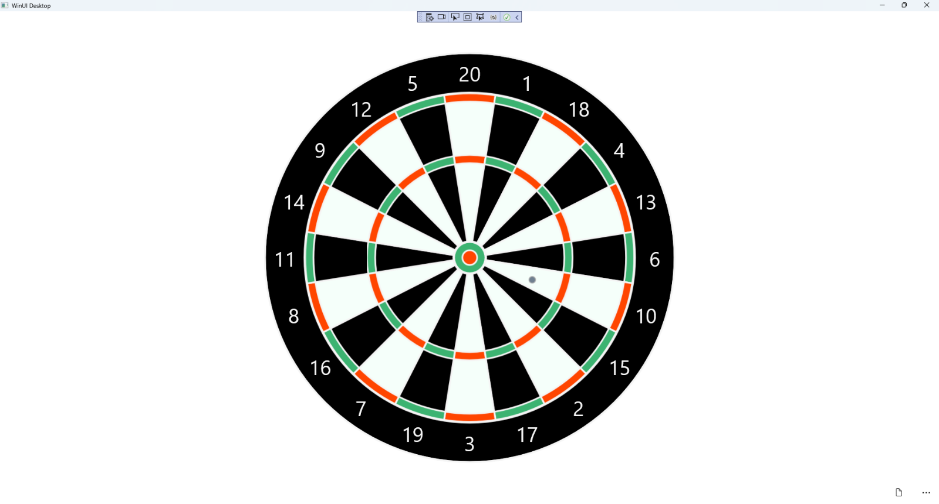

## Step 20

|  |  |
| --- | --- |
| To **Exit** the **Windows App SDK** application, select the **Close** button from the top right of the application as that concludes this **Tutorial** for **Windows App SDK** from [tutorialr.com](https://tutorialr.com)! |  |