

[](https://www.tutorialr.com/tutorials/)

Windows App SDK

Lucky Dominoes





# Lucky Dominoes

**Lucky Dominoes** shows how you can create a simple domino game using a control from **NuGet** using

the **Windows App SDK**.

## Step 1

Follow **Setup and Start** on how to get **Setup** and **Install** what you need for **Visual Studio 2022** and **Windows App SDK**.

|  |  |
| --- | --- |
| In **Windows 11** choose **Start** and then find or search for **Visual Studio 2022** and then select it. |  |
| Once **Visual Studio 2022** has started select **Create a new project**. |  |
| Then choose the **Blank App, Packages (WinUI in Desktop)** and then select **Next**. |  |
| After that in **Configure your new project** type in the **Project name** as *LuckyDominoes*, then select a Location and then select **Create** to start a new **Solution**. |  |

## Step 2

Then in **Visual Studio** within **Solution** **Explorer** for the **Solution**, right click on the **Project** shown below the **Solution** and then select **Manage NuGet Packages…**

## Step 3

Then in the **NuGet Package Manager** from the **Browse** tab search for **Comentsys.Toolkit.WindowsAppSdk** and then select **Comentsys.Toolkit.WindowsAppSdk by Comentsys** as indicated and select **Install**

This will add the package for **Comentsys.Toolkit.WindowsAppSdk** to your **Project**. If you get the **Preview Changes** screen saying **Visual Studio is about to make changes to this solution. Click OK to proceed with the changes listed below.** You can read the message and then select **OK** to **Install** the package, then you can close the **tab** for **Nuget: LuckyDominoes** by selecting the **x** next to it.

## Step 4

Then in **Visual Studio** within **Solution** **Explorer** for the **Solution**, right click on the **Project** shown below the **Solution** and then select **Add** then **New Item…**

## Step 5

Then in **Add New Item** from the **C# Items** list, select **Code** and then select **Code File** from the list next to this, then type in the name of *Library.cs* and then **Click** on **Add**.

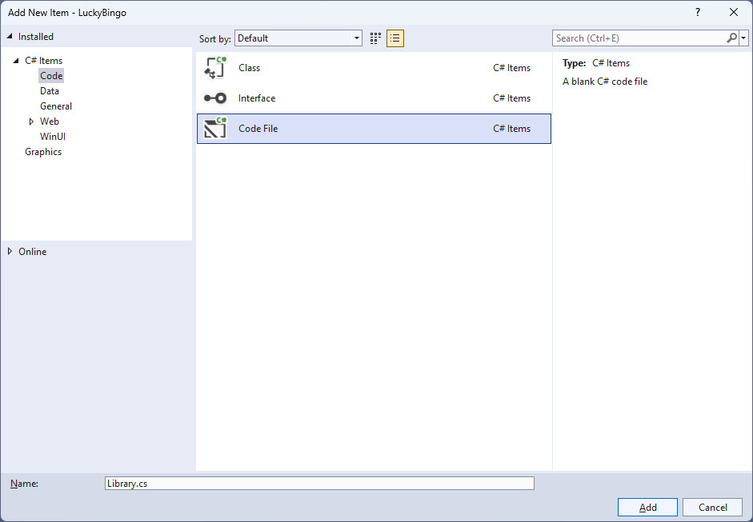

## Step 6

You will now be in the **View** for the **Code** of *Library.cs*, within this first type the following **Code**:

using Comentsys.Toolkit.WindowsAppSdk;

using Microsoft.UI;

using Microsoft.UI.Xaml;

using Microsoft.UI.Xaml.Controls;

using Microsoft.UI.Xaml.Input;

using Microsoft.UI.Xaml.Media;

using System;

using System.Collections.Generic;

using System.Linq;

public class Library

{

private const string set_one = "one";

private const string set_two = "two";

private const string name_upper = "upper";

private const string name_lower = "lower";

private static readonly string[] _tiles =

{

"0,0",

"0,1", "1,1",

"0,2", "1,2", "2,2",

"0,3", "1,3", "2,3", "3,3",

"0,4", "1,4", "2,4", "3,4", "4,4",

"0,5", "1,5", "2,5", "3,5", "4,5", "5,5",

"0,6", "1,6", "2,6", "3,6", "4,6", "5,6", "6,6"

};

private readonly Random _random = new((int)DateTime.UtcNow.Ticks);

private int _turns = 0;

private List<int> _one = new();

private List<int> _two = new();

private StackPanel _panel = new();

private List<int> Choose(int minimum, int maximum) =>

Enumerable.Range(minimum, maximum)

.OrderBy(r => _random.Next(minimum, maximum))

.ToList();

// Background, Get Portion & Set Portion

// Set Domino, Get Domino & New

}

The **Class** that has been defined in so far *Library.cs* has **using** amongst others for the packageof **Comentsys.Toolkit.WindowsAppSdk**. It also defines the tiles that represent the configurations of a domino. There is also a **StackPanel** for the layout of the dominos and the **Method** of **Choose** which is used to select a randomised list of numbers.

## Step 7

While still in the **Class** for *Library.cs* and after the **Comment** of **// Background, Get Portion & Set Portion** type in the following **Methods**:

private Brush Background() =>

new LinearGradientBrush(new GradientStopCollection()

{

new GradientStop()

{

Color = Colors.DarkSlateGray,

Offset = 0.0

},

new GradientStop()

{

Color = Colors.Black,

Offset = 1.0

}

}, 90);

private Dice GetPortion(string name) => new()

{

Name = name,

Background = Background(),

Foreground = new SolidColorBrush(Colors.WhiteSmoke)

};

private void SetPortion(string name, int value) =>

((Dice)_panel.FindName(name)).Value = value;

**Background** will create the appearance of the domino using a **LinearGradientBrush** and **GetPortion** is used to get the upper or lower part of a domino by using the **Dice** control and sets the **Background** using the **Method** of **Background** and **SetPortion** will set the **Value** of the **Dice** being used to represent the pips of the domino.

## Step 8

While still in the **Class** for *Library.cs* after the **Comment** of **// Set Domino, Get Domino & New** type in the following **Methods**.

private void SetDomino(string name, string tile)

{

string[] pair = tile.Split(',');

SetPortion($"{name}.{name_upper}", int.Parse(pair[0]));

SetPortion($"{name}.{name_lower}", int.Parse(pair[1]));

}

private StackPanel GetDomino(string name)

{

StackPanel domino = new()

{

Margin = new Thickness(25),

Orientation = Orientation.Vertical

};

domino.Tapped += (object sender, TappedRoutedEventArgs e) =>

{

if (_turns > 0)

{

SetDomino(set_one, _tiles[_one[_turns]]);

SetDomino(set_two, _tiles[_two[_turns]]);

_turns--;

}

else

New(_panel);

};

domino.Children.Add(GetPortion($"{name}.{name_upper}"));

domino.Children.Add(GetPortion($"{name}.{name_lower}"));

return domino;

}

public void New(StackPanel panel)

{

_panel = panel;

_panel.Children.Clear();

_panel.Children.Add(GetDomino(set_one));

_panel.Children.Add(GetDomino(set_two));

_turns = _tiles.Length - 1;

_one = Choose(0, _tiles.Length);

_two = Choose(0, _tiles.Length);

}

**SetDomino** will set the values of the upper and lower portions of a domino and use the set of values that a domino can show, **GetDomino** will create the layout for a domino and set up the **Event** when it is **Tapped** to show the relevant domino and **New** will start a new game.

## Step 9

|  |  |
| --- | --- |
| Then from **Solution** **Explorer** for the **Solution** double-click on **MainWindow.xaml** to see the **XAML** for the **Main Window**. |  |

## Step 10

In the **XAML** for **MainWindow.xaml** there be some **XAML** for a **StackPanel**, this should be **Removed** by removing the following:

<StackPanel Orientation="Horizontal"

HorizontalAlignment="Center" VerticalAlignment="Center">

<Button x:Name="myButton" Click="myButton_Click">Click Me</Button>

</StackPanel>

## Step 11

While still in the **XAML** for **MainWindow.xaml** above **</Window>**, type in the following **XAML**:

<Grid>

<Viewbox>

<StackPanel Margin="50" Name="Display" Orientation="Horizontal"

HorizontalAlignment="Center" VerticalAlignment="Center" Loaded="New"/>

</Viewbox>

<CommandBar VerticalAlignment="Bottom">

<AppBarButton Icon="Page2" Label="New" Click="New"/>

</CommandBar>

</Grid>

This **XAML** contains a **Grid** with a **Viewbox** which will scale a **StackPanel**. It has a **Loaded** event handler for **New** which is also shared by the **AppBarButton**.

## Step 12

|  |  |
| --- | --- |
| Then, within **Solution** **Explorer** for the **Solution** select the arrow next to **MainWindow.xaml** then double-click on **MainWindow.xaml.cs** to see the **Code** for the **Main Window**. |  |

## Step 13

In the **Code** for **MainWindow.xaml.cs** there be a **Method** of **myButton_Click(...)** this should be **Removed** by removing the following:

private void myButton_Click(object sender, RoutedEventArgs e)

{

myButton.Content = "Clicked";

}

## Step 14

Once **myButton_Click(...)** has been removed, type in the following **Code** below the end of the **Constructor** of **public MainWindow() { ... }**:

private readonly Library _library = new();

private void New(object sender, RoutedEventArgs e) =>

_library.New(Display);

Here an **Instance** of the **Class** of **Library** is created then below this is the **Method** of **New** that will be used with **Event Handler** from the **XAML**, this **Method** uses Arrow Syntax with the **=>** for an Expression Bodywhich is useful when a **Method** only has one line.

## Step 15

|  |  |
| --- | --- |
| That completes the **Windows App SDK** application. In **Visual Studio 2022** from the **Toolbar** select **LuckyDominos (Package)** to **Start** the application. |  |

## Step 16

Once running you should see the bingo card then you can select either domino which will show a randomised value of all the possible values, or you can select *New* to restart.

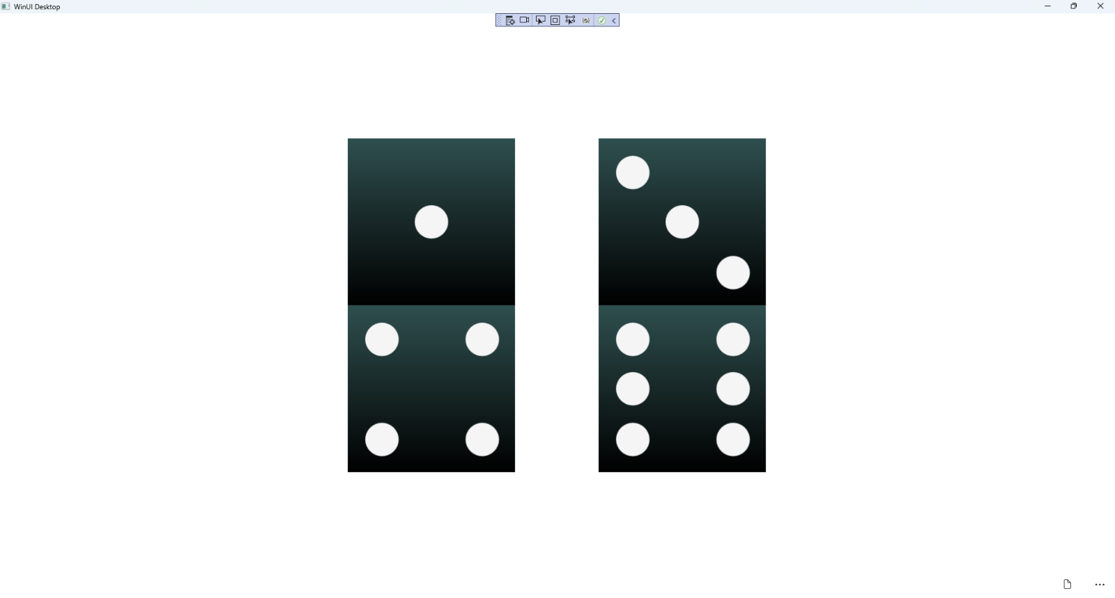

## Step 17

|  |  |
| --- | --- |
| To **Exit** the **Windows App SDK** application, select the **Close** button from the top right of the application as that concludes this **Tutorial** for **Windows App SDK** from [tutorialr.com](https://tutorialr.com)! |  |