

[](https://www.tutorialr.com/tutorials/)

Windows App SDK

Lucky Racer





# Lucky Racer

**Lucky Racer** shows how you can create a game where you can pick from a selection of cars to see if you

will be the winner in the quickest time using emoji and a toolkit from **NuGet** using the **Windows App SDK**.

## Step 1

Follow **Setup and Start** on how to get **Setup** and **Install** what you need for **Visual Studio 2022** and **Windows App SDK**.

|  |  |
| --- | --- |
| In **Windows 11** choose **Start** and then find or search for **Visual Studio 2022** and then select it. |  |
| Once **Visual Studio 2022** has started select **Create a new project**. |  |
| Then choose the **Blank App, Packages (WinUI in Desktop)** and then select **Next**. |  |
| After that in **Configure your new project** type in the **Project name** as *LuckyRacer*, then select a Location and then select **Create** to start a new **Solution**. |  |

## Step 2

Then in **Visual Studio** within **Solution** **Explorer** for the **Solution**, right click on the **Project** shown below the **Solution** and then select **Manage NuGet Packages…**

## Step 3

Then in the **NuGet Package Manager** from the **Browse** tab search for **Comentsys.Toolkit.WindowsAppSdk** and then select **Comentsys.Toolkit.WindowsAppSdk by Comentsys** as indicated and select **Install**

This will add the package for **Comentsys.Toolkit.WindowsAppSdk** to your **Project**. If you get the **Preview Changes** screen saying **Visual Studio is about to make changes to this solution. Click OK to proceed with the changes listed below.** You can read the message and then select **OK** to **Install** the package.

## Step 4

Then while still in the **NuGet Package Manager** from the **Browse** tab search for **Comentsys.Assets.FluentEmoji** and then select **Comentsys.Assets.FluentEmoji by Comentsys** as indicated and select **Install**

This will add the package for **Comentsys.Assets.FluentEmoji** to your **Project**. If you get the **Preview Changes** screen saying **Visual Studio is about to make changes to this solution. Click OK to proceed with the changes listed below.** You can read the message and then select **OK** to **Install** the package, then you can close the **tab** for **Nuget: LuckyRacer** by selecting the **x** next to it.

## Step 5

Then in **Visual Studio** within **Solution** **Explorer** for the **Solution**, right click on the **Project** shown below the **Solution** and then select **Add** then **New Item…**

## Step 6

Then in **Add New Item** from the **C# Items** list, select **Code** and then select **Code File** from the list next to this, then type in the name of *Library.cs* and then **Click** on **Add**.

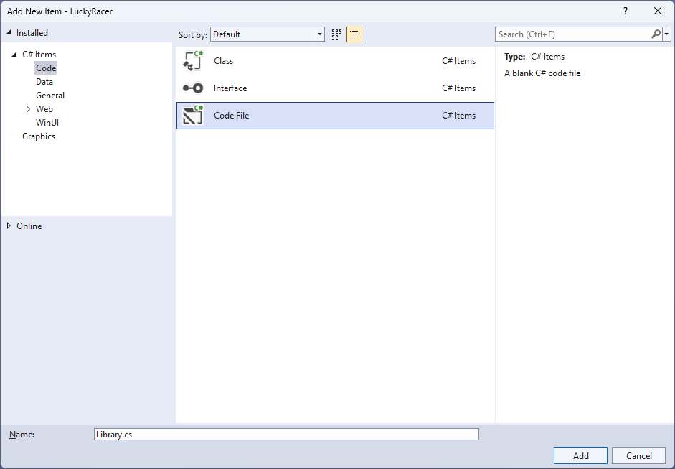

## Step 7

You will now be in the **View** for the **Code** of *Library.cs* to define a **namespace** allowing classes to be defined together, usually each is separate but will be defined in *Library.cs* by typing the following **Code** along with **using** for **Comentsys.Toolkit.WindowsAppSdk** and others plus an **enum** for **State** and **Class** for **Racer**.

using Comentsys.Assets.FluentEmoji;

using Comentsys.Toolkit.WindowsAppSdk;

using Microsoft.UI;

using Microsoft.UI.Xaml.Controls;

using Microsoft.UI.Xaml.Input;

using Microsoft.UI.Xaml.Media;

using Microsoft.UI.Xaml.Media.Animation;

using System;

using System.Collections.Generic;

using System.Linq;

using System.Threading.Tasks;

using Windows.UI;

namespace LuckyRacer;

public enum State

{

Select, Ready, Started, Finished

}

public class Racer

{

public int Index { get; set; }

public TimeSpan Time { get; set; }

public Racer(int index) =>

Index = index;

public Racer(int index, TimeSpan time) =>

(Index, Time) = (index, time);

}

public class Library

{

// Constants, Variables & Choose Method

// Get Finish, Get Racer, Set Sources & Get Image

// Content, Move & Start

// Finish & Progress

// Race, Ready & Select

// Add Racer & Add Finish

// Layout & New

}

## Step 8

While still in the **namespace** of **LuckyRacer** in *Library.cs* and in the **class** of **Library** after the **Comment** of **// Constants, Variables & Choose Method** type the following **Constants**, **Variables** and **Method**:

private const string title = "Lucky Racer";

private const int image_size = 72;

private const int size = 400;

private readonly Random _random = new((int)DateTime.UtcNow.Ticks);

private Dialog _dialog;

private Grid _grid;

private bool _finish;

private int _count;

private State _state;

private Racer _winner;

private Racer _select;

private List<Image> _images;

private ImageSource[] _sources;

private List<int> Choose(int minimum, int maximum, int total)

{

var choose = new List<int>();

var values = Enumerable.Range(minimum, maximum).ToList();

for (int index = 0; index < total; index++)

{

var value = _random.Next(0, values.Count);

choose.Add(values[value]);

}

return choose;

}

**Constants** are values that are used in the game that will not change and **Variables** are used to store various values, **Instances** of **Racer** and images needed for the game. There is also a **Method** of **Choose** which is used to select randomised numbers which can be duplicated so the race is more even and fair.

## Step 9

While still in the **namespace** of **LuckyRacer** in *Library.cs* and in the **class** of **Library** after the **Comment** of **// Get Finish, Get Racer, Set Sources & Get Image** type the following **Methods**:

private async Task<ImageSource> GetFinishAsync() =>

await FlatFluentEmoji.Get(FluentEmojiType.ChequeredFlag)

.AsImageSourceAsync();

private async Task<ImageSource> GetRacerAsync(Color main, Color trim) =>

await FlatFluentEmoji.Get(FluentEmojiType.RacingCar,

new[]

{

Color.FromArgb(255, 248, 49, 47).AsDrawingColor(),

Color.FromArgb(255, 202, 11, 74).AsDrawingColor()

},

new[]

{

main.AsDrawingColor(),

trim.AsDrawingColor()

}).AsImageSourceAsync();

private async Task SetSourcesAsync() =>

_sources ??= (new ImageSource[]

{

await GetFinishAsync(),

await GetRacerAsync(Colors.Red, Colors.DarkRed),

await GetRacerAsync(Colors.Blue, Colors.DarkBlue),

await GetRacerAsync(Colors.Green, Colors.DarkGreen),

await GetRacerAsync(Colors.Goldenrod, Colors.DarkGoldenrod)

});

private Image GetImage(ImageSource source) =>

new()

{

Height = image_size,

Width = image_size,

Source = source

};

**GetFinishAsync** will return a *Chequered Flag* emoji to represent the finish line for the racers and **GetRacerAsync** will return the image for the racers using the *Racing Car* emoji and will customise it using different colours and these **Methods** will be both used by **SetSourcesAsync** to set the images used in the game and **GetImage** will return an **Image** with a given **ImageSource**.

## Step 10

While still in the **namespace** of **LuckyRacer** in *Library.cs* and in the **class** of **Library** after the **Comment** of **// Content, Move & Start** type the following **Methods:**

private StackPanel Content(string text, int index)

{

var panel = new StackPanel()

{

Orientation = Orientation.Vertical,

};

panel.Children.Add(new TextBlock()

{

Text = text

});

panel.Children.Add(GetImage(_sources[index]));

return panel;

}

private void Move(Image image, double from, double to, TimeSpan duration)

{

var animation = new DoubleAnimation()

{

To = to,

From = from,

Duration = duration,

EasingFunction = new ExponentialEase()

{

EasingMode = EasingMode.EaseIn

}

};

var storyboard = new Storyboard();

Storyboard.SetTargetProperty(animation, "(Canvas.Left)");

Storyboard.SetTarget(animation, image);

storyboard.Completed += (object sender, object e) =>

Progress(sender as Storyboard);

storyboard.Children.Add(animation);

storyboard.Begin();

}

private void Start()

{

_count = 0;

_finish = false;

_state = State.Select;

}

**Content** will return a **StackPanel** containing a **TextBlock** as well as an image using **GetImage**, Move will be used to display the progress of the race, which will use a **Method** for **Progress** which will be defined in the next **Step** and **Start** will be ready for the game to start.

## Step 11

While still in the **namespace** of **LuckyRacer** in *Library.cs* and in the **class** of **Library** after the **Comment** of **// Finish & Progress** type the following **Methods:**

private async void Finish()

{

if (_state == State.Finished)

{

var message = _select.Index == _winner.Index ?

$"You Won in {_winner.Time}!" :

$"You Lost! Winning Car";

var content = Content(message, _winner.Index);

await _dialog.ConfirmAsync(content);

if (_finish)

{

foreach (var image in _images)

{

Move(image, 0, size - image_size,

TimeSpan.FromSeconds(1));

}

_finish = false;

}

Start();

}

}

private void Progress(Storyboard storyboard)

{

if (_state == State.Started)

{

var duration = storyboard.GetCurrentTime();

var racer = _images.First(w => (w.Tag as Racer)

.Time == duration).Tag as Racer;

_count++;

if (_count == 1)

_winner = new Racer(racer.Index, duration);

if (_count == _images.Count)

{

_state = State.Finished;

Finish();

}

_finish = true;

}

}

**Finish** will handle what happens when the race is over and determine if the **Racer** that was selected was the winning one or not and Progress which was called in **Move** will be used to set how the **Racer** should move across the game.

## Step 12

While still in the **namespace** of **LuckyRacer** in *Library.cs* and in the **class** of **Library** after the **Comment** of **// Race, Ready & Select** type the following **Methods:**

private void Race()

{

if (_state == State.Ready)

{

var index = 0;

var times = Choose(5, 15, _sources.Length - 1);

foreach (var image in _images)

{

var racer = image.Tag as Racer;

racer.Time = TimeSpan.FromSeconds(times[index]);

Move(image, size - image_size, 0, racer.Time);

index++;

}

_state = State.Started;

}

}

private async void Ready()

{

if (_state == State.Ready)

{

var content = Content("Selected to Win", _select.Index);

var result = await _dialog.ConfirmAsync(

content, "Race", "Cancel");

if (result)

Race();

else

_state = State.Select;

}

}

private void Select(Image image)

{

if (_state == State.Select)

{

var racer = image.Tag as Racer;

_select = racer;

_state = State.Ready;

}

Ready();

}

**Race** will determine which **Racer** will win and will then set each **Racer** so that the time it takes to move along the game matches the time that has been selected, **Ready** will give the player the option of which **Racer** they think will win and once selected it will begin the race and **Select** will be used to set which **Racer** has been selected.

## Step 13

While still in the **namespace** of **LuckyRacer** in *Library.cs* and in the **class** of **Library** after the **Comment** of **// Add Racer & Add Finish** type the following **Methods:**

private void AddRacer(Grid grid, int row)

{

grid.RowDefinitions.Add(new RowDefinition());

var racer = GetImage(_sources[row]);

racer.Tag = new Racer(row);

racer.Tapped += (object sender, TappedRoutedEventArgs e) =>

Select(sender as Image);

Canvas.SetLeft(racer, size - image_size);

_images.Add(racer);

var canvas = new Canvas()

{

Height = image_size,

Width = size

};

canvas.Children.Add(racer);

Grid.SetRow(canvas, row - 1);

grid.Children.Add(canvas);

}

private void AddFinish(Grid grid, int row)

{

grid.RowDefinitions.Add(new RowDefinition());

var finish = GetImage(_sources.First());

Grid.SetRow(finish, row - 1);

grid.Children.Add(finish);

}

**AddRacer** is used to add the racers to the game and will use **GetImage** to obtain the **Image** to be used where each one will be a different colour then will add this to each **Row** of the **Grid** up to the number of racers in the game and **AddFinish** will be used to get the image that will be used to indicate the finish line for the race in the game.

## Step 14

While still in the **namespace** of **LuckyRacer** in *Library.cs* and in the **class** of **Library** after the **Comment** of **// Layout & New** type in the following **Methods**:

private void Layout(Grid grid)

{

_images = new();

grid.Children.Clear();

var panel = new StackPanel()

{

Orientation = Orientation.Horizontal

};

_grid = new Grid()

{

Height = size,

Width = size

};

var finish = new Grid();

for (int row = 1; row < _sources.Length; row++)

{

AddRacer(_grid, row);

AddFinish(finish, row);

}

panel.Children.Add(finish);

panel.Children.Add(_grid);

grid.Children.Add(panel);

}

public async void New(Grid grid)

{

_dialog = new Dialog(grid.XamlRoot, title);

await SetSourcesAsync();

Layout(grid);

Start();

}

**Layout** will create the look-and-feel of the game by setting up all the elements including the racers and the finish line and **New** will setup and start a new game and will also setup the images used in the game.

## Step 15

|  |  |
| --- | --- |
| Then from **Solution** **Explorer** for the **Solution** double-click on **MainWindow.xaml** to see the **XAML** for the **Main Window**. |  |

## Step 16

In the **XAML** for **MainWindow.xaml** there be some **XAML** for a **StackPanel**, this should be **Removed** by removing the following:

<StackPanel Orientation="Horizontal"

HorizontalAlignment="Center" VerticalAlignment="Center">

<Button x:Name="myButton" Click="myButton_Click">Click Me</Button>

</StackPanel>

## Step 17

While still in the **XAML** for **MainWindow.xaml** above **</Window>**, type in the following **XAML**:

<Grid>

<Viewbox>

<Grid Margin="50" Name="Display"

HorizontalAlignment="Center"

VerticalAlignment="Center" Loaded="New"/>

</Viewbox>

<CommandBar VerticalAlignment="Bottom">

<AppBarButton Icon="Page2" Label="New" Click="New"/>

</CommandBar>

</Grid>

This **XAML** contains a **Grid** with a **Viewbox** which will scale a **Grid**. It has a **Loaded** event handler for **New** which is also shared by the **AppBarButton**.

## Step 18

|  |  |
| --- | --- |
| Then, within **Solution** **Explorer** for the **Solution** select the arrow next to **MainWindow.xaml** then double-click on **MainWindow.xaml.cs** to see the **Code** for the **Main Window**. |  |

## Step 19

In the **Code** for **MainWindow.xaml.cs** there be a **Method** of **myButton_Click(...)** this should be **Removed** by removing the following:

private void myButton_Click(object sender, RoutedEventArgs e)

{

myButton.Content = "Clicked";

}

## Step 20

Once **myButton_Click(...)** has been removed, type in the following **Code** below the end of the **Constructor** of **public MainWindow() { ... }**:

private readonly Library _library = new();

private void New(object sender, RoutedEventArgs e) =>

_library.New(Display);

Here an **Instance** of the **Class** of **Library** is created then below this is the **Method** of **New** that will be used with **Event Handler** from the **XAML**, this **Method** uses Arrow Syntax with the **=>** for an Expression Bodywhich is useful when a **Method** only has one line.

## Step 21

|  |  |
| --- | --- |
| That completes the **Windows App SDK** application. In **Visual Studio 2022** from the **Toolbar** select **LuckyRacer (Package)** to **Start** the application. |  |

## Step 22

Once running you can tap on any **Racer** and then tap **Race** to begin racing and you can watch and see which one wins, the one that reaches the **Finish** first will be the winner and if this is your **Racer** then you win, if not you lose or select *New* to start a new game.

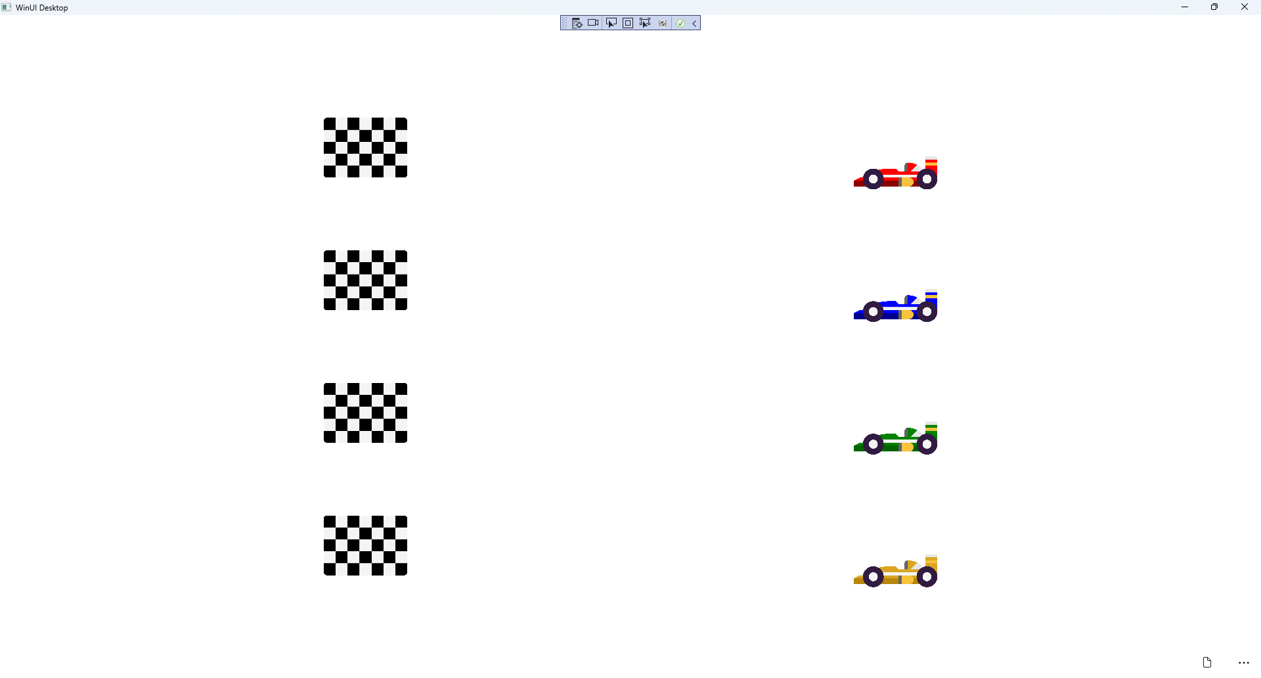

## Step 23

|  |  |
| --- | --- |
| To **Exit** the **Windows App SDK** application, select the **Close** button from the top right of the application as that concludes this **Tutorial** for **Windows App SDK** from [tutorialr.com](https://tutorialr.com)! |  |