

[](https://www.tutorialr.com/tutorials/)

Windows App SDK

Lucky Roulette





# Lucky Roulette

**Lucky Roulette** shows how you can generate a randomised roulette wheel-based game and pick numbers

with a control from **NuGet** using the **Windows App SDK**.

## Step 1

Follow **Setup and Start** on how to get **Setup** and **Install** what you need for **Visual Studio 2022** and **Windows App SDK**.

|  |  |
| --- | --- |
| In **Windows 11** choose **Start** and then find or search for **Visual Studio 2022** and then select it. |  |
| Once **Visual Studio 2022** has started select **Create a new project**. |  |
| Then choose the **Blank App, Packages (WinUI in Desktop)** and then select **Next**. |  |
| After that in **Configure your new project** type in the **Project name** as *LuckyRoulette*, then select a Location and then select **Create** to start a new **Solution**. |  |

## Step 2

Then in **Visual Studio** within **Solution** **Explorer** for the **Solution**, right click on the **Project** shown below the **Solution** and then select **Manage NuGet Packages…**

## Step 3

Then in the **NuGet Package Manager** from the **Browse** tab search for **Comentsys.Toolkit.WindowsAppSdk** and then select **Comentsys.Toolkit.WindowsAppSdk by Comentsys** as indicated and select **Install**

This will add the package for **Comentsys.Toolkit.WindowsAppSdk** to your **Project**. If you get the **Preview Changes** screen saying **Visual Studio is about to make changes to this solution. Click OK to proceed with the changes listed below.** You can read the message and then select **OK** to **Install** the package, then you can close the **tab** for **Nuget: LuckyRoulette** by selecting the **x** next to it.

## Step 4

Then in **Visual Studio** within **Solution** **Explorer** for the **Solution**, right click on the **Project** shown below the **Solution** and then select **Add** then **New Item…**

## Step 5

Then in **Add New Item** from the **C# Items** list, select **Code** and then select **Code File** from the list next to this, then type in the name of *Library.cs* and then **Click** on **Add**.

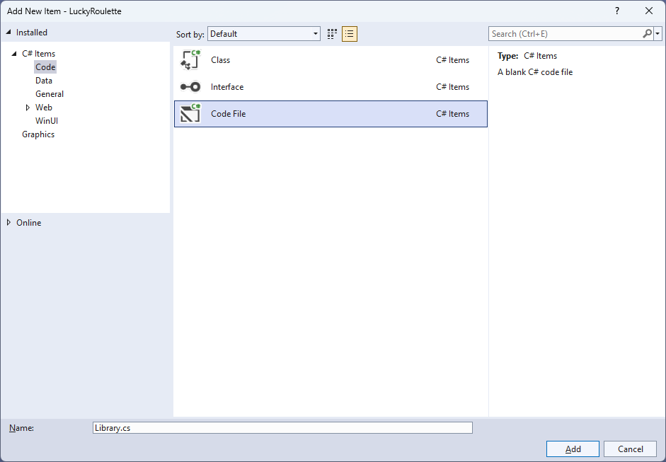

## Step 6

You will now be in the **View** for the **Code** of *Library.cs*, within this first type the following **Code**:

using Comentsys.Toolkit.WindowsAppSdk;

using Microsoft.UI;

using Microsoft.UI.Xaml;

using Microsoft.UI.Xaml.Controls;

using Microsoft.UI.Xaml.Input;

using Microsoft.UI.Xaml.Media;

using Microsoft.UI.Xaml.Shapes;

using System;

using System.Collections.Generic;

using System.Linq;

using Windows.Foundation;

using Windows.UI;

public class Library

{

private const string title = "Lucky Roulette";

private const int size = 400;

private const int rim = 50;

private static readonly int[] _wheel =

{

0, 32, 15, 19, 4, 21, 2, 25, 17,

34, 6, 27, 13, 36, 11, 30, 8, 23,

10, 5, 24, 16, 33, 1, 20, 14, 31,

9, 22, 18, 29, 7, 28, 12, 35, 3, 26

};

private readonly List<int> _values =

Enumerable.Range(0, _wheel.Length).ToList();

private readonly Random _random = new((int)DateTime.UtcNow.Ticks);

private int _spins = 0;

private int _spinValue = 0;

private int _pickValue = 0;

private Dialog _dialog;

private StackPanel _panel = new();

private bool IsOdd(int value) =>

value % 2 != 0;

// Style & Pocket

// Wheel

// Ball, Pick & Square

// Layout & New

}

The **Class** that has been defined in so far *Library.cs* has **using** for the packageof **Comentsys.Toolkit.WindowsAppSdk** amongst others. It also has the numbers for the roulette wheel and defines a **Method** to see if a number is odd with **IsOdd**.

## Step 7

While still in the **Class** for *Library.cs* and after the **Comment** of **// Style & Pocket** type in the following **Methods** for **Style** for the colours used for roulette and for the **Pocket** of a roulette wheel.

private Color Style(int value) =>

value switch

{

>= 1 and <= 10 or >= 19 and <= 28 => IsOdd(value) ?

Colors.Black : Colors.DarkRed,

>= 11 and <= 18 or >= 29 and <= 36 => IsOdd(value) ?

Colors.DarkRed : Colors.Black,

0 => Colors.DarkGreen,

_ => Colors.Transparent,

};

private Grid Pocket(int value)

{

Color fill = Style(value);

Grid grid = new()

{

Width = size,

Height = size

};

Grid pocket = new()

{

Width = 26,

Height = rim,

CornerRadius = new CornerRadius(4),

Background = new SolidColorBrush(fill),

VerticalAlignment = VerticalAlignment.Top

};

TextBlock text = new()

{

FontSize = 20,

Text = $"{value}",

VerticalAlignment = VerticalAlignment.Top,

Foreground = new SolidColorBrush(Colors.Gold),

HorizontalAlignment = HorizontalAlignment.Center

};

Ellipse ball = new()

{

Width = 20,

Height = 20,

Opacity = 0,

Name = $"ball{value}",

Margin = new Thickness(0, 0, 0, 4),

Fill = new SolidColorBrush(Colors.Snow),

VerticalAlignment = VerticalAlignment.Bottom

};

pocket.Children.Add(text);

pocket.Children.Add(ball);

grid.Children.Add(pocket);

return grid;

}

## Step 8

While still in the **Class** for *Library.cs* after the **Comment** of **// Wheel** type in the following **Method**.

private Canvas Wheel()

{

Canvas canvas = new()

{

Width = size,

Height = size,

Margin = new Thickness(5)

};

Ellipse ellipse = new()

{

Width = size,

Height = size,

StrokeThickness = rim,

Stroke = new SolidColorBrush(Colors.Peru)

};

canvas.Children.Add(ellipse);

int index = 0;

double radiusX = canvas.Width * 0.5;

double radiusY = canvas.Height * 0.5;

double delta = 2 * Math.PI / _wheel.Length;

Point centre = new(canvas.Width / 2, canvas.Height / 2);

foreach (int value in _wheel)

{

Grid pocket = Pocket(value);

Size size = new(pocket.DesiredSize.Width, pocket.DesiredSize.Height);

double angle = index * delta;

double x = centre.X + radiusX *

Math.Cos(angle) - size.Width / 2;

double y = centre.Y + radiusY *

Math.Sin(angle) - size.Height / 2;

pocket.RenderTransformOrigin = new Point(0.5, 0.5);

pocket.RenderTransform = new RotateTransform()

{

Angle = angle * 180 / Math.PI

};

pocket.Arrange(new Rect(x, y, size.Width, size.Height));

canvas.Children.Add(pocket);

index++;

}

return canvas;

}

This **Method** will create the look-and-feel of a roulette wheel by use **Pocket** to create each pocket of the roulette wheel which are positioned in a circle around the **Canvas**.

## Step 9

While still in the **Class** for *Library.cs* after the **Comment** of **// Ball, Pick & Square** type in the following **Methods**.

private void Ball(int value, int opacity)

{

UIElement element = (UIElement)_panel.FindName($"ball{value}");

if (element != null) element.Opacity = opacity;

}

private void Pick(int value, Color fill)

{

Piece piece = (Piece)_panel.FindName($"pick{value}");

if (piece != null) piece.Stroke = new SolidColorBrush(fill);

}

private void Square(ref Grid grid, int row, int column, int value)

{

var piece = new Piece()

{

IsSquare = true,

Value = $"{value}",

Name = $"pick{value}",

Fill = new SolidColorBrush(Style(value)),

Stroke = new SolidColorBrush(Style(value)),

Foreground = new SolidColorBrush(Colors.Gold)

};

piece.Tapped += (object sender, TappedRoutedEventArgs e) =>

{

Ball(_spinValue, 0);

Pick(_pickValue, Style(_pickValue));

_spins++;

_spinValue = _values[_random.Next(0, _values.Count)];

_pickValue = int.Parse(((Piece)sender).Value);

Ball(_spinValue, 1);

Pick(_pickValue, Colors.Peru);

// Check Win

if (_spinValue == _pickValue)

{

_spins = 0;

_dialog.Show($"Won {_spins} with {_spinValue}");

}

else

{

_dialog.Show($"Lost {_spins} with {_pickValue} was {_spinValue}");

}

};

piece.SetValue(Grid.RowProperty, row);

piece.SetValue(Grid.ColumnProperty, column);

grid.Children.Add(piece);

}

These **Methods** will be used for the ball of the roulette wheel with **Ball** and for selecting which number will be selected with **Pick** and **Square** which will represent the numbers that can be selected.

## Step 10

While still in the **Class** for *Library.cs* after the **Comment** of **// Layout & New** type in the following **Methods**.

private Grid Layout()

{

int count = 1;

int rows = 13;

int columns = 3;

Grid grid = new()

{

Height = size,

Margin = new Thickness(5)

};

for (int index = 0; index < rows; index++)

{

grid.RowDefinitions.Add(new RowDefinition());

grid.ColumnDefinitions.Add(new ColumnDefinition());

}

var numbers = _wheel.OrderBy(o => o).ToArray();

Square(ref grid, 0, 1, numbers[0]);

for (int row = 1; row < rows; row++)

{

for (int column = 0; column < columns; column++)

{

Square(ref grid, row, column, numbers[count]);

count++;

}

}

return grid;

}

public void New(StackPanel panel)

{

_spins = 0;

_panel = panel;

_panel.Children.Clear();

_panel.Children.Add(Wheel());

_panel.Children.Add(Layout());

_dialog = new Dialog(panel.XamlRoot, title);

}

The **Method** for **Layout** is used to create the layout for the numbers that can be selected which is used in **New** when starting a new game which also uses **Wheel** to create the layout of a roulette table with a roulette wheel and the numbers that can be picked.

## Step 11

|  |  |
| --- | --- |
| Then from **Solution** **Explorer** for the **Solution** double-click on **MainWindow.xaml** to see the **XAML** for the **Main Window**. |  |

## Step 12

In the **XAML** for **MainWindow.xaml** there be some **XAML** for a **StackPanel**, this should be **Removed** by removing the following:

<StackPanel Orientation="Horizontal"

HorizontalAlignment="Center" VerticalAlignment="Center">

<Button x:Name="myButton" Click="myButton_Click">Click Me</Button>

</StackPanel>

## Step 13

While still in the **XAML** for **MainWindow.xaml** above **</Window>**, type in the following **XAML**:

<Grid>

<Viewbox>

<StackPanel Margin="50" Name="Display" Orientation="Horizontal"

HorizontalAlignment="Center" VerticalAlignment="Center" Loaded="New"/>

</Viewbox>

<CommandBar VerticalAlignment="Bottom">

<AppBarButton Icon="Page2" Label="New" Click="New"/>

</CommandBar>

</Grid>

This **XAML** contains a **Grid** with a **Viewbox** which will scale a **StackPanel**. It has a **Loaded** event handler for **New** which is also shared by the **AppBarButton**.

## Step 14

|  |  |
| --- | --- |
| Then, within **Solution** **Explorer** for the **Solution** select the arrow next to **MainWindow.xaml** then double-click on **MainWindow.xaml.cs** to see the **Code** for the **Main Window**. |  |

## Step 15

In the **Code** for **MainWindow.xaml.cs** there be a **Method** of **myButton_Click(...)** this should be **Removed** by removing the following:

private void myButton_Click(object sender, RoutedEventArgs e)

{

myButton.Content = "Clicked";

}

## Step 16

Once **myButton_Click(...)** has been removed, type in the following **Code** below the end of the **Constructor** of **public MainWindow() { ... }**:

private readonly Library _library = new();

private void New(object sender, RoutedEventArgs e) =>

_library.New(Display);

Here an **Instance** of the **Class** of **Library** is created then below this is the **Method** of **New** that will be used with **Event Handler** from the **XAML**, this **Method** uses Arrow Syntax with the **=>** for an Expression Bodywhich is useful when a **Method** only has one line.

## Step 17

|  |  |
| --- | --- |
| That completes the **Windows App SDK** application. In **Visual Studio 2022** from the **Toolbar** select **LuckyRoulette (Package)** to **Start** the application. |  |

## Step 18

Once running you should see the roulette wheel along with the numbers that can be selected, you can then select one, if you get it right, then you win, if you don’t, you lose or you can select *New*to restart the game.

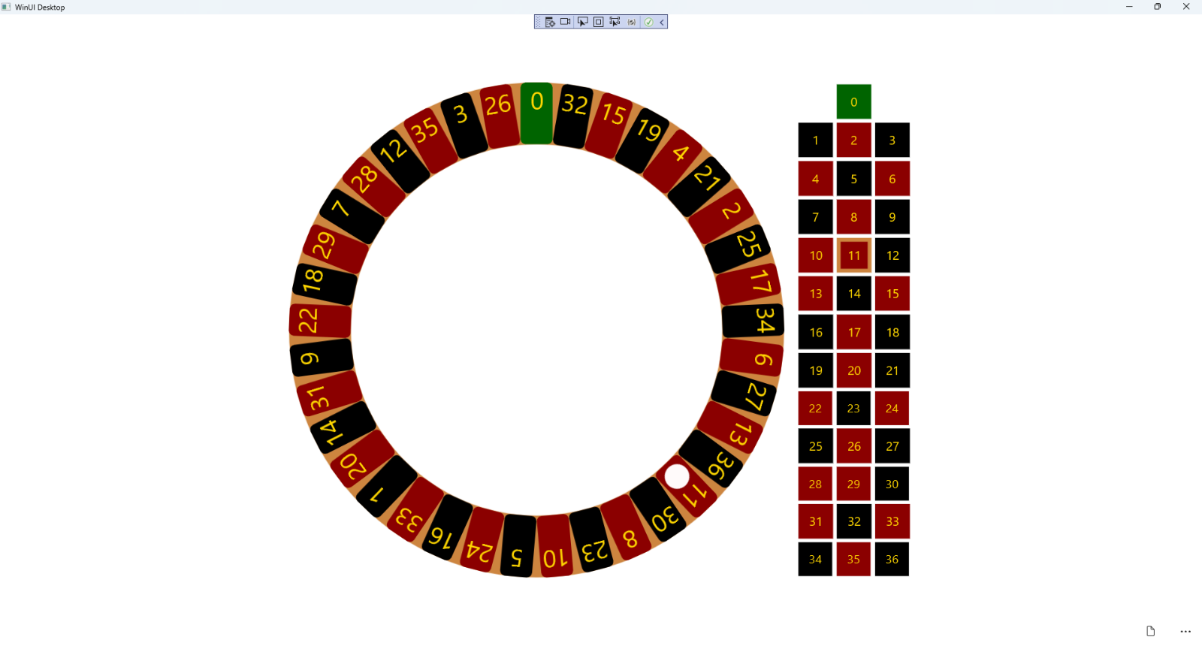

## Step 19

|  |  |
| --- | --- |
| To **Exit** the **Windows App SDK** application, select the **Close** button from the top right of the application as that concludes this **Tutorial** for **Windows App SDK** from [tutorialr.com](https://tutorialr.com)! |  |