

[](https://www.tutorialr.com/tutorials/)

Windows App SDK

Lucky Wheel





# Lucky Wheel

**Lucky Wheel** shows how you can create spinning wheel game with a random chance of getting a particular

score or you could lose it all, using a control in a toolkit from **NuGet** using the **Windows App SDK**.

## Step 1

Follow **Setup and Start** on how to get **Setup** and **Install** what you need for **Visual Studio 2022** and **Windows App SDK**.

|  |  |
| --- | --- |
| In **Windows 11** choose **Start** and then find or search for **Visual Studio 2022** and then select it. |  |
| Once **Visual Studio 2022** has started select **Create a new project**. |  |
| Then choose the **Blank App, Packages (WinUI in Desktop)** and then select **Next**. |  |
| After that in **Configure your new project** type in the **Project name** as *LuckyWheel*, then select a Location and then select **Create** to start a new **Solution**. |  |

## Step 2

Then in **Visual Studio** within **Solution** **Explorer** for the **Solution**, right click on the **Project** shown below the **Solution** and then select **Manage NuGet Packages…**

## Step 3

Then in the **NuGet Package Manager** from the **Browse** tab search for **Comentsys.Toolkit.WindowsAppSdk** and then select **Comentsys.Toolkit.WindowsAppSdk by Comentsys** as indicated and select **Install**

This will add the package for **Comentsys.Toolkit.WindowsAppSdk** to your **Project**. If you get the **Preview Changes** screen saying **Visual Studio is about to make changes to this solution. Click OK to proceed with the changes listed below.** You can read the message and then select **OK** to **Install** the package,, then you can close the **tab** for **Nuget: LuckyWheel** by selecting the **x** next to it.

## Step 4

Then in **Visual Studio** within **Solution** **Explorer** for the **Solution**, right click on the **Project** shown below the **Solution** and then select **Add** then **New Item…**

## Step 5

Then in **Add New Item** from the **C# Items** list, select **Code** and then select **Code File** from the list next to this, then type in the name of *Library.cs* and then **Click** on **Add**.

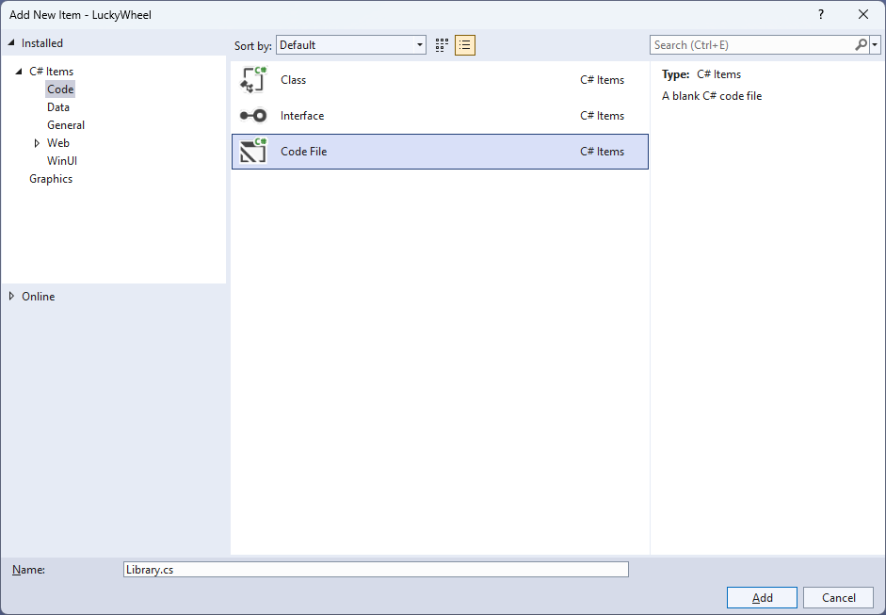

## Step 6

You will now be in the **View** for the **Code** of *Library.cs*, within this first type the following **Code**:

using Comentsys.Toolkit.WindowsAppSdk;

using Microsoft.UI;

using Microsoft.UI.Text;

using Microsoft.UI.Xaml;

using Microsoft.UI.Xaml.Controls;

using Microsoft.UI.Xaml.Documents;

using Microsoft.UI.Xaml.Input;

using Microsoft.UI.Xaml.Media;

using Microsoft.UI.Xaml.Media.Animation;

using Microsoft.UI.Xaml.Shapes;

using System;

using System.Collections.Generic;

using System.Linq;

using Windows.Foundation;

using Windows.UI;

public class Library

{

private const string title = "Lucky Wheel";

private const int size = 400, hole = 60, radius = 200, circle = 360;

private const int border = 4, marker = 30, duration = 5;

private static readonly List<(string Value, Color Fill)> wedges = new()

{

("1000", Colors.WhiteSmoke), ("600", Colors.LightGreen),

("500", Colors.Yellow), ("300", Colors.Red),

("500", Colors.Azure), ("800", Colors.Orange),

("550", Colors.Violet), ("400", Colors.Yellow),

("300", Colors.Pink), ("900", Colors.Red),

("500", Colors.Azure), ("300", Colors.LightGreen),

("900", Colors.Pink), ("LOSE", Colors.Black),

("600", Colors.Violet), ("400", Colors.Yellow),

("300", Colors.Azure), ("LOSE", Colors.Black),

("800", Colors.Red), ("350", Colors.Violet),

("450", Colors.Pink), ("700", Colors.LightGreen),

("300", Colors.Orange), ("600", Colors.Violet),

};

private static readonly double section = circle / wedges.Count;

private readonly Random _random = new((int)DateTime.UtcNow.Ticks);

// Variables, Get Ellipse, Add Circle, Get Sector & Add Section

// Get Text & Add Text

// Get Marker & Add Rotate

// Set Rotate, Play & Add Wheel

// Layout, Reset & New

}

**Class** defined so far *Library.cs* has **using** for packageof **Comentsys.Toolkit.WindowsAppSdk** and others.

## Step 7

Still in the **Class** for *Library.cs* after the **Comment** of **// Variables, Get Ellipse, Add Circle, Get Sector & Add Section** type the following **Variables** and **Methods** for **GetEllipse** which will get an **Ellipse** used by **AddCircle** along with **GetSector** which will get a **Sector** control used by **AddSection**.

private int _total;

private bool _over;

private bool _spin;

private double _position;

private double _selected;

private Canvas _canvas;

private Dialog _dialog;

private Storyboard _storyboard;

private Ellipse GetEllipse(double diameter, Color fill) => new()

{

Width = diameter,

Height = diameter,

StrokeThickness = border,

Fill = new SolidColorBrush(fill),

Stroke = new SolidColorBrush(Colors.Gold)

};

private void AddCircle(Canvas canvas, double diameter)

{

var circle = GetEllipse(diameter, Colors.Green);

Canvas.SetLeft(circle, (size - diameter) / 2);

Canvas.SetTop(circle, (size - diameter) / 2);

canvas.Children.Add(circle);

}

private Sector GetSector(double start, double finish, double radius, Color fill)

{

Sector sector = new()

{

Hole = hole,

Start = start,

Finish = finish,

Radius = radius,

Fill = new SolidColorBrush(fill)

};

Canvas.SetLeft(sector, (size - radius * 2) / 2);

Canvas.SetTop(sector, (size - radius * 2) / 2);

return sector;

}

private void AddSection(Canvas canvas, int index, double start)

{

var finish = section;

var sector = GetSector(start, finish, radius, wedges[index].Fill);

canvas.Children.Add(sector);

}

## Step 8

While still in the **Class** for *Library.cs* after the **Comment** of **// Get Text & Add Text** type in the following **Methods** for **GetText** which will create a **TextBlock** for amounts to be used by **AddText** which will position the amounts on the wheel.

private TextBlock GetText(string value, Color foreground)

{

TextBlock text = new()

{

FontSize = 20,

Margin = new Thickness(2),

FontWeight = FontWeights.SemiBold,

TextAlignment = TextAlignment.Center,

Foreground = new SolidColorBrush(foreground)

};

for (int index = 0; index < value.Length; index++)

{

text.Inlines.Add(new Run()

{

Text = value[index] + Environment.NewLine

});

}

text.Measure(new Size(

double.PositiveInfinity,

double.PositiveInfinity));

return text;

}

private void AddText(Canvas canvas, int index, double start)

{

double top = 0;

var (value, fill) = wedges[index];

var foreground = fill == Colors.Black ? Colors.White : Colors.Black;

var text = GetText(value, foreground);

double middle = text.DesiredSize.Width / 2;

double left = (size / 2) - middle;

Grid grid = new()

{

Height = radius,

RenderTransform = new RotateTransform()

{

Angle = start,

CenterX = middle,

CenterY = radius

}

};

grid.Children.Add(text);

Canvas.SetLeft(grid, left);

Canvas.SetTop(grid, top);

canvas.Children.Add(grid);

}

## Step 9

While still in the **Class** for *Library.cs* after the **Comment** of **// Get Marker & Add Rotate** type in the following **Methods** for **GetMarker** for the marker on top of the wheel and **AddRotate** for rotating it.

private Polygon GetMarker() => new()

{

Width = marker,

Height = marker / 2,

Fill = new SolidColorBrush(Colors.Gold),

VerticalAlignment = VerticalAlignment.Center,

HorizontalAlignment = HorizontalAlignment.Center,

Points =

{

new Point(0, 0),

new Point(marker, 0),

new Point(marker / 2, marker / 2)

}

};

private void AddRotate()

{

DoubleAnimation animation = new()

{

From = _position,

To = circle * 2,

EasingFunction = new QuadraticEase(),

RepeatBehavior = new RepeatBehavior(1),

Duration = new Duration(TimeSpan.FromSeconds(duration))

};

Storyboard.SetTargetProperty(animation,

"(Canvas.RenderTransform).(RotateTransform.Angle)");

Storyboard.SetTarget(animation, _canvas);

_storyboard = new Storyboard();

_storyboard.Completed += (object sender, object e) =>

{

_spin = false;

var angle = circle - _selected - (section / 2);

var index = (int)Math.Ceiling(angle / section);

var (value, _) = wedges[index];

if (int.TryParse(value, out int result) && !_over)

{

_total += result;

_dialog.Show($"You Won {result}, Total is {_total}");

}

else

{

_over = true;

_dialog.Show($"You Lose, Total was {_total}!");

}

};

_storyboard.Children.Add(animation);

}

## Step 10

While still in the **Class** for *Library.cs* after the **Comment** of **// Set Rotate, Play & Add Wheel** type in the following **Methods**:

private void SetRotate(double angle)

{

var animation = _storyboard.Children.First() as DoubleAnimation;

animation.From = _position;

animation.To = circle * 2 + angle;

_storyboard.Begin();

}

private void Play()

{

if (!_spin)

{

_spin = true;

if (_over)

{

_dialog.Show($"You Lost, Total was {_total}, Starting New Game");

Reset();

}

else

{

_position = _selected;

_selected = _random.Next(1, circle);

SetRotate(_selected);

}

}

}

private void AddWheel(Canvas canvas, double diameter)

{

var wheel = GetEllipse(diameter, Colors.Transparent);

wheel.Tapped += (object sender, TappedRoutedEventArgs e) =>

Play();

Canvas.SetLeft(wheel, (size - diameter) / 2);

Canvas.SetTop(wheel, (size - diameter) / 2);

canvas.Children.Add(wheel);

}

**SetRotate** will trigger the animation to rotate or spin the wheel, **Play** will be used when spinning the wheel and will select the next value or if the game is over it will show a message and **AddWheel** which will add a transparent **Ellipse** which will capture **Events** when it is **Tapped** to trigger **Play**.

## Step 11

While still in the **Class** for *Library.cs* after the **Comment** of **// Layout, Reset & New** type in the following **Methods**:

private void Layout(Grid grid)

{

grid.Children.Clear();

StackPanel panel = new();

_canvas = new Canvas()

{

Width = size,

Height = size,

RenderTransform = new RotateTransform()

{

Angle = 0,

CenterX = radius,

CenterY = radius

}

};

var start = -(section / 2);

for (int index = 0; index < wedges.Count; index++)

{

AddSection(_canvas, index, start);

AddText(_canvas, index, start + (section / 2));

start += section;

}

AddCircle(_canvas, hole * 2);

AddWheel(_canvas, size + border);

AddRotate();

panel.Children.Add(GetMarker());

panel.Children.Add(_canvas);

grid.Children.Add(panel);

}

private void Reset()

{

_total = 0;

_spin = false;

_over = false;

_selected = 0;

}

public void New(Grid grid)

{

Reset();

Layout(grid);

_dialog = new Dialog(grid.XamlRoot, title);

}

**Layout** will create the look-and-feel of the wheel by setting up all the elements, **Reset** will reset the values used in the game when a game is over or started and **New** will start a new game.

## Step 12

|  |  |
| --- | --- |
| Then from **Solution** **Explorer** for the **Solution** double-click on **MainWindow.xaml** to see the **XAML** for the **Main Window**. |  |

## Step 13

In the **XAML** for **MainWindow.xaml** there be some **XAML** for a **StackPanel**, this should be **Removed** by removing the following:

<StackPanel Orientation="Horizontal"

HorizontalAlignment="Center" VerticalAlignment="Center">

<Button x:Name="myButton" Click="myButton_Click">Click Me</Button>

</StackPanel>

## Step 14

While still in the **XAML** for **MainWindow.xaml** above **</Window>**, type in the following **XAML**:

<Grid>

<Viewbox>

<Grid Margin="50" Name="Display"

HorizontalAlignment="Center"

VerticalAlignment="Center" Loaded="New"/>

</Viewbox>

<CommandBar VerticalAlignment="Bottom">

<AppBarButton Icon="Page2" Label="New" Click="New"/>

</CommandBar>

</Grid>

This **XAML** contains a **Grid** with a **Viewbox** which will scale a **Grid**. It has a **Loaded** event handler for **New** which is also shared by the **AppBarButton**.

## Step 15

|  |  |
| --- | --- |
| Then, within **Solution** **Explorer** for the **Solution** select the arrow next to **MainWindow.xaml** then double-click on **MainWindow.xaml.cs** to see the **Code** for the **Main Window**. |  |

## Step 16

In the **Code** for **MainWindow.xaml.cs** there be a **Method** of **myButton_Click(...)** this should be **Removed** by removing the following:

private void myButton_Click(object sender, RoutedEventArgs e)

{

myButton.Content = "Clicked";

}

## Step 17

Once **myButton_Click(...)** has been removed, type in the following **Code** below the end of the **Constructor** of **public MainWindow() { ... }**:

private readonly Library _library = new();

private void New(object sender, RoutedEventArgs e) =>

_library.New(Display);

Here an **Instance** of the **Class** of **Library** is created then below this is the **Method** of **New** that will be used with **Event Handler** from the **XAML**, this **Method** uses Arrow Syntax with the **=>** for an Expression Bodywhich is useful when a **Method** only has one line.

## Step 18

|  |  |
| --- | --- |
| That completes the **Windows App SDK** application. In **Visual Studio 2022** from the **Toolbar** select **LuckyWheel (Package)** to **Start** the application. |  |

## Step 19

Once running you can then select anywhere on the wheel and it will start spinning and once it stops on a value that’s what you win, but if it lands on **LOSE** the game will be over or select *New* to restart the game.

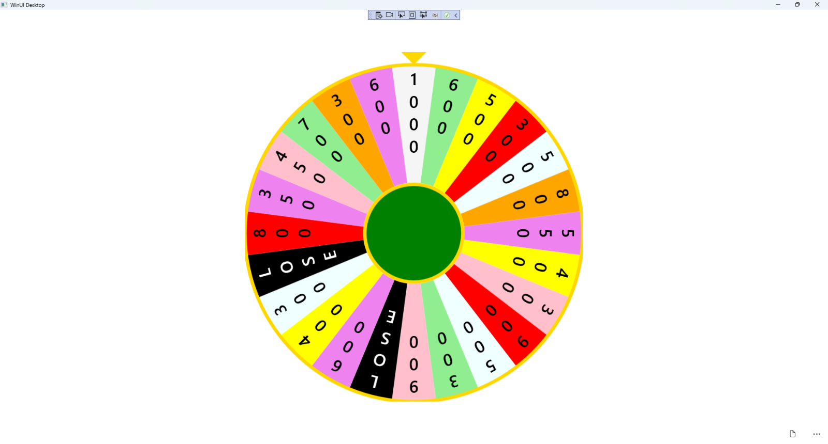

## Step 20

|  |  |
| --- | --- |
| To **Exit** the **Windows App SDK** application, select the **Close** button from the top right of the application as that concludes this **Tutorial** for **Windows App SDK** from [tutorialr.com](https://tutorialr.com)! |  |