

[](https://www.tutorialr.com/tutorials/)

Windows App SDK

Match Game





# Match Game

**Match Game** shows how to create a game where you will see a set of **Squares** that are **Black** and **White**

then remember where the **White** ones are, then you will see a set of **Grey** ones before seeing a set of **Black**

ones and then just need to simply **Match** the correct ones to **White** to proceed using a toolkit from **NuGet**

using the **Windows App SDK**.

## Step 1

Follow **Setup and Start** on how to get **Setup** and **Install** what you need for **Visual Studio 2022** and **Windows App SDK**.

|  |  |
| --- | --- |
| In **Windows 11** choose **Start** and then find or search for **Visual Studio 2022** and then select it. |  |
| Once **Visual Studio 2022** has started select **Create a new project**. |  |
| Then choose the **Blank App, Packages (WinUI in Desktop)** and then select **Next**. |  |
| After that in **Configure your new project** type in the **Project name** as *MatchGame*, then select a Location and then select **Create** to start a new **Solution**. |  |

## Step 2

Then in **Visual Studio** within **Solution** **Explorer** for the **Solution**, right click on the **Project** shown below the **Solution** and then select **Manage NuGet Packages…**

## Step 3

Then in the **NuGet Package Manager** from the **Browse** tab search for **Comentsys.Toolkit.WindowsAppSdk** and then select **Comentsys.Toolkit.WindowsAppSdk by Comentsys** as indicated and select **Install**

This will add the package for **Comentsys.Toolkit.WindowsAppSdk** to your **Project**. If you get the **Preview Changes** screen saying **Visual Studio is about to make changes to this solution. Click OK to proceed with the changes listed below.** You can read the message and then select **OK** to **Install** the package, then you can close the **tab** for **Nuget: MatchGame** by selecting the **x** next to it.

## Step 4

Then in **Visual Studio** within **Solution** **Explorer** for the **Solution**, right click on the **Project** shown below the **Solution** and then select **Add** then **New Item…**

## Step 5

Then in **Add New Item** from the **C# Items** list, select **Code** and then select **Code File** from the list next to this, then type in the name of *Library.cs* and then **Click** on **Add**.

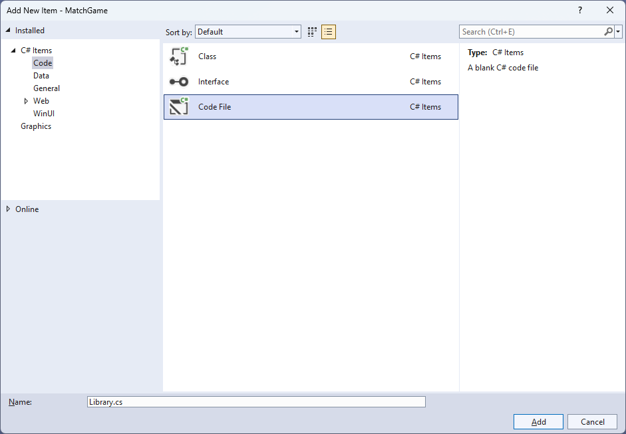

## Step 6

You will now be in the **View** for the **Code** of *Library.cs*, within this first type the following **Code**:

using Comentsys.Toolkit.Binding;

using Comentsys.Toolkit.WindowsAppSdk;

using Microsoft.UI;

using Microsoft.UI.Xaml;

using Microsoft.UI.Xaml.Controls;

using Microsoft.UI.Xaml.Data;

using Microsoft.UI.Xaml.Media;

using System;

using System.Collections.Generic;

using System.Collections.ObjectModel;

using System.Linq;

using System.Windows.Input;

namespace MatchGame;

public enum State

{

Wait,

Off,

On

}

public enum Match

{

Memorise,

Waiting,

Remember,

Complete

}

// Item Class

// StateToBrushConverter Class

public class Library

{

// Library Constants, Variables and Choose Method

// Library Set, Change, Update & Pattern Method

// Library Tick Method

// Library Play, Layout & New Method

}

**Class** defined so far *Library.cs* has **using** for packageof **Comentsys.Toolkit.WindowsAppSdk** and others along with a **namespace** which allows many classes to be defined together, usually a **class** is defined per file but to make things easier each will be defined in *Library.cs* instead.

## Step 7

Still in *Library.cs* for the **namespace** of **MatchGame** in *Library.cs* you will define a **class** after the **Comment** of **// Item Class** by typing the following:

public class Item : ObservableBase

{

private State _state;

private int _index;

private readonly Action<int> _action;

public Item(int index, State state, Action<int> action) =>

(_index, State, _action) = (index, state, action);

public ICommand Command =>

new ActionCommandHandler((param) => _action(_index));

public int Index

{

get => _index;

set => SetProperty(ref _index, value);

}

public State State

{

get => _state;

set => SetProperty(ref _state, value);

}

}

**Item** uses the **class** from the toolkit of **ObservableBase** which will be used for **Data Binding** the **Properties** which include the **State** and **Index** along with the **Command** which will be used to allow interaction with the element using **Commanding**.

## Step 8

Still in *Library.cs* for the **namespace** of **MatchGame** in *Library.cs* you will define a **class** after the **Comment** of **// StateToBrushConverter Class** by typing the following:

public class StateToBrushConverter : IValueConverter

{

public object Convert(object value, Type targetType,

object parameter, string language)

{

if (value is State state)

{

return new SolidColorBrush(value switch

{

State.On => Colors.White,

State.Off => Colors.Black,

_ => Colors.Gray

});

}

return null;

}

public object ConvertBack(object value, Type targetType,

object parameter, string language) =>

throw new NotImplementedException();

}

**StateToBrushConverter** uses the **interface** of **IValueConverter** for **Data Binding** which will allow the colours of the Item in the game to be represented from either *White*, *Black* or *Grey* as a **SolidColorBrush**.

## Step 9

While still in the **namespace** of **MatchGame** in *Library.cs* and in the **class** of **Library** after the **Comment** of **// Library Constants, Variables and Choose Method** type in the following **Constants**, **Variables** and **Method**:

private const string title = "Match Game";

private const int interval = 1;

private const int total = 16;

private const int delay = 4;

private const int size = 4;

private readonly List<int> _hits = new();

private readonly List<int> _miss = new();

private readonly Dictionary<int, State> _states = new();

private readonly ObservableCollection<Item> _items = new();

private readonly Random _random = new((int)DateTime.UtcNow.Ticks);

private DispatcherTimer _timer;

private Dialog _dialog;

private Match _match;

private int _count;

private int _turns;

private List<int> Choose(int minimum, int maximum, int total) =>

Enumerable.Range(minimum, maximum)

.OrderBy(r => _random.Next(minimum, maximum))

.Take(total).ToList();

**Constants** are values that are used in the game that will not change and **Variables** are used to store various values for the game. The **Method** of **Choose** will be used to create a list of unique randomised numbers.

## Step 10

While still in the **namespace** of **MatchGame** in *Library.cs* and in the **class** of **Library** after the **Comment** of **// Library Set, Change, Update & Pattern Method** type the following **Methods**:

private void Set(int index, State state) =>

_items.FirstOrDefault(w => w.Index == index)

.State = state;

private void Change(Match match) =>

(_count, _match) = (delay, match);

private void Update(State state)

{

foreach(var item in _items)

item.State = state;

}

private void Pattern()

{

_hits.Clear();

_miss.Clear();

_states.Clear();

Update(State.Off);

var positions = Choose(0, total, size);

for (int index = 0; index < total; index++)

{

State state = State.Off;

if (positions.Contains(index))

{

state = State.On;

_states.Add(index, state);

}

Set(index, state);

}

}

**Set** is used to update the **State** for an **Item** and **Change** uses tuple-syntax to update the values being passed in. **Update** is used to set the **State** for all items and **Pattern** is used to display the items that are to be matched using **Set**.

## Step 11

While still in the **namespace** of **MatchGame** in *Library.cs* and in the **class** of **Library** after the **Comment** of **// Library Tick Method** type the following **Method**:

private void Tick()

{

switch (_match)

{

case Match.Complete:

_dialog.Show($"Game Over with {_turns} Matches!");

_timer?.Stop();

break;

case Match.Memorise:

if (_count == delay)

Pattern();

_count--;

if (_count == 0)

Change(Match.Waiting);

break;

case Match.Waiting:

if (_count == delay)

Update(State.Wait);

_count--;

if (_count == 0)

Change(Match.Remember);

break;

case Match.Remember:

if (_count == delay)

Update(State.Off);

_count--;

if (_count == 0)

{

if (_hits.Count == size)

{

_turns++;

Change(Match.Memorise);

}

else

Change(Match.Complete);

}

break;

}

}

**Tick** will be used by the **Timer** and will perform the actions in the game depending on the value of the **enum** of **Match** which includes displaying a message when the game is finished using a **Dialog** and using the **Methods** of **Change** or **Update** to display elements in the game as needed.

## Step 12

While still in the **namespace** of **CodesGame** in *Library.cs* and in the **class** of **Library** after the **Comment** of **// Library Play, Layout & New Method** type the following **Methods**:

private void Play(int index)

{

if (_match == Match.Remember &&

_hits.Count + _miss.Count < size)

{

if (_states.ContainsKey(index) &&

!_hits.Contains(index))

_hits.Add(index);

else if(!_states.ContainsKey(index) &&

!_miss.Contains(index))

_miss.Add(index);

Set(index, State.On);

}

}

private void Layout(ItemsControl display)

{

for (int index = 0; index < total; index++)

{

_items.Add(new Item(index, State.Wait, (int i) => Play(i)));

}

display.ItemsSource = _items;

}

public void New(ItemsControl display)

{

_turns = 1;

_count = delay;

_hits.Clear();

_miss.Clear();

_items.Clear();

Layout(display);

_match = Match.Memorise;

_dialog = new Dialog(display.XamlRoot, title);

_timer?.Stop();

_timer = new DispatcherTimer()

{

Interval = TimeSpan.FromSeconds(interval)

};

_timer.Tick += (object sender, object e) =>

Tick();

_timer.Start();

}

**Play** will be used when recalling a pattern of elements and will set them accordingly, **Layout** will use **Play** and create set of elements and **New** will be used to start a new game and setup the **Timer**.

## Step 13

|  |  |
| --- | --- |
| Then from **Solution** **Explorer** for the **Solution** double-click on **MainWindow.xaml** to see the **XAML** for the **Main Window**. |  |

## Step 14

In the **XAML** for **MainWindow.xaml** there be some **XAML** for a **StackPanel**, this should be **Removed** by removing the following:

<StackPanel Orientation="Horizontal"

HorizontalAlignment="Center" VerticalAlignment="Center">

<Button x:Name="myButton" Click="myButton_Click">Click Me</Button>

</StackPanel>

## Step 15

While still in the **XAML** for **MainWindow.xaml** below **<Window**, type in the following **XAML**:

xmlns:ui="using:Comentsys.Toolkit.WindowsAppSdk"

The **XAML** for **<Window>** should then look as follows:

<Window

xmlns:ui="using:Comentsys.Toolkit.WindowsAppSdk"

x:Class="MatchGame.MainWindow"

xmlns="http://schemas.microsoft.com/winfx/2006/xaml/presentation"

xmlns:x="http://schemas.microsoft.com/winfx/2006/xaml"

xmlns:local="using:MatchGame"

xmlns:d="http://schemas.microsoft.com/expression/blend/2008"

xmlns:mc="http://schemas.openxmlformats.org/markup-compatibility/2006"

mc:Ignorable="d">

## Step 16

While still in the **XAML** for **MainWindow.xaml** above **</Window>**, type in the following **XAML**:

<Grid>

<Grid.Resources>

<local:StateToBrushConverter x:Key="StateToBrushConverter"/>

</Grid.Resources>

<Viewbox>

<ItemsControl Margin="50" Name="Display"

HorizontalAlignment="Center"

VerticalAlignment="Center" Loaded="New">

<ItemsControl.ItemTemplate>

<DataTemplate x:Name="DataTemplate">

<Button Command="{Binding Command}">

<ui:Piece IsSquare="True"

Fill="{Binding State, Mode=OneWay,

Converter={StaticResource StateToBrushConverter},

ConverterParameter=True}"

Foreground="{Binding State, Mode=OneWay,

Converter={StaticResource StateToBrushConverter},

ConverterParameter=False}" />

</Button>

</DataTemplate>

</ItemsControl.ItemTemplate>

<ItemsControl.ItemsPanel>

<ItemsPanelTemplate>

<VariableSizedWrapGrid MaximumRowsOrColumns="4"/>

</ItemsPanelTemplate>

</ItemsControl.ItemsPanel>

</ItemsControl>

</Viewbox>

<CommandBar VerticalAlignment="Bottom">

<AppBarButton Icon="Page2" Label="New" Click="New"/>

</CommandBar>

</Grid>

This **XAML** contains a **Grid** with **Resources** using the **StateToBrushConverter** and also contains a **Viewbox** which will **Scale** an **ItemsControl** which has a **DataTemplate** which contains a **Button** and **Piece** which will be bound using **Data Binding**. It has a **Loaded** event handler for **New** which is also shared by the **AppBarButton**.

## Step 17

|  |  |
| --- | --- |
| Then, within **Solution** **Explorer** for the **Solution** select the arrow next to **MainWindow.xaml** then double-click on **MainWindow.xaml.cs** to see the **Code** for the **Main Window**. |  |

## Step 18

In the **Code** for **MainWindow.xaml.cs** there be a **Method** of **myButton_Click(...)** this should be **Removed** by removing the following:

private void myButton_Click(object sender, RoutedEventArgs e)

{

myButton.Content = "Clicked";

}

## Step 19

Once **myButton_Click(...)** has been removed, type in the following **Code** below the end of the **Constructor** of **public MainWindow() { ... }**:

private readonly Library _library = new();

private void New(object sender, RoutedEventArgs e) =>

_library.New(Display);

Here an **Instance** of the **Class** of **Library** is created then below this is the **Method** of and **New** that will be used with **Event Handler** from the **XAML**, this **Method** uses Arrow Syntax with the **=>** for an Expression Bodywhich is useful when a **Method** only has one line.

## Step 20

|  |  |
| --- | --- |
| That completes the **Windows App SDK** application. In **Visual Studio 2022** from the **Toolbar** select **MatchGame (Package)** to **Start** the application. |  |

## Step 21

Once running you progress by remembering the positions of the **Squares** that are **White** that are shown before a set of **Squares** that are **Grey** when you see a set of **Squares** that are **Black** if you get them right you proceed to the next ones to **Match** but if you get any wrong you lose the game, or you can select *New*to start a new game.

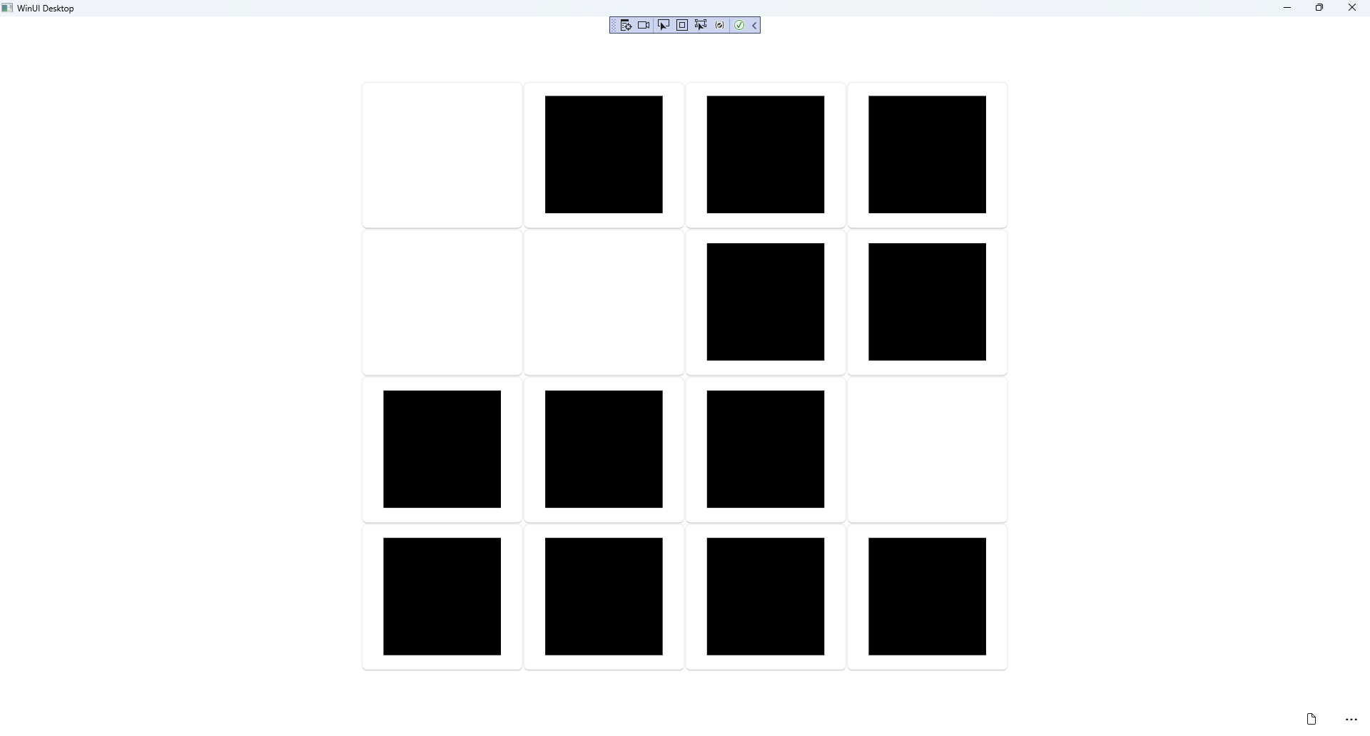

## Step 22

|  |  |
| --- | --- |
| To **Exit** the **Windows App SDK** application, select the **Close** button from the top right of the application as that concludes this **Tutorial** for **Windows App SDK** from [tutorialr.com](https://tutorialr.com)! |  |