

[](https://www.tutorialr.com/tutorials/)

Windows App SDK

Matrix Control





# Matrix Control

**Matrix Control** shows how to create a **Matrix** to display the **Time** or **Date** using **Windows App SDK**

## Step 1

Follow **Setup and Start** on how to get **Setup** and **Install** what you need for **Visual Studio 2022** and **Windows App SDK**.

|  |  |
| --- | --- |
| In **Windows 11** choose **Start** and then find or search for **Visual Studio 2022** and then select it. |  |
| Once **Visual Studio 2022** has started select **Create a new project**. |  |
| Then choose the **Blank App, Packages (WinUI in Desktop)** and then select **Next**. |  |
| After that in **Configure your new project** type in the **Project name** as *MatrixControl*, then select a Location and then select **Create** to start a new **Solution**. |  |

## Step 2

Then in **Visual Studio** within **Solution** **Explorer** for the **Solution**, right click on the **Project** shown below the **Solution** and then select **Add** then **New Item…**

## Step 3

Then in **Add New Item** from the **C# Items** list, select **Code** and then select **Code File** from the list next to this, then type in the name of *Matrix.cs* and then **Click** on **Add**.

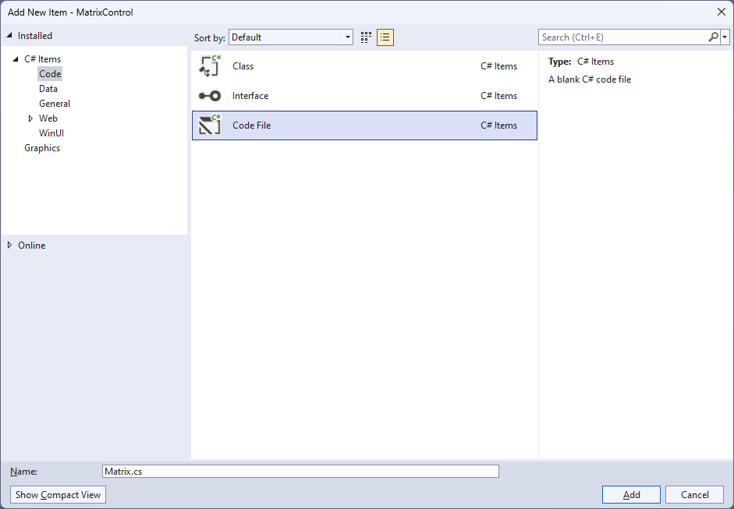

## Step 4

|  |  |
| --- | --- |
| Then from **Solution** **Explorer** for the **Solution** double-click on **Matrix.cs** to see the **Code** for the **User Control**. |  |

## Step 5

You will now be in the **View** for the **Code** of *Matrix.cs*, within this type in the following **Code**:

using Microsoft.UI.Xaml;

using Microsoft.UI.Xaml.Controls;

using Microsoft.UI.Xaml.Data;

using Microsoft.UI.Xaml.Media;

using Microsoft.UI.Xaml.Shapes;

using System;

using System.Collections.Generic;

using System.Linq;

namespace MatrixControl;

public enum Sources

{

Value, Time, Date, TimeDate

}

public class Matrix : StackPanel

{

private readonly byte[][] table =

{

// Table 0 - 4

// Table 5 - 9

// Table Minus, Slash, Colon & Space

};

// Constants & Members

// Dependency Properties & Properties

// Add Element & Add Section Methods

// Set Layout & Add Layout Methods

// Value Property & Constructor

}

There are **using** statements for the **User Control**, a **namespace** for **MatrixControl** with an **enum** for the **Sources** of the **Matrix Control** along with a **class** of **Matrix** that will represent the **User Control**.

## Step 6

Then in the **namespace** of **MatrixControl** in the **class** of **Matrix** after the **Comment** of **// Table 0 – 4** type the following **Code** for the **table** which will represent values between *0* and *4*:

new byte[] {

0,0,0,0,0,0,0,0,

0,1,1,1,1,1,1,0,

0,1,1,0,0,1,1,0,

0,1,1,0,0,1,1,0,

0,1,1,0,0,1,1,0,

0,1,1,1,1,1,1,0,

0,0,0,0,0,0,0,0

}, // 0

new byte[] {

0,0,0,0,0,0,0,0,

0,0,0,1,1,0,0,0,

0,1,1,1,1,0,0,0,

0,0,0,1,1,0,0,0,

0,0,0,1,1,0,0,0,

0,0,0,1,1,0,0,0,

0,0,0,0,0,0,0,0

}, // 1

new byte[] {

0,0,0,0,0,0,0,0,

0,1,1,1,1,1,1,0,

0,0,0,0,0,1,1,0,

0,1,1,1,1,1,1,0,

0,1,1,0,0,0,0,0,

0,1,1,1,1,1,1,0,

0,0,0,0,0,0,0,0

}, // 2

new byte[] {

0,0,0,0,0,0,0,0,

0,1,1,1,1,1,1,0,

0,0,0,0,0,1,1,0,

0,1,1,1,1,1,1,0,

0,0,0,0,0,1,1,0,

0,1,1,1,1,1,1,0,

0,0,0,0,0,0,0,0

}, // 3

new byte[] {

0,0,0,0,0,0,0,0,

0,1,1,0,0,1,1,0,

0,1,1,0,0,1,1,0,

0,1,1,1,1,1,1,0,

0,0,0,0,0,1,1,0,

0,0,0,0,0,1,1,0,

0,0,0,0,0,0,0,0

}, // 4

## Step 7

While still in the **namespace** of **MatrixControl** in the **class** of **Matrix** after the **Comment** of **// Table 5 – 9** type the following **Code** for the **table** which will represent values between *5* and *9*:

new byte[] {

0,0,0,0,0,0,0,0,

0,1,1,1,1,1,1,0,

0,1,1,0,0,0,0,0,

0,1,1,1,1,1,1,0,

0,0,0,0,0,1,1,0,

0,1,1,1,1,1,1,0,

0,0,0,0,0,0,0,0

}, // 5

new byte[] {

0,0,0,0,0,0,0,0,

0,1,1,1,1,1,1,0,

0,1,1,0,0,0,0,0,

0,1,1,1,1,1,1,0,

0,1,1,0,0,1,1,0,

0,1,1,1,1,1,1,0,

0,0,0,0,0,0,0,0

}, // 6

new byte[] {

0,0,0,0,0,0,0,0,

0,1,1,1,1,1,1,0,

0,0,0,0,0,1,1,0,

0,0,0,0,0,1,1,0,

0,0,0,0,0,1,1,0,

0,0,0,0,0,1,1,0,

0,0,0,0,0,0,0,0

}, // 7

new byte[] {

0,0,0,0,0,0,0,0,

0,1,1,1,1,1,1,0,

0,1,1,0,0,1,1,0,

0,1,1,1,1,1,1,0,

0,1,1,0,0,1,1,0,

0,1,1,1,1,1,1,0,

0,0,0,0,0,0,0,0

}, // 8

new byte[] {

0,0,0,0,0,0,0,0,

0,1,1,1,1,1,1,0,

0,1,1,0,0,1,1,0,

0,1,1,1,1,1,1,0,

0,0,0,0,0,1,1,0,

0,1,1,1,1,1,1,0,

0,0,0,0,0,0,0,0

}, // 9

## Step 8

While still in the **namespace** of **MatrixControl** in the **class** of **Matrix** after the **Comment** of **// Table Minus, Slash, Colon & Space** type the following **Code** for the **table** which will represent a *Minus*, *Slash*, *Colon*, and *Space*:

new byte[] {

0,0,0,0,0,0,0,0,

0,0,0,0,0,0,0,0,

0,0,0,0,0,0,0,0,

0,1,1,1,1,1,1,0,

0,0,0,0,0,0,0,0,

0,0,0,0,0,0,0,0,

0,0,0,0,0,0,0,0

}, // Minus

new byte[] {

0,0,0,0,0,0,0,0,

0,0,0,0,0,1,1,0,

0,0,0,0,1,1,0,0,

0,0,0,1,1,0,0,0,

0,0,1,1,0,0,0,0,

0,1,1,0,0,0,0,0,

0,0,0,0,0,0,0,0

}, // Slash

new byte[] {

0,0,0,0,0,0,0,0,

0,0,0,1,1,0,0,0,

0,0,0,1,1,0,0,0,

0,0,0,0,0,0,0,0,

0,0,0,1,1,0,0,0,

0,0,0,1,1,0,0,0,

0,0,0,0,0,0,0,0

}, // Colon

new byte[] {

0,0,0,0,0,0,0,0,

0,0,0,0,0,0,0,0,

0,0,0,0,0,0,0,0,

0,0,0,0,0,0,0,0,

0,0,0,0,0,0,0,0,

0,0,0,0,0,0,0,0,

0,0,0,0,0,0,0,0

} // Space

## Step 9

While still in the **namespace** of **MatrixControl** in the **class** of **Matrix** after the **Comment** of **// Constants & Members** type the following **Constants** and **Members**:

private readonly List<char> glyphs = new()

{

'0', '1', '2', '3', '4', '5', '6', '7', '8', '9', '-', '/', ':', ' '

};

private const string time = "HH:mm:ss";

private const string date = "dd/MM/yyyy";

private const string date_time = "HH:mm:ss dd/MM/yyyy";

private const string invalid_source = "Invalid argument";

private const int padding = 1;

private const int columns = 8;

private const int rows = 7;

private string _value;

private int _count;

The **Constants** include an **Array** of **glyphs** that will represent what can be displayed including *Digits* or *Minus*, *Slash*, *Colon*, and *Space* along with **Members** for the **Matrix Control**.

## Step 10

While still in the **namespace** of **MatrixControl** in the **class** of **Matrix** after the **Comment** of **// Dependency Properties & Properties** type the following **Dependency Properties** and **Properties**:

public static readonly DependencyProperty ForegroundProperty =

DependencyProperty.Register(nameof(Foreground), typeof(Brush),

typeof(Matrix), null);

public static readonly DependencyProperty SourceProperty =

DependencyProperty.Register(nameof(Source), typeof(Sources),

typeof(Matrix), new PropertyMetadata(Sources.Time));

public static readonly DependencyProperty SizeProperty =

DependencyProperty.Register(nameof(Size), typeof(UIElement),

typeof(Matrix), new PropertyMetadata(4));

public Brush Foreground

{

get { return (Brush)GetValue(ForegroundProperty); }

set { SetValue(ForegroundProperty, value); }

}

public Sources Source

{

get { return (Sources)GetValue(SourceProperty); }

set { SetValue(SourceProperty, value); }

}

public int Size

{

get { return (int)GetValue(SizeProperty); }

set { SetValue(SizeProperty, value); }

}

**Dependency Properties** or **Properties** for the **User Control** can be customised for the **Matrix Control**.

## Step 11

While still in the **namespace** of **MatrixControl** in the **class** of **Matrix** after the **Comment** of **// Add Element & Add Section Methods** type the following **Methods**:

private Rectangle AddElement(string name, int left, int top)

{

var element = new Rectangle()

{

Tag = name,

Opacity = 0,

RadiusX = 1,

RadiusY = 1,

Width = Size,

Height = Size,

Margin = new Thickness(2)

};

element.SetBinding(Shape.FillProperty, new Binding()

{

Path = new PropertyPath(nameof(Foreground)),

Mode = BindingMode.TwoWay,

Source = this

});

Canvas.SetLeft(element, left);

Canvas.SetTop(element, top);

return element;

}

private void AddSection(string name)

{

int x = 0;

int y = 0;

int index = 0;

var section = new Canvas()

{

Tag = name,

Height = rows * Size,

Width = columns * Size

};

for (int row = 0; row < rows; row++)

{

for (int column = 0; column < columns; column++)

{

section.Children.Add(AddElement($"{name}.{index}", x, y));

x = x + Size + padding;

index++;

}

x = 0;

y = y + Size + padding;

}

Children.Add(section);

}

The **Method** of **AddElement** will create an element for the **Matrix Control** which is used by **AddSection**.

## Step 12

While still in the **namespace** of **MatrixControl** in the **class** of **Matrix** after the **Comment** of **// Set Layout & Add Layout Methods** type the following **Methods**:

private void SetLayout(string name, char glyph)

{

var layout = Children.Cast<Canvas>()

.FirstOrDefault(f => (string)f.Tag == name);

int pos = glyphs.IndexOf(glyph);

byte[] values = table[pos];

for (int index = 0; index < layout.Children.Count; index++)

{

layout.Children.Cast<Rectangle>()

.FirstOrDefault(f => (string)f.Tag == $"{name}.{index}")

.Opacity = values[index];

}

}

private void AddLayout()

{

var array = _value.ToCharArray();

var length = array.Length;

var list = Enumerable.Range(0, length);

if (_count != length)

{

Children.Clear();

foreach (int item in list)

{

AddSection(item.ToString());

}

_count = length;

}

foreach (int item in list)

{

SetLayout(item.ToString(), array[item]);

}

}

The **Method** of **SetLayout** will display the appropriate value for the **Matrix Control** by setting the **Opacity** and **AddLayout** will setup the display of the **Matrix Control**.

## Step 13

While still in the **namespace** of **MatrixControl** in the **class** of **Matrix** after the **Comment** of **// Value Property & Constructor** type the following **Property** and **Constructor**:

public string Value

{

get { return _value; }

set { _value = value; AddLayout(); }

}

public Matrix()

{

Orientation = Orientation.Horizontal;

var timer = new DispatcherTimer()

{

Interval = TimeSpan.FromMilliseconds(250)

};

timer.Tick += (object s, object args) =>

{

if (Source != Sources.Value)

{

var format = Source switch

{

Sources.Time => time,

Sources.Date => date,

Sources.TimeDate => date_time,

_ => throw new ArgumentException(invalid_source)

};

Value = DateTime.Now.ToString(format);

}

};

timer.Start();

}

The **Property** of **Value** will setup the display of the **Matrix Control** using the **Method** of **AddLayout** and

the **Constructor** will setup a **DispatcherTimer** to be used to display the **Value** of the **Matrix Control**.

## Step 14

|  |  |
| --- | --- |
| Within **Solution** **Explorer** for the **Solution** double-click on **MainWindow.xaml** to see the **XAML** for the **Main Window**. |  |

## Step 15

In the **XAML** for **MainWindow.xaml** there be some **XAML** for a **StackPanel**, this should be **Removed** by removing the following:

<StackPanel Orientation="Horizontal"

HorizontalAlignment="Center" VerticalAlignment="Center">

<Button x:Name="myButton" Click="myButton_Click">Click Me</Button>

</StackPanel>

## Step 16

While still in the **XAML** for **MainWindow.xaml** above **</Window>**, type in the following **XAML**:

<Viewbox>

<local:Matrix Padding="50" Source="Time"

Foreground="{ThemeResource AccentButtonBackground}"/>

</Viewbox>

This **XAML** contains a **ViewBox** including the **User Control** of **Matrix** with the **Source** set to **Time**.

## Step 17

|  |  |
| --- | --- |
| Then, within **Solution** **Explorer** for the **Solution** select the arrow next to **MainWindow.xaml** then double-click on **MainWindow.xaml.cs** to see the **Code** for the **Main Window**. |  |

## Step 18

In the **Code** for **MainWindow.xaml.cs** there be a **Method** of **myButton_Click(...)** this should be **Removed** by removing the following:

private void myButton_Click(object sender, RoutedEventArgs e)

{

myButton.Content = "Clicked";

}

## Step 19

|  |  |
| --- | --- |
| That completes the **Windows App SDK** application. In **Visual Studio 2022** from the **Toolbar** select **MatrixControl (Package)** to **Start** the application. |  |

## Step 20

Once running you will see the **Matrix Control** displaying the current *Time*.

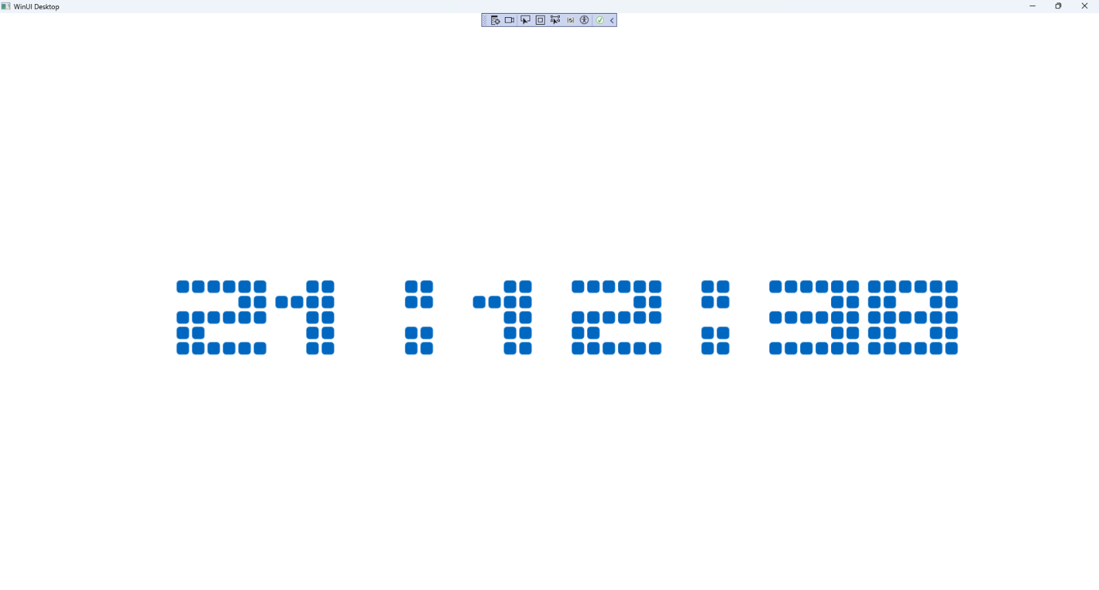

## Step 21

|  |  |
| --- | --- |
| To **Exit** the **Windows App SDK** application, select the **Close** button from the top right of the application as that concludes this **Tutorial** for **Windows App SDK** from [tutorialr.com](https://tutorialr.com)! |  |