

[](https://www.tutorialr.com/tutorials/)

Windows App SDK

Navigation View





# Navigation View

**Navigation View** shows how you can use the **NavigationView** with the **Windows App SDK** allowing for

the use of hamburger-menu style navigation within an application.

## Step 1

Follow **Setup and Start** on how to get **Setup** and **Install** what you need for **Visual Studio 2022** and **Windows App SDK**.

|  |  |
| --- | --- |
| In **Windows 11** choose **Start** and then find or search for **Visual Studio 2022** and then select it. |  |
| Once **Visual Studio 2022** has started select **Create a new project**. |  |
| Then choose the **Blank App, Packages (WinUI in Desktop)** and then select **Next**. |  |
| After that in **Configure your new project** type in the **Project name** as *NavigationView*, then select a Location and then select **Create** to start a new **Solution**. |  |

## Step 2

|  |  |
| --- | --- |
| Within **Solution** **Explorer** for the **Solution** and double-click on **MainWindow.xaml** to see the **XAML** for the **Main Window**. |  |

## Step 3

In the **XAML** for **MainWindow.xaml** there be some **XAML** for a **StackPanel**, this should be **Removed** by removing the following:

<StackPanel Orientation="Horizontal"

HorizontalAlignment="Center" VerticalAlignment="Center">

<Button x:Name="myButton" Click="myButton_Click">Click Me</Button>

</StackPanel>

## Step 4

While still in the **XAML** for **MainWindow.xaml** above **</Window>**, type in the following **XAML**:

<NavigationView Name="Navigation" IsSettingsVisible="False" IsPaneOpen="False">

<NavigationView.MenuItems>

<NavigationViewItem Content="Toggle" Tapped="Toggle_Tapped">

<NavigationViewItem.Icon>

<SymbolIcon Symbol="Accept"/>

</NavigationViewItem.Icon>

</NavigationViewItem>

</NavigationView.MenuItems>

</NavigationView>

**NavigationView** is a **Control** that is used to display a hamburger-menu style of navigation with an application, it has the **Property** of **IsPaneOpen** set to **False** so the **Pane** will not be open at first. The **NavigationView** also has a set of **MenuItems** which contains the items to be used in the **NavigationView** which in this case is a **NavigationViewItem** with the Text of *Toggle* and the Icon for *Accept* which when **Tapped** or **Clicked** will toggle if the **Pane** for the **NavigationView** is displayed or not, also done with the *“hamburger”*button at the top.

## Step 5

|  |  |
| --- | --- |
| Then, within **Solution** **Explorer** for the **Solution** select the arrow next to **MainWindow.xaml** then double-click on **MainWindow.xaml.cs** to see the **Code** for the **Main Window**. |  |

## Step 6

In the **Code** for **MainWindow.xaml.cs** there be a **Method** of **myButton_Click(...)** this should be **Removed** by removing the following:

private void myButton_Click(object sender, RoutedEventArgs e)

{

myButton.Content = "Clicked";

}

## Step 7

Once **myButton_Click(...)** has been removed, below the end of **public MainWindow() { ... }** type in the following **Code**:

private void Toggle_Tapped(object sender, TappedRoutedEventArgs e)

{

Navigation.IsPaneOpen = !Navigation.IsPaneOpen;

}

The **Method** of **Toggle_Tapped** will be triggered when the **NavigationViewItem** of *Toggle* is **Tapped** or **Clicked**, this will set the **Property** for **IsPaneOpen** of the **NavigationView** to be the opposite of itself. **IsPaneOpen** is a **bool** which means it can either be **true** or **false**, the **!** is the not-operator and this will change anything that is **true** to **false**, and anything **false** to **true** and this can be used to **Toggle** the value of the **Property** for **IsPaneOpen**.

## Step 8

|  |  |
| --- | --- |
| That completes the **Windows App SDK** application. In **Visual Studio 2022** from the **Toolbar** select **NavigationView (Package)** to **Start** the application. |  |

## Step 9

Once running you should see the **NavigationView** with the **NavigationViewItem** with the Icon for *Accept* which is a *“tick”* and above this is the *“hamburger”* button.

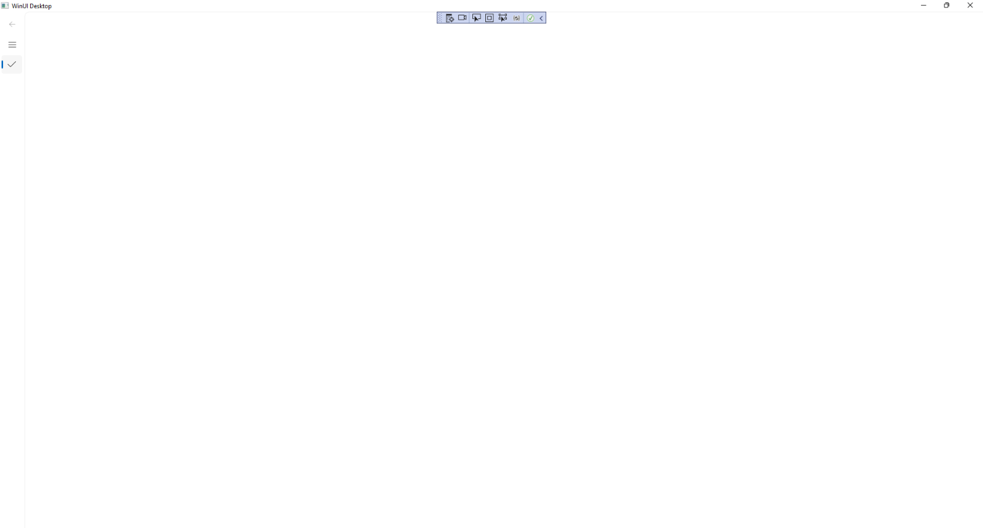

## Step 10

If you **Tap** or **Click** onthe **NavigationViewItem** with the Icon for *Accept*, this will show or hide the **Pane**

for the **NavigationView** which you can also do by **Tapping** or **Clicking** on the *“hamburger”* button and

allow you to see the Text of *Toggle* and you can **Click** or **Tap** this to hide the **Pane** again.

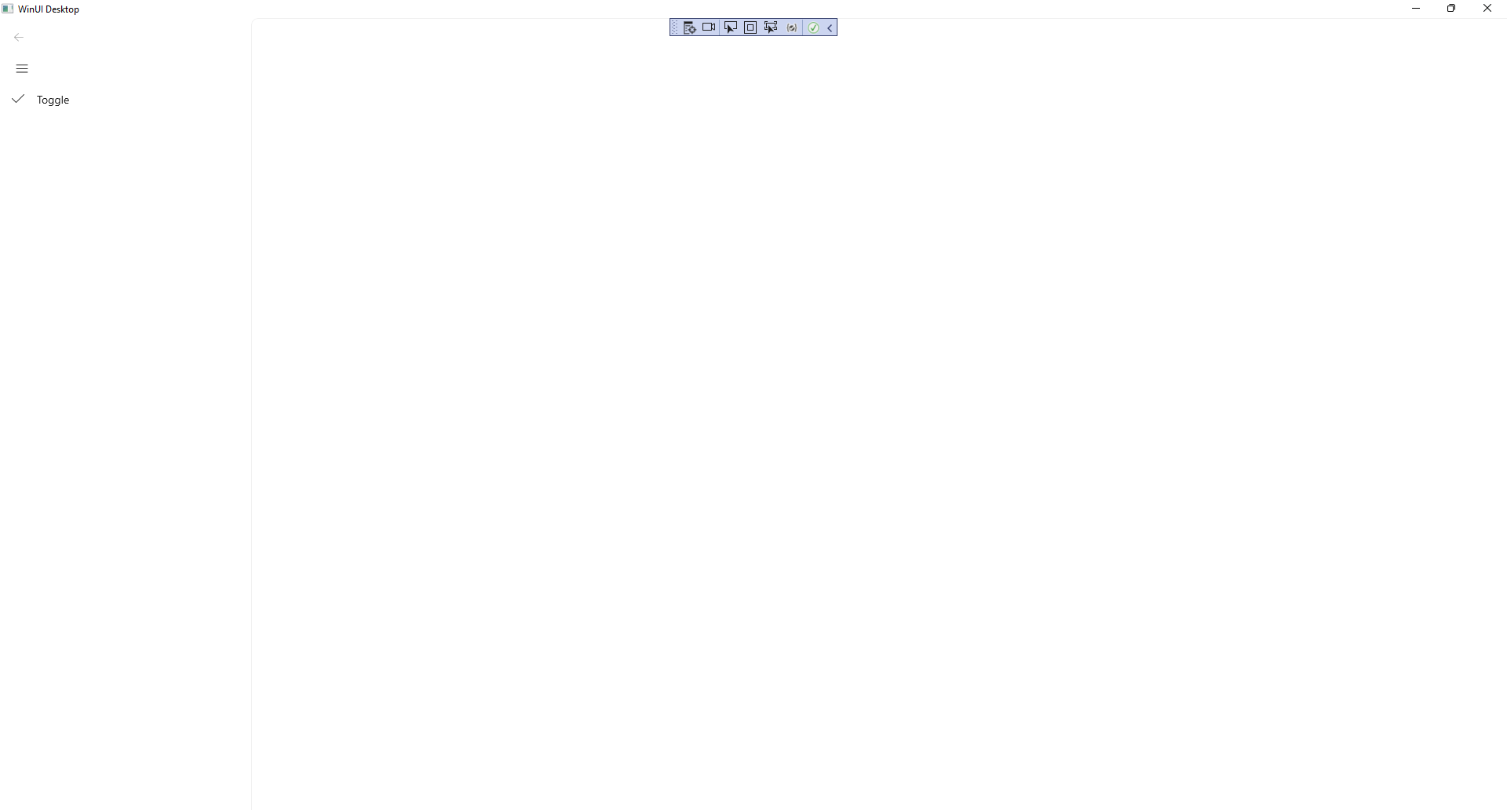

## Step 11

|  |  |
| --- | --- |
| To **Exit** the **Windows App SDK** application, select the **Close** button from the top right of the application as that concludes this **Tutorial** for **Windows App SDK** from [tutorialr.com](https://tutorialr.com)! |  |