

[](https://www.tutorialr.com/tutorials/)

Windows App SDK

Offset Layout





# Offset Layout

**Offset Layout** shows how to create an **Offset** **Panel** using **Windows App SDK**

## Step 1

Follow **Setup and Start** on how to get **Setup** and **Install** what you need for **Visual Studio 2022** and **Windows App SDK**.

|  |  |
| --- | --- |
| In **Windows 11** choose **Start** and then find or search for **Visual Studio 2022** and then select it. |  |
| Once **Visual Studio 2022** has started select **Create a new project**. |  |
| Then choose the **Blank App, Packages (WinUI in Desktop)** and then select **Next**. |  |
| After that in **Configure your new project** type in the **Project name** as *OffsetLayout*, then select a Location and then select **Create** to start a new **Solution**. |  |

## Step 2

Then in **Visual Studio** within **Solution** **Explorer** for the **Solution**, right click on the **Project** shown below the **Solution** and then select **Add** then **New Item…**

## Step 3

Then in **Add New Item** from the **C# Items** list, select **Code** and then select **Code File** from the list next to this, then type in the name of *OffsetPanel.cs* and then **Click** on **Add**.

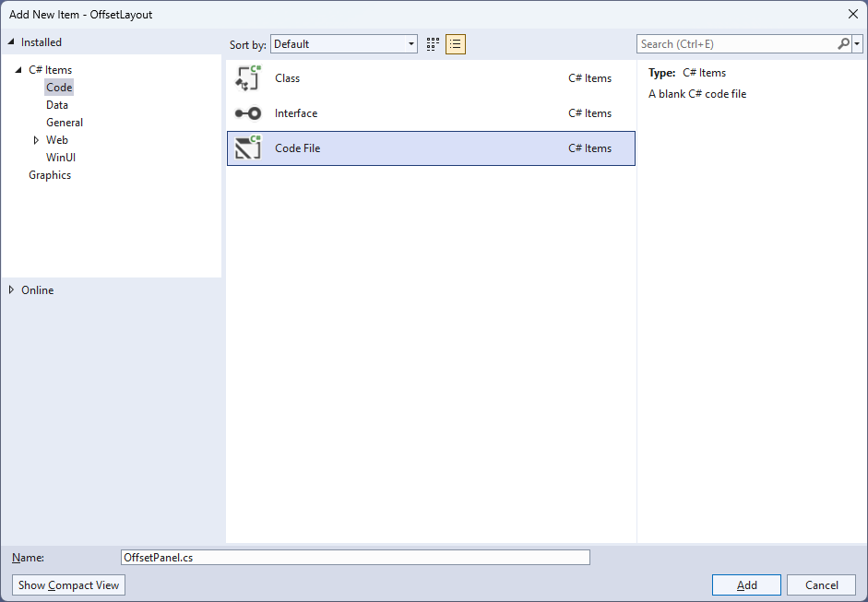

## Step 4

|  |  |
| --- | --- |
| Then from **Solution** **Explorer** for the **Solution** double-click on **OffsetPanel.cs** to see the **Code** for the **User Control**. |  |

## Step 5

You will now be in the **View** for the **Code** of *OffsetPanel.cs*, within this type in the following **Code**:

using Microsoft.UI.Xaml;

using Microsoft.UI.Xaml.Controls;

using Windows.Foundation;

namespace OffsetLayout;

public class OffsetPanel : Panel

{

// Dependency Properties & Properties

// Measure Override Method

// Arrange Override Method

}

There are **using** statements for the **User Control**, a **namespace** for **OffsetLayout** along with a **class** of **OffsetPanel** that will represent the **User Control** and **Inherits** the **class** of **Panel**.

## Step 6

Then in the **namespace** of **OffsetLayout** in the **class** of **OffsetPanel** after the **Comment** of **// Dependency Properties & Properties** type the following **Dependency Properties** and **Properties**:

public static readonly DependencyProperty MaximumColumnsProperty =

DependencyProperty.Register(nameof(MaximumColumns),

typeof(int), typeof(OffsetPanel), new PropertyMetadata(2));

public static readonly DependencyProperty ColumnOffsetProperty =

DependencyProperty.Register(nameof(ColumnOffset),

typeof(double), typeof(OffsetPanel), new PropertyMetadata(10.0));

public static readonly DependencyProperty RowOffsetProperty =

DependencyProperty.Register(nameof(RowOffset),

typeof(double), typeof(OffsetPanel), new PropertyMetadata(10.0));

public static readonly DependencyProperty SpacingYProperty =

DependencyProperty.Register(nameof(SpacingY),

typeof(double), typeof(OffsetPanel), new PropertyMetadata(10.0));

public static readonly DependencyProperty SpacingXProperty =

DependencyProperty.Register(nameof(SpacingX),

typeof(double), typeof(OffsetPanel), new PropertyMetadata(10.0));

public int MaximumColumns

{

get { return (int)GetValue(MaximumColumnsProperty); }

set { SetValue(MaximumColumnsProperty, value); }

}

public double ColumnOffset

{

get { return (double)GetValue(ColumnOffsetProperty); }

set { SetValue(ColumnOffsetProperty, value); }

}

public double RowOffset

{

get { return (double)GetValue(RowOffsetProperty); }

set { SetValue(RowOffsetProperty, value); }

}

public double SpacingX

{

get { return (double)GetValue(SpacingXProperty); }

set { SetValue(SpacingXProperty, value); }

}

public double SpacingY

{

get { return (double)GetValue(SpacingYProperty); }

set { SetValue(SpacingYProperty, value); }

}

## Step 7

While still in the **namespace** of **OffsetLayout** in the **class** of **OffsetPanel** after the **Comment** of **// Measure Override Method** type the following **Method**:

protected override Size MeasureOverride(Size availableSize)

{

double x = 0;

double y = 0;

double itemWidth = 0.0;

double itemHeight = 0.0;

for (int i = 0; i < Children.Count; i++)

{

var element = Children[i];

element.Measure(availableSize);

double width = element.DesiredSize.Width + x;

double height = element.DesiredSize.Height + y;

if (width > itemWidth) itemWidth = width;

if (height > itemHeight) itemHeight = height;

y += SpacingY;

if ((i + 1) % MaximumColumns == 0)

{

x -= SpacingX * (MaximumColumns - 1);

x += RowOffset;

y += ColumnOffset;

}

else

x += SpacingX;

}

return new Size(itemWidth, itemHeight);

}

The **Method** of **MeasureOverride** will **Measure** the **Size** required to layout the **Children** of the **Panel**.

## Step 8

While still in the **namespace** of **OffsetLayout** in the **class** of **OffsetPanel** after the **Comment** of **// Arrange Override Method** type the following **Method**:

protected override Size ArrangeOverride(Size finalSize)

{

double x = 0;

double y = 0;

for (int i = 0; i < Children.Count; i++)

{

var element = Children[i];

element.Arrange(new Rect(new Point(x, y),

element.DesiredSize));

y += SpacingY;

if ((i + 1) % MaximumColumns == 0)

{

x -= SpacingX * (MaximumColumns - 1);

x += RowOffset;

y += ColumnOffset;

}

else

x += SpacingX;

}

return finalSize;

}

The **Method** of **ArrangeOverride** will position the **Children** of the **Panel** at **Offsets** to each other for their **Rows** and **Columns** along with **Spacing** between them for the **User Control**.

## Step 9

|  |  |
| --- | --- |
| Within **Solution** **Explorer** for the **Solution** double-click on **MainWindow.xaml** to see the **XAML** for the **Main Window**. |  |

## Step 10

In the **XAML** for **MainWindow.xaml** there be some **XAML** for a **StackPanel**, this should be **Removed** by removing the following:

<StackPanel Orientation="Horizontal"

HorizontalAlignment="Center" VerticalAlignment="Center">

<Button x:Name="myButton" Click="myButton_Click">Click Me</Button>

</StackPanel>

## Step 11

While still in the **XAML** for **MainWindow.xaml** above **</Window>**, type in the following **XAML**:

<local:OffsetPanel MaximumColumns="4" SpacingX="50" SpacingY="50"

HorizontalAlignment="Center" VerticalAlignment="Center">

<Rectangle Width="100" Height="100" Fill="Red"/>

<Rectangle Width="100" Height="100" Fill="Orange"/>

<Rectangle Width="100" Height="100" Fill="Yellow"/>

<Rectangle Width="100" Height="100" Fill="Green"/>

<Rectangle Width="100" Height="100" Fill="Cyan"/>

<Rectangle Width="100" Height="100" Fill="Blue"/>

<Rectangle Width="100" Height="100" Fill="Magenta"/>

<Rectangle Width="100" Height="100" Fill="Purple"/>

</local:OffsetPanel>

This **XAML** contains the **User Control** of **OffsetPanel** with **MaximumColumns** set to **4** and **Spacing** between items set and the **Children** containing **Controls** for a **Rectangle** in various colours.

## Step 12

|  |  |
| --- | --- |
| Then, within **Solution** **Explorer** for the **Solution** select the arrow next to **MainWindow.xaml** then double-click on **MainWindow.xaml.cs** to see the **Code** for the **Main Window**. |  |

## Step 13

In the **Code** for **MainWindow.xaml.cs** there be a **Method** of **myButton_Click(...)** this should be **Removed** by removing the following:

private void myButton_Click(object sender, RoutedEventArgs e)

{

myButton.Content = "Clicked";

}

## Step 14

|  |  |
| --- | --- |
| That completes the **Windows App SDK** application. In **Visual Studio 2022** from the **Toolbar** select **OffsetLayout (Package)** to **Start** the application. |  |

## Step 15

Once running you will see the **Offset Panel** displayed.

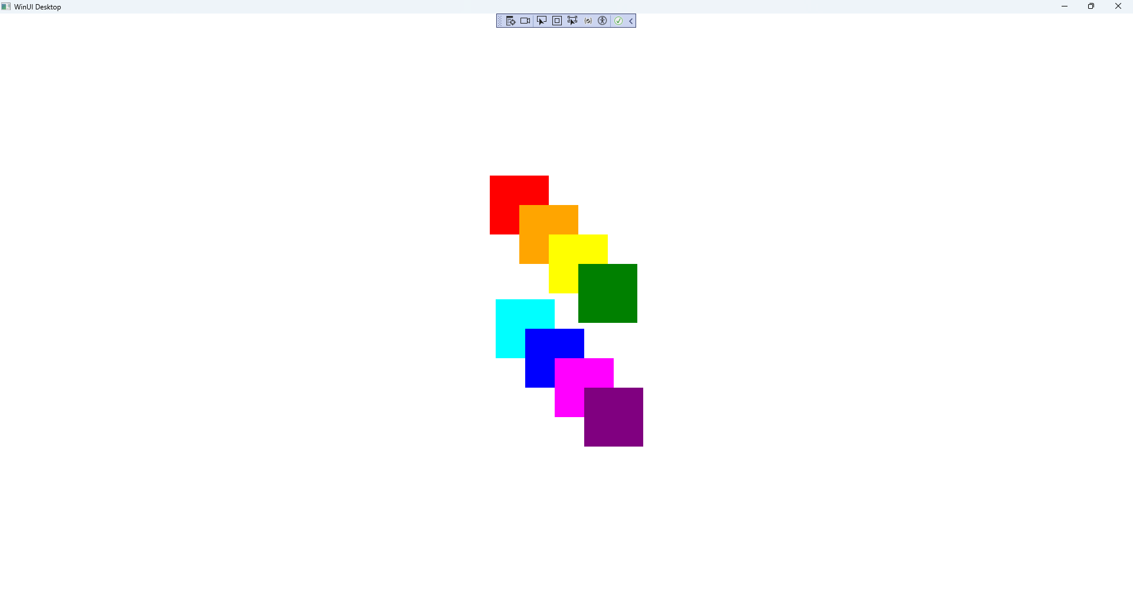

## Step 16

|  |  |
| --- | --- |
| To **Exit** the **Windows App SDK** application, select the **Close** button from the top right of the application as that concludes this **Tutorial** for **Windows App SDK** from [tutorialr.com](https://tutorialr.com)! |  |