

[](https://www.tutorialr.com/tutorials/)

Windows App SDK

Radial Layout





# Radial Layout

**Radial Layout** shows how to create a **Radial** **Panel** using **Windows App SDK**

## Step 1

Follow **Setup and Start** on how to get **Setup** and **Install** what you need for **Visual Studio 2022** and **Windows App SDK**.

|  |  |
| --- | --- |
| In **Windows 11** choose **Start** and then find or search for **Visual Studio 2022** and then select it. |  |
| Once **Visual Studio 2022** has started select **Create a new project**. |  |
| Then choose the **Blank App, Packages (WinUI in Desktop)** and then select **Next**. |  |
| After that in **Configure your new project** type in the **Project name** as *RadialLayout*, then select a Location and then select **Create** to start a new **Solution**. |  |

## Step 2

Then in **Visual Studio** within **Solution** **Explorer** for the **Solution**, right click on the **Project** shown below the **Solution** and then select **Add** then **New Item…**

## Step 3

Then in **Add New Item** from the **C# Items** list, select **Code** and then select **Code File** from the list next to this, then type in the name of *RadialPanel.cs* and then **Click** on **Add**.

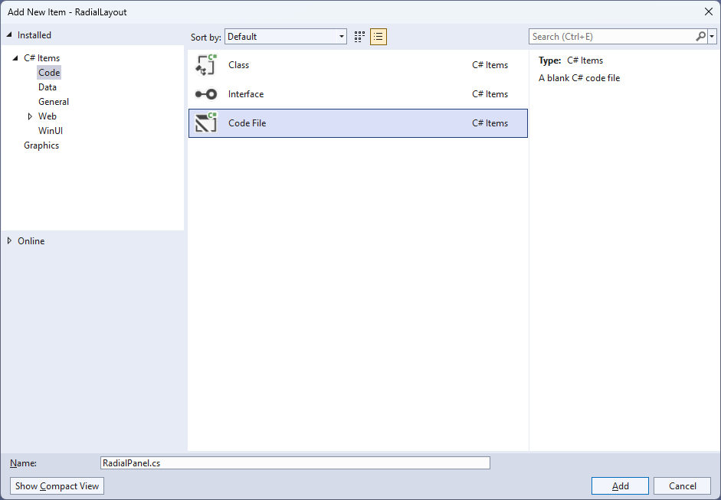

## Step 4

|  |  |
| --- | --- |
| Then from **Solution** **Explorer** for the **Solution** double-click on **RadialPanel.cs** to see the **Code** for the **User Control**. |  |

## Step 5

You will now be in the **View** for the **Code** of *RadialPanel.cs*, within this type in the following **Code**:

using Microsoft.UI.Xaml;

using Microsoft.UI.Xaml.Controls;

using Microsoft.UI.Xaml.Media;

using System;

using Windows.Foundation;

namespace RadialLayout;

public class RadialPanel : Panel

{

// Dependency Properties & Properties

// Measure Override Method

// Arrange Override Method

}

There are **using** statements for the **User Control**, a **namespace** for **RadialLayout** along with a **class** of **RadialPanel** that will represent the **User Control** and **Inherits** the **class** of **Panel**.

## Step 6

Then in the **namespace** of **RadialLayout** in the **class** of **RadialPanel** after the **Comment** of **// Dependency Properties & Properties** type the following **Dependency Properties** and **Properties**:

public static readonly DependencyProperty ItemHeightProperty =

DependencyProperty.Register(nameof(ItemHeight),

typeof(double), typeof(RadialPanel),

new PropertyMetadata(double.NaN));

public static readonly DependencyProperty ItemWidthProperty =

DependencyProperty.Register(nameof(ItemWidth),

typeof(double), typeof(RadialPanel),

new PropertyMetadata(double.NaN));

public static readonly DependencyProperty IsOrientedProperty =

DependencyProperty.Register(nameof(IsOriented),

typeof(bool), typeof(RadialPanel),

new PropertyMetadata(false));

public double ItemHeight

{

get { return (double)GetValue(ItemHeightProperty); }

set { SetValue(ItemHeightProperty, value); }

}

public double ItemWidth

{

get { return (double)GetValue(ItemWidthProperty); }

set { SetValue(ItemWidthProperty, value); }

}

public bool IsOriented

{

get { return (bool)GetValue(IsOrientedProperty); }

set { SetValue(IsOrientedProperty, value); }

}

**Dependency Properties** or **Properties** for the **User Control** can be customised for the **Radial Panel**.

## Step 7

While still in the **namespace** of **RadialLayout** in the **class** of **RadialPanel** after the **Comment** of **// Measure Override Method** type the following **Method**:

protected override Size MeasureOverride(Size availableSize)

{

double itemWidth = ItemWidth;

double itemHeight = ItemHeight;

bool hasFixedWidth = !double.IsNaN(itemWidth);

bool hasFixedHeight = !double.IsNaN(itemHeight);

var itemSize = new Size(

hasFixedWidth ? itemWidth : availableSize.Width,

hasFixedHeight ? itemHeight : availableSize.Height);

foreach (var element in Children)

{

element.Measure(itemSize);

}

return itemSize;

}

The **Method** of **MeasureOverride** will **Measure** the **Size** required to layout the **Children** of the **Panel**.

## Step 8

While still in the **namespace** of **RadialLayout** in the **class** of **RadialPanel** after the **Comment** of **// Arrange Override Method** type the following **Method**:

protected override Size ArrangeOverride(Size finalSize)

{

double itemWidth = ItemWidth;

double itemHeight = ItemHeight;

bool hasFixedWidth = !double.IsNaN(itemWidth);

bool hasFixedHeight = !double.IsNaN(itemHeight);

double radiusX = finalSize.Width * 0.5;

double radiusY = finalSize.Height * 0.5;

int count = Children.Count;

double deltaAngle = 2 * Math.PI / count;

var centre = new Point(finalSize.Width / 2,

finalSize.Height / 2);

for (int i = 0; i < count; i++)

{

var element = Children[i];

var elementSize = new Size(

hasFixedWidth ? itemWidth : element.DesiredSize.Width,

hasFixedHeight ? itemHeight : element.DesiredSize.Height);

double angle = i * deltaAngle;

double x = centre.X + radiusX * Math.Cos(angle)

- elementSize.Width / 2;

double y = centre.Y + radiusY * Math.Sin(angle)

- elementSize.Height / 2;

if (IsOriented)

element.RenderTransform = null;

else

{

element.RenderTransformOrigin = new Point(0.5, 0.5);

element.RenderTransform = new RotateTransform()

{

Angle = angle * 180 / Math.PI

};

}

element.Arrange(new Rect(x, y,

elementSize.Width, elementSize.Height));

}

return finalSize;

}

The **Method** of **ArrangeOverride** will position the **Children** of the **Panel** and position them at different degrees of rotation around the centre of the **User Control** and **IsOriented** will either rotate them to face downwards or towards the centre of the **User Control**.

## Step 9

|  |  |
| --- | --- |
| Within **Solution** **Explorer** for the **Solution** double-click on **MainWindow.xaml** to see the **XAML** for the **Main Window**. |  |

## Step 10

In the **XAML** for **MainWindow.xaml** there be some **XAML** for a **StackPanel**, this should be **Removed** by removing the following:

<StackPanel Orientation="Horizontal"

HorizontalAlignment="Center" VerticalAlignment="Center">

<Button x:Name="myButton" Click="myButton_Click">Click Me</Button>

</StackPanel>

## Step 11

While still in the **XAML** for **MainWindow.xaml** above **</Window>**, type in the following **XAML**:

<local:RadialPanel Height="500" Width="500" IsOriented="True">

<Rectangle Width="100" Height="100" Fill="Red"/>

<Rectangle Width="100" Height="100" Fill="Orange"/>

<Rectangle Width="100" Height="100" Fill="Yellow"/>

<Rectangle Width="100" Height="100" Fill="Green"/>

<Rectangle Width="100" Height="100" Fill="Cyan"/>

<Rectangle Width="100" Height="100" Fill="Blue"/>

<Rectangle Width="100" Height="100" Fill="Magenta"/>

<Rectangle Width="100" Height="100" Fill="Purple"/>

</local:RadialPanel>

This **XAML** contains the **User Control** of **RadialPanel** with **IsOriented** set to **True** with the **Children** containing **Controls** for a **Rectangle** in various colours.

## Step 12

|  |  |
| --- | --- |
| Then, within **Solution** **Explorer** for the **Solution** select the arrow next to **MainWindow.xaml** then double-click on **MainWindow.xaml.cs** to see the **Code** for the **Main Window**. |  |

## Step 13

In the **Code** for **MainWindow.xaml.cs** there be a **Method** of **myButton_Click(...)** this should be **Removed** by removing the following:

private void myButton_Click(object sender, RoutedEventArgs e)

{

myButton.Content = "Clicked";

}

## Step 14

|  |  |
| --- | --- |
| That completes the **Windows App SDK** application. In **Visual Studio 2022** from the **Toolbar** select **RadialLayout (Package)** to **Start** the application. |  |

## Step 15

Once running you will see the **Radial Panel** displayed.

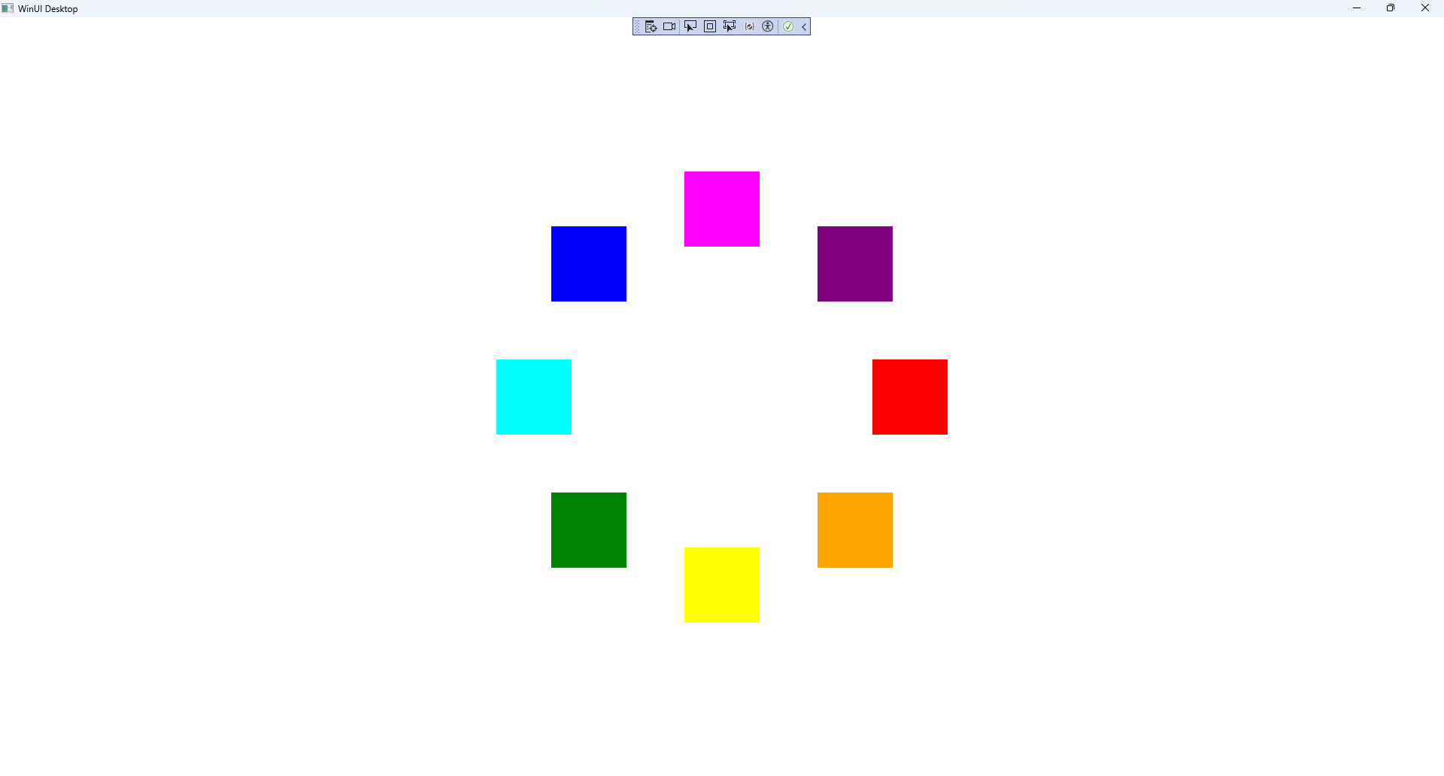

## Step 16

|  |  |
| --- | --- |
| To **Exit** the **Windows App SDK** application, select the **Close** button from the top right of the application as that concludes this **Tutorial** for **Windows App SDK** from [tutorialr.com](https://tutorialr.com)! |  |