

[](https://www.tutorialr.com/tutorials/)

Windows App SDK

Reversi





# Reversi

**Reversi** shows how you can create the game of **Reversi** or **Othello** based on the work by [OttoBotCode](https://github.com/OttoBotCode),

using emoji and with a toolkit from **NuGet** using the **Windows App SDK**.

## Step 1

Follow **Setup and Start** on how to get **Setup** and **Install** what you need for **Visual Studio 2022** and **Windows App SDK**.

|  |  |
| --- | --- |
| In **Windows 11** choose **Start** and then find or search for **Visual Studio 2022** and then select it. |  |
| Once **Visual Studio 2022** has started select **Create a new project**. |  |
| Then choose the **Blank App, Packages (WinUI in Desktop)** and then select **Next**. |  |
| After that in **Configure your new project** type in the **Project name** as *Reversi*, then select a Location and then select **Create** to start a new **Solution**. |  |

## Step 2

Then in **Visual Studio** within **Solution** **Explorer** for the **Solution**, right click on the **Project** shown below the **Solution** and then select **Manage NuGet Packages…**

## Step 3

Then in the **NuGet Package Manager** from the **Browse** tab search for **Comentsys.Toolkit.WindowsAppSdk** and then select **Comentsys.Toolkit.WindowsAppSdk by Comentsys** as indicated and select **Install**

This will add the package for **Comentsys.Toolkit.WindowsAppSdk** to your **Project**. If you get the **Preview Changes** screen saying **Visual Studio is about to make changes to this solution. Click OK to proceed with the changes listed below.** You can read the message and then select **OK** to **Install** the package.

## Step 4

Then while still in the **NuGet Package Manager** from the **Browse** tab search for **Comentsys.Assets.FluentEmoji** and then select **Comentsys.Assets.FluentEmoji by Comentsys** as indicated and select **Install**

This will add the package for **Comentsys.Assets.FluentEmoji** to your **Project**. If you get the **Preview Changes** screen saying **Visual Studio is about to make changes to this solution. Click OK to proceed with the changes listed below.** You can read the message and then select **OK** to **Install** the package, then you can close the **tab** for **Nuget: Reversi** by selecting the **x** next to it.

## Step 5

Then in **Visual Studio** within **Solution** **Explorer** for the **Solution**, right click on the **Project** shown below the **Solution** and then select **Add** then **New Item…**

## Step 6

Then in **Add New Item** from the **C# Items** list, select **Code** and then select **Code File** from the list next to this, then type in the name of *Library.cs* and then **Click** on **Add**.

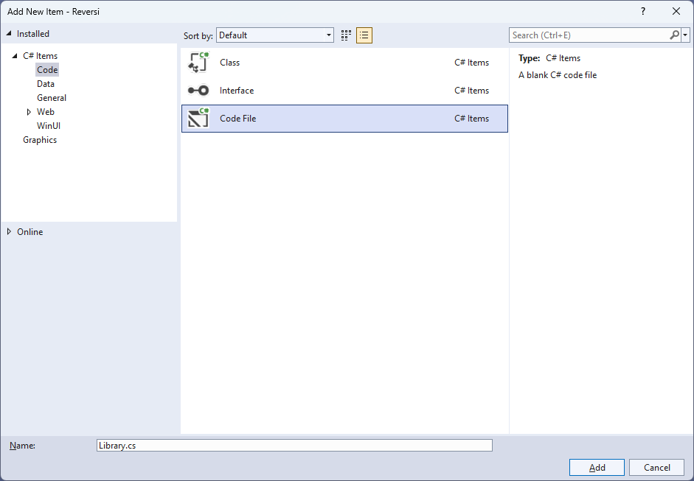

## Step 7

You will now be in the **View** for the **Code** of *Library.cs*, within this first type the following **Code**:

using Comentsys.Assets.FluentEmoji;

using Comentsys.Toolkit.Binding;

using Comentsys.Toolkit.WindowsAppSdk;

using Microsoft.UI;

using Microsoft.UI.Text;

using Microsoft.UI.Xaml;

using Microsoft.UI.Xaml.Controls;

using Microsoft.UI.Xaml.Input;

using Microsoft.UI.Xaml.Media;

using System;

using System.Collections.Generic;

using System.Linq;

using System.Threading.Tasks;

namespace Reversi;

public enum Player

{

None, Black, White

}

// Extensions, Position and Move Class

public class State

{

// State Variables, Is Inside & Outflanked

// Is Valid, Get Valid, Set Flip, Set Count & Swap

// Get Winner, Set Turn & Constructor

// Move & Occupied

}

public class Library

{

// Constants, Variables, Get Source, Set Source, Set Valid & Get Valid

// Player Source, Get Player, Get Score, Set Text, Set Flip & Set

// Add & Play

// Layout & New

}

So far in *Library.cs* has **using** for **Comentsys.Toolkit.WindowsAppSdk** and others along with a **namespace** which allows many classes to be defined together, usually a **class** is defined per file but to make things easier each will be defined in *Library.cs* instead.

## Step 8

Still in *Library.cs* for the **namespace** of **Reversi** in *Library.cs* you can define a **class** for **Extensions**, **Position** and **Move** after the **Comment** of **// Extensions, Position & Move Class** by typing the following:

public static class Extensions

{

public static Player Other(this Player player) =>

player switch

{

Player.Black => Player.White,

Player.White => Player.Black,

_ => Player.None

};

}

public class Position

{

public int Row { get; set; }

public int Column { get; set; }

public Position(int row, int column) =>

(Row, Column) = (row, column);

public override bool Equals(object obj) =>

obj is Position pos && Row == pos.Row && Column == pos.Column;

public override int GetHashCode() =>

Row.GetHashCode() + Column.GetHashCode();

}

public class Move

{

public Player Player { get; set; }

public Position Position { get; set; }

public IEnumerable<Position> Outflanked { get; set; }

public IEnumerable<Position> PreviousValid { get; set; }

public Move(Player player, Position position,

IEnumerable<Position> outflanked, IEnumerable<Position> previousValid) =>

(Player, Position, Outflanked, PreviousValid) =

(player, position, outflanked, previousValid);

}

**Extensions** is used to define an extension **Method** for **Player**, then **Position** is used to define the location of a piece in the game and **Move** is used to define which moves are possible and uses **Position**.

## Step 9

Still in the **namespace** of **Reversi** in *Library.cs* and in the **class** of **State**, after the **Comment** of **// Variables, Is Inside & Outflanked** type the following **Variables** which represent values in the game along with the gameboard along with **Methods** for **IsInside** which determines if a location is inside another and **Outflanked** which are used do get the positions to outflank the other player in the game.

private const int rows = 8;

private const int columns = 8;

public Player[,] Board { get; }

public Dictionary<Player, int> Count { get; }

public Player Current { get; private set; }

public bool Over { get; private set; }

public Player Winner { get; private set; }

public Dictionary<Position, IEnumerable<Position>> Valid { get; private set; }

private bool IsInside(int row, int column) =>

row >= 0 && row < rows && column >= 0 && column < columns;

private IEnumerable<Position> Outflanked(

Position position, Player player, int rowOffset, int columnOffset)

{

List<Position> outflanked = new();

int row = position.Row + rowOffset;

int column = position.Column + columnOffset;

while (IsInside(row, column) && Board[row, column] != Player.None)

{

if (Board[row, column] == player.Other())

{

outflanked.Add(new Position(row, column));

row += rowOffset;

column += columnOffset;

}

else if (Board[row, column] == player)

return outflanked;

}

return Enumerable.Empty<Position>();

}

private IEnumerable<Position> Outflanked(Position position, Player player)

{

List<Position> outflanked = new();

for (int rowOffset = -1; rowOffset <= 1; rowOffset++)

{

for (int columnOffset = -1; columnOffset <= 1; columnOffset++)

{

if (rowOffset == 0 && columnOffset == 0)

continue;

outflanked.AddRange(

Outflanked(position, player, rowOffset, columnOffset));

}

}

return outflanked;

}

## Step 10

While still in the **namespace** of **Reversi** in *Library.cs* and the **class** of **State** and after the **Comment** of **// Is Valid, Get Valid, Set Flip, Set Count & Swap** type the following **Methods**:

private bool IsValid(

Player player, Position position, out IEnumerable<Position> outflanked)

{

outflanked = Board[position.Row, position.Column] == Player.None ?

Outflanked(position, player) : Enumerable.Empty<Position>();

return outflanked.Any();

}

private Dictionary<Position, IEnumerable<Position>> GetValid(Player player)

{

Dictionary<Position, IEnumerable<Position>> valid = new();

for (int row = 0; row < rows; row++)

{

for (int column = 0; column < columns; column++)

{

var position = new Position(row, column);

if (IsValid(player, position, out IEnumerable<Position> outflanked))

{

valid[position] = outflanked;

}

}

}

return valid;

}

private void SetFlip(IEnumerable<Position> positions)

{

foreach (var position in positions)

{

Board[position.Row, position.Column] =

Board[position.Row, position.Column].Other();

}

}

private void SetCount(Player player, int count)

{

Count[player] += count + 1;

Count[player.Other()] -= count;

}

private void Swap()

{

Current = Current.Other();

Valid = GetValid(Current);

}

**IsValid** is used to determine if a location can be placed onto and is used with **GetValid** to determine this for a given player. **SetFlip** is used to flip a player and this takes advantage of the **Method** defined in **Extensions** which is also used in **SetCount** to update counter for a player and **Swap** to switch players**.**

## Step 11

While still in the **namespace** of **Reversi** in *Library.cs* and the **class** of **State** and after the **Comment** of **// Get Winner, Set Turn & Constructor** type the following **Methods**:

private Player GetWinner()

{

if (Count[Player.Black] > Count[Player.White])

return Player.Black;

if (Count[Player.Black] < Count[Player.White])

return Player.White;

return Player.None;

}

private void SetTurn()

{

Swap();

if (Valid.Any())

return;

Swap();

if (Valid.Count == 0)

{

Current = Player.None;

Over = true;

Winner = GetWinner();

}

}

public State()

{

Board = new Player[rows, columns];

Board[3, 3] = Player.White;

Board[3, 4] = Player.Black;

Board[4, 3] = Player.Black;

Board[4, 4] = Player.White;

Count = new Dictionary<Player, int>()

{

{ Player.Black, 2 },

{ Player.White, 2 }

};

Current = Player.Black;

Valid = GetValid(Current);

}

**GetWinner** will be used to check which of the players is the winner or if there is no winner. **SetTurn** will swap the players around so each can take their turn and the **Constructor** for **State** will setup the initial configuration and positions of the players to start the game.

## Step 12

While still in the **namespace** of **Reversi** in *Library.cs* and the **class** of **State** and after the **Comment** of **// Move & Occupied** type the following **Methods**:

public bool Move(Position position, out Move move)

{

if (!Valid.ContainsKey(position))

{

move = null;

return false;

}

var player = Current;

var previous = Valid.Keys;

var outflanked = Valid[position];

Board[position.Row, position.Column] = player;

SetFlip(outflanked);

SetCount(player, outflanked.Count());

SetTurn();

move = new Move(player, position, outflanked, previous);

return true;

}

public IEnumerable<Position> Occupied()

{

for (int row = 0; row < rows; row++)

{

for (int column = 0; column < columns; column++)

{

if (Board[row, column] != Player.None)

yield return new Position(row, column);

}

}

}

**Move** will be used to place a player on the board and flip the pieces the opposing player has placed appropriately to complete a move in the game and **Occupied** is used to determine which places on the board are not currently occupied by any player.

## Step 13

While still in the **namespace** of **Reversi** in *Library.cs* and in the **class** of **Library** after the **Comment** of **// Constants, Variables, Get Source, Set Source, Set Valid & Get Valid** type the following **Constants**, **Variables** and **Methods**:

private const string title = "Reversi";

private const int square_size = 100;

private const int disc_size = 72;

private const int font = 24;

private const int size = 8;

private ImageSource[] _sources;

private State _state;

private TextBlock _text;

private Dialog _dialog;

private Grid _grid;

private async Task<ImageSource> GetSourceAsync(FluentEmojiType type) =>

await FlatFluentEmoji.Get(type).AsImageSourceAsync();

private async Task SetSourceAsync() =>

_sources ??= (new ImageSource[]

{

await GetSourceAsync(FluentEmojiType.GreenCircle),

await GetSourceAsync(FluentEmojiType.BlackCircle),

await GetSourceAsync(FluentEmojiType.WhiteCircle)

});

private void SetSource(Position position, ImageSource source) =>

_grid.Children.Cast<Grid>()

.First(f => Grid.GetRow(f) == position.Row

&& Grid.GetColumn(f) == position.Column)

.Children.Cast<Image>().First().Source = source;

private void SetValid(IEnumerable<Position> positions, ImageSource source)

{

foreach (var position in positions)

{

var square = _state.Board[position.Row, position.Column];

if (square == Player.None)

SetSource(position, source);

}

}

private ImageSource GetValid(int row, int column) =>

_state.Valid.ContainsKey(new Position(row, column)) ? _sources[0] : null;

**Constants** are values that are used in the game that will not change and **Variables** are used to store various values and controls needed for the game. **GetSourceAsync**, **SetSourceAsync** and **SetSource** are used to set the **Emoji** used to represent the players in the game. **SetValid** is used to set a valid position and **GetValue** is used to get a valid position.

## Step 14

While still in the **namespace** of **Reversi** in *Library.cs* and in the **class** of **Library** after the **Comment** of **// Player Source, Get Player, Get Score, Set Text, Set Flip & Set** type the following **Methods**:

private ImageSource PlayerSource(int row, int column)

{

var player = _state.Board[row, column];

return player != Player.None ? _sources[(int)player] : GetValid(row, column);

}

private string GetPlayer(Player player) =>

Enum.GetName(typeof(Player), player);

private string GetScore() =>

$"Score: {GetPlayer(Player.Black)}: {_state.Count[Player.Black]} {GetPlayer(Player.White)}: {_state.Count[Player.White]}";

private void SetText() =>

_text.Text = $"Current: {GetPlayer(_state.Current)} - {GetScore()}";

private void SetFlip(Move move)

{

foreach (var position in move.Outflanked)

SetSource(position, _sources[(int)move.Player]);

}

private void Set(Position position, Move move)

{

SetValid(move.PreviousValid, null);

var player = _state.Board[position.Row, position.Column];

if (player != Player.None)

SetSource(position, _sources[(int)player]);

SetFlip(move);

SetValid(_state.Valid.Keys, _sources[0]);

SetText();

}

**PlayerSource** will get the image needed to represent a player where valid, **GetPlayer** will get the name of the player. **GetScore** will be used to get the score for both players, and this will be used by **SetText** to display this. **SetFlip** will be used to flip the player images where needed and **Set** will be used to perform a move in the game and update the valid locations.

## Step 15

While still in the **namespace** of **Reversi** in *Library.cs* and in the **class** of **Library** after the **Comment** of **// Play & Add** type the following **Methods**:

private void Play(Position position)

{

if (!_state.Over)

{

if (_state.Move(position, out Move move))

Set(position, move);

}

else

{

_dialog.Show(

$"Game Over! Winner: {GetPlayer(_state.Winner)} - {GetScore()}");

}

}

private void Add(int row, int column)

{

Grid square = new()

{

Width = square_size,

Height = square_size,

BorderThickness = new Thickness(1),

BorderBrush = new SolidColorBrush(Colors.Black),

Background = new SolidColorBrush(Colors.ForestGreen)

};

Image image = new()

{

Width = disc_size,

Height = disc_size,

Source = PlayerSource(row, column)

};

square.Children.Add(image);

square.SetValue(Grid.RowProperty, row);

square.SetValue(Grid.ColumnProperty, column);

square.Tapped += (object sender, TappedRoutedEventArgs e) =>

Play(new Position((int)((Grid)sender).GetValue(Grid.RowProperty),

(int)((Grid)sender).GetValue(Grid.ColumnProperty)));

_grid.Children.Add(square);

}

**Play** used to perform a move in the game or indicate the game is over with a message and **Add** will be used to add the squares that make up the layout of the board and will respond to the **Event** of **Tapped** and will call **Play** along with adding an **Image** that will represent the player for the square.

## Step 16

While still in the **namespace** of **Reversi** in *Library.cs* and in the **class** of **Library** after the **Comment** of **// Layout & New** type in the following **Methods**:

private void Layout(Grid grid)

{

grid.Children.Clear();

StackPanel panel = new()

{

Orientation = Orientation.Vertical

};

_text = new TextBlock()

{

FontSize = font,

Margin = new Thickness(2),

FontWeight = FontWeights.Bold,

VerticalAlignment = VerticalAlignment.Center

};

SetText();

panel.Children.Add(_text);

_grid = new Grid();

for (int row = 0; row < size; row++)

{

_grid.RowDefinitions.Add(new RowDefinition());

for (int column = 0; column < size; column++)

{

if (row == 0)

_grid.ColumnDefinitions.Add(new ColumnDefinition());

Add(row, column);

}

}

panel.Children.Add(_grid);

grid.Children.Add(panel);

}

public async void New(Grid grid)

{

_grid = grid;

_state = new State();

await SetSourceAsync();

_dialog = new Dialog(grid.XamlRoot, title);

Layout(grid);

}

**Layout** will create the look-and-feel of the game by setting up all the elements and **New** will setup and start a new game.

## Step 17

|  |  |
| --- | --- |
| Then from **Solution** **Explorer** for the **Solution** double-click on **MainWindow.xaml** to see the **XAML** for the **Main Window**. |  |

## Step 18

In the **XAML** for **MainWindow.xaml** there be some **XAML** for a **StackPanel**, this should be **Removed** by removing the following:

<StackPanel Orientation="Horizontal"

HorizontalAlignment="Center" VerticalAlignment="Center">

<Button x:Name="myButton" Click="myButton_Click">Click Me</Button>

</StackPanel>

## Step 19

While still in the **XAML** for **MainWindow.xaml** above **</Window>**, type in the following **XAML**:

<Grid>

<Viewbox>

<Grid Margin="50" Name="Display"

HorizontalAlignment="Center"

VerticalAlignment="Center" Loaded="New"/>

</Viewbox>

<CommandBar VerticalAlignment="Bottom">

<AppBarButton Icon="Page2" Label="New" Click="New"/>

</CommandBar>

</Grid>

This **XAML** contains a **Grid** with a **Viewbox** which will scale a **Grid**. It has a **Loaded** event handler for **New** which is also shared by the **AppBarButton**.

## Step 20

|  |  |
| --- | --- |
| Then, within **Solution** **Explorer** for the **Solution** select the arrow next to **MainWindow.xaml** then double-click on **MainWindow.xaml.cs** to see the **Code** for the **Main Window**. |  |

## Step 21

In the **Code** for **MainWindow.xaml.cs** there be a **Method** of **myButton_Click(...)** this should be **Removed** by removing the following:

private void myButton_Click(object sender, RoutedEventArgs e)

{

myButton.Content = "Clicked";

}

## Step 22

Once **myButton_Click(...)** has been removed, type in the following **Code** below the end of the **Constructor** of **public MainWindow() { ... }**:

private readonly Library _library = new();

private void New(object sender, RoutedEventArgs e) =>

_library.New(Display);

Here an **Instance** of the **Class** of **Library** is created then below this is the **Method** of **New** that will be used with **Event Handler** from the **XAML**, this **Method** uses Arrow Syntax with the **=>** for an Expression Bodywhich is useful when a **Method** only has one line.

## Step 23

|  |  |
| --- | --- |
| That completes the **Windows App SDK** application. In **Visual Studio 2022** from the **Toolbar** select **Reversi (Package)** to **Start** the application. |  |

## Step 24

Once running you can then tap on the appropriate indicated **Square** to place either a **White** or **Black** counteron the board to play the game until the game is over or the player with the highest score wins or select *New* to start a new game.

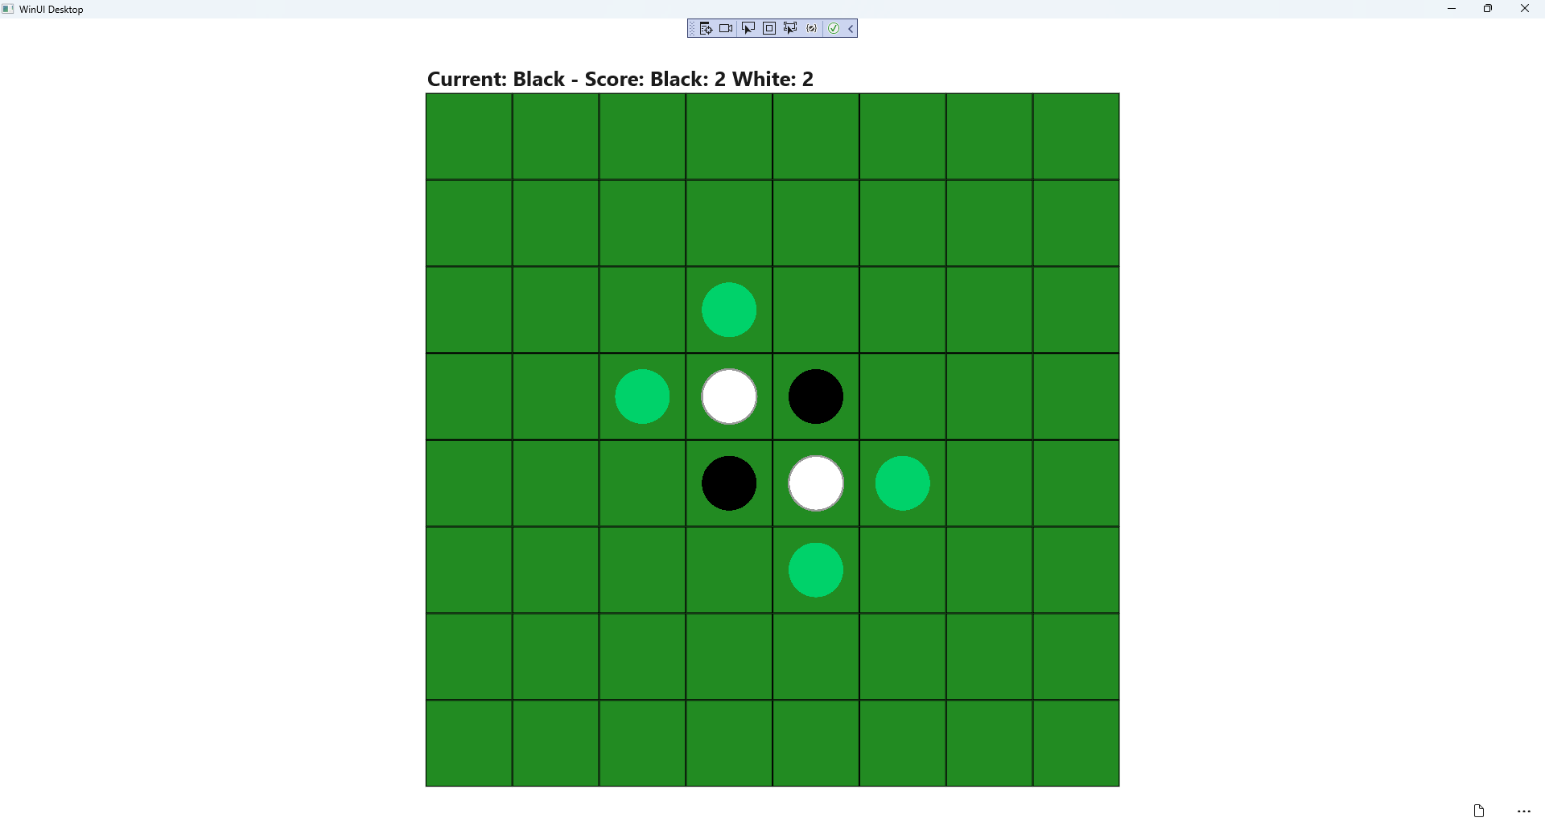

## Step 25

|  |  |
| --- | --- |
| To **Exit** the **Windows App SDK** application, select the **Close** button from the top right of the application as that concludes this **Tutorial** for **Windows App SDK** from [tutorialr.com](https://tutorialr.com)! |  |