

[](https://www.tutorialr.com/tutorials/)

Windows App SDK

Segment Control





# Segment Control

**Segment Control** shows how to create a seven-segment display using **Windows App SDK**

## Step 1

Follow **Setup and Start** on how to get **Setup** and **Install** what you need for **Visual Studio 2022** and **Windows App SDK**.

|  |  |
| --- | --- |
| In **Windows 11** choose **Start** and then find or search for **Visual Studio 2022** and then select it. |  |
| Once **Visual Studio 2022** has started select **Create a new project**. |  |
| Then choose the **Blank App, Packages (WinUI in Desktop)** and then select **Next**. |  |
| After that in **Configure your new project** type in the **Project name** as *SegmentControl*, then select a Location and then select **Create** to start a new **Solution**. |  |

## Step 2

Then in **Visual Studio** within **Solution** **Explorer** for the **Solution**, right click on the **Project** shown below the **Solution** and then select **Add** then **New Item…**

## Step 3

Then in **Add New Item** from the **C# Items** list, select **Code** and then select **Code File** from the list next to this, then type in the name of *Segment.cs* and then **Click** on **Add**.

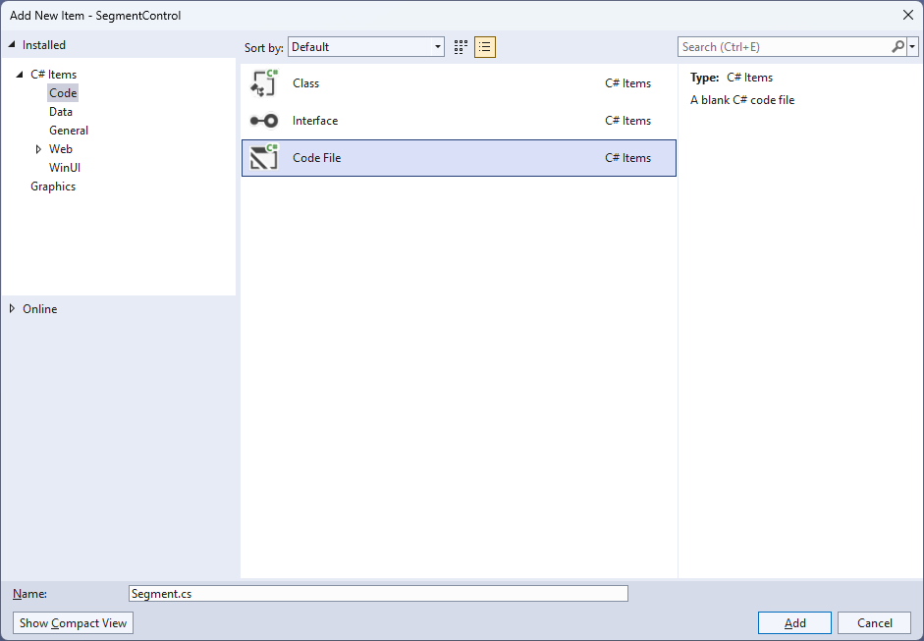

## Step 4

|  |  |
| --- | --- |
| Then from **Solution** **Explorer** for the **Solution** double-click on **Segment.cs** to see the **Code** for the **User Control**. |  |

## Step 5

You will now be in the **View** for the **Code** of *Segment.cs*, within this type in the following **Code**:

using Microsoft.UI;

using Microsoft.UI.Xaml;

using Microsoft.UI.Xaml.Controls;

using Microsoft.UI.Xaml.Data;

using Microsoft.UI.Xaml.Media;

using Microsoft.UI.Xaml.Shapes;

using System;

using System.Linq;

namespace SegmentControl;

public enum Sources

{

Value, Time, Date, TimeDate

}

public class Segment : StackPanel

{

// Constants & Members

// Dependency Properties & Properties

// Get Element & Add Element Methods

// Set Segment & Add Segment Methods

// Add Layout Method & Value Property

// Constructor

}

There are **using** statements for the **User Control**, a **namespace** for **SegmentControl** with an **enum** for the **Sources** of the **Segment Control** along with a **class** of **Segment** that will represent the **User Control**.

## Step 6

Then in the **namespace** of **SegmentControl** in the **class** of **Segment** after the **Comment** of **// Constants & Members** type the following **Constants** and **Members**:

private readonly byte[][] table =

{

// a, b, c, d, e, f, g

new byte[] { 1, 1, 1, 1, 1, 1, 0 }, // 0

new byte[] { 0, 1, 1, 0, 0, 0, 0 }, // 1

new byte[] { 1, 1, 0, 1, 1, 0, 1 }, // 2

new byte[] { 1, 1, 1, 1, 0, 0, 1 }, // 3

new byte[] { 0, 1, 1, 0, 0, 1, 1 }, // 4

new byte[] { 1, 0, 1, 1, 0, 1, 1 }, // 5

new byte[] { 1, 0, 1, 1, 1, 1, 1 }, // 6

new byte[] { 1, 1, 1, 0, 0, 0, 0 }, // 7

new byte[] { 1, 1, 1, 1, 1, 1, 1 }, // 8

new byte[] { 1, 1, 1, 0, 0, 1, 1 }, // 9

new byte[] { 0, 0, 0, 0, 0, 0, 1 }, // Minus

new byte[] { 0, 0, 0, 0, 0, 0, 0 }, // Colon

new byte[] { 0, 0, 0, 0, 0, 0, 0 } // Space

};

private const int width = 5;

private const int height = 25;

private const int spacing = 10;

private const int minus_pos = 10;

private const int colon_pos = 11;

private const int space_pos = 12;

private const string minus = "-";

private const string colon = ":";

private const string space = " ";

private const string time = "HH:mm:ss";

private const string date = "dd-MM-yyyy";

private const string date_time = "HH:mm:ss dd-MM-yyyy";

private const string invalid_source = "Invalid argument";

private int _count;

private string _value;

The **Constants** include a two-dimensional **Array** of **table** that will represent the elements of the segments that will be displayed for each *Digit* or *Minus*, *Colon*, and *Space* along with **Members** for the **Segment Control**.

## Step 7

While still in the **namespace** of **SegmentControl** in the **class** of **Segment** after the **Comment** of **// Dependency Properties & Properties** type the following **Dependency Properties** and **Properties**:

public static readonly DependencyProperty SourceProperty =

DependencyProperty.Register(nameof(Source), typeof(Sources),

typeof(Segment), new PropertyMetadata(Sources.Time));

public static readonly DependencyProperty ForegroundProperty =

DependencyProperty.Register(nameof(Foreground), typeof(Brush),

typeof(Segment), new PropertyMetadata(new SolidColorBrush(Colors.Black)));

public Sources Source

{

get { return (Sources)GetValue(SourceProperty); }

set { SetValue(SourceProperty, value); }

}

public Brush Foreground

{

get { return (Brush)GetValue(ForegroundProperty); }

set { SetValue(ForegroundProperty, value); }

}

The **Dependency Properties** or **Properties** for the **User Control** can be customised for the **Segment Control**.

## Step 8

While still in the **namespace** of **SegmentControl** in the **class** of **Segment** after the **Comment** of **// Get Element & Add Element Methods** type the following **Methods**:

private static Rectangle GetElement(Canvas segment, string name) =>

segment.Children.Cast<Rectangle>()

.FirstOrDefault(f => (string)f.Tag == name);

private Rectangle AddElement(string name,

int left, int top, int width, int height)

{

var element = new Rectangle()

{

Tag = name,

Opacity = 0,

RadiusX = 2,

RadiusY = 2,

Width = width,

Height = height,

Margin = new Thickness(2)

};

element.SetBinding(Shape.FillProperty, new Binding()

{

Path = new PropertyPath(nameof(Foreground)),

Mode = BindingMode.TwoWay,

Source = this

});

Canvas.SetLeft(element, left);

Canvas.SetTop(element, top);

return element;

}

The **Method** of **GetElement** will be used to obtain an element to be modified and **AddElement** will create an element for part of the segments of the **Segment Control**.

## Step 9

While still in the **namespace** of **SegmentControl** in the **class** of **Segment** after the **Comment** of **// Set Segment & Add Segment Methods** type the following **Methods**:

private void SetSegment(string name, int digit)

{

var segment = Children.Cast<Canvas>()

.FirstOrDefault(f => (string)f.Tag == name);

byte[] values = table[digit];

GetElement(segment, $"{name}.a").Opacity = values[0];

GetElement(segment, $"{name}.b").Opacity = values[1];

GetElement(segment, $"{name}.c").Opacity = values[2];

GetElement(segment, $"{name}.d").Opacity = values[3];

GetElement(segment, $"{name}.e").Opacity = values[4];

GetElement(segment, $"{name}.f").Opacity = values[5];

GetElement(segment, $"{name}.g").Opacity = values[6];

GetElement(segment, $"{name}.h").Opacity = digit == colon_pos ? 1 : 0;

GetElement(segment, $"{name}.i").Opacity = digit == colon_pos ? 1 : 0;

}

private void AddSegment(string name)

{

var segment = new Canvas()

{

Tag = name,

Width = 25,

Height = 50,

Margin = new Thickness(2)

};

segment.Children.Add(AddElement($"{name}.a",

width, 0, height, width));

segment.Children.Add(AddElement($"{name}.h",

width * 3, width * 3, width, width));

segment.Children.Add(AddElement($"{name}.f",

0, width, width, height));

segment.Children.Add(AddElement($"{name}.b",

height + width, width, width, height));

segment.Children.Add(AddElement($"{name}.g",

width, height + width, height, width));

segment.Children.Add(AddElement($"{name}.e",

0, height + (width * 2), width, height));

segment.Children.Add(AddElement($"{name}.c",

height + width, height + width + width, width, height));

segment.Children.Add(AddElement($"{name}.i",

width * 3, height + (width * 4), width, width));

segment.Children.Add(AddElement($"{name}.d",

width, (height * 2) + (width * 2), height, width));

Children.Add(segment);

}

The **Method** of **SetSegment** will use **GetElement** along with the **Array** of **table** to display the appropriate value by setting the **Opacity** and **AddSegment** will add the segments to the **Segment Control**.

## Step 10

While still in the **namespace** of **SegmentControl** in the **class** of **Segment** after the **Comment** of **// Add Layout Method & Value Property** type the following **Method** and **Property**:

private void AddLayout()

{

var array = _value.ToCharArray();

var length = array.Length;

var list = Enumerable.Range(0, length);

if (_count != length)

{

Children.Clear();

foreach (var item in list)

{

AddSegment(item.ToString());

}

_count = length;

}

foreach (int item in list)

{

var value = array[item].ToString();

var digit = value switch

{

minus => minus_pos,

colon => colon_pos,

space => space_pos,

_ => int.Parse(value),

};

SetSegment(item.ToString(), digit);

}

}

public string Value

{

get { return _value; }

set { _value = value; AddLayout(); }

}

The **Method** of **AddLayout** creates the look-and-feel for the **User Control** and the **Property** of **Value** will setup the display of the **Segment Control** using the **Method** of **AddLayout**.

## Step 11

While still in the **namespace** of **SegmentControl** in the **class** of **Segment** after the **Comment** of **// Constructor** type the following **Constructor**:

public Segment()

{

Spacing = spacing;

Orientation = Orientation.Horizontal;

var timer = new DispatcherTimer()

{

Interval = TimeSpan.FromMilliseconds(250)

};

timer.Tick += (object s, object args) =>

{

if (Source != Sources.Value)

{

var format = Source switch

{

Sources.Time => time,

Sources.Date => date,

Sources.TimeDate => date_time,

_ => throw new ArgumentException(invalid_source)

};

Value = DateTime.Now.ToString(format);

}

};

timer.Start();

}

The **Constructor** will setup a **DispatcherTimer** to be used to display the **Value** of the **Segment Control**.

## Step 12

|  |  |
| --- | --- |
| Within **Solution** **Explorer** for the **Solution** double-click on **MainWindow.xaml** to see the **XAML** for the **Main Window**. |  |

## Step 13

In the **XAML** for **MainWindow.xaml** there be some **XAML** for a **StackPanel**, this should be **Removed** by removing the following:

<StackPanel Orientation="Horizontal"

HorizontalAlignment="Center" VerticalAlignment="Center">

<Button x:Name="myButton" Click="myButton_Click">Click Me</Button>

</StackPanel>

## Step 14

While still in the **XAML** for **MainWindow.xaml** above **</Window>**, type in the following **XAML**:

<Viewbox>

<local:Segment Padding="50" Source="Time"

Foreground="{ThemeResource SystemControlHighlightAccentBrush}" />

</Viewbox>

This **XAML** contains a **ViewBox** including the **User Control** of **Segment** with the **Source** set to **Time**.

## Step 15

|  |  |
| --- | --- |
| Then, within **Solution** **Explorer** for the **Solution** select the arrow next to **MainWindow.xaml** then double-click on **MainWindow.xaml.cs** to see the **Code** for the **Main Window**. |  |

## Step 16

In the **Code** for **MainWindow.xaml.cs** there be a **Method** of **myButton_Click(...)** this should be **Removed** by removing the following:

private void myButton_Click(object sender, RoutedEventArgs e)

{

myButton.Content = "Clicked";

}

## Step 17

|  |  |
| --- | --- |
| That completes the **Windows App SDK** application. In **Visual Studio 2022** from the **Toolbar** select **SegmentControl (Package)** to **Start** the application. |  |

## Step 18

Once running you will see the **Segment Control** displaying the current *Time*.

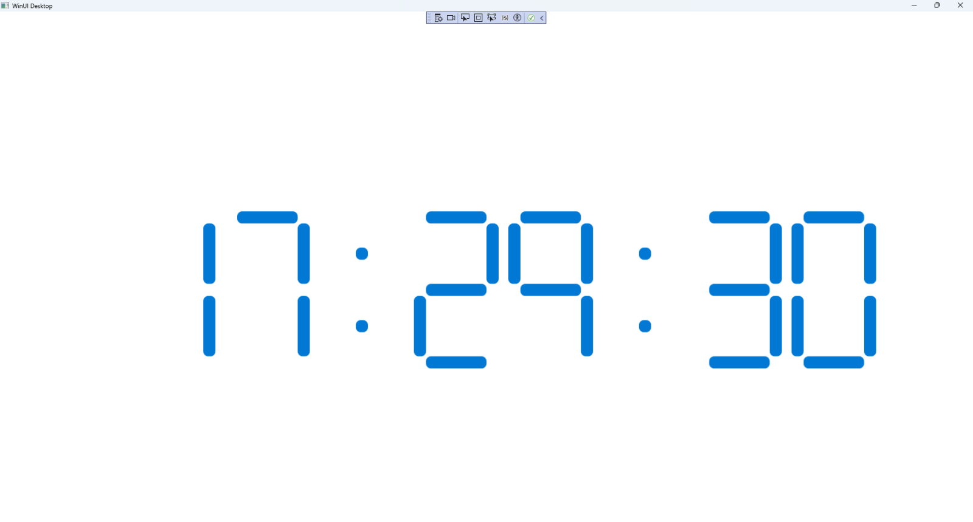

## Step 19

|  |  |
| --- | --- |
| To **Exit** the **Windows App SDK** application, select the **Close** button from the top right of the application as that concludes this **Tutorial** for **Windows App SDK** from [tutorialr.com](https://tutorialr.com)! |  |