](https://www.buymeacoffee.com/tutorialrdotcom)

[](https://www.tutorialr.com/tutorials/)

Windows App SDK





# Setup and Start

**Windows App SDK** allows you to create Applications by providing a modern Development **Platform** for **Windows 11** and **Windows 10** for version 1809 and later. You can get **Setup** in **Windows 11**, **Install** what you need with **Visual Studio 2022** and get ready to **Start** creating Applications using **Windows App SDK**.

## Setup

You will need to enable **Developer Mode** in **Windows 11** if this has not been enabled then you can do so with the following:

|  |  |
| --- | --- |
| Right-Click on **Start** then select **Settings** or Search for **Settings** from the **Start Menu** and Select it. |  |
| Next from **Settings** select **Privacy & security** |  |
| Then in **Privacy & security** select **For developers** |  |
| Finally in **For developers** make sure that the **Toggle** underneath **Install apps from any source, including loose** **files** is set to **On** if it is not already. |  |

## Install

**Windows App SDK** Applications will be created using **Visual Studio 2022** to **Install** this, if this has not be done already or to check you have what you need, you can do so with the following:

|  |  |
| --- | --- |
| Visit [visualstudio.com](https://visualstudio.com/) from your **Browser**,then from the **Download Visual Studio** section you can pick **Community 2022** which is a version of **Visual Studio 2022** that you can use for free to create your Applications with. |  |
| Next once the **Download** has completed from the **Thank you for downloading Visual Studio** screen choose the **Open file** option or similar in your **Browser** or find the **VisualStudioSetup.exe** in your **Downloads** and double-click on it. |  |
| Once the **VisualStudioSetup.exe** has started this will launch the **Visual Studio Installer**, select **Continue** to begin **Installation**. |  |
| Next select **.NET desktop development** fromthe **Workloads** section in the **Visual Studio** **Installer**. |  |
| Then from **Installation details** make sure that **Windows App SDK C# Templates** is selected and then select **Install** or **Modify** and follow any further instructions to complete the **Installation** of **Visual Studio 2022** and **Windows App SDK**. |  |

## Start

To get Started with a **Tutorial** you will need to open **Visual Studio 2022** and **Create a new project**, do this with the following:

|  |  |
| --- | --- |
| In **Windows 11** choose **Start** and then find or search for **Visual Studio 2022** and then select it. |  |
| Once **Visual Studio 2022** has started select **Create a new project**. |  |
| Then choose the **Blank App, Packages (WinUI in Desktop)** and then select **Next**. |  |
| After that in **Configure your new project** pick a **Project name** and **Location** and then select **Create** |  |

Finally the **Solution** for your Application will be opened in **Visual Studio 2022**

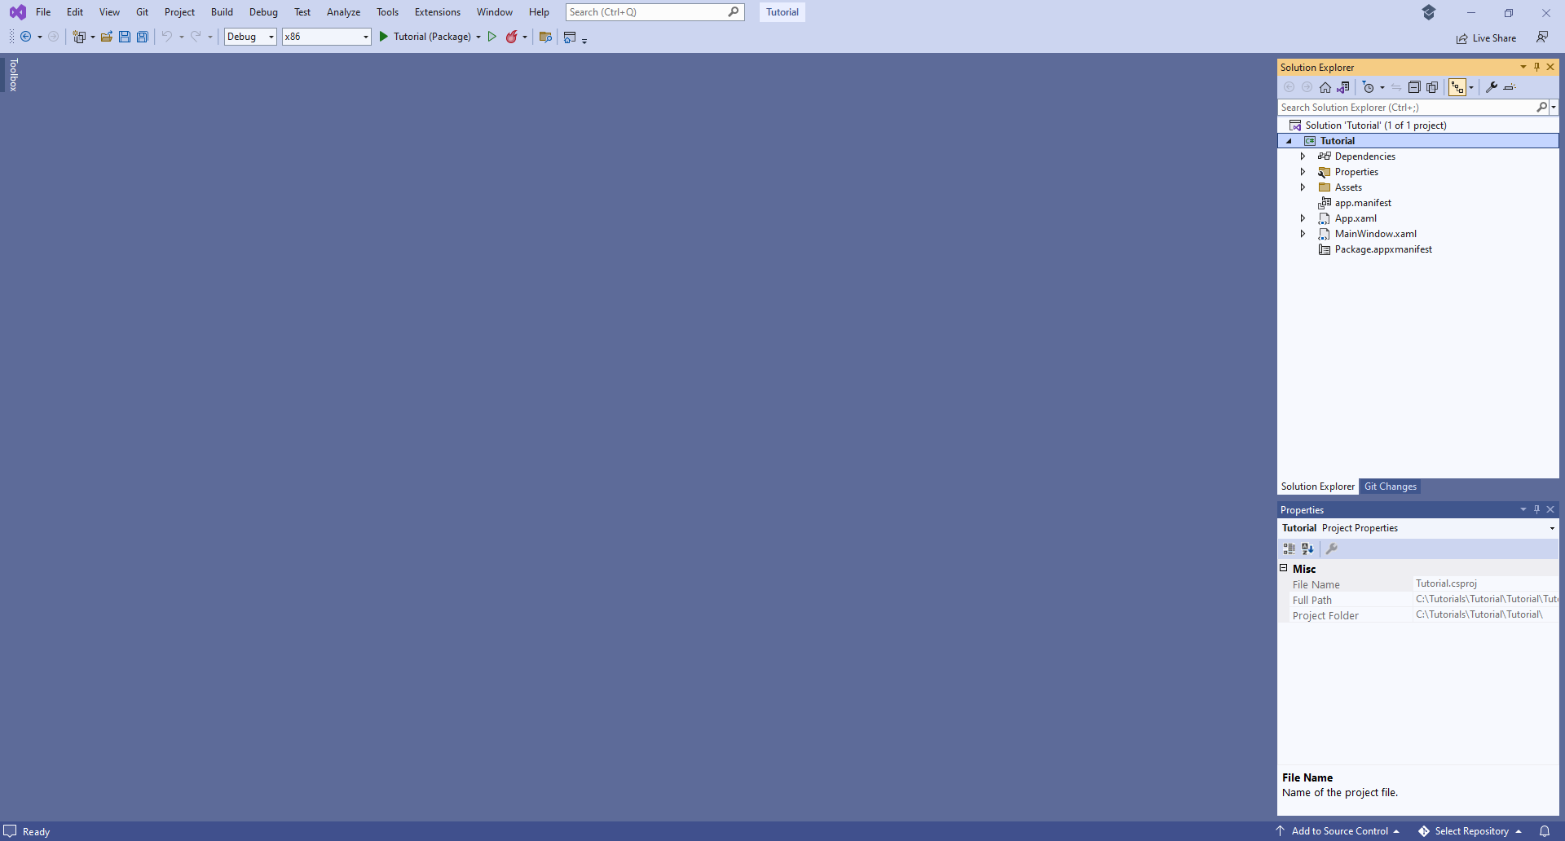

## Guide

**Visual Studio** has a **Menu** at the top of the **Window**, when you need to do something from the **Menu** this is where you need to do it and there is also a **Search** box to find commands if needed.



In **Visual Studio**, below the **Menu** is the **Toolbar** options include **Debug** which will Start your Application with the name of the Application along with other options including **Save**.



When your Application is **Running**, the **Toolbar** will change to include other options including **Stop**

to finish **Debugging** and **Close** your Application.



When a **Solution** has been opened or created in **Visual Studio** to then **Edit** or **Add** any **XAML** for the **Main Window** for your Application in **Visual Studio** from **Solution** **Explorer** double-click on **MainWindow.xaml** for the **XAML** of **Main Window**.

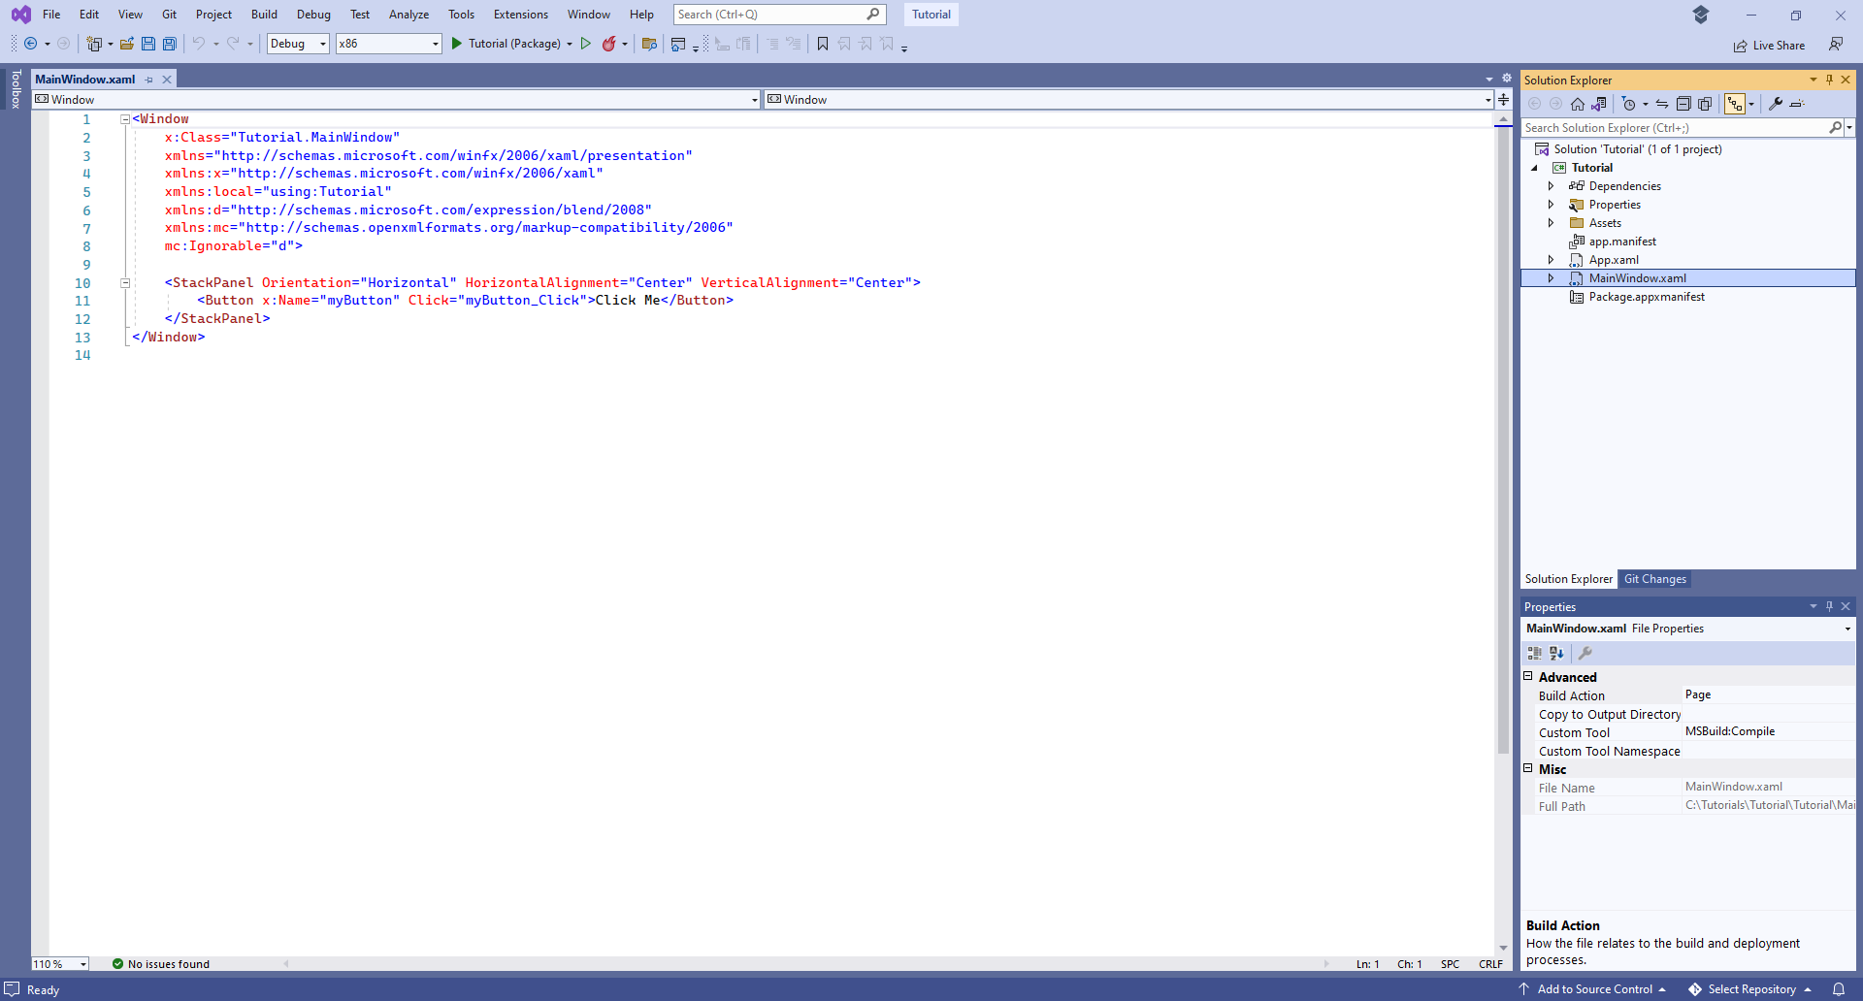

Then to **Edit** or **Add** any **Code** for the **Main Window** for your Application, from **Solution** **Explorer** select the arrow next to **MainWindow.xaml** to reveal **MainWindow.xaml.cs** then double-click on it to for the **Code** for the **Main Window**.

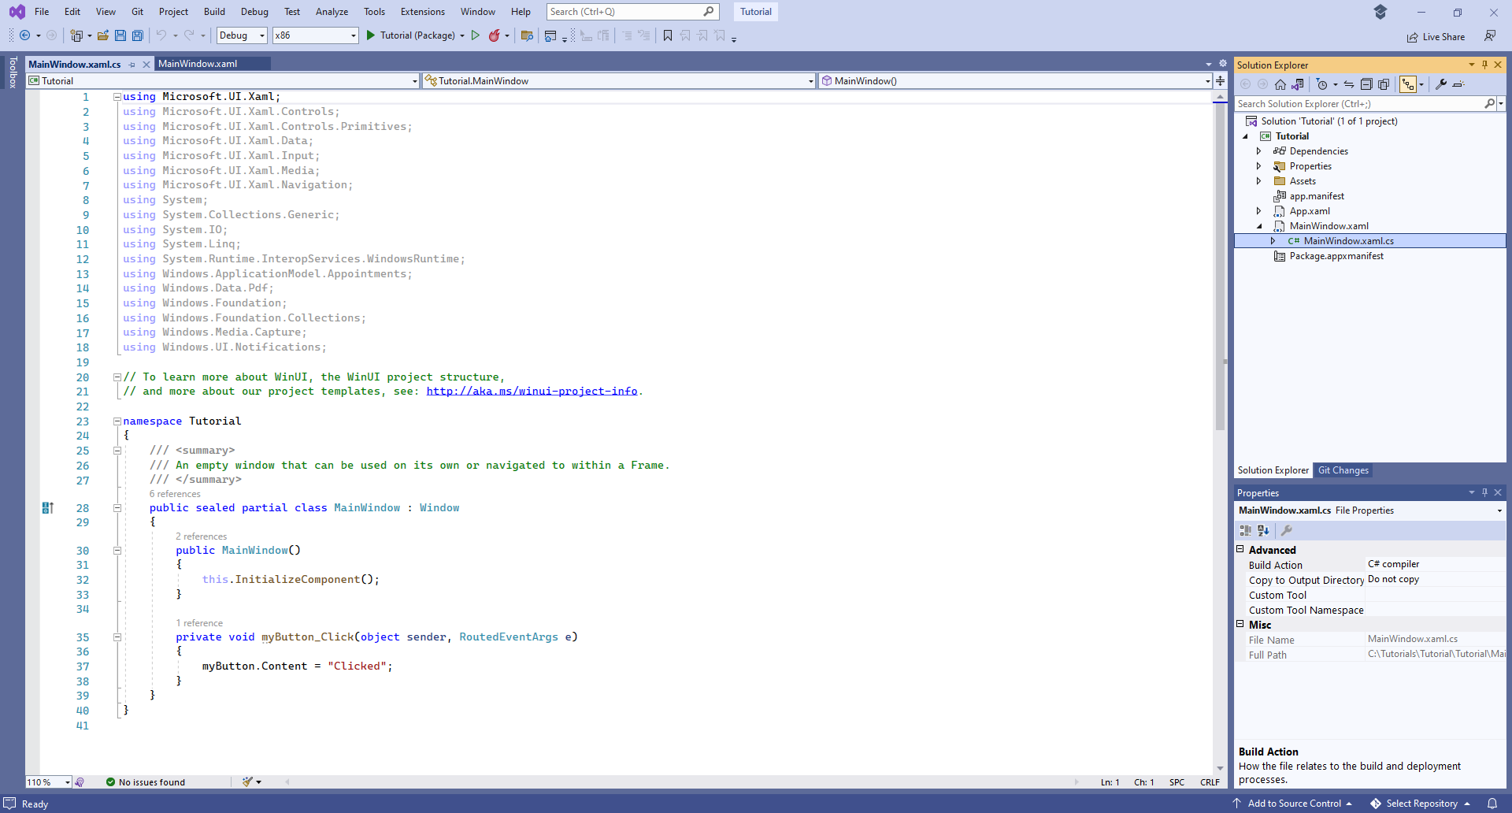

If you need to **Add** anything else to your Application, in **Visual Studio** from **Solution Explorer** right-click on the **Project** which is displayed under the **Solution** and then select the **Add** then **New Item…** option.

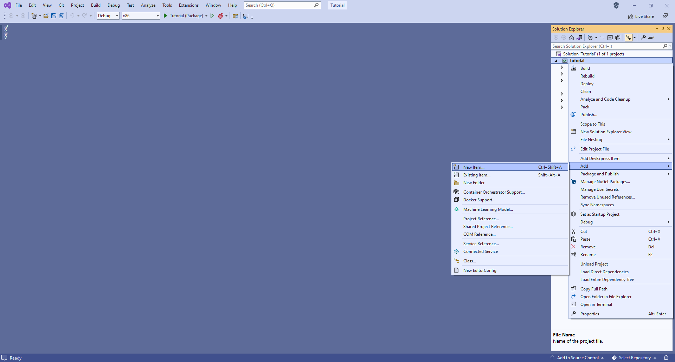

In **Add New Item** you could select **Code File** in **Code** for a **Class** such as *Library.cs* or a **Blank** **Page** in **WinUI**, and then select the **Add** to include this new item in your Application and that concludes this **Tutorial** for **Windows App SDK** from [tutorialr.com](https://tutorialr.com)!