

[](https://www.tutorialr.com/tutorials/)

Windows App SDK

Shade Effect





# Shade Effect

**Shade Effect** shows how you can use **DropShadow** with an element to create a **Shade Effect** in an

application using the **Windows App SDK**.

## Step 1

Follow **Setup and Start** on how to get **Setup** and **Install** what you need for **Visual Studio 2022** and **Windows App SDK**.

|  |  |
| --- | --- |
| In **Windows 11** choose **Start** and then find or search for **Visual Studio 2022** and then select it. |  |
| Once **Visual Studio 2022** has started select **Create a new project**. |  |
| Then choose the **Blank App, Packages (WinUI in Desktop)** and then select **Next**. |  |
| After that in **Configure your new project** type in the **Project name** as *ShadeEffect*, then select a Location and then select **Create** to start a new **Solution**. |  |

## Step 2

Then in **Visual Studio** within **Solution** **Explorer** for the **Solution**, right click on the **Project** shown below the **Solution** and then select **Add** then **New Item…**

## Step 3

Then in **Add New Item** from the **C# Items** list, select **Code** and then select **Code File** from the list next to this, then type in the name of *Library.cs* and then **Click** on **Add**.

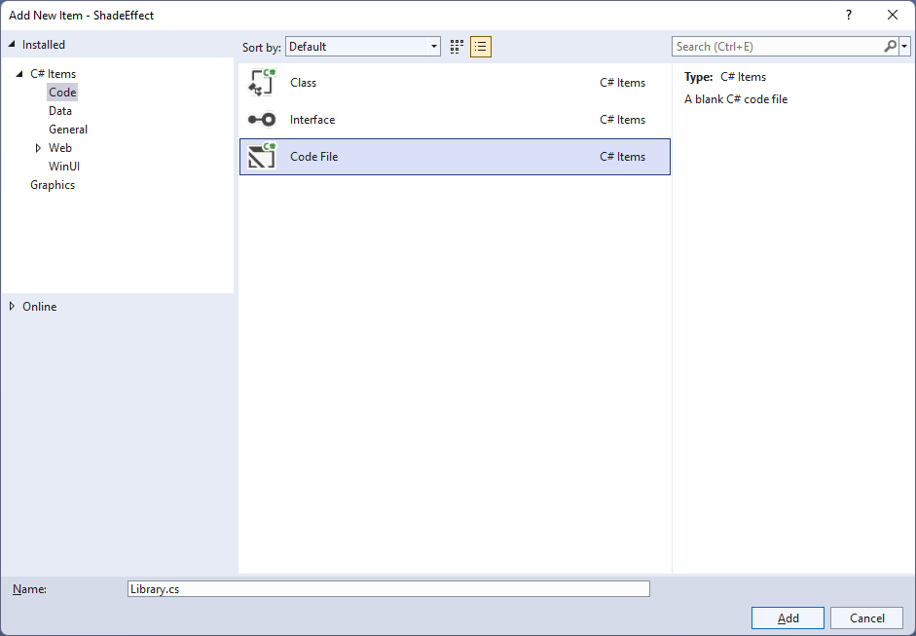

## Step 4

You will now be in the **View** for the **Code** of *Library.cs*, within this type the following **Code**:

using Microsoft.UI;

using Microsoft.UI.Composition;

using Microsoft.UI.Xaml;

using Microsoft.UI.Xaml.Hosting;

using Microsoft.UI.Xaml.Shapes;

internal class Library

{

private SpriteVisual _shade;

public void SetShade(Shape shape, FrameworkElement element)

{

var compositor = ElementCompositionPreview

.GetElementVisual(shape).Compositor;

_shade = compositor.CreateSpriteVisual();

_shade.Size = new System.Numerics.Vector2(

(float)shape.ActualWidth,

(float)shape.ActualHeight);

DropShadow shadow = compositor.CreateDropShadow();

shadow.Color = Colors.Black;

shadow.Offset = new System.Numerics.Vector3(10, 10, 0);

shadow.Mask = shape.GetAlphaMask();

_shade.Shadow = shadow;

ElementCompositionPreview.SetElementChildVisual(element, _shade);

}

public void ClearShade()

{

if (_shade != null)

_shade.Shadow = null;

}

}

The **Class** that has been defined in *Library.cs* has a **Member** for a **SpriteVisual** then there is a **Method** of **SetShade** which will create a **Shadow Effect** for a **Shape** in a **FrameworkElement** by first creating a **Compositor** with **ElementCompositionPreview** you’ll also notice the use of **var**, which means the type of the value doesn’t need to be explicitly specified, instead it will be **Inferred**. Then a **Compositor** is used with **CreateSpriteVisual** is configured where various values are set for a **DropShadow** to display it as needed as a **Shadow** with the **SpriteVisual**. The other **Method** of **ClearShade** is used to remove the **Shade Effect** of the **DropShadow** from the **SpriteVisual**.

## Step 5

|  |  |
| --- | --- |
| Then from **Solution** **Explorer** for the **Solution** double-click on **MainWindow.xaml** to see the **XAML** for the **Main Window**. |  |

## Step 6

In the **XAML** for **MainWindow.xaml** there be some **XAML** for a **StackPanel**, this should be **Removed** by removing the following:

<StackPanel Orientation="Horizontal"

HorizontalAlignment="Center" VerticalAlignment="Center">

<Button x:Name="myButton" Click="myButton_Click">Click Me</Button>

</StackPanel>

## Step 7

While still in the **XAML** for **MainWindow.xaml** above **</Window>**, type in the following **XAML**:

<Grid>

<Viewbox Margin="25">

<Grid Margin="50" Height="400" Width="400">

<Border x:Name="ShadowElement"/>

<Rectangle Name="Display" Stretch="Uniform" Fill="#FF5c2d91"/>

</Grid>

</Viewbox>

<CommandBar Name="Options" VerticalAlignment="Bottom"

HorizontalAlignment="Stretch">

<AppBarButton Icon="Accept" Label="Accept" Click="Accept_Click"/>

<AppBarButton Icon="Cancel" Label="Clear" Click="Clear_Click"/>

</CommandBar>

</Grid>

This **XAML** features a **Grid** with a **ViewBox** which is used to **Scale** elements, then within this is a **Border** that will form the **Shade Effect** for the **Rectangle** which is a **FrameworkElement**. Then there is a **CommandBar** with an **AppBarButton** to apply the **Shade Effect** of *Accept* and another to remove it of *Clear*.

## Step 8

|  |  |
| --- | --- |
| Then, within **Solution** **Explorer** for the **Solution** select the arrow next to **MainWindow.xaml** then double-click on **MainWindow.xaml.cs** to see the **Code** for the **Main Window**. |  |

## Step 9

In the **Code** for **MainWindow.xaml.cs** there be a **Method** of **myButton_Click(...)** this should be **Removed** by removing the following:

private void myButton_Click(object sender, RoutedEventArgs e)

{

myButton.Content = "Clicked";

}

## Step 10

Once **myButton_Click(...)** has been removed, type in the following **Code** below the end of the **Constructor** of **public MainWindow() { ... }**:

private readonly Library _library = new();

private void Accept_Click(object sender, RoutedEventArgs e)

{

_library.SetShade(Display, ShadowElement);

}

private void Clear_Click(object sender, RoutedEventArgs e)

{

_library.ClearShade();

}

The **Method** of **Accept_Click** will call the **Method** within *Library.cs* of **SetShade** from an **Instance** of **Library** called **_library** created with **new()** and **Clear_Click** will call the **Method** of **ClearShade**.

## Step 11

|  |  |
| --- | --- |
| That completes the **Windows App SDK** application. In **Visual Studio 2022** from the **Toolbar** select **ShadeEffect (Package)** to **Start** the application. |  |

## Step 12

Once running you should see a **Rectangle** and **CommandBar** with the *Accept* and *Clear* options.

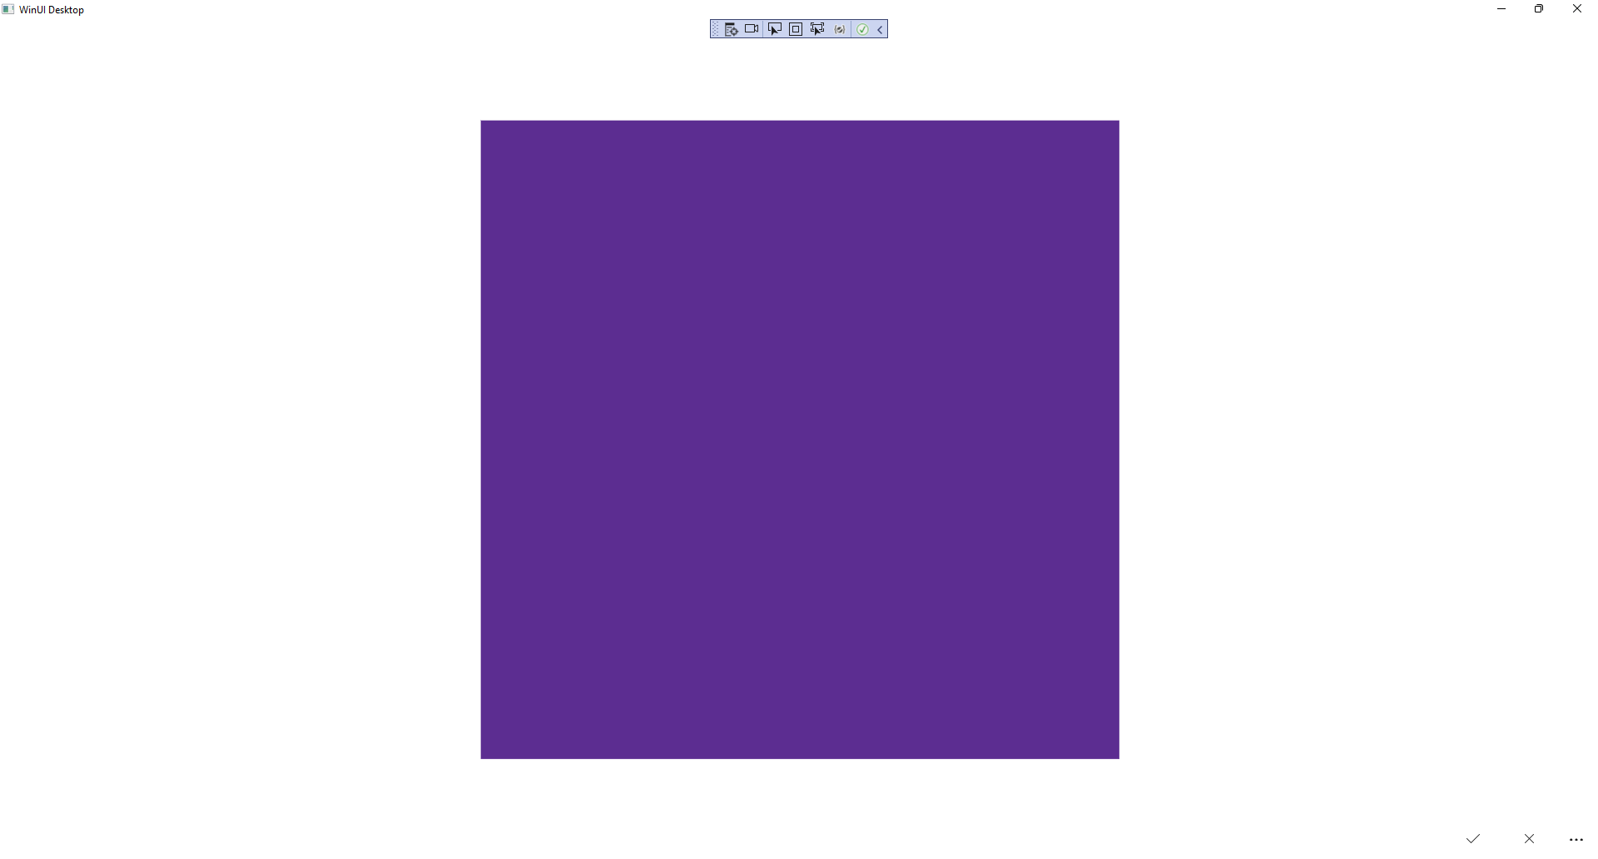

## Step 13

You can select *Apply* to set the **Shade Effect** and *Clear* to remove the **Shade Effect**

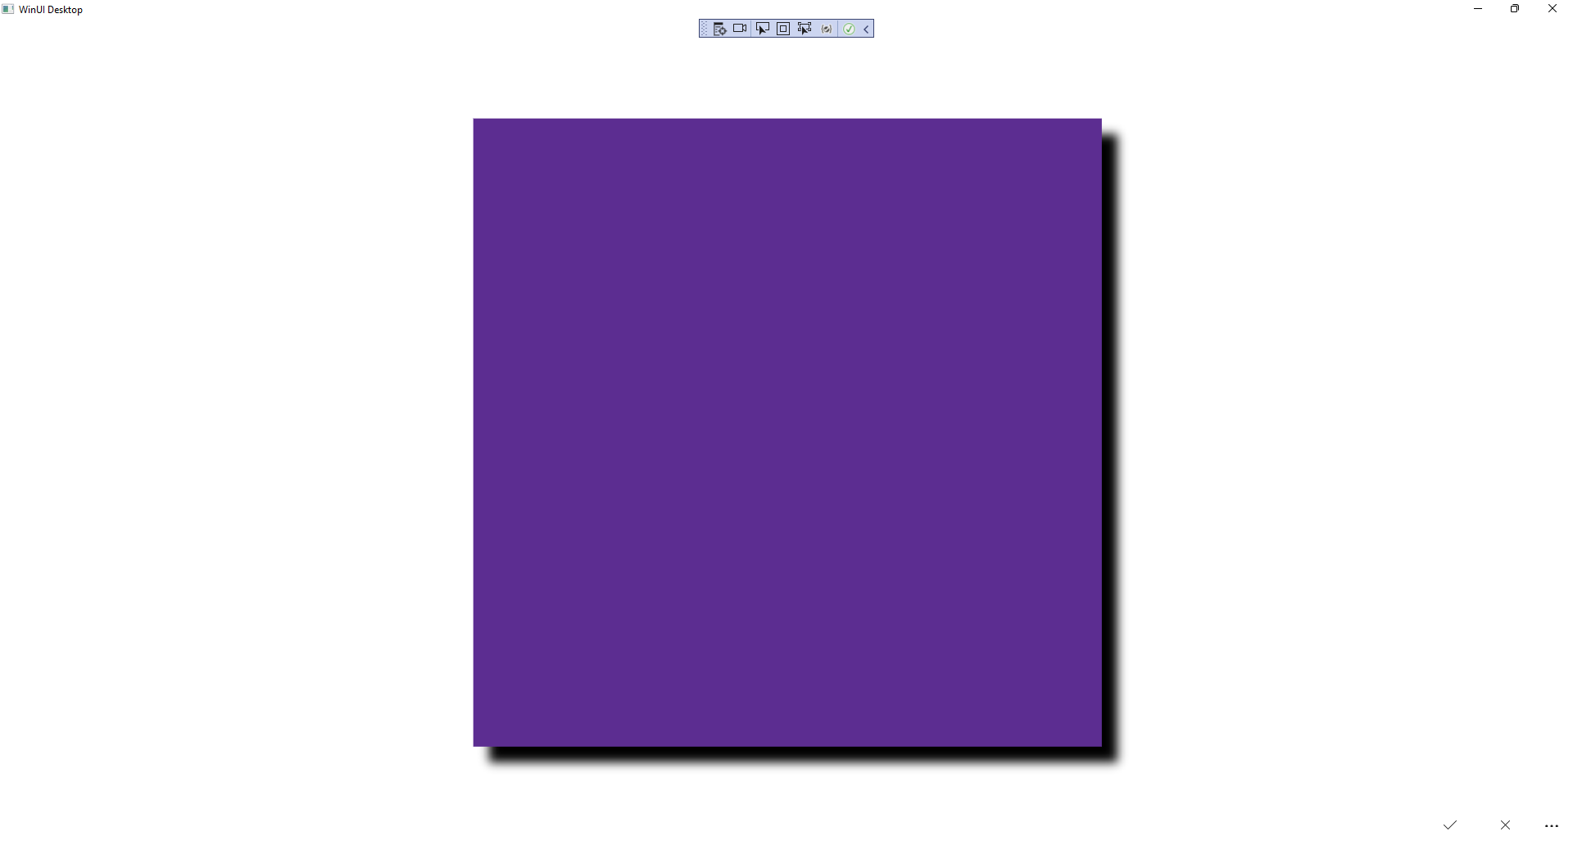

## Step 14

|  |  |
| --- | --- |
| To **Exit** the **Windows App SDK** application, select the **Close** button from the top right of the application as that concludes this **Tutorial** for **Windows App SDK** from [tutorialr.com](https://tutorialr.com)! |  |