

[](https://www.tutorialr.com/tutorials/)

Windows App SDK

Slide Game





# Slide Game

**Slide Game** shows how to create a game based on those sliding puzzle games where the objective is to

place all the numbers in descending numerical order by **Clicking** on a **Square** to move it into the empty

position using a toolkit from **NuGet** using the **Windows App SDK**.

## Step 1

Follow **Setup and Start** on how to get **Setup** and **Install** what you need for **Visual Studio 2022** and **Windows App SDK**.

|  |  |
| --- | --- |
| In **Windows 11** choose **Start** and then find or search for **Visual Studio 2022** and then select it. |  |
| Once **Visual Studio 2022** has started select **Create a new project**. |  |
| Then choose the **Blank App, Packages (WinUI in Desktop)** and then select **Next**. |  |
| After that in **Configure your new project** type in the **Project name** as *SlideGame*, then select a Location and then select **Create** to start a new **Solution**. |  |

## Step 2

Then in **Visual Studio** within **Solution** **Explorer** for the **Solution**, right click on the **Project** shown below the **Solution** and then select **Manage NuGet Packages…**

## Step 3

Then in the **NuGet Package Manager** from the **Browse** tab search for **Comentsys.Toolkit.WindowsAppSdk** and then select **Comentsys.Toolkit.WindowsAppSdk by Comentsys** as indicated and select **Install**

This will add the package for **Comentsys.Toolkit.WindowsAppSdk** to your **Project**. If you get the **Preview Changes** screen saying **Visual Studio is about to make changes to this solution. Click OK to proceed with the changes listed below.** You can read the message and then select **OK** to **Install** the package, then you can close the **tab** for **Nuget: SlideGame** by selecting the **x** next to it.

## Step 4

Then in **Visual Studio** within **Solution** **Explorer** for the **Solution**, right click on the **Project** shown below the **Solution** and then select **Add** then **New Item…**

## Step 5

Then in **Add New Item** from the **C# Items** list, select **Code** and then select **Code File** from the list next to this, then type in the name of *Library.cs* and then **Click** on **Add**.

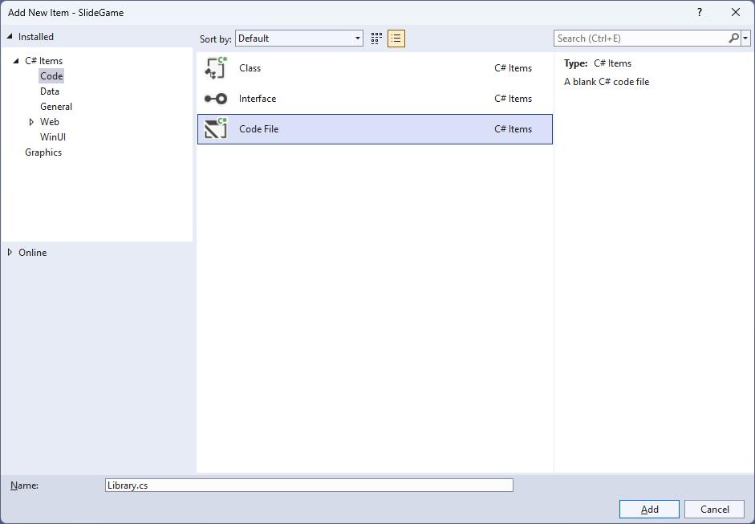

## Step 6

You will now be in the **View** for the **Code** of *Library.cs*, within this first type the following **Code**:

using Comentsys.Toolkit.WindowsAppSdk;

using Microsoft.UI;

using Microsoft.UI.Xaml.Controls;

using Microsoft.UI.Xaml.Input;

using Microsoft.UI.Xaml.Media;

using System;

using System.Collections.Generic;

using System.Linq;

namespace SlideGame;

public class Item : Piece

{

public Item(int row, int column, int index) =>

(Row, Column, Value) = (row, column, $"{index}");

public int Row { get; set; }

public int Column { get; set; }

}

public class Library

{

private const string title = "Slide Game";

private const int canvas_size = 400;

private const int size = 4;

private readonly Random _random = new((int)DateTime.UtcNow.Ticks);

private readonly int[,] _board = new int[size, size];

private Dialog _dialog;

private Canvas _canvas;

private int _moves;

private List<int> _values;

// Choose, IsValid & IsComplete

// Update & Move

// Play & Setup

// Layout & New

}

**Class** defined so far *Library.cs* has **using** for packageof **Comentsys.Toolkit.WindowsAppSdk** and others. It also has a **namespace** as it will contain multiple **Classes** although usually those are defined in separate files. *Library.cs* contains a **Class** for **Item** and for **Library** which has **Constants** to represent things needed in the game and there are **Variables** to keep track of values used in the game.

## Step 7

While still in the **Class** for *Library.cs* after the **Comment** of **// Choose, IsValid & IsComplete** type the following **Methods**:

private List<int> Choose(int minimum, int maximum, int total) =>

Enumerable.Range(minimum, maximum)

.OrderBy(r => _random.Next(minimum, maximum))

.Take(total).ToList();

private bool IsValid(int row, int column) =>

row >= 0 && column >= 0 && row <= 3 &&

column <= 3 && _board[row, column] == 0;

private bool IsComplete()

{

int previous = _board[0, 0];

for (int row = 0; row < size; row++)

{

for (int column = 0; column < size; column++)

{

if (_board[row, column] < previous)

return false;

previous = _board[row, column];

}

}

return true;

}

**Choose** is used to produce a list of unique randomised numbers, **IsValid** will check if a position is acceptable and **IsComplete** will be used to check if the game has finished correctly.

## Step 8

While still in the **Class** for *Library.cs* after the **Comment** of **// Update & Move** type the following **Methods**:

private void Update()

{

_canvas.Children.Clear();

for (int row = 0; row < size; row++)

{

for (int column = 0; column < size; column++)

{

if (_board[row, column] > 0)

{

var index = _board[row, column];

var piece = new Item(row, column, index)

{

Foreground = new SolidColorBrush(Colors.White),

Fill = new SolidColorBrush(Colors.Black),

Height = _canvas.Height / size,

Width = _canvas.Width / size,

IsSquare = true

};

piece.PointerReleased += (object sender,

PointerRoutedEventArgs e) =>

Play(sender as Item);

Canvas.SetTop(piece, row * (_canvas.Width / size));

Canvas.SetLeft(piece, column * (_canvas.Width / size));

_canvas.Children.Add(piece);

}

}

}

}

private void Move(Item item, int row, int column)

{

_moves++;

_board[row, column] = _board[item.Row, item.Column];

_board[item.Row, item.Column] = 0;

item.Row = row;

item.Column = column;

Update();

if (IsComplete())

_dialog.Show($"Correct in {_moves} Moves");

}

**Update** is used to update the **Canvas** with the current position of the items and will use a **Method** of **Play** that will be defined in the next **Step** and **Move** is used to set the location of an **Item** and will use **Update** and will check if the game is finished using **IsComplete**.

## Step 9

While still in the **Class** for *Library.cs* after the **Comment** of **// Play & Setup** type the following **Methods**:

private void Play(Item item)

{

if (IsValid(item.Row - 1, item.Column))

Move(item, item.Row - 1, item.Column);

else if (IsValid(item.Row, item.Column + 1))

Move(item, item.Row, item.Column + 1);

else if (IsValid(item.Row + 1, item.Column))

Move(item, item.Row + 1, item.Column);

else if (IsValid(item.Row, item.Column - 1))

Move(item, item.Row, item.Column - 1);

}

public void Setup()

{

int index = 1;

_values = Choose(1, _board.Length - 1, _board.Length - 1);

_values.Insert(0, 0);

for (int row = 0; row < size; row++)

{

for (int column = 0; column < size; column++)

{

_board[row, column] = _values[index++];

if (index == size * size)

index = 0;

}

}

}

**Play** is used to position an **Item** and will use **IsValid** to check if the position is valid then use **Move** to place the **Item** in the position and **Setup** is used to initialise the game using **Choose**.

## Step 10

While still in the **Class** for *Library.cs* after the **Comment** of **// Layout & New** type the following **Methods**:

public void Layout(Grid grid)

{

grid.Children.Clear();

_canvas = new Canvas()

{

Height = canvas_size,

Width = canvas_size

};

grid.Children.Add(_canvas);

}

public void New(Grid grid)

{

_dialog = new Dialog(grid.XamlRoot, title);

Layout(grid);

Setup();

Update();

}

**Layout** will create the layout for the game with a **Canvas** and **New** will setup and start a new game.

## Step 11

|  |  |
| --- | --- |
| Then from **Solution** **Explorer** for the **Solution** double-click on **MainWindow.xaml** to see the **XAML** for the **Main Window**. |  |

## Step 12

In the **XAML** for **MainWindow.xaml** there be some **XAML** for a **StackPanel**, this should be **Removed** by removing the following:

<StackPanel Orientation="Horizontal"

HorizontalAlignment="Center" VerticalAlignment="Center">

<Button x:Name="myButton" Click="myButton_Click">Click Me</Button>

</StackPanel>

## Step 13

While still in the **XAML** for **MainWindow.xaml** above **</Window>**, type in the following **XAML**:

<Grid>

<Viewbox>

<Grid Margin="50" Name="Display"

HorizontalAlignment="Center"

VerticalAlignment="Center" Loaded="New"/>

</Viewbox>

<CommandBar VerticalAlignment="Bottom">

<AppBarButton Icon="Page2" Label="New" Click="New"/>

</CommandBar>

</Grid>

This **XAML** contains a **Grid** with a **Viewbox** which will scale a **Grid**. It has a **Loaded** event handler for **New** which is also shared by the **AppBarButton**.

## Step 14

|  |  |
| --- | --- |
| Then, within **Solution** **Explorer** for the **Solution** select the arrow next to **MainWindow.xaml** then double-click on **MainWindow.xaml.cs** to see the **Code** for the **Main Window**. |  |

## Step 15

In the **Code** for **MainWindow.xaml.cs** there be a **Method** of **myButton_Click(...)** this should be **Removed** by removing the following:

private void myButton_Click(object sender, RoutedEventArgs e)

{

myButton.Content = "Clicked";

}

## Step 16

Once **myButton_Click(...)** has been removed, type in the following **Code** below the end of the **Constructor** of **public MainWindow() { ... }**:

private readonly Library _library = new();

private void New(object sender, RoutedEventArgs e) =>

_library.New(Display);

Here an **Instance** of the **Class** of **Library** is created then below this is the **Method** of **New** that will be used with **Event Handler** from the **XAML**, this **Method** uses Arrow Syntax with the **=>** for an Expression Bodywhich is useful when a **Method** only has one line.

## Step 17

|  |  |
| --- | --- |
| That completes the **Windows App SDK** application. In **Visual Studio 2022** from the **Toolbar** select **SlideGame (Package)** to **Start** the application. |  |

## Step 18

Once running you win by putting all the numbers in **Order** from *1* to *15* from left to right by selecting the **Square** next to the the empty slot to move it into that slot and then continue until all the **Squares** are in the correct **Order** to complete the game, or you can select *New*to start a new game.

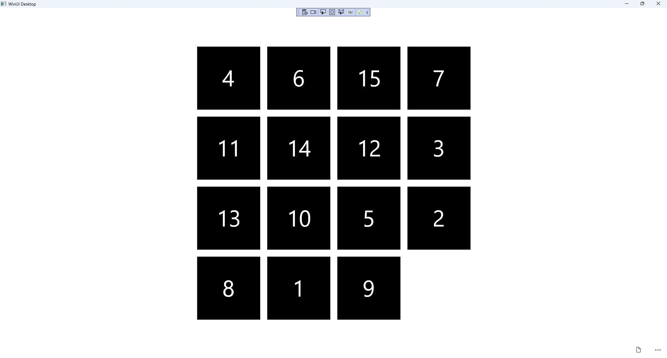

## Step 19

|  |  |
| --- | --- |
| To **Exit** the **Windows App SDK** application, select the **Close** button from the top right of the application as that concludes this **Tutorial** for **Windows App SDK** from [tutorialr.com](https://tutorialr.com)! |  |