

[](https://www.tutorialr.com/tutorials/)

Windows App SDK

Split Control





# Split Control

**Split Control** shows how to create a split-flap or **Flap** display using **Windows App SDK**

## Step 1

Follow **Setup and Start** on how to get **Setup** and **Install** what you need for **Visual Studio 2022** and **Windows App SDK**.

|  |  |
| --- | --- |
| In **Windows 11** choose **Start** and then find or search for **Visual Studio 2022** and then select it. |  |
| Once **Visual Studio 2022** has started select **Create a new project**. |  |
| Then choose the **Blank App, Packages (WinUI in Desktop)** and then select **Next**. |  |
| After that in **Configure your new project** type in the **Project name** as *SplitControl*, then select a Location and then select **Create** to start a new **Solution**. |  |

## Step 2

Then in **Visual Studio** within **Solution** **Explorer** for the **Solution**, right click on the **Project** shown below the **Solution** and then select **Add** then **New Item…**

## Step 3

Then in **Add New Item** from the **C# Items** list, select **Win UI** and then select **User Control (Win UI 3)** from the list next to this, then type in the name of *Flap.xaml* and then **Click** on **Add**.

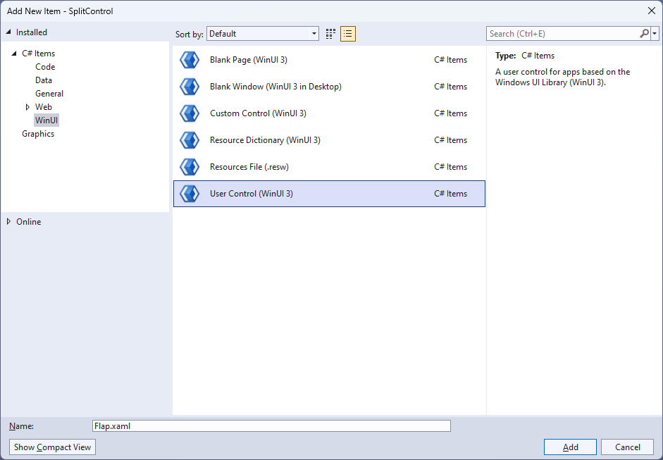

## Step 4

|  |  |
| --- | --- |
| Then from **Solution** **Explorer** for the **Solution** double-click on **Flip.xaml** to see the **XAML** for the **User Control**. |  |

## Step 5

In the **XAML** for *Flap.xaml* there be some **XAML** for a **Grid**, above **<Grid>**, type in the following **XAML**:

<UserControl.Resources>

<Style x:Key="SplitLabel" TargetType="TextBlock">

<Setter Property="FontFamily" Value="Arial"/>

<Setter Property="Foreground" Value="White"/>

<Setter Property="FontSize" Value="75"/>

</Style>

<Style x:Key="GridStyle" TargetType="Grid">

<Setter Property="CornerRadius" Value="4"/>

<Setter Property="Background" Value="White"/>

<Setter Property="BorderBrush" Value="Gray"/>

<Setter Property="BorderThickness" Value="1,1,1,1"/>

</Style>

<LinearGradientBrush x:Key="BackgroundBrush"

EndPoint="0.5,1" StartPoint="0.5,0">

<GradientStop Color="#FF202020" Offset="1"/>

<GradientStop Color="#FF404040"/>

</LinearGradientBrush>

<!-- Storyboard -->

</UserControl.Resources>

This is the start of the **Resources** which will control the **Style** of the **User Control**.

## Step 6

While still in the **XAML** for *Flap.xaml* below **<!-- Storyboard -->**, type in the following **XAML**:

<Storyboard x:Name="FlipAnimation">

<DoubleAnimationUsingKeyFrames Storyboard.TargetName="BlockFlip"

Storyboard.TargetProperty="(UIElement.RenderTransform).(TransformGroup.Children)[0].(ScaleTransform.ScaleY)">

<EasingDoubleKeyFrame Value="1" KeyTime="0">

<EasingDoubleKeyFrame.EasingFunction>

<BounceEase EasingMode="EaseOut" Bounces="1" Bounciness="6"/>

</EasingDoubleKeyFrame.EasingFunction>

</EasingDoubleKeyFrame>

<EasingDoubleKeyFrame Value="-1" KeyTime="00:00:00.250">

<EasingDoubleKeyFrame.EasingFunction>

<BounceEase EasingMode="EaseOut" Bounces="1" Bounciness="6"/>

</EasingDoubleKeyFrame.EasingFunction>

</EasingDoubleKeyFrame>

</DoubleAnimationUsingKeyFrames>

<ObjectAnimationUsingKeyFrames Storyboard.TargetName="TextBlockFlipTop"

Storyboard.TargetProperty="(UIElement.Visibility)">

<DiscreteObjectKeyFrame KeyTime="0">

<DiscreteObjectKeyFrame.Value>

<Visibility>Visible</Visibility>

</DiscreteObjectKeyFrame.Value>

</DiscreteObjectKeyFrame>

<DiscreteObjectKeyFrame KeyTime="00:00:00.125">

<DiscreteObjectKeyFrame.Value>

<Visibility>Collapsed</Visibility>

</DiscreteObjectKeyFrame.Value>

</DiscreteObjectKeyFrame>

</ObjectAnimationUsingKeyFrames>

<ObjectAnimationUsingKeyFrames Storyboard.TargetName="TextBlockFlipBottom"

Storyboard.TargetProperty="(UIElement.Visibility)">

<DiscreteObjectKeyFrame KeyTime="0">

<DiscreteObjectKeyFrame.Value>

<Visibility>Collapsed</Visibility>

</DiscreteObjectKeyFrame.Value>

</DiscreteObjectKeyFrame>

<DiscreteObjectKeyFrame KeyTime="00:00:00.125">

<DiscreteObjectKeyFrame.Value>

<Visibility>Visible</Visibility>

</DiscreteObjectKeyFrame.Value>

</DiscreteObjectKeyFrame>

</ObjectAnimationUsingKeyFrames>

</Storyboard>

This **Resource** is the **Storyboard** which contains the animations for the **User Control**.

## Step 7

While still in the **XAML** for *Flap.xaml* below **<Grid>**, type in the following **XAML**:

<Grid Height="80" Width="50">

<Grid.RowDefinitions>

<RowDefinition Height="0.5*"/>

<RowDefinition Height="0.5*"/>

</Grid.RowDefinitions>

<Grid x:Name="BlockTop" Grid.Row="0" Style="{StaticResource GridStyle}"

Background="{StaticResource BackgroundBrush}">

<TextBlock x:Name="TextBlockTop" Style="{StaticResource SplitLabel}"

HorizontalAlignment="Center" VerticalAlignment="Top" Margin="0,-2,0,0"/>

</Grid>

<Grid x:Name="BlockBottom" Grid.Row="1" Style="{StaticResource GridStyle}">

<Grid.Background>

<LinearGradientBrush EndPoint="0.5,1" StartPoint="0.5,0">

<GradientStop Color="#FF202020"/>

<GradientStop Color="#FF404040" Offset="1"/>

</LinearGradientBrush>

</Grid.Background>

<TextBlock x:Name="TextBlockBottom" Style="{StaticResource SplitLabel}"

HorizontalAlignment="Center" VerticalAlignment="Bottom"

RenderTransformOrigin="0.5,0.5" Margin="0,0,0,-4"/>

</Grid>

<Grid x:Name="BlockFlip" Style="{StaticResource GridStyle}"

Background="{StaticResource BackgroundBrush}" RenderTransformOrigin="0.5,1">

<Grid.RenderTransform>

<TransformGroup>

<ScaleTransform/>

<SkewTransform/>

<RotateTransform/>

<TranslateTransform/>

</TransformGroup>

</Grid.RenderTransform>

<TextBlock x:Name="TextBlockFlipTop" Style="{StaticResource SplitLabel}"

HorizontalAlignment="Center" VerticalAlignment="Top" Margin="0,-2,0,0"/>

<TextBlock x:Name="TextBlockFlipBottom" Style="{StaticResource SplitLabel}"

HorizontalAlignment="Center" VerticalAlignment="Bottom"

Visibility="Collapsed" RenderTransformOrigin="0.5,0.5" Margin="0,0,0,-4">

<TextBlock.RenderTransform>

<TransformGroup>

<ScaleTransform ScaleY="-1"/>

<SkewTransform/>

<RotateTransform/>

<TranslateTransform Y="40"/>

</TransformGroup>

</TextBlock.RenderTransform>

</TextBlock>

</Grid>

</Grid>

This **Grid** will represent the **Flap** of the **Split Control** with the parts to make the top and bottom parts along with the part which will flip over as part of the **User Control**.

## Step 8

|  |  |
| --- | --- |
| Then, within **Solution** **Explorer** for the **Solution** select the arrow next to **Flap.xaml** then double-click on **Flap.xaml.cs** to see the **Code** for the **User Control**. |  |

## Step 9

You will now be in the **View** for the **Code** of *Flap.xaml.cs* type in the following **Code** below the end of the **Constructor** of **public Flap() { ... }**:

private string _value;

private string _from;

public string Value

{

get { return _value; }

set

{

_value = value;

if (_from != null)

{

if (_from != value)

{

TextBlockTop.Text = TextBlockFlipBottom.Text = value;

TextBlockFlipTop.Text = _from;

FlipAnimation.Begin();

FlipAnimation.Completed -= (s, e) => { };

FlipAnimation.Completed += (s, e) =>

TextBlockBottom.Text = _from;

}

}

if (_from == null)

{

TextBlockFlipTop.Text = TextBlockBottom.Text = value;

}

_from = value;

}

}

The **class** for **Flip** represents the **User Control** for the **Flap** and includes a **Property** of **Value** which contains triggers for the animation of the **Storyboard** when set.

## Step 10

Then in **Visual Studio** within **Solution** **Explorer** for the **Solution**, right click on the **Project** shown below the **Solution** and then select **Add** then **New Item…**

## Step 11

Then in **Add New Item** from the **C# Items** list, select **Code** and then select **Code File** from the list next to this, then type in the name of *Split.cs* and then **Click** on **Add**.

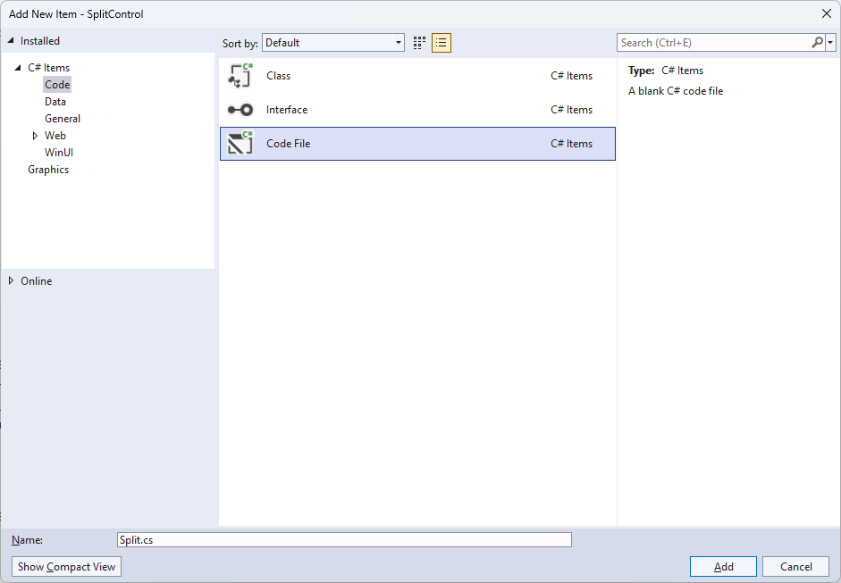

## Step 12

|  |  |
| --- | --- |
| Then from **Solution** **Explorer** for the **Solution** double-click on **Split.cs** to see the **Code** for the **User Control**. |  |

## Step 13

You will now be in the **View** for the **Code** of *Split.cs*, within this type in the following **Code**:

using Microsoft.UI.Xaml;

using Microsoft.UI.Xaml.Controls;

using System;

using System.Linq;

namespace SplitControl;

public enum Sources

{

Value, Time, Date, TimeDate

}

public class Split : StackPanel

{

// Constants, Members, Dependency Property & Property

// Set Element & Add Element Methods

// Add Layout Method & Value Property

// Constructor

}

There are **using** statements for this **User Control**, a **namespace** for **SplitControl** with an **enum** for the **Sources** of the **Split Control** along with a **class** of **Split** that will represent this **User Control**.

## Step 14

Then in the **namespace** of **SplitControl** in the **class** of **Split** after the **Comment** of **// Constants, Members, Dependency Property & Property** type the following **Constants**, **Members**, **Dependency Property** and **Property**.

private const char space = ' ';

private const string time = "HH mm ss";

private const string date = "dd MM yyyy";

private const string date_time = "HH mm ss dd MM yyyy";

private const string invalid_source = "Invalid argument";

private string _value;

private int _count;

public static readonly DependencyProperty SourceProperty =

DependencyProperty.Register(nameof(Source), typeof(Sources),

typeof(Split), new PropertyMetadata(Sources.Time));

public Sources Source

{

get { return (Sources)GetValue(SourceProperty); }

set { SetValue(SourceProperty, value); }

}

The **Constants** include formatsfor the *time* and*date* that can be displayed with the **Split Control** along with **Members** for the **Split Control** and a **Dependency Property** and **Property** for the **Source** to be used.

## Step 15

While still in the **namespace** of **SplitControl** in the **class** of **Split** after the **Comment** of **// Set Element & Add Element Methods** type the following **Methods**:

private void SetElement(string name, char glyph)

{

var element = Children.Cast<FrameworkElement>()

.FirstOrDefault(f => (string)f.Tag == name);

if (element is Flap flap)

{

flap.Value = glyph.ToString();

}

}

private void AddElement(string name)

{

FrameworkElement element = name == null

? new Canvas

{

Width = 5

}

: new Flap()

{

Tag = name

};

Children.Add(element);

}

The **Method** of **SetElement** will be used to set a **Flap** to a particular **Value** and **AddElement** will be used to either add a **Flap** or a **Canvas** for a *Space*.

## Step 16

While still in the **namespace** of **SplitControl** in the **class** of **Split** after the **Comment** of **// Add Layout Method & Value Property** type the following **Method** and **Property**:

private void AddLayout()

{

var array = _value.ToCharArray();

var length = array.Length;

var list = Enumerable.Range(0, length);

if (_count != length)

{

Children.Clear();

foreach (int item in list)

{

AddElement((array[item] == space)

? null : item.ToString());

}

_count = length;

}

foreach (int item in list)

{

SetElement(item.ToString(), array[item]);

}

}

public string Value

{

get { return _value; }

set { _value = value; AddLayout(); }

}

The **Method** of **AddLayout** creates the look-and-feel for the **User Control** and the **Property** of **Value** will setup the display of the **Split Control** using the **Method** of **AddLayout**.

## Step 17

While still in the **namespace** of **SplitControl** in the **class** of **Split** after the **Comment** of **// Constructor** type the following **Constructor**:

public Split()

{

Orientation = Orientation.Horizontal;

var timer = new DispatcherTimer()

{

Interval = TimeSpan.FromMilliseconds(250)

};

timer.Tick += (object s, object args) =>

{

if (Source != Sources.Value)

{

var format = Source switch

{

Sources.Time => time,

Sources.Date => date,

Sources.TimeDate => date_time,

_ => throw new ArgumentException(invalid_source)

};

Value = DateTime.Now.ToString(format);

}

};

timer.Start();

}

The **Constructor** will setup a **DispatcherTimer** to be used to display the **Value** of the **Split Control**.

## Step 18

|  |  |
| --- | --- |
| Within **Solution** **Explorer** for the **Solution** double-click on **MainWindow.xaml** to see the **XAML** for the **Main Window**. |  |

## Step 19

In the **XAML** for **MainWindow.xaml** there be some **XAML** for a **StackPanel**, this should be **Removed** by removing the following:

<StackPanel Orientation="Horizontal"

HorizontalAlignment="Center" VerticalAlignment="Center">

<Button x:Name="myButton" Click="myButton_Click">Click Me</Button>

</StackPanel>

## Step 20

While still in the **XAML** for **MainWindow.xaml** above **</Window>**, type in the following **XAML**:

<Viewbox>

<local:Split Padding="50" Source="Time"/>

</Viewbox>

This **XAML** contains a **ViewBox** including the **User Control** of **Split** with the **Source** set to **Time**.

## Step 21

|  |  |
| --- | --- |
| Then, within **Solution** **Explorer** for the **Solution** select the arrow next to **MainWindow.xaml** then double-click on **MainWindow.xaml.cs** to see the **Code** for the **Main Window**. |  |

## Step 22

In the **Code** for **MainWindow.xaml.cs** there be a **Method** of **myButton_Click(...)** this should be **Removed** by removing the following:

private void myButton_Click(object sender, RoutedEventArgs e)

{

myButton.Content = "Clicked";

}

## Step 23

|  |  |
| --- | --- |
| That completes the **Windows App SDK** application. In **Visual Studio 2022** from the **Toolbar** select **SplitControl (Package)** to **Start** the application. |  |

## Step 24

Once running you will see the **Flip Control** displaying the current *Time*.

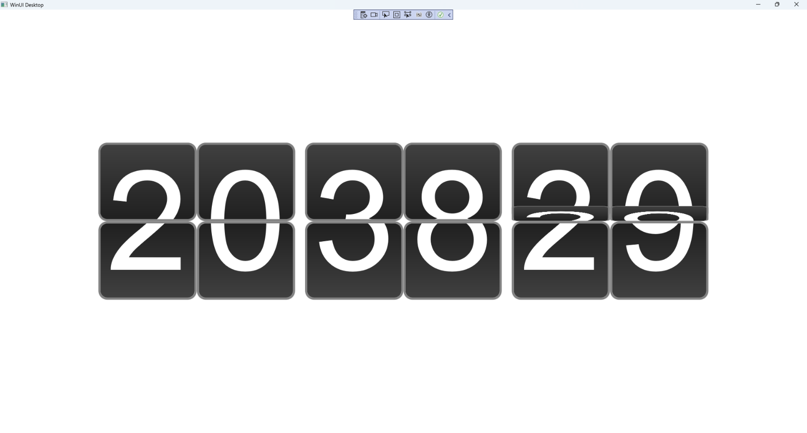

## Step 25

|  |  |
| --- | --- |
| To **Exit** the **Windows App SDK** application, select the **Close** button from the top right of the application as that concludes this **Tutorial** for **Windows App SDK** from [tutorialr.com](https://tutorialr.com)! |  |