

[](https://www.tutorialr.com/tutorials/)

Windows App SDK

Stick Control





# Stick Control

**Stick Control** shows how to create a **Directional Stick** that can be used for selecting an **Angle** and **Ratio** using **Windows App SDK**

## Step 1

Follow **Setup and Start** on how to get **Setup** and **Install** what you need for **Visual Studio 2022** and **Windows App SDK**.

|  |  |
| --- | --- |
| In **Windows 11** choose **Start** and then find or search for **Visual Studio 2022** and then select it. |  |
| Once **Visual Studio 2022** has started select **Create a new project**. |  |
| Then choose the **Blank App, Packages (WinUI in Desktop)** and then select **Next**. |  |
| After that in **Configure your new project** type in the **Project name** as *StickControl*, then select a Location and then select **Create** to start a new **Solution**. |  |

## Step 2

Then in **Visual Studio** within **Solution** **Explorer** for the **Solution**, right click on the **Project** shown below the **Solution** and then select **Add** then **New Item…**

## Step 3

Then in **Add New Item** from the **C# Items** list, select **Code** and then select **Code File** from the list next to this, then type in the name of *Stick.cs* and then **Click** on **Add**.

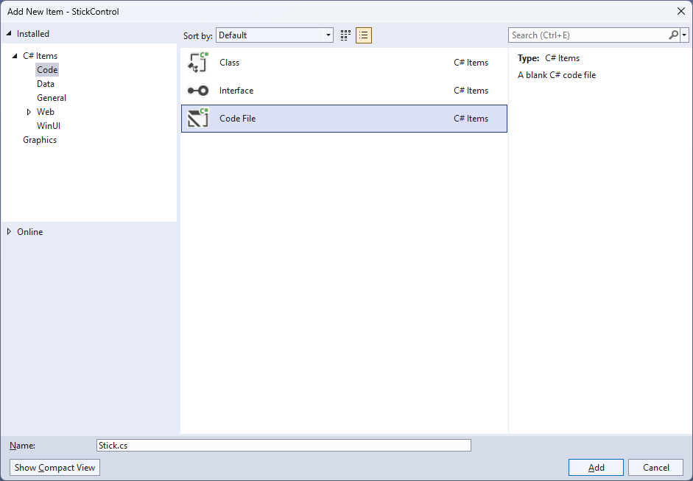

## Step 4

|  |  |
| --- | --- |
| Then from **Solution** **Explorer** for the **Solution** double-click on **Stick.cs** to see the **Code** for the **User Control**. |  |

## Step 5

You will now be in the **View** for the **Code** of *Stick.cs*, within this type in the following **Code**:

using Microsoft.UI;

using Microsoft.UI.Xaml;

using Microsoft.UI.Xaml.Controls;

using Microsoft.UI.Xaml.Data;

using Microsoft.UI.Xaml.Input;

using Microsoft.UI.Xaml.Media;

using Microsoft.UI.Xaml.Shapes;

using System;

namespace StickControl;

public class Stick : Grid

{

// Members & Event

// Dependency Properties

// Properties

// ToRadians, ToDegrees, SetMiddle, & GetCircle Methods

// Move Method

// Layout & Load Methods and Constructor

}

There are **using** statements for the **User Control**, a **namespace** for **StickControl** along with a **class** of **Stick** that will represent the **User Control** for the **Directional Stick**.

## Step 6

Then in the **namespace** of **StickControl** in the **class** of **Stick** after the **Comment** of **// Members & Event** type the following **Members** and **Event**:

private bool _capture;

private Ellipse _knob;

private Ellipse _face;

private double x = 0;

private double y = 0;

private double _m = 0;

private double _res = 0;

private double _width = 0;

private double _height = 0;

private double _alpha = 0;

private double _alphaM = 0;

private double _centreX = 0;

private double _centreY = 0;

private double _distance = 0;

private double _oldAlphaM = -999.0;

private double _oldDistance = -999.0;

public delegate void ValueChangedEventHandler(

object sender, double angle, double ratio);

public event ValueChangedEventHandler ValueChanged;

**Members** include **Ellipses** needed to represent the different directional parts of the **Directional Stick** and there is also a **delegate** along with an **event** for when the **Directional Stick** is interacted with.

## Step 7

While still in the **namespace** of **StickControl** in the **class** of **Stick** after the **Comment** of **// Dependency Properties** type the following **Dependency Properties**:

public static readonly DependencyProperty RadiusProperty =

DependencyProperty.Register(nameof(Radius), typeof(int),

typeof(Stick), new PropertyMetadata(100));

public static readonly DependencyProperty KnobProperty =

DependencyProperty.Register(nameof(Knob), typeof(Brush),

typeof(Stick), new PropertyMetadata(new SolidColorBrush(Colors.Red)));

public static readonly DependencyProperty FaceProperty =

DependencyProperty.Register(nameof(Face), typeof(Brush),

typeof(Stick), new PropertyMetadata(new SolidColorBrush(Colors.Black)));

public static readonly DependencyProperty AngleProperty =

DependencyProperty.Register(nameof(Angle), typeof(double),

typeof(Stick), null);

public static readonly DependencyProperty RatioProperty =

DependencyProperty.Register(nameof(Ratio), typeof(double),

typeof(Stick), null);

public static readonly DependencyProperty SensitivityProperty =

DependencyProperty.Register(nameof(Sensitivity), typeof(double),

typeof(Stick), null);

There will also be some **Errors** as these refer to **Properties** that will be added in the next step.

These **Dependency Properties** refer to various **Properties** of the **Directional Stick** that can be customised for the **User Control**.

## Step 8

While still in the **namespace** of **StickControl** in the **class** of **Stick** after the **Comment** of **// Properties** type the following **Properties**:

public int Radius

{

get { return (int)GetValue(RadiusProperty); }

set { SetValue(RadiusProperty, value); Load(); }

}

public Brush Knob

{

get { return (Brush)GetValue(KnobProperty); }

set { SetValue(KnobProperty, value); }

}

public Brush Face

{

get { return (Brush)GetValue(FaceProperty); }

set { SetValue(FaceProperty, value); }

}

public double Angle

{

get { return (double)GetValue(AngleProperty); }

set { SetValue(AngleProperty, value); }

}

public double Ratio

{

get { return (double)GetValue(RatioProperty); }

set { SetValue(RatioProperty, value); }

}

public double Sensitivity

{

get { return (double)GetValue(SensitivityProperty); }

set { SetValue(SensitivityProperty, value); }

}

All previous **Errors** should now be resolved, however there will be just one for a **Method** of **Load** which will be resolved in a future step but if you are getting any others check any previous steps to see if you have missed anything.

These **Properties** are for values for the **User Control** such as the **Angle** or **Ratio** values for the **Directional Stick**.

## Step 9

While still in the **namespace** of **StickControl** in the **class** of **Stick** after the **Comment** of **// ToRadians, ToDegrees, SetMiddle, & GetCircle Methods** type the following **Methods**:

private static double ToRadians(double angle) =>

Math.PI * angle / 180.0;

private static double ToDegrees(double angle) =>

angle * (180.0 / Math.PI);

private void SetMiddle()

{

_capture = false;

Canvas.SetLeft(_knob, (Width - _width) / 2);

Canvas.SetTop(_knob, (Height - _height) / 2);

_centreX = Width / 2;

_centreY = Height / 2;

}

private Ellipse GetCircle(double dimension, string path)

{

var circle = new Ellipse()

{

Height = dimension,

Width = dimension

};

circle.SetBinding(Shape.FillProperty, new Binding()

{

Source = this,

Path = new PropertyPath(path),

Mode = BindingMode.TwoWay

});

return circle;

}

The **Methods** of **ToRadians** and **ToDegrees** will perform the relevant conversions, **SetMiddle** will determine the centre point of the **Directional Stick** and **GetCircle** will create an **Ellipse** with a **Binding** for the **Fill**.

## Step 10

While still in the **namespace** of **StickControl** in the **class** of **Stick** after the **Comment** of **// Move Method** type the following **Method**:

private void Move(PointerRoutedEventArgs e)

{

x = e.GetCurrentPoint(this).Position.X;

y = e.GetCurrentPoint(this).Position.Y;

_res = Math.Sqrt((x - _centreX) *

(x - _centreX) + (y - _centreY) * (y - _centreY));

_m = (y - _centreY) / (x - _centreX);

_alpha = ToDegrees(Math.Atan(_m) + Math.PI / 2);

if (x < _centreX)

_alpha += 180.0;

else if (x == _centreX && y <= _centreY)

_alpha = 0.0;

else if (x == _centreX)

_alpha = 180.0;

if (_res > Radius)

{

x = _centreX + Math.Cos(ToRadians(_alpha) - Math.PI / 2) * Radius;

y = _centreY + Math.Sin(ToRadians(_alpha) - Math.PI / 2) * Radius

* ((_alpha % 180.0 == 0.0) ? -1.0 : 1.0);

_res = Radius;

}

if (Math.Abs(_alpha - _alphaM) >= Sensitivity ||

Math.Abs(_distance * Radius - _res) >= Sensitivity)

{

_alphaM = _alpha;

_distance = _res / Radius;

}

if (_oldAlphaM != _alphaM ||

_oldDistance != _distance)

{

Angle = _alphaM;

Ratio = _distance;

_oldAlphaM = _alphaM;

_oldDistance = _distance;

ValueChanged?.Invoke(this, Angle, Ratio);

}

Canvas.SetLeft(_knob, x - _width / 2);

Canvas.SetTop(_knob, y - _height / 2);

}

The **Method** of **Move** will be used by the **Directional Stick** to determine the current **Angle** and **Ratio** along with raising the **Event** of **ValueChanged** with those values.

## Step 11

While still in the **namespace** of **StickControl** in the **class** of **Stick** after the **Comment** of **// Layout & Load Methods and Constructor** type the following **Methods** and **Constructor**:

private void Layout()

{

_knob = GetCircle(Radius, "Knob");

_face = GetCircle(Radius * 2, "Face");

_height = _knob.ActualHeight;

_width = _knob.ActualWidth;

Width = _width + Radius * 2;

Height = _height + Radius * 2;

SetMiddle();

PointerExited -= null;

PointerExited += (object sender, PointerRoutedEventArgs e) =>

SetMiddle();

_knob.PointerReleased += (object sender, PointerRoutedEventArgs e) =>

SetMiddle();

_knob.PointerPressed += (object sender, PointerRoutedEventArgs e) =>

_capture = true;

_knob.PointerMoved += (object sender, PointerRoutedEventArgs e) =>

{

if (_capture)

Move(e);

};

_knob.PointerExited += (object sender, PointerRoutedEventArgs e) =>

SetMiddle();

}

private void Load()

{

Layout();

Children.Clear();

Children.Add(_face);

var canvas = new Canvas()

{

Width = Width,

Height = Height

};

canvas.Children.Add(_knob);

Children.Add(canvas);

}

public Stick() => Load();

All **Errors** should now be resolved, if you continue to get them check any previous steps to see if you have missed anything.

The **Constructor** will be used to create the look-and-feel of the **User Control** and will use the **Method** of **Load** which will use the **Method** of **Layout** which will capture if the **User Control** is being interacted with.

## Step 12

|  |  |
| --- | --- |
| Within **Solution** **Explorer** for the **Solution** double-click on **MainWindow.xaml** to see the **XAML** for the **Main Window**. |  |

## Step 13

In the **XAML** for **MainWindow.xaml** there be some **XAML** for a **StackPanel**, this should be **Removed** by removing the following:

<StackPanel Orientation="Horizontal"

HorizontalAlignment="Center" VerticalAlignment="Center">

<Button x:Name="myButton" Click="myButton_Click">Click Me</Button>

</StackPanel>

## Step 14

While still in the **XAML** for **MainWindow.xaml** above **</Window>**, type in the following **XAML**:

<StackPanel VerticalAlignment="Center" HorizontalAlignment="Center">

<TextBlock Name="Label" HorizontalAlignment="Center"

Style="{StaticResource SubtitleTextBlockStyle}"/>

<local:Stick Radius="200" Knob="{ThemeResource AccentButtonBackground}"

Face="WhiteSmoke" ValueChanged="ValueChanged"/>

</StackPanel>

This **XAML** contains a **StackPanel** including a **TextBlock** and the **User Control** of **Stick** with the **Event** of **ValueChanged**.

## Step 15

|  |  |
| --- | --- |
| Then, within **Solution** **Explorer** for the **Solution** select the arrow next to **MainWindow.xaml** then double-click on **MainWindow.xaml.cs** to see the **Code** for the **Main Window**. |  |

## Step 16

In the **Code** for **MainWindow.xaml.cs** there be a **Method** of **myButton_Click(...)** this should be **Removed** by removing the following:

private void myButton_Click(object sender, RoutedEventArgs e)

{

myButton.Content = "Clicked";

}

## Step 17

Once **myButton_Click(...)** has been removed, type in the following **Code** below the end of the **Constructor** of **public MainWindow() { ... }**:

private void ValueChanged(object sender, double angle, double ratio) =>

Label.Text = $"Angle {angle}, Ratio {ratio}";

The **Method** of **ValueChanged** will be used with **Event Handler** from the **XAML** to display the selected **Angle** and **Ratio**, this **Method** uses Arrow Syntax with the **=>** for an Expression Bodywhich is useful when a **Method** only has one line.

## Step 18

|  |  |
| --- | --- |
| That completes the **Windows App SDK** application. In **Visual Studio 2022** from the **Toolbar** select **StickControl (Package)** to **Start** the application. |  |

## Step 19

Once running you will see the **Stick Control** displayed, then you can select and move the centre portion of the **Directional Stick** and can see the *Angle* around the centre, or the *Ratio* of the distance between the centre and the outside displayed.

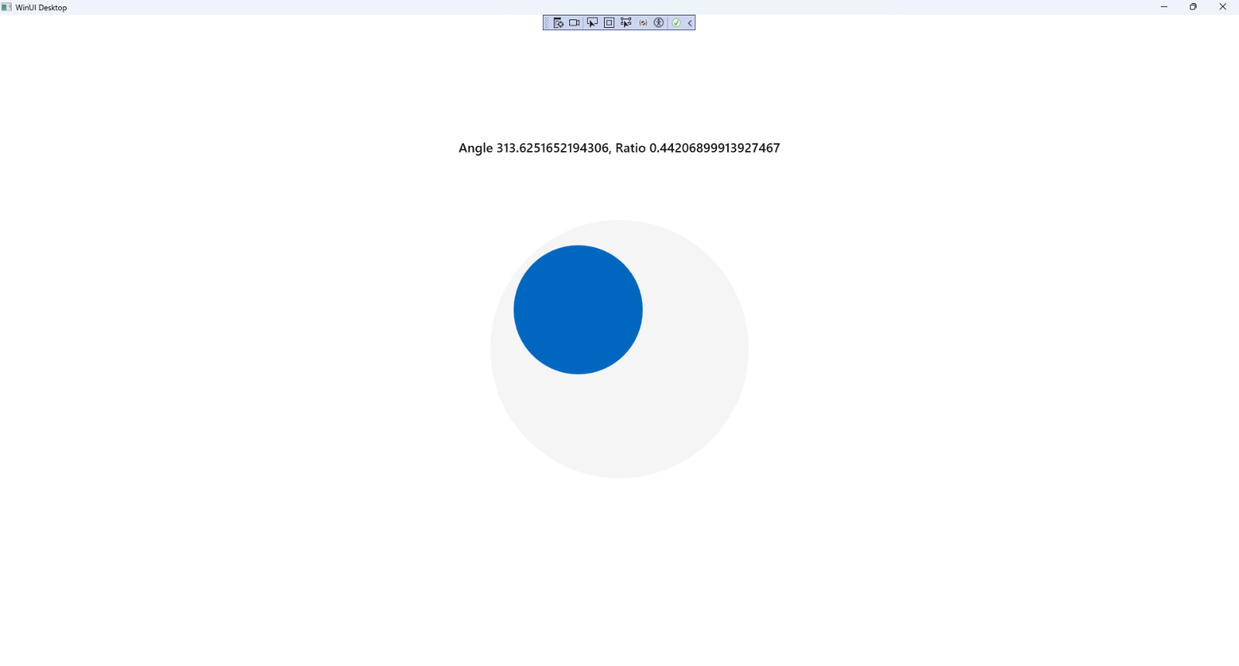

## Step 20

|  |  |
| --- | --- |
| To **Exit** the **Windows App SDK** application, select the **Close** button from the top right of the application as that concludes this **Tutorial** for **Windows App SDK** from [tutorialr.com](https://tutorialr.com)! |  |