

[](https://www.tutorialr.com/tutorials/)

Windows App SDK

System Backdrops





# System Backdrops

**System Backdrops** shows how you can use **SystemBackdrops** within the **Window** of an application using

the **Windows App SDK**.

## Step 1

Follow **Setup and Start** on how to get **Setup** and **Install** what you need for **Visual Studio 2022** and **Windows App SDK**.

|  |  |
| --- | --- |
| In **Windows 11** choose **Start** and then find or search for **Visual Studio 2022** and then select it. |  |
| Once **Visual Studio 2022** has started select **Create a new project**. |  |
| Then choose the **Blank App, Packages (WinUI in Desktop)** and then select **Next**. |  |
| After that in **Configure your new project** type in the **Project name** as *SystemBackdrops*, then select a Location and then select **Create** to start a new **Solution**. |  |

## Step 2

Then in **Visual Studio** within **Solution** **Explorer** for the **Solution**, right click on the **Project** shown below the **Solution** and then select **Add** then **New Item…**

## Step 3

Then in **Add New Item** from the **C# Items** list, select **Code** and then select **Code File** from the list next to this, then type in the name of *Library.cs* and then **Click** on **Add**.

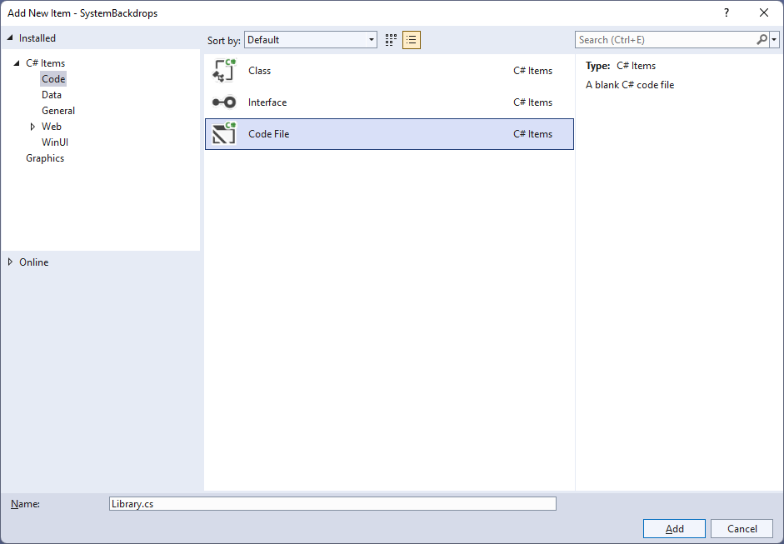

## Step 4

You will now be in the **View** for the **Code** of *Library.cs*, within this first type the following **Code**:

using Microsoft.UI.Composition;

using Microsoft.UI.Composition.SystemBackdrops;

using Microsoft.UI.Xaml;

using Microsoft.UI.Xaml.Controls;

using System.Runtime.InteropServices;

using Windows.System;

using WinRT;

internal class Library

{

private object _queue;

private ISystemBackdropControllerWithTargets _controller;

[StructLayout(LayoutKind.Sequential)]

struct DispatcherQueueOptions

{

internal int dwSize;

internal int threadType;

internal int apartmentType;

}

[DllImport("CoreMessaging.dll")]

private static extern int CreateDispatcherQueueController(

[In] DispatcherQueueOptions options,

[In, Out, MarshalAs(UnmanagedType.IUnknown)]

ref object dispatcherQueueController);

private void EnsureDispatcherQueueController()

{

if (DispatcherQueue.GetForCurrentThread() != null)

return;

if (_queue == null)

{

DispatcherQueueOptions options;

options.dwSize = Marshal.SizeOf(typeof(DispatcherQueueOptions));

options.threadType = 2; // DQTYPE_THREAD_CURRENT

options.apartmentType = 2; // DQTAT_COM_STA

_ = CreateDispatcherQueueController(options, ref _queue);

}

}

// Set Backdrop

}

The **Class** that has been defined so far in *Library.cs* has a **Member** for an **object** and an **Interface** of **ISystemBackdropControllerWithTargets** then there is some code to make the **System Backdrops** work correctly. There is a **struct** that will be used with the **Method** which will use a **DllImport** for some **Unmanaged Code** that is part of the **API** for **Windows** to use **CreateDispatcherQueueController**. This is called from the **Method** which will configure a **DispatcherQueue** which will ensure the **System Backdrops** work as needed of **EnsureDispatcherQueueController**.

## Step 5

While still in the **Class** for *Library.cs* and after the **Comment** of **// Set Backdrop** type in the following **Method**:

public void SetBackdrop(Window window, ComboBox options)

{

if (_controller != null)

_controller.Dispose();

EnsureDispatcherQueueController();

string value = (options.SelectedItem as ComboBoxItem).Content as string;

switch (value)

{

case "Acrylic":

if (DesktopAcrylicController.IsSupported())

{

_controller = new DesktopAcrylicController();

_controller.AddSystemBackdropTarget(

window.As<ICompositionSupportsSystemBackdrop>());

_controller.SetSystemBackdropConfiguration(

new SystemBackdropConfiguration());

}

break;

case "Mica":

if (MicaController.IsSupported())

{

_controller = new MicaController();

_controller.AddSystemBackdropTarget(

window.As<ICompositionSupportsSystemBackdrop>());

_controller.SetSystemBackdropConfiguration(

new SystemBackdropConfiguration());

}

break;

default:

_controller = null;

break;

}

}

This **Method** will check if **ISystemBackdropControllerWithTargets** has been set, or is not **null** then it will call the **Method** for **EnsureDispatcherQueueController** then it will get the value from the **ComboBox** that was passed in, then within a **switch** Statement, there is an option for *Acrylic*and *Mica* which is one of the **System Backdrops** that can be supported, to check this is supported the **Method** of **IsSupported()** of the **Class** of **DesktopAcrylicController** or **MicaController** is called, then the **Method** of **AddSystemBackdropTarget** and **SetSystemBackdropConfiguration** is used to apply the **System Backdrop** with **ISystemBackdropControllerWithTargets** to the **Window** that was passed in and the **default** option of the **switch** will set the **ISystemBackdropControllerWithTargets** to **null**.

## Step 6

|  |  |
| --- | --- |
| Then from **Solution** **Explorer** for the **Solution** double-click on **MainWindow.xaml** to see the **XAML** for the **Main Window**. |  |

## Step 7

In the **XAML** for **MainWindow.xaml** there be some **XAML** for a **StackPanel**, this should be **Removed** by removing the following:

<StackPanel Orientation="Horizontal"

HorizontalAlignment="Center" VerticalAlignment="Center">

<Button x:Name="myButton" Click="myButton_Click">Click Me</Button>

</StackPanel>

## Step 8

While still in the **XAML** for **MainWindow.xaml** above **</Window>**, type in the following **XAML**:

<Grid>

<Grid.RowDefinitions>

<RowDefinition Height="Auto"/>

<RowDefinition Height="*"/>

</Grid.RowDefinitions>

<ComboBox Grid.Row="0" Name="Options" Margin="25" HorizontalAlignment="Stretch"

SelectionChanged="Options_SelectionChanged">

<ComboBoxItem IsSelected="True">None</ComboBoxItem>

<ComboBoxItem>Acrylic</ComboBoxItem>

<ComboBoxItem>Mica</ComboBoxItem>

</ComboBox>

<Viewbox Grid.Row="1">

<StackPanel Spacing="5" Orientation="Horizontal"

HorizontalAlignment="Center">

<Rectangle Width="50" Height="50" Fill="Black"/>

<Rectangle Width="50" Height="50" Fill="Gray"/>

<Rectangle Width="50" Height="50" Fill="Red"/>

<Rectangle Width="50" Height="50" Fill="Orange"/>

<Rectangle Width="50" Height="50" Fill="Yellow"/>

<Rectangle Width="50" Height="50" Fill="Green"/>

<Rectangle Width="50" Height="50" Fill="Cyan"/>

<Rectangle Width="50" Height="50" Fill="Blue"/>

<Rectangle Width="50" Height="50" Fill="Magenta"/>

<Rectangle Width="50" Height="50" Fill="Purple"/>

</StackPanel>

</Viewbox>

</Grid>

This **XAML** features a **Grid** with two **Rows**, the first **Row** is for a **ComboBox** which contains the name of the **System Backdrops** and *None* that will be used to apply the selected **System Backdrop**. The second **Row** is a **ViewBox** which is used to **Scale** elements and in this is a **StackPanel** that contains **Rectangle** elements.

## Step 9

|  |  |
| --- | --- |
| Then, within **Solution** **Explorer** for the **Solution** select the arrow next to **MainWindow.xaml** then double-click on **MainWindow.xaml.cs** to see the **Code** for the **Main Window**. |  |

## Step 10

In the **Code** for **MainWindow.xaml.cs** there be a **Method** of **myButton_Click(...)** this should be **Removed** by removing the following:

private void myButton_Click(object sender, RoutedEventArgs e)

{

myButton.Content = "Clicked";

}

## Step 11

Once **myButton_Click(...)** has been removed, type in the following **Code** below the end of the **Constructor** of **public MainWindow() { ... }**:

private readonly Library _library = new();

private void Options_SelectionChanged(object sender, SelectionChangedEventArgs e)

{

_library.SetBackdrop(this, Options);

}

The **Method** of **Options_SelectionChanged** will call the **Method** within *Library.cs* of **SetBackdrop** from an **Instance** of **Library** called **_library** created with **new()** and will also pass in the current **Window** with the **Keyword** of **this** which will pass in the current **Instance** of the **Window**.

## Step 12

|  |  |
| --- | --- |
| That completes the **Windows App SDK** application. In **Visual Studio 2022** from the **Toolbar** select **SystemBackdrops (Package)** to **Start** the application. |  |

## Step 13

Once running you should a **Combobox** with **System Backdrop** options and some **Rectangle** elements.

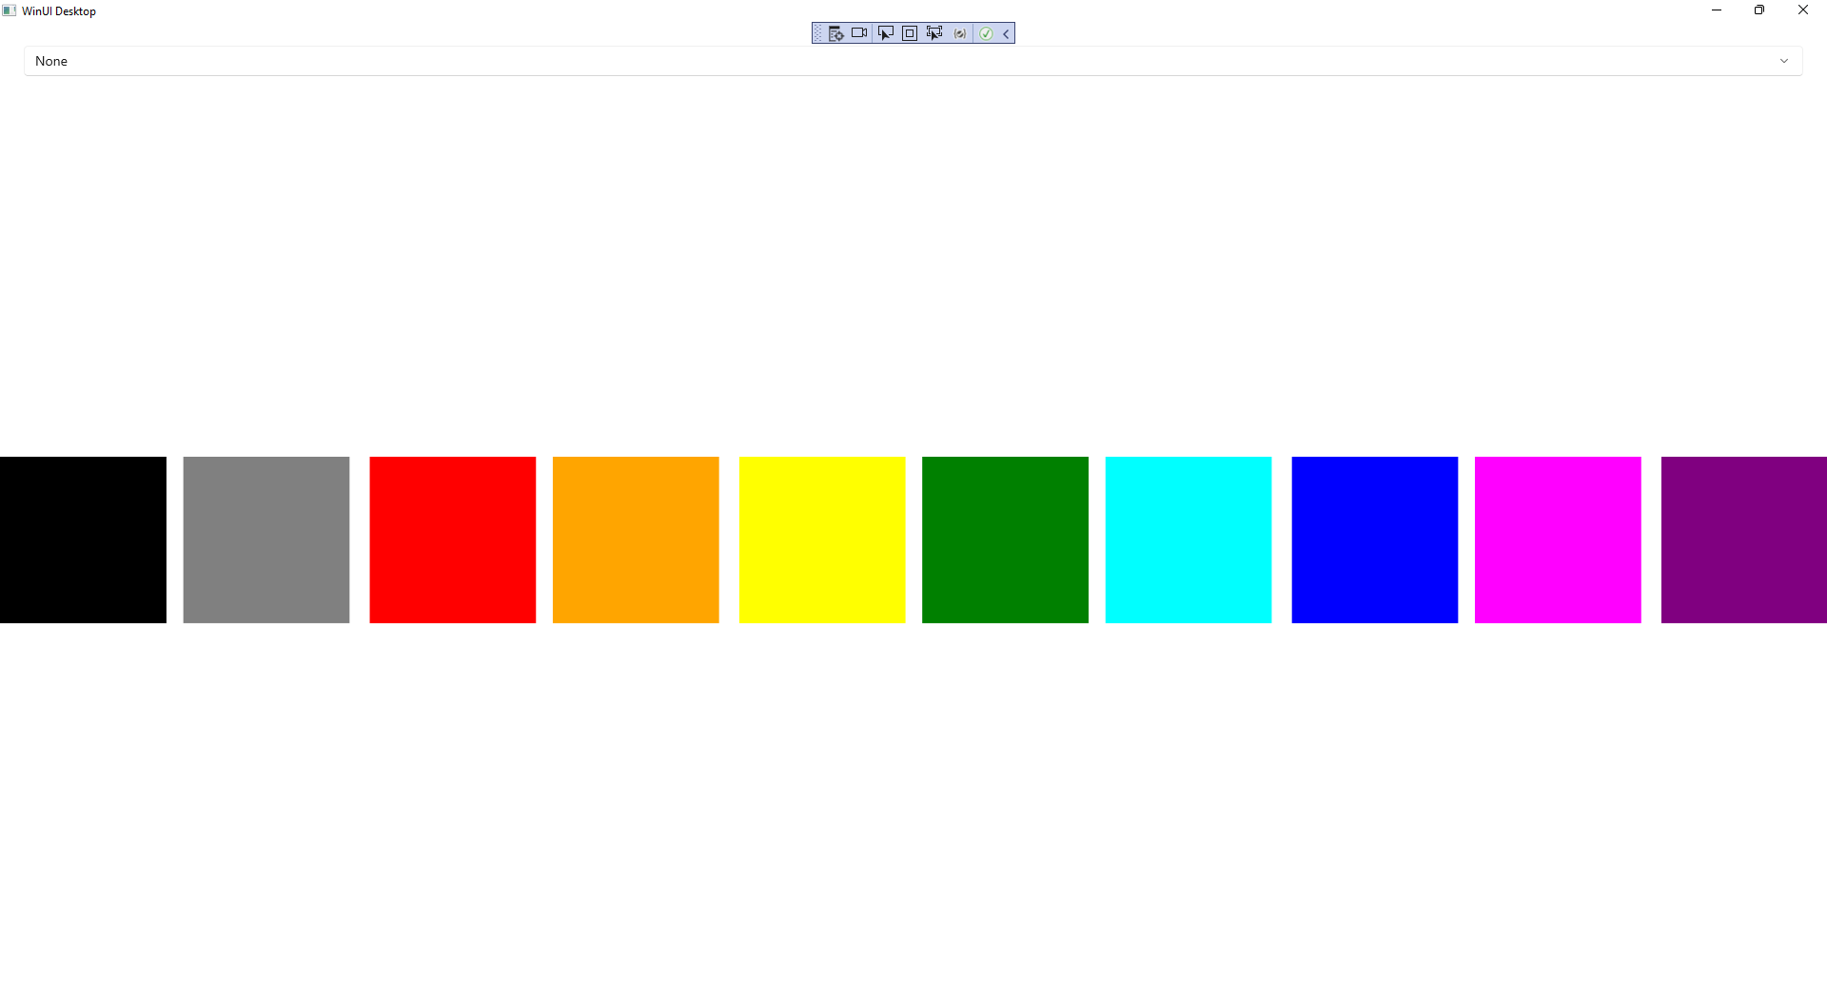

## Step 14

You can select one of the options of *Acrylic* or *Mica* to see the **System Backdrop** applied to the **Window** or you can select *None* to clear the **System Backdrop**.

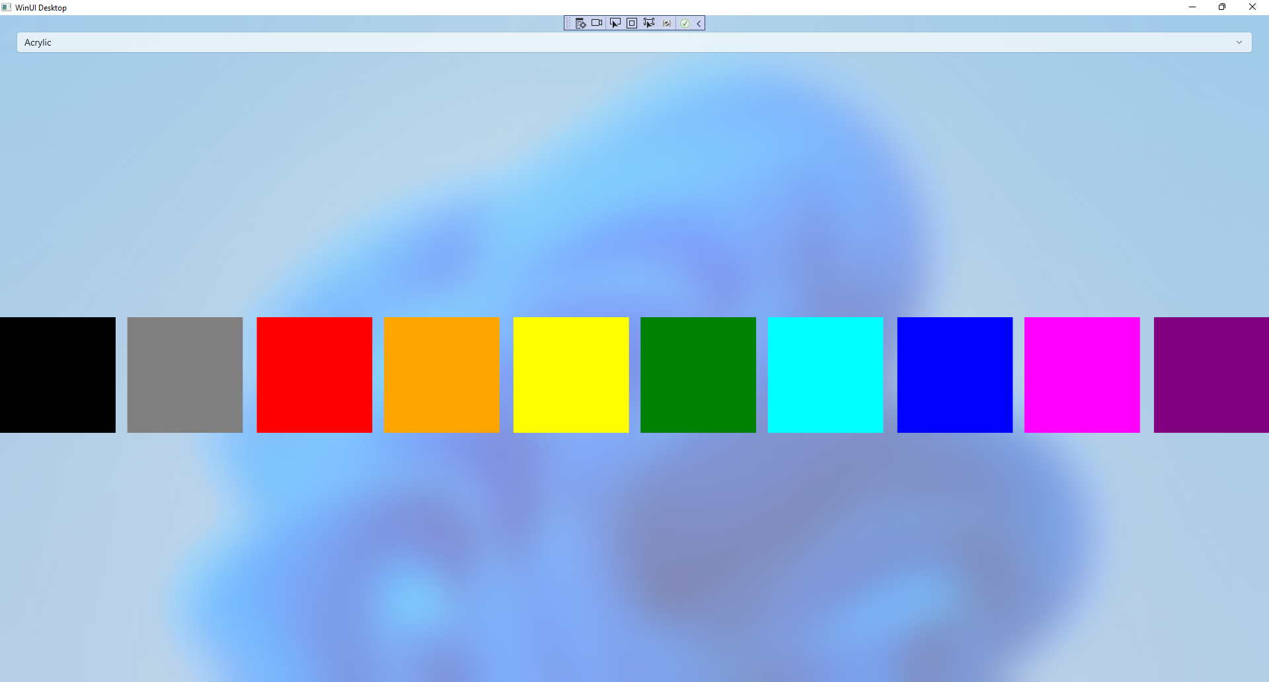

## Step 15

|  |  |
| --- | --- |
| To **Exit** the **Windows App SDK** application, select the **Close** button from the top right of the application as that concludes this **Tutorial** for **Windows App SDK** from [tutorialr.com](https://tutorialr.com)! |  |