

[](https://www.tutorialr.com/tutorials/)

Windows App SDK

Teaching Tip





# Teaching Tip

**Teaching Tip** shows how you can use **TeachingTip** with the **Windows App SDK** which is a **Control** that

can be used to provide contextual information combined with other elements such as the **CommandBar** to

help users understand an application.

## Step 1

Follow **Setup and Start** on how to get **Setup** and **Install** what you need for **Visual Studio 2022** and **Windows App SDK**.

|  |  |
| --- | --- |
| In **Windows 11** choose **Start** and then find or search for **Visual Studio 2022** and then select it. |  |
| Once **Visual Studio 2022** has started select **Create a new project**. |  |
| Then choose the **Blank App, Packages (WinUI in Desktop)** and then select **Next**. |  |
| After that in **Configure your new project** type in the **Project name** as *TeachingTip*, then select a Location and then select **Create** to start a new **Solution**. |  |

## Step 2

|  |  |
| --- | --- |
| Within **Solution** **Explorer** for the **Solution** and double-click on **MainWindow.xaml** to see the **XAML** for the **Main Window**. |  |

## Step 3

In the **XAML** for **MainWindow.xaml** there be some **XAML** for a **StackPanel**, this should be **Removed** by removing the following:

<StackPanel Orientation="Horizontal"

HorizontalAlignment="Center" VerticalAlignment="Center">

<Button x:Name="myButton" Click="myButton_Click">Click Me</Button>

</StackPanel>

## Step 4

While still in the **XAML** for **MainWindow.xaml** above **</Window>**, type in the following **XAML**:

<Grid>

<TeachingTip Name="Display"

Title="Teaching Tip"

Subtitle="Show Teaching Tips in your Application">

<TeachingTip.IconSource>

<SymbolIconSource Symbol="Comment"/>

</TeachingTip.IconSource>

</TeachingTip>

<CommandBar IsOpen="True" IsSticky="True" VerticalAlignment="Bottom">

<AppBarButton Name="Tip" Icon="Comment" Label="Tip" Click="Tip_Click"/>

</CommandBar>

</Grid>

This **XAML** features a **Grid** containing the **TeachingTip** with the **Title** and **Subtitle** set to some content, along with the use of an **IconSource** to be displayed in the **TeachingTip**, which will be used with the **CommandBar** which has a single **AppBarButton** with the **Label** of *Tip*, that will be used to show the **TeachingTip** in the **Method** of **Tip_Click** when it is **Clicked**.

## Step 5

|  |  |
| --- | --- |
| Then, within **Solution** **Explorer** for the **Solution** select the arrow next to **MainWindow.xaml** then double-click on **MainWindow.xaml.cs** to see the **Code** for the **Main Window**. |  |

## Step 6

In the **Code** for **MainWindow.xaml.cs** there be a **Method** of **myButton_Click(...)** this should be **Removed** by removing the following:

private void myButton_Click(object sender, RoutedEventArgs e)

{

myButton.Content = "Clicked";

}

## Step 7

Once **myButton_Click(...)** has been removed, below the end of **public MainWindow() { ... }** type in the following **Code**:

private void Tip_Click(object sender, RoutedEventArgs e)

{

Display.Target = Tip;

Display.IsOpen = true;

}

The **Method** of **Tip_Click** will be triggered by the **Event** of **Click** from the **AppBarButton** then all it does is set the **Target** of the **TeachingTip** to be the **AppBarButton** and to then show it by setting the **Property** of **IsOpen** to **true**.

## Step 8

|  |  |
| --- | --- |
| That completes the **Windows App SDK** Application. In **Visual Studio 2022** from the **Toolbar** select **TeachingTip (Package)** to **Start** the Application. |  |

## Step 9

Once running you should see the **CommandBar** with the **AppBarButton** with the **Label** of *Tip*.

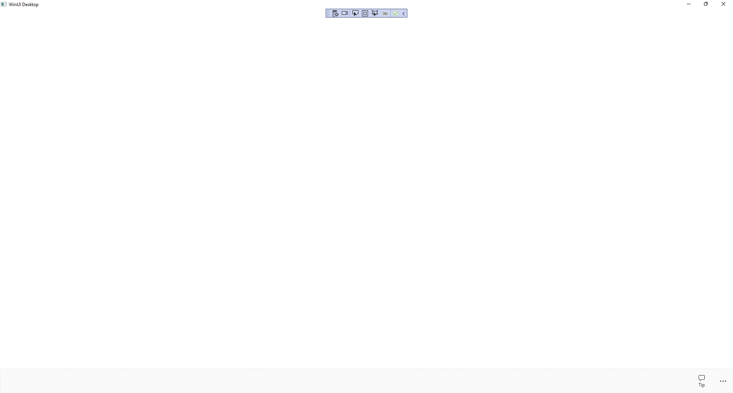

## Step 10

If you **Click** on the **AppBarButton** with the **Label** of *Tip* you will see the **TeachingTip** displayed which can be closed with the **Close** button in the top-right of the **TeachingTip**.

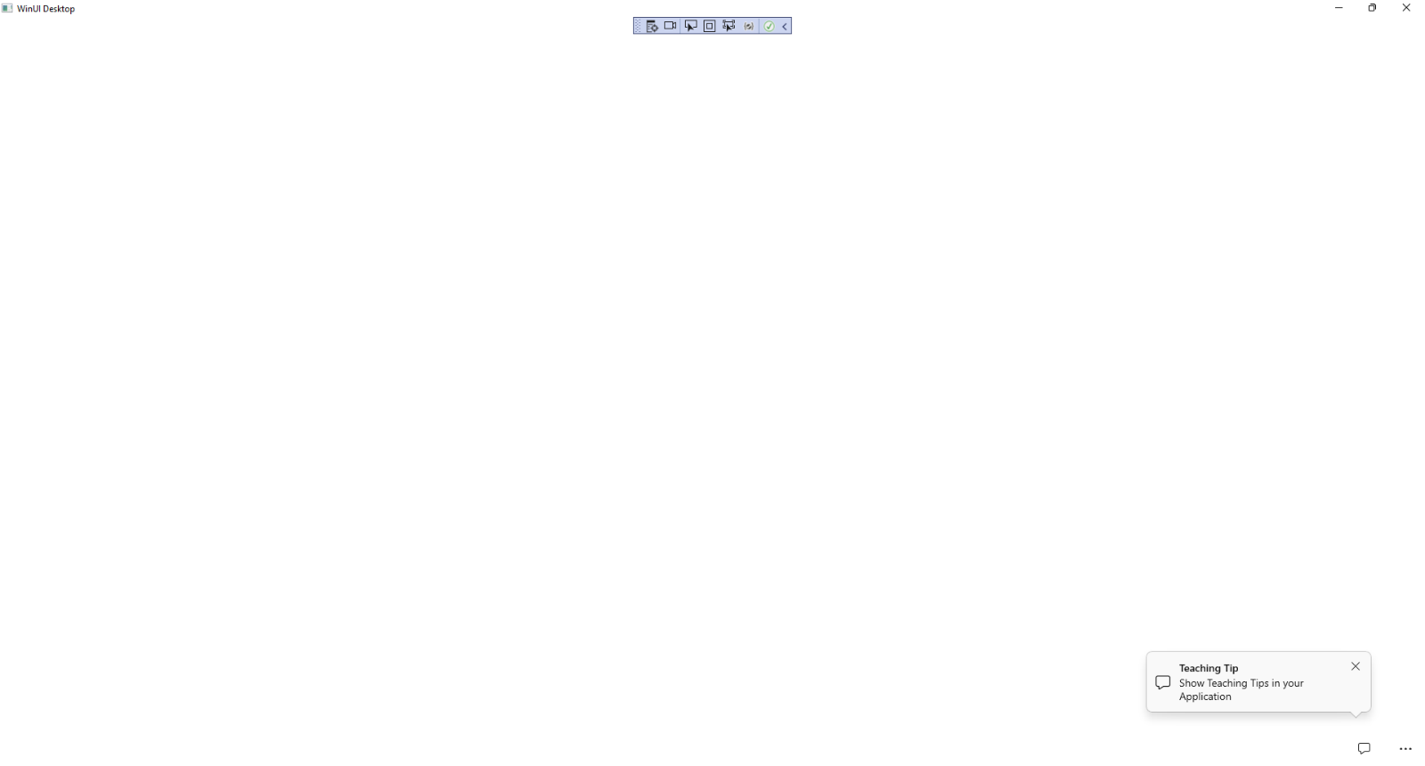

## Step 11

|  |  |
| --- | --- |
| To **Exit** the **Windows App SDK** application, select the **Close** button from the top right of the application as that concludes this **Tutorial** for **Windows App SDK** from [tutorialr.com](https://tutorialr.com)! |  |