

[](https://www.tutorialr.com/tutorials/)

Windows App SDK

Theme Transition





# Theme Transition

**Theme Transition** shows how you can create **Transitions** that apply to elements within an application

using the **Windows App SDK**.

## Step 1

Follow **Setup and Start** on how to get **Setup** and **Install** what you need for **Visual Studio 2022** and **Windows App SDK**.

|  |  |
| --- | --- |
| In **Windows 11** choose **Start** and then find or search for **Visual Studio 2022** and then select it. |  |
| Once **Visual Studio 2022** has started select **Create a new project**. |  |
| Then choose the **Blank App, Packages (WinUI in Desktop)** and then select **Next**. |  |
| After that in **Configure your new project** type in the **Project name** as *ThemeTransition*, then select a Location and then select **Create** to start a new **Solution**. |  |

## Step 2

Then in **Visual Studio** within **Solution** **Explorer** for the **Solution**, right click on the **Project** shown below the **Solution** and then select **Add** then **New Item…**

## Step 3

Then in **Add New Item** from the **C# Items** list, select **Code** and then select **Code File** from the list next to this, then type in the name of *Library.cs* and then **Click** on **Add**.

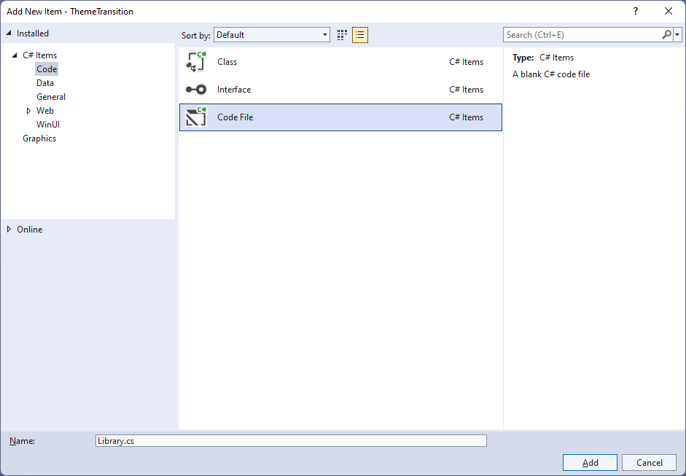

## Step 4

You will now be in the **View** for the **Code** of *Library.cs*, within this type the following **Code**:

using Microsoft.UI;

using Microsoft.UI.Xaml.Controls;

using Microsoft.UI.Xaml.Media;

using Microsoft.UI.Xaml.Shapes;

using System.Collections.Generic;

using System.Linq;

using Windows.UI;

internal class Library

{

private static readonly List<Color> _colours = new()

{

Colors.Black, Colors.Gray, Colors.Red, Colors.Orange, Colors.Yellow,

Colors.Green, Colors.Cyan, Colors.Blue, Colors.Magenta, Colors.Purple

};

private static int _index = 0;

public static void Add(StackPanel panel)

{

Rectangle previous = panel.Children.LastOrDefault() as Rectangle;

if(previous == null || _index == _colours.Count)

{

_index = 0;

}

panel.Children.Add(new Rectangle()

{

Width = 50,

Height = 50,

Fill = new SolidColorBrush(_colours[_index])

});

_index++;

}

public static void Remove(StackPanel panel)

{

int count = panel.Children.Count;

if (count > 0)

{

panel.Children.RemoveAt(count - 1);

}

}

}

The **Class** that has been defined in *Library.cs* has **List** of **Color** for the colours to use for elements along with an **int** value for keeping track of which one will be used. Then there is a **Method** of **Add**, which will add a **Rectangle** to a **StackPanel** with the given next colour to use and the **Method** of **Remove**, which will remove added **Rectangle** elements from a **StackPanel**.

## Step 5

|  |  |
| --- | --- |
| Then from **Solution** **Explorer** for the **Solution** double-click on **MainWindow.xaml** to see the **XAML** for the **Main Window**. |  |

## Step 6

In the **XAML** for **MainWindow.xaml** there be some **XAML** for a **StackPanel**, this should be **Removed** by removing the following:

<StackPanel Orientation="Horizontal"

HorizontalAlignment="Center" VerticalAlignment="Center">

<Button x:Name="myButton" Click="myButton_Click">Click Me</Button>

</StackPanel>

## Step 7

While still in the **XAML** for **MainWindow.xaml** above **</Window>**, type in the following **XAML**:

<Grid>

<Viewbox Margin="25">

<StackPanel Name="Display" Spacing="5"

Orientation="Horizontal" HorizontalAlignment="Center">

<StackPanel.ChildrenTransitions>

<TransitionCollection>

<EntranceThemeTransition IsStaggeringEnabled="True" />

</TransitionCollection>

</StackPanel.ChildrenTransitions>

</StackPanel>

</Viewbox>

<CommandBar VerticalAlignment="Bottom" HorizontalAlignment="Stretch" >

<AppBarButton Icon="Add" Label="Add" Click="Add_Click"/>

<AppBarButton Icon="Remove" Label="Remove" Click="Remove_Click"/>

</CommandBar>

</Grid>

This **XAML** features a **Grid** with a **ViewBox** to **Scale** elements and in this is a **StackPanel** which has the **Theme Transition** set for the **ChildrenTransitions** of **EntranceThemeTransition** with an **AppBarButton** to *Add* and *Remove* elements.

## Step 8

|  |  |
| --- | --- |
| Then, within **Solution** **Explorer** for the **Solution** select the arrow next to **MainWindow.xaml** then double-click on **MainWindow.xaml.cs** to see the **Code** for the **Main Window**. |  |

## Step 9

In the **Code** for **MainWindow.xaml.cs** there be a **Method** of **myButton_Click(...)** this should be **Removed** by removing the following:

private void myButton_Click(object sender, RoutedEventArgs e)

{

myButton.Content = "Clicked";

}

## Step 10

Once **myButton_Click(...)** has been removed, type in the following **Code** below the end of the **Constructor** of **public MainWindow() { ... }**:

private void Add_Click(object sender, RoutedEventArgs e)

{

Library.Add(Display);

}

private void Remove_Click(object sender, RoutedEventArgs e)

{

Library.Remove(Display);

}

The **Methods** of **Add_Click** and **Remove_Click** will when **Clicked** will call the **Methods** within *Library.cs* of **Add** and **Remove** from **Library** passing in the **StackPanel**.

## Step 11

|  |  |
| --- | --- |
| That completes the **Windows App SDK** application. In **Visual Studio 2022** from the **Toolbar** select **ThemeTransition (Package)** to **Start** the application. |  |

## Step 12

Once running you should see the **AppBarButton** for *Add* and *Remove*.

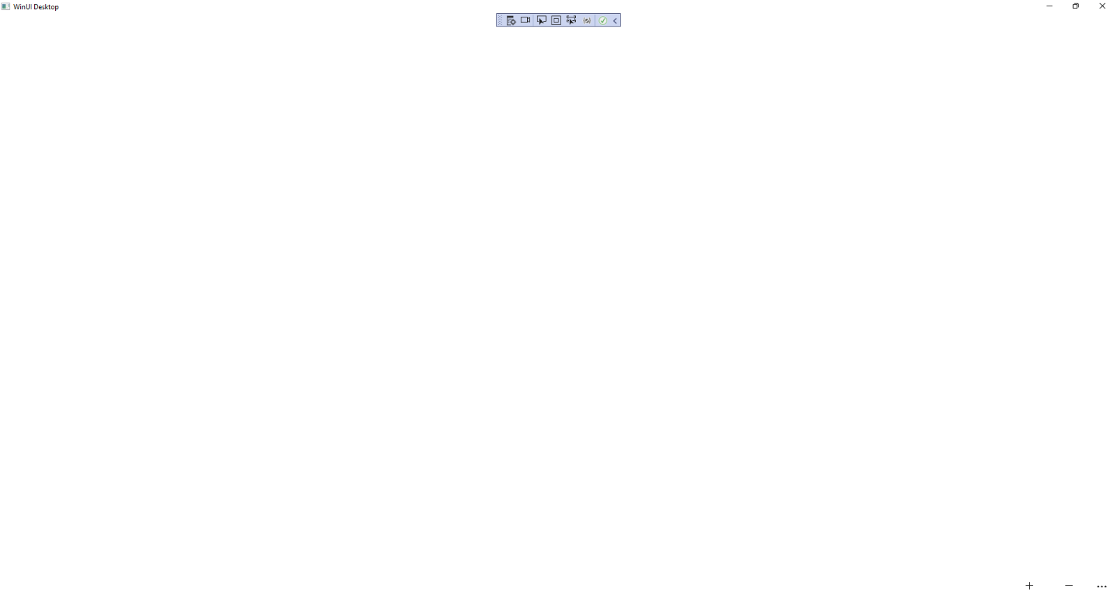

## Step 13

You can select the **AppBarButton** for *Add* to add some elements and they should appear with a **Theme** **Transition**.

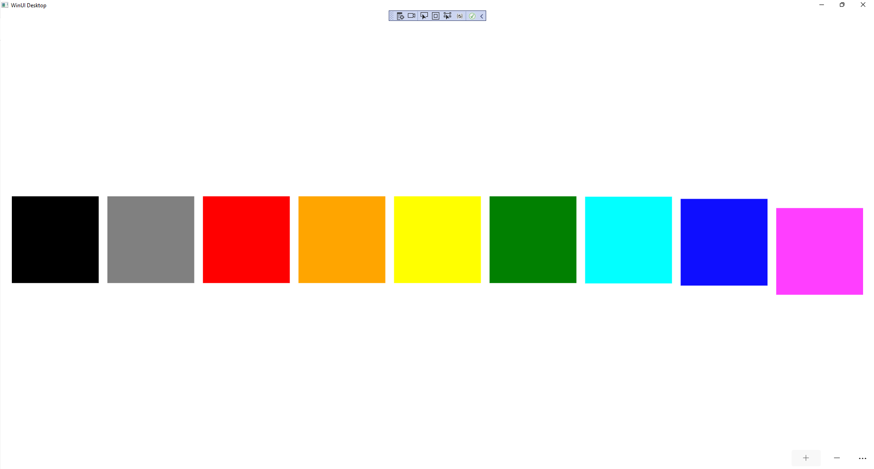

## Step 14

|  |  |
| --- | --- |
| To **Exit** the **Windows App SDK** application, select the **Close** button from the top right of the application as that concludes this **Tutorial** for **Windows App SDK** from [tutorialr.com](https://tutorialr.com)! |  |