

[](https://www.tutorialr.com/tutorials/)

Windows App SDK

Tic Tac Toe





# Tic Tac Toe

**Tic Tac Toe** shows how you can create the game also known as **Noughts and Crosses** displayed with emoji

and with a toolkit from **NuGet** using the **Windows App SDK**.

## Step 1

Follow **Setup and Start** on how to get **Setup** and **Install** what you need for **Visual Studio 2022** and **Windows App SDK**.

|  |  |
| --- | --- |
| In **Windows 11** choose **Start** and then find or search for **Visual Studio 2022** and then select it. |  |
| Once **Visual Studio 2022** has started select **Create a new project**. |  |
| Then choose the **Blank App, Packages (WinUI in Desktop)** and then select **Next**. |  |
| After that in **Configure your new project** type in the **Project name** as *TicTacToe*, then select a Location and then select **Create** to start a new **Solution**. |  |

## Step 2

Then in **Visual Studio** within **Solution** **Explorer** for the **Solution**, right click on the **Project** shown below the **Solution** and then select **Manage NuGet Packages…**

## Step 3

Then in the **NuGet Package Manager** from the **Browse** tab search for **Comentsys.Toolkit.WindowsAppSdk** and then select **Comentsys.Toolkit.WindowsAppSdk by Comentsys** as indicated and select **Install**

This will add the package for **Comentsys.Toolkit.WindowsAppSdk** to your **Project**. If you get the **Preview Changes** screen saying **Visual Studio is about to make changes to this solution. Click OK to proceed with the changes listed below.** You can read the message and then select **OK** to **Install** the package.

## Step 4

Then while still in the **NuGet Package Manager** from the **Browse** tab search for **Comentsys.Assets.FluentEmoji** and then select **Comentsys.Assets.FluentEmoji by Comentsys** as indicated and select **Install**

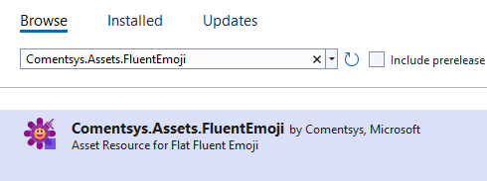

This will add the package for **Comentsys.Assets.FluentEmoji** to your **Project**. If you get the **Preview Changes** screen saying **Visual Studio is about to make changes to this solution. Click OK to proceed with the changes listed below.** You can read the message and then select **OK** to **Install** the package, then you can close the **tab** for **Nuget: TicTacToe** by selecting the **x** next to it.

## Step 5

Then in **Visual Studio** within **Solution** **Explorer** for the **Solution**, right click on the **Project** shown below the **Solution** and then select **Add** then **New Item…**

## Step 6

Then in **Add New Item** from the **C# Items** list, select **Code** and then select **Code File** from the list next to this, then type in the name of *Library.cs* and then **Click** on **Add**.

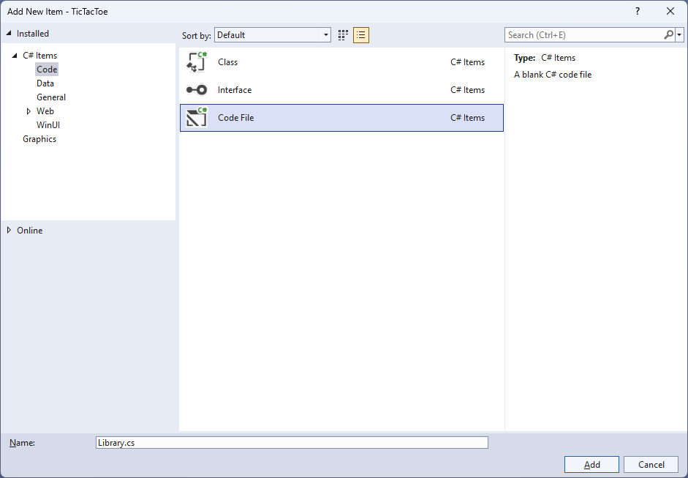

## Step 7

You will now be in the **View** for the **Code** of *Library.cs*, within this first type the following **Code**:

using Comentsys.Assets.FluentEmoji;

using Comentsys.Toolkit.WindowsAppSdk;

using Microsoft.UI.Xaml;

using Microsoft.UI.Xaml.Controls;

using Windows.UI;

public class Library

{

private const string title = "Tic Tac Toe";

private const string blank = " ";

private const string nought = "O";

private const string cross = "X";

private const int size = 3;

private readonly string[,] _board = new string[size, size];

private readonly Color _red = Color.FromArgb(255, 249, 47, 96);

private readonly Color _blue = Color.FromArgb(255, 0, 166, 237);

private Dialog _dialog;

private bool _won = false;

private string _piece = string.Empty;

// Winner & Drawn

// Asset

// Add

// Layout & New

}

The **Class** that has been defined in so far *Library.cs* has **using** for the packages that were addedof **Comentsys.Assets.FluentEmoji** and **Comentsys.Toolkit.WindowsAppSdk** amongst others needed. There are also some **const** and **readonly** values for parts of the game and to represent the board and some colours. Then there are some **Variables** including another control of **Dialog** which can be used to show messages.

## Step 8

Still in the **Class** for *Library.cs* after the **Comment** of **// Winner & Drawn** type the following **Methods**:

private bool Winner() =>

(_board[0, 0] == _piece && _board[0, 1] ==

_piece && _board[0, 2] == _piece) ||

(_board[1, 0] == _piece && _board[1, 1] ==

_piece && _board[1, 2] == _piece) ||

(_board[2, 0] == _piece && _board[2, 1] ==

_piece && _board[2, 2] == _piece) ||

(_board[0, 0] == _piece && _board[1, 0] ==

_piece && _board[2, 0] == _piece) ||

(_board[0, 1] == _piece && _board[1, 1] ==

_piece && _board[2, 1] == _piece) ||

(_board[0, 2] == _piece && _board[1, 2] ==

_piece && _board[2, 2] == _piece) ||

(_board[0, 0] == _piece && _board[1, 1] ==

_piece && _board[2, 2] == _piece) ||

(_board[0, 2] == _piece && _board[1, 1] ==

_piece && _board[2, 0] == _piece);

private bool Drawn() =>

_board[0, 0] != blank && _board[0, 1] !=

blank && _board[0, 2] != blank &&

_board[1, 0] != blank && _board[1, 1] !=

blank && _board[1, 2] != blank &&

_board[2, 0] != blank && _board[2, 1] !=

blank && _board[2, 2] != blank;

**Winner** will work out the winning positions the **_piece** is in and will be **true** if the positions result in a complete set of either noughts or crosses or **false** and **Drawn** will be used to check if the game is a draw.

## Step 9

While still in the **Class** for *Library.cs* after the **Comment** of **// Asset** type in the following **Method**:

private Viewbox Asset() => new()

{

Child = new Asset

{

AssetResource =

_piece switch

{

nought => FlatFluentEmoji.Get(

FluentEmojiType.HollowRedCircle,

_red.AsDrawingColor(),

_blue.AsDrawingColor()),

_ => FlatFluentEmoji.Get(

FluentEmojiType.CrossMark)

}

}

};

## Step 10

While still in the **Class** for *Library.cs* after the **Comment** of **// Add** type the following **Method**:

private void Add(Grid grid, int row, int column)

{

Button button = new()

{

Width = 75,

Height = 75,

Margin = new Thickness(10)

};

button.Click += (object sender, RoutedEventArgs e) =>

{

if (!_won)

{

button = (Button)sender;

if (button.Content == null)

{

button.Content = Asset();

_board[(int)button.GetValue(Grid.RowProperty),

(int)button.GetValue(Grid.ColumnProperty)] = _piece;

}

if (Winner())

{

_won = true;

_dialog.Show($"{_piece} wins!");

}

else if (Drawn())

{

_dialog.Show("Draw!");

}

else

{

// Swap Players

_piece = _piece == cross ? nought : cross;

}

}

else

{

_dialog.Show("Game Over!");

}

};

button.SetValue(Grid.ColumnProperty, column);

button.SetValue(Grid.RowProperty, row);

grid.Children.Add(button);

}

**Add** will be used to create a **Button** which will have **Event Handler** of **Click** set which will use **Asset** to set the **Content** to the nought with *Hollow Red Circle* which has been modified to be blue instead of red or the *Red Cross Mark* for cross. This **Method** will also check if the game has been won with **Winner** or **Drawn** and will display a message if the game is over.

## Step 11

While still in the **Class** for *Library.cs* after the **Comment** of **// Layout & New** type the following **Methods**:

private void Layout(Grid grid)

{

grid.Children.Clear();

grid.RowDefinitions.Clear();

grid.ColumnDefinitions.Clear();

// Setup Grid

for (int index = 0; index < size; index++)

{

grid.RowDefinitions.Add(new RowDefinition());

grid.ColumnDefinitions.Add(new ColumnDefinition());

}

// Setup Board

for (int row = 0; row < size; row++)

{

for (int column = 0; column < size; column++)

{

Add(grid, row, column);

_board[row, column] = blank;

}

}

}

public async void New(Grid grid)

{

_won = false;

_dialog = new Dialog(grid.XamlRoot, title);

_piece = await _dialog.ConfirmAsync("Who goes First?", nought, cross) ?

nought : cross;

Layout(grid);

}

**Layout** will be used with **Add** to setup what the game will look like and **New** will start a game, it will setup the **Dialog** and will show a message to choose which player should go first and then uses **Layout**.

## Step 12

|  |  |
| --- | --- |
| Then from **Solution** **Explorer** for the **Solution** double-click on **MainWindow.xaml** to see the **XAML** for the **Main Window**. |  |

## Step 13

In the **XAML** for **MainWindow.xaml** there be some **XAML** for a **StackPanel**, this should be **Removed** by removing the following:

<StackPanel Orientation="Horizontal"

HorizontalAlignment="Center" VerticalAlignment="Center">

<Button x:Name="myButton" Click="myButton_Click">Click Me</Button>

</StackPanel>

## Step 14

While still in the **XAML** for **MainWindow.xaml** above **</Window>**, type in the following **XAML**:

<Grid>

<Viewbox>

<Grid Margin="50" Name="Display"

HorizontalAlignment="Center"

VerticalAlignment="Center" Loaded="New"/>

</Viewbox>

<CommandBar VerticalAlignment="Bottom">

<AppBarButton Icon="Page2" Label="New" Click="New"/>

</CommandBar>

</Grid>

This **XAML** contains a **Grid** with a **Viewbox** which will scale a **Grid**. It has a **Loaded** event handler for **New** which is also shared by the **AppBarButton**.

## Step 15

|  |  |
| --- | --- |
| Then, within **Solution** **Explorer** for the **Solution** select the arrow next to **MainWindow.xaml** then double-click on **MainWindow.xaml.cs** to see the **Code** for the **Main Window**. |  |

## Step 16

In the **Code** for **MainWindow.xaml.cs** there be a **Method** of **myButton_Click(...)** this should be **Removed** by removing the following:

private void myButton_Click(object sender, RoutedEventArgs e)

{

myButton.Content = "Clicked";

}

## Step 17

Once **myButton_Click(...)** has been removed, type in the following **Code** below the end of the **Constructor** of **public MainWindow() { ... }**:

private readonly Library _library = new();

private void New(object sender, RoutedEventArgs e) =>

_library.New(Display);

Here an **Instance** of the **Class** of **Library** is created then below this is the **Method** of **New** that will be used with **Event Handler** from the **XAML**, this **Method** uses Arrow Syntax with the **=>** for an Expression Bodywhich is useful when a **Method** only has one line.

## Step 18

|  |  |
| --- | --- |
| That completes the **Windows App SDK** application. In **Visual Studio 2022** from the **Toolbar** select **TicTacToe (Package)** to **Start** the application. |  |

## Step 19

Once running you should see a **Message** asking *Who goes First?* You can then choose *X* or *O*then **Click** on any **Button** to take your turn in the game, with three noughts or crosses in any horizontal, vertical or diagonal direction to win the game! You can restart the game by selecting *New*.

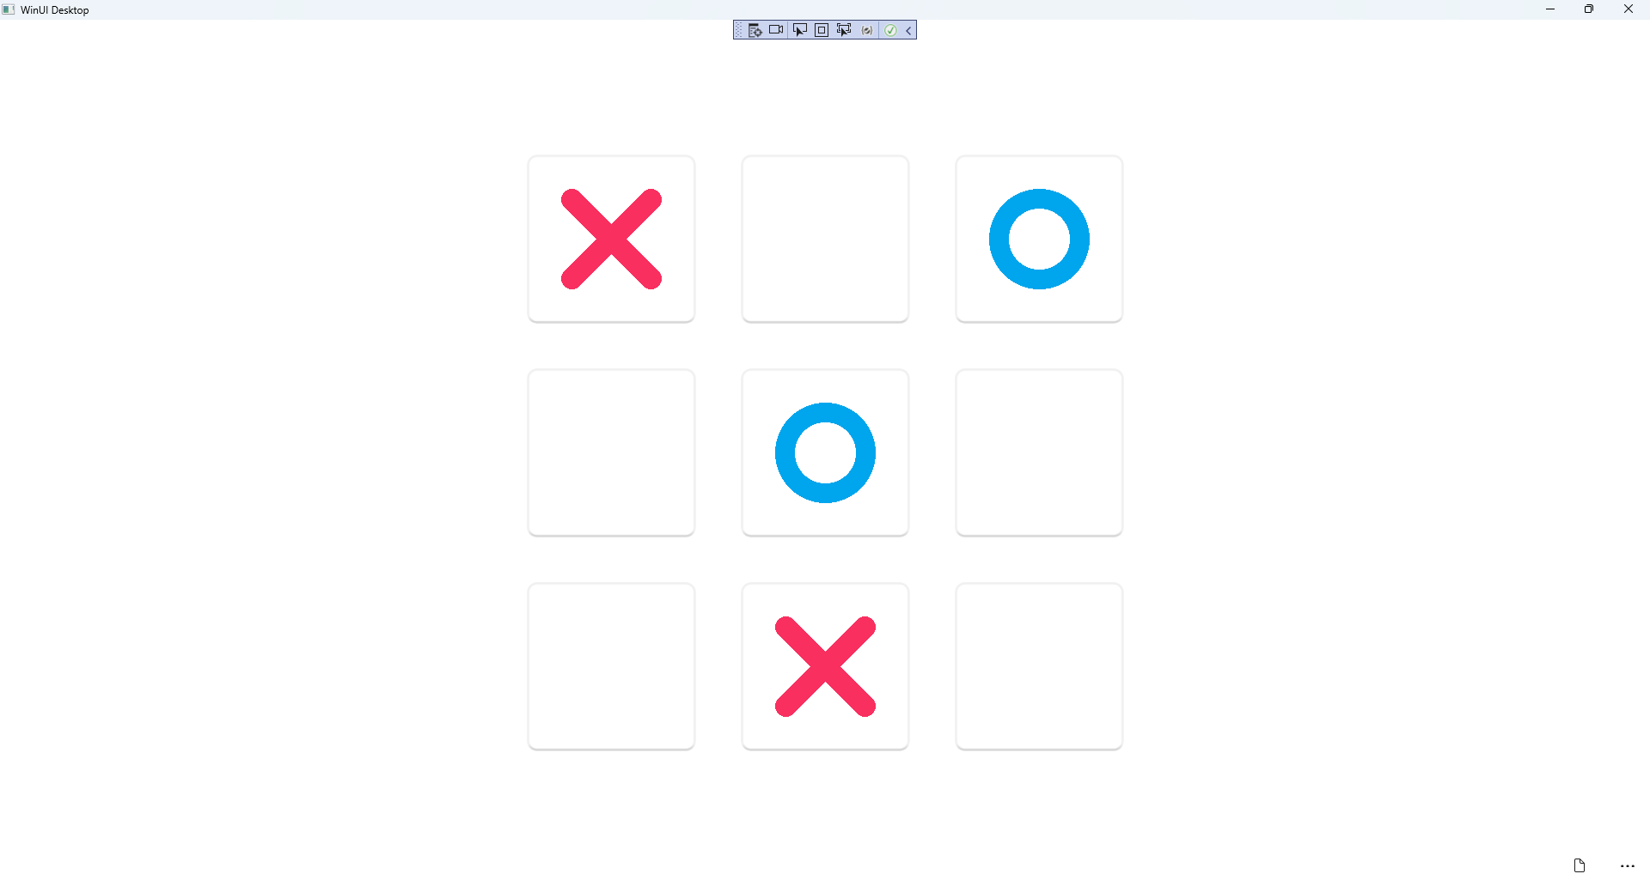

## Step 20

|  |  |
| --- | --- |
| To **Exit** the **Windows App SDK** application, select the **Close** button from the top right of the application as that concludes this **Tutorial** for **Windows App SDK** from [tutorialr.com](https://tutorialr.com)! |  |