

[](https://www.tutorialr.com/tutorials/)

Windows App SDK

Tiles Game





Tiles Game

**Tiles Game** shows how you can create the game where you must tap all the **Tiles** that are **Black** in

the quickest time using a control in a toolkit from **NuGet** using the **Windows App SDK**.

## Step 1

Follow **Setup and Start** on how to get **Setup** and **Install** what you need for **Visual Studio 2022** and **Windows App SDK**.

|  |  |
| --- | --- |
| In **Windows 11** choose **Start** and then find or search for **Visual Studio 2022** and then select it. |  |
| Once **Visual Studio 2022** has started select **Create a new project**. |  |
| Then choose the **Blank App, Packages (WinUI in Desktop)** and then select **Next**. |  |
| After that in **Configure your new project** type in the **Project name** as *TilesGame*, then select a Location and then select **Create** to start a new **Solution**. |  |

## Step 2

Then in **Visual Studio** within **Solution** **Explorer** for the **Solution**, right click on the **Project** shown below the **Solution** and then select **Manage NuGet Packages…**

## Step 3

Then in the **NuGet Package Manager** from the **Browse** tab search for **Comentsys.Toolkit.WindowsAppSdk** and then select **Comentsys.Toolkit.WindowsAppSdk by Comentsys** as indicated and select **Install**

This will add the package for **Comentsys.Toolkit.WindowsAppSdk** to your **Project**. If you get the **Preview Changes** screen saying **Visual Studio is about to make changes to this solution. Click OK to proceed with the changes listed below.** You can read the message and then select **OK** to **Install** the package, then you can close the **tab** for **Nuget: TilesGame** by selecting the **x** next to it.

## Step 4

Then in **Visual Studio** within **Solution** **Explorer** for the **Solution**, right click on the **Project** shown below the **Solution** and then select **Add** then **New Item…**

## Step 5

Then in **Add New Item** from the **C# Items** list, select **Code** and then select **Code File** from the list next to this, then type in the name of *Library.cs* and then **Click** on **Add**.

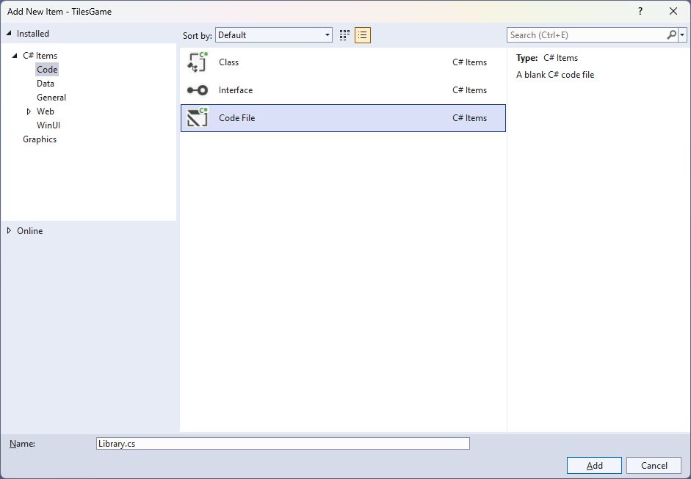

## Step 6

You will now be in the **View** for the **Code** of *Library.cs* then define a **namespace** allowing classes to be defined together, usually each is separate but will be defined in *Library.cs* by typing the following **Code**:

using Comentsys.Toolkit.Binding;

using Comentsys.Toolkit.WindowsAppSdk;

using Microsoft.UI;

using Microsoft.UI.Xaml;

using Microsoft.UI.Xaml.Controls;

using Microsoft.UI.Xaml.Data;

using Microsoft.UI.Xaml.Input;

using Microsoft.UI.Xaml.Media;

using System;

using System.Collections.Generic;

using System.Linq;

namespace TilesGame;

public enum State

{

White,

Black,

Start,

Finish,

Correct,

Incorrect

}

// Item Class

public class Board : ObservableBase

{

// Board Constants, Members & Properties

// Board Choose, Set & Start Methods

// Board Play Method

// Board Get & New Methods and Constructor

}

public class Library

{

// Library Constants, Variables & Play Method

// Library SetPieces Method

// Library GetBoundText Method

// Library Layout & New Methods

}

## Step 7

Still in *Library.cs* for the **namespace** of **TilesGame** in *Library.cs* you will define a **class** for **Item** after the **Comment** of **// Item Class** by typing the following:

public class Item

{

public int Row { get; set; }

public int Column { get; set; }

public State State { get; set; }

public Item(int row, int column, State state) =>

(Row, Column, State) = (row, column, state);

}

**Item** has **Properties** for **Row**, **Column** and **State** along with a **Constructor** to set them which will represent an item in the game.

## Step 8

Still in *Library.cs* for the **namespace** of **TilesGame** in *Library.cs* in the **class** for **Board** after the **Comment** of **// Board Constants, Members & Properties** type the following **Constants**, **Members** and **Properties**:

private const int bound = 1;

private const int timer = 100;

private readonly State[,] _board;

private readonly Random _random = new((int)DateTime.UtcNow.Ticks);

private readonly int _rows;

private readonly int _columns;

private readonly int _levels;

private readonly int _start;

private readonly int _finish;

private int _index;

private int _offset;

private bool _over;

private bool _started;

private TimeSpan _time;

private TimeSpan _best;

private DateTime _when;

private string _message;

private DispatcherTimer _timer;

public TimeSpan Time { get => _time; set => SetProperty(ref _time, value); }

public TimeSpan Best { get => _best; set => SetProperty(ref _best, value); }

public string Message { get => _message; set => SetProperty(ref _message, value); }

## Step 9

Still in *Library.cs* for the **namespace** of **TilesGame** in *Library.cs* in the **class** for **Board** after the **Comment** of **// Board Choose, Set & Start Methods** type the following **Methods** for **Choose** to pick random numbers. **Set** will update the **State** of game elements and **Start** which will begin the **Timer** for the game.

private List<int> Choose(int minimum, int maximum, int total)

{

var choose = new List<int>();

var values = Enumerable.Range(minimum, maximum).ToList();

for (int index = 0; index < total; index++)

{

var value = _random.Next(0, values.Count);

choose.Add(values[value]);

}

return choose;

}

private void Set(int columns, int levels)

{

var values = Choose(0, columns, levels - bound);

for (int level = 0; level < levels; level++)

{

for (int column = 0; column < columns; column++)

{

State tile;

if (level < _finish)

tile = State.Finish;

else if (level >= _start)

tile = State.Start;

else

tile = values[level] == column ? State.Black : State.White;

_board[level, column] = tile;

}

}

}

private void Start()

{

_when = DateTime.UtcNow;

if (_timer != null)

_timer.Stop();

_timer = new DispatcherTimer()

{

Interval = TimeSpan.FromMilliseconds(timer)

};

_timer.Tick += (object sender, object e) =>

{

if(_started && !_over)

Time = DateTime.UtcNow - _when;

else

_timer.Stop();

};

_started = true;

_timer.Start();

}

## Step 10

Still in *Library.cs* for the **namespace** of **TilesGame** in *Library.cs* in the **class** for **Board** after the **Comment** of **// Board Play Method** type the following **Method:**

public void Play(Item item)

{

if (!_over)

{

if (item.State == State.Black)

{

if(item.Row == _index)

{

if(!_started)

Start();

_board[item.Row, item.Column] = State.Correct;

_index--;

if (_offset > 0)

_offset--;

if (_index < _finish)

{

_started = false;

Time = DateTime.UtcNow - _when;

if (Best == TimeSpan.Zero || Time < Best)

Best = Time;

Message = $"Completed in {Time:ss\\.fff}!";

}

}

else

{

_board[item.Row, item.Column] = State.Incorrect;

Message = $"Game Over, Hit Wrong Tile!";

_over = true;

}

}

else if (item.State == State.White)

{

_board[item.Row, item.Column] = State.Incorrect;

Message = $"Game Over, Hit White Tile!";

_over = true;

}

}

else

Message = $"Game Over!";

}

**Play** is used when an element is interacted with in the game, the **State** will be checked and if the game is completed the finish time will be displayed, if anything other than the correct **Tile** is interacted with then the game is over, and a message will be displayed or if the game is over that message will be shown.

## Step 11

Still in *Library.cs* for the **namespace** of **TilesGame** in *Library.cs* in the **class** for **Board** after the **Comment** of **// Board Get & New Methods and Constructor** type the following **Methods** and **Constructor:**

public Item Get(int row, int column) =>

new(row + _offset, column, _board[row + _offset, column]);

public void New()

{

_over = false;

_started = false;

Time = TimeSpan.Zero;

Set(_columns, _levels);

_offset = _levels - _rows;

_index = _levels - (bound * 2);

Message = "Don't Hit White Tiles!";

}

public Board(int rows, int columns, int levels)

{

_rows = rows;

_columns = columns;

_levels = levels;

_start = levels - bound;

_finish = rows - bound;

_board = new State[levels, columns];

New();

}

**Get** will be used to determine what element is at the given position, **New** will start a new game and the **Constructor** for **Board** is used to setup the game.

## Step 12

While still in the **namespace** of **TilesGame** in *Library.cs* and in the **class** of **Library** after the **Comment** of **// Library Constants, Variables & Play Method** type the following **Constants**, **Variables** and **Method**:

private const int rows = 6;

private const int columns = 4;

private const int levels = 32;

private const int size = 36;

private const int font = 10;

private readonly Dictionary<State, SolidColorBrush> _brushes = new()

{

{ State.White, new SolidColorBrush(Colors.White) },

{ State.Black, new SolidColorBrush(Colors.Black) },

{ State.Start, new SolidColorBrush(Colors.Gold) },

{ State.Finish, new SolidColorBrush(Colors.ForestGreen) },

{ State.Correct, new SolidColorBrush(Colors.Gray) },

{ State.Incorrect, new SolidColorBrush(Colors.IndianRed) }

};

private readonly Board _board = new(rows, columns, levels);

private Piece[,] _pieces;

private Grid _grid;

private void Play(Item selected)

{

_board.Play(selected);

for (int row = 0; row < rows; row++)

{

for (int column = 0; column < columns; column++)

{

var item = _board.Get(row, column);

var piece = _pieces[row, column];

piece.Tag = item;

piece.Fill = _brushes[item.State];

}

}

}

**Constants** are values that are used in the game that will not change and **Variables** are used to store various values for the game, there is also the **Method** of **Play** which will be used to perform an action in the game for a given **Tile** or **Item**.

## Step 13

While still in the **namespace** of **Tetrominos** in *Library.cs* and in the **class** of **Library** after the **Comment** of **// Library SetPieces Method** type in the following **Method**:

private Piece[,] SetPieces(Grid grid)

{

grid.Children.Clear();

var pieces = new Piece[rows, columns];

for (int row = 0; row < rows; row++)

{

grid.RowDefinitions.Add(new RowDefinition());

for (int column = 0; column < columns; column++)

{

if (row == 0)

grid.ColumnDefinitions.Add(new ColumnDefinition());

var item = _board.Get(row, column);

var piece = new Piece()

{

Tag = item,

Width = size,

Height = size,

IsSquare = true,

Fill = _brushes[item.State],

Stroke = new SolidColorBrush(Colors.WhiteSmoke)

};

piece.Tapped += (object sender, TappedRoutedEventArgs e) =>

Play((Item)(sender as Piece).Tag);

Grid.SetColumn(piece, column);

Grid.SetRow(piece, row);

grid.Children.Add(piece);

pieces[row, column] = piece;

}

}

return pieces;

}

**SetPieces** is where the elements that make up the visuals for the game for a **Tile** using **Piece**.

## Step 14

While still in the **namespace** of **TilesGame** in *Library.cs* and in the **class** of **Library** after the **Comment** of **// Library GetBoundText Method** type in the following **Method**:

private TextBlock GetBoundText(string property, string format = null)

{

var text = new TextBlock()

{

FontSize = font,

VerticalAlignment = VerticalAlignment.Center,

HorizontalAlignment = HorizontalAlignment.Center

};

var binding = new Binding()

{

Source = _board,

Mode = BindingMode.OneWay,

Path = new PropertyPath(property),

UpdateSourceTrigger = UpdateSourceTrigger.PropertyChanged,

Converter = new StringFormatConverter(),

ConverterParameter = format

};

BindingOperations.SetBinding(text, TextBlock.TextProperty, binding);

return text;

}

**GetBoundText** is used to get a **TextBlock** that will be used with **Data Binding** to output the messages from the game such as to indicate the current time, whether the game is competed or if the game is over.

## Step 15

While still in the **namespace** of **TilesGame** in *Library.cs* and in the **class** of **Library** after the **Comment** of **// Library Layout & New Methods** type in the following **Methods**:

private void Layout(Grid grid)

{

grid.Children.Clear();

var panel = new StackPanel()

{

Orientation = Orientation.Horizontal

};

var time = GetBoundText(nameof(_board.Time), "Time: {0:ss\\.fff}");

panel.Children.Add(time);

var inner = new StackPanel()

{

Orientation = Orientation.Vertical

};

var message = GetBoundText(nameof(_board.Message));

inner.Children.Add(message);

_grid = new()

{

VerticalAlignment = VerticalAlignment.Top,

HorizontalAlignment = HorizontalAlignment.Center

};

_pieces = SetPieces(_grid);

inner.Children.Add(_grid);

panel.Children.Add(inner);

var best = GetBoundText(nameof(_board.Best), "Best: {0:ss\\.fff}");

panel.Children.Add(best);

grid.Children.Add(panel);

}

public void New(Grid grid)

{

_board.New();

Layout(grid);

}

**Layout** will create the look-and-feel of the game including to display the messages using **GetBoundText** and **New** will start a new game.

## Step 16

|  |  |
| --- | --- |
| Then from **Solution** **Explorer** for the **Solution** double-click on **MainWindow.xaml** to see the **XAML** for the **Main Window**. |  |

## Step 17

In the **XAML** for **MainWindow.xaml** there be some **XAML** for a **StackPanel**, this should be **Removed** by removing the following:

<StackPanel Orientation="Horizontal"

HorizontalAlignment="Center" VerticalAlignment="Center">

<Button x:Name="myButton" Click="myButton_Click">Click Me</Button>

</StackPanel>

## Step 18

While still in the **XAML** for **MainWindow.xaml** above **</Window>**, type in the following **XAML**:

<Grid>

<Viewbox>

<Grid Margin="50" Name="Display"

HorizontalAlignment="Center"

VerticalAlignment="Center" Loaded="New"/>

</Viewbox>

<CommandBar VerticalAlignment="Bottom">

<AppBarButton Icon="Page2" Label="New" Click="New"/>

</CommandBar>

</Grid>

This **XAML** contains a **Grid** with a **Viewbox** which will scale a **Grid**. It has a **Loaded** event handler for **New** which is also shared by the **AppBarButton**.

## Step 19

|  |  |
| --- | --- |
| Then, within **Solution** **Explorer** for the **Solution** select the arrow next to **MainWindow.xaml** then double-click on **MainWindow.xaml.cs** to see the **Code** for the **Main Window**. |  |

## Step 20

In the **Code** for **MainWindow.xaml.cs** there be a **Method** of **myButton_Click(...)** this should be **Removed** by removing the following:

private void myButton_Click(object sender, RoutedEventArgs e)

{

myButton.Content = "Clicked";

}

## Step 21

Once **myButton_Click(...)** has been removed, type in the following **Code** below the end of the **Constructor** of **public MainWindow() { ... }**:

private readonly Library _library = new();

private void New(object sender, RoutedEventArgs e) =>

_library.New(Display);

Here an **Instance** of the **Class** of **Library** is created then below this is the **Method** of **New** that will be used with **Event Handler** from the **XAML**, this **Method** uses Arrow Syntax with the **=>** for an Expression Bodywhich is useful when a **Method** only has one line.

## Step 22

|  |  |
| --- | --- |
| That completes the **Windows App SDK** application. In **Visual Studio 2022** from the **Toolbar** select **TilesGame (Package)** to **Start** the application. |  |

## Step 23

Once running you can tap on the first **Tile** that is **Black** above the **Tiles** that are **Yellow** to begin the game, tap on them all until you then you get to the **Tiles** that are **Green** to win the game, but tap on the wrong **Tile** that is **Black** or a **White** one then you lose the game or select *New* to start a new game.

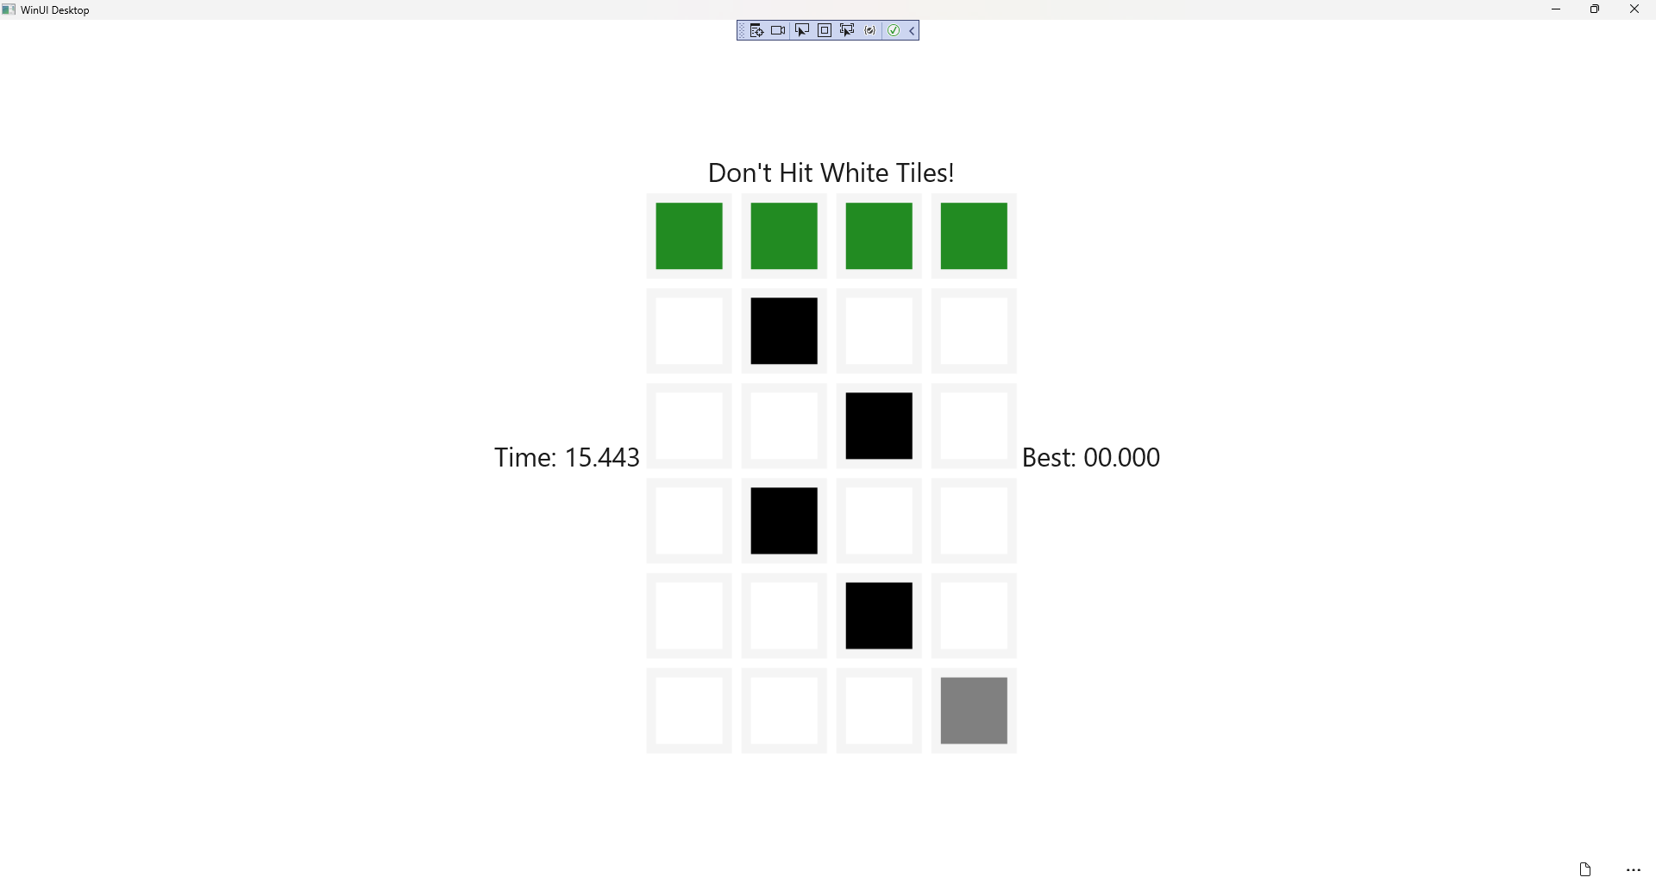

## Step 24

|  |  |
| --- | --- |
| To **Exit** the **Windows App SDK** application, select the **Close** button from the top right of the application as that concludes this **Tutorial** for **Windows App SDK** from [tutorialr.com](https://tutorialr.com)! |  |