

[](https://www.tutorialr.com/tutorials/)

Windows App SDK

Toast Notifications





# Toast Notifications

**Toast Notifications** shows how you can use **ToastNotification** with the **Windows App SDK**. This

allows you to display a **Toast Notification** for your application in the **Notifications** pane in **Windows**.

## Step 1

Follow **Setup and Start** on how to get **Setup** and **Install** what you need for **Visual Studio 2022** and **Windows App SDK**.

|  |  |
| --- | --- |
| In **Windows 11** choose **Start** and then find or search for **Visual Studio 2022** and then select it. |  |
| Once **Visual Studio 2022** has started select **Create a new project**. |  |
| Then choose the **Blank App, Packages (WinUI in Desktop)** and then select **Next**. |  |
| After that in **Configure your new project** type in the **Project name** as *ToastNotifications*, then select a Location and then select **Create** to start a new **Solution**. |  |

## Step 2

Then in **Visual Studio** within **Solution** **Explorer** for the **Solution**, right click on the **Project** shown below the **Solution** and then select **Add** then **New Item…**

## Step 3

Then in **Add New Item** from the **C# Items** list, select **Code** and then select **Code File** from the list next to this, then type in the name of *Library.cs* and then **Click** on **Add**.

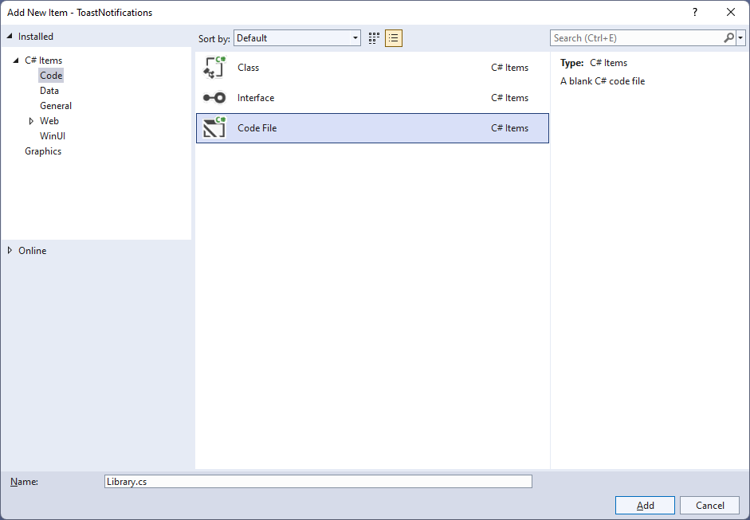

## Step 4

You will now be in the **View** for the **Code** of *Library.cs*, within this type the following **Code**:

using Microsoft.UI.Xaml.Controls;

using System;

using System.Collections.Generic;

using System.Linq;

using Windows.Data.Xml.Dom;

using Windows.UI.Notifications;

internal class Library

{

public List<string> Options =>

Enum.GetValues(typeof(ToastTemplateType))

.Cast<ToastTemplateType>()

.Select(s => s.ToString())

.ToList();

public void SetToast(ComboBox options, TextBox value)

{

var selected = options.SelectedValue as string;

ToastTemplateType template = Enum.Parse<ToastTemplateType>(selected);

XmlDocument toast = ToastNotificationManager.GetTemplateContent(template);

XmlNodeList text = toast.GetElementsByTagName("text");

if (text.Length > 0)

{

text[0].AppendChild(toast.CreateTextNode(value.Text));

}

XmlNodeList image = toast.GetElementsByTagName("image");

if (image.Length > 0)

{

image[0].Attributes.GetNamedItem("src").NodeValue =

"Assets/Square44x44Logo.scale-200.png";

}

ToastNotification notification = new(toast);

ToastNotificationManager.CreateToastNotifier().Show(notification);

}

}

The **Class** that has been defined in *Library.cs* has a **Property** for **Options**, which is the list of all possible values for the **Enum** of **ToastTemplateType** for use with the **ComboBox**. Then there is the **Method** for **SetToast** which will get the **SelectedValue** of a **ComboBox** passed in and use this to get the **ToastTemplateType** that was selected in the **ComboBox**. There is also a **TextBox** passed in for what value should be shown in the **Toast Notification**. Then there is some code to build up the elements of the **Toast Notification** using **XML** which is needed to create the **ToastNotification** which includes the **text** and there is also an **image** set to one of the **Assets** in the application for any **ToastTemplateType** that supports **Images** and this is then is used to **Show** the **notification** with **ToastNotificationManager**.

## Step 5

|  |  |
| --- | --- |
| Then from **Solution** **Explorer** for the **Solution** double-click on **MainWindow.xaml** to see the **XAML** for the **Main Window**. |  |

## Step 6

In the **XAML** for **MainWindow.xaml** there be some **XAML** for a **StackPanel**, this should be **Removed** by removing the following:

<StackPanel Orientation="Horizontal"

HorizontalAlignment="Center" VerticalAlignment="Center">

<Button x:Name="myButton" Click="myButton_Click">Click Me</Button>

</StackPanel>

## Step 7

While still in the **XAML** for **MainWindow.xaml** above **</Window>**, type in the following **XAML**:

<Grid>

<Grid.RowDefinitions>

<RowDefinition Height="Auto"/>

<RowDefinition Height="*"/>

<RowDefinition Height="Auto"/>

</Grid.RowDefinitions>

<StackPanel Grid.Row="0" Margin="25">

<ComboBox Margin="5" Name="Options"

HorizontalAlignment="Stretch"/>

<TextBox Margin="5" PlaceholderText="Value"

Name="Value" HorizontalAlignment="Stretch"/>

</StackPanel>

<CommandBar Grid.Row="3" VerticalAlignment="Bottom">

<AppBarButton Icon="Comment" Label="Accept" Click="Accept_Click"/>

</CommandBar>

</Grid>

This **XAML** features a **Grid** with a **StackPanel** for the **ComboBox** for the *Options* and a **TextBox** for the *Value*, along with an **AppBarButton** to show the **ToastNotification** when **Clicked**.

## Step 8

|  |  |
| --- | --- |
| Then, within **Solution** **Explorer** for the **Solution** select the arrow next to **MainWindow.xaml** then double-click on **MainWindow.xaml.cs** to see the **Code** for the **Main Window**. |  |

## Step 9

In the **Code** for **MainWindow.xaml.cs** there be a **Method** of **myButton_Click(...)** this should be **Removed** by removing the following:

private void myButton_Click(object sender, RoutedEventArgs e)

{

myButton.Content = "Clicked";

}

## Step 10

Once **myButton_Click(...)** has been removed, type in the following **Code** below the end of the **Constructor** of **public MainWindow() { ... }**:

private readonly Library _library = new();

private void Accept_Click(object sender, RoutedEventArgs e)

{

_library.SetToast(Options, Value);

}

The **Method** of **Accept_Click** will call the **Method** within *Library.cs* of **SetToast** from an **Instance** of **Library** called **_library** created with **new()**.

## Step 11

While still in the **Code** for **MainWindow.xaml.cs** within the **Constructor** of **public MainWindow() { ... }** and below the line of **this.InitializeComponent();** type in the following **Code**:

Options.ItemsSource = _library.Options;

Options.SelectedIndex = 0;

The **Constructor** of **public MainWindow() { ... }** should look like the following:

public MainWindow()

{

this.InitializeComponent();

Options.ItemsSource = _library.Options;

Options.SelectedIndex = 0;

}

These set up the **Properties** for the **ComboBox** for **ItemsSource** to the list of **Options** from **Library** and for **SelectedIndex** to the first index which is **0** to select the first item.

## Step 12

|  |  |
| --- | --- |
| That completes the **Windows App SDK** application. In **Visual Studio 2022** from the **Toolbar** select **ToastNotifications (Package)** to **Start** the application. |  |

## Step 13

Once running you should see the **ComboBox**, **TextBox** and **CommandBar** with the *Accept* option.

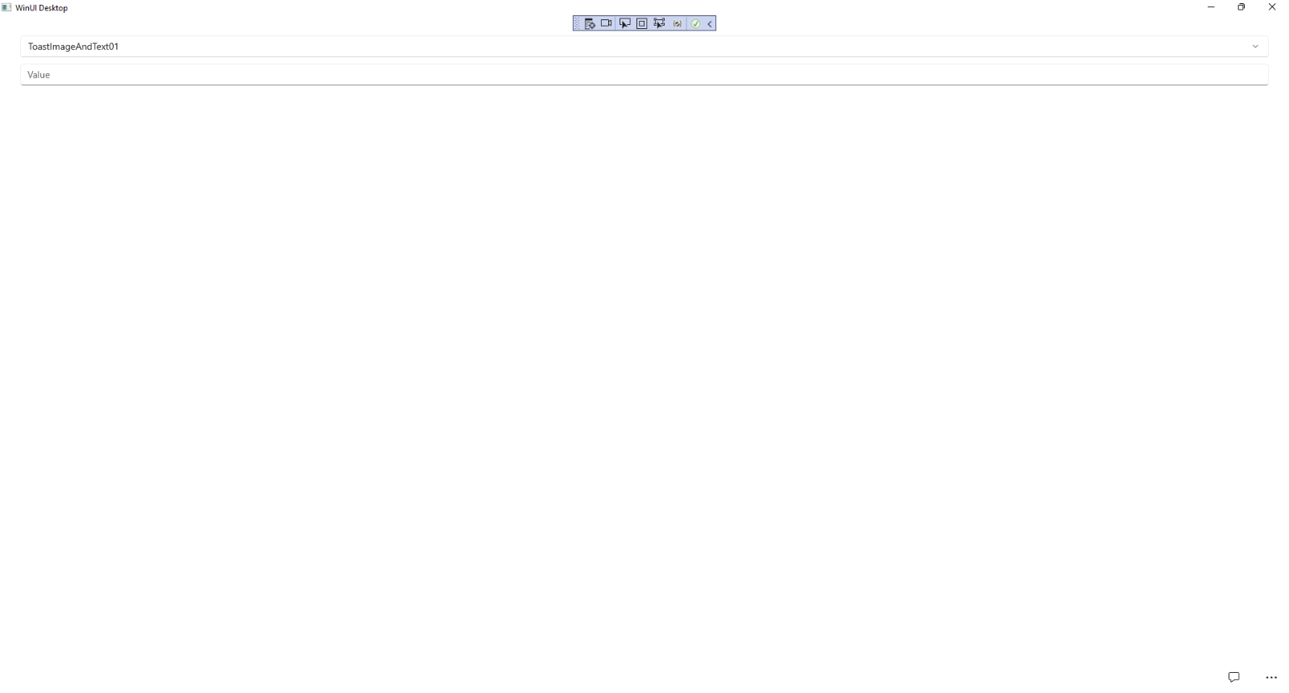

## Step 14

You can select a value from the **ComboBox** then type a value in the **TextBox** and then use *Accept* to see a **Toast** **Notification** in the **Notifications** for **Windows** for the Application.

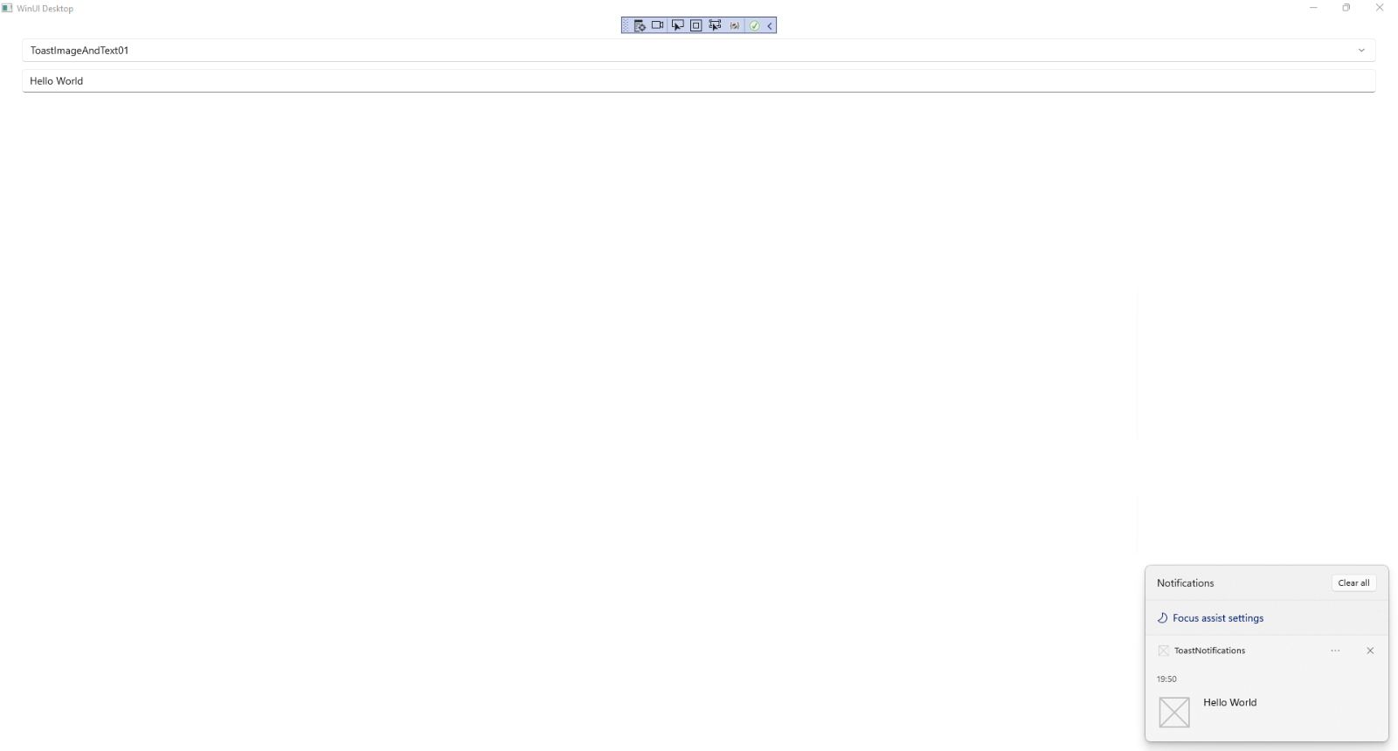

## Step 15

|  |  |
| --- | --- |
| To **Exit** the **Windows App SDK** application, select the **Close** button from the top right of the application as that concludes this **Tutorial** for **Windows App SDK** from [tutorialr.com](https://tutorialr.com)! |  |