

[](https://www.tutorialr.com/tutorials/)

Windows App SDK

Words Game





# Words Game

**Words Game** shows how you can create a game based on **Wordle** where the aim is to guess the five-letter

word with just five chances to guess correctly using toolkit from **NuGet** using the **Windows App SDK**.

## Step 1

Follow **Setup and Start** on how to get **Setup** and **Install** what you need for **Visual Studio 2022** and **Windows App SDK**.

|  |  |
| --- | --- |
| In **Windows 11** choose **Start** and then find or search for **Visual Studio 2022** and then select it. |  |
| Once **Visual Studio 2022** has started select **Create a new project**. |  |
| Then choose the **Blank App, Packages (WinUI in Desktop)** and then select **Next**. |  |
| After that in **Configure your new project** type in the **Project name** as *WordsGame*, then select a Location and then select **Create** to start a new **Solution**. |  |

## Step 2

Then in **Visual Studio** within **Solution** **Explorer** for the **Solution**, right click on the **Project** shown below the **Solution** and then select **Manage NuGet Packages…**

## Step 3

Then in the **NuGet Package Manager** from the **Browse** tab search for **Comentsys.Toolkit.WindowsAppSdk** and then select **Comentsys.Toolkit.WindowsAppSdk by Comentsys** as indicated and select **Install**

This will add the package for **Comentsys.Toolkit.WindowsAppSdk** to your **Project**. If you get the **Preview Changes** screen saying **Visual Studio is about to make changes to this solution. Click OK to proceed with the changes listed below.** You can read the message and then select **OK** to **Install** the package, then you can close the **tab** for **Nuget: WordsGame** by selecting the **x** next to it.

## Step 4

Then in **Visual Studio** within **Solution** **Explorer** for the **Solution**, right click on the **Project** shown below the **Solution** and then select **Add** then **New Item…**

## Step 5

Then in **Add New Item** from the **C# Items** list, select **Code** and then select **Code File** from the list next to this, then type in the name of *Library.cs* and then **Click** on **Add**.

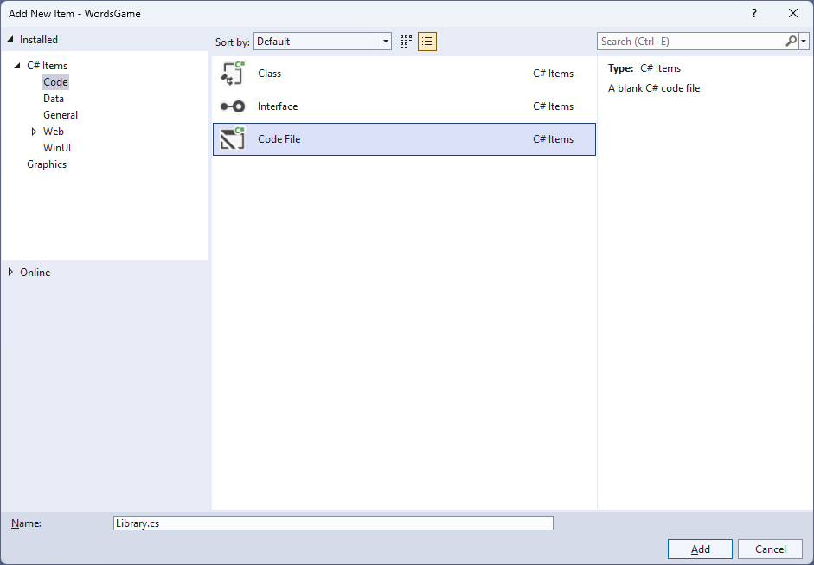

## Step 6

You will now be in the **View** for the **Code** of *Library.cs* to define a **namespace** allowing classes to be defined together, usually each is separate but will be defined in *Library.cs* by typing the following **Code** for **using** for **Comentsys.Toolkit.WindowsAppSdk** and others plus an **enum** for **State**.

using Comentsys.Toolkit.Binding;

using Comentsys.Toolkit.WindowsAppSdk;

using Microsoft.UI;

using Microsoft.UI.Xaml;

using Microsoft.UI.Xaml.Controls;

using Microsoft.UI.Xaml.Data;

using Microsoft.UI.Xaml.Media;

using System;

using System.Collections.Generic;

using System.Collections.ObjectModel;

using System.IO;

using System.Linq;

using System.Net.Http;

using System.Threading.Tasks;

namespace WordsGame;

public enum State

{

Key,

Empty,

Absent,

Present,

Correct

}

// Position Class

// Item Class

// StateToBrushConvertor Class

// ItemTemplateSelector Class

// Words Class

public class Library

{

// Library Constants, Variables & GetIndexes Method

// Library ListCurrent, GetCurrent, Set & Check Method

// Library Over & Select Method

// Layout Method

// Setup, Load, Accept & New Methods

}

## Step 7

Still in *Library.cs* for the **namespace** of **WordsGame** in *Library.cs* you will define a **class** for **Position** after the **Comment** of **// Position Class** by typing the following:

public class Position : ObservableBase

{

private int _row;

private int _column;

private char _letter;

public Position(int row, int column, char letter) =>

(_column, _row, _letter) = (column, row, letter);

public int Row

{

get => _row;

set => SetProperty(ref _row, value);

}

public int Column

{

get => _column;

set => SetProperty(ref _column, value);

}

public char Letter

{

get => _letter;

set => SetProperty(ref _letter, value);

}

}

**Position** represents a **Row** and **Column** along with the **Letter** and uses **ObservableBase** from the package of **Comentsys.Toolkit.WindowsAppSdk.**

## Step 8

Still in *Library.cs* for the **namespace** of **WordsGame** in *Library.cs* you will define a **class** for **Item** after the **Comment** of **// Item Class** by typing the following:

public class Item : ActionCommandObservableBase

{

private State _state;

private Position _position;

public Item(Position position, State state) : base(null) =>

(_position, State) = (position, state);

public Item(Position position, State state, Action<Position> action) :

base(new ActionCommandHandler((param) => action(position))) =>

(_position, State) = (position, state);

public Position Position

{

get => _position;

set => SetProperty(ref _position, value);

}

public State State

{

get => _state;

set => SetProperty(ref _state, value);

}

}

**Item** has **Properties** for **Position** and **State** uses **ActionCommandObservableBase** from the package of **Comentsys.Toolkit.WindowsAppSdk.**

## Step 9

Still in *Library.cs* for the **namespace** of **WordsGame** in *Library.cs* you will define a **class** after the **Comment** of **// StateToBrushConverter Class** by typing the following:

public class StateToBrushConverter : IValueConverter

{

public object Convert(object value, Type targetType,

object parameter, string language)

{

if (value is State state)

{

return new SolidColorBrush(value switch

{

State.Empty => Colors.White,

State.Absent => Colors.DarkGray,

State.Present => Colors.DarkKhaki,

State.Correct => Colors.DarkSeaGreen,

_ => Colors.LightGray

});

}

return null;

}

public object ConvertBack(object value, Type targetType,

object parameter, string language) =>

throw new NotImplementedException();

}

**StateToBrushConverter** uses the **interface** of **IValueConverter** for **Data Binding** which will allow the colours of the **Item** in the game to be represented from either *White*, *Dark Grey*, *Dark Khaki*, *Dark Sea Green* or *Light Grey* as a **SolidColorBrush**.

## Step 10

Still in *Library.cs* for the **namespace** of **WordsGame** in *Library.cs* you will define a **class** after the **Comment** of **// ItemTemplateSelector Class** by typing the following:

public class ItemTemplateSelector : DataTemplateSelector

{

public DataTemplate SpacerItem { get; set; }

public DataTemplate KeyItem { get; set; }

protected override DataTemplate SelectTemplateCore

(object value, DependencyObject container) =>

value is Item item ? item?.Command != null ?

KeyItem : SpacerItem : null;

}

**ItemTemplateSelector** will be used to provide a different **DataTemplate** depending on whether the **Command** has been set on an **Item**, this will be useful when creating the **Keyboard** used in the game.

## Step 11

Still in *Library.cs* for the **namespace** of **WordsGame** in *Library.cs* you will define a **class** after the **Comment** of **// Words Class** by typing the following which will use **HttpClient** to get a list of **Words** for the game:

public class Words

{

private const string request = "https://raw.githubusercontent.com/tutorialr/winappsdk-tutorials/main/Code/WordsGame/words.txt";

private readonly List<string> _results = new();

private readonly HttpClient _client = new();

public async Task RequestAsync()

{

try

{

_results.Clear();

var response = await _client.GetStreamAsync(request);

using var reader = new StreamReader(response);

while (!reader.EndOfStream)

{

var word = await reader.ReadLineAsync();

if (word != null)

_results.Add(word);

}

}

catch { }

}

public List<string> Response => _results;

}

## Step 12

While still in the **namespace** of **WordsGame** in *Library.cs* and in the **class** of **Library** after the **Comment** of **// Library Constants, Variables & GetIndexes Method** type the following **Constants**, **Variables** and **Method**:

private const string title = "Words Game";

private const char backspace = '**⌫**';

private const char empty = ' ';

private const int count = 5;

private const int keys = 11;

private const int rows = 3;

private readonly Words _words = new();

private readonly ObservableCollection<Item> _keys = new();

private readonly ObservableCollection<Item> _items = new();

private readonly Random _random = new((int)DateTime.UtcNow.Ticks);

private readonly List<char> _letters = new()

{

'Q', 'W', 'E', 'R', 'T', 'Y', 'U', 'I', 'O', 'P', backspace,

empty, 'A', 'S', 'D', 'F', 'G', 'H', 'J', 'K', 'L', empty,

empty, empty, 'Z', 'X', 'C', 'V', 'B', 'N', 'M', empty, empty

};

private Dialog _dialog;

private string _word;

private bool _winner;

private int _column;

private int _row;

public static IEnumerable<int> GetIndexes(string source, char target)

{

int index = source.IndexOf(target);

while (index != -1)

{

yield return index;

index = source.IndexOf(target, index + 1);

}

}

**Constants** are values that are used in the game that will not change, **Variables** are values that will be changed in the game and the **Method** of **GetIndex** is used to get the positions of characters in a **string**.

## Step 13

While still in the **namespace** of **WordsGame** in *Library.cs* and in the **class** of **Library** after the **Comment** of **// Library ListCurrent, GetCurrent, Set & Check Method** type the following **Methods**:

private IEnumerable<Item> ListCurrent() =>

_items.Where(f => f.Position.Row == _row);

private Item GetCurrent() =>

_items.FirstOrDefault(

f => f.Position.Row == _row

&& f.Position.Column == _column);

private void Set(Position position, State state)

{

var key = _keys.FirstOrDefault(

f => f.Position.Letter == position.Letter);

if (key != null)

key.State = state;

var item = _items.FirstOrDefault(

f => f.Position.Row == _row

&& f.Position.Column == position.Column

&& f.Position.Letter == position.Letter);

if (item != null)

{

item.Position.Letter = position.Letter;

item.State = state;

}

}

private bool Check()

{

var current = ListCurrent();

foreach(var item in current)

{

var state = State.Absent;

var indexes = GetIndexes(_word, item.Position.Letter);

if(indexes?.Any() == true)

{

foreach (var index in indexes)

{

state = item.Position.Column == index ?

State.Correct : State.Present;

}

}

Set(item.Position, state);

}

var word = string.Join(string.Empty, current.Select(s => s.Position.Letter));

_winner = _word.Equals(word, StringComparison.InvariantCultureIgnoreCase);

return _winner;

}

**ListCurrent** is used to return the items for a given **Row** with **GetCurrent** returning an **Item** for a given **Row** and **Column** plus **Set** is used to update the **State** for the **Keyboard** and **Display** of items and **Check** is used to determine if the letters are there, in right place or not present at all in the **Word** to guess.

## Step 14

While still in the **namespace** of **WordsGame** in *Library.cs* and in the **class** of **Library** after the **Comment** of **// Library Over & Select Method** type the following **Methods**:

private bool Over()

{

if (_row == count)

{

_dialog.Show($"Game Over! You did not get the word {_word}!");

return true;

}

else if(_winner)

{

_dialog.Show($"Game Over! You got the word {_word} correct!");

return true;

}

return false;

}

private void Select(Position position)

{

if (!Over())

{

if (position.Letter == backspace)

{

if (_column > 0)

{

_column--;

var current = GetCurrent();

if (current != null)

{

current.State = State.Empty;

current.Position.Letter = empty;

}

}

}

else

{

if (_column < count)

{

var current = GetCurrent();

if (current != null)

{

current.State = State.Key;

current.Position.Letter = position.Letter;

_column++;

}

}

}

}

}

**Over** is used to check if the game has been completed and show the appropriate message using a **Dialog** and **Select** is used when choosing a letter or using the **backspace** option.

## Step 15

While still in the **namespace** of **WordsGame** in *Library.cs* and in the **class** of **Library** after the **Comment** of **// Library Layout Method** type the following **Method**:

private void Layout(ItemsControl display, ItemsControl keyboard)

{

int index = 0;

_keys.Clear();

_items.Clear();

for (int row = 0; row < count; row++)

{

for (int column = 0; column < count; column++)

{

_items.Add(new Item(

new Position(column, row, empty),

State.Empty));

}

}

display.ItemsSource = _items;

for (int row = 0; row < rows; row++)

{

for (int column = 0; column < keys; column++)

{

var letter = _letters[index];

var position = new Position(row, column, letter);

if (letter == empty)

_keys.Add(new Item(position,

State.Empty));

else

_keys.Add(new Item(position,

State.Key, (Position p) => Select(p)));

index++;

}

}

keyboard.ItemsSource = _keys;

}

**Layout** is used to create the look and feel of the game including configuring the **Display** and **Keyboard** elements used in the game which use an **ItemsControl**.

## Step 16

While still in the **namespace** of **WordsGame** in *Library.cs* and in the **class** of **Library** after the **Comment** of **// Setup, Load, Accept & New Method** type in the following **Methods** for **Setup** and **Load** which will initialise the game and list of **Words** plus **Accept** to confirm the input **Word** and **New** to start a new game.

private void Setup()

{

_row = 0;

_column = 0;

_winner = false;

var total = _words.Response.Count;

if (total > 0)

{

var choice = _random.Next(0, total - 1);

_word = _words.Response[choice];

foreach (var key in _keys)

key.State = State.Key;

foreach (var item in _items)

{

item.State = State.Empty;

item.Position.Letter = empty;

}

}

else

_dialog.Show("Failed to load Word List!");

}

public async void Load(ItemsControl display, ItemsControl keyboard)

{

_dialog = new Dialog(display.XamlRoot, title);

await _words.RequestAsync();

Layout(display, keyboard);

Setup();

}

public void Accept()

{

if(_row < count)

{

if (_column == count)

{

if (!Check())

{

_column = 0;

_row++;

}

}

else

_dialog.Show("Not enough letters");

}

Over();

}

public void New() =>

Setup();

## Step 17

|  |  |
| --- | --- |
| Then from **Solution** **Explorer** for the **Solution** double-click on **MainWindow.xaml** to see the **XAML** for the **Main Window**. |  |

## Step 18

In the **XAML** for **MainWindow.xaml** there be some **XAML** for a **StackPanel**, this should be **Removed** by removing the following:

<StackPanel Orientation="Horizontal"

HorizontalAlignment="Center" VerticalAlignment="Center">

<Button x:Name="myButton" Click="myButton_Click">Click Me</Button>

</StackPanel>

## Step 19

While still in the **XAML** for **MainWindow.xaml** below **<Window**, type in the following **XAML**:

xmlns:ui="using:Comentsys.Toolkit.WindowsAppSdk"

The **XAML** for **<Window>** should then look as follows:

<Window

xmlns:ui="using:Comentsys.Toolkit.WindowsAppSdk"

x:Class="WordsGame.MainWindow"

xmlns="http://schemas.microsoft.com/winfx/2006/xaml/presentation"

xmlns:x="http://schemas.microsoft.com/winfx/2006/xaml"

xmlns:local="using:WordsGame"

xmlns:d="http://schemas.microsoft.com/expression/blend/2008"

xmlns:mc="http://schemas.openxmlformats.org/markup-compatibility/2006"

mc:Ignorable="d">

## Step 20

While still in the **XAML** for **MainWindow.xaml** above **</Window>**, type in the following **XAML**:

<Grid>

<Grid.Resources>

<local:StateToBrushConverter x:Key="StateToBrushConverter"/>

<DataTemplate x:Name="ItemTemplate">

<ui:Piece IsSquare="True"

Stroke="LightGray"

Value="{Binding Position.Letter}"

Fill="{Binding State, Mode=OneWay,

Converter={StaticResource StateToBrushConverter},

ConverterParameter=True}" />

</DataTemplate>

<DataTemplate x:Name="KeyTemplate">

<Button Command="{Binding Command}">

<ui:Piece IsSquare="True"

Value="{Binding Position.Letter}"

Fill="{Binding State, Mode=OneWay,

Converter={StaticResource StateToBrushConverter},

ConverterParameter=True}" />

</Button>

</DataTemplate>

<DataTemplate x:Name="SpacerTemplate">

<Grid/>

</DataTemplate>

<local:ItemTemplateSelector x:Key="ItemTemplateSelector"

KeyItem="{StaticResource KeyTemplate}"

SpacerItem="{StaticResource SpacerTemplate}"/>

</Grid.Resources>

<Viewbox>

<!-- StackPanel -->

</Viewbox>

<CommandBar VerticalAlignment="Bottom">

<AppBarButton Icon="Accept" Label="Accept" Click="Accept"/>

<AppBarButton Icon="Page2" Label="New" Click="New"/>

</CommandBar>

</Grid>

This **XAML** contains a **Grid** with a **Viewbox** which will scale a **StackPanel** to be added in the next **Step**. It has an event handler for **Accept** and **New** for each **AppBarButton** and defines the **Templates** that will be used in the game.

## Step 21

While still in the **XAML** for **MainWindow.xaml** below the **Comment** of **<!-- StackPanel -->** type in the following **XAML**:

<StackPanel Margin="50" Orientation="Vertical" Loaded="Load">

<ItemsControl Name="Display" Margin="10"

HorizontalAlignment="Center"

ItemTemplate="{StaticResource ItemTemplate}">

<ItemsControl.ItemsPanel>

<ItemsPanelTemplate>

<VariableSizedWrapGrid MaximumRowsOrColumns="5"/>

</ItemsPanelTemplate>

</ItemsControl.ItemsPanel>

<ProgressRing/>

</ItemsControl>

<ItemsControl Name="Keyboard" Margin="10"

HorizontalAlignment="Center"

ItemTemplateSelector="{StaticResource ItemTemplateSelector}">

<ItemsControl.ItemsPanel>

<ItemsPanelTemplate>

<ItemsWrapGrid MaximumRowsOrColumns="11"

Orientation="Horizontal"/>

</ItemsPanelTemplate>

</ItemsControl.ItemsPanel>

</ItemsControl>

</StackPanel>

This **XAML** contains a **StackPanel** with a **Loaded** event handler for **Load** with the **ItemsPanel** for it set to use a **VariableSizedWrapGrid** and **ItemsWrapGrid** and uses the **ItemTemplate** and the previously defined **class** of **ItemTemplateSelector**.

## Step 22

|  |  |
| --- | --- |
| Then, within **Solution** **Explorer** for the **Solution** select the arrow next to **MainWindow.xaml** then double-click on **MainWindow.xaml.cs** to see the **Code** for the **Main Window**. |  |

## Step 23

In the **Code** for **MainWindow.xaml.cs** there be a **Method** of **myButton_Click(...)** this should be **Removed** by removing the following:

private void myButton_Click(object sender, RoutedEventArgs e)

{

myButton.Content = "Clicked";

}

## Step 24

Once **myButton_Click(...)** has been removed, type in the following **Code** below the end of the **Constructor** of **public MainWindow() { ... }**:

private readonly Library _library = new();

private void Load(object sender, RoutedEventArgs e) =>

_library.Load(Display, Keyboard);

private void Accept(object sender, RoutedEventArgs e) =>

_library.Accept();

private void New(object sender, RoutedEventArgs e) =>

_library.New();

Here an **Instance** of the **Class** of **Library** is created then below this are the **Methods** of **Load**, **Accept** and **New** that will be used with **Event Handler** from the **XAML**, these **Methods** use Arrow Syntax with the **=>** for an Expression Bodywhich is useful when a **Method** only has one line.

## Step 25

|  |  |
| --- | --- |
| That completes the **Windows App SDK** application. In **Visual Studio 2022** from the **Toolbar** select **WordsGame (Package)** to **Start** the application. |  |

## Step 26

Once running you can then use the on-screen **Keyboard** to enter a **Word** with *5* letters and then use *Accept* then you will see which letters are in the correct position in *Green,* are in the **Word** but in the wrong position in *Yellow* or *Dark Grey* if no letters are in the **Word** and you get *5* chances to guess or you lose so guess correctly to win or you can select *New* to start a new game.

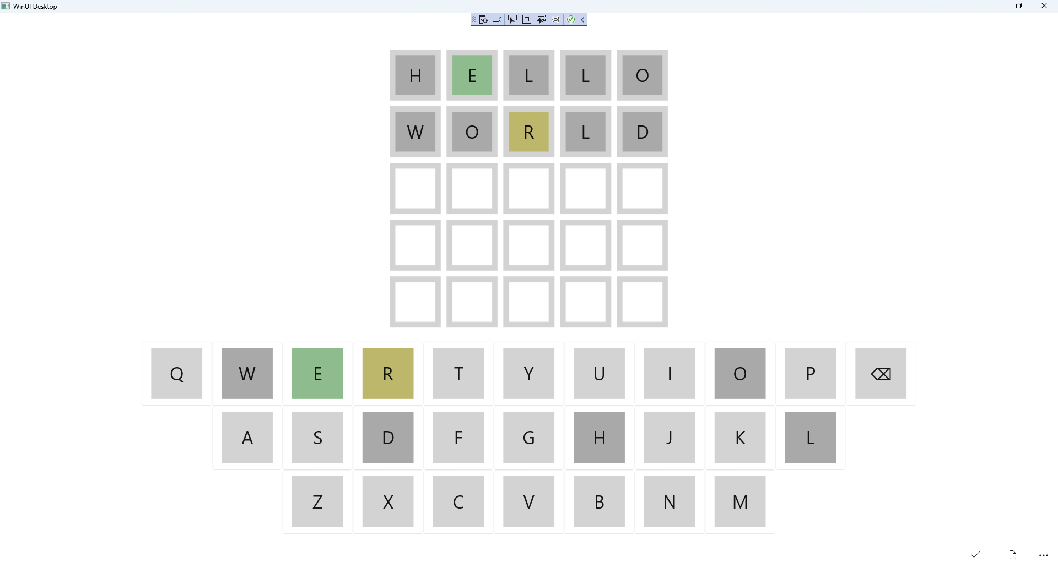

## Step 27

|  |  |
| --- | --- |
| To **Exit** the **Windows App SDK** application, select the **Close** button from the top right of the application as that concludes this **Tutorial** for **Windows App SDK** from [tutorialr.com](https://tutorialr.com)! |  |