

[](https://www.tutorialr.com/tutorials/)

Windows App SDK

Yatzy Game





# Yatzy Game

**Yatzy Game** shows how to create a dice game based on **Yacht** or **Yahtzee** using a toolkit from **NuGet**

using the **Windows App SDK**.

## Step 1

Follow **Setup and Start** on how to get **Setup** and **Install** what you need for **Visual Studio 2022** and **Windows App SDK**.

|  |  |
| --- | --- |
| In **Windows 11** choose **Start** and then find or search for **Visual Studio 2022** and then select it. |  |
| Once **Visual Studio 2022** has started select **Create a new project**. |  |
| Then choose the **Blank App, Packages (WinUI in Desktop)** and then select **Next**. |  |
| After that in **Configure your new project** type in the **Project name** as *YatzyGame*, then select a Location and then select **Create** to start a new **Solution**. |  |

## Step 2

Then in **Visual Studio** within **Solution** **Explorer** for the **Solution**, right click on the **Project** shown below the **Solution** and then select **Manage NuGet Packages…**

## Step 3

Then in the **NuGet Package Manager** from the **Browse** tab search for **Comentsys.Toolkit.WindowsAppSdk** and then select **Comentsys.Toolkit.WindowsAppSdk by Comentsys** as indicated and select **Install**

This will add the package for **Comentsys.Toolkit.WindowsAppSdk** to your **Project**. If you get the **Preview Changes** screen saying **Visual Studio is about to make changes to this solution. Click OK to proceed with the changes listed below.** You can read the message and then select **OK** to **Install** the package, then you can close the **tab** for **Nuget: YatzyGame** by selecting the **x** next to it.

## Step 4

Then in **Visual Studio** within **Solution** **Explorer** for the **Solution**, right click on the **Project** shown below the **Solution** and then select **Add** then **New Item…**

## Step 5

Then in **Add New Item** from the **C# Items** list, select **Code** and then select **Code File** from the list next to this, then type in the name of *Library.cs* and then **Click** on **Add**.

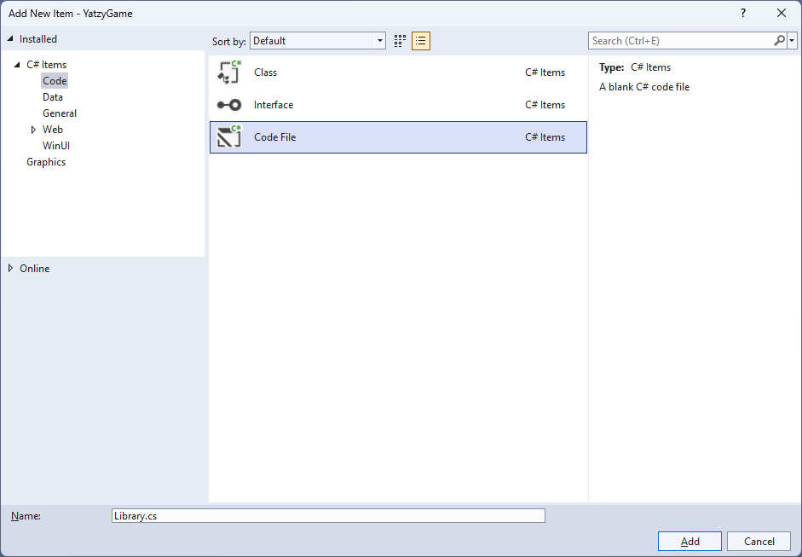

## Step 6

You will now be in the **View** for the **Code** of *Library.cs* and then you need to type the following **Code**:

// Usings & Namespace

public enum ScoreType

{

AcesScore, TwosScore, ThreesScore, FoursScore, FivesScore,

SixesScore, UpperTotalScore, UpperTotalBonusScore, ThreeOfAKindScore,

FourOfAKindScore, FullHouseScore, SmallStraightScore, LargeStraightScore,

YahtzeeScore, ChanceScore, YahtzeeBonusScore, LowerTotalScore, TotalScore

}

// Extensions Class

// Item Class

// Option Class

public class Calculate

{

// Calculate GetAddUp, GetOfAKind & GetFullHouse Method

// Calculate GetSmallStraight & GetLargeStraight Method

// Calculate Get GetYahtzee & GetChance Method

}

public class Board // : ActionCommandObservableBase

{

// Board Constants, Variables, Properties and Choose, SetScore & GetScore Method

// Board Clear & Reset Method

// Board SetTotal & AddUpDice Method

// Board SetValueOfAKind Method

// Board SetItemScore Method

// Board SetYahtzee Method

// Board SetChance, SetBonus & New Method

// Board Roll Method

// Board Constructor

}

// OptionTemplateSelector Class

// Library Class

## Step 7

Still in *Library.cs* you will define a **namespace** which allows classes to be defined together, usually each is separate but will be defined in *Library.cs* along with adding **using** statements below the **Comment** of **// Usings & Namespace** by typing the following **Code**:

using Comentsys.Toolkit.Binding;

using Comentsys.Toolkit.WindowsAppSdk;

using Microsoft.UI.Xaml;

using Microsoft.UI.Xaml.Controls;

using System;

using System.Collections.Generic;

using System.Linq;

using System.Text.RegularExpressions;

using System.Threading.Tasks;

namespace YatzyGame;

The **using** statements including ones for the package of **Comentsys.Toolkit.Binding** and **Comentsys.Toolkit.WindowsAppSdk** along with the **namespace** for **YatzyGame**.

## Step 8

Still in *Library.cs* for the **namespace** of **YatzyGame** in *Library.cs* you will define a **class** for **Extensions** after the **Comment** of **// Extensions Class** by typing the following:

public static class Extensions

{

private const string space = " ";

private const string score = "Score";

private static readonly Regex regex = new(@"\p{Lu}\p{Ll}*");

public static string Name(this ScoreType type) =>

string.Join(space, regex

.Matches(Enum.GetName(typeof(ScoreType), type)

.Replace(score, string.Empty))

.Select(s => s.Value));

public static string Name(this ScoreType type, int take) =>

string.Join(space, regex

.Matches(Enum.GetName(typeof(ScoreType), type))

.Select(s => s.Value)

.Take(take));

}

**Extensions** will provide formatting capabilities for outputting the values for elements in the game.

## Step 9

Still in *Library.cs* for the **namespace** of **YatzyGame** in *Library.cs* you will define a **class** for **Item** after the **Comment** of **// Item Class** by typing the following:

public class Item : ActionCommandObservableBase

{

private int _value;

private bool _hold;

public int Index { get; }

public int Value { get => _value; set => SetProperty(ref _value, value); }

public bool Hold { get => _hold; set => SetProperty(ref _hold, value); }

public Item(int index, Action<int> action) :

base(new ActionCommandHandler((param) =>

action((param as Item).Index),

(param) => (param as Item).IsEnabled)) =>

(Index, Value) = (index, index + 1);

}

**Item** has **Properties** for **Index**, **Value** and **State** plus uses **ActionCommandObservableBase** from the package of **Comentsys.Toolkit.WindowsAppSdk.**

## Step 10

Still in *Library.cs* for the **namespace** of **YatzyGame** in *Library.cs* you will define a **class** for **Option** after the **Comment** of **// Option Class** by typing the following:

public class Option : ActionCommandObservableBase

{

private int _score;

public int Score { get => _score; set => SetProperty(ref _score, value); }

public ScoreType Type { get; }

public string Content => Type.Name();

public Option(ScoreType type) : base(null) =>

Type = type;

public Option(ScoreType type, Action<object> action) :

base(new ActionCommandHandler((param) =>

action(null),

(param) => (param as Option).IsEnabled)) =>

Type = type;

}

**Option** has **Properties** for **Score**, **Type** and **Content** and also uses **ActionCommandObservableBase** from the package of **Comentsys.Toolkit.WindowsAppSdk.**

## Step 11

While still in the **namespace** of **YatzyGame** in *Library.cs* and in the **class** of **Calculate** after the **Comment** of **// Calculate GetAddUp, GetOfAKind & GetFullHouse Method** type the following **Methods**:

public static int GetAddUp(Item[] dice, int value)

{

int sum = 0;

foreach(var item in dice.Where(w => w.Value == value))

sum += value;

return sum;

}

public static int GetOfAKind(Item[] dice, int value)

{

int sum = 0;

bool result = false;

for (int i = 1; i <= 6; i++)

{

int count = 0;

for (int j = 0; j < 5; j++)

{

if (dice[j].Value == i)

count++;

if (count > value)

result = true;

}

}

if(result)

{

foreach (var item in dice)

sum += item.Value;

}

return sum;

}

public static int GetFullHouse(Item[] dice)

{

int sum = 0;

int[] item = dice.Select(s => s.Value).ToArray();

Array.Sort(item);

if (((item[0] == item[1]) && (item[1] == item[2]) && // Three of a Kind

(item[3] == item[4]) && // Two of a Kind

(item[2] != item[3])) ||

((item[0] == item[1]) && // Two of a Kind

(item[2] == item[3]) && (item[3] == item[4]) && // Three of a Kind

(item[1] != item[2])))

sum = 25;

return sum;

}

**GetAddUp** will add up the values for the items, **GetOfAKind** will add up values for all the items of a given kind, passed in as value and **GetFullHouse** will see if the items make up a full house.

## Step 12

While still in the **namespace** of **YatzyGame** in *Library.cs* and in the **class** of **Calculate** after the **Comment** of **// Calculate GetSmallStraight & GetLargeStraight Method** type the following **Methods**:

public static int GetSmallStraight(Item[] dice)

{

int sort = 0;

int[] item = dice.Select(s => s.Value).ToArray();

Array.Sort(item);

for (int j = 0; j < 4; j++)

{

int value = 0;

if (item[j] == item[j + 1])

{

value = item[j];

for (int k = j; k < 4; k++)

item[k] = item[k + 1];

item[4] = value;

}

}

if (((item[0] == 1) && (item[1] == 2) && (item[2] == 3) && (item[3] == 4)) ||

((item[0] == 2) && (item[1] == 3) && (item[2] == 4) && (item[3] == 5)) ||

((item[0] == 3) && (item[1] == 4) && (item[2] == 5) && (item[3] == 6)) ||

((item[1] == 1) && (item[2] == 2) && (item[3] == 3) && (item[4] == 4)) ||

((item[1] == 2) && (item[2] == 3) && (item[3] == 4) && (item[4] == 5)) ||

((item[1] == 3) && (item[2] == 4) && (item[3] == 5) && (item[4] == 6)))

sort = 30;

return sort;

}

public static int GetLargeStraight(Item[] dice)

{

int sum = 0;

int[] i = dice.Select(s => s.Value).ToArray();

Array.Sort(i);

if (((i[0] == 1) && (i[1] == 2) && (i[2] == 3) && (i[3] == 4) && (i[4] == 5)) ||

((i[0] == 2) && (i[1] == 3) && (i[2] == 4) && (i[3] == 5) && (i[4] == 6)))

sum = 40;

return sum;

}

**GetSmallStraight** and **GetLargeStraight** will calculate those values for the game and return the score.

## Step 13

While still in the **namespace** of **YatzyGame** in *Library.cs* and in the **class** of **Calculate** after the **Comment** of **// Calculate Get GetYahtzee & GetChance Method** type the following **Methods**:

public static int GetYahtzee(Item[] dice)

{

int sum = 0;

for (int i = 1; i <= 6; i++)

{

int Count = 0;

for (int j = 0; j < 5; j++)

{

if (dice[j].Value == i)

Count++;

if (Count > 4)

sum = 50;

}

}

return sum;

}

public static int GetChance(Item[] dice)

{

int sum = 0;

for (int i = 0; i < 5; i++)

sum += dice[i].Value;

return sum;

}

**GetYahtzee** will work out if the result is a **Yahtzee** and **GetChance** will work out the chance score.

## Step 14

While still in the **namespace** of **YatzyGame** in *Library.cs* and in the **class** of **Board** remove the **//** between **Board** and **: ActionCommandObservableBase** so that the top of the **class** of **Board** appears as follows:

public class Board : ActionCommandObservableBase

You will then provide what is needed for **ActionCommandObservableBase** to resolve the error of *There is no argument given that corresponds to the required parameter 'handler'* and define the rest of the **class** of **Board** in the following **Steps**.

## Step 15

While still in the **namespace** of **YatzyGame** in *Library.cs* and in the **class** of **Board** after the **Comment** of **// Constants, Variables, Properties and Choose, SetScore & GetScore Method** type the following **Constants**, **Variables**, **Properties** and **Methods**:

private const int dice = 5;

private const int count = 14;

private const string accept = "Accept?";

private readonly Random _random = new((int)DateTime.UtcNow.Ticks);

private readonly Func<string, Task<bool>> _confirm = null;

private List<Option> _options;

private Item[] _dice;

private int _rolls;

private int _count;

private int _total;

private int _upper;

private int _lower;

private int _bonus;

public List<Option> Options { get => _options; set => SetProperty(ref _options, value); }

public Item[] Dice { get => _dice; set => SetProperty(ref _dice, value); }

private List<int> Choose(int minimum, int maximum, int total)

{

var choose = new List<int>();

var values = Enumerable.Range(minimum, maximum).ToList();

for (int index = 0; index < total; index++)

{

var value = _random.Next(0, values.Count);

choose.Add(values[value]);

}

return choose;

}

private void SetScore(ScoreType type, int value)

{

var score = Options.FirstOrDefault(f => f.Type == type);

if(score != null)

score.Score = value;

}

private int GetScore(ScoreType type) =>

Options.FirstOrDefault(f => f.Type == type)?.Score ?? 0;

**Constants** are values that are used in the game that will not change, **Variables** are values that will be changed in the game of which some are exposed as **Properties**. The **Method** of **Choose** is used to a list of randomised numbers and **SetScore** is used to update the score for an **Option** and **GetScore** will obtain a score for an **Option**. You will also have an error *There is no argument given that corresponds to the required parameter 'handler'* this will be resolved when you add the **Constructor** in a later **Step**.

## Step 16

While still in the **namespace** of **YatzyGame** in *Library.cs* and in the **class** of **Board** after the **Comment** of **// Board Clear & Reset Method** type the following **Methods**:

private void Clear()

{

_rolls = 0;

_count = 0;

_total = 0;

_upper = 0;

_lower = 0;

_bonus = 0;

foreach (ScoreType type in Enum.GetValues(typeof(ScoreType)))

SetScore(type, 0);

int value = 1;

foreach(var dice in Dice)

{

dice.Hold = false;

dice.Value = value++;

dice.IsEnabled = false;

}

foreach (var option in Options)

option.IsEnabled = false;

IsEnabled = true;

}

private async Task Reset()

{

_rolls = 0;

_count++;

foreach(var dice in _dice)

dice.Hold = false;

SetScore(ScoreType.UpperTotalScore, _upper);

SetScore(ScoreType.UpperTotalBonusScore, _bonus);

SetScore(ScoreType.LowerTotalScore, _lower);

SetScore(ScoreType.TotalScore, _total);

if(_count == count)

{

int total = GetScore(ScoreType.TotalScore);

bool result = await _confirm($"Game Over, Score {total}. Play again?");

if(result)

Clear();

}

}

**Clear** is used to reset all scores and uses **SetScore** and **Reset** resets all totals in the game.

## Step 17

While still in the **namespace** of **YatzyGame** in *Library.cs* and in the **class** of **Board** after the **Comment** of **// Board SetTotal & AddUpDice Method** type the following **Methods**:

private void SetTotal(int score, bool isUpper)

{

var isBonus = false;

if (isUpper)

{

_upper += score;

if (_upper >= 63)

isBonus = true;

}

else

_lower += score;

_total = 0;

_total += _upper;

if (isBonus)

{

_bonus = 35;

_total += _bonus;

}

_total += _lower;

}

private async void AddUpDice(ScoreType type, int value)

{

int score = GetScore(type);

if (_rolls > 0 && score == 0)

{

int total = Calculate.GetAddUp(_dice, value);

bool result = await _confirm($"Total is {total}. {accept}");

if (result)

{

SetScore(type, total);

SetTotal(total, true);

await Reset();

}

}

}

**SetTotal** is used to set the total score value and **AddUpDice** is used to get the scores from the **Dice**.

## Step 18

While still in the **namespace** of **YatzyGame** in *Library.cs* and in the **class** of **Board** after the **Comment** of **// Board SetValueOfAKind Method** type the following **Method**:

private async void SetValueOfAKind(ScoreType type, int value)

{

string name = type.Name(1);

int score = GetScore(type);

if (_count > 0 && score == 0)

{

int total = Calculate.GetOfAKind(_dice, value - 1);

if (total != 0)

{

bool result = await _confirm($"Total is {total}. {accept}");

if (result)

{

SetScore(type, total);

SetTotal(total, false);

await Reset();

}

}

else

{

bool result = await _confirm($"No {name} of a Kind. {accept}");

if (result)

{

SetScore(type, 0);

SetTotal(total, false);

await Reset();

}

}

}

}

**SetValueOfAKind** is used to set the values where the **Dice** are of the same kind.

## Step 19

While still in the **namespace** of **YatzyGame** in *Library.cs* and in the **class** of **Board** after the **Comment** of **// Board SetItemScore Method** type the following **Method**:

private async void SetItemScore(ScoreType type, int value)

{

string name = type.Name();

int score = GetScore(type);

if ((_rolls > 0) && (score == 0))

{

int total = type switch

{

ScoreType.FullHouseScore => Calculate.GetFullHouse(_dice),

ScoreType.SmallStraightScore => Calculate.GetSmallStraight(_dice),

ScoreType.LargeStraightScore => Calculate.GetLargeStraight(_dice),

_ => 0,

};

if (total == value)

{

SetScore(type, total);

SetTotal(total, false);

await Reset();

}

else

{

bool result = await _confirm($"No {name}. {accept}");

if (result)

{

SetScore(type, 0);

SetTotal(total, false);

await Reset();

}

}

}

}

**SetItemScore** will set the score using **GetFullHouse**, **GetSmallStraight** and **GetLargeStraight**.

## Step 20

While still in the **namespace** of **YatzyGame** in *Library.cs* and in the **class** of **Board** after the **Comment** of **// Board SetYahtzee Method** type the following **Method**:

private async void SetYahtzee()

{

int score = GetScore(ScoreType.YahtzeeScore);

if ((_rolls > 0) && (score == 0))

{

int total = Calculate.GetYahtzee(_dice);

if (total == 50)

{

SetScore(ScoreType.YahtzeeScore, total);

SetTotal(total, false);

await Reset();

}

else

{

bool result = await _confirm($"No Yahtzee. {accept}");

if (result)

{

SetScore(ScoreType.YahtzeeScore, 0);

SetScore(ScoreType.YahtzeeBonusScore, 0);

_count++;

SetTotal(total, true);

await Reset();

}

}

}

}

**SetYahtzee** will determine if the values of the **Dice** are a **Yatzee** and if so update the score accordingly.

## Step 21

While still in the **namespace** of **YatzyGame** in *Library.cs* and in the **class** of **Board** after the **Comment** of **// Board SetChance, SetBonus & New Method** type the following **Methods**:

private async void SetChance()

{

int score = GetScore(ScoreType.ChanceScore);

if ((_rolls > 0) && (score == 0))

{

int total = Calculate.GetChance(_dice);

bool result = await _confirm($"Total is {total}. {accept}");

if (result)

{

SetScore(ScoreType.ChanceScore, total);

SetTotal(total, false);

await Reset();

}

}

}

private async void SetBonus()

{

int score = GetScore(ScoreType.YahtzeeScore);

int bonus = GetScore(ScoreType.YahtzeeBonusScore);

if ((_rolls > 0) && (score == 0) && (bonus != 0))

{

int total = Calculate.GetYahtzee(_dice);

if (total == 50)

{

SetScore(ScoreType.YahtzeeBonusScore, 100);

SetTotal(100, false);

await Reset();

}

else

{

SetScore(ScoreType.YahtzeeBonusScore, 0);

SetTotal(0, true);

await Reset();

}

}

}

public void New() =>

Clear();

**SetChance** will be used for a chance score and **SetBonus** will be used for a bonus score with **New** using **Clear** to start a game.

## Step 22

While still in the **namespace** of **YatzyGame** in *Library.cs* and in the **class** of **Board** after the **Comment** of **// Board Roll Method** type the following **Method**:

internal void Roll()

{

if (_rolls < 3)

{

if (_rolls == 0)

{

foreach (var dice in Dice)

{

dice.IsEnabled = true;

dice.Hold = false;

}

foreach (var option in Options)

option.IsEnabled = true;

}

var values = Choose(1, 6, dice);

for (int i = 0; i < Dice.Length; i++)

{

if (!Dice[i].Hold)

Dice[i].Value = values[i];

}

_rolls++;

if (_rolls == 3)

{

foreach (var dice in Dice)

{

dice.IsEnabled = false;

dice.Hold = true;

}

IsEnabled = false;

}

}

}

**Roll** is used to roll the **Dice** used in the game and will also handle if they are held or not, this **Method** is also declared as **internal** as it will only be used within the **class** of **Board** in the next **Step** for the **Constructor**.

## Step 23

While still in the **namespace** of **YatzyGame** in *Library.cs* and in the **class** of **Board** after the **Comment** of **// Board Constructor** type the following **Constructor**:

public Board(Func<string, Task<bool>> confirm) : base(

new ActionCommandHandler((param) => (param as Board).Roll(),

(param) => (param as Board).IsEnabled))

{

IsEnabled = true;

_confirm = confirm;

_dice = new Item[dice];

for (int i = 0; i < _dice.Length; i++)

_dice[i] = new Item(i, (int i) =>

_dice[i].Hold = !_dice[i].Hold);

Options = new()

{

new Option(ScoreType.AcesScore,

(p) => AddUpDice(ScoreType.AcesScore, 1)),

new Option(ScoreType.TwosScore,

(p) => AddUpDice(ScoreType.TwosScore, 2)),

new Option(ScoreType.ThreesScore,

(p) => AddUpDice(ScoreType.ThreesScore, 3)),

new Option(ScoreType.FoursScore,

(p) => AddUpDice(ScoreType.FoursScore, 4)),

new Option(ScoreType.FivesScore,

(p) => AddUpDice(ScoreType.FivesScore, 5)),

new Option(ScoreType.SixesScore,

(p) => AddUpDice(ScoreType.SixesScore, 6)),

new Option(ScoreType.UpperTotalScore),

new Option(ScoreType.UpperTotalBonusScore),

new Option(ScoreType.ThreeOfAKindScore,

(p) => SetValueOfAKind(ScoreType.ThreeOfAKindScore, 3)),

new Option(ScoreType.FourOfAKindScore,

(p) => SetValueOfAKind(ScoreType.FourOfAKindScore, 4)),

new Option(ScoreType.FullHouseScore,

(p) => SetItemScore(ScoreType.FullHouseScore, 25)),

new Option(ScoreType.SmallStraightScore,

(p) => SetItemScore(ScoreType.SmallStraightScore, 30)),

new Option(ScoreType.LargeStraightScore,

(p) => SetItemScore(ScoreType.FullHouseScore, 25)),

new Option(ScoreType.YahtzeeScore,

(p) => SetYahtzee()),

new Option(ScoreType.ChanceScore,

(p) => SetChance()),

new Option(ScoreType.YahtzeeBonusScore,

(p) => SetBonus()),

new Option(ScoreType.LowerTotalScore),

new Option(ScoreType.TotalScore)

};

}

Once the **Constructor** has been added the error *There is no argument given that corresponds to the required parameter 'handler'* will have been resolved, as you have now provided what was needed.

## Step 24

Still in *Library.cs* for the **namespace** of **YatzyGame** in *Library.cs* you will define a **class** for **OptionTemplateSelector** after the **Comment** of **// OptionTemplateSelector Class** by typing the following:

public class OptionTemplateSelector : DataTemplateSelector

{

public DataTemplate ScoreItem { get; set; }

public DataTemplate TotalItem { get; set; }

protected override DataTemplate SelectTemplateCore(

object value, DependencyObject container) =>

value is Option item ? item.Command != null ?

ScoreItem : TotalItem : null;

}

**OptionTemplateSelector** will be used to provide a different **DataTemplate** depending on whether the **Command** has been set on an **Item**, this will be useful when displaying the output for the game as needed.

## Step 25

Still in *Library.cs* for the **namespace** of **YatzyGame** in *Library.cs* you will define a **class** for **Library** after the **Comment** of **// Library Class** by typing the following:

public class Library

{

private const string title = "Yatzy Game";

private Board _board;

private Dialog _dialog;

public void Load(StackPanel display)

{

_dialog = new Dialog(display.XamlRoot, title);

display.DataContext = _board = new Board(

(content) => _dialog.ConfirmAsync(content, "Yes", "No"));

}

public async void New()

{

var result = await _dialog.ConfirmAsync("Start a New Game?", "Yes", "No");

if(result)

_board.New();

}

}

**Library** will set the **DataContext** of the **StackPanel** to the **Board** in **Load** and **New** will begin a game.

## Step 26

|  |  |
| --- | --- |
| Then from **Solution** **Explorer** for the **Solution** double-click on **MainWindow.xaml** to see the **XAML** for the **Main Window**. |  |

## Step 27

In the **XAML** for **MainWindow.xaml** there be some **XAML** for a **StackPanel**, this should be **Removed** by removing the following:

<StackPanel Orientation="Horizontal"

HorizontalAlignment="Center" VerticalAlignment="Center">

<Button x:Name="myButton" Click="myButton_Click">Click Me</Button>

</StackPanel>

## Step 28

While still in the **XAML** for **MainWindow.xaml** below **<Window**, type in the following **XAML**:

xmlns:ui="using:Comentsys.Toolkit.WindowsAppSdk"

The **XAML** for **<Window>** should then look as follows:

<Window

xmlns:ui="using:Comentsys.Toolkit.WindowsAppSdk"

x:Class="YatzyGame.MainWindow"

xmlns="http://schemas.microsoft.com/winfx/2006/xaml/presentation"

xmlns:x="http://schemas.microsoft.com/winfx/2006/xaml"

xmlns:local="using:YatzyGame"

xmlns:d="http://schemas.microsoft.com/expression/blend/2008"

xmlns:mc="http://schemas.openxmlformats.org/markup-compatibility/2006"

mc:Ignorable="d">

## Step 29

While still in the **XAML** for **MainWindow.xaml** above **</Window>**, type in the following **XAML**:

<Grid>

<Grid.Resources>

<!-- Resources -->

</Grid.Resources>

<Viewbox>

<!-- StackPanel -->

</Viewbox>

<CommandBar VerticalAlignment="Bottom">

<AppBarButton Icon="Page2" Label="New" Click="New"/>

</CommandBar>

</Grid>

This **XAML** contains a **Grid** with a **Viewbox** which will scale a **StackPanel** to be added in a later **Step** along with using **Resources** which will be added in the next **Step** and has an **AppBarButton** set to **New**.

## Step 30

While still in the **XAML** for **MainWindow.xaml** below the **Comment** of **<!-- Resources -->** type in the following **XAML** for **Data Templates** for look-and-feel of the game along with **OptionTemplateSelector**.

<DataTemplate x:Name="DiceTemplate">

<StackPanel>

<ui:Dice Height="50" Width="50" Value="{Binding Value}"

Foreground="Red" Background="WhiteSmoke" CornerRadius="5"/>

<ToggleButton Margin="2" HorizontalAlignment="Center" Content="Hold"

IsChecked="{Binding Hold}" Command="{Binding Command}"

CommandParameter="{Binding}"/>

</StackPanel>

</DataTemplate>

<DataTemplate x:Key="ScoreTemplate">

<StackPanel>

<Grid Margin="2">

<Grid.ColumnDefinitions>

<ColumnDefinition Width="*"/>

<ColumnDefinition Width="Auto"/>

</Grid.ColumnDefinitions>

<Button Width="200" Grid.Column="0"

HorizontalContentAlignment="Left"

Content="{Binding Content}" Command="{Binding Command}"

CommandParameter="{Binding}"/>

<Grid Grid.Column="1" Background="Blue">

<TextBlock Width="75" Text="{Binding Score}"

TextAlignment="Center" VerticalAlignment="Center"

Foreground="WhiteSmoke"/>

</Grid>

</Grid>

</StackPanel>

</DataTemplate>

<DataTemplate x:Key="TotalTemplate">

<StackPanel>

<Grid Margin="2">

<Grid.ColumnDefinitions>

<ColumnDefinition Width="*"/>

<ColumnDefinition Width="Auto"/>

</Grid.ColumnDefinitions>

<TextBlock Width="200" Grid.Column="0" TextAlignment="Right"

Text="{Binding Content}" FontWeight="SemiBold"/>

<Grid Grid.Column="1">

<TextBlock Width="75" Text="{Binding Score}"

TextAlignment="Center" VerticalAlignment="Center"

Foreground="Blue"/>

</Grid>

</Grid>

</StackPanel>

</DataTemplate>

<ItemsPanelTemplate x:Name="ItemsTemplate">

<StackPanel Orientation="Horizontal"/>

</ItemsPanelTemplate>

<local:OptionTemplateSelector x:Key="OptionTemplateSelector"

ScoreItem="{StaticResource ScoreTemplate}"

TotalItem="{StaticResource TotalTemplate}" />

## Step 31

While still in the **XAML** for **MainWindow.xaml** below the **Comment** of **<!-- StackPanel -->** type in the following **XAML**:

<StackPanel Name="Display" Margin="50"

HorizontalAlignment="Center"

VerticalAlignment="Center"

Loaded="Load">

<Button Margin="2" HorizontalAlignment="Stretch" VerticalAlignment="Center"

Command="{Binding Command}" CommandParameter="{Binding}" Content="Roll"/>

<ItemsControl ItemsSource="{Binding Dice}"

ItemTemplate="{StaticResource DiceTemplate}"

ItemsPanel="{StaticResource ItemsTemplate}"/>

<ItemsControl ItemsSource="{Binding Options}" HorizontalAlignment="Center">

<ItemsControl.ItemTemplate>

<DataTemplate>

<ContentControl Content="{Binding}"

ContentTemplateSelector="{StaticResource OptionTemplateSelector}"/>

</DataTemplate>

</ItemsControl.ItemTemplate>

</ItemsControl>

</StackPanel>

This **XAML** contains a **StackPanel** with a **Loaded** event handler for **Load** it also contains a **Button** along with an **ItemsControl** for the **Dice** and the other **Buttons** and **Totals** for the game.

## Step 32

|  |  |
| --- | --- |
| Then, within **Solution** **Explorer** for the **Solution** select the arrow next to **MainWindow.xaml** then double-click on **MainWindow.xaml.cs** to see the **Code** for the **Main Window**. |  |

## Step 33

In the **Code** for **MainWindow.xaml.cs** there be a **Method** of **myButton_Click(...)** this should be **Removed** by removing the following:

private void myButton_Click(object sender, RoutedEventArgs e)

{

myButton.Content = "Clicked";

}

## Step 34

Once **myButton_Click(...)** has been removed, type in the following **Code** below the end of the **Constructor** of **public MainWindow() { ... }**:

private readonly Library _library = new();

private void Load(object sender, RoutedEventArgs e) =>

_library.Load(Display);

private void New(object sender, RoutedEventArgs e) =>

_library.New();

Here an **Instance** of the **Class** of **Library** is created then below this are the **Methods** of **Load** and **New** that will be used with **Event Handler** from the **XAML**, these **Methods** use Arrow Syntax with the **=>** for an Expression Bodywhich is useful when a **Method** only has one line.

## Step 35

|  |  |
| --- | --- |
| That completes the **Windows App SDK** application. In **Visual Studio 2022** from the **Toolbar** select **YatzyGame (Package)** to **Start** the application. |  |

## Step 36

Once running you can select *Roll* to randomly select the values for the **Dice** and you can use the other **Buttons** to total up your score based on the values of the **Dice**, or you can select *New* to start a new game.

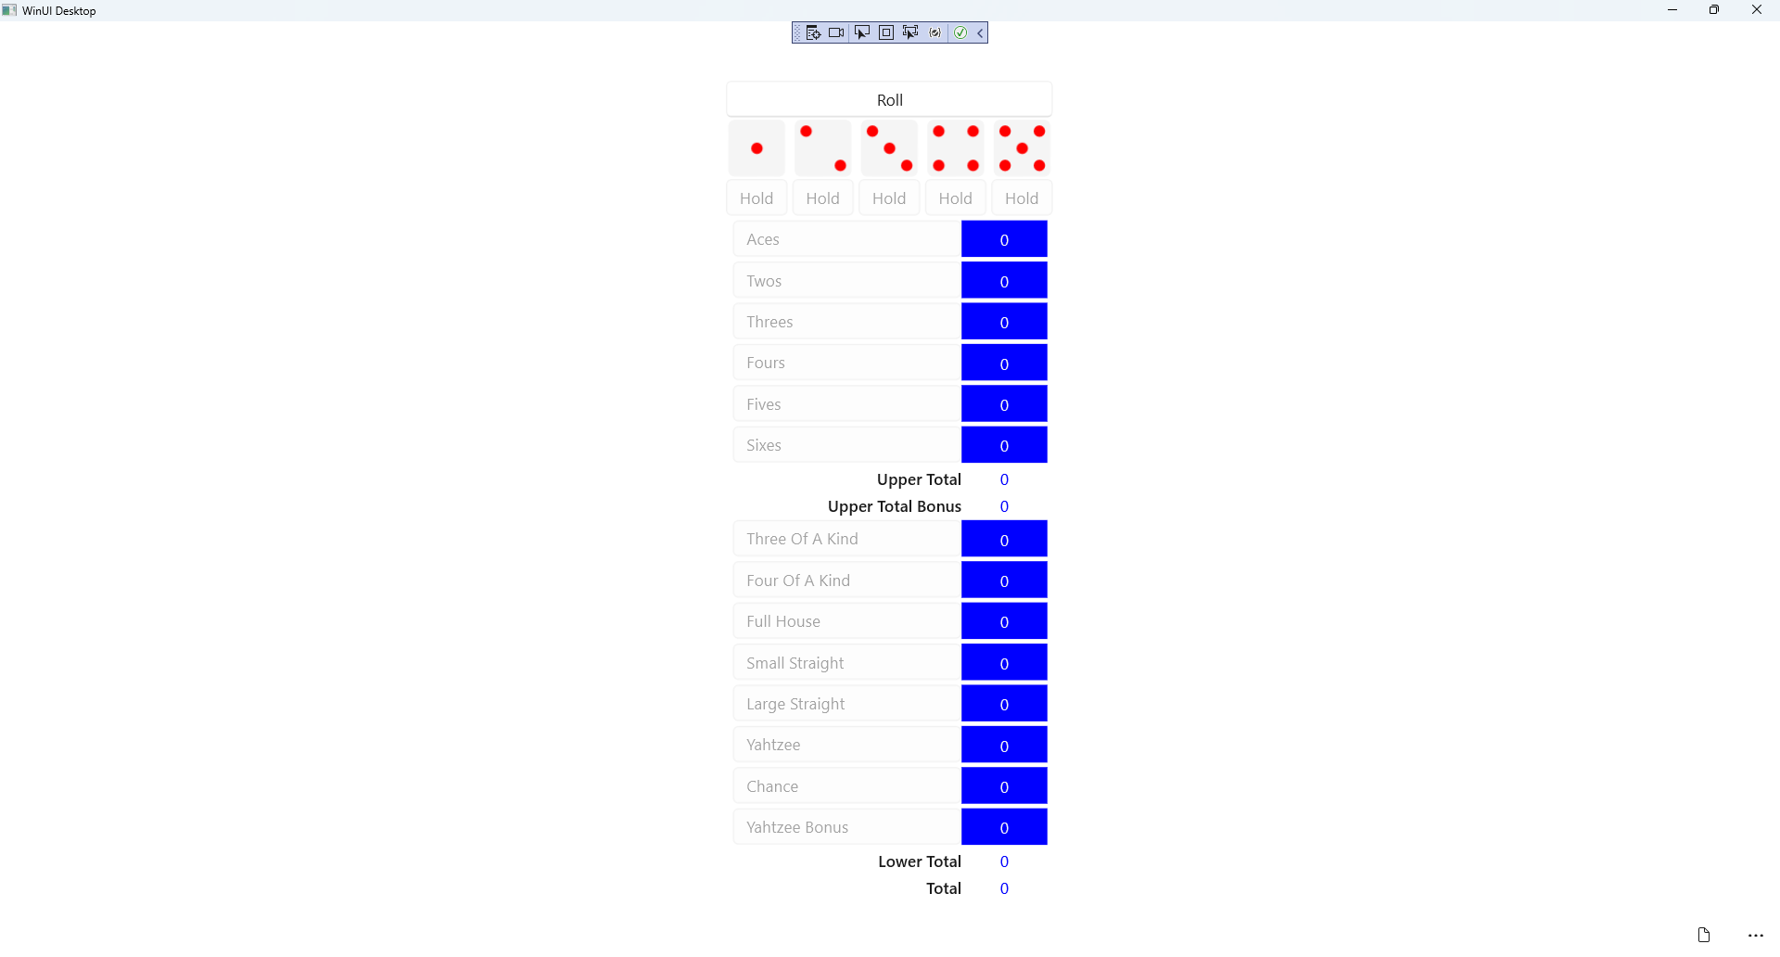

## Step 37

|  |  |
| --- | --- |
| To **Exit** the **Windows App SDK** application, select the **Close** button from the top right of the application as that concludes this **Tutorial** for **Windows App SDK** from [tutorialr.com](https://tutorialr.com)! |  |