](https://www.buymeacoffee.com/tutorialrdotcom)[](https://www.tutorialr.com/workshops/)

Blazor





# Contents

Contents

Introduction 2

What is Blazor? 2

What is Visual Studio Code? 3

Setup and Start 4

Blazor 4

Visual Studio Code 7

Components 12

Routing 12

Markup 14

Styles and CSS 15

Images 16

Binding and Events 17

Binding 17

Events 18

Conditions and Collections 23

Forms 26

Dependency Injection 28

# Introduction

## What is Blazor?

**Blazor** allows you to build interactive client web applications using **C#** instead of **JavaScript** with Applications composed using reusable **Components** using **C#**, **HTML** and **CSS** that supports both **Client** using **Web Assembly** and **Server** using **ASP.NET** created by **Microsoft**.

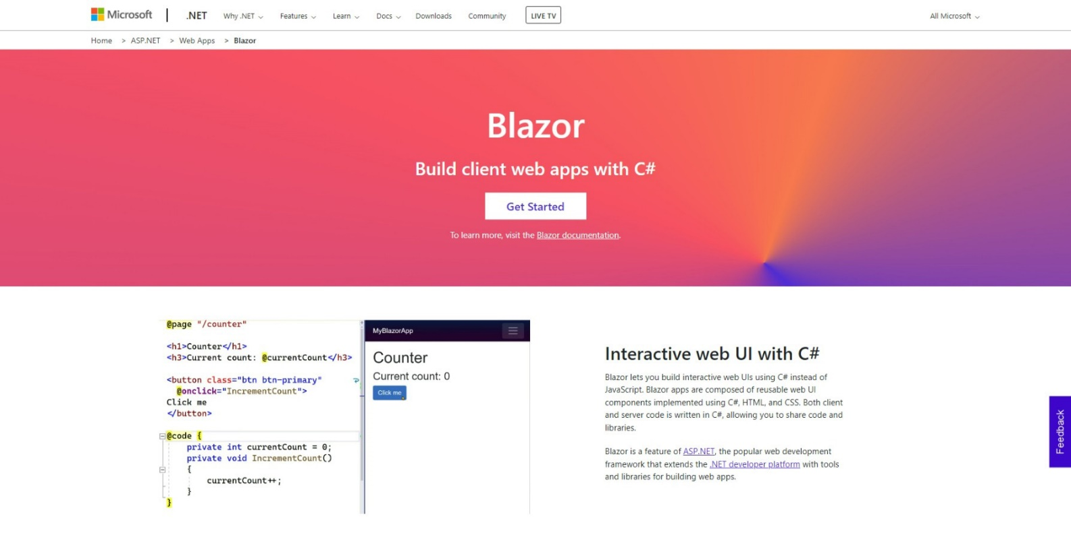

**Blazor** uses **C#,** which supports many features common in modern programming languages. **C#** is used with **.NET**,which not only supports developing Applications in **Blazor** but you can also use **C#** to develop Applications for web, mobile, desktop, games, IoT and more. For more information about using **.NET** along with documentation, examples and more then visit [dot.net](https://dot.net).

**Blazor** allows you to develop Applications that run on the **Server** where events are passed using **SignalR**, you can run your **C#** code directly in the **Browser** using **WebAssembly** and can re-use code between the **Client** and **Server**. **Blazor** also enables **Native** cross-platform Applications using **Blazor Hybrid** with **.NET MAUI**. and you can still work with **JavaScript** in the **Browser** from **Blazor** when needed. You can find out more about **Blazor** including documentation, examples and more at [blazor.net](https://blazor.net).

## What is Visual Studio Code?

**Visual Studio Code** will help create **Blazor** applications even more easily. **Visual Studio Code** is a free **Integrated Development Environment or IDE** created by **Microsoft**.

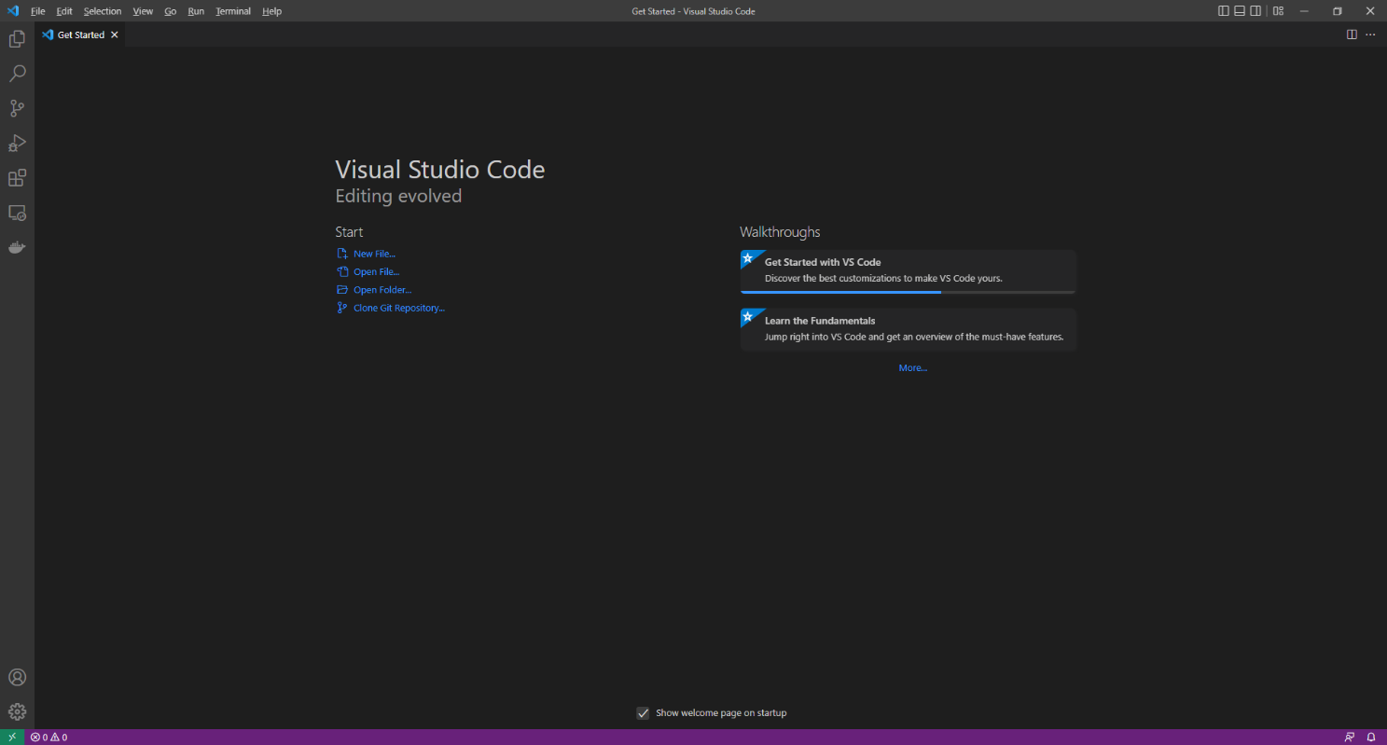

**Visual Studio Code** supports syntax highlighting which will add colours to certain parts of the text and make it easy to make sure everything is being entered correctly when writing **Blazor** Applications. You can use **Visual Studio Code** to edit any other **C#**, **Razor**, **CSS**, **HTML** and more, making more than just creating **Blazor** applications straightforward. If you want to find out more about **Visual Studio Code** along with documentation, extensions and more you can visit [code.visualstudio.com](https://code.visualstudio.com).

# Setup and Start

## Blazor

**Blazor** requires the latest version of the **.NET SDK** which if you have it already you can **Download** the version for your Platform such as **Windows** from [dot.net](https://dot.net)

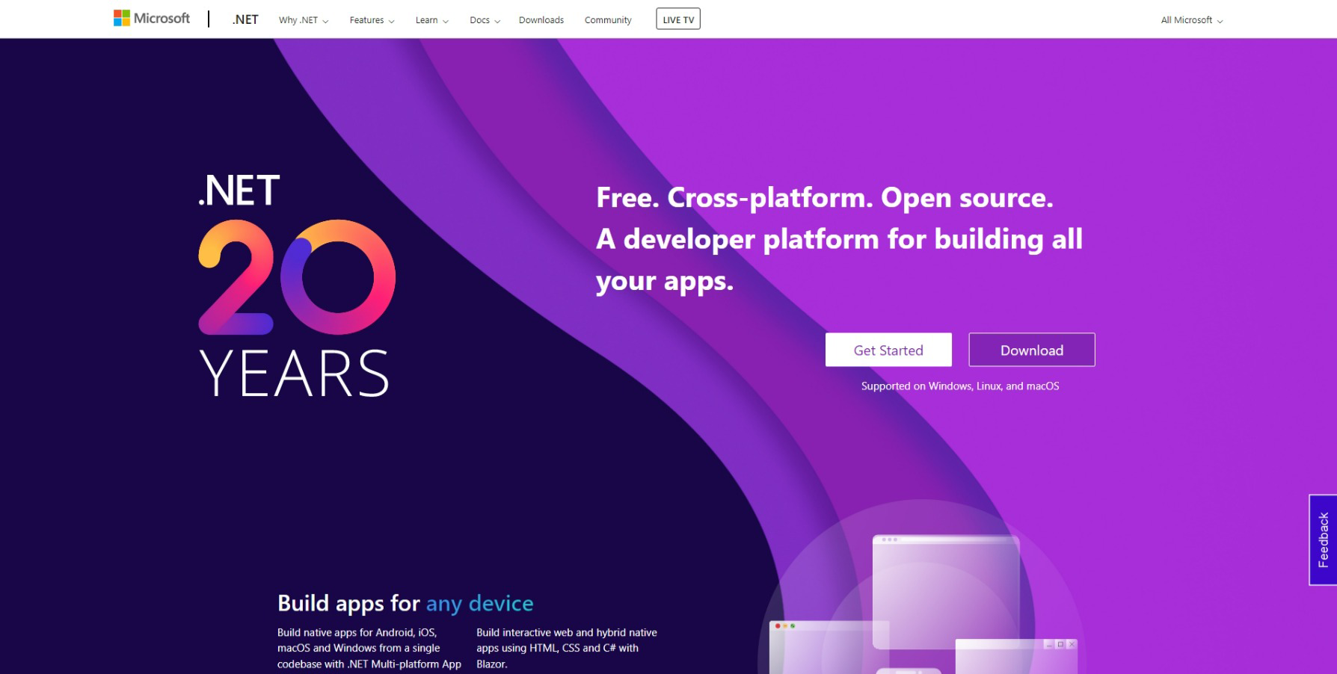

Once you have **Downloaded** then **Install** the **.NET SDK** by following the steps in the **Installation Wizard**

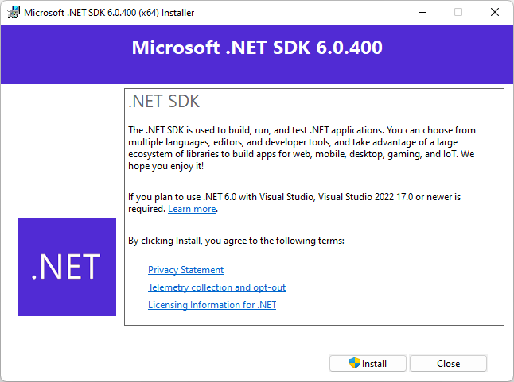

Once the **.NET SDK** has been **Installed**, or if it was already **Installed**, then if using **Windows** you need to go to **Start** then search for **Command Prompt** and then select it.

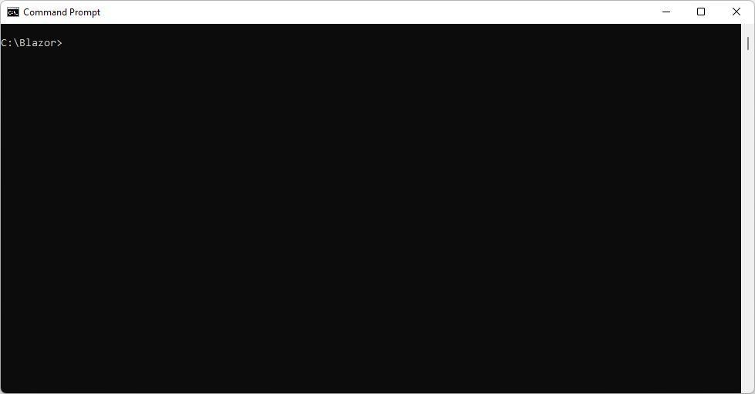

Once in the **Command Prompt** you will need to create a new **Folder**, you can use **mkdir** followed by the name of the **Folder** e.g. *Blazor* and then press **Enter**.

mkdir Blazor

Then you will need to switch to this **Folder**, to do this from the **Command Prompt**, type in the following command and then press **Enter**:

cd Blazor

Once in this **Folder** you can create a new **Blazor** Application using the **.NET CLI** that was installed as part of the **.NET SDK**. To do this, while still in the **Command Prompt** type in the following command and then press **Enter**:

dotnet new blazorwasm -o workshop

This will create a new **Blazor** for **WebAssembly** or **wasm** Application, once done in the **Command Prompt** you will need to change to the **Folder** for the **Workshop** by typing in the following and then press **Enter**:

cd workshop

Once done, while still in the **Command Prompt** type in the following command and then press **Enter**.

dotnet watch

This will **Build** and **Start** the Application and display it in your **Browser**

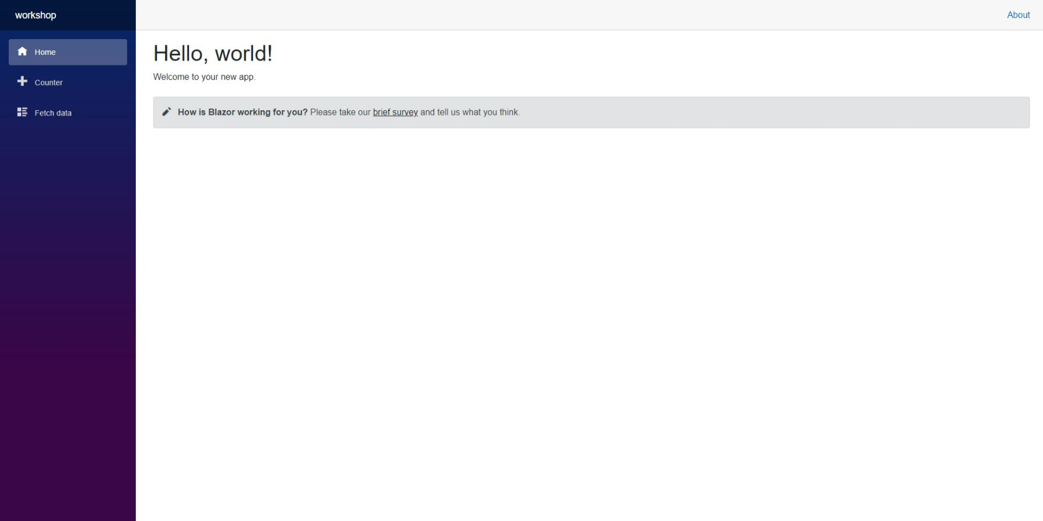

Keep the **Command Prompt** and **Browser** open during the **Workshop** but can **Close** it if finished. If **Closed** and you need to continue the **Workshop**, just go to **Start** then find **Command** **Prompt** then go to the **Folder** for the **Workshop** e.g. *C:\Blazor\workshop* and to then **Build** and **Start** the Application by typing the following commands, after each press **Enter**:

cd C:\Blazor\workshop

dotnet watch

Should you need to, you can get information, documentation and more about **Blazor** at [blazor.net](https://blazor.net)



This **Workshop** supports at least **.NET 6** and **C# 10** throughout for **Blazor**.

## Visual Studio Code

To be able to **Edit** your Application you will need to **Download**, if you don’t have it already, **Visual Studio Code** for your Platform such as **Windows** from [code.visualstudio.com](https://code.visualstudio.com/).

Once **Downloaded,** you can then **Install** itby following the steps in the **Installation Wizard**

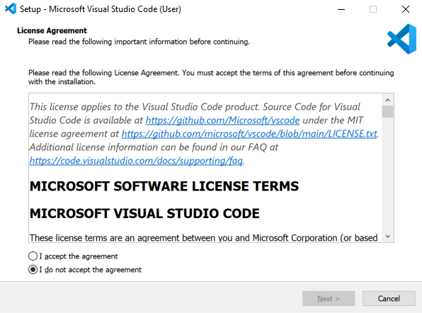

Once **Visual Studio Code** has been **Installed**, or if it was already **Installed**, then if using **Windows** you need to go to **Start** then search for **Visual Studio Code** and then select it.



Once **Visual Studio Code** has opened from the **Menu** choose **File** then **Open Folder...** then select the **Folder** for your Application e.g. *C:\Blazor\workshop*. Then once the **Folder** has been opened Select the **Yes, I trust the authors** option in the **Do you trust the authors of the files in this folder?** if this is displayed.

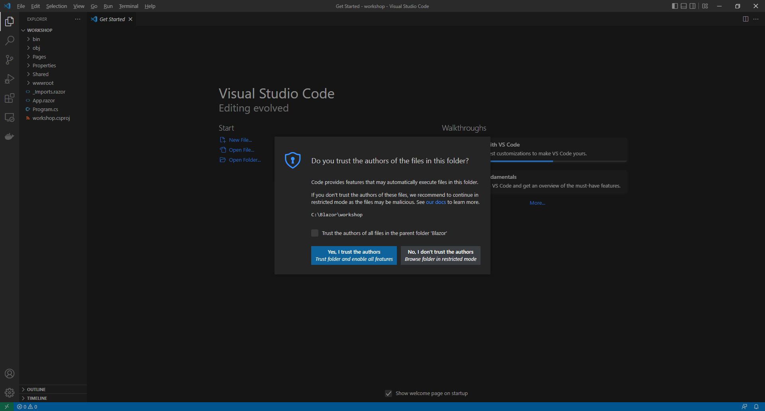

Within **Visual Studio Code** is **Explorer**, expand the **Folder** for **wwwroot** and then **css** to find *app.css*, this defines **CSS** styles for the Application, then at the bottom of *app.css*,type in the following **Comment**:

/* CSS */

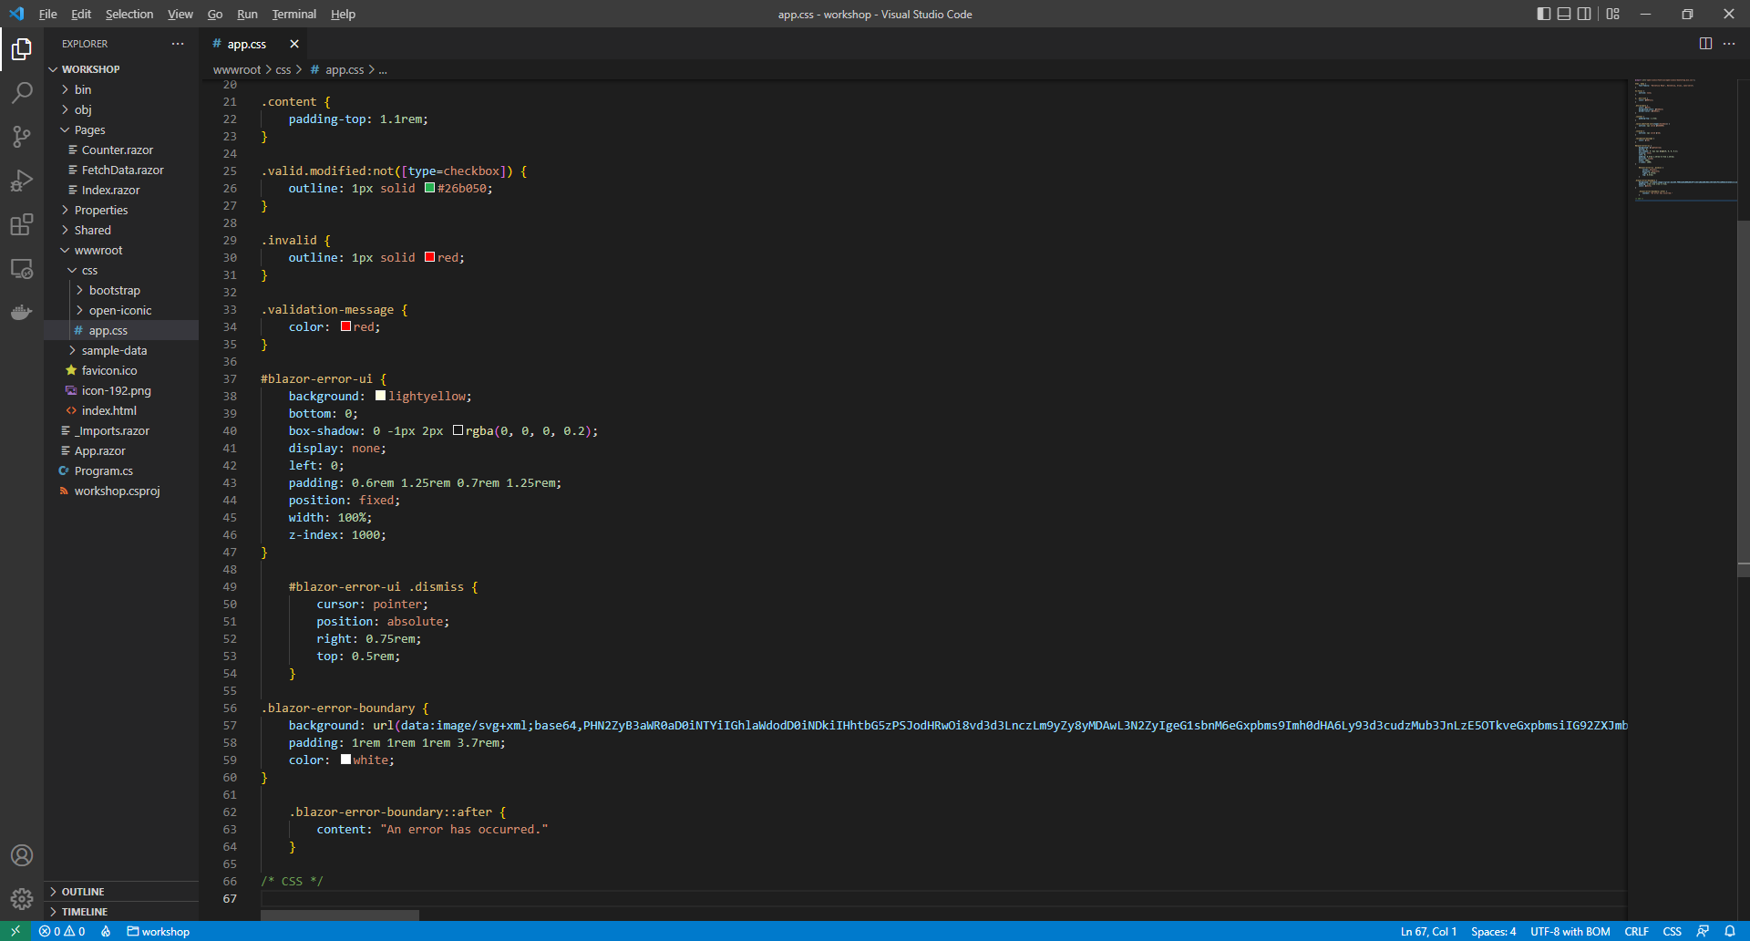

Also in **Visual Studio Code** within the **Explorer** you can Expand the **Folder** for **Pages** to find the main **Component** for the Application which is *Index.razor*, this is where you will be spending most of your time in the **Workshop**, you need to clear the contents of this file so that it is Blank, like as follows:

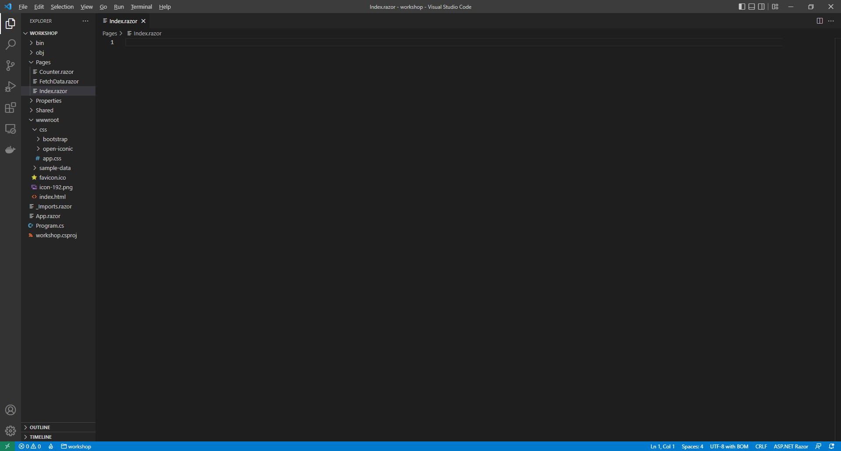

Then while still in the **Component** of *Index.razor* in **Visual Studio Code** type in the following:

@page "/"

@* Injects *@

@code

{

// Variables

// Methods

}

@* Application *@

Then in **Visual Studio Code** from the **Menu** select **File** then **Save** to save these **Changes** to *Index.razor*. You should always do this when you make any Changes to *Index.razor* and other files.

Switch over to the **Command Prompt** that should be still open for **dotnet watch** and there should be the following message, **Do you want to restart your app - Yes (y) / No (n) / Always (a) / Never (v)?** Press **a** to select the **Always** Option and should you **Close** the **Workshop** then you will need to do this again in the **Command Prompt** after getting everything running again and making your first **Changes** after doing so.

Then back in **Visual Studio Code** for the **Component** for the Application of *Index.razor* when you need to use an **@inject** in the **Component** for the Application of *Index.razor* then these should be placed below the **Comment** using the **Razor** Syntax **@\*** and **\*@** of **@* Injects *@** when needed in the **Workshop**.

To add or declare a **Variable** in the **Component** for the Application of *Index.razor* these should be placed on their own line within the **Block** for **@code** below the **Comment** using the **C#** Syntax **//** of **// Variables** or placed on their own line below any previously declared **Variable**.

To add a **Method** in the **Component** for the Application of *Index.razor* such as a **Function** that has a **return** for a **Value** or one that is **void** and performs some functionality without **Returning** a **Value**, both will contain **{** for the start of the **Body** of the **Method** and **}** for the end of the **Body** of the **Method**, then these should be placed the **Block** for **@code** below the **C#** Syntax **Comment** of **// Methods** or placed below the end of the **Body** of the **Method** of any previously declared **Methods**.

Finally anything else to be added using a combination of **HTML** and **Razor** Syntax in the **Component** for the Application of *Index.razor* then this should be typed in below the **Razor** Syntax **Comment** of **@* Application *@** or below any previously entered **HTML** and **Razor**.

You can use the same **Blazor** Application throughout the **Workshop** and you don’t need to remove anything else.

# Components

**Components** make up **Blazor** Applications using **Razor Components** also known as **Blazor Components**. **Components** are self-contained, they define part of a **User Interface** and with **Logic** to define and enable **Dynamic Behaviour**. **Components** are a combination of **C#**, **HTML** and **Razor** Syntax.

Follow **Setup and Start** and you should have the **Command Prompt** for **dotnet watch** open, your **Browser** should also be open and you should also have **Visual Studio Code** open with the **Folder** for the **Workshop** open e.g. *C:\Blazor\workshop*.

Then in **Visual Studio Code** select within **Explorer** in the **Folder** of **Pages** the **Component** for the Application of *Index.razor* and below the **Comment** of **// Variables** type in the following **Variable**:

string message = "Hello World";

This **Variable** is a **string** which contains some text, in this case **Hello World** when using a **string** it needs to be surrounded by a pair of double quotes **"** and **"**. Then to use this **Variable** within a **H1** Tag in **HTML**, you can do so by putting **@** in front of the **Variable** by typing below the **Comment** of **@* Application *@** the following:

<h1>@message</h1>

Then in **Visual Studio Code** from the **Menu** select **File** then **Save** to save these Changes to *Index.razor*. Then switch to the **Browser** that was opened with **dotnet watch** from the **Command Prompt** and you should see the text Hello World displayed in a **h1** Tag.

## Routing

**Routing** in **Blazor** allows you to provide a **Route** to a **Component** using the **Directive** of **@page** allowing the **Component** to be accessed using a Relative **URL** or **Website** Address in the **Browser**.

Return to **Visual Studio Code** and from the **Explorer** you need to **Right-Click** on the **Folder** for **Pages** and select the **New File** option then type in the following and then press **Enter**:

Message.razor

*Message.razor* will form the basis of a new **Component** so while still in *Message.razor* type in the following:

@page "/message/{Value}"

<h2>@Value</h2>

@code

{

[Parameter]

public string Value { get; set; } = string.Empty;

}

Then in **Visual Studio Code** from the **Menu** select **File** then **Save** to save these Changes to *Message.razor*.

This **Component** for **Message** uses the **Directive** of **@page** with **/message/{Value}**, which will allow the **Component** to be accessed using a Relative **URL** or **Website** Address in the **Browser** along with being able to specify the **Value**. Then there a **h2** Tag being used to display a **Property** of **Value**. This **Property** is C# Syntax allowing the **Value** which is a **string** to be Read, denoted with **get** and to be Written, denoted with **set**. This **Property** is assigned to, using **=** to the **string.Empty** which would be **""** and this **Property** is also used with the **Attribute** of **Parameter** which indicates that this **Property** can be set from another **Component**.

To use this **Component**, from **Visual Studio Code** within **Explorer** from the **Folder** of **Pages** select the *Index.razor*, then in the section with the **Comment** of **@* Application *@** and below **<h1>@message</h1>** type in the following:

<**Message** **Value**="Hello Again!"/>

Then in **Visual Studio Code** from the **Menu** select **File** then **Save** to save these Changes to *Index.razor*. Then switch to the **Browser** that was opened with **dotnet watch** from the **Command Prompt** and you should see the text *Hello Again!* displayed in a **h2** Tag, then while still in the **Browser** in the **Address Bar** type the following Relative **URL** after whatever is there e.g. *https://localhost:7095* (your number may be different):

/message/Hello!

In the **Browser** the **Address Bar** will be something like *https://localhost:7095/message/Hello!* and you should see the Text *Hello!* displayed in the **Browser** you can also change the *Hello!* passed in to anything you like. When done use the **Home** option from list of options shown below **Workshop** to return to the **Page** showing *Hello World* and *Hello Again!*

## Markup

**Components** can also be created to output specific **Markup** using **C#**, **HTML** and **Razor** Syntax. Return to **Visual Studio Code** and from the **Explorer** you need to **Right-Click** on the **Folder** for **Pages** and select the **New File** option then type in the following and then press **Enter**:

Date.razor

*Date.razor* will form the basis of a new **Component** so while still in *Date.razor* type in the following:

<h3>@Value.ToString("MMMM dd, yyyy")</h3>

@code

{

[Parameter]

public DateOnly Value { get; set; }

}

This **Component** for **Date** is being used to display a **Property** of **Value** in a **h3** Tag using **Method** of **ToString("MMMM dd, yyyy")** to **Format** the Output with **MMMM** for the **Month**, **dd** for the **Day** and **yyyy** for the **Year**, these are **Date Format Strings**. This **Property** is **C#** Syntax allowing the **Value** which is a **DateOnly** to be Read, denoted with **get** and to be Written, denoted with **set**. This **Property** is also used with the **Attribute** of **Parameter** which indicates that this **Property** can be set from another **Component**.

To use this **Component**, from **Visual Studio Code** within **Explorer** from the **Folder** of **Pages** select *Index.razor* and below the **Comment** of **// Variables** and after any previously declared **Variable**, type in the following **Variable**:

DateOnly dateOfBirth = DateOnly.Parse("23-June-1912");

**DateOnly** is a **Type** in **C#** that only stores a **Date** and can use **Method** the **Parse** to get this from a **string** representation of a **Date** such as **"23-June-1912"**. While still in the **Component** for the Application of *Index.razor* in the section with the **Comment** of **@* Application *@** below **<Message Value="Hello Again!"/>** type in the following:

<**Date** **Value**="dateOfBirth"/>

While still in **Visual Studio Code** from the **Menu** select **File** then **Save** to save these Changes to *Index.razor*. If you switch to the **Browser** is open for the **Workshop**, you will see the **Component** for **Date** being displayed as *June 23, 1912*, which is Alan Turing’s birthday, a pioneer in the field of computing!

## Styles and CSS

**Components** can also allow a **Value** to be used to define the **CSS Style** of a Tag of **HTML**. In **Visual Studio Code** within **Explorer** from the **Folder** of **Pages** select the *Index.razor* and below the **Comment** of **// Variables** and after any previously declared **Variables**, type in the following **Variable**:

string styling = "background-color: yellow";

To use the **string** as **CSS Style**, while still in the **Component** for the Application of *Index.razor* type in below **<Date Value="dateOfBirth"/>** the following:

<div><span style="@styling">Highlighted</span></div>

Then in **Visual Studio Code** from the **Menu** select **File** then **Save** to save these Changes to *Index.razor*. Then switch over to the **Browser** that was opened with dotnet watch you will see the Text of *Highlighted* with a Background Colour of *yellow*.

Then, back in **Visual Studio Code** from **Explorer** in the **Folder** of **wwwroot** and **css** select *app.css* and define some **CSS** for the Application by typing in below the **Comment** of **/* CSS */** the following:

.inverted {

color: white;

background-color: black;

}

.large {

font-size: 2.0em;

}

Then in **Visual Studio Code** from the **Menu** select **File** then **Save** to save these Changes for *app.css*. Return to the **Component** for the Application within the **Folder** for **Pages** of *Index.razor* and below the **Comment** of **// Variables** and after any previously declared **Variables**, type in the following **Variable**:

string[] contrast = { "inverted", "large" };

The square-brackets of **[** and **]** denote an **Array** which is a set of **Elements** of a given **Type** in this case they are a **string** with the **Values** of **inverted** and **large**. While still in the **Component** of *Index.razor* and below **<div><span style="@styling">Highlighted</span></div>** type in the following:

<div><span class="@string.Join(" ", contrast)">Contrast</span></div>

This will set the **class** for the **span** using the **Variable** of **contrast** since **CSS** needs to be defined with Spaces inbetween the **Method** for **string.Join** will be used to combine the Values from the **Array** with a Space, denoted with **" "**. If you switch over to the Browser that was opened with **dotnet watch** from the **Command Prompt** it will have the Text of *Contrast* in *white* with a *black* Background.

## Images

**Components** can contain any other **HTML** Elements such as an **Image** using the **img** Tag and can set the **src** from anything, including a **Method**, to do this, in **Visual Studio Code** in the **Component** for the **Application** of *Index.razor* within the **Folder** of **Pages** type below the **Comment** for **// Methods** the following **Method**:

Uri GetImage()

{

return new("https://openmoji.org/data/color/svg/1F600.svg");

}

This **Method** of **GetImage()** will **return** a **Uri**, to use this, while still in the **Component** for the Application of *Index.razor* below **<div><span class="@string.Join(" ", contrast)">Contrast</span></div>** in the section with the **Comment** of **@* Application *@**, type in the following:

<div>

<img src="@GetImage()" height="150" width="150" title="Image" />

</div>

This will set the **src** the **img** Tag using the **Result** from the **Method** of **GetImage()**. Back in the **Browser**, you should see a *Grinning Face* displayed, image courtesy of [openmoji.org](https://openmoji.org).

# Binding and Events

## Binding

**Binding** in **Blazor** can be used in **Components** to allow for **Data Binding** Elements using the **Directive** of **@bind** with **Values** such as a **Field** or **Variable**, **Property** or an **Expression**.

After following **Setup and Start** and **Components** you should have the **Command Prompt** for **dotnet watch** open, your **Browser** should also be open and you should also have **Visual Studio Code** open with the **Folder** for the **Workshop** open e.g. *C:\Blazor\workshop*.

In **Visual Studio Code** select the **Component** for the Application, *Index.razor* found within **Explorer** in the **Folder** of **Pages** below the **Comment** of **// Variables** and after any previously declared **Variables**, type in the following **Variable**:

string text = string.Empty;

Then while still in **Visual Studio Code** for the **Component** for the Application of *Index.razor*, within the section containing the **Comment** of **@* Application *@** below the final **</div>** type in the following:

<div>

<input type="text" @bind="text" @bind:event="oninput" />

<h2>@text</h2>

</div>

This will use the **Directive** for **@bind** to **Bind** to the **Field** or **Variable** of **text** that was declared, and using the **bind:event** will update **text** when the **input** is typed into as this will trigger the **Event** for **oninput** of the **input** and underneath the **Value** of **input** will be displayed in a **h2** Tag.

Then **Visual Studio Code** from the **Menu** select **File** then **Save** to save the Changes to *Index.razor*.

Switch to the **Browser** opened with **dotnet watch** from the **Command Prompt** you will see an **input**, which when Typed into will have the same contents displayed underneath in a **h2** Tag.

## Events

**Events** in **Blazor** can be used in **Components** to create more **Dynamic Behaviour** in a **Blazor** Application. In **Visual Studio Code** select the **Component** for the Application, *Index.razor* found within **Explorer** in the **Folder** of **Pages** type below the **Comment** of **@* Injects *@** type in the following:

@inject IJSRuntime runtime;

This will use **inject** to include **IJSRuntime** which is an **Interface** exposing functionality from **JavaScript** to allow the **Blazor** application to **Invoke** features from **JavaScript**. Then below the **Comment** for **// Methods** and after the **Body** of any previous **Methods** type the following **Methods**:

async void Alert(string message)

{

await runtime.InvokeVoidAsync("alert", message);

}

void ShowMessage()

{

Alert("Hello World");

}

The first **Method** is used to **Invoke** a feature from **JavaScript**, in this case for **alert** which is used to display an **alert** Message in a **Browser**. This **Method** uses **async** and **await** which means it will perform a **Task** that won’t happen at the same time as anything else, or **Asynchronously** denoted with **async** and when this is completed it will come back after this **Task** has completed which is denoted with **await**. The second **Method** will **Call** the **Method** for **Alert** with the **string** of **Hello World**.

While still in the **Component** of *Index.razor* in the section with the **Comment** of **@* Application *@** below the final **</div>** type in the following:

<div>

<button class="btn btn-primary" @onclick="ShowMessage">

Show Message

</button>

</div>

Then you can select the **Browser** opened with **dotnet watch** from the **Command Prompt** you will see a **button** labelled *Show Message* which when **Clicked** will display an **alert** displaying the Message of **Hello World**.

You can also use **Events** to perform other **Dynamic Behaviour** such as changing the **Style** of an Element. Return to **Visual Sudio Code** and select the **Component** for the Application, *Index.razor* found within **Explorer** in the **Folder** of **Pages** then below the **Comment** of **// Variables** and after any previously declared **Variables**, type in the following **Variables**:

string style = string.Empty;

bool isSelected = false;

The first **Variable** is a **string** for the **Style** and the second **Variable** is a **bool** which is a **Value** that can be either **true** or **false**. Then below the **Comment** for **// Methods** and after the **Body** of any previous **Methods** type the following **Method**:

void SetStyle()

{

isSelected = !isSelected;

style = $"font-weight:{(isSelected ? "bold" : "normal")}";

}

This **Method** will first set **isSelected** to **isSelected** with the **!** or the **Operator** for **Not**, this works with a **bool** by changing anything that was **true** to be **false** and anything that was **false** to be **true**. Then **style** is set with a string using **String Interpolation** which is denoted with the use of **$** at the start. There is an **Expression** contained within the brackes of **(** and **)** which uses the **Conditional Operators** of **?** and **:**. Should the **Value** of **isSelected** be **true** then **"bold"** will be **Returned** from the **Conditional** or when **isSelected** **false** then **"normal"** will be **Returned** from the **Conditional**.

Then, while still in the **Component** of *Index.razor* in the section with the **Comment** of **@* Application *@** and below the final **</div>** type in the following:

<div>

<a href="#" style="@style" @onclick="SetStyle">Toggle Style</a>

</div>

Then **Visual Studio Code** from the **Menu** select **File** then **Save** to save the Changes to *Index.razor* and then go to the **Browser** that was opened with **dotnet watch** and **Click** the **Link** with the Text of *Toggle Style* and this Text will switch between being *bold* or *normal* when **Clicked**.

It is possible to combine **Binding** with **Events**. Return to **Visual Sudio Code** then select the **Component** for the Application, *Index.razor* found within **Explorer** in the **Folder** of **Pages** and below the **Comment** of **// Variables** and after any previously declared **Variables**, type in the following **Variable**:

string value = string.Empty;

While still in the **Component** of *Index.razor* in the section with the **Comment** of **@* Application *@** below the final **</div>** type in the following:

<div>

<input type="text" @bind="value" />

<button class="btn btn-primary" type="button"

@onclick="@(e => Alert(value))">

Show

</button>

</div>

This will use **@bind** to **Bind** the **input** to the **Variable** of **value**, then the **button** will use the **Event** of **@onclick** to **Call** the **Method** of **Alert** with **value**.

In **Visual Studio Code** from the **Menu** select **File** then **Save** to save the Changes to *Index.razor* and then you can select the **Browser** opened with **dotnet watch** and you should see an **input** with a **button** labelled *Show*, anything you type in the **input** will be displayed in an **alert** when the **button** of *Show* is **Clicked**.

You can define **Events** in a **Component**. In **Visual Studio Code** and then from **Explorer** you need to **Right-Click** on the **Folder** for **Pages** and select **New File** then type in the following and then press **Enter**.

Sizer.razor

This will form the basis of a new **Component**,within the **Component** of *Sizer.razor* type in the following:

<div>

<button class="btn btn-primary"

@onclick="Decrease" title="Decrease">-</button>

<button class="btn btn-primary"

@onclick="Increase" title="Increase">+</button>

<span style="font-size:@(Size)px">Font Size: @Size<text>px</text></span>

</div>

@code

{

[Parameter]

public int Size { get; set; }

[Parameter]

public EventCallback<int> SizeChanged { get; set; }

private async void Resize(int delta)

{

Size = Math.Min(40, Math.Max(8, + this.Size + delta));

await SizeChanged.InvokeAsync(Size);

}

private void Decrease() =>

Resize(-1);

private void Increase() =>

Resize(+1);

}

Starting with the **Block** for **@code** there is a **Parameter** for the **Component** of **Size** which is an **int** which represents a whole number such as *20*, there is also another **Parameter** for the **Compoonent** for an **EventCallback**, this uses the **Generic** Syntax denoted by the angled-brackets or chevrons of **<** and **>** and in this case this is the **Type** of **int** which will be used for the latest value of **Size**. Both of these use the **Keyword** in **C#** for **public**, this means they are accessible outside of the **Component**.

Then there are **Methods**, marked with **private** which indicates they should only be used or be accessible from within the **Component**, starting with **Resize** which is marked **async** which means it will perform a **Task** that won’t happen at the same time as anything else or **Asynchronously**. The **Method** performs a **Calculation** using the **delta** value passed in as a **Parameter** for the **Method**, once the **Calculation** is done, then the **Method** for **InvokeAsync** is invoked which will be used to get the latest **Value** to use. The last two **Methods** invoke **Resize** and either pass in **-1** or **+1** accordingly.

Then above the **Block** for **@code** there is a **button** when **Clicked** or **@onclick** will either *Decrease* with *-* or *Increase* with *+* and then there is a **span** which will display the **Value** of **Size** and use this with the **Style** of **font-size** with it too.

To use this **Component**, from **Visual Studio Code** within **Explorer** from the **Folder** of **Pages** select *Index.razor*, then below the **Comment** of **// Variables** and after any previously declared **Variables**, type in the following **Variable**:

int size = 20;

This **Variable** is an **int** and has been set to **20** for the initial **Value** of size. While still in *Index.razor*, in the section with the **Comment** of **@* Application *@** below the final **</div>**, type in the following:

<div>

<**Sizer** **Size**="@size" **SizeChanged**="(int value) => size = value" />

<div style="font-size:@(size)px">Resizable Text</div>

</div>

This will include the **Component** of **Sizer** and then will set the **Value** for **Size** with the **Variable** of **size**, along with creating an **Expression** to use with **SizeChanged** which will update the **Variable** of **size** and there is also a **div** where the **Style** for the **font-size** will be used too.

Then **Visual Studio Code** from the **Menu** select **File** then **Save** to save the Changes to *Index.razor*.

Then when you switch over to the **Browser** you can use the *Sizer* to change the *font-size* of itself and the **div** contained the Text of *Resizable Text* too.

# Conditions and Collections

**Conditions** can be used in **Blazor** to control what is being displayed to add even more **Dynamic Behaviour** to an Application.

After following **Setup and Start**, **Components** and **Binding and Events**. Then you should have the **Command Prompt** for **dotnet watch** open, your **Browser** should also be open and you should also have **Visual Studio Code** open with the **Folder** for the **Workshop** open e.g. *C:\Blazor\workshop*.

In **Visual Studio Code** select the **Component** for the Application, *Index.razor* found within **Explorer** in the **Folder** of **Pages** below the **Comment** of **// Variables** and after any previously declared **Variables**, type in the following **Variable** for a **bool**:

bool isShown = false;

Then in **Visual Studio Code** for *Index.razor*, below the **Comment** for **// Methods** and after the **Body** of any previous **Methods** type the following **Method**:

void Toggle()

{

this.isShown = !this.isShown;

}

The **Method** of **Toggle()** will set **isShown** to **isShown** with the **!** or the **Operator** for **Not**, this works with a **bool** by changing anything that was **true** to be **false** and anything that was **false** to be **true**.

Then while still in *Index.razor*, in the section with the **Comment** of **@* Application *@** below the final **</div>**, type in the following:

<div>

<button class="btn btn-primary"

@onclick="Toggle">Click Here</button>

@if (isShown)

{

<h2>Hello World!</h2>

}

</div>

This contains a **button** that when **Clicked** or **@onclick** will invoke the **Method** for **Toggle** which updates **isShown**. Below this is a **Conditional Statement** of **if** which the contents of which, containing a **h2** Tag with the Text of *Hello World!* but this will only be displayed when **isShown** is **true**.

If you switch to the **Browser** that was opened with **dotnet watch** from the **Command Prompt**, you will see the **button** with the Text of *Click Here*, which when **Clicked** will either display underneath the Text of *Hello World!* in a **h2** Tag or hide it when **Clicked** if it is already there.

**Components** can also display the contents of a **Collection**. Return to **Visual Sudio Code** and select the **Component** for the Application, *Index.razor* found within **Explorer** in the **Folder** of **Pages** then below the **Comment** of **// Variables** and after any previously declared **Variables**, type in the following **Variable**:

List<string> items = new()

{

"Hello",

"World"

};

The **Collection** used here is a **List** which uses the **Generic** Syntax denoted by the angled-brackets or chevrons of **<** and **>** and in this case this **List** is has Elements with a **Type** of **string** with the **Values** being the **string** of **"Hello"** and **"World"**.

While still in the **Component** for the Application of *Index.razor*, in the section with the **Comment** of **@* Application *@** and below the final **</div>**, type in the following:

<div>

<ul>

@foreach (string item in items)

{

<li>@item</li>

}

</ul>

</div>

Within this is a **ul** for an **Unordered List** or **Bulleted List** then uses **foreach** to go through each **Value** in the **Collection** as a **string** and output them using a **li** or **List Item**.

In **Visual Studio Code** from the **Menu** select **File** then **Save** to save the Changes to *Index.razor*, then switch over to the **Browser** that was opened, there will be a **Bulleted List** showing the **List Items** of *Hello* and *World*.

You can combine **Conditions** and **Collections** using a **switch** to display values from a **Variable**. Return to **Visual Sudio Code** and select the **Component** for the Application, *Index.razor* found within **Explorer** in the **Folder** of **Pages** then below the **Comment** of **// Variables** and after any previously declared **Variables**, type in the following **Variable**:

Dictionary<string, string> values = new()

{

{ "None", "" },

{ "Danger", "red" },

{ "Warning", "yellow" },

{ "Proceed", "green" }

};

The **Collection** used here is a **Dictionary** which also uses the **Generic** Syntax denoted by the angled-brackets or chevrons of **<** and **>** and in this case this **Dictionary** is has Elements with the **Key** and the **Value** the **Type** of **string** and has some **Values** set.

While still in the **Component** for the Application of *Index.razor*, in the section with the **Comment** of **@* Application *@** and below the final **</div>**, type in the following:

<div>

<ul>

@foreach (var value in values)

{

<li>

@switch (value.Key)

{

case "Danger":

<span style="background-color: red">

Danger

</span>

break;

case "Warning":

<span style="background-color: yellow">

Warning

</span>

break;

case "Proceed":

<span style="background-color: green">

Proceed

</span>

break;

default:

<span>

None

</span>

break;

}

</li>

}

</ul>

</div>

Within this is a **ul** for an **Unordered List** or **Bulleted List** then uses **foreach** to go through each **Value** in the **Collection** as a **var** which means the **Type** can be **Inferred** rather than **Explicitly** stated. Then there is a **switch** which will use the **Key** from the **Dictionary** of **Values** and output using a **li** or **List Item** for a given **case** of the **Key** with **default** being used for any other **Value**.

In **Visual Studio Code** from the **Menu** select **File** then **Save** to save the Changes to *Index.razor*. Then if you switch over to the **Browser** there will be another **Bulleted List** showing the List Items of *None*, then *Danger* with a *red* Background, *Warning* with a *yellow* Background and Proceed with a *green* Background.

# Forms

**Forms** in **Blazor** take advantage of built-in **Components** for **Input** and you can **Bind** to a **Model** using **Data Annotations** that allow you to **Validate** any **Input** from **Forms**.

Follow **Setup and Start**, **Components**, **Binding and Events** and **Conditions and Collections**. You should then have the **Command Prompt** for dotnet watch open, your **Browser** should also be open and you should also have **Visual Studio Code** open with the **Folder** for the **Workshop** open e.g. *C:\Blazor\workshop*.

In **Visual Studio Code** from the **Menu** select **File** and then **New Text File** then select **File** again and this time choose the **Save** option, select the **Folder** for the **Workshop** e.g. *C:\Blazor\workshop*, then set the **Filename** to the following:

Model.cs

Then either press **Enter** or select **Save** once done, in **Visual Studio Code** from the **Explorer** within the **Workshop** select *Model.cs* and then type in the following:

using System.ComponentModel.DataAnnotations;

public class Model

{

[Required]

public string? Name { get; set; }

}

Then in **Visual Studio Code** from the **Menu** select **File** then **Save** to save the Changes for *Model.cs*, which is a **class** which in **C#** is a pattern of a particular object. In this case it will be for **Name** which is a **Property** with the **Type** of a **string?** the **?** denotes that this **Property** can be **null** which is a special **Value** that means it has no value. The **Property** also has an **Attribute** that is part of the **Data Annotations** which is brought in with **using** of **System.ComponentModel.DataAnnotations** to denote that this **Property** is **Required** so it must have a **Value** when used with the **Form**.

Then in **Visual Studio Code** in the **Explorer** within the **Folder** of **Pages** in the **Component** for the Application of *Index.razor* below the **Comment** of **// Variables** and after any previously declared **Variables** type in the following **Variable**:

Model model = new();

This will create an **Instance** of the **Class** for the **Model** so it can be used in the **Form**.

While still in **Visual Studio Code** for *Index.razor*, below the **Comment** for **// Methods** and after the **Body** of any previous **Methods** type the following **Method**:

void HandleValidSubmit()

{

Alert(model.Name ?? string.Empty);

}

This **Method** will use the **Method** for **Alert** to display a message containing the **Value** of **Name** from the **Instance** of **Class** for **Model** of **model**. This also features the **??** or **Null-coalescing Operator** which when the value is **null** it will use **Value** for **string.Empty** or **""** instead.

Then while still in **Visual Studio** **Code** in the **Component** for the Application of *Index.razor*, in the section with the **Comment** of **@* Application *@** and below the final **</div>**, type in the following:

<div>

<**EditForm** **Model**="@model" **OnValidSubmit**="@HandleValidSubmit">

<**DataAnnotationsValidator** />

<label>

Name

<**InputText** id="name" @bind-Value="model.Name" />

</label>

<**ValidationSummary** />

<button class="btn btn-primary" type="submit">Submit</button>

</**EditForm**>

</div>

This uses the built-in **Component** of **EditForm** with the **Model** set to the **Instance** of **model** for the **Class** it uses the **Method** of **HandleValidSubmit** when the **Form** is **Valid**, this is based on the **DataAnnotationsValidator** which will check if the **Property** of **Name** is not **null** and has a **Value**. The **Component** of **InputText** and is **Bound** to the **Property** from the **Model** of **Name**. If there is no **Valid** input then any issues will be displayed using the **ValidationSummary** then finally there is the **button** with the **type** of **submit** to process the **Form** with the Text of *Submit*.

In **Visual Studio Code** from the **Menu** select **File** then **Save** to save the Changes to *Index.razor*. Then, when you switch to the **Browser** that was opened with **dotnet watch** from the **Command Prompt**, there will be an **input** next to the **button** with the Text of *Submit* if you type in anything then **Click** on *Submit* then it will display an **alert** with what was typed in, if nothing is entered then it will state that *The Name field is required.* along with showing the **input** in red.

# Dependency Injection

**Dependency Injection** in **Blazor** allows **Services** to be **Injected** into an Application, these **Services** can be either **Framework-registered** or **Custom**. **Dependency Injection** is a software design pattern allowing functionality to be provided to a given part of an **Application** to achieve **Inversion of Control** where **Implementation** is written to depend on or **Implement** higher-level abstractions to allow for more modular and maintainable code.

Follow **Setup and Start**, **Components**, **Binding and Events**, **Conditions and Collections** and **Forms**. You should then have the **Command Prompt** for dotnet watch open, your **Browser** should also be open and you should also have **Visual Studio Code** open with the **Folder** for the **Workshop** open e.g. *C:\Blazor\workshop*.

In **Visual Studio Code** from the **Menu** select **File** and then **New Text File** then select **File** again and this time choose the **Save** option, select the **Folder** for the **Workshop** e.g. *C:\Blazor\workshop*, then set the **Filename** to the following:

DemoService.cs

Then either press **Enter** or select **Save** once done, in **Visual Studio Code** from the **Explorer** within the **Workshop** select *DemoService.cs* and then type in the following **class**:

public class DemoService

{

public string GetMessage()

{

return "Hello Demo!";

}

}

This **class** represents a simple **Service** that has a single **Method** of **GetMessage()** which will **return** the **string** of **"Hello Demo!"**.

Then in **Visual Studio Code** from the **Explorer** for **Workshop** you should find *program.cs*. In this, below the line of **builder.Services.AddScoped(sp => new HttpClient { BaseAddress = new Uri(builder.HostEnvironment.BaseAddress) });** type in the following:

builder.Services.AddScoped(sp => new DemoService());

This line will **Register** the **Service** with the Application. Then in **Visual Studio Code** from the **Menu** select **File** then **Save** to save the Changes to *program.cs*.

Then while still in **Visual Studio Code** select the **Component** for the Application, *Index.razor* found within **Explorer** in the **Folder** of **Pages** and type below the **Comment** of **@* Injects *@** and after any previous **@inject** type in the following:

@inject DemoService service;

Then while still in the **Component** for the Application of *Index.razor*, within the section with the **Comment** of **@* Application *@** and below the final **</div>**, type in the following:

<h2>@service.GetMessage()</h2>

This will get the **Value** for a **h2** Tag using the **Method** of **GetMessage** from the **Service** that was **Injected** using **Dependency Injection**.

Then switch to the **Browser** that was opened with **dotnet watch** from the **Command Prompt** and you should see the text *Hello Demo!* displayed in a **h2** Tag and that concludes this **Workshop** about **Blazor** from [tutorialr.com](https://tutorialr.com)!