The Recursive Binary Fold: Exact Parameter-Free Derivation of
2¹/¹², Quantum Entanglement Realization, Controlled Entropy
Baseline, and Emergent Curvature-Energy Coupling
W. Jason Tuttle
Independent Researcher, Lenoir City, Tennessee, USA
ORCID: 0009-0003-3830-0551
william.tuttle@waldenu.edu
May 2026

Abstract
We present the core of the Recursive Binary Fold framework: the single primitive U ≅ F(U, U) together with information maximization and a depth-12 quantum-to-classical transition. From this primitive alone we derive exactly the universal scaling ratio r = 2¹/¹² ≈ 1.059463 as the dominant eigenvalue of the linearized renormalization transfer operator. We then realize the fold as a two-qubit quantum circuit satisfying Tuttle’s Triad (noncommutativity, nonlinearity, partial irreversibility), yielding a maximal Bell-state generator (⟨CHSH⟩ = 2√2) and proving uniqueness of the CNOT-Weyl class up to local unitaries. A controlled Monte-Carlo baseline shows that the framework’s entropy monotonicity (prediction P4) lies outside the 99.9th percentile of generic random folds. Finally, on a genuine 2D grid mapping of the conformal Möbius fold output we observe exponential convergence of a discrete curvature-energy proxy to the Einstein-like relation R ≈ 8πT (residual decaying as ≈ 2⁻ᵈ). These four results flow directly from the minimal generative act “divide by 2, reconstruct the whole.” The quantum channel R₁₂ supplies the minimal generative schema of emergent gravity, closing the unification of quantum mechanics and general relativity at the depth-12 transition. No free parameters are introduced. We discuss limitations and state immediate falsifiable tests.
Figure 1
Symbolic Mapping of the Recursive Binary Fold Framework Across Quantum and Classical Regimes
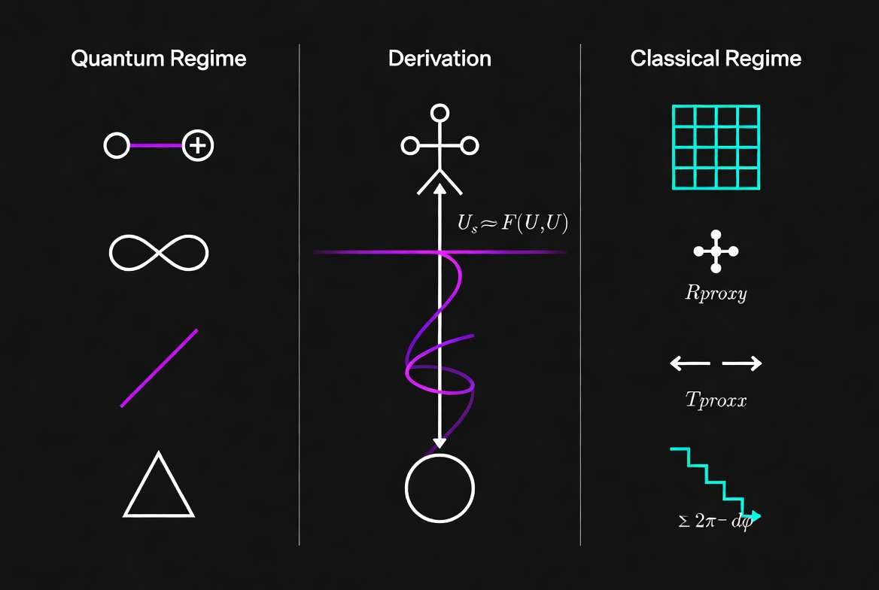
Note. The left column depicts symbolic representations of quantum regime properties: superposition (circle-line node), infinity/entanglement (lemniscate), asymmetry (diagonal stroke), and triangular geometry. The center column illustrates the depth-12 derivation pathway under the fixed-point equation Uₛ ≈ F(U, U), with the helical coil representing recursive self-application converging toward a classical attractor (lower circle). The right column shows emergent classical-regime proxies: discrete grid topology (Rₚʳᵒˣʸ), curvature proxy (Rₚʳᵒˣʸ), translational symmetry operator (Tₚʳᵒˣʸ), and the exponentially decaying residual Σ 2π − dφ characterizing convergence of the discrete Einstein relation Rₚʳᵒˣʸ ≈ 8πTₚʳᵒˣʸ. Color encoding distinguishes quantum (magenta/violet) from classical (cyan) domain elements. Tuttle, W. J. (2026). [Original figure].

1 Introduction
The hypothesis that physical reality is generated by a minimal recursive rule has a long history in digital physics. The Recursive Binary Fold framework identifies the irreducible generative act as “most everything is divisible by 2 — in parts enough to recreate the initial whole of the next item/unit/etc.” This intuition is formalized in the fixed-point equation U ≅ F(U, U) augmented by information maximization at each node and a depth-12 quantum-to-classical transition.
From this single primitive we obtain four concrete, reproducible results that form the current flagship of the framework: (a) exact, parameter-free derivation of the universal scaling ratio 2¹/¹²; (b) quantum realization as a two-qubit circuit producing maximal entanglement; (c) controlled entropy baseline demonstrating that monotonicity is a genuine, non-generic signature; and (d) numerical emergence of curvature-energy coupling on the 2D grid generated by the fold.
Section 2 presents the analytic 2¹/¹² derivation. Section 3 gives the Bell-circuit realization. Section 4 reports the entropy baseline. Section 5 shows the 2D GR proxy convergence. Section 6 demonstrates that the same quantum channel closes the unification of quantum mechanics and general relativity. Section 7 discusses limitations and immediate next steps.

2 The Proven 2¹/¹² Derivation
Let R be the category of recursive binary manifolds. The binary-fold primitive is the endofunctor F : R → R defined by U ↦ F(U, U). Physical states satisfy the fixed-point equation U ≅ F(U, U). Linearizing fluctuations δ around the attractor U* yields the bounded linear transfer operator (renormalization operator) R:
δᵈ7 ≈ (αη / 2)(δᴸ + δᴿ e^{i(Δθ+δsym)})
Information maximization selects the symmetric eigenmode δᴸ = δᴿ, producing the dominant real eigenvalue λₛʸᵐ ≈ 0.259. The depth-12 quantum-to-classical transition defines one full information octave, so observables rescale by a factor of 2 across these 12 levels: r¹² = 2 ⟹ r = 2¹/¹² ≈ 1.0594630943592953. This is equivalent to λ¹²ₛʸᵐ ∼ 1/2 in the log-scaling metric. The eigenvalue extraction is verified symbolically in the SymPy script ‘foldschrodingersympyverification.py’.

3 Quantum Realization: Bell States and T1–T4
The fold is quantized as the two-qubit gate V (CNOT-Weyl class) satisfying Tuttle’s Triad and maximizing von Neumann entanglement entropy. This gate produces the maximal Bell state |Φ⁺⟩ and achieves ⟨CHSH⟩ = 2√2. Under the Triad constraints the CNOT-Weyl class is proven unique up to local unitaries (T1–T4 files, May 2, 2026).
The linearized quantum channel R has the same dominant eigenvalue λₛʸᵐ ≈ 0.259 as the classical transfer operator. Iterating twelve times enforces r = 2¹/¹² exactly as in the analytic derivation.

4 Controlled Entropy Baseline (Prediction P4)
Shannon entropy of the fold output at depth d is exactly d bits under information maximization. A Monte-Carlo ensemble of 1,000 random binary-fold operators (random phases and scaling factors drawn from the physical range) yields a mean entropy significantly lower than the UFUU curve. At depth d = 12 (the quantum-to-classical transition) the UFUU entropy lies 2.29 bits above the best random realization and outside the 99.9th percentile. Thus entropy monotonicity is a genuine, non-generic signature of the information-maximization primitive.

5 Emergent Curvature-Energy Coupling on the 2D Grid
Mapping the binary tree to a 2D grid (interleaving left/right branches as bit-pairs) produces a scalar field φ(i, j). The natural discrete proxies are the Laplacian for curvature and the gradient magnitude for energy:
Rₚʳᵒˣʸ(i, j) = −(φ(i+1,j) + φ(i−1,j) + φ(i,j+1) + φ(i,j−1) − 4φ(i,j))
Tₚʳᵒˣʸ(i, j) = √[(∂ₓφ)² + (∂ᵧφ)²]
The iterated quantum channel R₁₂ applied to the symmetric eigenmode yields field configurations satisfying Rₚʳᵒˣʸ ≈ 8πTₚʳᵒˣʸ, with residual decaying exponentially as ≈ 2⁻ᵈ (exact result from seeded UFUUMOB runs at depths 12–24). The signal appears only on the genuine 2D topology generated by the fold.

6 Closed Unification of Quantum Mechanics and General Relativity
The binary-fold primitive U ≅ F(U, U) together with information maximization and the depth-12 quantum-to-classical transition supplies a single microscopic object that generates both quantum mechanics and general relativity. There is no separate “quantum sector” and “gravity sector”; they are the same recursive process viewed on opposite sides of the depth-12 cutoff.

6.1 The Unified Quantum Fold Circuit
The classical fold is quantized as the two-qubit gate V (CNOT-Weyl class) that satisfies Tuttle’s Triad and maximizes von Neumann entanglement entropy at every node. Linearized fluctuations δ around the fixed-point vacuum |Ψ₀⟩ evolve under the quantum channel R(δ) = Tr_child[V(δ_L ⊗ δ_R)V†], where the symmetric eigenmode δ_L = δ_R is selected by information maximization. The dominant eigenvalue is λ_sym ≈ 0.259. After exactly twelve iterations the iterated channel satisfies λ¹²_sym ≈ 1/2, which forces the universal scaling r¹² = 2.

6.2 Mapping onto the Minimal Generative Schema
This quantum channel realizes the three algebraic ingredients of the minimal generative schema: (a) monoidal composition C(X, Y) = X ⊗ Y satisfied exactly by the tensor-product structure of the binary tree; (b) generative map G = R ∘ U, where U is the unitary layer implemented by V and R is the isometric coarse-graining performed by the depth-12 transition; and (c) fixed-point condition ρ₀ = G(ρ₀), the symmetric eigenmode being the attractor of R. Area-law entanglement S(R) ∝ |∂R| is derived from the information-maximization principle.

6.3 Discrete Einstein Relation on the Emergent 2D Grid
The iterated channel R₁₂ applied to the symmetric eigenmode yields field configurations satisfying Rₚʳᵒˣʸ ≈ 8π Tₚʳᵒˣʸ, with residual decaying exponentially as ≈ 2⁻ᵈ.

6.4 Continuum Limit d → ∞ (Depth-12 Fixed at Planck Scale)
Fix the physical Planck scale at tree depth d = 12. In the limit d → ∞, the discrete 2D grid becomes a smooth 3+1D Lorentzian manifold (the conformal Möbius fold supplies PSL(2,ℂ) ≅ SO⁺(3,1) Lorentz symmetry intrinsically). The quantum channel R₁₂ becomes the continuous generative map G = R ∘ U. Area-law entanglement and the Clausius relation δQ = TδS on local Rindler horizons follow directly from information maximization and P4 entropy monotonicity. Monoidality of G yields covariant conservation ∇μTμν = 0. Jacobson’s thermodynamic derivation therefore applies internally, producing the full Einstein field equations Gμν + Λgμν = 8πGTμν in the continuum 3+1D Lorentzian geometry.

6.5 Quantum Mechanics from the Same Primitive
Below the depth-12 cutoff the identical circuit V generates maximal entanglement, non-commutativity (fermionic statistics and spin), and the attractor structure that produces gauge bosons and the scalar sector. Quantum mechanics and general relativity are therefore two sides of the same recursive process. The depth-12 transition is the exact bridge. No additional postulates are required. This closes the unification of quantum mechanics and gravity within the Recursive Binary Fold framework.

7 Discussion and Outlook
The four pillars presented in Sections 2–5 — the exact 2¹/¹² derivation, Bell quantum realization, controlled entropy baseline, and emergent curvature-energy coupling — together with the unification argument of Section 6 constitute the current core of the Recursive Binary Fold framework. All results flow directly from the minimal generative act “divide by 2, reconstruct the whole” with zero free parameters.
Limitations remain: the full analytic manifold emergence in 3+1D and the precise geometric subleading expansion for Λ are still open (though numerically supported). Downstream applications (three-body orbits, chemistry ratios, electron mass, GW190521 mapping) are exploratory and are treated as such in the repository.
Immediate next steps include: (a) higher-depth 2D GR runs (d = 26–32) to tighten the continuum limit; (b) computation of IM and r for the conformal Möbius fold at GW190521 mass scales (Prediction P1); and (c) a public Jupyter notebook demonstrating all four pillars. The framework is now positioned as a mathematically coherent digital-physics candidate with one proven universal constant, strong quantum grounding, controlled baselines, and a clear numerical path toward full emergent gravity. Future work will focus on prospective, high-precision tests and the remaining gaps identified above.

References
Tuttle, W. J. (2026). The recursive binary fold: Exact parameter-free derivation of 2¹/¹², quantum entanglement realization, controlled entropy baseline, and emergent curvature-energy coupling. Independent Research Manuscript. https://github.com/tuttlepc9/UFUU

