**LAB 1 - PRACTICE ASSIGNMENT 1**

|  |  |
| --- | --- |
| **Your Full Name** | **Student ID** |
| Le Thi Minh Tuoi | 2231200122 |

Capture the screen shots of the results for the following questions. Save all the screen shots in this word file and upload the file into Moodle.

**NOTE:** the screenshot must have your username (question.2), otherwise the post will not be graded and will not receive any points. You have 2 weeks to complete for each Lab.

**Total Points : 100**

1. Capture a screenshot of **VMWare Workstation Player** after running it.
2. 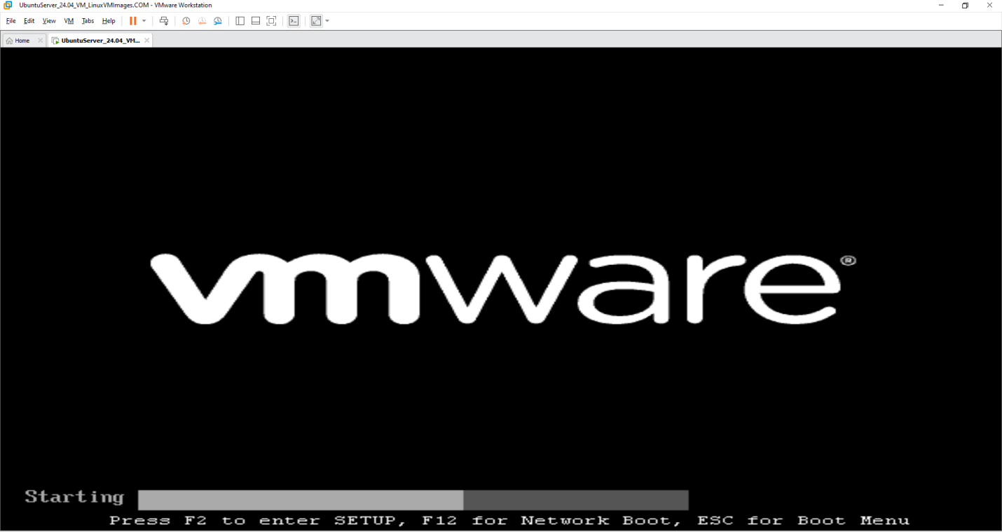

2. Capture the screenshot of **Ubuntu** after it starts successfully. **(10 points)**

**User and Privilege Setup**

* Create a new username and password for ubuntu (your firstname+ surname, ex: thanhtruong)

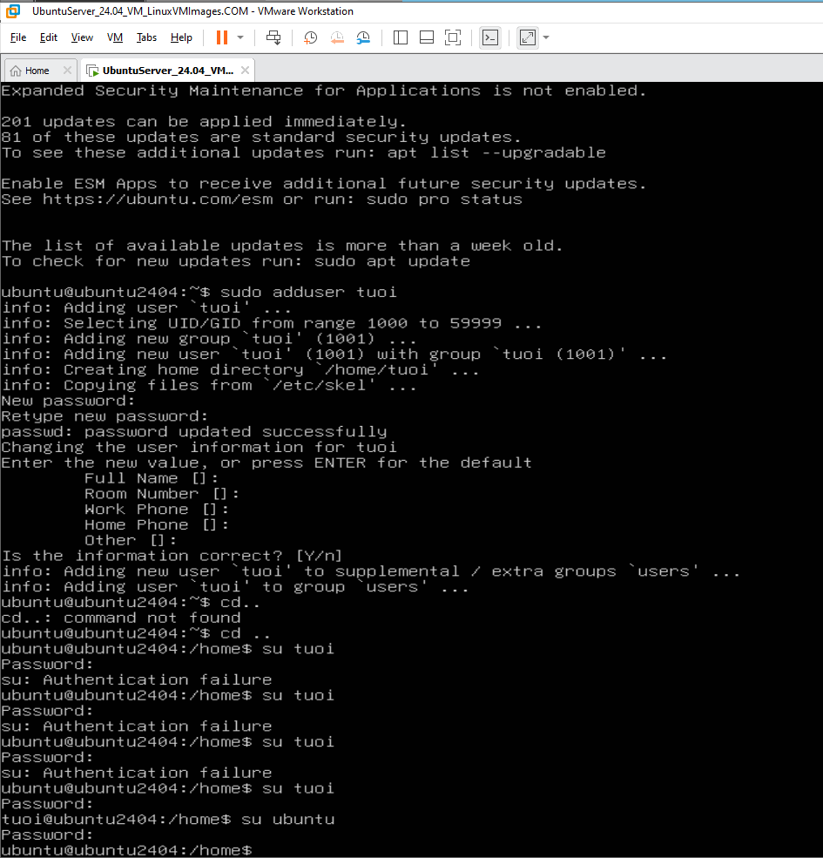

* Set the new username has admin right, as root



I ran “sudo init 6” but it led to something else so quickly that I was not able to capture the screen of the command

* Reboot Ubuntu by ‘init’ command and see the updated result (login with new username NOT ubuntu as before)
* 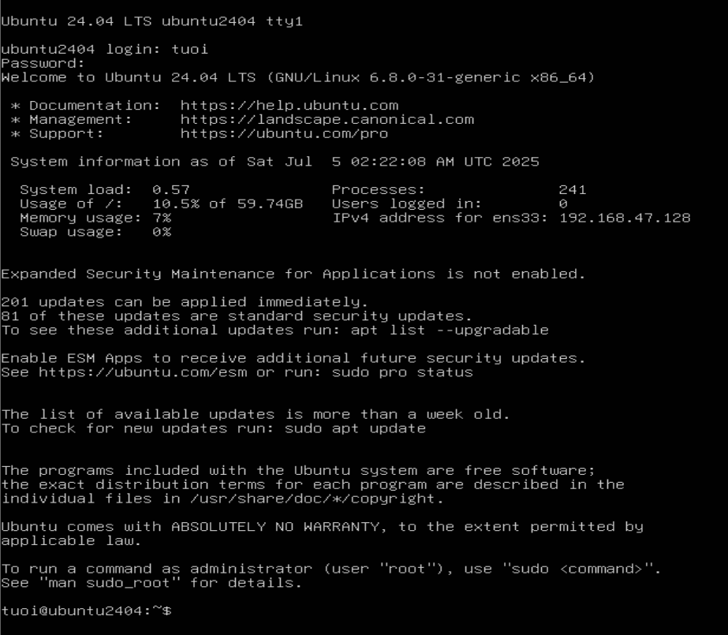

**File and Directory Operations**

1. Create a directory named as “CSE302”.

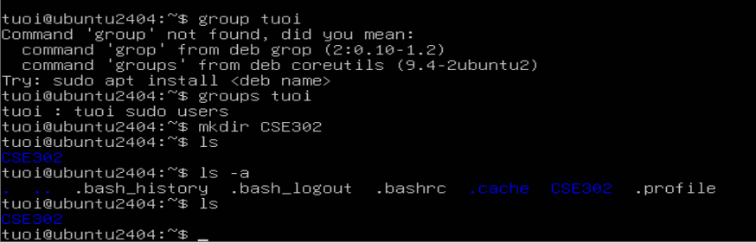

1. Go to directory “CSE302” and create a file named as “Lab1”.

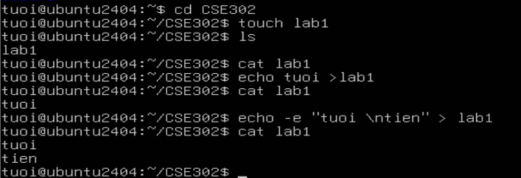

1. Copy “Lab1” towards another file named as “Lab2” in the same directory.

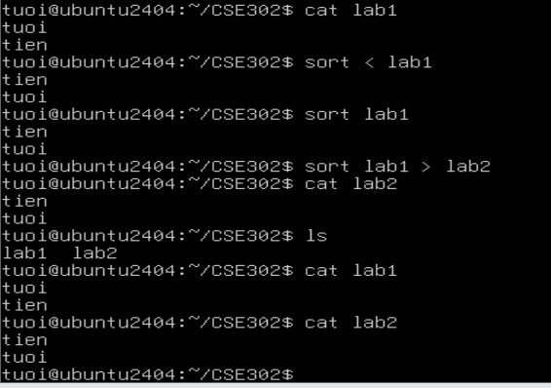

1. Create another directory named as “SCIT”.



1. Copy “Lab1” towards another file named as “Practice1” in another directory “SCIT”.

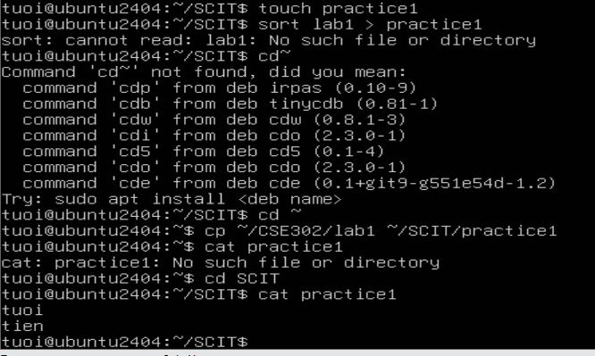

1. Rename the file “Lab1” as “Practice Lab 1”.

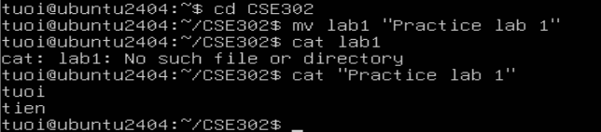

1. Delete the file “Lab2”.

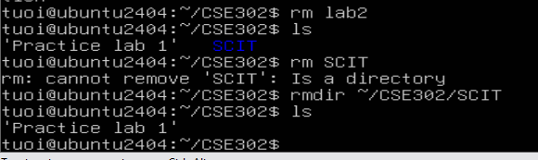

1. List all contents of your current working directory.



1. List all contents of your current working directory, including hidden files.



1. View the directory.



1. Change your current directory towards “CSE302”.



1. Return from “CSE302” directory towards your home directory



1. View the directory.

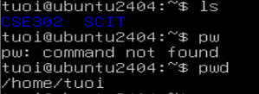

1. Change your current directory towards “SCIT”.

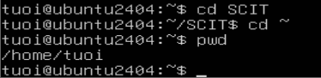

1. Go to your home directory, and display full path of your current directory.



1. Delete the directory “SCIT”.

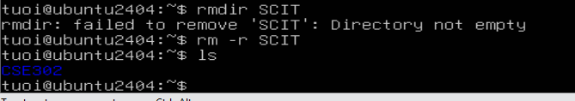

1. Read documentation on the command “ls”.

I ran man ls but it led to something else so quickly that I couldn’t capture the screen of the command

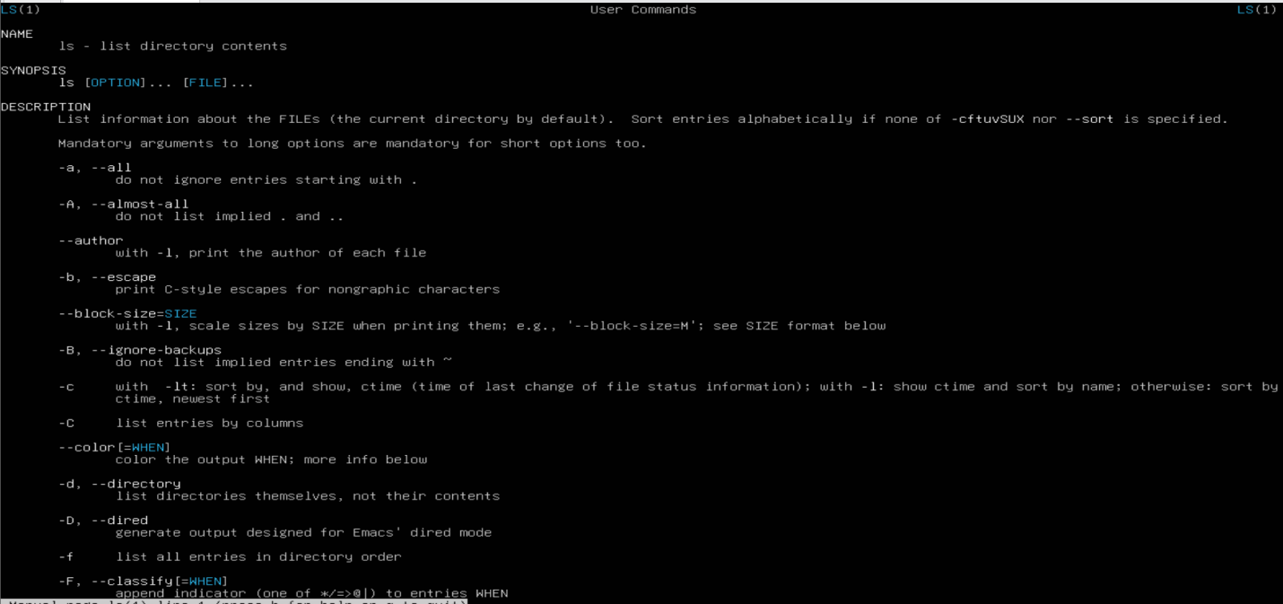

1. Search document for the matching command that have something do with “sort”.

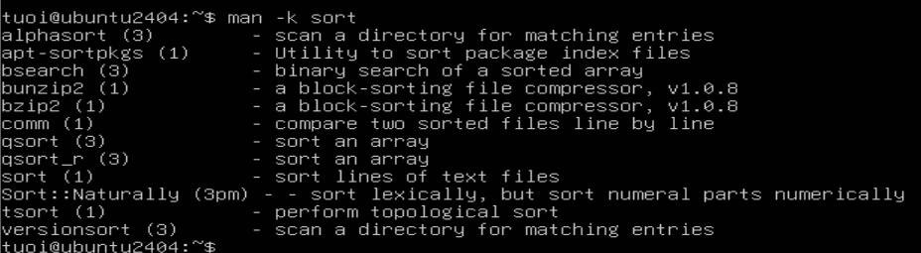

1. Install a software package named as “build-essential”.

I ran the command “sudo apt-get install build-essential “ but it led to something so quickly that i couldn’t capture the screen of the command

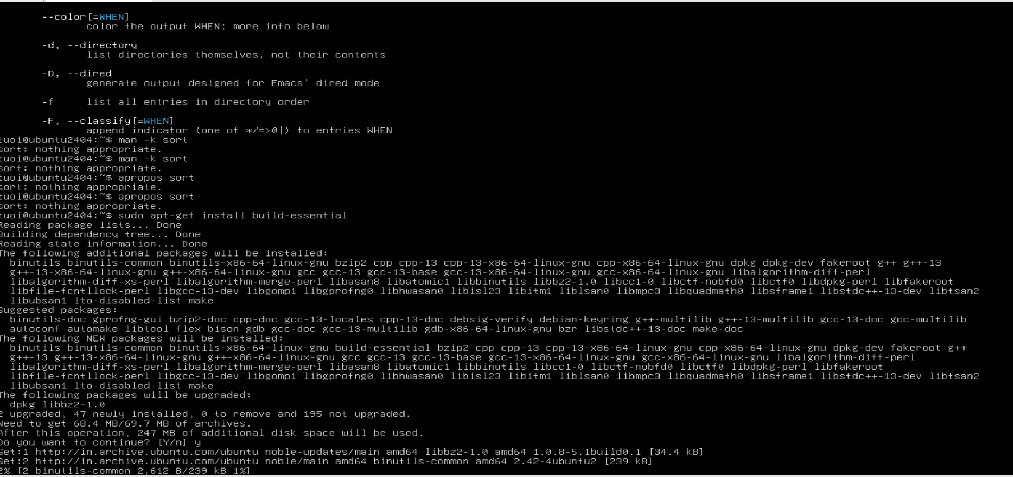

1. Print the version of “gcc” compiler.

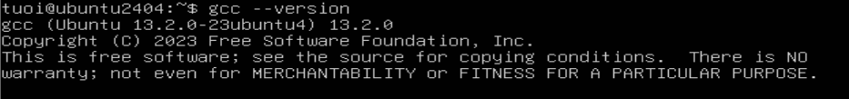

**Download and Check File**

23. Download the following file from internet.

wget https://cdn.kernel.org/pub/linux/kernel/v4.x/linux-4.17.2.tar.xz

* If you want to copy and paste the command, you need to set up SSH on Ubuntu
* Your Network Adapter of VMware needs to be Bridged
* After that, go to terminal or powerShell on your real computer and type:

*ssh username@IP_address*

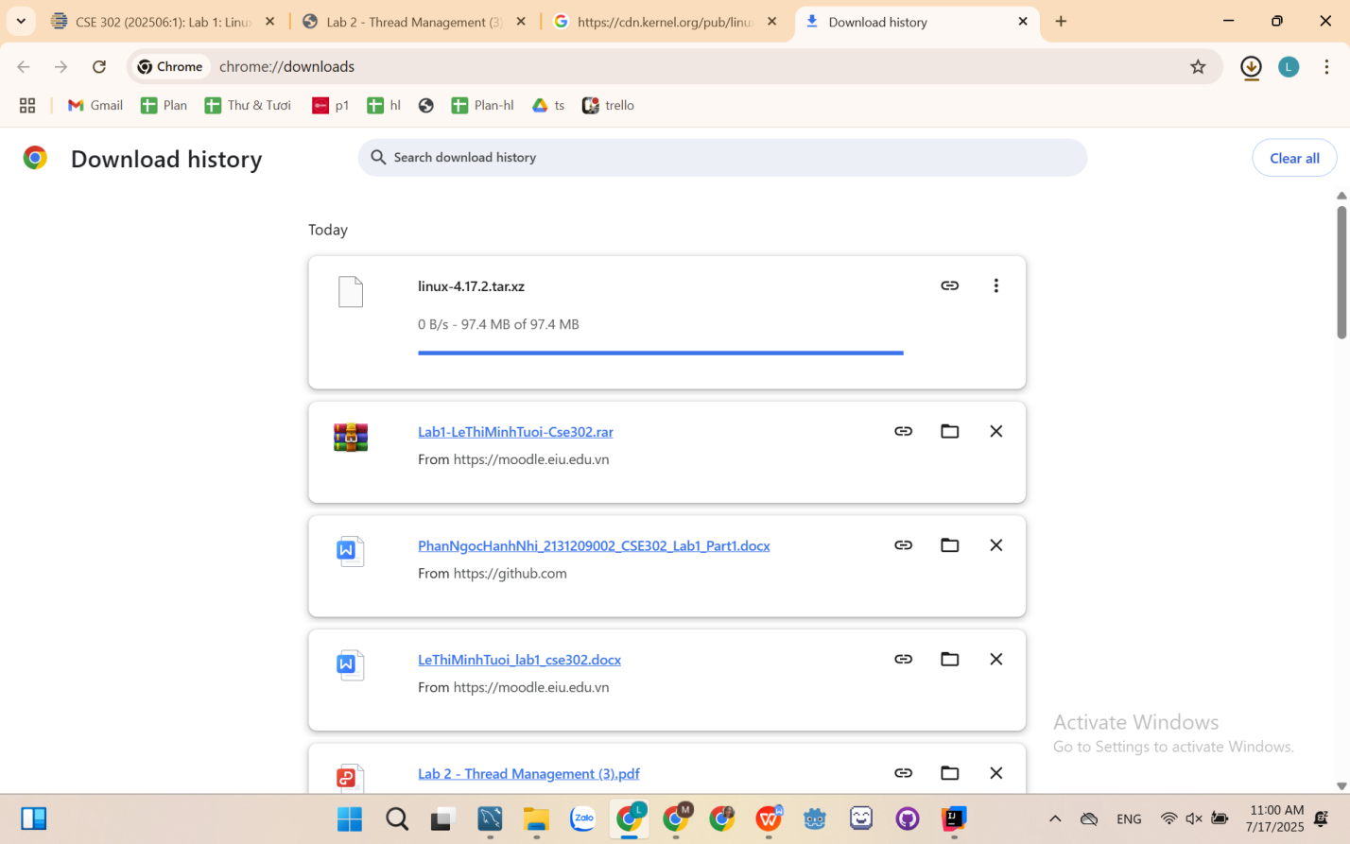

24. Can you view the file inside your current directory?

**Text File Editing and Reading**

25. Edit the file “LabInstruction.txt”.

Place the following text in “LabInstruction.txt” and save it.

*This course covers the basic knowledge of principles and operations of operating systems, including operating system structures, process management, CPU scheduling, process/thread synchronization, memory management, storage management, input/output systems and file systems. Students will understand how an operating system works and how to make the most effective use of whatever operating system they are using to develop effective and efficient software with a high level of expertise.* 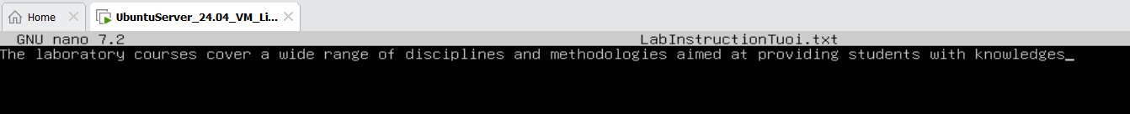

26. Count the number of characters, words, or lines in the file “LabInstruction.txt”.

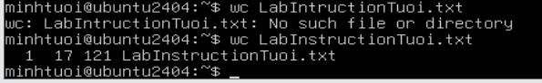

27. View the content of the file “LabInstruction.txt” in the terminal.



28. Write the output of “man wc” towards a new file “docs_for_wc_program.txt”. [Hints: You need to create the file “docs_for_wc_program.txt” first.]



29. View the content of the file “docs_for_wc_program.txt”.

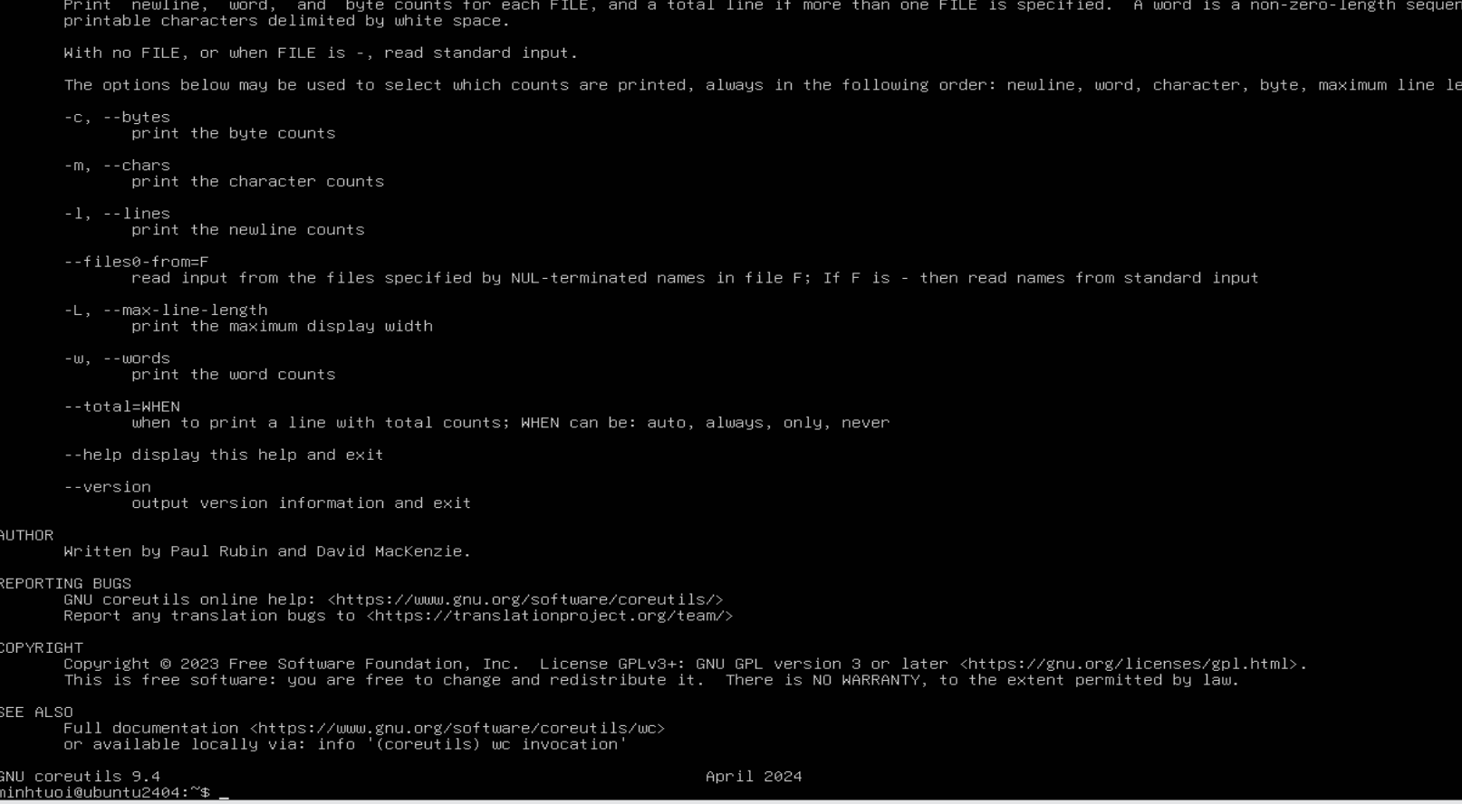

I am sorry. I cannot scroll up, so this is all I can capture

30. Append the output of “man ls” towards the file “docs_for_wc_program.txt”. Again, view the content of the file.

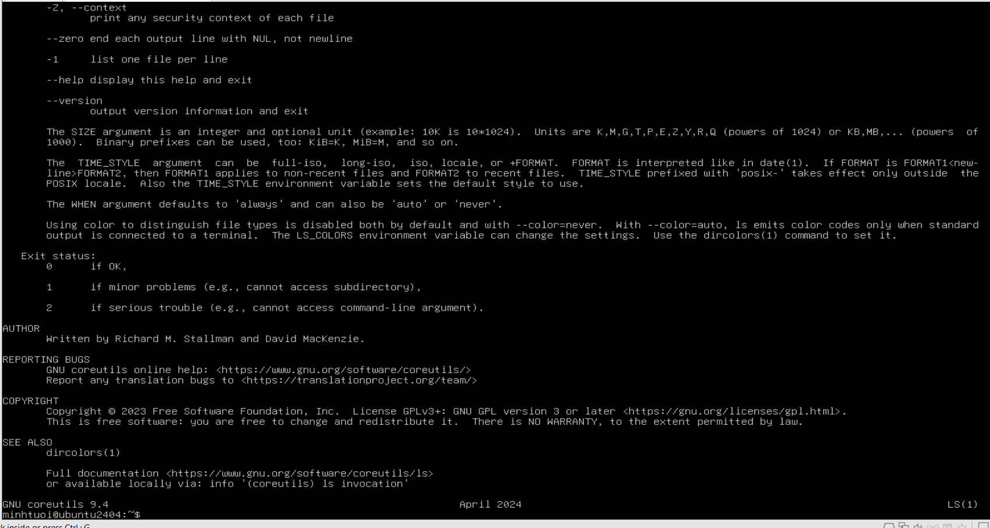

I am sorry. I cannot scroll up, so this is all I can capture

**Sorting file Content**

31. Create a text file named “mylist.txt” that contains the following lines:

cat

dog

horse

cow

Observe that the animals are not listed in alphabetical order.

What do if you need to list them in order? [Hints: You can pull the contents of the file into the *sort* command by using the *<* operator.

