Name: Le Thi Minh Tuoi

Lab: 2

A1/

\*Explanation:

Question a: Because thread 1 started, already finished and joined back and only then, thread 2 started, already finished and joined back. All threads were complete (No race conditions).

Question b:

Addition:

Reg1 = value

Reg1 += 1

Value = Reg1

Substraction:

Reg2 = value

Reg2 -= 1

Value = Reg2

But when both thread 1 and thread 2 started at nearly the same time, thread 1 might not do the “addition” completely and suddenly stopped to make way for thread 2. Therefore, it might be as following:

Reg1 = value ( assume value = 5 => Reg1 = 5)

Reg1 += 1 (Reg1 = 6)

Reg2 = value (The value is still not updated, so Reg2 = value = 5)

Reg2 -= 1 (Reg2 = 4)

Value = Reg1 (Value = 6)

Value = Reg2 (Value = 4)

=> Race conditions

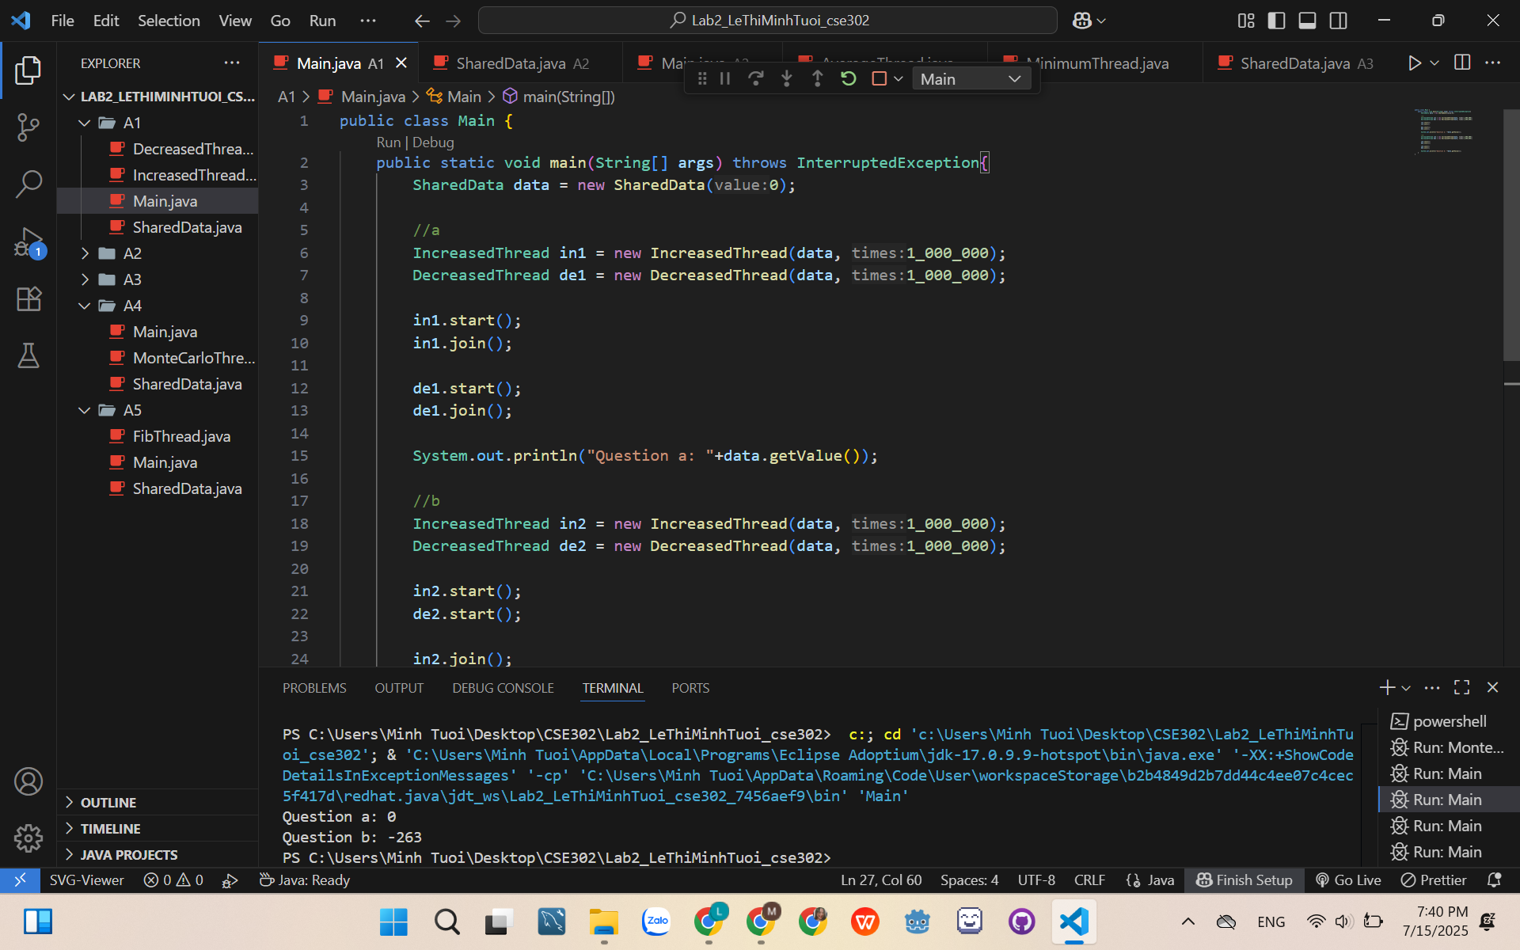

A2/

5+7+0+4+8 = 24

24/5 = 4.8

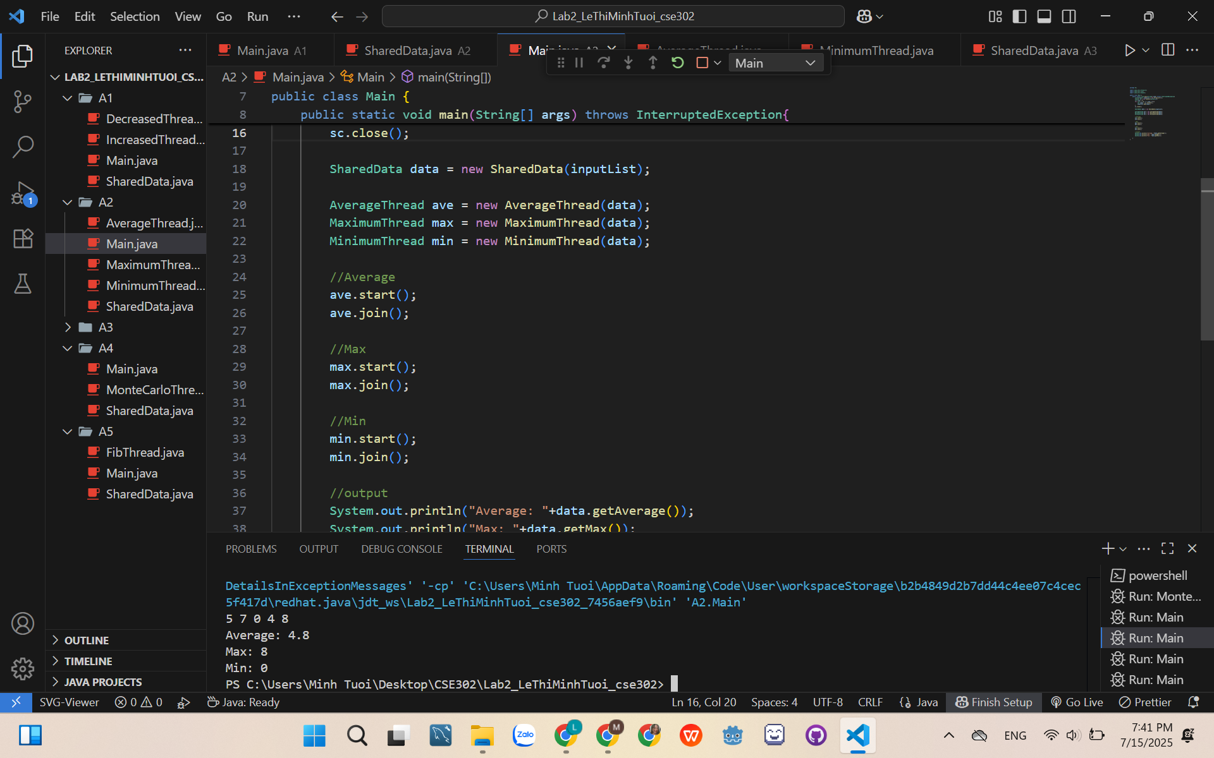

A3/

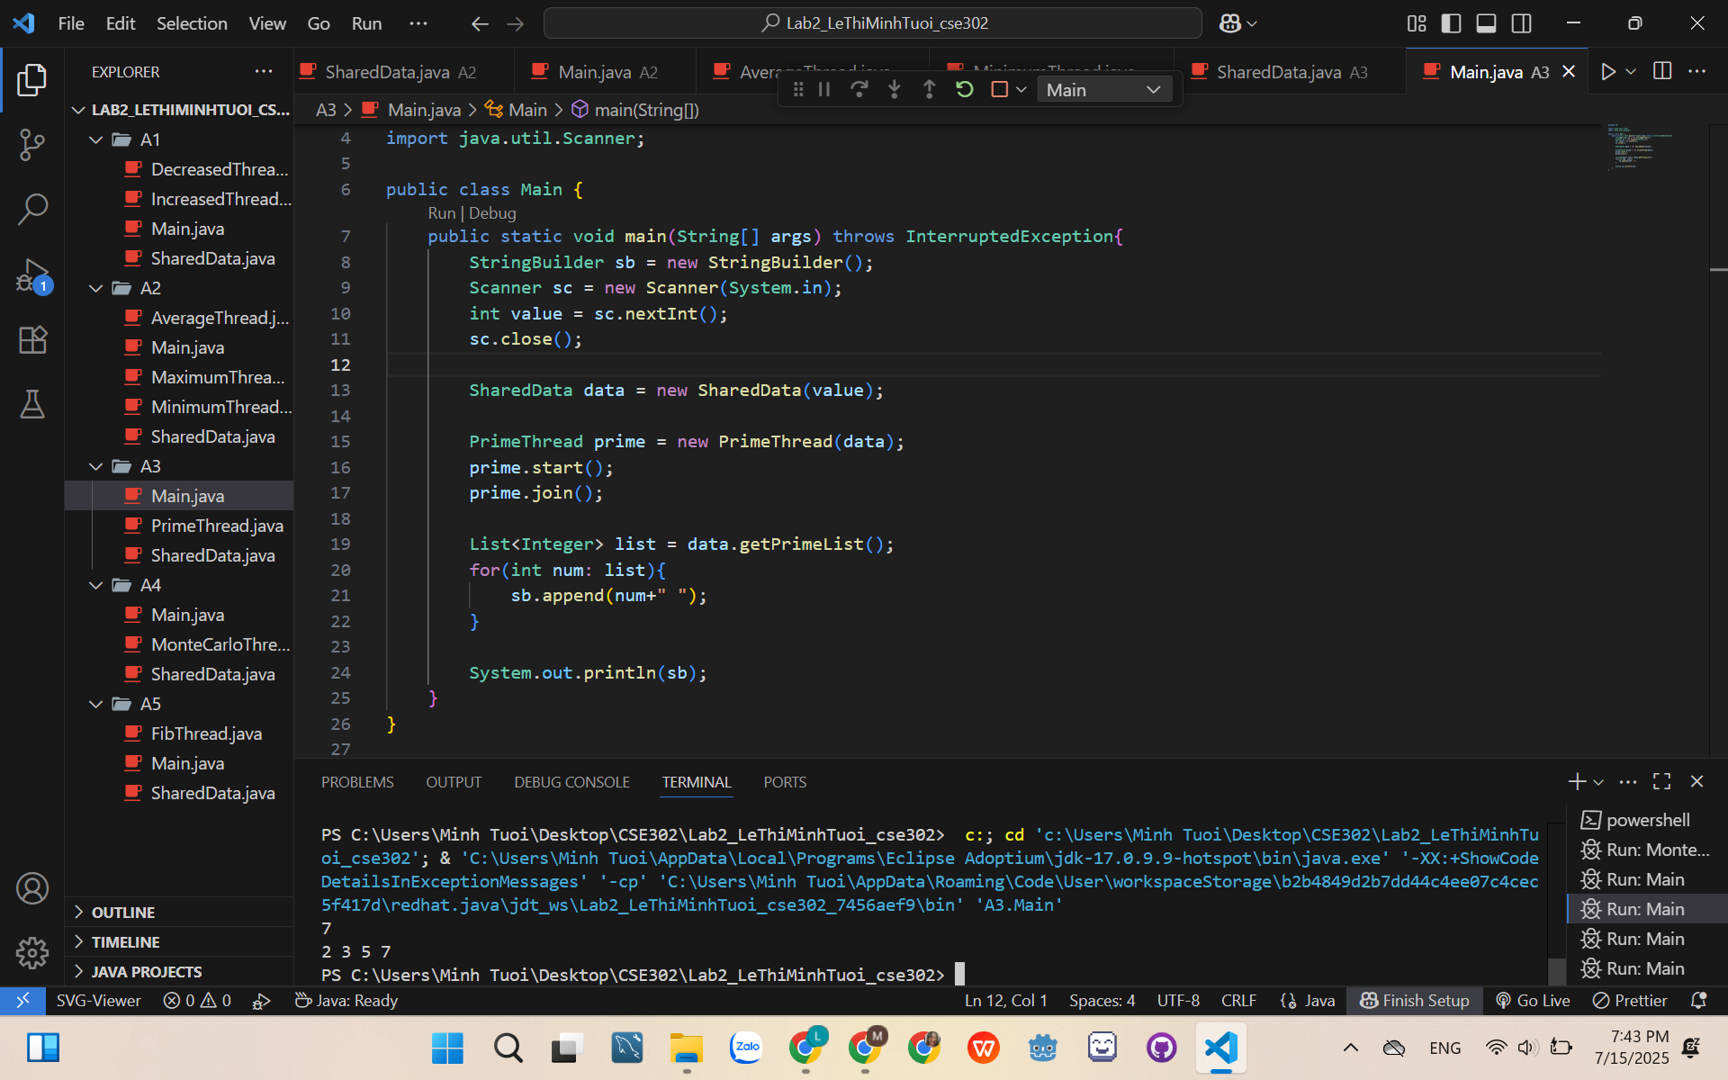

A4/

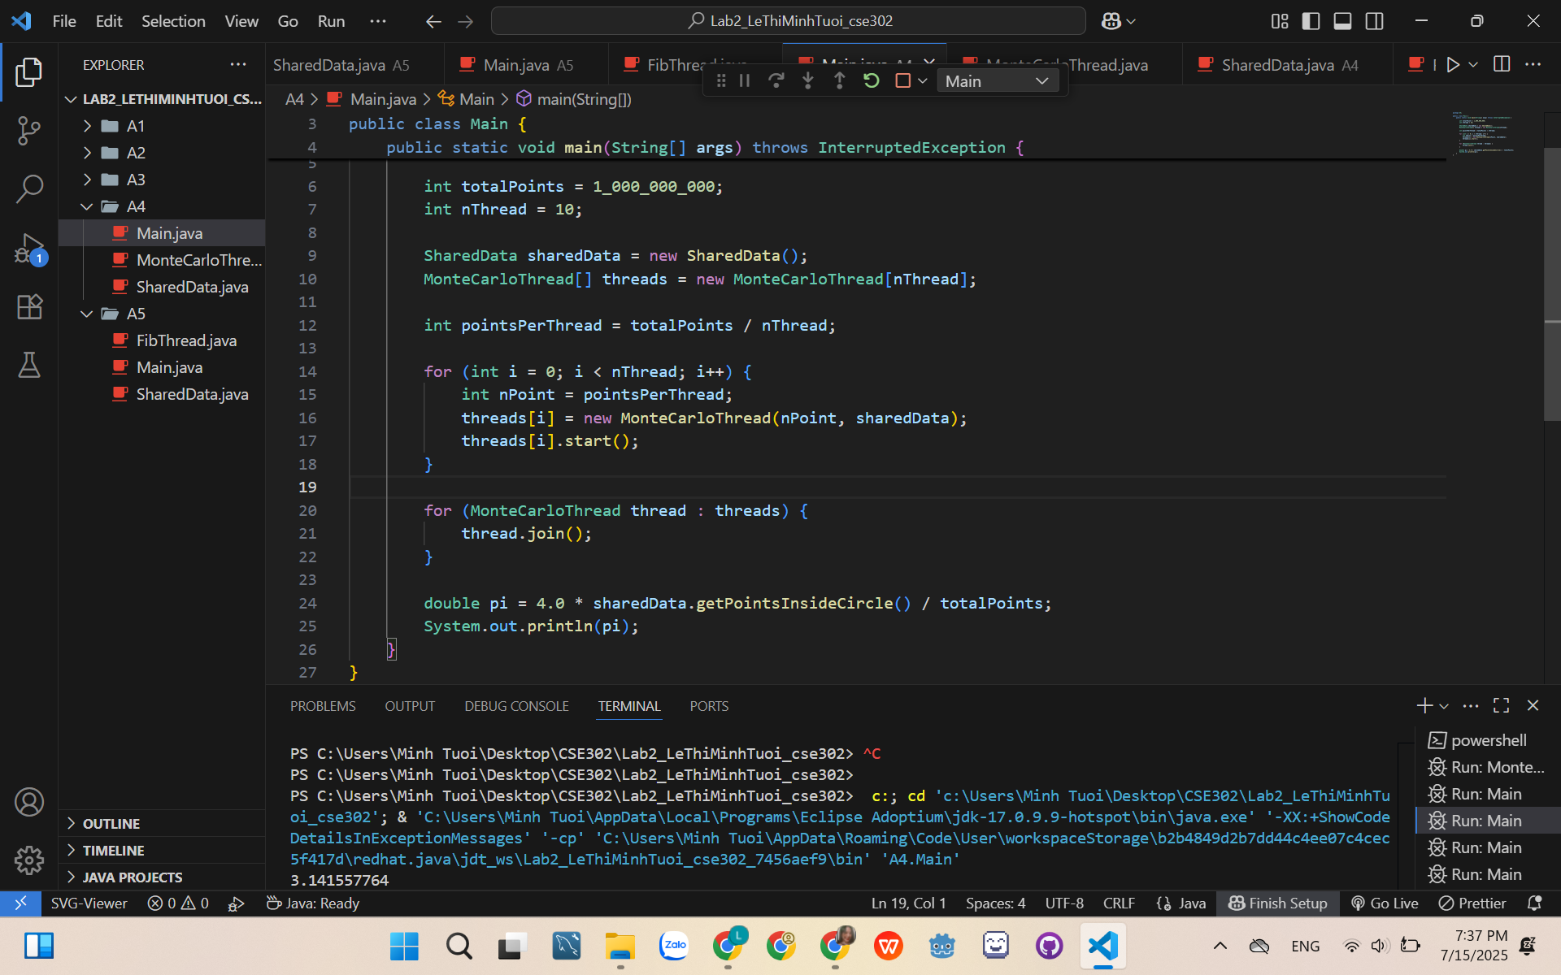

A5/

