The dynamic behaviors of an engineered system are generally reflected by one or more observable signals, which can be discretely sampled into time series. The values in a time series are determined by both an operational trend (i.e. main trend) and stochastic fluctuations. In the case of the complex dynamic social-ecological system, a detrending4 procedure is often necessary to extract the stochastic components for analyzing early warning signals1. As rather obvious variations can be observed in the curves of variance, autocorrelation and skewness (Fig. 1), we devise a Fluctuation Mining (FM) framework to ascertain stochastic fluctuations that is not directly associated to the designed operation of engineered systems (Fig. 2a-c). The framework consists of a data cleansing step that removes the failure-insensitive components in the observed signals and a detrending step that eliminates the dominant trend, i.e. the overall tendency of change, in the time series. For instance, the application of the FM on the IGBT dataset successfully reveals a much more obvious propensity of increasing variance and autocorrelation as well as deviating skewness (Fig. 2f-h and Supplementary Fig. S2).

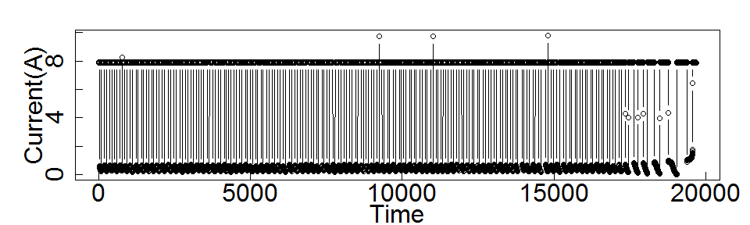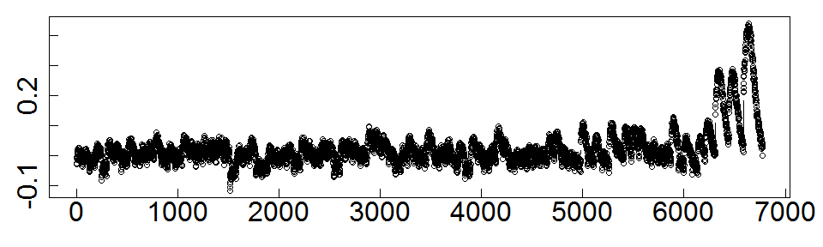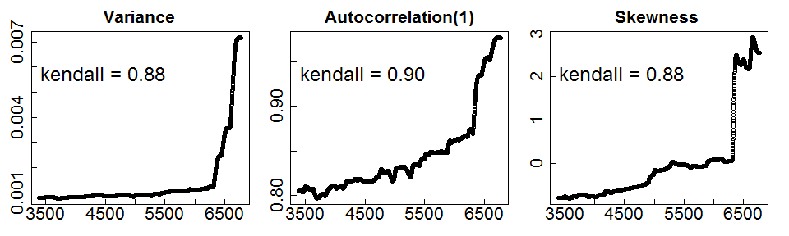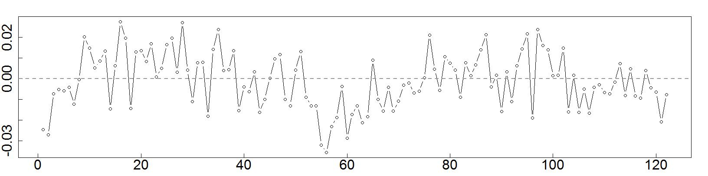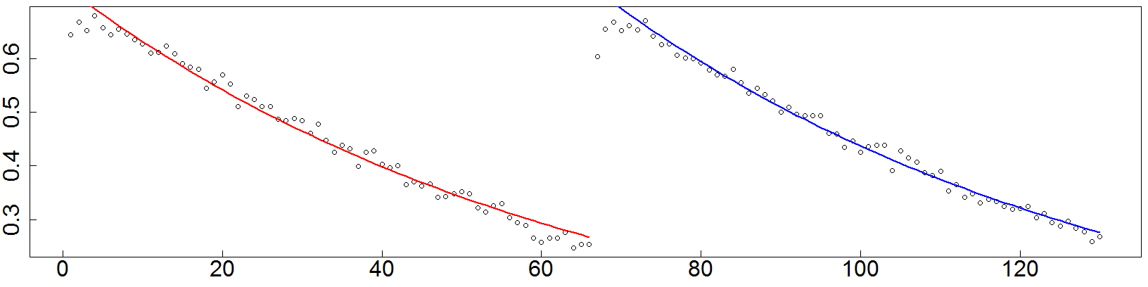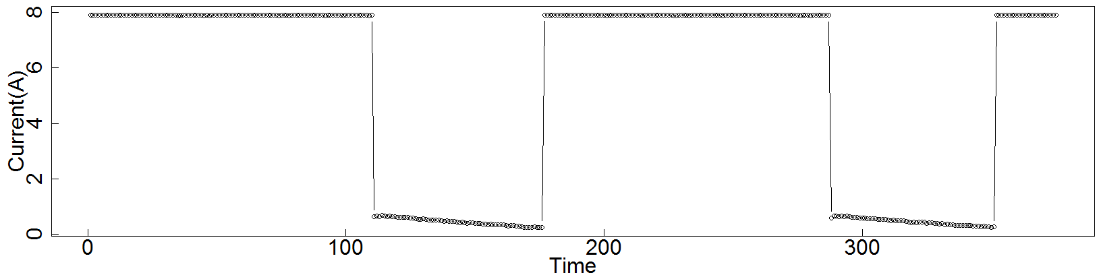

a

b

c

d

e

f

g

h

**Figure 2 | The Fluctuation Mining (FM) process and the identification of intrinsic stochastic fluctuations. a-c,** The processing flow of FM on the collector current of the IGBT system**. a,** A snippet of the time series of collector current collected from the IGBT system. **b,** The failure sensitive component, i.e., the switch-off current that exponentially converges to 0, in the collector current. **c,** The fluctuations derived after performing FM on the previous snippet of the time series. **d**, The original time series of collector current collected from the IGBT accelerated aging test**. e,** The fluctuations derived after FM for **d**. **f**, **g**, and **h,** The variance, autocorrelation and skewness indicators after FM. Analysis on the signals after the FM process shows strong evidence of CSD and deviating skewness.

The findings so far validate the existence of early-warning signals in engineered systems with forthcoming failures. The correspondence between the critical transition and the system failure, however, is still open. We endeavored the Student t-test25, the Gaussian kernel based probability density test25, the Akaike Information Criterion (AIC) based ARIMA model analysis26, and the phase space analysis27 on the four engineered systems before and after they reach their failures (Fig. 3 and Supplementary Fig. S4). The analysis results consistently suggest that the studied systems undergo an abrupt change of state. For example, the bearing system remains stable under normal operation and diverges to an unstable tate upon failure (Fig. 3b-e), the Turbofan engine witnesses a complete change of the underlying dynamical function (Fig. 3g), and in the case of the IGBT system, the normal functioning stage and failure stage reveal significant varying limit cycles in the phase portrait (Fig. 3i&k). The above analysis shows strong evidence on the equivalence between the critical transition and the system failure in the engineered systems. Such correspondence further demonstrates the applicability of the early warning signals in predicting incoming system failures.

Critical transition, as shown to have a strong correlation with system failure, is likely to be the aftermath of a catastrophic bifurcation28. Taking the bearing system and the IGBT system as examples, the sudden shift in the fluctuation signals exhibit the features of bifurcations (Fig. 4a&b). In fact, nonlinear phenomena like hysteresis, which are closely related with bifurcations, can be found in many engineered systems, e.g., hysteretic actuators in control systems, positive feedback based circuits in electronics, airstream in aerodynamics, elastic deformation of materials, magnetic and electrical hysteresis in ferromagnetic materials29. Hence we anticipate that the catastrophic bifurcation, which can be triggered by a small perturbation of a latent parameter, to be a common phenomenon in engineered systems approaching failures (Fig. 4c). We propose that the engineered systems with dynamical behaviors can be abstracted to have three phases: a nominal design phase that is equivalent to the basin of attraction, a predefined safety-oriented phase when the system initializes the self-protection after certain faults happened, and an unstable failure phase exhibiting out-of-control performance (Fig. 4d). The critical transition occurs when the system departs from the basin of attraction and loses its resilience30 as the system fails.

Our findings are the first to recognize the critical transition as a common property in engineered systems and early warning signals can be effectively used in predicting failures in such systems. The discoveries have implications in several aspects. First, we offer evidence that the phenomenon of early warning signals is prevalent in both natural and engineered systems. It is probably not surprising that there are no absolutely boundaries between the two as the complex dynamics are fundamentally universal. Second, we validate an often taken-for-granted hypothesis, that the failure of engineered systems can be attributed to the respective critical transitions. Third, it is feasible to catch disastrous bifurcations with early warning indicators, which can be identified by investigating the fluctuations in an engineered system. Such a discovery paves the way toward a generic methodology to predict and prevent potential disasters caused by the failure of engineered systems.

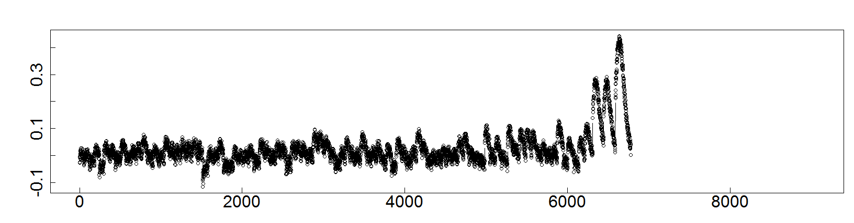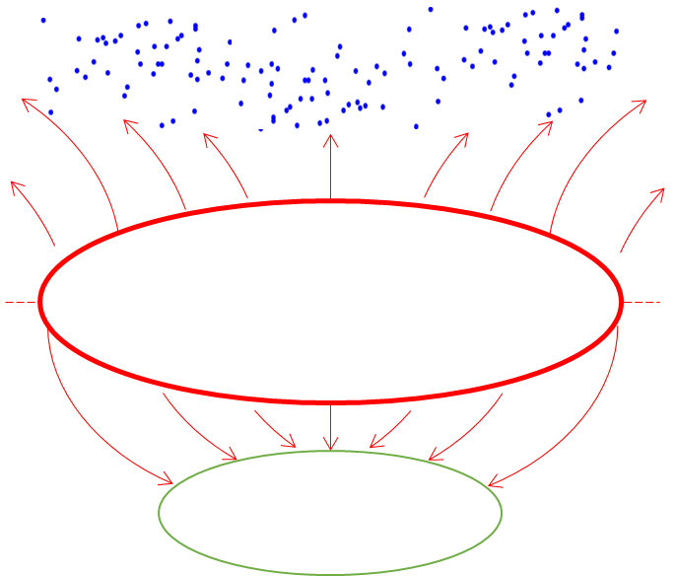

The designed working area

as the basin of attractor

The catastrophic failure phase

Safety-oriented

failure phase

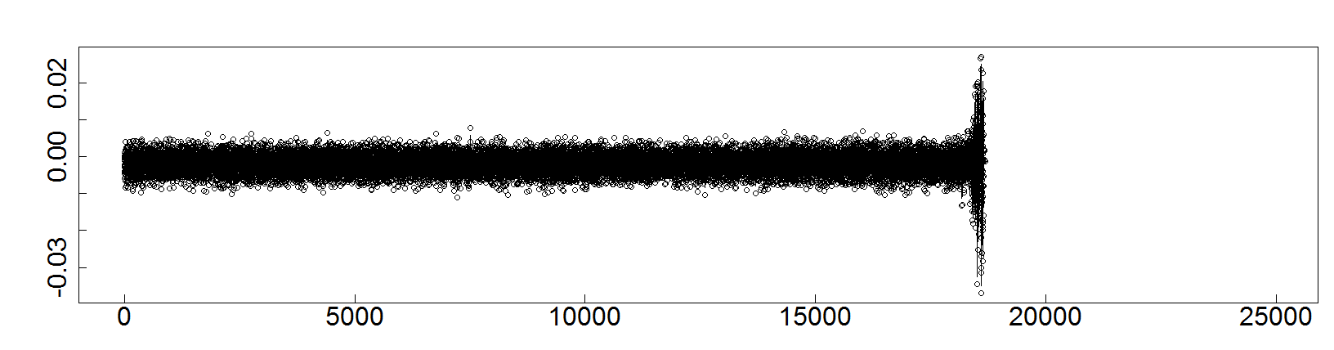

**a**

**b**

**d**

**c**

**Figure 4 | The potential catastrophic bifurcation and critical transition in engineered systems.** **a**, The abrupt state change in the vibration signal of the bearing system while running into failure. **b**, The abrupt state change in the fluctuation of the IGBT collector current extracted with FM. **c**, The hypothesized catastrophic bifurcation at the system failure. The catastrophic bifurcation can be mapped to the sudden regime shifts in **a** and **b**. Considering the nonlinear phenomenon like hysteresis, the above hypothesis is likely to hold. **d**, The proposed three phases, a nominal designed working phase that is equivalent to the basin of attractions, a predefined safety-oriented phase when the system initializes the self-protection after certain failures happened, and an unstable failure phase exhibiting out-of-control performance, in engineered systems with dynamical behaviors. The catastrophic bifurcation, i.e., critical transition, occurs when the system departs from the basin of attraction and lose its resilience as the system fails.

a

d

b

c

REFERENCES

1. Scheffer, M. (2009). Critical transitions in nature and society. Princeton University Press.

2. Scheffer, M., Carpenter, S. R., Lenton, T. M., Bascompte, J., Brock, W., Dakos, V., ... & Pascual, M. (2012). Anticipating critical transitions. science,338(6105), 344-348.

3. Scheffer, M., Bascompte, J., Brock, W. A., Brovkin, V., Carpenter, S. R., Dakos, V., ... & Sugihara, G. (2009). Early-warning signals for critical transitions. Nature, 461(7260), 53-59.

4. Wang, R., Dearing, J. A., Langdon, P. G., Zhang, E., Yang, X., Dakos, V., & Scheffer, M. (2012). Flickering gives early warning signals of a critical transition to a eutrophic lake state. Nature, 492(7429), 419-422.

5. Boettiger, C., & Hastings, A. (2012). Quantifying limits to detection of early warning for critical transitions. Journal of the Royal Society Interface, 9(75), 2527-2539.

6. Guttal, V., & Jayaprakash, C. (2008). Changing skewness: an early warning signal of regime shifts in ecosystems. Ecology letters, 11(5), 450-460.

7. Scheffer, M., Carpenter, S., Foley, J. A., Folke, C., & Walker, B. (2001). Catastrophic shifts in ecosystems. Nature, 413(6856), 591-596.

8. Rietkerk, M., Dekker, S. C., de Ruiter, P. C., & van de Koppel, J. (2004). Self-organized patchiness and catastrophic shifts in ecosystems. Science,305(5692), 1926-1929.

9. Carpenter, S. R., Cole, J. J., Pace, M. L., Batt, R., Brock, W. A., Cline, T., ... & Smith, L. (2011). Early warnings of regime shifts: a whole-ecosystem experiment. Science, 332(6033), 1079-1082.

10. Christian Meisel, Andreas Klaus, Christian Kuehn, and Dietmar Plenz. Critical Slowing Down Governs the Transition to Neuron Spiking. PLoS Comput Biol. 2015 Feb; 11(2).

11. Lenton, T. M., Held, H., Kriegler, E., Hall, J. W., Lucht, W., Rahmstorf, S., & Schellnhuber, H. J. (2008). Tipping elements in the Earth's climate system. Proceedings of the national Academy of Sciences, 105(6), 1786-1793.

12. May, R. M., Levin, S. A., & Sugihara, G. (2008). Complex systems: Ecology for bankers. Nature, 451(7181), 893-895.

13. Bar-Yam, Y. (1997). Dynamics of complex systems (Vol. 213). Reading, MA: Addison-Wesley.

**Figure 1 | The presence of early warning signals in terms of the CSD (*i.e.*, increasing variance and autocorrelation) and deviating skewness in four engineered systems, the airbrake system of a locomotive, the bearing, the turbofan engine and the IGBT.** **a**(1), The air pressure signal in the brake pipe of a locomotive in the period of two days before the failure of un-recoverable pressure loss. The signal was collected by the Train Control/Management System (TCMS) of the locomotive every second. It was preprocessed by eliminating the data corresponding to the parking states. **b**(1), The vibration signal from a bearing test platform collected by NASA PCoE while the bearing is operating until breaking down. **c**(1), An unspecified signal in the Turbofan engine degradation simulation collected by NASA PCoE while the engine runs to failure. **d**(1), The collector current signal of a power IGBT during accelerated aging tests collected by NASA PCoE. **a**(2-4), **b**(2-4), **c**(2-4) and **d**(2-4), The early warning signal indicators. **a(2), b(2), c(2),** and **d**(2), The variance of the respective signal. **a(3), b(3), c(3),** and **d**(3), The lag 1 autocorrelation of the respective signal. **a(4), b(4), c(4)** and **d(4),** The skewness of the respective signal. The sliding window to compute variance, autocorrelation and skewness is chosen as 50% of the span of time series for all the four systems. There are strong evidences of CSD and deviating skewness in all the four systems when they approach system failures. An increasing trend in both variance and lag 1 autocorrelation (i.e., CSD) can be clearly recognized. Clear deviations are observed in the skewness indicator. For instance, the airbrake and the IGBT systems show a strong tendency of increase before the system failure. The skewness in the bearing system significantly oscillates when approaching failure, while the skewness in the case of the Turbofan has a consistent tendency of decreasing from the original value at around 1.5. Despite the clear trend, strong fluctuations on the variance, autocorrelation and skewness are observed in all the cases, suggesting systematic disturbances existing in the original time-series. For example, the IGBT data was collected from the accelerated aging test by periodically switching on and off the device. It is the transient current after switching off that reflects the inherent resilience24. The times series of the collector current mainly be two components, the switch on current signal (which is failure-insensitive) at around 8A and the switch off current signal (which is failure-sensitive) exponentially converging to zero (**d**(1)). We show how to derive a more evident tendency in the early warning signals by focusing on failure-sensitive components in Fig. 2.

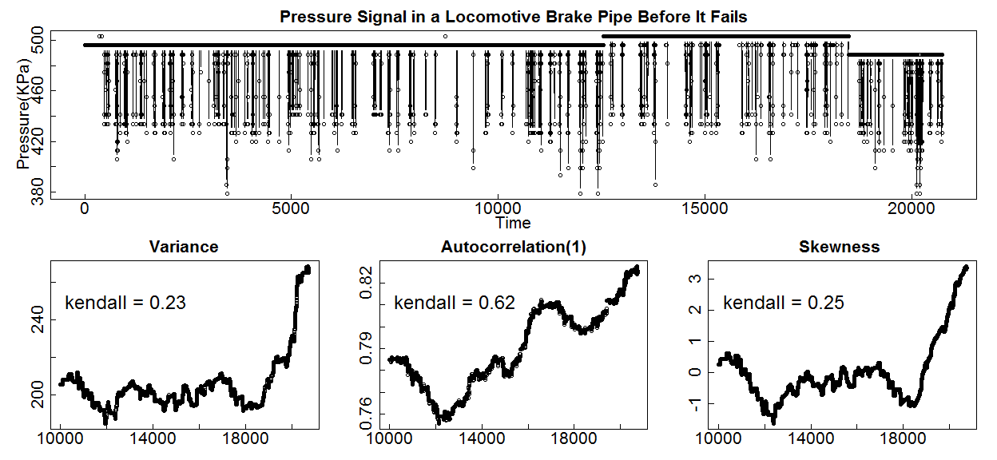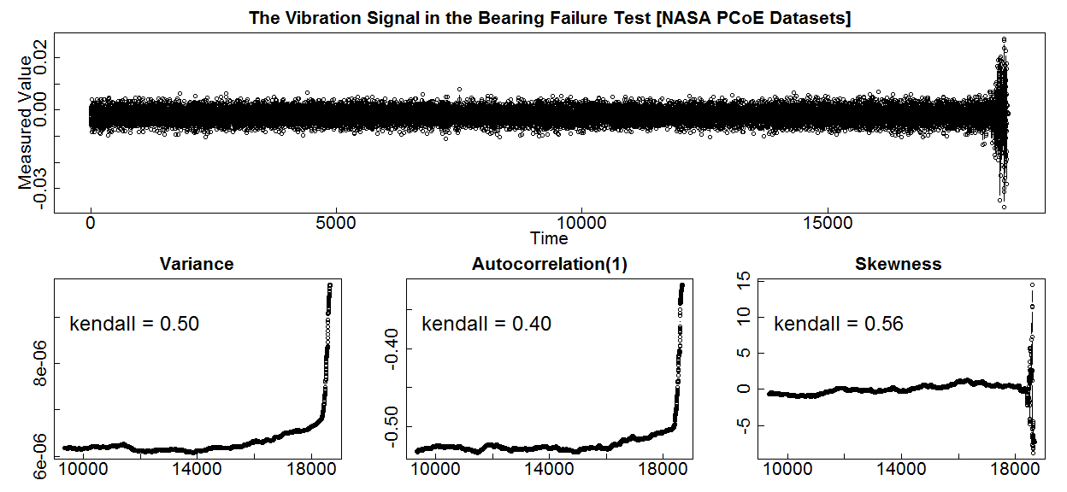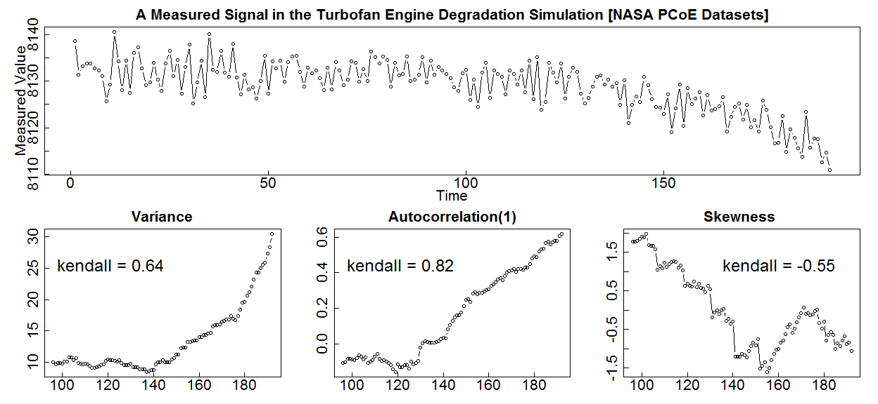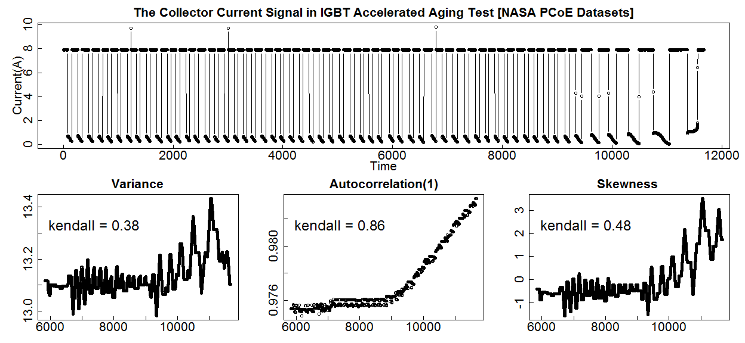

a(2)

a(1)

a(3)

a(4)

b(2)

b(1)

b(3)

b(4)

c(2)

c(1)

c(3)

c(4)

d(2)

d(1)

d(3)

d(4)

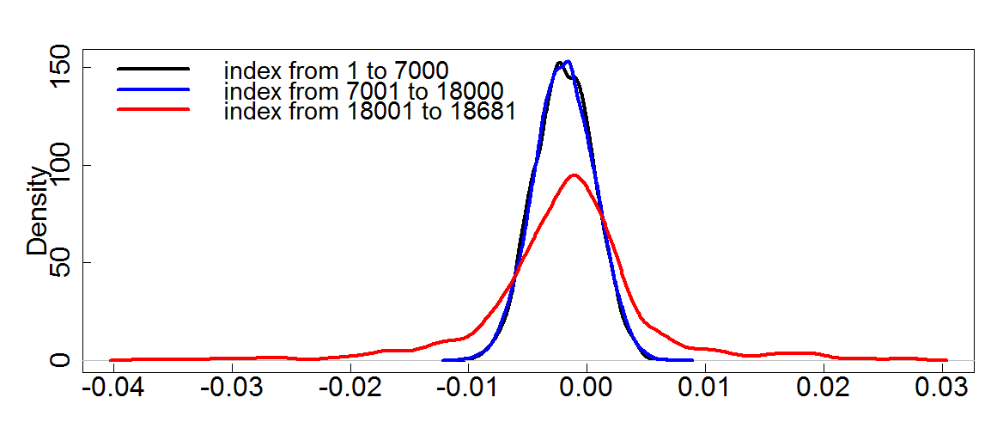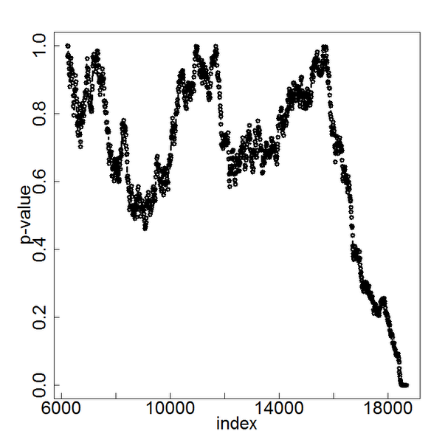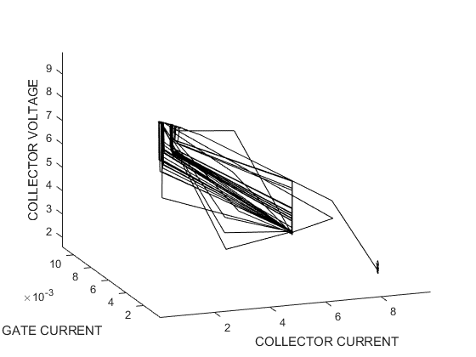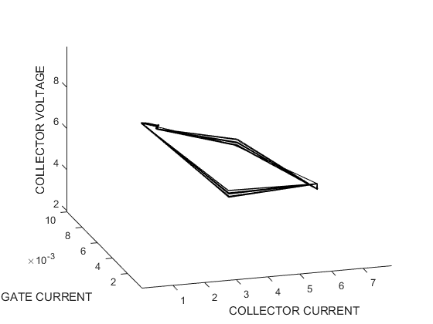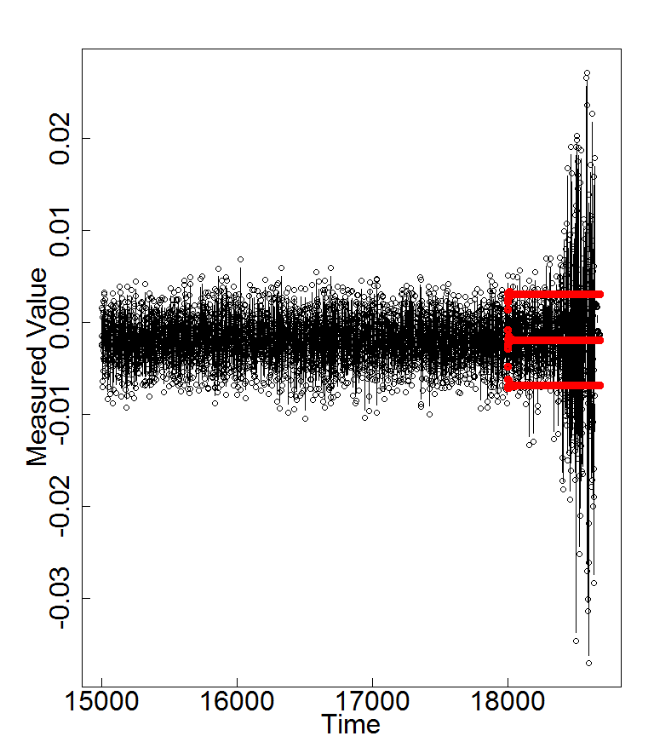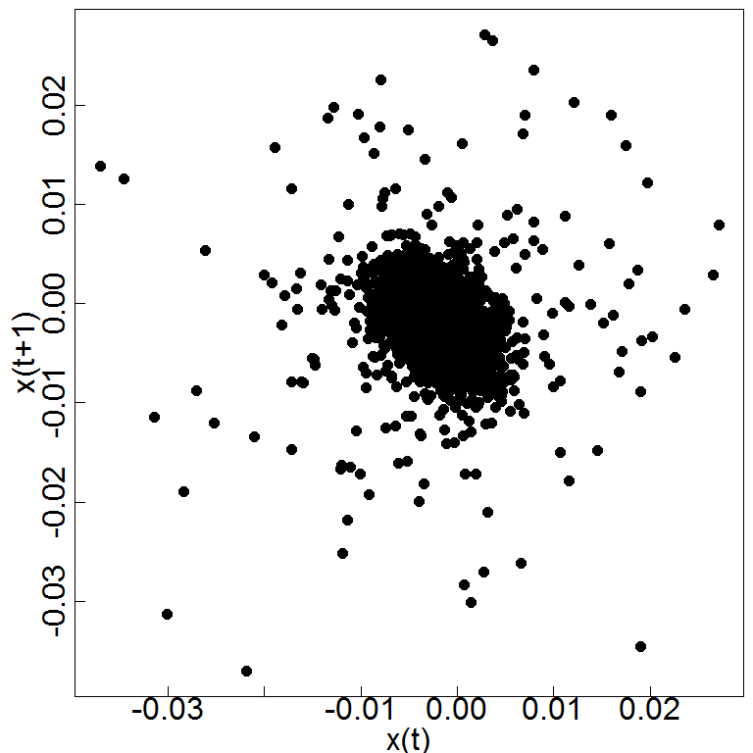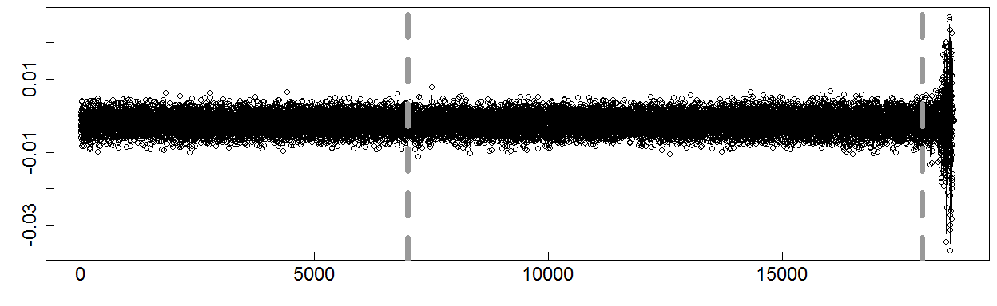

a

c

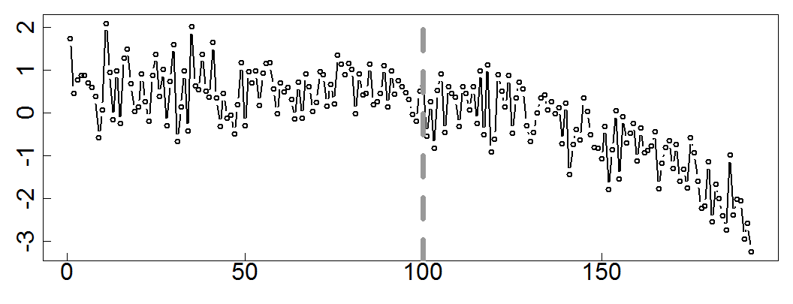

f

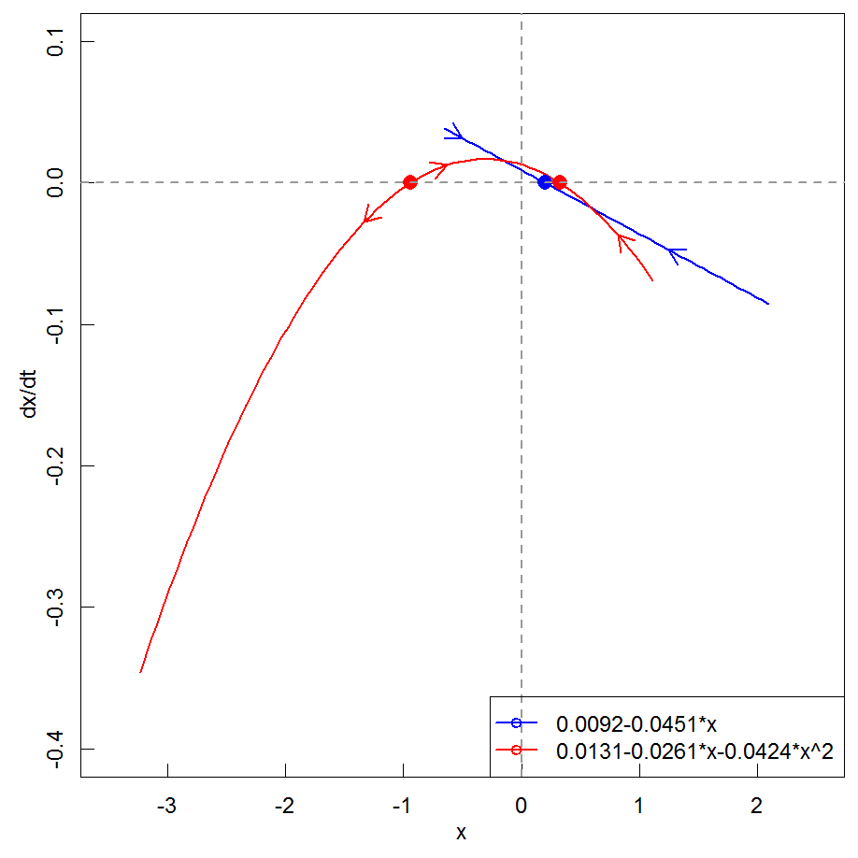

g

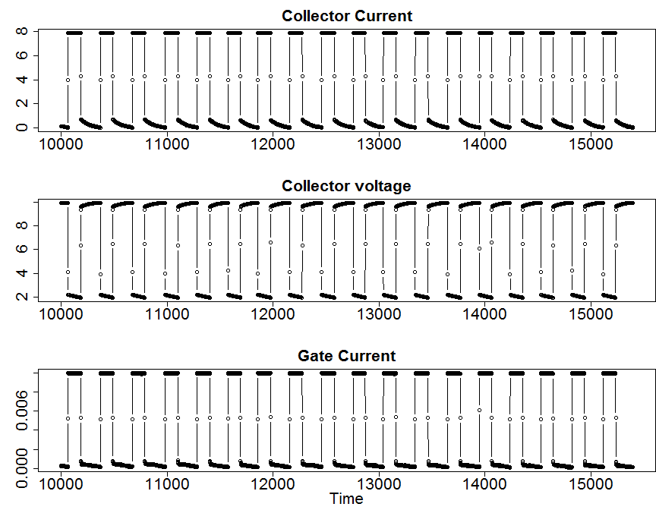

h(1)

h(2)

h(3)

i

k

b

d

e

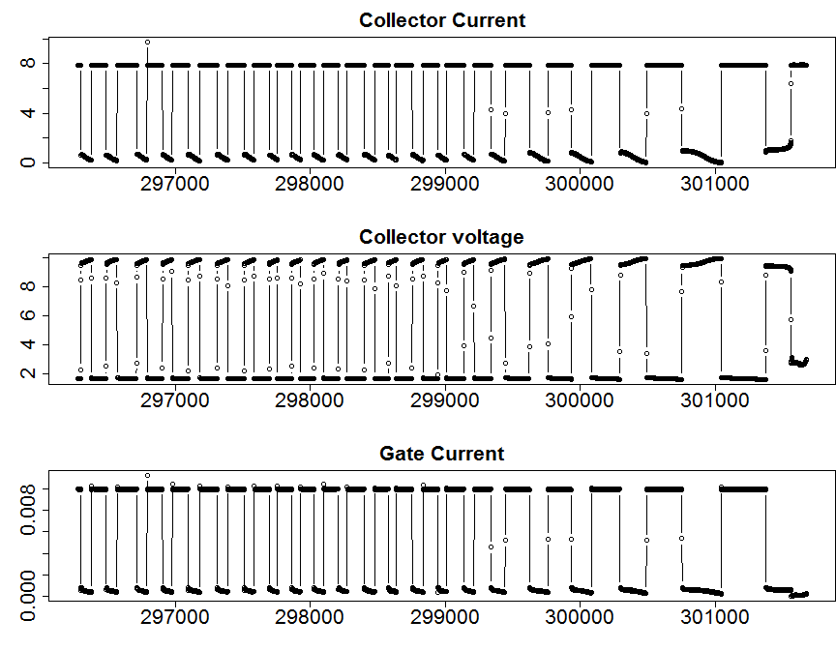

j(1)

j(2)

j(3)

**Figure 3 | Critical transition analysis of the engineered systems when running into failures with various methods. a,** The original time series of the vibration signal collected from the bearing system approaching failure, with the dashed line segment the signals into three parts for succeeding analysis. **b-e**, Critical transition analysis for **a**. **b**, The Gaussian kernel based probability density estimate for the three parts of the vibration signal. The density of the third part significantly differs from the first two. **c**, The results of Student’s t-test of the vibration amplitude signal with the true value of the mean be the mean of a normally functioning section. The tested p-value show an evident decrease to below 0.01, which significantly denies the null-hypothesis, indicating that the system evolves into a different state when getting into system failure. **d**, A forecasting with a 95% confidence interval (enclosed in the red bars) derived from the AIC based ARIMA model for the third part of the vibration signal. The fail in encompass the vibration signal in the part suggests a phase transient. **e**, Logistic map for phase space analysis of the vibration signal. The first two parts are rather concentrated while the third part diverges to unstable. **b-e** indicate that there is a critical transition in the bearing system when it is arriving a system failure. **f**, A time series of the turbofan engine system during the degradation simulation process with thedashed line separates the signals into two parts at a departure point. **g**, The phase portrait of the two parts of the time series signal of the turbofan engine system. A governing dynamical equation, dx/dt = 0.0092-0.0451x, is learned from the left part and a system equation, dx/dt = 0.0131-0.0261x-0.0424x2, for the right part28. It shows that the left part has only one stable equilibrium point, while the right part has two, of which the one at the negative axis potentially drives the system to unstable (*i.e.*, the corresponding system failure). **h(1-3)** and **j(1-3),** Two snippets of the three selected signals of the IGBT system at the normal functioning stage and the close-to-failure stage. **i** and **k**, The phase portraits of the signals in h(1-3) and g(1-3). The phase portrait of the normal functioning stage has a clear limit cycle serving as the basin of attractor, while the portrait of the close-to-failure stage reveals divergent behaviors indicating the occurring of critical transition. More analysis of critical transition can be found in the supplemental material. The above analysis of the engineered systems suggests that the systems undergo certain critical transitions when running into system failures.