This is a simple Front End project.

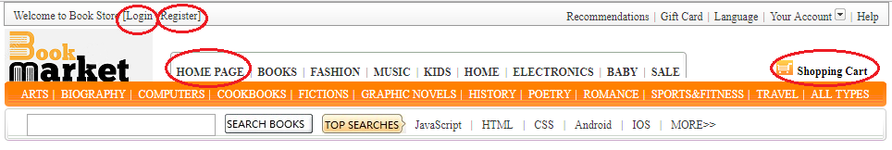

For this project, I just made 4 pages, that are Home Page, Shopping Cart, Login and Register. You can jump between these pages by click on the red cycle shown above.

