**AI-Driven Exploration and prediction of Company Registration Trends**

**Phase 5: Project Documentation & Submission**

**Team member**

**Name : SARANRAJ S**

**Dept : CSE-III year,**

**Domain : AI101(IBM-Artificial Group1),**

**NM ID : au410121104041**

**Team Name : The aesthetic coder**

**College : Adhi college of engineering and technology.**

**Problem Definition and Design Thinking**

In this part you will need to understand the problem statement and create a document on what have you understood and how will you proceed ahead with solving the problem. Please think on a design and present in form of a document.

• **Design**: Utilize Al to forecast future company registrations using

historical data.

• **Applicability**: Informs business decisions and guides policy-

making.

• **Technology:** Al algorithms for trend prediction and pattern

recognition.

• **Coding:** Python, Al libraries, data manipulation, and predictive

modeling.

• **Architecture:** An Al business astrologer predicting company

registration trends.

• **Transformation:** Transforms decision-making from reactive to

proactive.

• **Real-World Analogy:** A financial analyst predicting market trends

for investors.

**We are implement our AI program by this data set:**

https://tn.data.gov.in/resource/company-master-data-tamil-nadu-

upto-28th-february-2019

**Project Implementation Steps**:

Step-1: Install the visual studio code or Anaconda navigator.

Step-2: It requires a language and some techniques such as python,

data manipulation and predictive modeling.

Step-3: Import AI libraries and AI algorithms.

Step-4: We develop the AI model to predict the future company

registrations trends using the dataset Data_Gov_Tamil_Nadu.csv

Step-5: By using this model to understand the market demand and

identify the growth opportunities.

**Innovation**

In this phase, we can explore innovative techniques such as ensemble methods and deep learning architectures to improve the prediction system's accuracy and robustness.

Consider exploring advanced AI algorithms like time series forecasting or ensemble methods for improved predictive accuracy.

**Technology:**

**AI algorithms for our technology is:**

**Trend prediction:**

Trend prediction is a technique that uses historical

data to make predictions about future trends and

patterns. It is often used in financial and economic

analysis, as well as in social media and web analytics.

Trend prediction involves analyzing patterns in historical

data, such as increases or decreases in stock prices or

website traffic, and using statistical models to predict

future trend.

**Pattern recognition:**

Pattern recognition is a technique in which a

machine learning algorithm learns to recognize patterns in

data and make decisions based on those patterns. It is

used in a wide range of applications, including image and

speech recognition, fraud detection, and natural language

processing.

**Advanced Innovate algorithms for predict accuracy**

Time series forecasting and ensemble methods are

advanced AI algorithms that can improve predictive

accuracy in certain situations. Here is a general

overview of how these algorithms work:

* **Time series forecasting:** Time series forecasting

is a technique that predicts future values based

on historical data. It is commonly used in

finance, economics, and other industries that

deal with time series data. Time series

forecasting algorithms can take into account

trends, seasonality, and other patterns in the

data to produce accurate predictions.

* **Ensemble methods:** Ensemble methods are

machine learning algorithms that combine the

predictions of multiple models to produce a

more accurate prediction**.**

**Development Part 1**

In this part you will begin building your project by loading and preprocessing the dataset.

Start building the AI-driven exploration and prediction project by loading and preprocessing the dataset.

Load the company registration dataset and preprocess the data for analysis.

#Import the libraries

import pandas as pd

import numpy as np

#Load the given dataset

df=pd.read_csv('D:\Data_Gov_Tamil_Nadu.csv')

df.head()

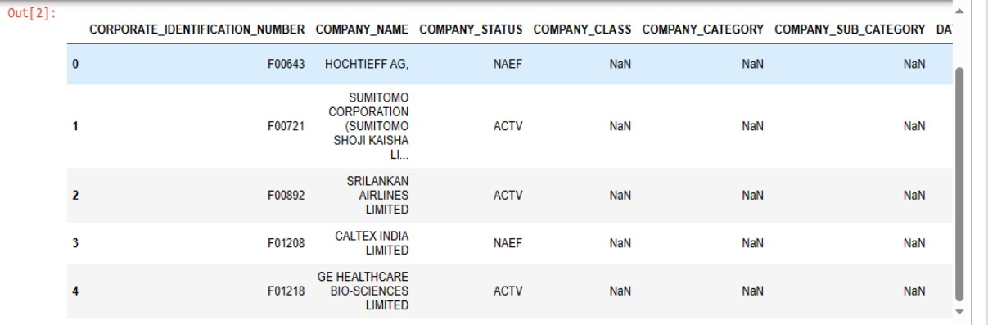

#Data preprocessing

#Check for missing values

df.isnull().sum()

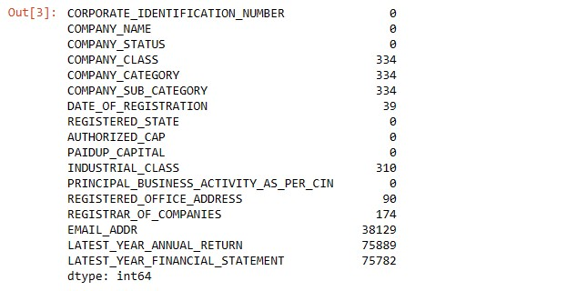

#Check for duplicate values

df.dropna(inplace=True)

#Remove the duplicate values

df.drop_duplicates(inplace=True)

#Again check the missing values are occur or not

df.isnull().sum()

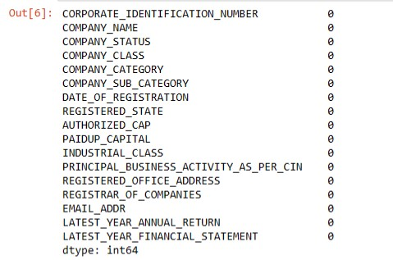

#Finally preprocessed data can be done successfully

df.head()

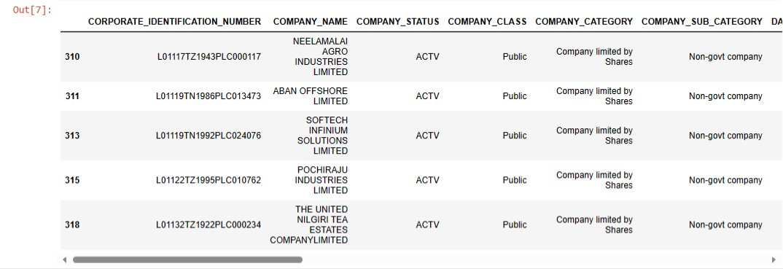

**Development part 2**

In this part you will continue building your project.

Continue building the AI-driven exploration and prediction project by:

* Performing exploratory data analysis
* Feature engineering
* Predictive modeling.



