**AI-Driven Exploration and prediction of Company Registration Trends**

**Phase 4: Development part 2**

**Team member**

**Name : S. Saranraj**

**Dept : CSE-III year,**

**Domain : AI101(IBM-Artificial Group1),**

**NM ID : au410121104041**

**Team Name : The aesthetic coders**

**College : Adhi college of engineering and technology.**

**Introduction:**

This project leverages AI to predict future company registration trends, revolutionizing strategic decision-making. Utilizing advanced AI techniques like ensemble methods and deep learning enhances prediction accuracy, fostering a data-driven approach in understanding registrations.

**In this part you will continue building your project.**

**Continue building the AI-driven exploration and prediction project by:**

* **Performing exploratory data analysis**
* **Feature engineering**
* **Predictive modeling.**

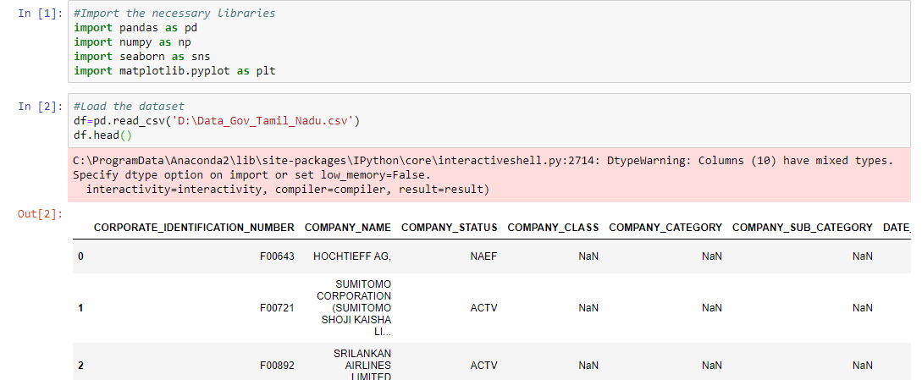

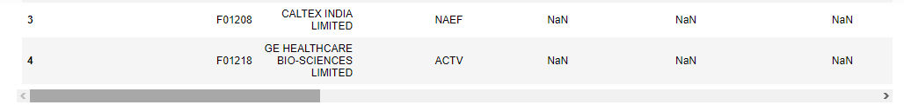

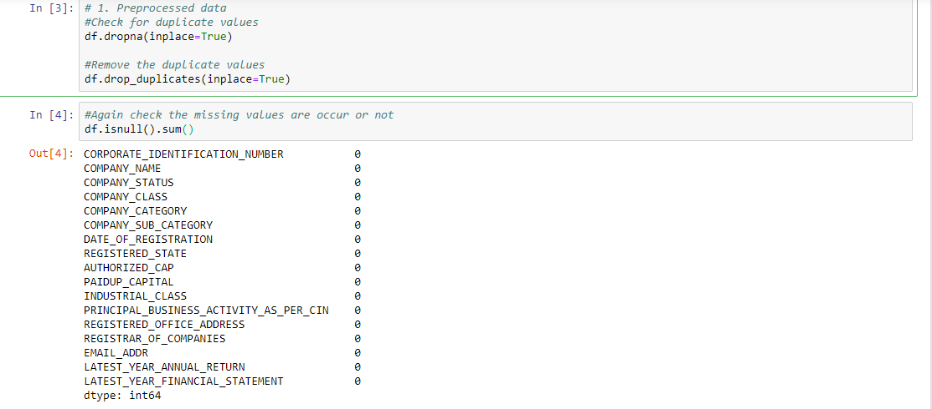

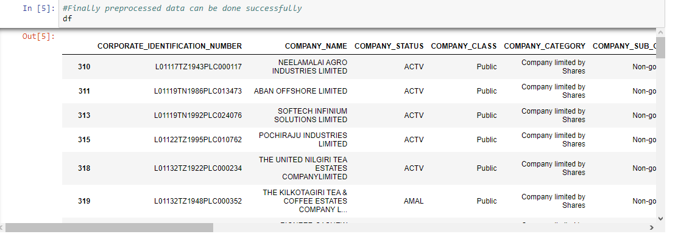

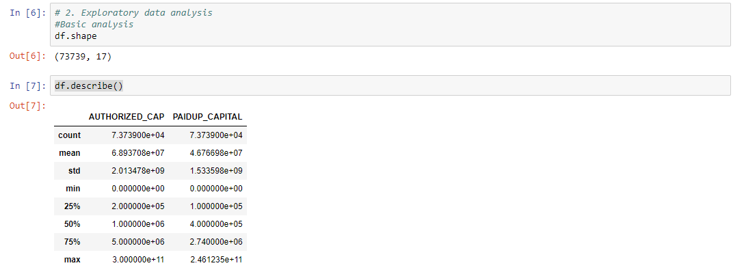

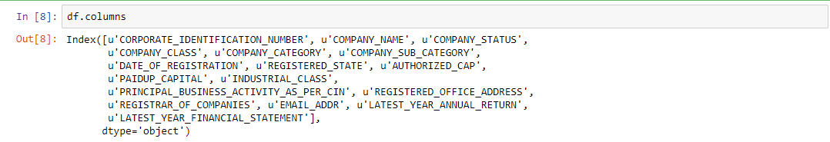

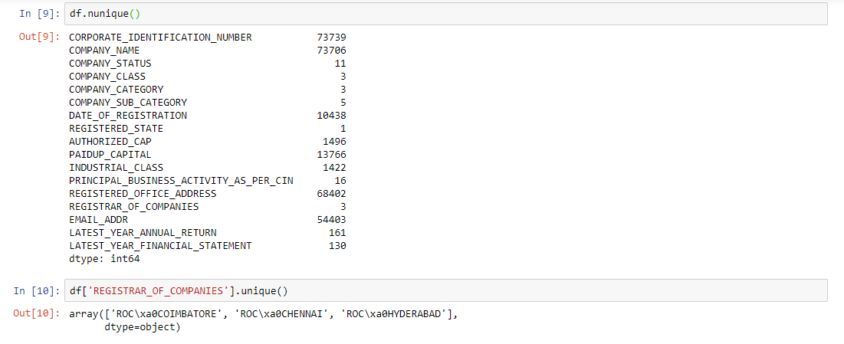

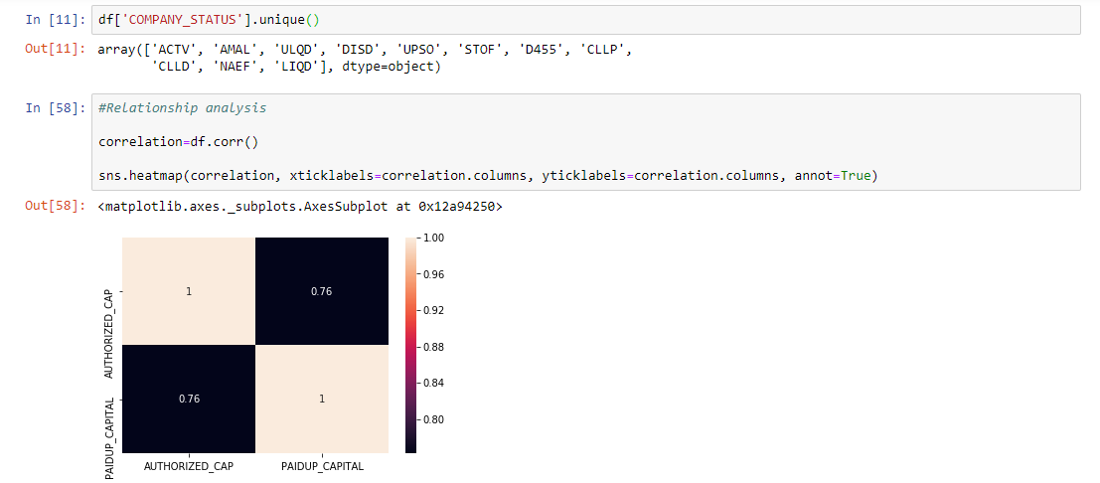

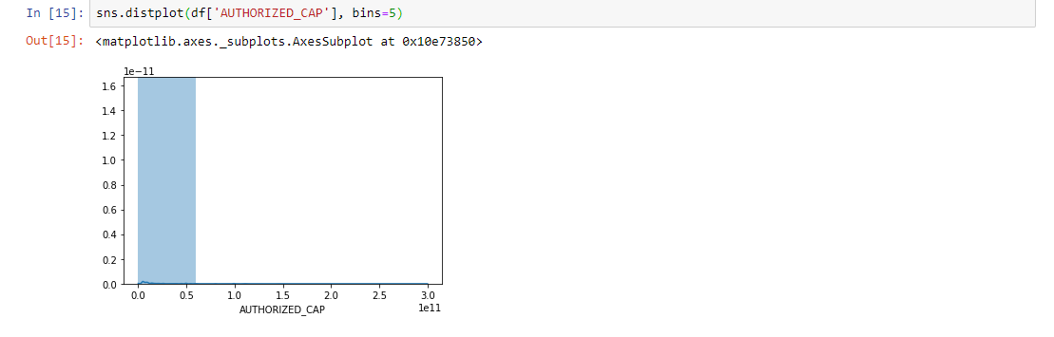

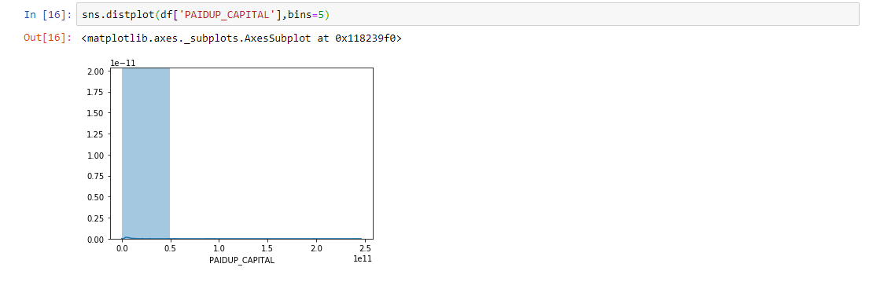

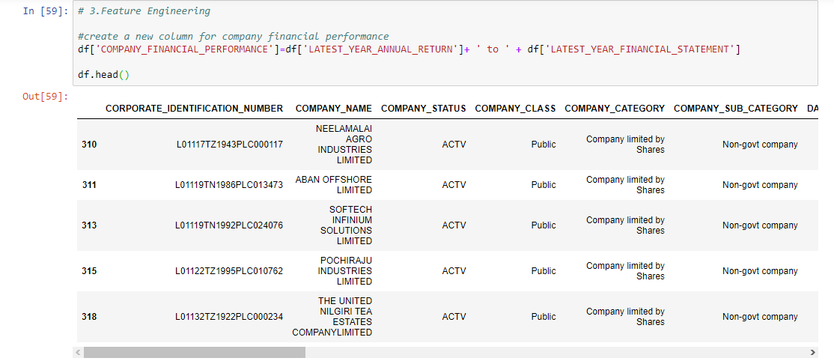

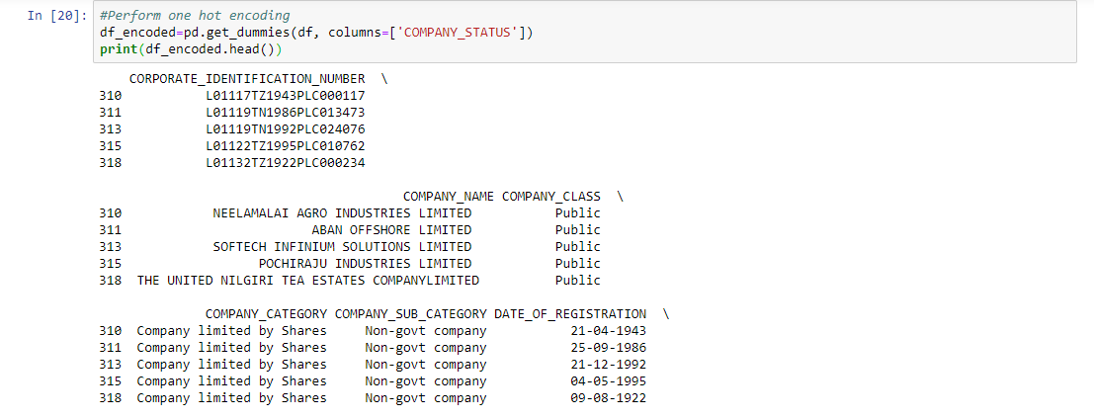

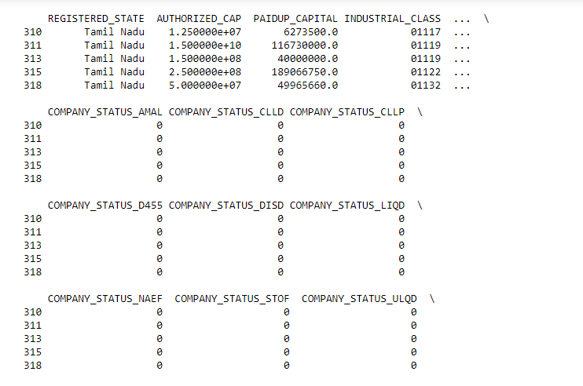

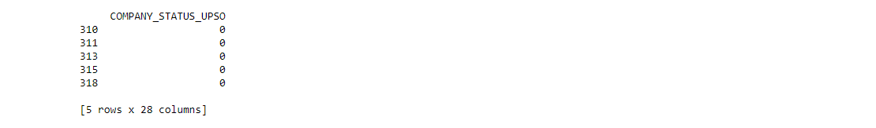

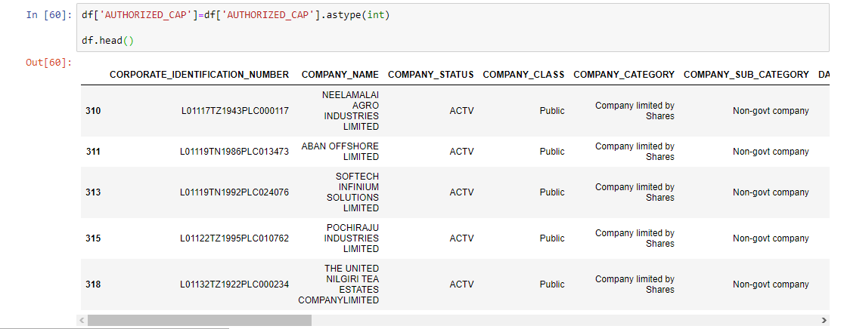

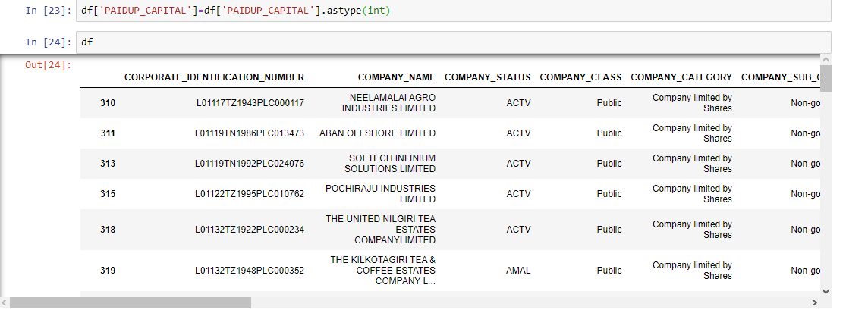

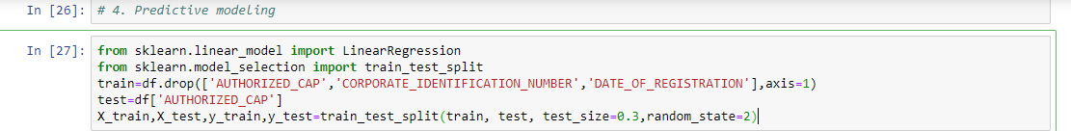



**Conclusion:**

Summarizes the project's key findings, achievements, and their significance. It provides a concise wrap-up, highlighting the project's impact and the knowledge gained during its development