BUDGET LAMBDA EVIDENCE DOCUMENTATION
BudgetBot Serverless Personal Finance System

Item | Value
Lambda name | budgetbot-budget-handler
Handler | lambda_function_budget.lambda_handler
Runtime | Python 3.11 with compatible Lambda Layer
Database | Amazon RDS PostgreSQL
Secret storage | AWS Systems Manager Parameter Store - SecureString
Notification service | Amazon SNS Email
Logging service | Amazon CloudWatch Logs

1. Purpose of the Budget Lambda
The Budget Lambda is an AWS Lambda function responsible for performing the budget validation process after the Parser Lambda has processed the uploaded bank statement file and persisted transaction data into Amazon RDS PostgreSQL.
This Lambda retrieves the user’s configured monthly budget, calculates the user’s total spending for the current month, compares the spending amount against the predefined budget threshold, and publishes an alert through Amazon SNS if the spending exceeds the allowed budget limit.
The Budget Lambda is designed as a post-processing component in the transaction pipeline. It does not directly process raw files. Instead, it consumes structured transaction data that has already been extracted and stored in the database by the Parser Lambda.
- It does not directly read or process CSV/PDF files.
- It does not perform AI-based transaction classification.
- It only consumes transaction data that has already been stored in Amazon RDS PostgreSQL.
- It performs budget validation based on the user’s spending data.
- It sends an email notification through Amazon SNS when the user’s total monthly spending exceeds the configured budget threshold.

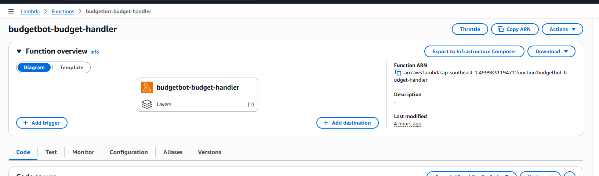2. Position in the System Architecture
The Budget Lambda is located at the final stage of the transaction processing pipeline.
User uploads CSV/PDF file
→ Amazon S3
→ Amazon SQS
→ Parser Lambda
→ Parser Lambda reads the uploaded file
→ Parser Lambda parses transactions and classifies transaction categories
→ Parser Lambda writes transaction records to Amazon RDS PostgreSQL
→ Parser Lambda asynchronously invokes Budget Lambda
→ Budget Lambda queries Amazon RDS PostgreSQL
→ If spending exceeds the configured budget, Budget Lambda sends an email alert through Amazon SNS
In this architecture, the Parser Lambda is responsible for file processing, transaction extraction, and category classification. The Budget Lambda is responsible for validating the user’s spending after transaction data has already been committed to the database.
The invocation between Parser Lambda and Budget Lambda is asynchronous. Parser Lambda does not need to wait for the budget checking process to finish. After writing the transactions to RDS, it triggers Budget Lambda using an event-based invocation.
[User]
│
▼ (1) Upload CSV/PDF file
[Amazon S3]
│
▼ (2) Send event notification
[Amazon SQS]
│
▼ (3) Trigger
[Parser Lambda] ──(4) Read and process file from S3──► [Amazon S3]
│
├──(5) Parse transactions and classify categories
│
├──(6) Store transaction data
│ └──► [Amazon RDS PostgreSQL]
│
▼ (7) Asynchronous invocation
[Budget Lambda]
│
├──(8) Query spending data
│ └──► [Amazon RDS PostgreSQL]
│
▼ (9) Check whether spending exceeds the configured budget
[Amazon SNS]
│
▼ (10) Send budget alert email
[User]
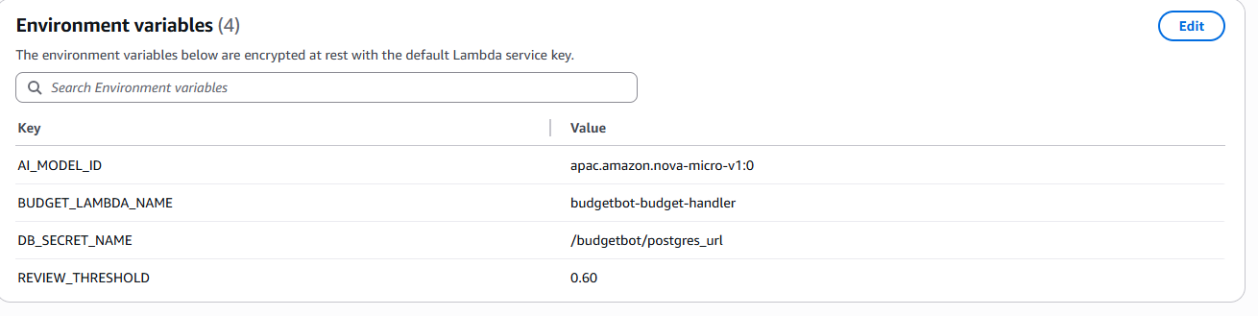

3. Budget Lambda Input
The Budget Lambda receives an event payload either from the Parser Lambda through asynchronous invocation or from a manual test event in the AWS Lambda Console.
{
"user_id": "00000000-0000-0000-0000-000000000001",
"file_id": "test"
}
Field | Description
user_id | The unique identifier of the user whose budget needs to be validated. This is the most important field in the payload.
file_id | The identifier of the uploaded file that triggered the budget validation process. This field is mainly used for logging, tracing, and pipeline tracking.
The user_id field is required because Budget Lambda uses it to query the user’s budget and transaction records from Amazon RDS PostgreSQL.
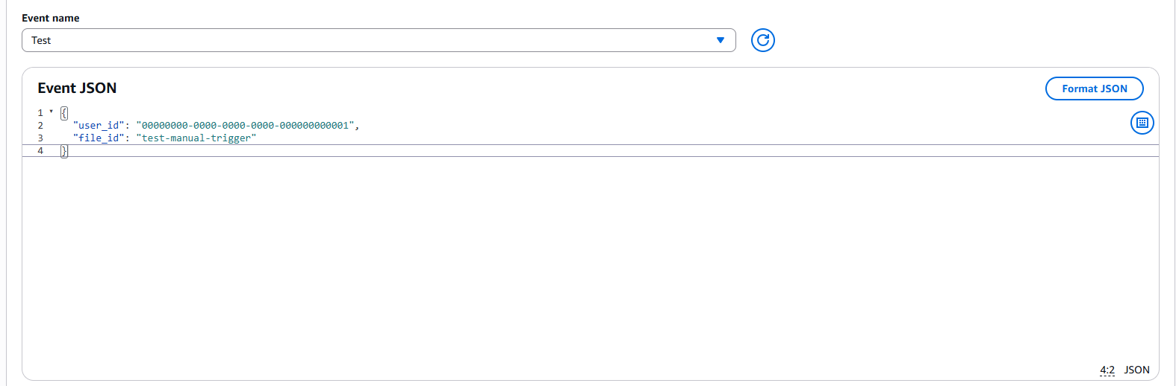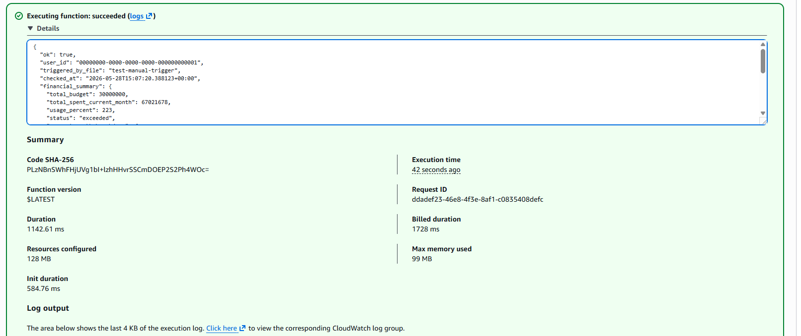

4. AWS Services Used by Budget Lambda
The Budget Lambda integrates with several AWS services to securely access data, validate spending, and send alerts.
Service | Role in Budget Lambda
AWS Lambda | Executes the budget validation logic and triggers the alerting process.
Amazon RDS PostgreSQL | Stores user information, uploaded file metadata, and transaction records.
AWS Systems Manager Parameter Store | Stores the database connection string securely as a SecureString.
AWS KMS | Decrypts the encrypted SecureString when Lambda reads the database connection parameter.
Amazon SNS | Sends email notifications when the user’s monthly spending exceeds the configured budget threshold.
Amazon CloudWatch Logs | Stores execution logs for debugging, monitoring, and project evidence.
VPC / Security Group | Allows Budget Lambda to securely access Amazon RDS inside private subnets.

5. Securing the Database Connection
The Budget Lambda does not store the database password directly in its Environment Variables. Instead, it only stores the name of the parameter in AWS Systems Manager Parameter Store:
DB_URL_PARAM_NAME=/budgetbot/postgres_url
The actual database connection string is stored securely in SSM Parameter Store as a SecureString value. The value follows the PostgreSQL connection string format:
postgresql://<user>:<password>@<rds-endpoint>:5432/<database>
At runtime, the Budget Lambda calls AWS Systems Manager Parameter Store using GetParameter with WithDecryption=True to retrieve and decrypt the database connection string.
This design improves security because the database username and password are not exposed directly in the Lambda configuration. The Lambda only has access to the secret through its IAM execution role, which is granted permission to read the specific SSM parameter and decrypt the SecureString using AWS KMS.
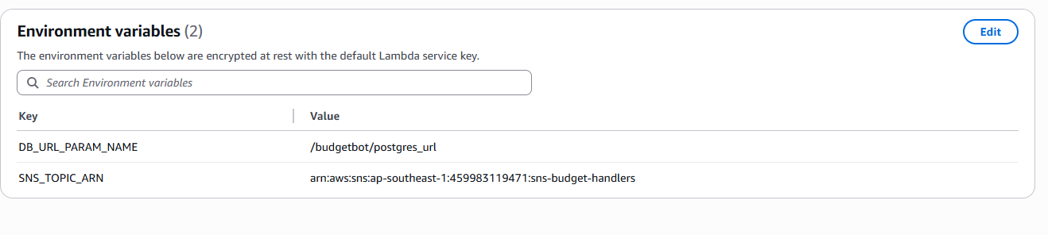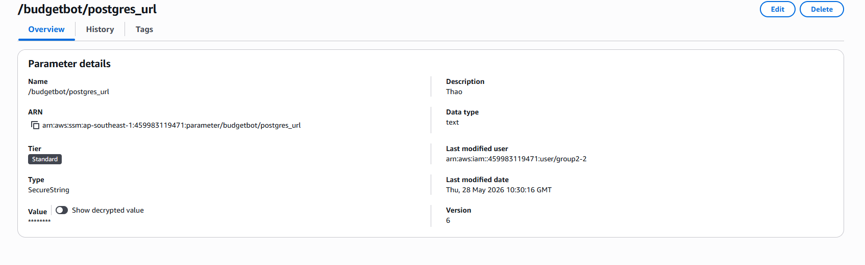

6. Environment Variables
The Budget Lambda uses environment variables to store non-secret configuration values.
Key | Example Value | Purpose
DB_URL_PARAM_NAME | /budgetbot/postgres_url | Stores the name of the SSM parameter that contains the PostgreSQL connection string.
SNS_TOPIC_ARN | arn:aws:sns:ap-southeast-1:459983119471:sns-budget-handlers | Defines the SNS Topic used to send budget alert emails.
The database connection string itself is not stored directly in the Lambda environment variables. This prevents sensitive database credentials from being exposed in the Lambda configuration.7. IAM Permissions
The Budget Lambda execution role must be granted the required permissions to access AWS services securely. These permissions follow the least-privilege principle, meaning the Lambda only receives the access it needs to complete its budget validation and alerting workflow.
Permission | Purpose
ssm:GetParameter | Allows Budget Lambda to read the database connection string from SSM Parameter Store.
kms:Decrypt | Allows Budget Lambda to decrypt the SecureString value if the parameter is encrypted using AWS KMS.
sns:Publish | Allows Budget Lambda to publish alert messages to the SNS Topic.
logs:CreateLogGroup / logs:CreateLogStream / logs:PutLogEvents | Allows Budget Lambda to write logs to Amazon CloudWatch Logs.
AWSLambdaVPCAccessExecutionRole | Allows Budget Lambda to create and manage Elastic Network Interfaces when running inside a VPC.
The screenshot evidence shows that the execution role has AWS managed policies and customer managed policies attached. The important managed policies include:
- AWSLambdaBasicExecutionRole: Allows the Lambda function to write execution logs to Amazon CloudWatch Logs.
- AWSLambdaVPCAccessExecutionRole: Allows the Lambda function to create and manage network interfaces when running inside a VPC. This is required for accessing private resources such as Amazon RDS.
- BudgetBotApiLambdaPolicy: Provides additional application-specific permissions required by BudgetBot Lambda components.
- BudgetBotApiSendParserSQSPolicy: Allows related Lambda components to interact with Amazon SQS in the transaction processing pipeline.
- BudgetBotBedrockRuntimePolicy: Allows Lambda components to invoke Amazon Bedrock Runtime when AI-based transaction classification is required.
For Budget Lambda specifically, the most important custom permissions are:
{
"Effect": "Allow",
"Action": "ssm:GetParameter",
"Resource": "arn:aws:ssm:ap-southeast-1:459983119471:parameter/budgetbot/postgres_url"
}
{
"Effect": "Allow",
"Action": "sns:Publish",
"Resource": "arn:aws:sns:ap-southeast-1:459983119471:sns-budget-handlers"
}
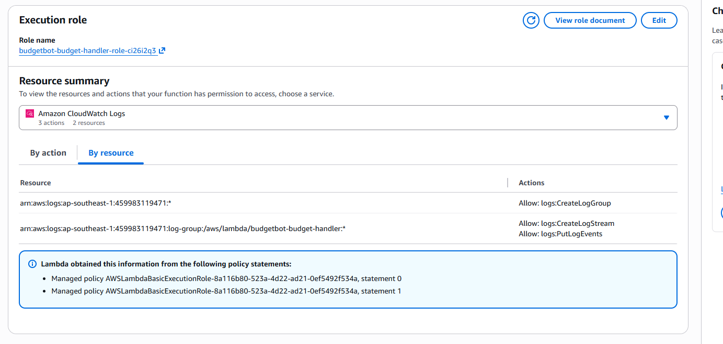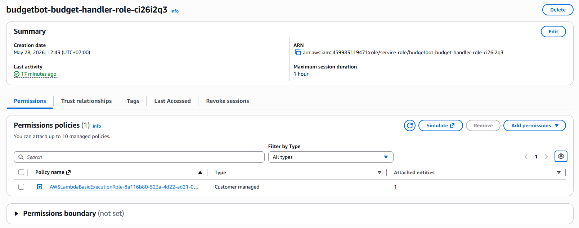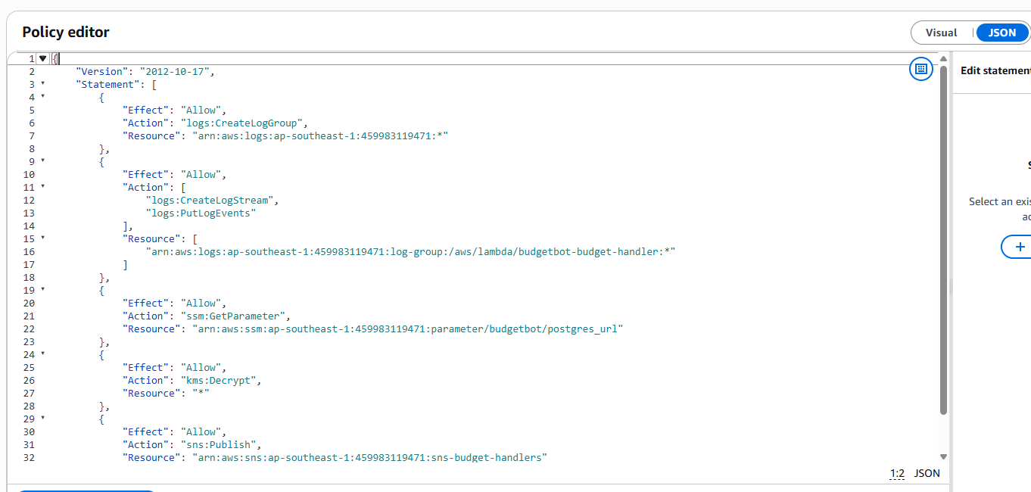

7. VPC and Security Group Configuration
The Budget Lambda runs inside private subnets so it can securely connect to Amazon RDS PostgreSQL, which is also deployed as a private database resource.
The RDS instance is not publicly accessible. Access to PostgreSQL port 5432 is restricted using Security Groups.
Budget Lambda Security Group:
Inbound: none
Outbound: HTTPS 443 to VPC Endpoints and PostgreSQL 5432 to RDS
RDS Security Group:
Inbound PostgreSQL 5432 from the Lambda Security Group
This means the database is not open to the public internet. It only accepts PostgreSQL connections from the Lambda Security Group.
If the system does not use a NAT Gateway, VPC Endpoints are required so the Lambda can privately access AWS services such as SSM, KMS, SNS, and CloudWatch Logs.
Required VPC Endpoints when NAT Gateway is not used:
- SSM Endpoint
- KMS Endpoint
- SNS Endpoint
- CloudWatch Logs Endpoint
- S3 Gateway Endpoint

8. Lambda Layer and Dependency Management
Budget Lambda connects to Amazon RDS PostgreSQL using the psycopg2 Python library. Since psycopg2 is not included in the default AWS Lambda Python runtime, it must be packaged with the Lambda function or provided through a Lambda Layer.
In this implementation, a Lambda Layer is used to provide the required PostgreSQL dependency.
No module named psycopg2
Without this layer, the Lambda may fail with the error above. The use of a Lambda Layer helps keep the Lambda deployment package smaller and allows the same dependency to be reused by multiple Lambda functions if needed.

9. Main Processing Logic
- Receive event containing user_id and file_id.
- Read the database connection string from SSM Parameter Store.
- Connect to Amazon RDS PostgreSQL using psycopg2.
- Read the user’s total budget from the "user" table.
- Calculate total spending for the current month from the transaction table.
- Join transaction data with the file table to identify the correct user.
- Group spending by transaction category.
- Compare total_spent with total_budget.
- If total_spent exceeds total_budget, calculate usage_percent and send an SNS email alert.
- Return a structured response containing financial_summary and alert_sent.
This logic separates budget validation from file parsing. Parser Lambda focuses on extracting and storing transaction data, while Budget Lambda focuses only on checking the spending result.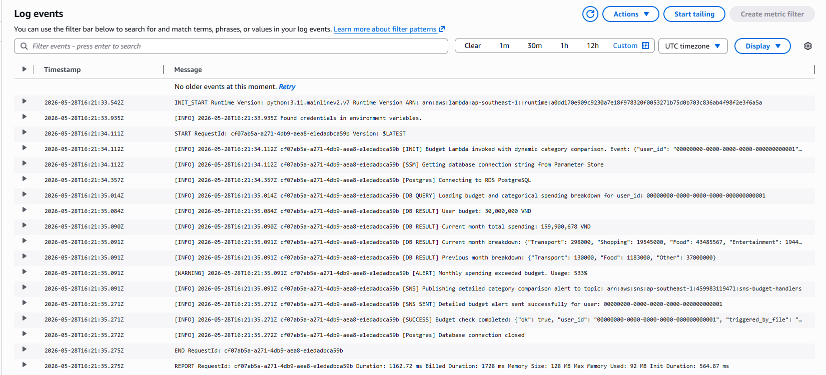

10. SNS Email Alert
When the user’s monthly spending exceeds the configured budget, Budget Lambda sends an email alert through Amazon SNS.
- User ID
- Check period
- Total monthly budget
- Current month total spending
- Budget usage percentage
- Category-level spending comparison with the previous month
Example email content:
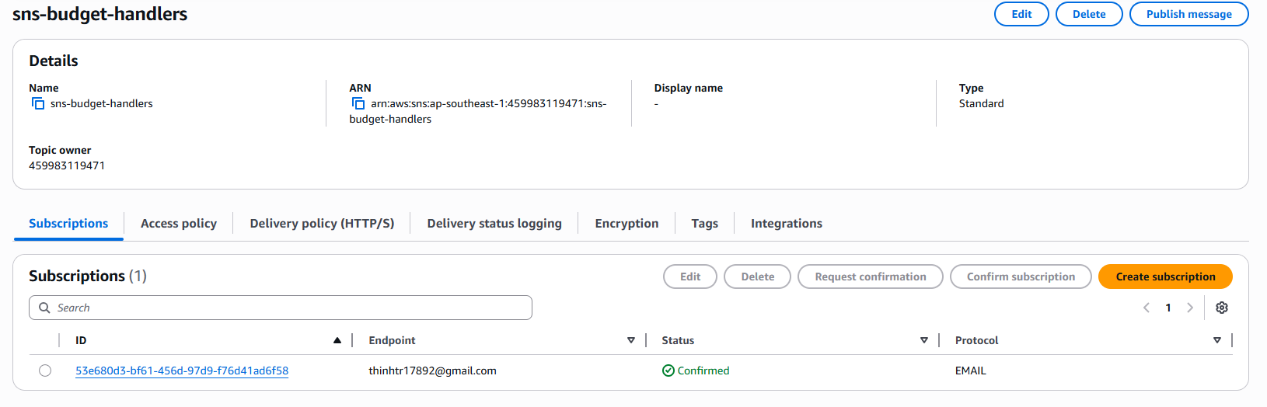
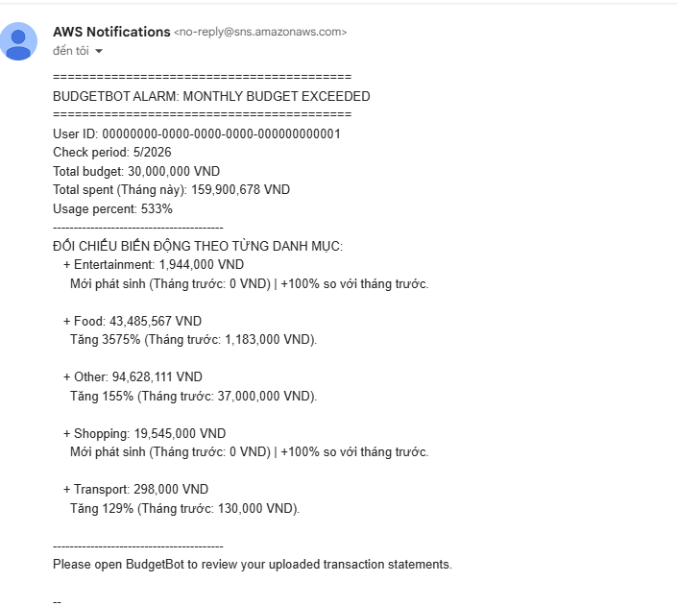

11. Budget Lambda Output
When the Lambda executes successfully, it returns a structured JSON response.
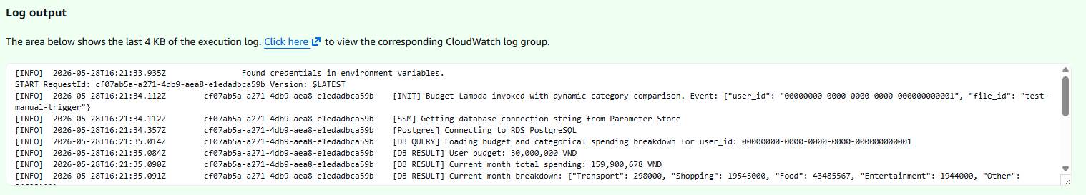The output confirms whether the Lambda executed successfully, what the budget status is, and whether an alert was sent.

12. Presentation Script
The Budget Lambda is designed to validate the user’s monthly budget after the Parser Lambda has processed a bank statement file and stored transaction records in Amazon RDS PostgreSQL. The Lambda receives user_id and file_id, then retrieves the database connection string securely from AWS Systems Manager Parameter Store. This avoids storing database credentials directly in Lambda environment variables.
After connecting to RDS, the Lambda reads the user’s configured budget from the "user" table and calculates the current month’s total spending from the transaction table. It also generates a category-level comparison between the current month and the previous month. If the total spending exceeds the configured budget, the Lambda publishes an email alert through Amazon SNS.
This design separates budget validation from transaction parsing, improves maintainability, and keeps sensitive database credentials protected through SSM SecureString and IAM-based access control.

