THIS IS DOCUMENTATION ON A BASIC NETWORK KEYLOGGER I WROTE

Files By Category

PHP
fileread.php
filewrite.php
keyloggeroutput.txt

PYTHON

CLIENT
client.py
localinfo.txt

VICTIM
server.py
info.txt
output.txt

DOCS

Upload the PHP Files to a server of your choice give write permissions on “keyloggeroutput.txt”

Python Client

Specify the IP of the Victim in the text file “localinfo.txt”

Python Victim

Open up info.txt specify the web server address where the PHP Files are stored but just the server address not the full path

Make sure info.txt is on the victims computer You could hardcode the web server address in the server.py file if needed

Interacting with the client and server

There are only two functions built into this application

keyit() and senddata0()
The keyit() function starts the keylogger on the remote machine the senddata() function sends the data to the remote “web server”

You use an interactive console to start these functions

The keyword is “key” to interact with server see below example

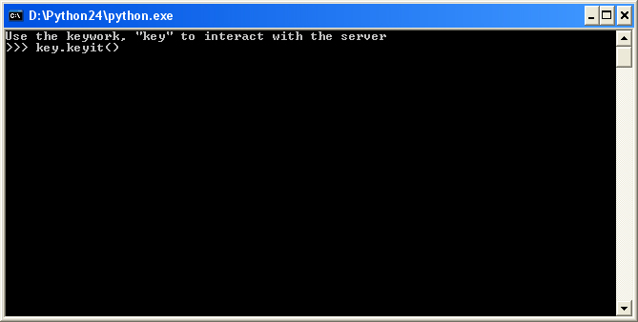

IMPORTANT NOTE

After starting the keylogger and now you want to send the data you have to close the client and start a new session to use the senddata() function

