Asg 4: Neural Networks

Question 1:

This model was created using jupyter with the MNIST dataset. Open the file in jupyter and run after installing missing libraries.

This model was recreated after finishing question 2 and working through some online courses in tensorflow. The initial model performed at about 93% accuracy. This performs much better, with ~98% accuracy, but as high as >99% often.

The x and y arrays were assigned with the load_data() function. The next step was to transform the y_test and y_train arrays into a binary class matrix to make categorization easier. This created the y_cat_test and y_cat_train matrices.

The x_train and x_test arrays were normalized. This was done by dividing the values by 255 since the lowest value is 0 and the highest is 255. This produces an array with values between 0 and 1.
x_train and x_test were reshaped with the reshape() functions. This produced x_train with 60000 entries, each 28x28 with a single image in each. x_test contained 10000 entries, each 28x28 with a single image per entry.

The model chosen was sequential. I used sequential because it’s the easiest to add layers to.
The first layer was a Conv2D layer so I could control how the program inspects each image. I used 32 filters as a starting point since a power of 2 is the rule of thumb for this. The kernel_size was selected to be evenly divided into the 28x28 image size. The strides was selected as 1,1, or default. The padding was selected as default, since additional padding was not needed to cover the image. Since this is the first layer, it is given an input shape of an image, 28,28,1. The activation function used is ‘relu’, mostly be trial and error and it is the most recommended one to start with for a categorization problem.

The next layer was a a MaxPool2D layer. The pooling layer condenses the output from the kernel instead of processing the entire image every time for subsequent layers.

The model is flattened from a matrix to an 1D array.

The next layer is a densely connected layer with 128 neurons, which is a power of 2 and lies between 0 and 1000, as recommended as a rule of thumb. The activation function is relu, by trial and error and since it is the most common for this kind of problem.

The next layer is the output layer. It is a densely connected layer with 10 neurons, one for each category of number (0-9). Softmax is generally used for a categorization problem.

The model is compiled with categorical_crossentropy, as it is a categorical problem. Others were tried as an experiment but resulted in as little as 1% accuracy occasionally. The optimizer used is Adam, since it had the best results for this test. The metric used is accuracy, since I used it later on to analyze the models performance.

An early stop was used when running the model. When val_loss begins to climb, the model is halted and saved.

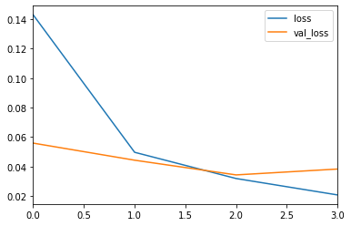
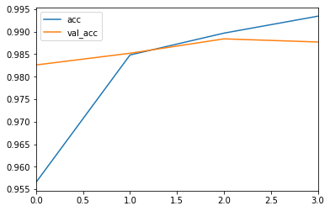

model.evaluate() prints out the success of the model: [0.03831030464032083, 0.9877]
This particular run was 98.77% accurate, but it varies slightly between runs. It goes as low as 98.5% and above 99%. This was an average run, since most of the results lay within 98% accuracy.

Code
#MNISTmodel.ipynb
import pandas as pd
import numpy as np
import matplotlib.pyplot as plt
%matplotlib inline
import tensorflow as tf
from tensorflow.keras.utils import to_categorical
from tensorflow.keras.models import Sequential
from tensorflow.keras.layers import Dense,Conv2D,MaxPool2D,Flatten
from sklearn.metrics import classification_report,confusion_matrix

mnist = tf.keras.datasets.mnist
(x_train, y_train), (x_test, y_test) = mnist.load_data()

y_cat_test = to_categorical(y_test,num_classes=10)
y_cat_train = to_categorical(y_train,10)

x_train = x_train/255
x_test = x_test/255
#check shape of x_train for input_shape later
x_train.shape

#batch size and width,height,color
x_train = x_train.reshape(60000,28,28,1)
x_test = x_test.reshape(10000,28,28,1)

model = Sequential()
#input_shape should match the size of one picture
model.add(Conv2D(filters=32,kernel_size=(4,4),strides=(1,1),padding='valid', input_shape=(28,28,1),activation='relu'))
model.add(MaxPool2D(pool_size=(2,2)))

#flatten images into array
model.add(Flatten())

model.add(Dense(128,activation='relu'))

#output layer: softmax for multiclass problem
#number of neurons should match the number of categories: 0 through 9 = 10 categorical possibilities
model.add(Dense(10,activation='softmax'))

model.compile(loss='categorical_crossentropy',optimizer='adam', metrics=['acc'])

early_stop = EarlyStopping(monitor='val_loss',patience=1)
model.fit(x_train, y_cat_train, epochs=10, validation_data=(x_test,y_cat_test), callbacks=[early_stop])
#################################################################################
#model evaluation
metrics = pd.DataFrame(model.history.history)

#view available metrics for graphing
metrics

metrics[['loss','val_loss']].plot()
metrics[['acc','val_acc']].plot()
model.evaluate(x_test,y_cat_test,verbose=0)

predictions=model.predict_classes(x_test)
print(classification_report(y_test,predictions))
confusion_matrix(y_test,predictions)
#batch size: number of images,width,height,color_channels
model.predict_classes(my_number.reshape(1,28,28,1))

Question 2

This model was created using jupyter with the MNIST dataset. The location of the dataset will need to be changed to reflect the local location. Open the file in jupyter and run after installing missing libraries.

This model was finished and worked better than my first attempt at question 1. After doing more research and completing some online classes to better understand how to perform this task better, I redid question 1 with my work in question 2.

The dataset is loaded with np.load. And the x_test, x_train, y_test and y_train arrays were filled.

The x_train and x_test arrays were normalized. This was done by dividing the values by 255 since the lowest value is 0 and the highest is 255. This produces an array with values between 0 and 1.
x_train and x_test were reshaped with the reshape() functions. This produced x_train with 60000 entries, each 28x28 with a single image in each. x_test contained 10000 entries, each 28x28 with a single image per entry.

The model chosen was sequential. I used sequential because it’s the easiest to add layers to.
The first layer was a Conv2D layer so I could control how the program inspects each image. I used 32 filters as a starting point since a power of 2 is the rule of thumb for this. The kernel_size was selected to be evenly divided into the 28x28 image size. The strides was selected as 1,1, or default. The padding was selected as default, since additional padding was not needed to cover the image. Since this is the first layer, it is given an input shape of an image, 28,28,1. The activation function used is ‘relu’, mostly be trial and error and it is the most recommended one to start with for a categorization problem.

The next layer was a a MaxPool2D layer. The pooling layer condenses the output from the kernel instead of processing the entire image every time for subsequent layers.

The model is flattened from a matrix to an 1D array.

The next layer is a densely connected layer with 128 neurons, which is a power of 2 and lies between 0 and 1000, as recommended as a rule of thumb. The activation function is relu, by trial and error and since it is the most common for this kind of problem.

The next layer is the output layer. It is a densely connected layer with 10 neurons, one for each category of number (0-9). Softmax is generally used for a categorization problem.

The model is compiled with categorical_crossentropy, as it is a categorical problem. Others were tried as an experiment but resulted in as little as 1% accuracy occasionally. The optimizer used is Adam, since it had the best results for this test. The metric used is accuracy, since I used it later on to analyze the models performance.

An early stop was used when running the model. When val_loss begins to climb, the model is halted and evaluated.

model.evaluate() prints out the success of the model: [0.18657778711467982, 0.9472]
At the end, the user can perform tests by displaying any image from the test data and printing it to the screen to identify it. The program can then be run on the flattened image and outputs the index of the appropriate classification.

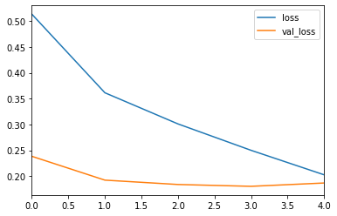
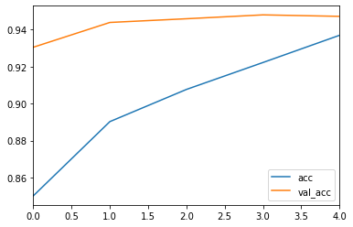

To try and fool the network I created this letter ‘E’:
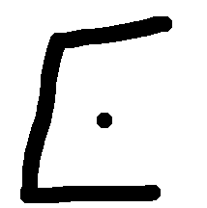
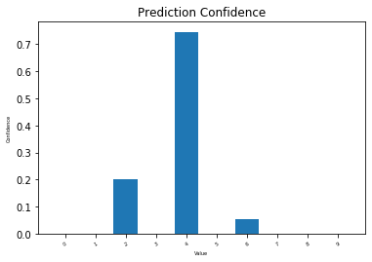

I could not improve the performance of the network any further. The performance was acceptable, unless the test was unfair because the letter was not recognizable by a human. Anything I did to try to limit the small number of false positives in the graph had a large negative effect on the overall performance.

Code
#MNISTmodel.ipynb
import pandas as pd
import numpy as np
import matplotlib.pyplot as plt
%matplotlib inline
import tensorflow as tf
from tensorflow.keras.utils import to_categorical
from tensorflow.keras.models import Sequential
from tensorflow.keras.layers import Dense,Conv2D,MaxPool2D,Flatten
from sklearn.metrics import classification_report,confusion_matrix
import seaborn as sns

with np.load("/home/don/Asg4/notMNIST.npz", allow_pickle=True) as f:
x_train, y_train = f['x_train'], f['y_train']
x_test, y_test = f['x_test'], f['y_test']

y_cat_test = to_categorical(y_test,num_classes=10)
y_cat_train = to_categorical(y_train,10)

x_train = x_train/255
x_test = x_test/255
#check shape of x_train for input_shape later
x_train.shape

#batch size and width,height,color
x_train = x_train.reshape(60000,28,28,1)
x_test = x_test.reshape(10000,28,28,1)

model = Sequential()
#input_shape should match the size of one picture
model.add(Conv2D(filters=32,kernel_size=(4,4),strides=(1,1),padding='valid', input_shape=(28,28,1),activation='relu'))
model.add(MaxPool2D(pool_size=(2,2)))

#flatten images into array
model.add(Flatten())

model.add(Dense(128,activation='relu'))

#output layer: softmax for multiclass problem
#number of neurons should match the number of categories: 0 through 9 = 10 categorical possibilities
model.add(Dense(10,activation='softmax'))

model.compile(loss='categorical_crossentropy',optimizer='adam', metrics=['acc'])

early_stop = EarlyStopping(monitor='val_loss',patience=1)
model.fit(x_train, y_cat_train, epochs=10, validation_data=(x_test,y_cat_test), callbacks=[early_stop])
#################################################################################
#model evaluation
metrics = pd.DataFrame(model.history.history)

#view available metrics for graphing
metrics

metrics[['loss','val_loss']].plot()
metrics[['acc','val_acc']].plot()
model.evaluate(x_test,y_cat_test,verbose=0)

predictions=model.predict_classes(x_test)
print(classification_report(y_test,predictions))
confusion_matrix(y_test,predictions)
#batch size: number of images,width,height,color_channels
model.predict_classes(my_number.reshape(1,28,28,1))

#testing
my_number = x_test[0]
#show number for human classification
plt.imshow(my_number.reshape(28,28))
model.predict_classes(my_number.reshape(1,28,28,1))

pred = model.predict(my_number.reshape(1,28,28,1))
pred[0]

label = ['0', '1','2','3','4','5','6','7','8','9']
index = np.arange(len(label))
def plot_bar_x():
# this is for plotting purpose
index = np.arange(len(label))
plt.bar(index, pred[0])
plt.xlabel('Value', fontsize=5)
plt.ylabel('Confidence', fontsize=5)
plt.xticks(index, label, fontsize=5, rotation=30)
plt.title('Prediction Confidence')
plt.show()
plot_bar_x()

img = plt.imread("/home/don/Asg4/image.png")
if np.amax(img.flatten()) > 1:
img = img/255
img = 1 - img
test_pred = model.predict_classes(img.reshape(1,28,28,1))
pred = model.predict(img.reshape(1,28,28,1))

label = ['0', '1','2','3','4','5','6','7','8','9']
index = np.arange(len(label))
def plot_bar_x():
# this is for plotting purpose
index = np.arange(len(label))
plt.bar(index, pred[0])
plt.xlabel('Value', fontsize=5)
plt.ylabel('Confidence', fontsize=5)
plt.xticks(index, label, fontsize=5, rotation=30)
plt.title('Prediction Confidence')
plt.show()
plot_bar_x()

model.save("notMNIST.h")

Model Predictions
The lines changed in predict_test.py are hardcoded, as it couldn’t find the file if I passed in the filename as an argument. I’m having trouble putting the image into the correct format. I get an error expecting 4 dimensions, so I reshaped the image to fit my model. The image is then corrupted and can’t be read by the viewer. I rewrote these programs again at the end of notMNIST.ipynb to perform these tests.
I included a test at the end of my file that produces the same output, printing out the image and then testing it before printing out the confidence array.
To replicate predict_test.py, change the index of the highlighted line to assign my_number to any of the test data images.
To replicate predict.py, change the index of the highlighted line to the img file name of the image created by grabimage.py
Interactive.py can be replicated with the functionality of the previous steps.

Question 3

This question was completed using jupyter. To run, open the ipynb in jupyter and run all cells if there are no packages that need to be installed.

The dataframe is created by reading in the csv values from heart.csv. The ‘Present’ and ‘Absent’ values posed a problem, so they were converted to ‘Present’:True and ‘Absent’:False when reading them in.
The row.names column was dropped, as it doesn’t serve a purpose here. It only makes the spreadsheet more readable.

I used df.info() to see if there were any null values and to count the number of columns.
famhist was converted from a boolean to an integer using .astype(int) so it could be scaled like the rest of the data.

I plotted a correlation graph to determine if any of the factors could be eliminated due to extremely low correlation. They were all ok, so they stayed.

x_test, x_train, y_test and y_train were created using train_test_split. The inputs were shuffled and given a random state to ensure the data was completely random, in case there was any ordering to the csv file.

MinMaxScaler was used to assign weights to all the variables. For X_train, fit_transform was used to train the model on data that leads to the chd column. Training with the chd data included didn’t lead to good results when testing.

The x_test, x_train, y_test and y_train data was written to the appropriate .csv files and saved to fulfill the assignment requirement.

The shape of x_train was checked to ensure the input size for the first layer.
The model suffered a lot of over and underfitting when I was beginning to solve this problem.
Overfit can be seen on the left, and underfit can be seen on the right:
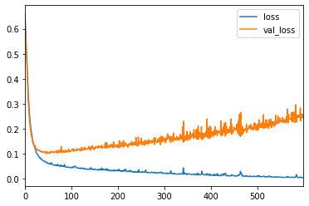
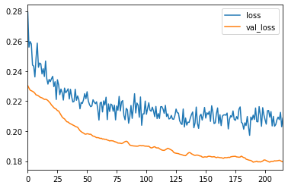
Severe over or under fit lead to the test data being inconclusive, and not assigning any guesses that determined that someone had CHD. If the model was very simple, overfit occurred very easily. If the model was slightly too complicated, underfit was hard to tune out of it. Changing the amount of training data helped tune the fitment issues.

The first model has one or two dense layers, with 9 neurons each. This lead to very poor accuracy and overfit most of the time. The model behaved very erratically. In order to bring the fitment closer, dropouts were used to decrease the overfit problem. This helped, but usually lead to the model being severely underfit. The model was run dozens of times and the erratic behaviour was still seen. The last attempt on the first model had two an intake layer, with 9 neurons and a hidden layer with either 4 or 5 neurons, which changed with testing. The activation function used was relu, it had the best performance when trying different ones. The dropouts remained and stabilized the performance between runs and performance improved, with usually about 75% accuracy. The last layer was a dense layer with one neuron and used the sigmoid activation function to determine a value between 0 and 1 to categorize people with or without CHD.

The adam optimizer was used with a learning rate of 0.001. A slow learning rate lead to higher accuracy. Mean squared error was the loss function that was recommended by the Tensorflow tutorials, and had the best performance overall.

The best model uses 6 layers total. The first layer has 9 neurons to take in the 9 categories we use to assess the outcome. The first layer has a dropout of 0.2 to attempt to reduce overfit. There are three hidden layers with 9 neurons that increased the accuracy slightly. Another layer has 5 neurons, as it was recommended by Tensorflow to begin with the input size, then divide by two for each subsequent layer until output. The output layer has one neuron and uses sigmoid to output a value between 0 and 1 according to their risk for CHD.

The loss function is MSE, which had the best performance. RMSprop was used as the optimizer. The learning rate had a smaller effect with this optimizer. It had the lowest loss, as others would remain at 5% loss throughout the test.

An early stop was used to stop training when var_loss began to climb again. The performance of the best model was alright, but is not reliable. The best performance I could get out of it is in the chart below:
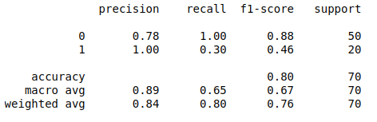

This model achieved 100% accuracy in determining if someone had the disease, and 78% accuracy in determining if someone did not have it. The 100% value is somewhat skewed, however. The model is hesitant to label someone with having the disease, so it guesses 1 fewer times. The weighted average is acceptable, but could be better. More data would help with training.

Code
import pandas as pd
import numpy as np
import matplotlib.pyplot as plt
import seaborn as sns
from sklearn.model_selection import train_test_split
from tensorflow.keras.callbacks import EarlyStopping
import tensorflow as tf
from sklearn.preprocessing import MinMaxScaler
from sklearn.preprocessing import StandardScaler
from sklearn.preprocessing import Normalizer
from tensorflow.keras.models import Sequential
from tensorflow.keras.layers import Dense,Dropout
from sklearn.metrics import classification_report,confusion_matrix

df = pd.read_csv('/home/don/Asg4/heart.csv',true_values=['Present'],false_values=['Absent'])
df = df.drop('row.names',axis=1)

df.info()

df.famhist = df.famhist.astype(int)
df.info()

df.describe().transpose()

sns.countplot(x='chd',data=df)

df.corr()['chd'][:-1].sort_values().plot(kind='bar')

X= df.drop('chd',axis=1).values

y=df['chd'].values

X_train, X_test, y_train, y_test = train_test_split(X, y, test_size=0.15, shuffle=True, random_state=19)

scaler = MinMaxScaler()

X_train = scaler.fit_transform(X_train)

X_test = scaler.transform(X_test)

#demonstrate how test and training data was divided
heart_X_train = pd.DataFrame(X_train).to_csv('~/Asg4/heart_X_train.csv')
heart_X_test = pd.DataFrame(X_test).to_csv('~/Asg4/heart_X_test.csv')
heart_y_train = pd.DataFrame(y_train).to_csv('~/Asg4/heart_y_train.csv')
heart_y_test = pd.DataFrame(y_test).to_csv('~/Asg4/heart_y_test.csv')

X_train.shape

#explore overfit

model = Sequential()

model.add(Dense(9,activation='relu'))
model.add(Dropout(0.5))
model.add(Dense(4,activation='relu'))
model.add(Dropout(0.5))

#binary classification = sigmoid
model.add(Dense(1,activation='sigmoid')) #somewhere between 0 and 1
#rms = tf.keras.optimizers.RMSprop(0.001)
adam = tf.keras.optimizers.Adam(0.001)
model.compile(loss='mse',optimizer=adam)

early_stop = EarlyStopping(monitor='val_loss',mode='min',verbose=1,patience=25)

model.fit(x=X_train,y=y_train,epochs=600,validation_data=(X_test,y_test),callbacks=[early_stop])

model_loss = pd.DataFrame(model.history.history)
model_loss.plot()

model.predict_classes(X_test)

predictions = model.predict_classes(X_test)
print(classification_report(y_test,predictions))

#best model
#model = Sequential()

model.add(Dense(9,activation='relu'))#relu
model.add(Dropout(0.2))
model.add(Dense(9,activation='relu'))

model.add(Dense(9,activation='relu'))

model.add(Dense(9,activation='relu'))
model.add(Dense(5,activation='relu'))

#binary classification = sigmoid
model.add(Dense(1,activation='sigmoid')) #somewhere between 0 and 1
rms = tf.keras.optimizers.RMSprop(0.001)
adam = tf.keras.optimizers.Adam(0.001)
model.compile(loss='mse',optimizer=rms, metrics=['accuracy'])

early_stop = EarlyStopping(monitor='val_loss',mode='min',verbose=1,patience=15)
model.fit(x=X_train,y=y_train,epochs=600,validation_data=(X_test,y_test),callbacks=[early_stop])

model_loss = pd.DataFrame(model.history.history)
model_loss.plot()

model.predict_classes(X_test)

predictions = model.predict_classes(X_test)
print(classification_report(y_test,predictions))

print(confusion_matrix(y_test,predictions))

