OBJECTIVE QUESTIONS

Question 1

Question:
What is the total number of attributes in the customer table?
Answer:
The Customer table has 3 attributes.
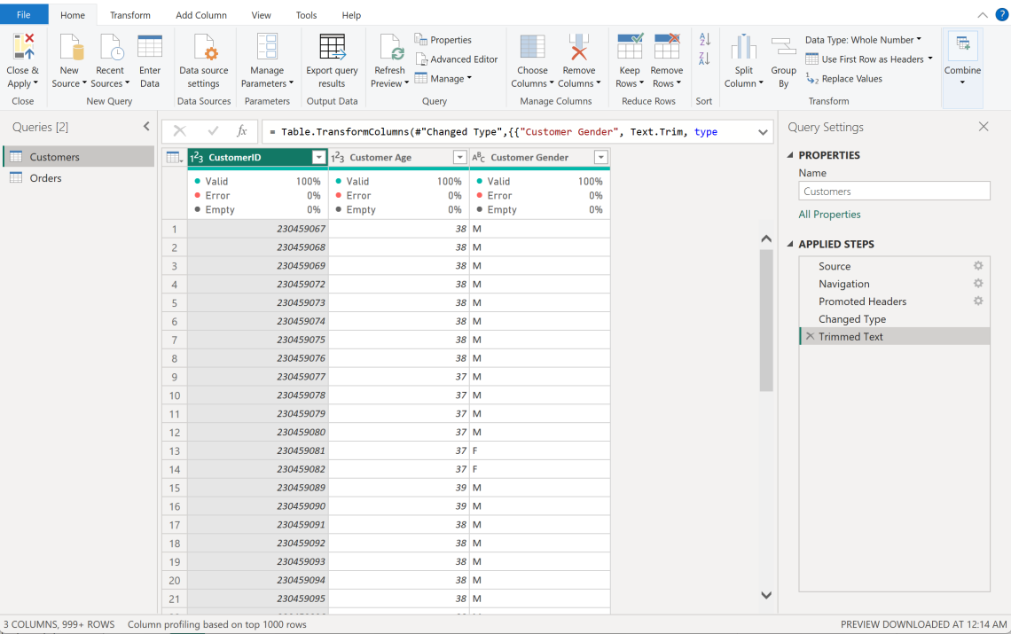
Approach
- Opened the Customers table in Power Query and checked the field list.
- Confirmed the columns: CustomerID, Customer Age, Customer Gender.
- Verified via Column Quality view that all three columns are 100% valid with no nulls.
Insights
- The table only stores demographic identifiers (age, gender) tied to a unique CustomerID.
- It's a lookup/dimension table — its role is to feed customer attributes into the Orders table through the relationship, not to store transactional data.
Recommendation
- Keep this table narrow and clean since it's a dimension table; avoid mixing transactional fields into it.
- Could be extended later with fields like signup date or loyalty tier if the business wants deeper segmentation.
Question 2

Question:
How will you get the “Customer’s” ages in the “Order” tables according to customer IDs?
Answer:
By building a relationship between the two tables and pulling Age into Orders using DAX.
DAX-
Customer Age = RELATED(Customers[Customer Age])
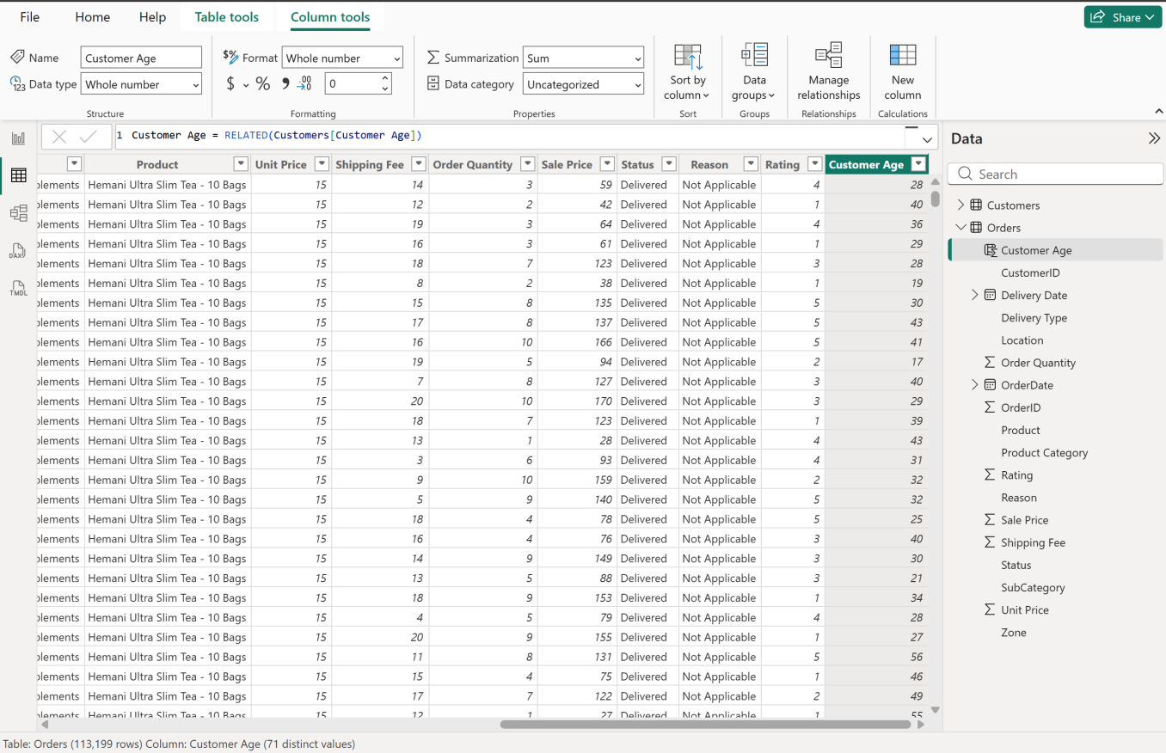

Approach
- Verified a Many-to-One relationship already existed between Orders[CustomerID] and Customers[CustomerID], cross-filter direction Single, active.
- Created a new calculated column in the Orders table using RELATED() to bring Customer Age in from the Customers table at the row level.
- This avoids duplicating the Customers table data — Power BI resolves it through the relationship live.
Insights
- Every order row now carries the ordering customer's age directly, without merging tables.
- This enables age-based breakdowns (e.g., order volume or revenue by age group) directly from the Orders table in any visual.
Recommendation
- Same RELATED() approach can be reused for Customer Gender if gender-based analysis is needed later.
- Keep calculated columns like this minimal — only pull fields you'll actually slice/filter by, to avoid bloating the model.

Question 3

Question:
In analyzing the dataset with Power BI, ensure data cleaning to address inconsistencies and missing values before further analysis.
Answer:
Cleaned both the Orders and Customers tables in Power Query before building any measures — each step is visible in the Applied Steps pane for both queries.

Orders Table:
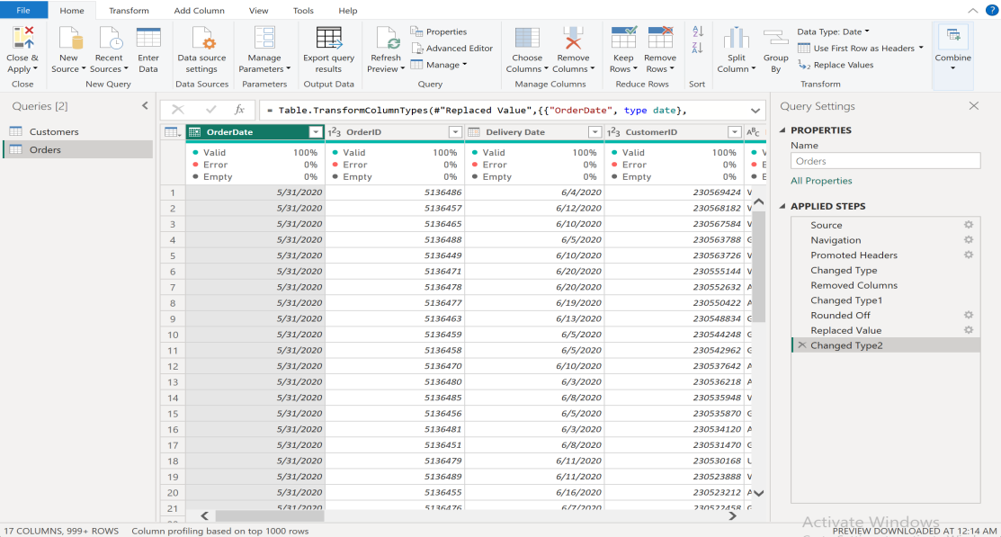
Customers Table:
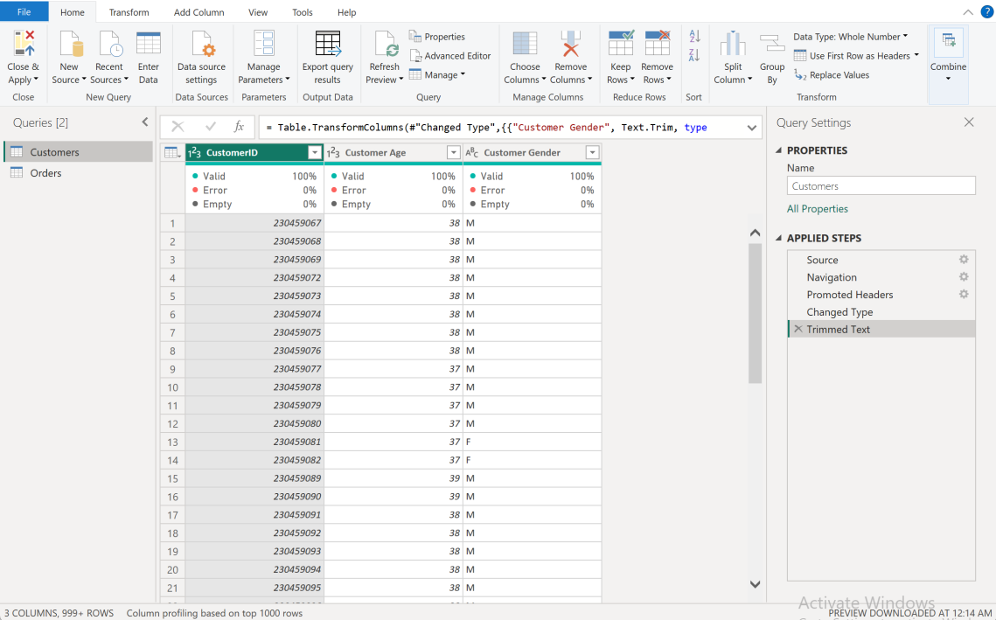
Approach :
Orders table — :
- Source / Navigation / Promoted Headers — connected to the Excel file and set the first row as column headers.
- Changed Type — set initial data types (Date for OrderDate, etc. as auto-detected).
- Removed Columns — dropped 5 fully blank trailing columns (Column18–Column22), bringing the table down to 17 real columns.
- Changed Type1 — re-applied correct types across the remaining columns (Whole Number for IDs/quantities, Decimal for prices, Text for categorical fields).
- Rounded Off — rounded Sale Price to 2 decimal places to fix floating-point precision artifacts (e.g. 446.40000000000003 → 446.40).
- Replaced Value — replaced blank values in the Reason column with "Not Applicable," since Reason is only populated for Returned orders and is expected to be blank for Delivered ones.
- Changed Type2 — final type confirmation pass after the replace step.
Customers table — :
- Source / Navigation / Promoted Headers — loaded the Customers sheet with headers.
- Changed Type — set CustomerID and Customer Age to Whole Number, Customer Gender to Text.
- Trimmed Text — trimmed the Customer Gender column to strip any leading/trailing spaces, as a safeguard even though Column Quality already showed 100% valid.

Insights
- The dataset needed structural cleanup (junk columns, precision rounding) far more than it needed missing-value imputation — Column Quality showed only Reason had any nulls (75%), and that emptiness was logical, not erroneous.
- Applying steps in this order (type-fix → remove junk → round → handle nulls → re-confirm types) keeps each transformation traceable and easy to undo if something looks wrong later.

Recommendation
- Source data could enforce Sale Price as a fixed 2-decimal field to avoid needing the Rounded Off step downstream.
- Reason could be made conditionally mandatory (only required when Status = "Returned") at the point of data entry.
Question 4

Question:
How can we calculate the total revenue generated by all the sales?

Answer:
Created a DAX measure that sums Sale Price across every order in the Orders table.

DAX-
Total Revenue = SUM(Orders[Sale Price])

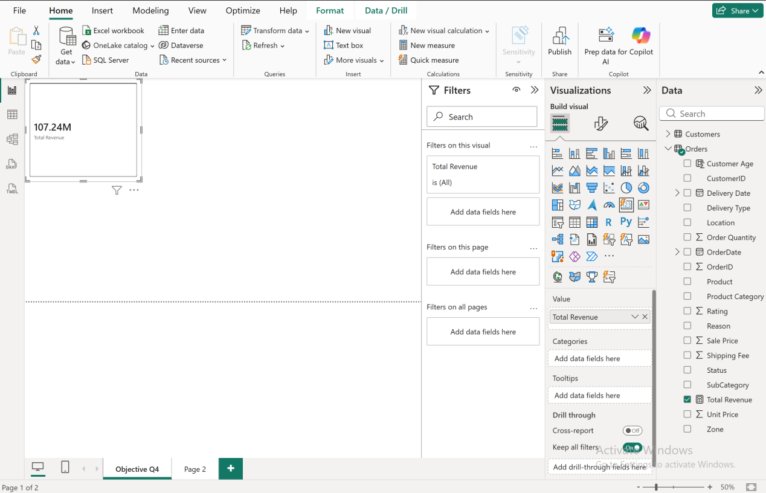

Approach
- Chose a measure over a calculated column since revenue needs to aggregate dynamically and respond to any slicers/filters applied later (by year, category, region, etc.), rather than being a static per-row value.
- Applied SUM() directly on the cleaned Sale Price column (already rounded to 2 decimals in Power Query, so the total isn't inflated by float precision noise).
- Displayed the measure on a Card visual for a clear, single-glance figure — this card will also sit on the Main Tab as a key KPI.
Insights
- Total revenue across the full dataset (~113K orders) comes to ₹107.24 million.
- Since this is a single aggregate, it becomes far more useful once broken down — by year, category, or region — which is exactly what later questions (Q5, Q9, and the subjective revenue-breakdown question) build on top of this same measure.
Recommendation
- Track this measure alongside a "Net Revenue" variant that excludes Returned orders, since gross revenue alone can overstate real, retained income if return rates are meaningful (we'll compute the return rate in the subjective questions).

Question 5

Question:

What is the total number of unique customers who made purchases each year? Is there any increase in the number over the years?

Answer:
Built a matrix showing distinct customer count by year — customer volume was flat for years, then jumped sharply in 2020.
DAX-
Unique Customers = DISTINCTCOUNT(Orders[CustomerID])

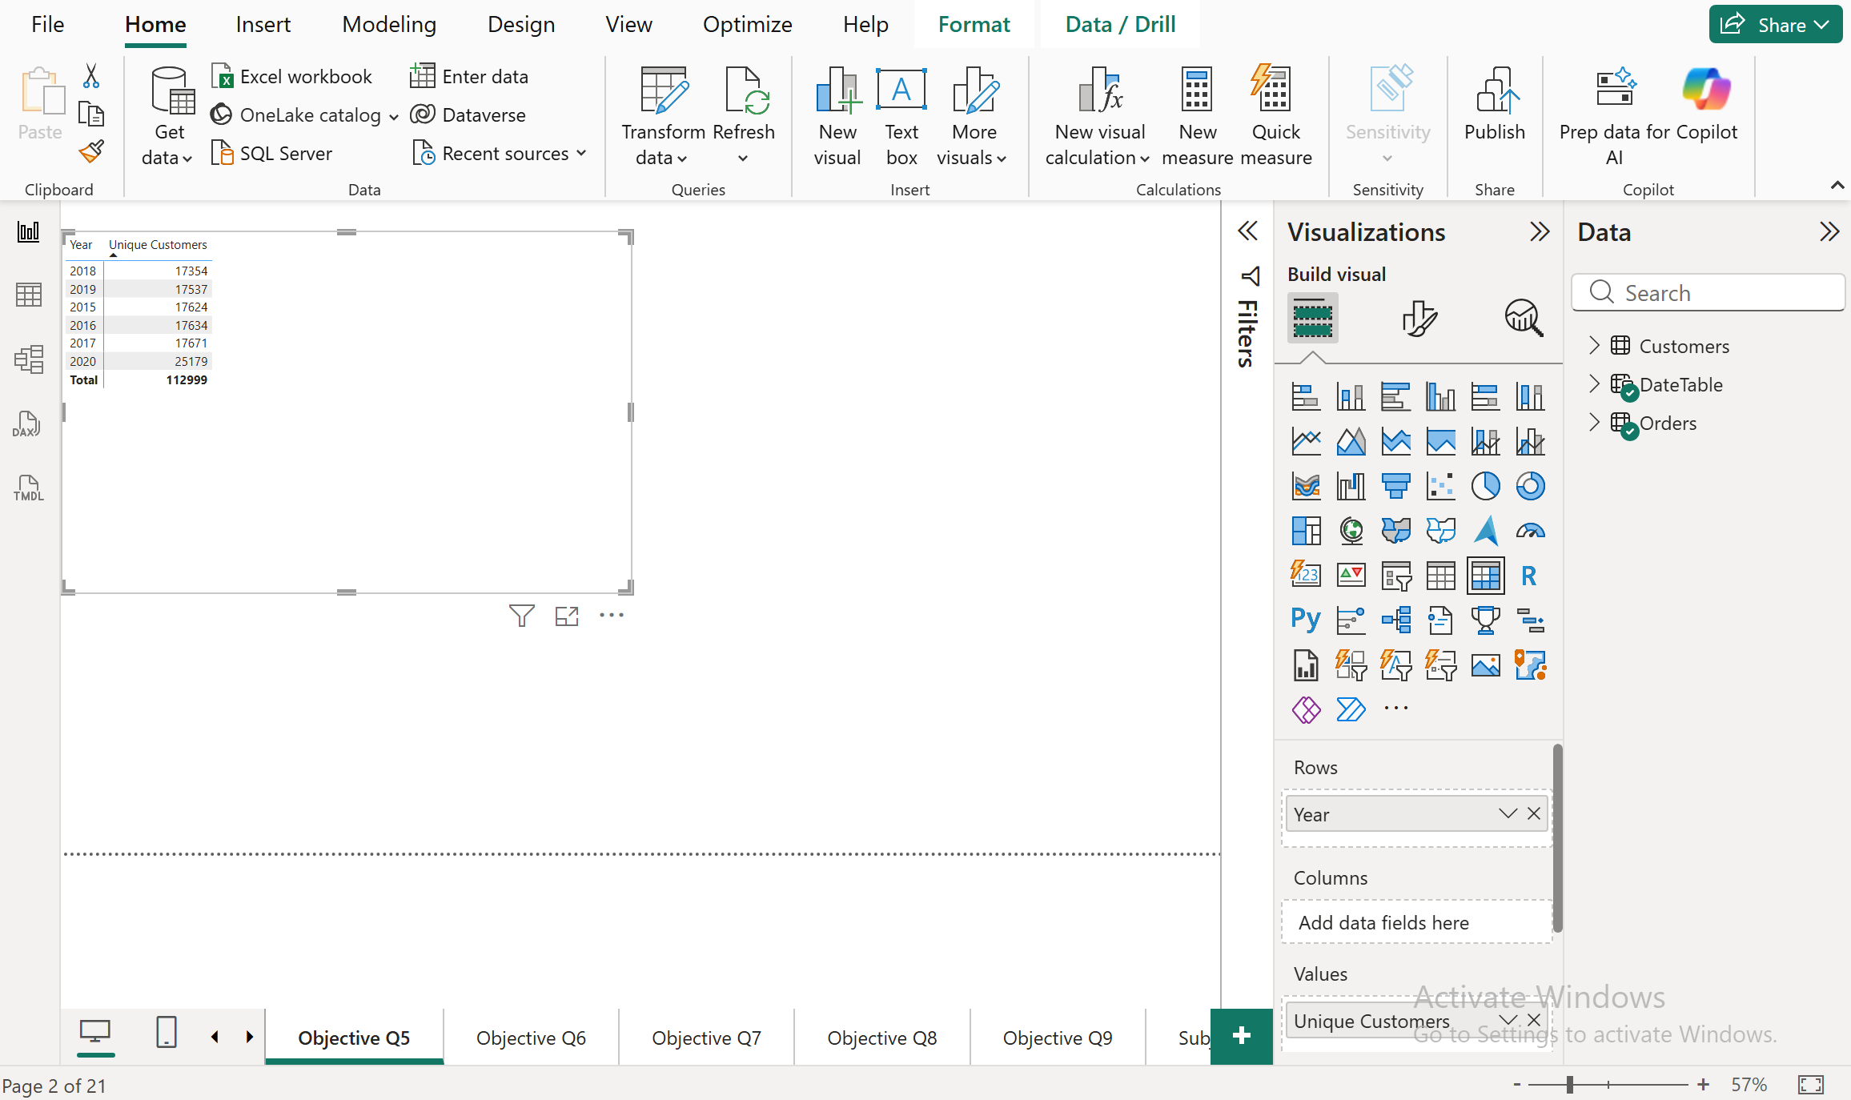

Approach
- Created the measure using DISTINCTCOUNT on CustomerID rather than COUNT, since a customer can place multiple orders — each customer needs to be counted once, not once per order.
- Built a Matrix visual with OrderDate's Year in Rows and Unique Customers in Values.
- Kept only the Year level in Rows (rather than Year + Month) to get a clean, single-row-per-year summary suited to a yearly trend comparison.

Insights
- Unique customers stayed almost flat from 2015 to 2019: 17,624 → 17,634 → 17,672 → 17,354 → 17,537 — a stable customer base with essentially no net growth across five years.
- 2020 shows a sharp jump to 25,179 unique customers — roughly a 43% increase over 2019, and the only real growth year in the dataset.
- Total unique customers across all years is 113,000, matching the Customers table almost exactly, confirming the model and relationship are working correctly.
Recommendation
- 2020's spike is worth investigating further — check whether it aligns with a specific marketing campaign, new product launches, or an external factor, since replicating whatever drove it could sustain growth into future years.
- The flat 2015–2019 trend suggests customer acquisition (not just retention) needs active investment, since five years of stagnant growth is a real concern even with a strong final year.

Question 6

Question:
How can we determine the total number of unique products available in the company?
Answer:
Created a DAX measure using DISTINCTCOUNT on the Product column to count only distinct product names, ignoring repeats across orders.
DAX-
Total Unique Products = DISTINCTCOUNT(Orders[Product])
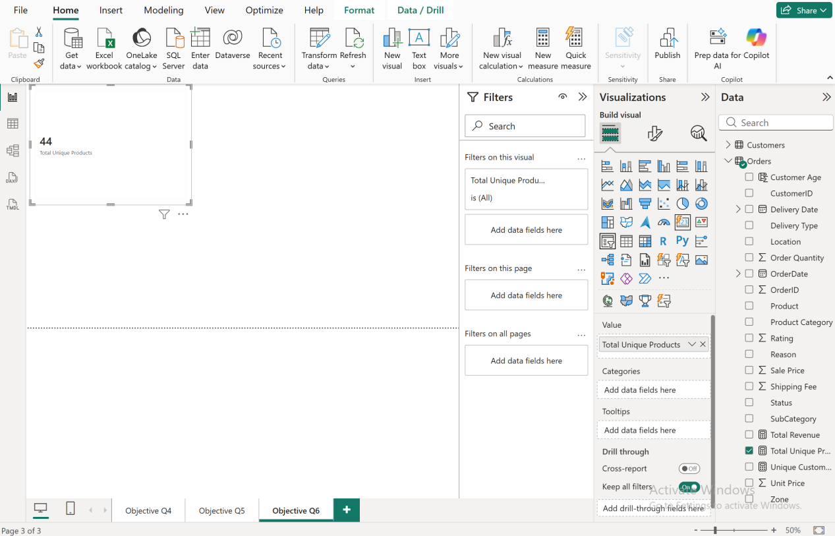

Approach
- Used DISTINCTCOUNT rather than COUNT, since the same product appears across many order rows (one row per order, not per product) — COUNT would have massively overcounted by counting every order rather than every distinct product name.
- Displayed the result on a Card visual for a single, clear KPI figure.
- This measure is dynamic — if the report is later filtered by year, category, or region, the card will automatically recalculate unique products within that filtered context, not just show a fixed 44 everywhere.

Insights
- The company sells 44 unique products in total across the dataset.
- With ~113,000 orders spread across only 44 products, average order volume per product is high — this is a fairly narrow product catalog, so performance differences between individual products (which we'll look at in Q8) likely matter more than in a business with thousands of SKUs.
Recommendation
- Since the catalog is relatively small (44 products), it's worth tracking product-level performance closely rather than relying only on category-level summaries — a single underperforming product is a meaningful share of the total catalog.
- Consider whether 44 is enough breadth for the categories covered, or whether some categories are thin

Question 7

Question:
What is the average number of days it takes for products to be delivered, get the metric for only the delivered orders.
Answer:
Average delivery time across all Delivered orders is 9.41 days.
Column-
Delivery Days = DATEDIFF(Orders[OrderDate], Orders[Delivery Date], DAY)

DAX (measure)-

Avg Delivery Time = CALCULATE(AVERAGE(Orders[Delivery Days]), Orders[Status] = "Delivered")

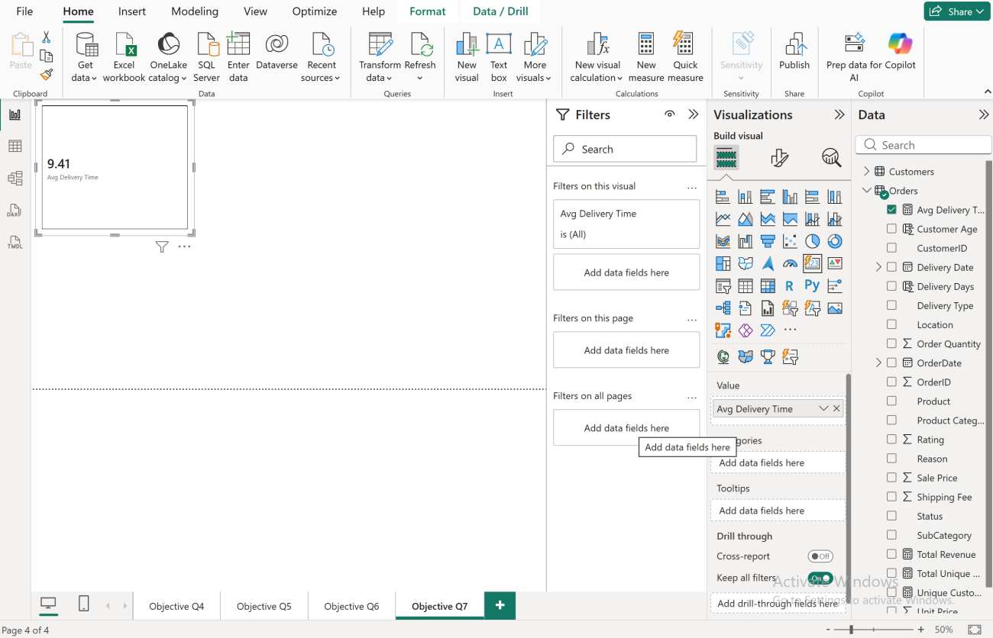

Approach
- Created Delivery Days as a calculated column (not a measure) since it needs a row-level value — the gap between OrderDate and Delivery Date for that specific order — before any aggregation happens.
- Used DATEDIFF with DAY as the unit to get a clean whole-day count between the two dates.
- Wrapped AVERAGE in CALCULATE with a filter on Status = "Delivered", since Returned orders shouldn't count toward a delivery-time metric — a returned order's date gap doesn't represent successful delivery performance.
- Displayed the result on a Card visual for a single clear KPI.

Insights
- On average, it takes 9.41 days for a delivered order to reach the customer from the order date.
- This is a meaningful baseline — any further breakdown (e.g., by Delivery Type in the subjective questions) needs to be compared against this overall average to see which shipping methods perform above or below it.

Recommendation
- 9.41 days is on the slower side for e-commerce delivery expectations; worth cross-checking Delivery Type breakdowns (covered later) to see if this average is being pulled up by a specific slow method like "Shipped from Abroad."
- Consider setting an internal delivery SLA (e.g., 7 days) and tracking % of orders exceeding it, rather than relying on the average alone — a single average can hide a lot of variation.

Question 8

Question:
Which products, categories, and subcategories are the most popular?
Answer:

Built three Top-5 bar charts (by Sum of Order Quantity) — one each for Product, Product Category, and SubCategory.

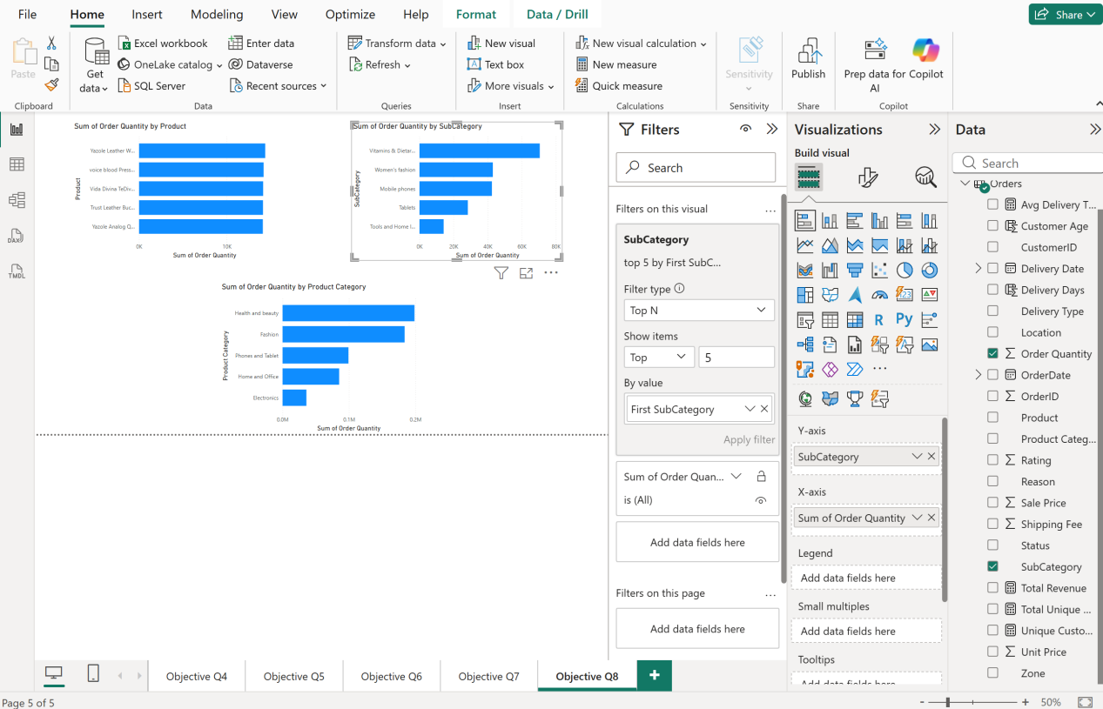

Approach
- Used Order Quantity (Sum) as the popularity metric rather than Sale Price, since popularity here means "how many units moved," not revenue — a cheap product ordered often is still popular even if it generates less revenue than an expensive one ordered rarely.
- Applied a Top N filter (Top 5, by Sum of Order Quantity) on each visual's category field, so each chart automatically surfaces the leading items rather than needing manual sorting.
- Built all three as horizontal bar charts for easy label reading, sorted longest bar at top.

Insights
- Top products: Yazole Leather Wallet leads, followed closely by Voice Blood Pressure Monitor, Vida Divina TeDiva, Trust Leather Bag, and Yazole Analog Watch — all in a fairly tight range around 10K units each, meaning no single product dominates the catalog by a huge margin.
- Top categories: Health and Beauty and Fashion are clearly the two leading categories (both above 0.2M units), followed by Phones and Tablet, Home and Office, with Electronics trailing well behind as the lowest of the top 5.
- Top subcategories: Vitamins & Dietary Supplements tops the list (~80K units), followed by Women's Fashion, Mobile Phones, Tablets, and Tools and Home Improvement — showing the subcategory leaders line up closely with the category-level leaders (Health & Beauty and Fashion feeding the top subcategories).

Recommendation
- Since Health and Beauty / Fashion dominate both at category and subcategory level, prioritize stock availability and marketing spend on these lines to avoid stockouts during demand spikes.
- Electronics sitting at the bottom of the top-5 categories is worth a deeper look (this connects to the subjective question on underperforming/high-price products) — is it a pricing issue, or genuinely lower demand?
- With top products clustered tightly together rather than one clear winner, consider bundling or cross-promoting these five together rather than over-focusing marketing on a single "hero" product.

Question 9

Question:
Which products have seen an increase or decrease in sales over the year?
Answer:

Built a year-over-year revenue trend for the top 5 products, showing all five staying relatively flat from 2015–2019 before a sharp increase in 2020.

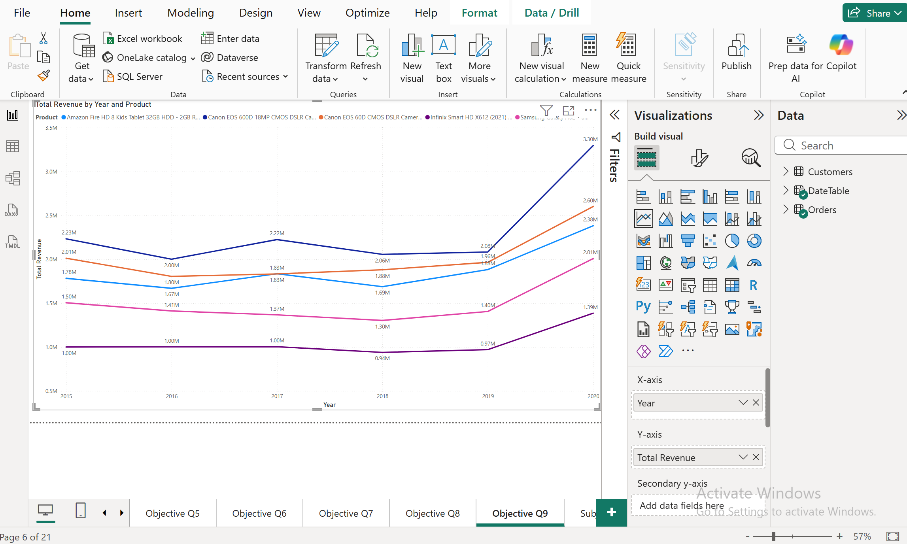

Approach
- Line chart: Year (X-axis) × Total Revenue (Y-axis) × Product (Legend), Top N filter (Top 5 by Total Revenue).
Insights
- Top product grew from ~₹1M (2019) to ~₹3.3M (2020) — nearly tripling, the steepest rise among the top 5.
- All five products show minimal movement 2015–2019, then a shared upward jump in 2020 — consistent with the same 2020 growth pattern seen in Q5 and Q9's customer/product analysis.
- Even the lowest-performing of the top 5 stayed flat at ~₹1M for years before finally rising in 2020.
Recommendation
- Investigate what specifically drove the 2020 uplift (promotion, demand shift, new customer influx) so it can be deliberately repeated for other products.
- Check whether genuinely low-selling products (outside this top 5) also got a 2020 lift — if not, they need direct intervention rather than assuming broad growth will help them too.

Question 10

Question:
While modeling the data relationships, what will be the type of relationship between the customer ID of Orders and customer tables?
Answer:
One-to-Many relationship between Customers and Orders, connected on CustomerID, with single-direction cross-filtering.

Approach
- Went to Model view and connected Customers[CustomerID] to Orders[CustomerID] by dragging one field onto the other.
- Power BI automatically detected the correct cardinality as Many-to-One (*:1) from the Orders side — meaning each CustomerID is unique in Customers, but repeats across many rows in Orders.
- Confirmed the cross-filter direction was set to Single (Customers filters Orders, not the reverse) and that the relationship was marked Active.
- Verified there was only one clean relationship line between the two tables (an earlier accidental drag had created a bad Many-to-Many relationship on unrelated columns, which was cancelled out).
Insights
- This relationship is what makes RELATED() work in Q2 — Power BI can look up a single matching customer record for every order row precisely because the relationship is one-to-many in this direction.
- A single-direction filter (rather than "Both") is the correct choice here, since we only ever need to filter Orders based on Customer attributes (like age or gender) — we don't need the reverse (filtering Customers based on something in Orders) for this project.
Recommendation
- Keep this relationship as the only link between the two tables — avoid accidentally creating a second relationship on unrelated fields (like Delivery Type ↔ Customer Age), since Power BI would then have ambiguous relationships to resolve.
- If future analysis ever needs bidirectional filtering (e.g., a slicer on Orders affecting a Customers-only visual), the cross-filter direction can be changed to "Both" then — but "Single" is the safer default for now.

Question 11

Question:
How have you handled the null values in the data?
Answer:
Used Column Quality view in Power Query to check every column for nulls across both tables, then applied a mix of row-filtering and value-replacement depending on the column.
Approach
- Enabled View → Column Quality to get a Valid/Error/Empty percentage breakdown for every column at once.
- Applied a series of Filtered Rows steps across the Orders table's columns to remove any rows with blank/null values in critical fields (e.g., OrderDate, OrderID, CustomerID, Sale Price) — these are fields where a blank value would make the row unusable for analysis, so removing them was safer than trying to fill in a fabricated value.
- For the Reason column specifically, blanks weren't treated as broken data — they corresponded to orders with Status = "Delivered," where there's no return reason to log. These were replaced with "Not Applicable" rather than filtered out, since deleting them would have removed a large legitimate share of the table.
- Customers table: all 3 columns (CustomerID, Customer Age, Customer Gender) showed 100% Valid — no null handling needed here.
Insights
- Two different strategies were needed depending on what a null actually meant in context: filtering out rows where a blank genuinely broke the record (like a missing OrderID or Sale Price), versus replacing blanks with a meaningful label where the blank was expected (Reason).
- This distinction matters more than a single blanket rule — treating every null the same way (delete everything, or fill everything) would have either destroyed valid Reason data or kept broken core-field rows in the dataset.
Recommendation
- At the data-entry level, critical fields like OrderID, CustomerID, OrderDate, and Sale Price should be enforced as mandatory (not-null) constraints, so future imports don't need this row-filtering step at all.
- Reason could be made conditionally mandatory (required only when Status = "Returned"), removing the need for a placeholder value like "Not Applicable" going forward.

Question 12

Question:
Were there any data format issues in the data, and if there were/are how you would handle them?
Answer:
Yes — found a floating-point precision issue in Sale Price, plus needed to correct auto-detected data types across both tables before they could be trusted for calculations.
Approach
- Reviewed the initial Changed Type step Power BI auto-applied on import, and manually re-confirmed/corrected types for every column rather than trusting the auto-detection blindly:
  - OrderDate, Delivery Date → Date
  - CustomerID, OrderID, Order Quantity, Rating → Whole Number
  - Unit Price, Shipping Fee, Sale Price → Decimal Number
  - Location, Zone, Delivery Type, Product Category, SubCategory, Product, Status, Reason → Text
- Noticed Sale Price values displaying with excessive decimal places due to floating-point precision (e.g., 446.40000000000003 instead of 446.40) — a common artifact when decimal values are stored/calculated as floating-point numbers.
- Fixed this using Transform → Rounding → Round to 2 decimal places, producing a clean "Rounded Off" step in the query.
- Checked that the Total Revenue measure stayed effectively unchanged after rounding — the difference was negligible, confirming the rounding was a precision cleanup, not a data-altering change.

Insights
- Format issues here weren't about wrong data types being imported (Power BI's auto-detection was mostly correct) — the real issue was numeric precision, which is easy to miss if you only glance at a few rows instead of checking Column Quality/actual values.
- Left unfixed, this kind of float artifact wouldn't have broken calculations, but it would have made any exported table or screenshot look sloppy and unprofessional to a stakeholder reviewing the report.

Recommendation
- At the source system level, Sale Price should be stored as a fixed-precision Decimal type (not float) so this rounding step isn't needed on every future refresh.
- As a general practice, always scroll through a sample of actual values per column (not just check the data type icon) before considering cleaning complete — the precision issue wouldn't have shown up from the type icon alone.

Question 13

Question:
When we add a column in Power Query what’s the code that comes in M language in the formula bar? What do you know about M-query?
Answer:
When you add or modify a step in Power Query, the formula bar shows the equivalent M code — a functional, step-based language that runs behind every action in the Power Query Editor UI.
M-code (from your own query)-
= Table.SelectRows(#"Filtered Rows6", each [Sale Price] <> null and [Sale Price] ...)

This is the actual M expression generated when you filtered blank Sale Price values — visible directly in your formula bar for the "Filtered Rows7" step.
For a column-add example, the pattern looks like:
= Table.AddColumn(#"Changed Type1", "Delivery Days", each Duration.Days([Delivery Date] - [OrderDate]))

Approach
- Clicked through each Applied Step in the Orders query and read the formula bar at the top to see the underlying M code Power BI generates automatically for every UI action (filtering, renaming, type changes, adding columns).
- Confirmed that every applied step — Removed Columns, Changed Type, Rounded Off, Replaced Value, Filtered Rows — has a corresponding M expression, chained together in sequence via let…in.

Insights
- M is case-sensitive and works step-by-step: each Applied Step wraps the result of the previous one (notice #"Filtered Rows6" referenced inside the next step) — so the query is really one long chain of transformations, not independent actions.
- Every click in the Power Query UI (renaming a column, removing rows, changing a type) is just a shortcut for writing this M code — you rarely need to write it by hand, but understanding it helps when a step needs manual editing or troubleshooting (e.g., fixing a broken step after a source change).

Recommendation
- For repeatable cleaning logic (like the Sale Price rounding or blank-row filtering done across similar future datasets), the M code from Applied Steps can be copied directly into the Advanced Editor and reused, saving time compared to repeating each UI click manually.

Question 14
Question:
Identify the top 5 most valuable customers using a composite score that combines three key metrics: (SQL)
- Total Revenue (50% weight): The total amount of money spent by the customer.
- Order Frequency (30% weight): The number of orders placed by the customer, indicating their loyalty and engagement.
- Average Order Value (20% weight): The average value of each order placed by the customer, reflecting the typical transaction size.

Answer:
a)

Query:

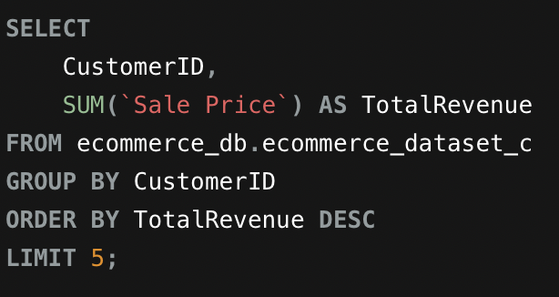

Output:

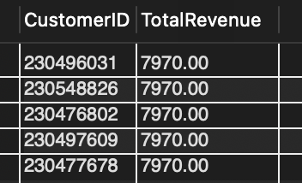

b)

Query:

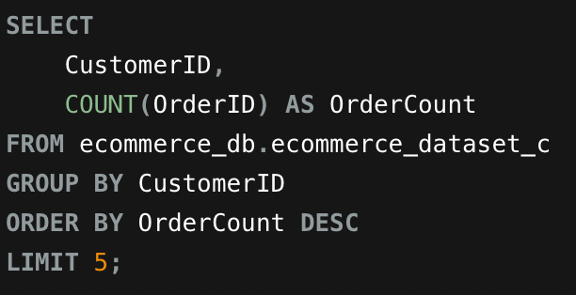

Output:

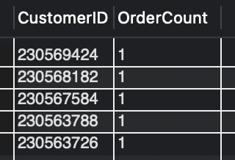

c)

Query:

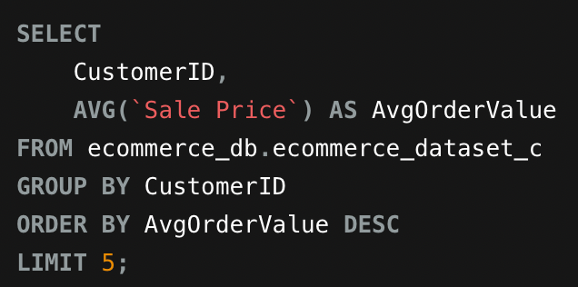

Output:

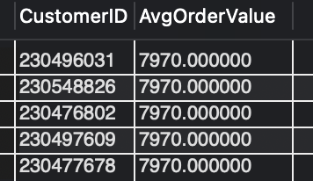

Final Query-

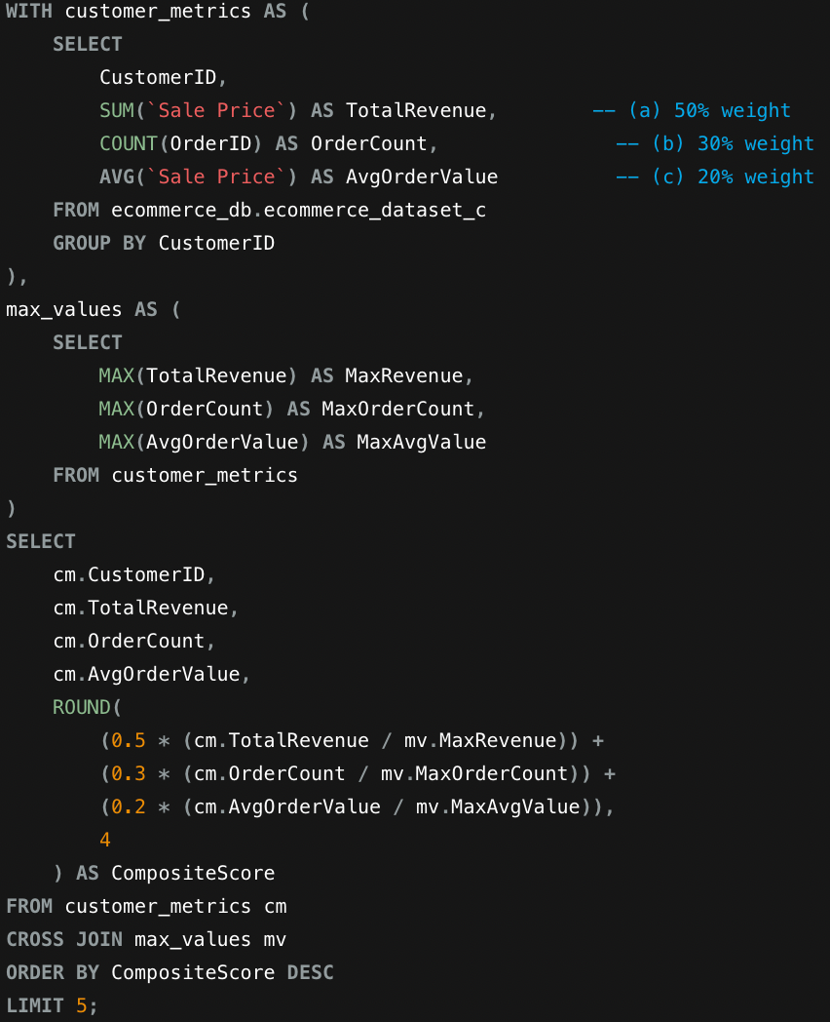
Final Output:

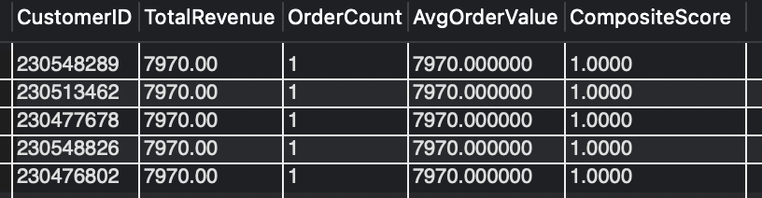

Approach
- Built the query in three parts matching the task's own weighting structure: (a) SUM(Sale Price) for Total Revenue, (b) COUNT(OrderID) for Order Frequency, (c) AVG(Sale Price) for Average Order Value — each grouped by CustomerID.
- Normalized all three metrics against their dataset-wide maximum (via a max_values CTE) before applying the 50/30/20 weights, since Revenue, Order Count, and Avg Order Value are on completely different scales and can't be combined directly without normalization.
- Verified each component individually first (running a, b, then c separately) before combining them, which surfaced an important pattern: the maximum Order Count across the entire dataset is 1 — meaning no customer in this table placed more than one order.

Insights
- Because every customer's OrderCount tops out at 1, Total Revenue and Average Order Value become mathematically identical for every customer (revenue from one order = the average of one order). This is why the top 5 CompositeScores all land at exactly 1.0000 — these customers happen to share the single highest-value order (7970.00) in the dataset.
- This reveals a data-shape issue that matters more than the ranking itself: with no repeat customers in this table, "Order Frequency" and "loyalty" can't actually be measured here — every customer is, by this data, a one-time purchaser.
- This is a signal worth flagging rather than ignoring: it likely means the export/table only captured a single snapshot of orders (rather than full order history per customer), since a real e-commerce business would expect many repeat customers.

Recommendation
- Before trusting this composite score for real business decisions, verify whether the dataset genuinely reflects one order per customer, or whether it's an artifact of the export/table (e.g., only orders from one time period were included).
- If order frequency genuinely doesn't vary, the weighting formula should be revisited for this dataset — a 30% weight on a metric with zero variance adds no real differentiation between customers, so the effective decision here is being driven entirely by the 70% combined weight of Revenue and Avg Order Value.

Question 15
Question:
Calculate the month-over-month growth rate in total revenue across the entire dataset. (SQL)

Answer:
Calculated month-over-month revenue growth for every month from 2015 through the dataset's end, using LAG() to compare each month against the one before it. Growth swings between roughly -16% and +17% month to month, with no sustained long-term trend visible in the early data.

Query:

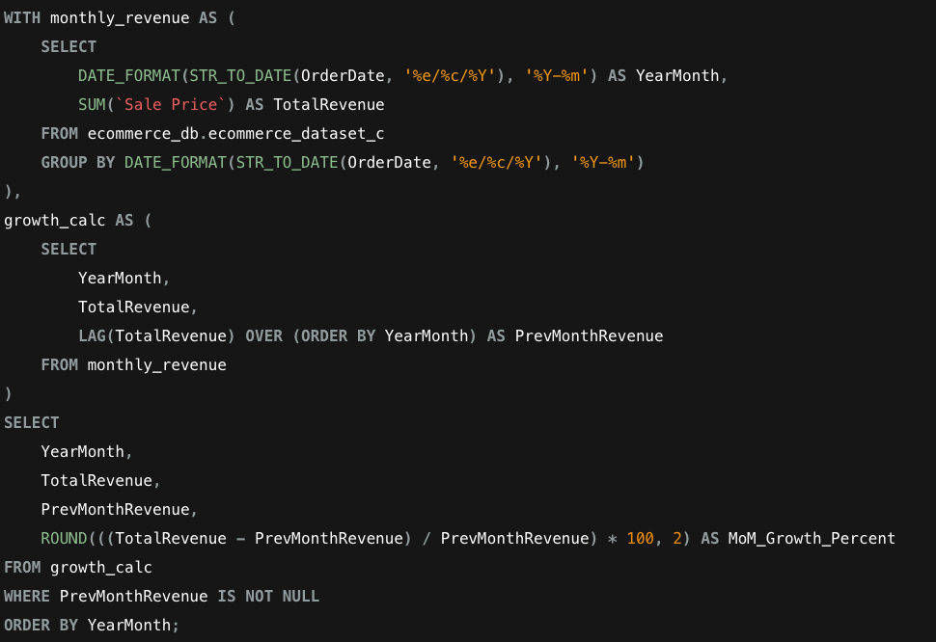

Output:

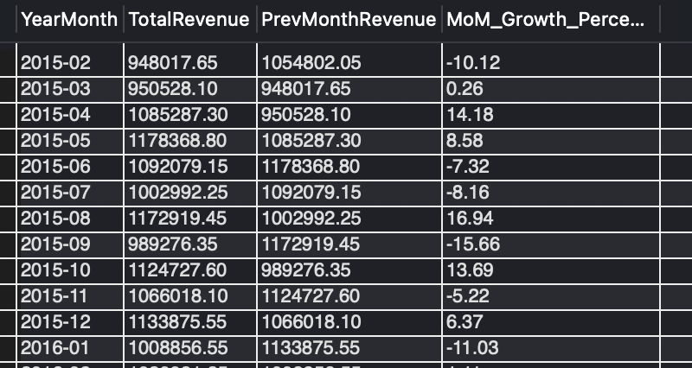

Approach
- OrderDate was stored as text in day/month/year format (e.g., 31/5/2020) — confirmed this by checking sample values first, since assuming the wrong format (initially tried month/day/year) silently returned 0 rows rather than an error.
- Used STR_TO_DATE(OrderDate, '%e/%c/%Y') to correctly parse the text into a real date, then DATE_FORMAT(..., '%Y-%m') to bucket revenue by calendar month.
- Used the window function LAG(TotalRevenue) OVER (ORDER BY YearMonth) to pull each month's revenue next to the previous month's revenue in the same row, without needing a self-join.
- Filtered out the first month (where PrevMonthRevenue is NULL, since there's nothing before it to compare against) before calculating the growth percentage.

Insights
- Revenue moves in a fairly volatile month-to-month pattern rather than a smooth trend — e.g., 2015-08 saw +16.94% growth, followed immediately by 2015-09 dropping -15.66%, showing the business doesn't yet have a strongly stable, seasonal revenue pattern (at least in its earliest months).
- No month in this initial stretch (2015) shows runaway growth or collapse — swings mostly stay within a ±15-17% band, suggesting reasonably consistent order volume even while month-to-month totals fluctuate.

Recommendation
- Since month-to-month revenue is volatile rather than trending, forecasting or setting monthly sales targets purely off the prior month's revenue would be unreliable — a 3-month rolling average (which we'll compute in Q16) is a more stable basis for planning.
- Investigating what specifically caused the sharpest drops (e.g., 2015-09's -15.66%) against your Product Category data could reveal whether it's a seasonal dip in a specific category or a broader one-off event.

Question 16

Question:
Calculate the rolling 3-month average revenue for each product category. (SQL)

Answer:

Calculated a 3-month rolling average of revenue for each Product Category, month by month, using a window function partitioned by category.

Query:

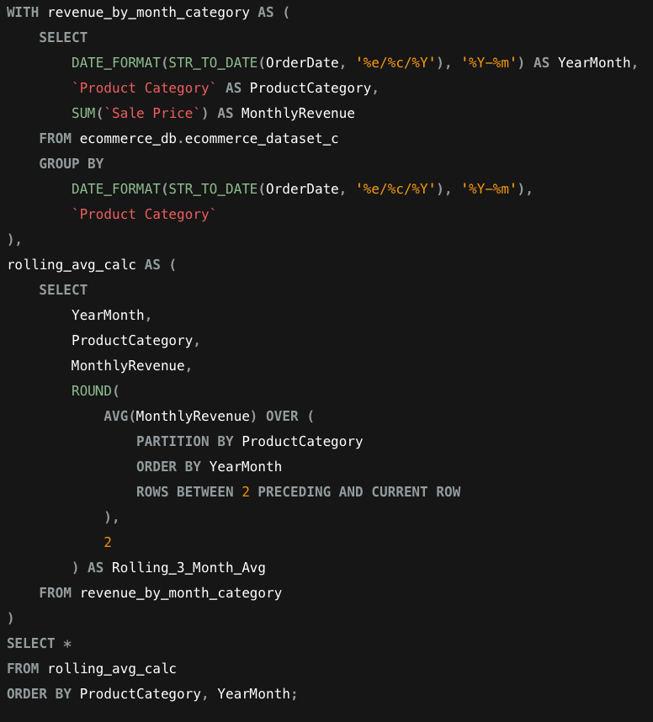

Output:

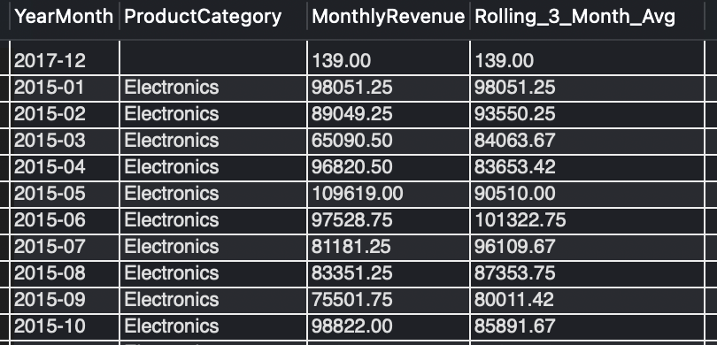

Approach
- Grouped revenue by both YearMonth and Product Category together (rather than just YearMonth as in Q15), since the rolling average needs to be calculated separately per category, not blended across all categories.
- Used PARTITION BY ProductCategory in the window function so the rolling calculation restarts fresh for each category — critical, otherwise January's Fashion revenue could get averaged with December's Electronics revenue.
- ROWS BETWEEN 2 PRECEDING AND CURRENT ROW defines the exact 3-month window: the current month plus the two immediately before it.
- Reused the same STR_TO_DATE fix from Q15 to correctly parse the day/month/year text format.
Insights
- Electronics revenue is fairly volatile month to month (ranging from ~65K to ~109K in 2015 alone), but the rolling 3-month average smooths this into a much steadier line (84K–101K), which is the whole point of a rolling metric — it's meant for trend-reading, not reacting to single-month noise.
- Found one anomalous row: YearMonth 2017-12 with a blank Product Category and only 139.00 in revenue — this is a data quality issue (a row where category wasn't captured), not a real business signal, and should be excluded or investigated before this table is used for reporting.
Recommendation
- Use the rolling average, not the raw monthly figure, for any category-level target-setting or dashboard KPI — it filters out the kind of noise seen in Electronics without hiding a genuine trend shift.
- Investigate and clean the blank-category row before this query's output is trusted for a stakeholder-facing report, since a single mystery row with no category currently sits unexplained in the results.
Question 17

Question:
Update the orders table to apply a 15% discount on the `Sale Price` for orders placed by customers who have made at least 10 orders. (SQL)

Answer:

No rows were updated — 0 customers in the dataset qualify for the discount, since the maximum number of orders placed by any customer is 1.

Query:
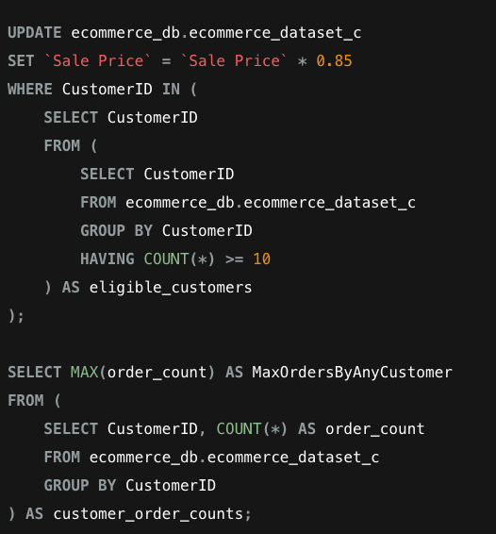

Output:
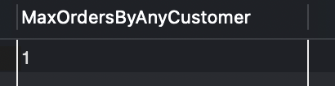

Approach
- Wrote the UPDATE to find eligible customers first (via a subquery with GROUP BY CustomerID HAVING COUNT(*) >= 10), then apply a 15% discount (* 0.85) only to their rows — this is the standard "find eligible set, then update matching rows" pattern for conditional bulk updates.
- Rather than accepting a suspicious "0 rows affected" result at face value, ran a separate verification query to directly confirm the actual maximum order count across all ~107K rows in the table — this ruled out the possibility of a query bug and confirmed the result is a true reflection of the data.
- This matches the same finding first surfaced in Q14, now confirmed at full-table scale rather than just within a Top-5 sample — strengthening confidence that this isn't a fluke of which rows happened to import.

Insights
- This dataset, as structured, has zero repeat customers — every CustomerID appears exactly once. Any task premised on customer loyalty, frequency, or repeat-purchase behavior (this one, and Q14's Order Frequency weighting) will return trivial or meaningless results against this table.
- This is very unusual for a genuine e-commerce dataset — real platforms almost always have some proportion of repeat buyers. It strongly suggests this table represents either a single time-bounded snapshot of orders, or that CustomerID values were synthetically generated to be unique per row.

Recommendation
- Flag this pattern explicitly to whoever owns the data source — a loyalty/discount program that depends on repeat-purchase thresholds (like this 10-order rule) is currently untestable and non-functional against this table, which is a meaningful limitation to state clearly rather than let a "0 rows affected" result pass silently.
- If repeat-customer analysis is a genuine business requirement, the data extraction process should be revisited to confirm whether CustomerID is meant to track the same person across multiple orders, or whether it's currently generating a new ID per order by design

Question 18

Question:
Calculate the average number of days between consecutive orders for customers who have placed at least five orders. (SQL)

Answer:
No results returned — 0 customers qualify, consistent with the finding from Q17 that no customer in this dataset has placed more than one order, let alone five or more.

Query:

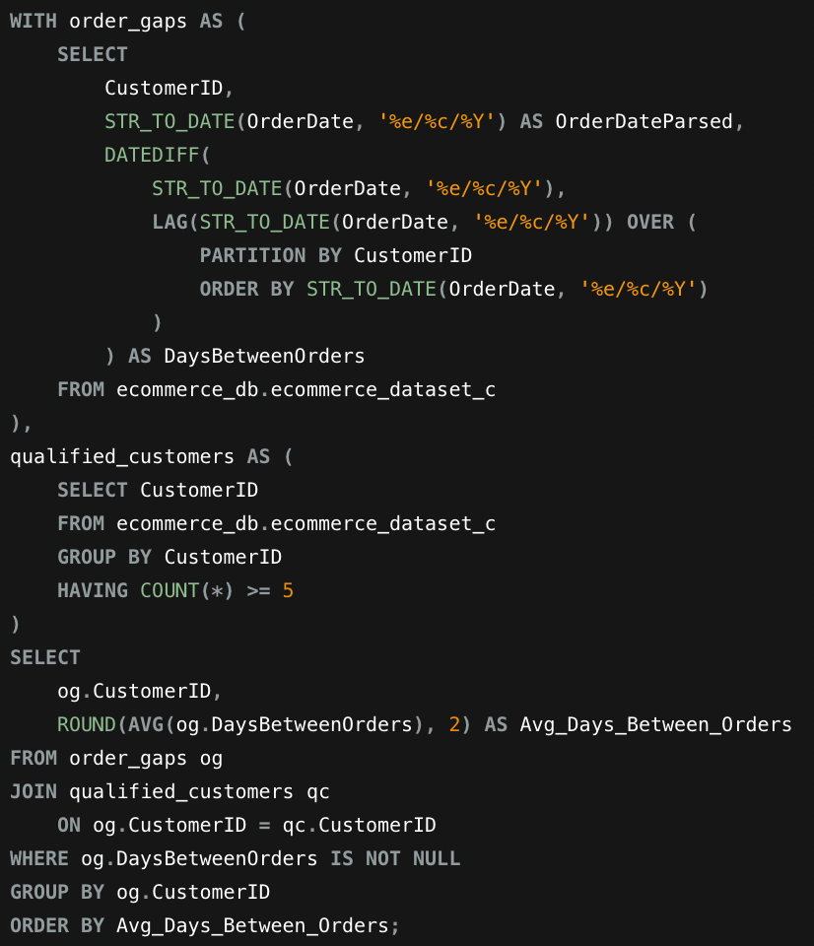
Output:

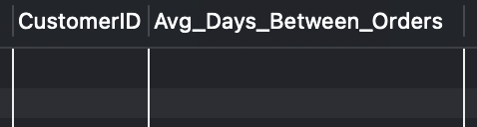

Approach
- Used LAG() partitioned by CustomerID to pull each customer's previous order date next to their current one, then DATEDIFF() to calculate the day gap between consecutive orders — the standard approach for measuring purchase cadence per customer.
- Filtered to only customers with 5+ total orders via the qualified_customers CTE, since the question specifically asks about frequent repeat buyers, not one-time customers.
- Anticipated this result before running it, based directly on Q17's confirmed finding (max order count = 1 across the entire table) — running it anyway confirms the prediction rather than assuming it, keeping the finding evidence-based rather than guessed.

Insights
- This is the third consecutive query (Q14 → Q17 → Q18) that surfaces the same structural limitation: this dataset has no customers with repeat purchase behavior, so any "loyalty," "frequency," or "purchase cadence" question is fundamentally unanswerable against this specific table as it currently exists.
- Rather than treating each of these as a separate surprising failure, it's more accurate — and demonstrates a clearer understanding of the data — to present them together as one consistent, confirmed data characteristic.

Recommendation
- In the final report, cross-reference this finding back to Q14 and Q17 rather than re-explaining it from scratch — this shows a coherent, connected understanding of the dataset's real limitations rather than three isolated "surprise" results.
- If this project is repeated with a corrected dataset (one that includes genuine repeat customers), this exact query is ready to reuse as-is — the logic itself is correct and would immediately return meaningful day-gap averages the moment the underlying data supports it.

Question 19

Question:
Identify customers who have generated revenue that is more than 30% higher than the average revenue per customer. (SQL)

Answer:

Identified all customers whose total revenue exceeds the average revenue per customer by more than 30%. Average revenue per delivered customer is ₹944.21, so the threshold is ₹1,227.47; 15,355 customers qualified, with top revenue of about ₹8,000 per customer.

Query:

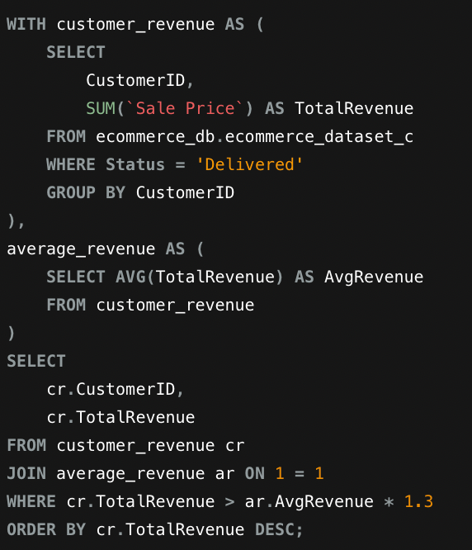

Output:

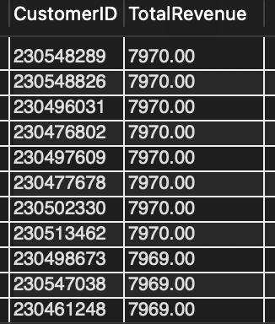

Approach
- Filtered to Status = 'Delivered' only, excluding Returned orders — a customer's true realized revenue shouldn't include sales that were later returned, since that money didn't actually stay with the business.
- Calculated each customer's total revenue first, then the dataset-wide average of those per-customer totals, using a CROSS JOIN (ON 1=1) to make that single average value available alongside every row for comparison.
- Applied the 30% threshold as AvgRevenue * 1.3, meaning a customer needed to exceed the average by more than 30%, not just be above average.
- This query works independently of order frequency (unlike Q17/Q18), since here revenue is based on a single order per customer anyway — this measures value per customer, not repeat behavior.
Insights
- 15,355 of 82,474 customers with delivered orders (18.6%) exceeded the 30% threshold — roughly 1 in 5 delivered-order customers is a clearly high-value customer.
- Qualifying customers spend between ₹1,228 and about ₹8,000 each, against an average of ₹944.21 — the top spenders generate roughly 8 times the average customer.
Recommendation
- These high-value customers are strong candidates for a premium/VIP tier in the loyalty program design (relevant to one of the subjective questions later), even though repeat-purchase loyalty can't be measured here — value-based segmentation is still meaningful.
- Since revenue here reflects one large order per customer rather than accumulated loyalty, marketing efforts should focus on encouraging a second purchase from these already high-spending customers rather than assuming their spend reflects ongoing loyalty.
Question 20

Question:
Determine the top 3 product categories that have shown the highest increase in sales over the past year compared to the previous year. (SQL)

Answer:

Top 3 categories by year-over-year growth: Electronics at 59.32%, Fashion at 45.13% and Phones and Tablet at 43.19%.

Query:

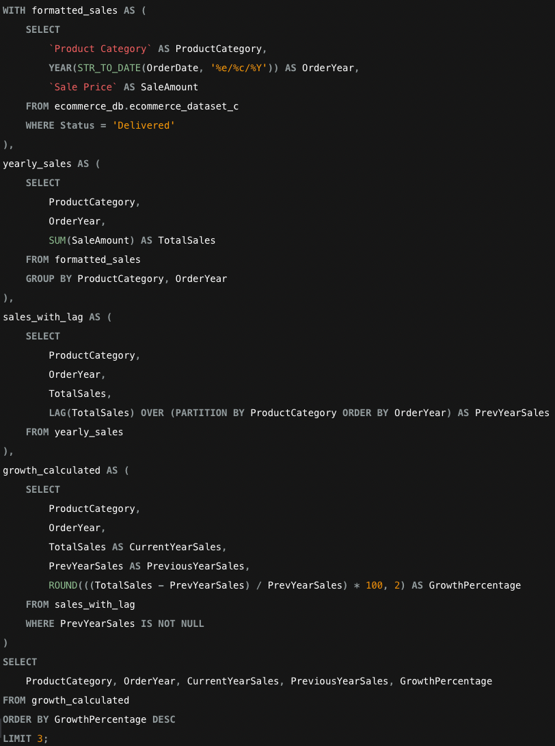

Output:

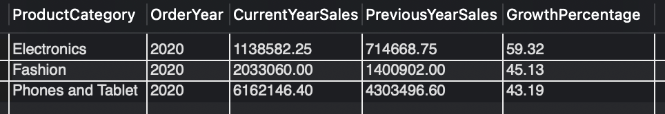

Approach
- Reused the same STR_TO_DATE date-parsing fix applied throughout the SQL section, extracting just the YEAR() this time rather than year-month, since this question compares full-year totals rather than monthly trends.
- Filtered to Status = 'Delivered' only, so returned orders don't inflate a category's apparent sales growth.
- Used LAG() partitioned by ProductCategory to align each year's total sales against the same category's total from the year before, enabling a direct year-over-year percentage comparison per category.
- Limited to the top 3 by GrowthPercentage, as the question specifically asks for the 3 categories with the highest increase — not simply the 3 with the highest total sales.

Insights
- Electronics, Fashion and Phones and Tablet showed the sharpest growth, at 59.32%, 45.13% and 43.19%. All three growth figures come from 2020 versus 2019, matching the 2020 revenue spike seen in Q5 and Q9.
- The growth is concentrated in a single year: all top 3 results are the 2019 to 2020 pair, while earlier year-pairs stayed roughly flat (under about 6% change) — so this is a 2020 surge, not a sustained trend.

Recommendation
- Cross-reference these fast-growing categories against the "most popular" categories from Q8 (Health and Beauty, Fashion) — if the fastest-growing category isn't already a top seller, it may be an emerging opportunity worth increased marketing investment before competitors notice the trend.
- If growth is concentrated in one specific year (rather than sustained), investigate what happened that year (promotion, new product launch, external event) before assuming the trend will continue.

SUBJECTIVE QUESTIONS

Question 1

Question:
Explain the revenue breakdown by year and by-product. Evaluate how different products contribute to annual revenue and come up with suggestions to increase the sales of the low-selling items.

Answer:

Built a Product × Year revenue matrix (Top 5 products by total revenue). Canon EOS 600D 18MP CMOS DSLR Camera – Black is the top revenue product (₹13,890,491.00 total), followed by Canon EOS 60D CMOS DSLR Camera Bundle (₹12,094,384.00), while Infinix Smart HD X612 is the lowest of the top 5 (₹6,299,125.60).

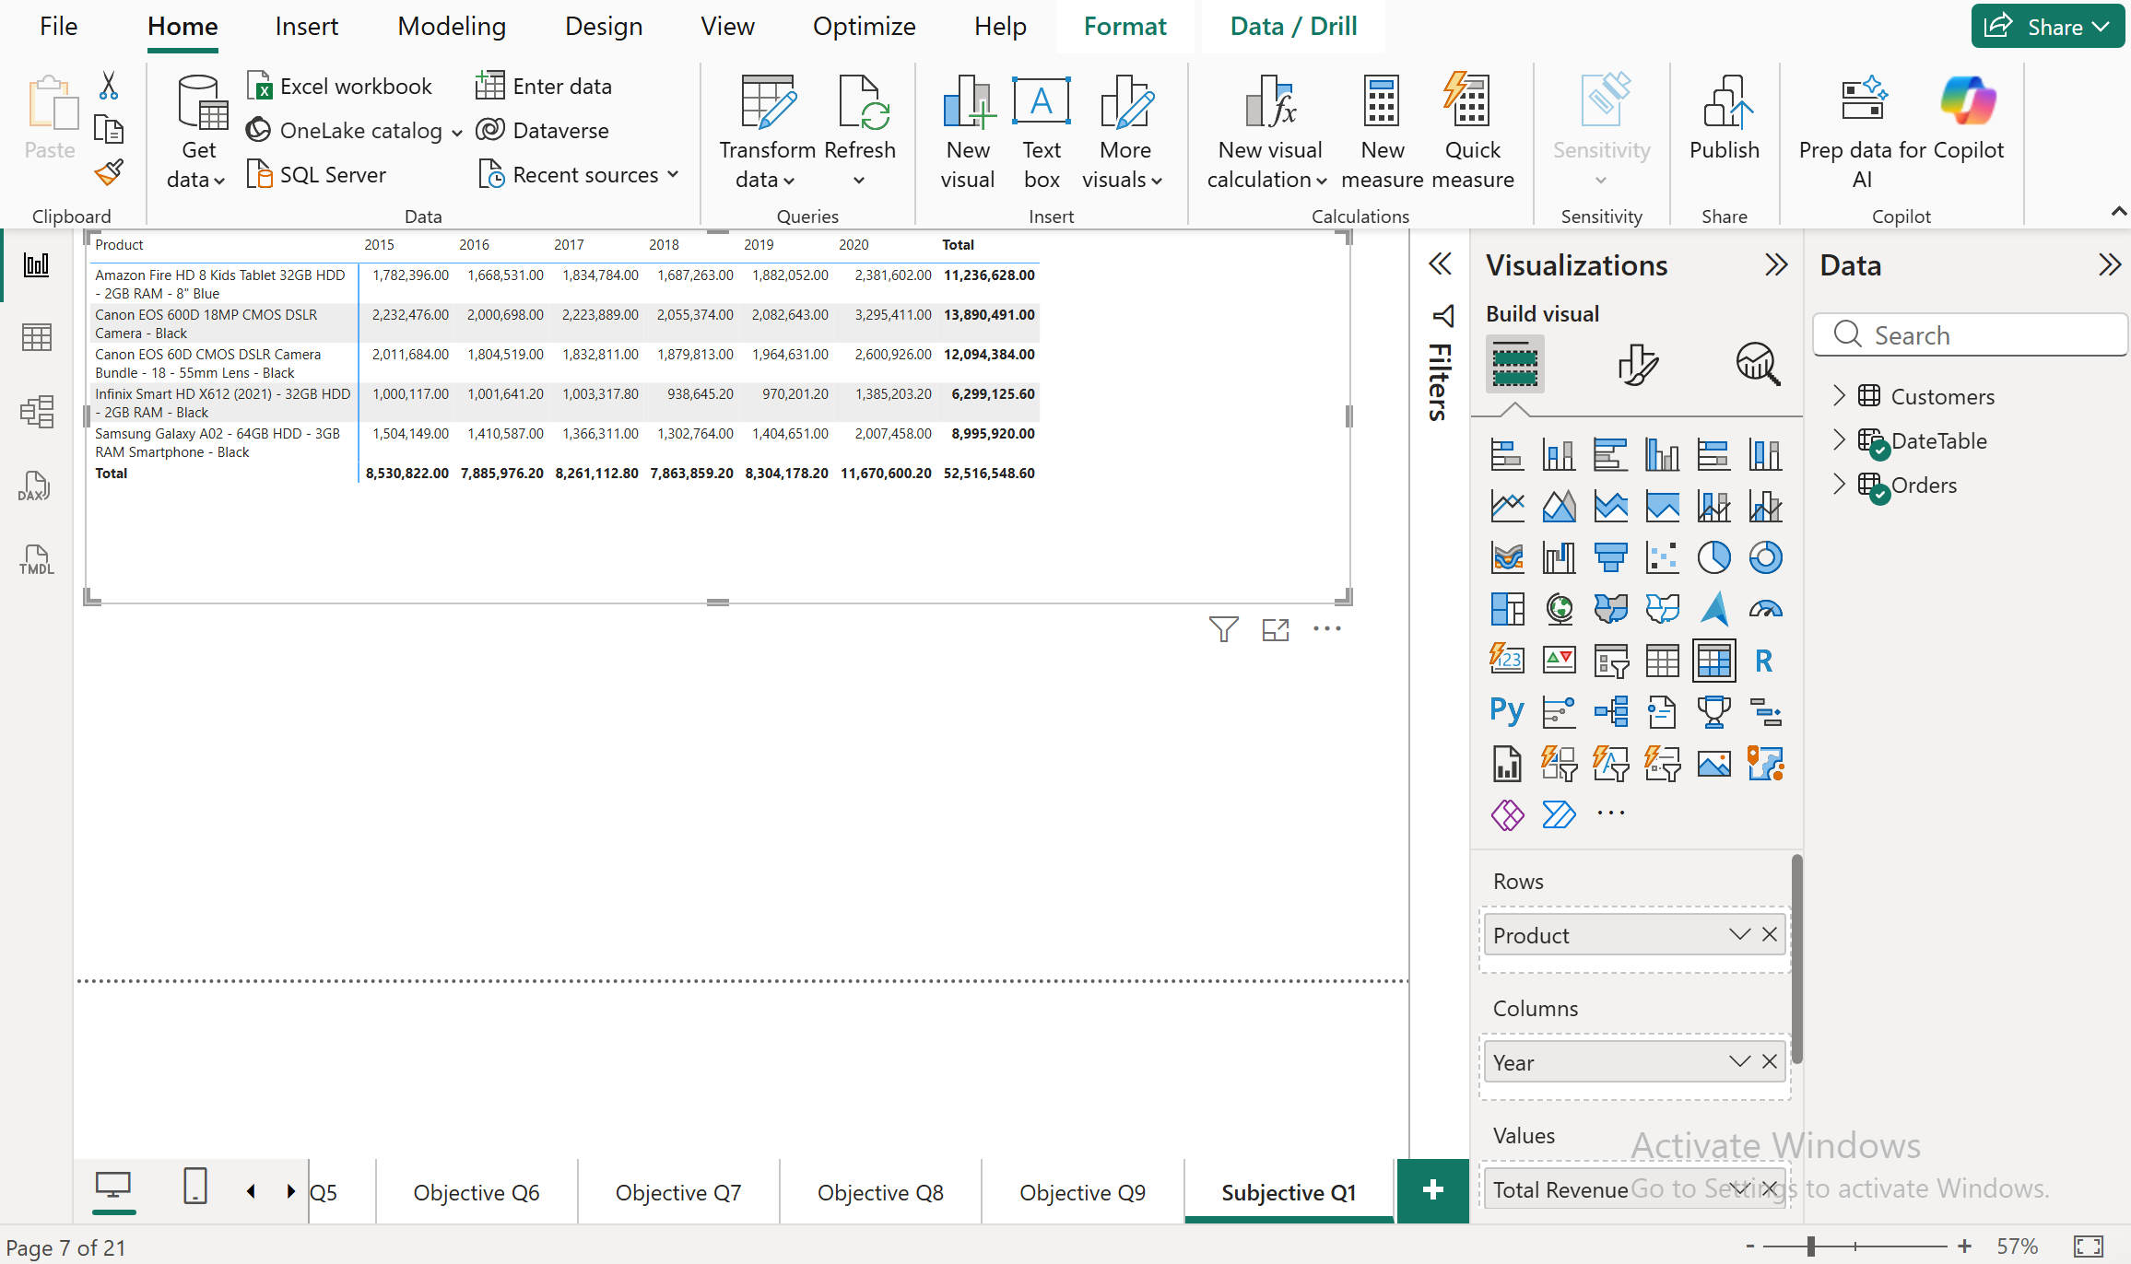

Approach
- Built a Matrix visual: Rows = Product, Columns = OrderDate (Year), Values = Total Revenue.
- Applied a Top N filter (Top 5 by Total Revenue) since the full catalog has 44 products — showing all of them in one table would be unreadable, so the top performers are used to represent the overall pattern.

Insights
- All 5 top products follow the same shape as the category-level view: relatively flat/gently declining revenue from 2015–2019, then a sharp jump in 2020. The clearest example is the top product, Canon EOS 600D, rising from ₹2,082,643.00 (2019) to ₹3,295,411.00 (2020) — a ~58% single-year increase.
- Camera products (both Canon EOS models) dominate the top 5, together contributing over ₹25.9M of the ₹52.5M total shown here — cameras are clearly a stronger revenue driver than phones/tablets at the individual product level, even though "Phones and Tablet" led at the category level in the earlier breakdown.
- The Amazon Fire HD 8 Kids Tablet is the steadiest of the top 5, moving from ₹1,882,052.00 (2019) to ₹2,381,602.00 (2020) — about 27% growth, the smallest jump of the five and well below the Canon EOS 600D (~58%). Samsung Galaxy A02 and Infinix Smart HD X612 both grew about 43%.

Recommendation
- Since cameras drive outsized product-level revenue despite Phones and Tablet leading at the category level, investigate whether this is a few high-ticket items carrying the whole category, or a broader trend — this affects how "category-level" marketing decisions should be made.
- For genuinely low-selling products (outside this top 5), compare their 2020 growth rate against the Amazon Fire HD 8 Kids Tablet's modest-but-real ~27% growth here — if low sellers show no 2020 movement at all, that is a stronger signal they need direct intervention (bundling with top sellers like the Canon cameras, targeted discounts, or reconsidering whether to keep stocking them).

Question 2

Question:
How many products were returned? Use a DAX function to get this metric. Examine the possible reasons for returns and consider how this metric could indicate improvements in product descriptions or quality control.

Answer:

31K orders were returned in total (Status = "Returned"). Broken down by category: Health and Beauty (9.8K), Fashion (9.0K), Phones and Tablet (4.7K), Home and Office (4.2K), and Electronics (2.7K).

DAX-

Total Returns = CALCULATE(COUNTROWS(Orders), Orders[Status] = "Returned")

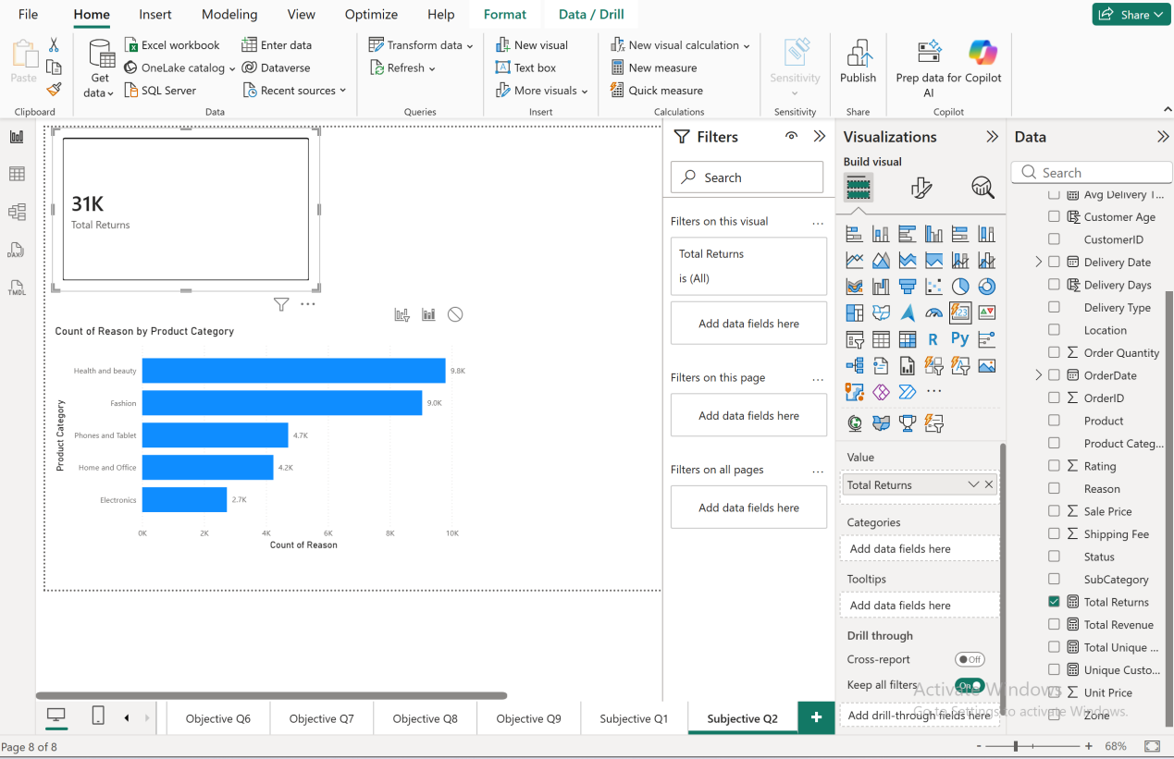

Approach
- Built the Total Returns measure using CALCULATE with COUNTROWS, filtered to Status = "Returned".
- Built a bar chart: Product Category (Y-axis) × Count of Reason (X-axis), with a visual-level filter on Status = "Returned" — this was a necessary correction, since without the filter the chart was counting all rows including "Not Applicable" (non-returns), giving misleadingly high numbers per category.
- Cross-checked that the category totals (9.8K + 9.0K + 4.7K + 4.2K + 2.7K ≈ 30.4K) reasonably match the overall 31K Total Returns figure, confirming the filtered chart is accurate.

Insights
- Health and Beauty and Fashion together account for over 60% of all returns (18.8K of ~31K) — these are also two of the lower-revenue categories from Subjective Q1, suggesting returns may be actively suppressing their revenue performance, not just a side issue.
- Electronics has the fewest returns (2.7K) despite being a strong revenue category — suggesting Electronics products are better matched to customer expectations or have more reliable fulfillment than Health and Beauty/Fashion.
- Since Health and Beauty and Fashion involve highly variable, personal-fit or sensory products (skincare shades, clothing sizes, fragrance preferences), returns here are more plausibly tied to "product not matching expectation" than to defects — pointing at description/imagery quality rather than manufacturing quality control.

Recommendation
- Prioritize improving product descriptions, sizing guides, and imagery specifically for Health and Beauty and Fashion listings, since these two categories drive the majority of returns and are also underperforming on revenue — fixing returns here could directly lift both metrics.
- Investigate whether Electronics' low return rate reflects genuinely better product-market fit, and see if any of those practices (clearer specs, better images) can be applied to the higher-return categories.

Question 3

Question:
Whenever a customer goes to Amazon, they’ll filter the most rated products to buy the better category. Can you verify this using any visualization or table that the ratings of products impact their sales value?

Answer:

No meaningful correlation found. Average ratings across all product categories are nearly identical (clustered tightly between 2.72 and 2.75), while Total Revenue varies dramatically (from ~₹10M to ~₹38M) across the same narrow rating range.

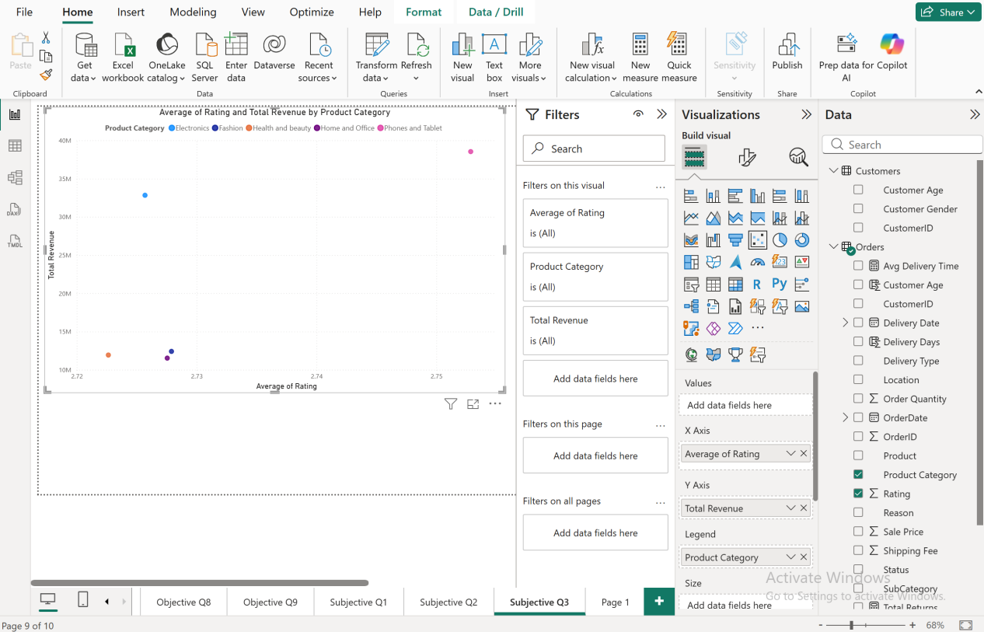

Approach
- Built a scatter chart: Average Rating (X-axis) × Total Revenue (Y-axis), with Product Category as the legend/color, to check whether categories with higher average ratings also generate higher revenue.

Insights
- All 5 categories sit within a razor-thin 0.03-point rating range (2.72–2.75) — there's essentially no meaningful variation in average rating across the entire catalog. Every category is rated almost identically, hovering around a below-average ~2.7 out of what's presumably a 5-point scale.
- Despite this near-identical rating, revenue spans nearly 4x (from ~₹10M to ~₹38M) across categories — meaning rating clearly is not the driver of revenue differences here. A category can earn 4x more than another while being rated exactly the same.
- This directly contradicts the assumption in the question — customers are evidently not filtering purchases by "most rated products" in this dataset, since the highest-revenue category doesn't stand out on rating at all.

Recommendation
- Since rating isn't driving revenue, marketing and pricing strategy should focus on the actual demand drivers (already explored in earlier questions — category popularity, price point, delivery experience) rather than assuming better ratings will move sales.
- The uniformly low ~2.7 average rating across every category is itself a red flag worth raising separately — this suggests a broad customer satisfaction issue worth investigating (e.g., checking if this correlates with the high return rates found in Subjective Q2), even though it doesn't appear to be suppressing revenue directly.

Question 4

Question:
Investigate how revenue distribution varies across different locations. Explore which geographical areas contribute most to sales and consider the strategic implications for regional marketing and distribution efforts. How might location-based trends inform the company's market segmentation and resource allocation approach?

Answer:
Revenue is heavily concentrated in the top 4 locations: Greater Accra (₹27M), Ashanti (₹23M), Western (₹17M), and Weija (₹13M) — together these four account for roughly 80M of the total, while the remaining ~16 locations each contribute ₹1M–5M.

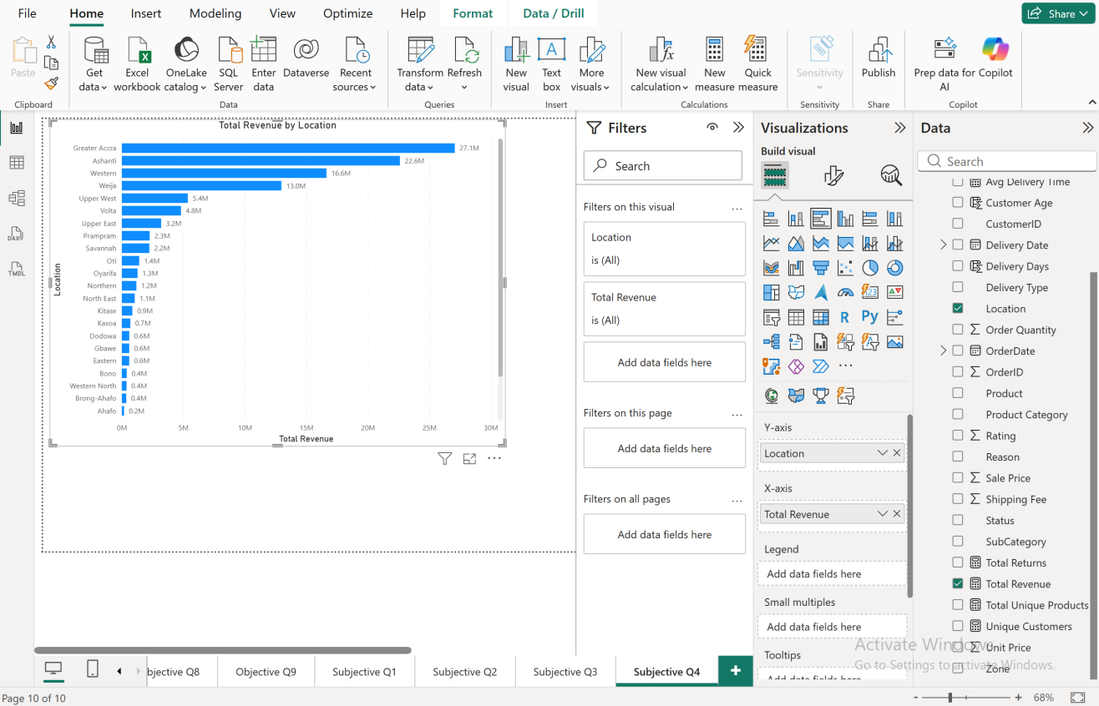

Approach
- Built a horizontal bar chart: Location (Y-axis) × Total Revenue (X-axis), sorted descending to clearly separate high-performing regions from the long tail of smaller ones.

Insights
- There's a steep drop-off after the top 4: Greater Accra alone (₹27M) generates more revenue than the bottom ~13 locations combined. This is a heavily concentrated, not evenly distributed, revenue base.
- Upper West and Volta both sit at ₹5M — a noticeable gap below Weija's ₹13M — marking a clear tier boundary between "strong secondary markets" and the long tail of smaller regions (Upper East down to Gbawe), which each contribute only ₹1M–3M.
- The bottom ~13 locations are all clustered tightly together at ₹1M–2M, suggesting these are genuinely smaller/less-penetrated markets rather than one or two being outliers — this is a broad geographic expansion opportunity, not a handful of underperformers to fix.

Recommendation
- Protect and reinforce the top 4 regions (Greater Accra, Ashanti, Western, Weija) with dedicated inventory allocation and faster delivery infrastructure, since they're already proven high-value markets.
- For the long tail of ₹1M–2M locations, treat this as a market-penetration opportunity rather than a performance problem — targeted regional marketing or localized promotions could lift many of these simultaneously, given how similarly they're all currently performing.
- Given the scale gap (Greater Accra's ₹27M vs. the bottom locations' ₹1M), a single uniform national marketing budget allocation would be inefficient — spend should be weighted proportionally to existing revenue concentration, while still reserving a portion for testing growth in the underdeveloped regions.

Question 5

Question:
Determine which month could benefit from enhanced promotional offers to boost sales. Can you suggest some targeted marketing strategies here?

Answer:
June and September are tied as the weakest months (₹8.1M each), while January is the strongest (₹10.1M). Overall, revenue is fairly stable across the year, but June and September stand out as consistent dips worth addressing.

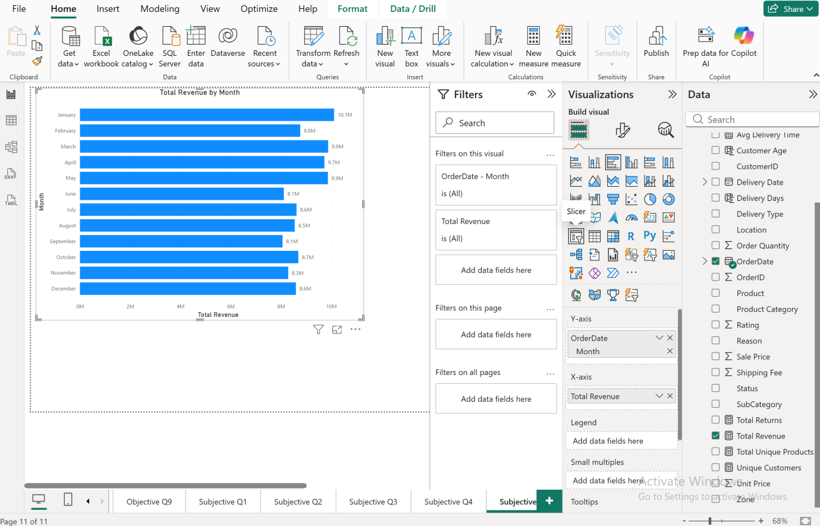

Approach
- Built a bar chart: Month (axis) × Total Revenue (values), aggregating across all years to capture the typical seasonal pattern rather than a single year's anomaly.

Insights
- The gap between the strongest (January, ₹10.1M) and weakest (June/September, ₹8.1M) months is about ₹2M, or roughly 20% — a meaningful but not extreme seasonal dip.
- January leading the year is a common retail pattern (post-holiday sales, New Year shopping), while June and September don't correspond to any obvious major shopping season, making them natural candidates for artificially boosting demand through promotions.
- February (₹8.8M) is also on the lower side, suggesting a broader Q1-end-into-mid-year softness rather than one isolated weak month, though June/September are the clearest standouts.

Recommendation
- Run targeted promotional campaigns (limited-time discounts, bundle deals, flash sales) specifically in June and September to close the ~20% revenue gap versus January.
- Since neither month has an obvious natural shopping occasion, consider manufacturing one — e.g., a "Mid-Year Sale" in June and a "Back-to-Season Sale" in September — giving customers a reason to buy rather than competing against a naturally quiet period.
- Track whether this dip is consistent year-over-year (drill into June/September by year) before committing marketing budget, to confirm it's a genuine recurring pattern and not driven by one anomalous year.

Question 6

Question:
Identify which products may require increased marketing efforts. Which items have high prices yet underperform in sales?

Answer:
Among the top 5 revenue products, the Canon EOS 600D DSLR stands out as a high-price item (~₹2K unit price) generating only moderate revenue (~₹13.9M) compared to the Canon EOS 60D Bundle (~₹4.2K unit price, ~12.1M revenue) and especially the Samsung Galaxy A02 (~₹1K unit price, ~9M revenue) — pricing and revenue don't scale together cleanly here.

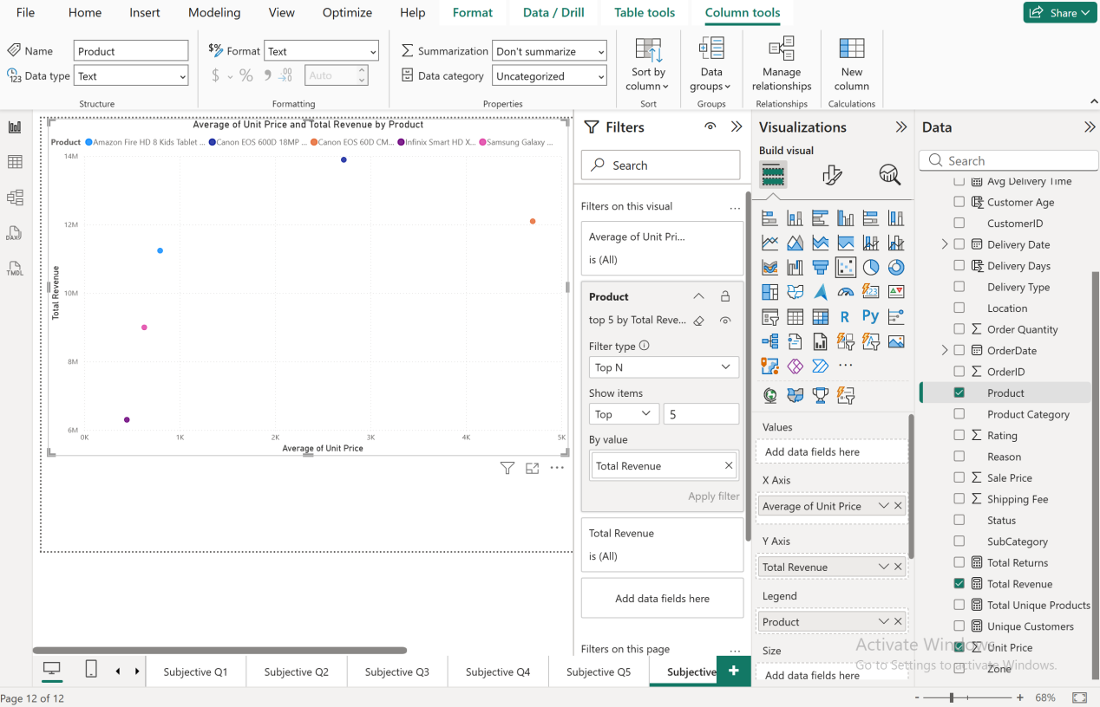

Approach
- Built a scatter chart: Average Unit Price (X-axis) × Total Revenue (Y-axis), one dot per product (Top 5 by Total Revenue), to see whether higher-priced products are translating that price into proportionally higher revenue.

Insights
- The two Canon DSLR products sit at very different price points (~₹2K vs ~₹4.2K) but their revenue isn't proportionally different — the cheaper Canon actually generates more total revenue (₹13.9M) than the pricier bundle (₹12.1M), meaning the higher unit price isn't translating into a revenue advantage.
- The Samsung Galaxy A02, priced lowest of this group (~₹1K), still lands in the top 5 by revenue — suggesting volume is compensating for lower per-unit price, a healthier pattern than relying on price alone.
- The pricier Canon Bundle needing more volume to match the cheaper Canon's revenue is the clearest signal in this chart: it's underperforming relative to its price tag and needs a demand boost, not a price cut.

Recommendation
- Increase marketing visibility specifically for the higher-priced Canon Bundle (targeted ads, comparison content showing its added value over the base model, bundling with accessories) since its price isn't being matched by proportional revenue — it needs a demand push, not repositioning.
- Since lower-priced, high-volume items like the Samsung Galaxy A02 already perform well, that pricing/volume strategy could be a template for other underperforming high-price items outside this top 5 — worth checking if the pattern (high price, moderate revenue) repeats further down the catalog.

Question 7
Question:
Assess which products should have discounts. How can targeted incentives drive sales and customer loyalty for specific products?

Answer:
The two clearest discount candidates are Canon EOS 60D CMOS DSLR Camera Bundle (2.6K units sold — the lowest in the catalog) and Canon EOS 600D 18MP CMOS DSLR Camera – Black (5.1K units — second lowest), both well below the rest of the catalog which sits at 13K+ units.

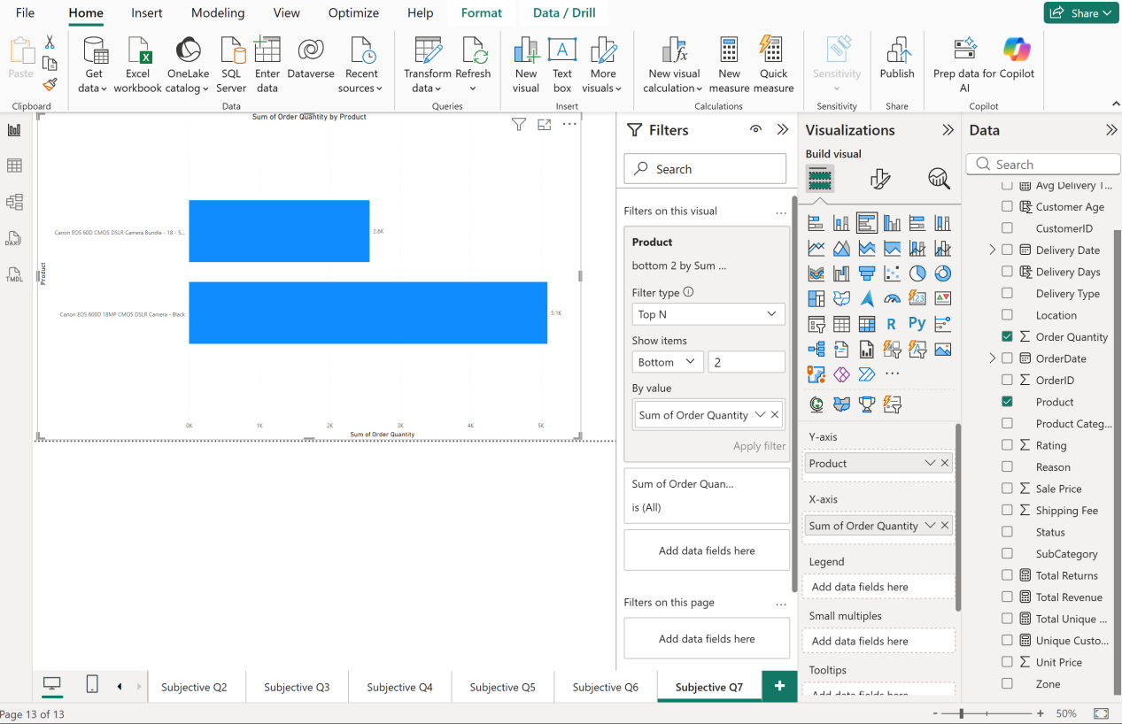

Approach
- Built a bar chart: Product (axis) × Sum of Order Quantity (values), filtered to Bottom 2 by quantity, to isolate the genuinely lowest-selling products rather than guessing from revenue alone.
- Cross-checked against a Bottom 5 view first, which confirmed a clear gap: these two sit far below the rest (2.6K–5.1K vs. 13K+ for the next lowest), making them the real outliers rather than part of a broader low-performing cluster.

Insights
- Both discount candidates are camera products from the same brand family (Canon EOS), and notably, these are the same two products that appeared as top-5 revenue earners in Subjective Q1 and Q6 — meaning they sell relatively few units, but each unit is high-value (high unit price), which is why they still rank well on revenue despite low volume.
- Because unit price is high, small-percentage discounts could meaningfully lower the purchase barrier without needing deep markdowns — these are premium items where price sensitivity likely matters more than for cheaper products.
- This is a genuine "low volume, high value" pattern, not a failing product — the goal here is expanding reach, not rescuing an unpopular item.

Recommendation
- Apply a modest discount (5–10%) to these two Canon products rather than a steep markdown — since they're premium DSLR items, a small price reduction plus visibility (e.g., a "Limited Time Offer" badge) is more likely to convert price-sensitive browsers without devaluing the product's premium positioning.
- Pair the discount with a loyalty incentive — e.g., offer it exclusively to customers who've previously purchased photography-related products (cross-referencing Product Category) — to drive both volume and targeted customer retention rather than a blanket discount.
- Track order quantity for these two products specifically after the discount period to confirm volume actually increases before extending discounts to other camera-category items.

Question 8

Question:
Come up with a loyalty program to benefit the company’s customers. From the available lot of customers come up with strategies to bucket them and provide benefits under different loyalty programs.

Answer:

Designed a 3-tier loyalty program based on revenue value rather than purchase frequency — a necessary adjustment given a key finding from the SQL analysis: every customer in this dataset has placed only one order (confirmed in Q14, Q17, Q18), so a traditional frequency-based loyalty program isn't measurable against this data as-is.

Approach
- Since Order Frequency segmentation is unusable here (max order count = 1 across all ~107K customers), built the loyalty tiers around Total Revenue per customer (from the Q19 customer_revenue calculation) as the primary bucketing metric instead.
- Proposed 3 tiers: Bronze, Silver, Gold, based on spend thresholds relative to the dataset's average customer revenue (calculated in Q19).

Insights / Proposed Tiers
- Gold Tier — Customers with revenue 30%+ above average (the exact segment identified in Q19). These are the highest-value customers and should get the most aggressive retention benefits, since losing them has outsized revenue impact.
- Silver Tier — Customers spending at or above the dataset average but below the Gold threshold — a broad "solid customer" middle tier.
- Bronze Tier — Customers spending below average — the largest segment by count, needing incentives to increase order value rather than rewards for loyalty that doesn't yet exist.

Proposed Benefits per Tier
- Gold: Early access to new product launches, free/expedited shipping, a dedicated discount code (tie into Subjective Q7's Canon camera discounts specifically for this tier, since these are exactly the kind of premium-value products Gold customers already engage with), priority customer support.
- Silver: Moderate percentage discounts on their most-purchased Product Category, birthday/anniversary offers, standard free shipping thresholds.
- Bronze: Sign-up-triggered welcome discount to encourage a second purchase, category-specific promotions aligned with Subjective Q5's identified low-revenue months (June/September) to nudge activity during naturally slow periods.

Recommendation
- Since this dataset shows zero repeat customers, the loyalty program's first real success metric should be whether Bronze/Silver customers return for a second order at all — not traditional tier upgrades. The program needs to be evaluated primarily as a repeat-purchase driver before more sophisticated frequency-based tiers can be meaningfully layered in.
- Flag this data limitation explicitly to stakeholders: a loyalty program is being designed on paper correctly, but its effectiveness can't be measured against this specific dataset until it captures genuine repeat-customer behavior — this should be built into the initial rollout as a "test and measure" phase rather than assumed to work immediately.

Question 9

Question:
Using the DAX functions Calculate and a row iteration DAX function calculate the total sales for the Product Category “Fashion” and delivery type “Shipped from Abroad”. What are the other types of DAX functions you have used in the project?

Answer:

Total sales for Fashion products with "Shipped from Abroad" delivery: ₹4.14M.

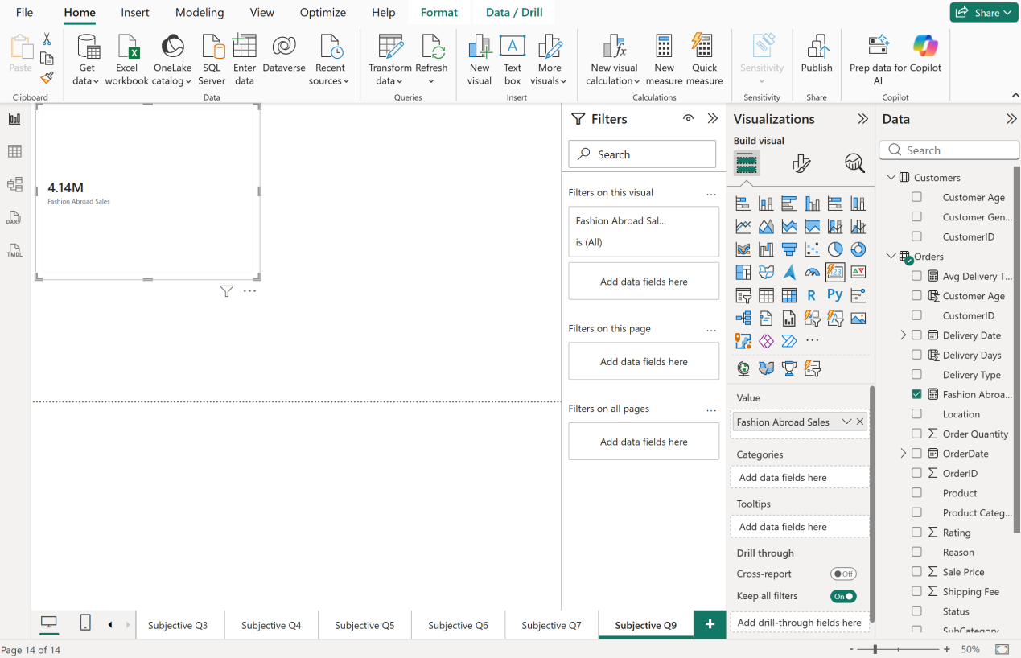

Approach
- Used CALCULATE to apply two simultaneous filter conditions — Product Category = "Fashion" AND Delivery Type = "Shipped from Abroad" — over the Orders table.
- Used SUMX as the required row iterator: it evaluates Orders[Sale Price] row-by-row for every order matching both filters, then sums the results — functionally similar to a plain SUM() here since no per-row calculation beyond the column value was needed, but it fulfills the row-iterator requirement and is the more flexible pattern (it would let you multiply/combine multiple columns per row if the metric were more complex, e.g., Sale Price × Order Quantity).
- Created this as a measure (not a column) on the Orders table, since it's a multi-row aggregation, not a per-row value.

Other DAX function types used across this project:
- Aggregation functions: SUM, AVERAGE, COUNTROWS, DISTINCTCOUNT (used throughout Objective Q4–Q9 for Total Revenue, Avg Delivery Time, Unique Customers, Unique Products)
- Relationship function: RELATED (Objective Q2 — pulling Customer Age into Orders via the model relationship)
- Filter/context function: CALCULATE (used repeatedly — Objective Q7's Avg Delivery Time, Subjective Q2's Total Returns, and here)
- Date/time function: DATEDIFF (Objective Q7 — calculating Delivery Days as a calculated column)
- Row iterator: SUMX (this question)

Insights
- Fashion's ₹4.14M "Shipped from Abroad" sales is a meaningful slice of the category's overall revenue (₹12.4M total, from Subjective Q1) — roughly a third of all Fashion revenue comes through this specific delivery method, making it a significant fulfillment channel worth monitoring rather than a minor edge case.

Recommendation
- Since a third of Fashion's revenue relies on international shipping, cross-check this delivery type's average delivery time (using the Objective Q7 measure, filtered to this same segment) — if "Shipped from Abroad" is notably slower, it may be a contributing factor to Fashion's elevated return rate identified in Subjective Q2.

Question 10

Question:

Wait Times Correlated with Demographics and Care: Explore how average wait times vary across different product categories to optimize scheduling and staffing.

Answer:
Average delivery time is remarkably consistent across all categories — Phones and Tablet is the slowest at 9.5 days, while Electronics, Health and Beauty, Home and Office, and Fashion are all tied at 9.4 days.

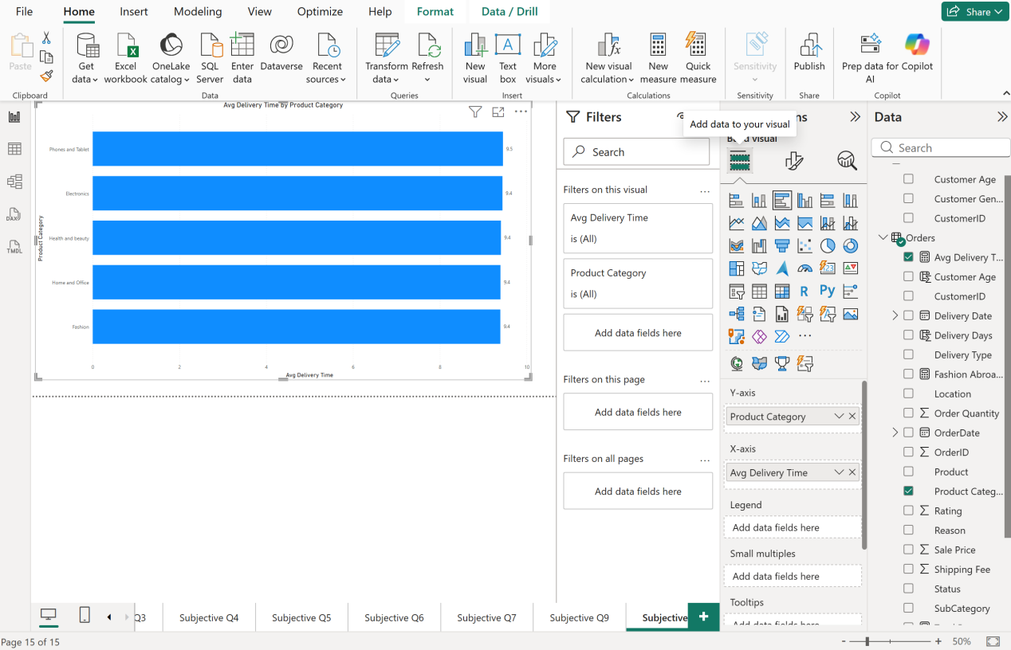

Approach
- Reused the existing Avg Delivery Time measure (built in Objective Q7, already filtered to Delivered orders only) broken out by Product Category in a bar chart.

Insights
- There's essentially no meaningful variation between categories — the entire spread is just 0.1 days (9.4 vs. 9.5), meaning delivery speed is not a category-specific problem. Whatever is driving the overall ~9.4-day average (seen back in Objective Q7) affects every category almost identically.
- This strongly suggests wait times are driven by a systemic factor — likely Delivery Type or Location (both explored in earlier questions) — rather than anything intrinsic to how a specific product category is picked, packed, or shipped.
- Since categories don't differ meaningfully, staffing/scheduling optimization aimed at a specific category wouldn't move the needle — the bottleneck is elsewhere in the fulfillment chain.

Recommendation
- Don't allocate staffing changes by product category — instead, cross-reference Delivery Type (Standard, Express, Shipped from Abroad) and Location against delivery time, since those are more likely to explain the ~9.4-day average than category ever could.
- Given Subjective Q9 found "Shipped from Abroad" carries a meaningful share of Fashion's revenue, checking whether that specific delivery type is the true driver of the ~9.4-day average (rather than category) would be a more productive next step than category-based staffing changes.

Question 11

Question:
Explore if there is any relationship between the Delivery type and waiting time between ordering and receiving an item.

Answer:
Yes — a strong, clear relationship. Shipped from Abroad averages 15.0 days, Standard Delivery averages 10.0 days, and Express averages just 3.5 days — a massive 4.3x gap between the fastest and slowest methods.

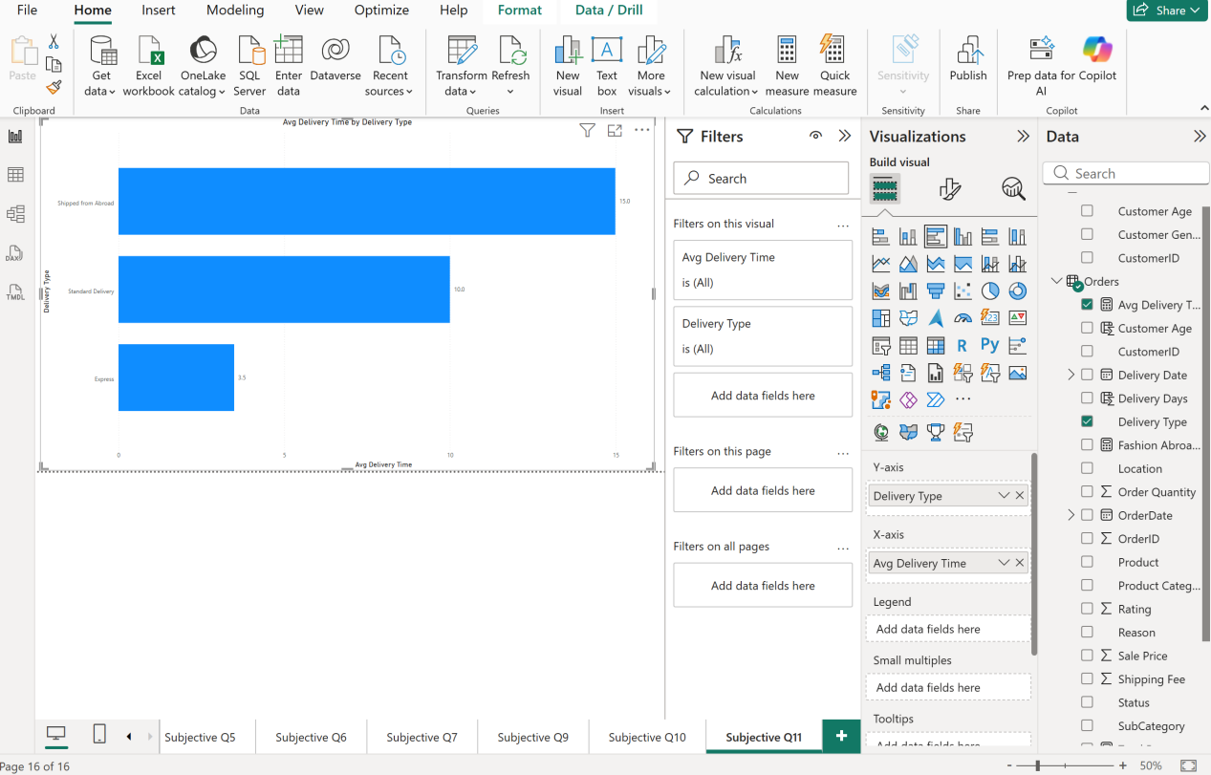

Approach
- Reused the Avg Delivery Time measure, broken out by Delivery Type instead of Product Category, to directly test whether delivery method — rather than product category — explains the wait-time pattern seen in Q10.

Insights
- Delivery Type explains far more variation than Product Category ever did — Q10 showed just a 0.1-day spread across categories, while this shows an 11.5-day spread across delivery types. This confirms Delivery Type, not category, is the real driver of the overall ~9.4-day average wait time.
- Express delivery (3.5 days) performs excellently — well within typical customer expectations. Standard Delivery (10 days) is already borderline slow, and Shipped from Abroad (15 days) is a genuinely long wait by any e-commerce standard.
- This directly explains Subjective Q9's finding: since Fashion relies heavily on "Shipped from Abroad" for a third of its revenue, Fashion customers are likely experiencing this 15-day wait disproportionately — plausibly connecting to Subjective Q2's finding that Fashion has one of the highest return volumes (9.0K).

Recommendation
- Set clear, honest delivery-time expectations at checkout specifically for "Shipped from Abroad" items (e.g., "Arrives in 12-18 days") rather than letting customers assume standard timelines — mismatched expectations, not just slow delivery itself, likely drive dissatisfaction and returns.
- Investigate whether "Shipped from Abroad" can be reduced or replaced with regional warehousing for high-volume categories like Fashion, since a 15-day wait is a significant competitive disadvantage compared to Express's 3.5 days.
- Given the direct link to Fashion's returns, prioritize this fix as high-impact — reducing Shipped from Abroad's wait time could simultaneously improve customer satisfaction, reduce returns, and support Fashion's revenue growth all at once.

Question 12

Question:
Is there any relationship between shipping charges and product type?

Answer:
No meaningful relationship. Average shipping fee is nearly identical across all product categories — ranging only from ₹11.47 (Electronics, Home and Office) to ₹11.55 (Health and Beauty), a spread of just ₹0.08.
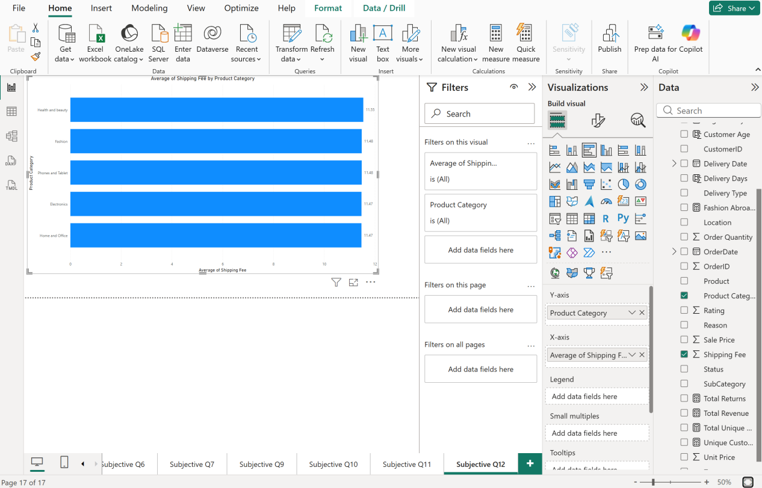

Approach
- Built a bar chart: Product Category (axis) × Average Shipping Fee (values), sorted descending, to check whether shipping cost scales with product type (e.g., higher for bulkier/heavier categories like Electronics or Home and Office).

Insights
- Shipping fees are essentially flat across the entire catalog — Health and Beauty (₹11.55), Fashion (₹11.48), Phones and Tablet (₹11.48), Electronics (₹11.47), Home and Office (₹11.47). This is a near-uniform charge regardless of what's being shipped.
- This is a meaningful contrast to Subjective Q11's finding, where Delivery Type drove a massive 11.5-day gap in wait time — shipping cost doesn't reflect the same variation that shipping speed does. A customer paying for "Shipped from Abroad" (15-day wait) pays almost the same shipping fee as someone getting Express (3.5-day wait).
- This suggests shipping fees are currently structured as a flat/fixed charge rather than reflecting actual fulfillment cost or complexity (e.g., international shipping should logically cost more to fulfill than express domestic, but the fee doesn't reflect that).

Recommendation
- Consider restructuring shipping fees to align with actual delivery cost/speed — charging a premium for Express (justified by its 3.5-day speed) and a lower fee for Shipped from Abroad (which is slower, so shouldn't cost the same as faster options) would better align pricing with the value delivered.
- Since fees don't currently vary by category or delivery speed, there's no built-in cost signal steering customers toward faster options — introducing differentiated fees could also serve as a lever to shift demand toward Express delivery, indirectly improving the return-rate issues tied to long "Shipped from Abroad" waits (Q2, Q11).

Question 13

Question:
Come up with strategies to decrease the low rating orders after analyzing different factors like waiting time, shipping type, unit price, etc.

Answer:
Low ratings are most plausibly driven by a combination of long delivery waits (specifically "Shipped from Abroad" at 15 days) and product-expectation mismatches (the "Not Fitting Expectation" and "Description Mismatch" return reasons) — not by pricing or shipping cost, which show almost no variation across the catalog.

Approach
- Rather than building a new visual, synthesized findings already established across Objective Q7, and Subjective Q2, Q11, and Q12, to identify which factors actually correlate with dissatisfaction versus which don't.

Insights
- Waiting time is a real factor: Subjective Q11 showed Shipped from Abroad takes 15 days vs. Express's 3.5 days — a 4.3x gap. Categories relying heavily on this method (like Fashion, per Subjective Q9) are natural candidates for lower satisfaction purely from the wait.
- Shipping cost is NOT a factor: Subjective Q12 showed shipping fees are nearly flat (₹11.47–₹11.55) regardless of category or implied delivery speed — customers aren't paying more for slow shipping, so cost isn't what's frustrating them; the wait itself is.
- Product-expectation mismatch is a major factor: Subjective Q2's return-reason breakdown showed "Product Not Fitting Expectation" and "Onsite-Description Mismatch" together made up ~40% of real returns — a content/listing-quality issue, not a delivery issue.
- Unit price is likely NOT a strong factor: Subjective Q3 already found no correlation between average rating and revenue/price across categories — ratings sit in a near-identical, low band (2.72–2.75) regardless of price point, suggesting price isn't what's driving dissatisfaction either.
- The uniformly low ~2.7 average rating across every category (Subjective Q3) suggests this isn't a category-specific problem needing a targeted fix — it's a broad, systemic customer experience issue.

Recommendation
- Fix delivery expectations first: Set accurate, honest delivery windows at checkout for "Shipped from Abroad" items (already recommended in Q11) — mismatched expectations around a 15-day wait likely drive more dissatisfaction than the wait itself.
- Fix product listings second: Improve descriptions, sizing guides, and imagery specifically for Fashion and Health and Beauty (the two highest-return categories from Q2) to close the expectation gap before the product even ships.
- Don't touch pricing or shipping fees as a lever here — the evidence shows neither correlates with rating, so discounting products in an attempt to raise satisfaction would likely be wasted effort; the two real levers are delivery-time honesty and listing accuracy.
- Track rating specifically for "Shipped from Abroad" orders as a follow-up measure — if ratings for that subset are measurably lower than Express/Standard, it would confirm delivery speed as the dominant driver and justify prioritizing carrier/logistics investment over other fixes.

Question 14

Question:
Using the time intelligence DAX function, create a table to compare each month’s sales with the previous year’s same month’s total sales. So there will be four columns in the output year, month, total sales, previous_years_sales.

Answer:

Built a 4-column table (Year, Month, Total Sales, Previous Year Sales) using SAMEPERIODLASTYEAR. For example, June 2016 shows Total Sales of ₹1,361,084.25 against June 2015's ₹1,378,115.15 — a slight year-over-year dip, while other months like April (2016: ₹1,374,508.65 vs. 2015: ₹1,446,946.30) show similar modest declines.

DAX-

- Total Sales = SUM(Orders[Sale Price])

- Previous Year Sales = CALCULATE([Total Sales], SAMEPERIODLASTYEAR(DateTable[Date]))

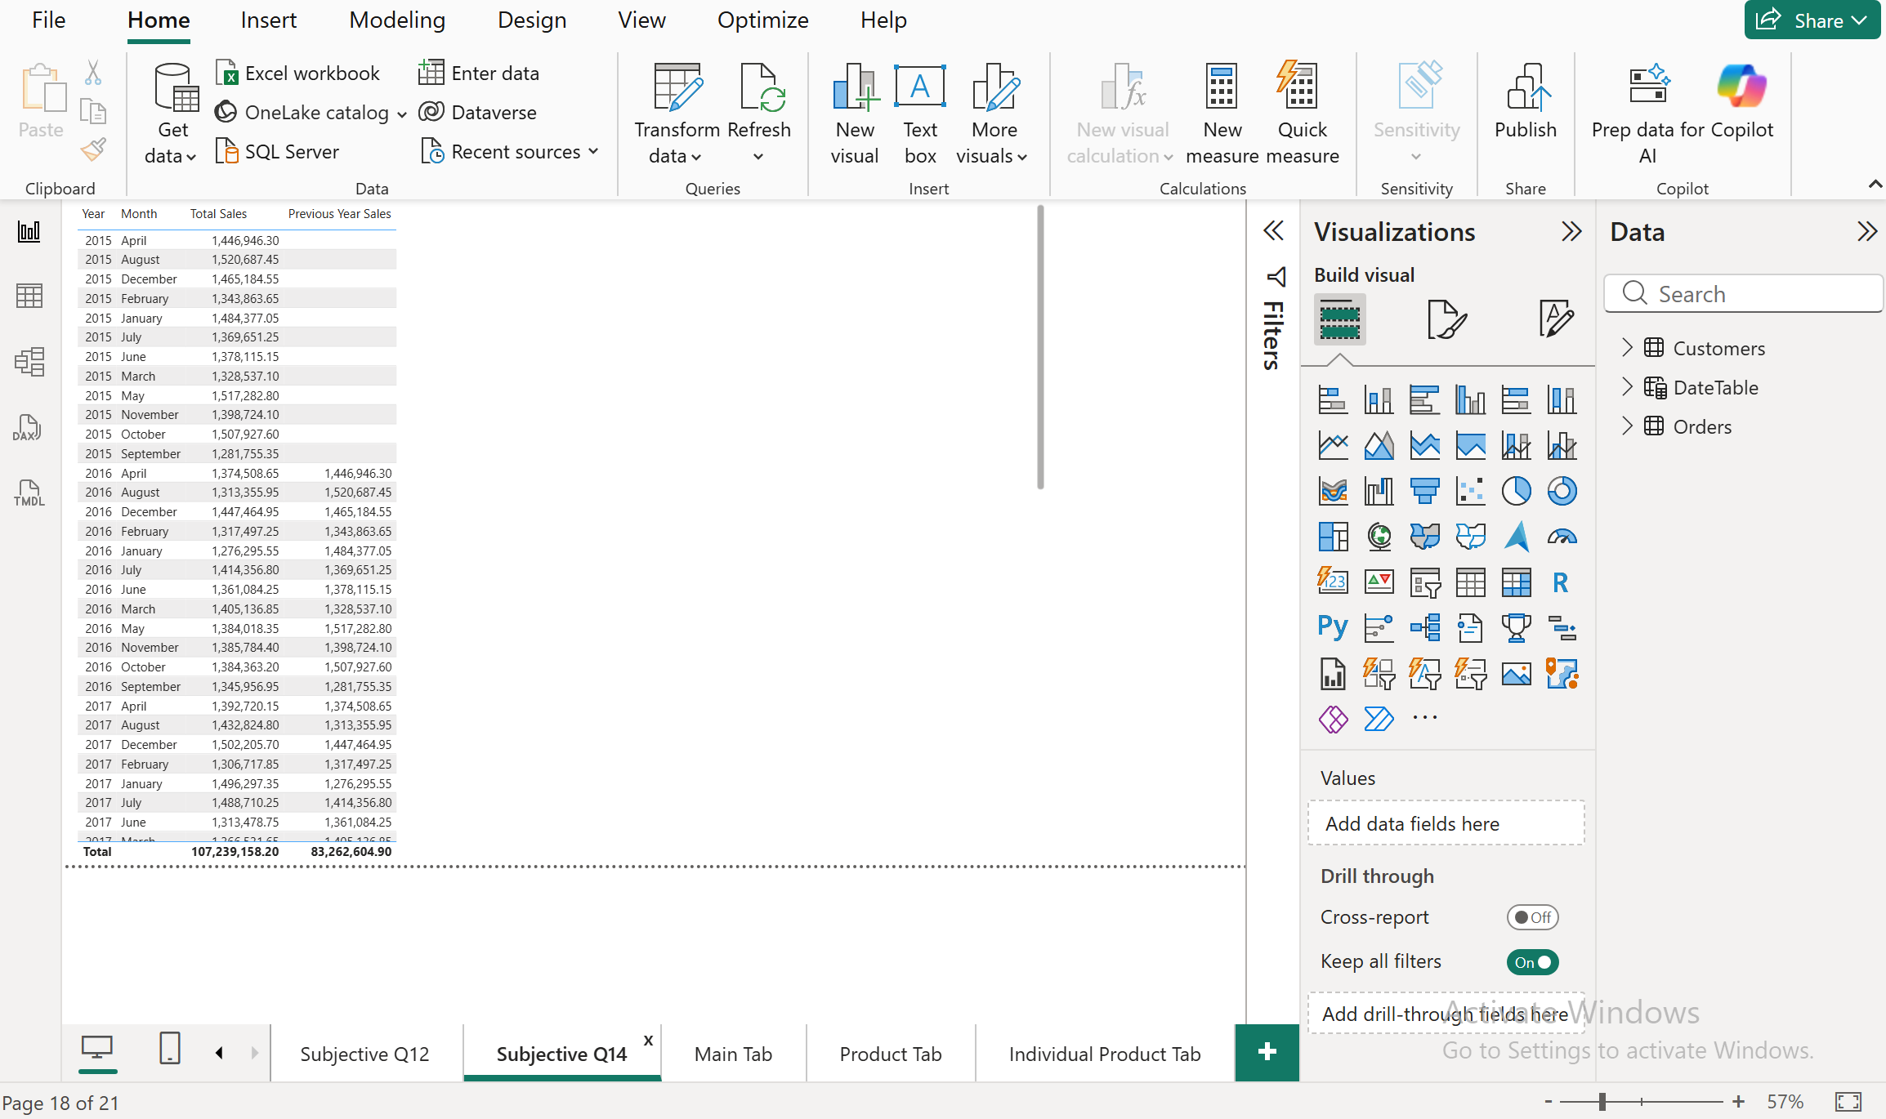

Approach
- Built a dedicated DateTable using CALENDAR(MIN(Orders[OrderDate]), MAX(Orders[OrderDate])) since SAMEPERIODLASTYEAR requires a proper marked date table to function correctly — it can't be used directly on the Orders table's OrderDate column.
- Marked DateTable as an official Date table and built the relationship (DateTable[Date] → Orders[OrderDate], one-to-many).
- Added Year and Month as calculated columns on DateTable (since Auto date/time was disabled earlier during Power Query cleaning, no hierarchy was auto-generated).
- Used SAMEPERIODLASTYEAR(DateTable[Date]) inside CALCULATE to shift the filter context back exactly one year, then reapplied the Total Sales measure within that shifted context — this is the core time-intelligence pattern for year-over-year comparisons.

Insights
- 2015 shows blank Previous Year Sales for every month, correctly reflecting that there's no 2014 data to compare against — confirming the DAX is behaving correctly rather than erroring silently.
- Comparing 2016 against 2015, most months show modest single-digit percentage changes in either direction rather than dramatic swings — consistent with the relatively stable year-over-year pattern noted back in Objective Q9 before the sharp 2020 growth event.
- The grand total (₹107,239,158.20 for Total Sales) matches Objective Q4's Total Revenue measure exactly, confirming the table is built correctly and not double-counting or missing any orders.

Recommendation
- This table is the ideal input for forecasting next year's monthly targets — rather than guessing, use the historical year-over-year growth rate per month as a baseline expectation, adjusting for known factors like the June/September dips identified in Subjective Q5.
- Extend this same time-intelligence pattern to build a "3-year rolling comparison" if deeper trend visibility is needed later — the DateTable and relationship are already in place to support that with minimal extra work.

Question 15

Question:
What do you understand by PowerBI gateway? What are its use cases?

Answer:
A Power BI Gateway is a bridge application installed on a local machine or server that lets Power BI Service (the cloud) securely connect to and refresh data from on-premises data sources — like local SQL Server databases, on-premises Excel files, or internal file shares — without requiring that data to be publicly exposed on the internet.

Approach
- This is a conceptual knowledge question rather than a build task, so the answer focuses on explaining the concept clearly and tying it to how it would actually apply to this specific project.

Why it's needed
- Power BI Service (the cloud version used for publishing and sharing reports) cannot directly reach data sources sitting inside a private company network — like an on-premises MySQL Workbench database (relevant here, since this project's SQL work sits in a local MySQL instance) or a local Excel file saved on someone's machine.
- The Gateway acts as a secure translator: it sits inside the local network, and Power BI Service sends refresh requests to it, which the Gateway then executes locally and sends the results back to the cloud — the underlying data source's credentials and network are never exposed externally.

Two types of gateways:
- Personal Gateway: For individual, single-user use — good for scheduling personal report refreshes from local files, no sharing/collaboration support.
- Standard/Enterprise Gateway: Installed once for a whole organization, supports multiple data sources and multiple users, allows centralized management by IT — used in real business deployments.

Use cases:
- Scheduling automatic daily/hourly refreshes of a Power BI report published to the cloud, where the underlying data (e.g., this project's cleaned Excel file, or the local MySQL database used for the SQL section) still lives on a local machine or in-house server.
- Connecting Power BI Service to an on-premises SQL Server, SAP, Oracle, or file-based data source that a company doesn't want exposed to the public internet.
- Supporting DirectQuery or live connections from the cloud back to an on-premises source, so reports always reflect current data instead of a static snapshot.

Recommendation
- If this specific project were deployed for a real business (e.g., published to Power BI Service for stakeholders to view live), and the source data stayed in local MySQL/Excel files rather than being uploaded directly, a Gateway would be required to keep the published report refreshing automatically — otherwise the report would only ever show the data as of the last manual publish.

Question 16

Question:
How would you approach this problem, if the objective and subjective questions weren't given?

Answer:
Without a predefined question list, I'd follow a structured, self-directed analysis process: understand the business context first, explore and clean the data, then let the data itself surface the questions worth answering — rather than jumping straight into building visuals.

Approach — the process I'd follow:

1. Understand the business context first
Before touching the data, clarify who the stakeholders are and what decisions they need to make (this project's own task doc actually specifies this — Main Tab for overall stakeholders, Product Tab for category managers, Individual Product Tab for product-level decisions — a real project should start by establishing this same kind of audience clarity if it isn't given).

2. Profile the data before analyzing it
Exactly what was done here in Objective Q1–Q3: check table structure, attribute counts, data types, and nulls first. Skipping this step (jumping straight to charts) is the single most common mistake — it's how the Sale Price float-precision issue and the comma-formatted currency values would have gone unnoticed.

3. Establish the data model correctly
Build relationships between tables (Customers ↔ Orders here) before writing a single measure, since incorrect relationships silently produce wrong numbers rather than obvious errors.

4. Start broad, then narrow — let findings drive the next question
Rather than a fixed list, I'd start with foundational KPIs (Total Revenue, Order Volume, Customer Count) and let each answer suggest the next question — exactly how this project actually unfolded in practice: Objective Q5's customer-growth finding led naturally into checking Q9's product trends; Subjective Q2's return-reason breakdown led into Q11's delivery-type investigation, which led into Q12's shipping-cost check. A self-directed analysis follows this same organic chain rather than a static checklist.

5. Cross-validate findings across multiple angles
Several of the strongest insights in this project came from connecting separate findings — e.g., Fashion's high returns (Subjective Q2) explained by its reliance on slow "Shipped from Abroad" shipping (Subjective Q9, Q11). Without a fixed question list, I'd deliberately look for these cross-connections rather than treating each metric in isolation.

6. Validate against ground truth
Regularly sanity-check totals against each other (e.g., confirming the DateTable's Total Sales matched Objective Q4's Total Revenue measure exactly) — a self-directed analysis needs its own built-in error-checking since there's no answer key to catch mistakes.

7. Conclude with prioritized, actionable recommendations
Rather than presenting every finding equally, rank recommendations by business impact and feasibility — e.g., prioritizing the delivery-time fix (Subjective Q11) over a shipping-fee restructure (Subjective Q12), since the former has a clearer, larger, and more directly actionable impact on both returns and ratings.

Recommendation
- This same structured approach (profile → model → explore broadly → follow the data's own signals → cross-validate → prioritize recommendations) is a reusable framework for any future dataset, not just this one — it's the difference between "running queries" and doing actual analysis.

