OBJECTIVE QUESTIONS

Question 1

Question:

What is the total no. of tables present in the data?

Solution:

Final Answer:

2

Approach:
The dataset consists of two tables that were used for analysis:
- The Raw Data Table contains detailed restaurant-level information such as restaurant name, locality, ratings, cost, cuisines, and many more.
- The Country Description Table contains mappings between Country Code and Country Name, which helps in identifying the actual country for each restaurant.

Charts & Tables (if any):

N/A

Question 2

Question:
What is the total no. of attributes present in the data?

Solution:

Final Answer:

22

Approach:

Attributes represent the columns in the dataset. The total number of attributes was calculated by counting the column headers present in the Raw Data (20) sheet and the Country description (2) .

Charts & Tables (if any):

N/A

Question 3

Question:

How many categorical columns are there in the data?

Solution:

Final Answer:

14

Approach:

Categorical columns were identified as those containing text values or fixed categories such as names, locations, Yes/No flags, and price ranges. By reviewing the column headers in the Raw Data sheet and classifying them based on data type, a total of 14 categorical columns were identified.

Charts & Tables (if any):

N/A

Question 4

Question:

The data consists of some inconsistent and missing values so ensure that the data used for further analysis is cleaned.

Solution:

Final Answer:

The dataset was reviewed and a cleaned version of the data was used for all further analysis to ensure accuracy.

Approach:

- Cuisines Column: Handling Missing and Irregular Data
The Cuisines column had 9 missing values out of 9552 rows. These were dropped as cuisine is a key feature for restaurant classification and customer behaviour analysis. Imputation was avoided to prevent bias, especially since cuisine offerings vary significantly across cities and countries.
- City Column: Correction of Inconsistencies
Misspelled city names were corrected using a reference sheet. A Corrected_city column was created using VLOOKUP with IFERROR, ensuring only incorrect values were replaced while valid ones were preserved. This enabled accurate city-wise analysis and avoided grouping errors.

- Average Cost for Two: Standardization and Invalid Value Handling
Values were recorded in different currencies, so a Conversion Rate column was created using VLOOKUP, and a new column calculated cost in INR for consistency.

Charts & Tables (if any):

N/A

Question 5

Question:

Using the LookUp functions, fill up the countries in the original data using the country code.

Solution:

Final Answer:

All records in the dataset now display the correct Country Name based on the Country Code, ensuring accurate country-wise analysis.

Approach:

The Country Code column from the Raw Data table was used as a reference to retrieve the corresponding country names from the Country Description Table.
A VLOOKUP function was applied to map each country code to its respective country name.
Formula Used:
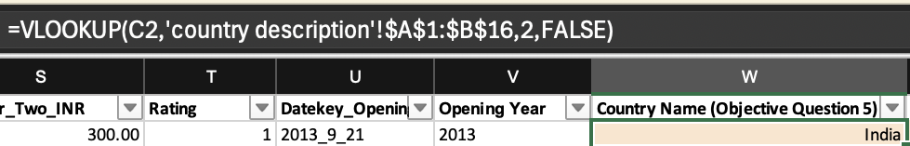

Charts & Tables (if any):

N/A

Question 6

Question:

Create a table to represent the number of restaurants opened in each country.

Solution:

Final Answer:

A table showing the count of restaurants for each country is created using the dataset.

Approach:

A pivot table is created using the cleaned data, where the Country column is placed in the rows and the Restaurant ID is used in the values field as a count. This provides the total number of restaurants present in each country.

Charts & Tables (if any):

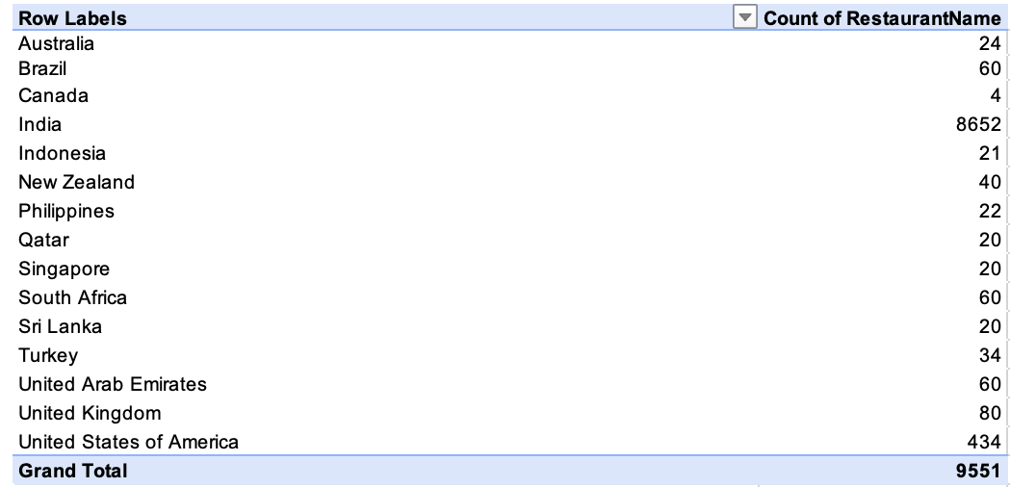

Question 7

Question:

The management wants to look at the number of restaurants opened each year, so provide them with something here.

Solution:

Final Answer:

A year-wise view of the number of restaurants opened is created using the dataset.

Approach:

The year of restaurant opening is extracted from the opening date column using a text function. A pivot table is created by placing the Year column in the rows and counting the Restaurant Name in the values field to obtain the number of restaurants opened each year.

Charts & Tables (if any):

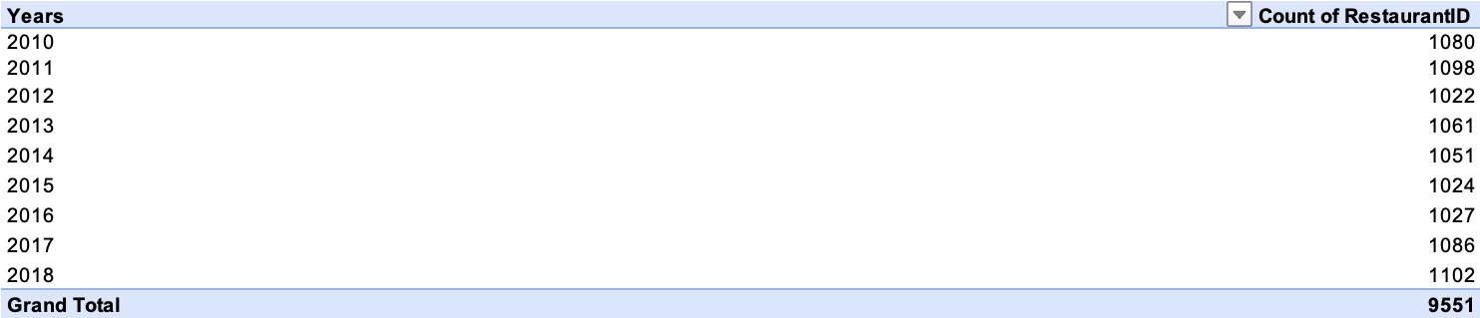

Question 8

Question:

What is the total number of restaurants in India in the price range of 4?

Solution:

Final Answer:

The total number of restaurants in India that fall under price range 4 is 388.

Approach:

A pivot table is created using the cleaned data. Country and Price Range are used as filters, and the Restaurant Name is counted in the values field. The data is filtered for India and price range 4 to obtain the required count.

Charts & Tables (if any):

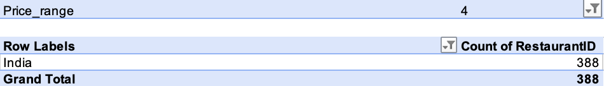

Question 9

Question:
What is the average number of voters for the restaurants in each country according to the data?

Solution:

Final Answer:
The average number of voters for restaurants is calculated separately for each country using the available data.

Approach:
A pivot table is created using the cleaned data by placing the Country column in the rows and calculating the average of Votes in the values field. This provides the average number of voters for restaurants in each country.

Charts & Tables (if any):
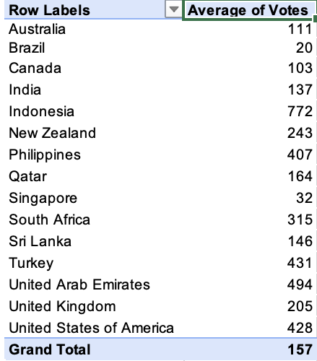

Question 10

Question:

Calculate the average rating for all the restaurants that have price_range < 4 and provide online delivery.

Solution:

Final Answer:

The required average rating is calculated by applying multiple conditions within the IF function and then aggregating the result using the AVERAGE function

Approach:

An array formula was used to evaluate multiple conditions simultaneously:
- Restaurants with price range less than 4 were filtered using a logical condition.
- Restaurants offering online delivery = "Yes" were selected.
- Both conditions were combined using the multiplication (*) operator, which acts as an AND condition.
- The IF function returned ratings only for rows satisfying both conditions.
- The AVERAGE function was then applied to compute the final result.

So the average for all the restaurants for the above condition is 3.27

Charts & Tables (if any):

N/A

Question 11

Question:

Using Conditional formatting highlight the rows of restaurants that are located in the countries or cities that you’ve suggested to the management for opening new restaurants.

Solution:

Final Answer:

Rows corresponding to restaurants located in Turkey, Indonesia, Philippines and United Arab Emirates are highlighted using Conditional Formatting.

Approach:

The Countries Turkey, Indonesia, Philippines and United Arab Emirates are selected on the basis of few restaurant counts, good number average of votes, and top average ratings.
Used conditional formatting with the formula =OR(TRIM($W2)="Turkey",
TRIM($W2)="Indonesia", TRIM($W2)="Philippines", TRIM($W2)="United Arab Emirates") to highlight rows from the suggested cities.

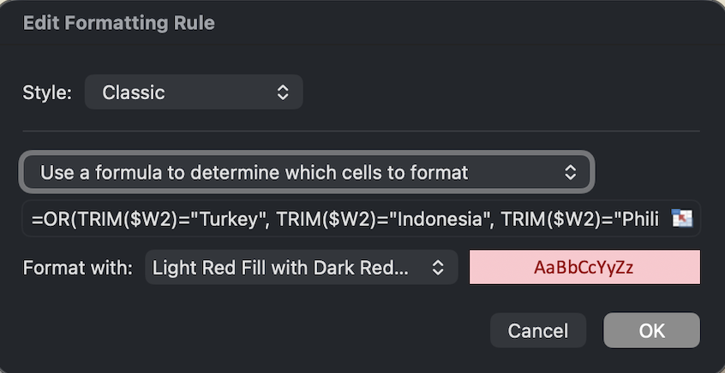

Charts & Tables (if any):

N/A

Question 12

Question:
Create a new customized price column that consists of the abbreviation/symbol of the currency along with the Average_cost_for_two value. [Use string operations to do this task]

Solution:

Final Answer:

The customized price column successfully displays values in a readable format by s howing the currency symbol followed by the cost value (e.g., ₹ 500, $ 30, etc.).

Approach:

- The currency column contains symbols enclosed within brackets (e.g., (₹), ($), etc.).
- The MID and FIND functions were used to extract the currency symbol from within the brackets.
- The extracted symbol was then combined with the Average Cost for Two using the concatenation operator (&).
- A space was added between the symbol and the cost value for better readability.

Charts & Tables (if any):

N/A

Question 13

Question:
How can you create an array formula in Excel or Google Sheets to count the number of restaurants listed that do not offer online delivery, are in the lowest price range, and have an average cost for two people less than or equal to 250 Indian Rupees?

Solution:

Final Answer:

The total number of restaurants meeting the conditions is calculated using a multi-condition counting formula.

Approach:

• The dataset was filtered based on multiple conditions:
- Online Delivery = "No"
- Price Range = 1 (lowest)
- Average Cost for Two ≤ 250
- Country = India
• The COUNTIFS function was used to apply all conditions together.
• Each condition was applied to its respective column range.
• Only the rows satisfying all conditions simultaneously were counted.

Number of Restaurants according to above condition are 1685.

OUTPUT:-



Charts & Tables (if any):

N/A

SUBJECTIVE QUESTIONS

Question 1

Question:

Suggest a few countries where the team can open newer restaurants with lesser competition. Which visualization/technique will you use here to justify the suggestions?

Solution:
To identify countries suitable for expansion with relatively lower competition, I analysed:
- Average Rating (to measure customer satisfaction)
- Average Number of Votes (to measure customer engagement and digital activity)
Based on the analysis, the recommended countries for expansion are:
- Indonesia
- Philippines
- Turkey
- United Arab Emirates
Approach:

• A Pivot Table was created to calculate:
- Average Rating per Country
- Average Number of Votes per Country
• A Combo Chart (Dual Axis Chart) was developed:
- Bar Chart → representing Average Rating
- Line Chart → representing Average Number of Votes
- Secondary Axis used to compare different scales
• Countries with:
- High average ratings (≥ 4.0)
- Strong customer engagement (high votes)
- Relatively smaller restaurant presence compared to highly saturated markets

Charts & Tables:
A Combo Chart (Dual Axis Chart) was used to compare:
- Customer Satisfaction (Average Rating)
- Customer Engagement (Average Votes)
This technique allows simultaneous comparison of two key performance indicators, enabling data-driven identification of attractive expansion markets.

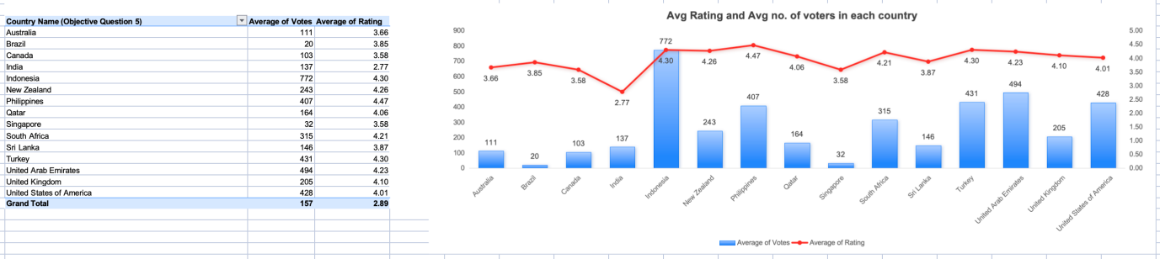

Insights:
- Philippines (4.5 rating) demonstrates the highest customer satisfaction with strong engagement levels.
- Indonesia (4.3 rating, 772 votes) shows exceptional customer engagement, indicating strong digital adoption.
- Turkey (4.3 rating, 431 votes) reflects consistent demand and positive customer experience.
- United Arab Emirates (4.2 rating, 493 votes) indicates a premium and highly engaged customer base.
In comparison, markets such as India show significantly higher restaurant concentration but lower average ratings (2.8), indicating saturation and intense competition.
Recommendations:
Zomato should prioritize expansion in:
- Indonesia
- Philippines
- Turkey
- United Arab Emirates
These countries demonstrate strong customer demand, high satisfaction levels, and favorable market conditions, making them strategically suitable for expansion.

Question 2

Question:

Come up with the names of States and cities in the suggested countries suitable for opening restaurants.

Solution:
To identify suitable cities within the recommended countries (Indonesia, Philippines, Turkey, and United Arab Emirates), I analysed:
- Count of Restaurants (to assess competition level)
- Average Rating (to measure customer satisfaction)
Cities with high ratings and relatively lower restaurant presence were considered ideal expansion targets.
A Pivot Table and Combo Chart were used to compare restaurant count and average ratings at the city level.

Approach:

Country-wise Recommendations

🇵🇭 Philippines
The Philippines stands out as a high-potential market with a strong national average rating of 4.5. Most cities show very limited restaurant presence, indicating low saturation and strong expansion opportunity.

Key Cities to Consider:
- Makati (4.7 rating, 2 restaurants)
Extremely high customer satisfaction with very limited competition. Ideal for premium positioning.
- Mandaluyong City (4.6, 4 restaurants)
Strong ratings and manageable competition. Suitable for stable expansion.
- Pasig City (4.6, 3 restaurants)
High satisfaction with limited players. Strong mid-term growth potential.
- Tagaytay City (4.5, 1 restaurant)
Almost untapped market. Excellent first-mover advantage opportunity.
- Taguig City (4.5, 4 restaurants)
Consistent performance and expansion capacity.
Conclusion for Philippines:
Cities like Makati and Tagaytay provide strong white-space opportunities with minimal competition and high customer satisfaction.

🇮🇩 Indonesia
Indonesia demonstrates strong engagement and solid average ratings (4.3). While Jakarta has moderate competition, several surrounding cities show low saturation.

Key Cities to Consider:
- Bandung (4.2 rating, 1 restaurant)
Very low competition. Strong opportunity for early positioning.
- Tangerang (4.3, 2 restaurants)
High rating with limited restaurant presence.
- Bogor (3.9, 2 restaurants)
Moderate rating but minimal competition. Potential for value-focused formats.
- Jakarta (4.4, 16 restaurants)
Larger market with higher competition but strong demand and brand visibility potential.
Conclusion for Indonesia:
Bandung and Tangerang offer first-mover advantage, while Jakarta provides scale potential.

🇹🇷 Turkey
Turkey maintains a healthy national average rating of 4.3. Restaurants are mainly concentrated in Ankara and Istanbul, but the market is not fully saturated.

Key Cities to Consider:
- Istanbul (4.3 rating, 14 restaurants)
Tourism hub with consistent demand. Ideal for premium or differentiated offerings.
- Ankara (4.3, 20 restaurants)
Slightly higher competition but strong demand. Requires niche positioning.
Conclusion for Turkey:
Entry strategy should focus on differentiation, premium positioning, and localized marketing.

🇦🇪 United Arab Emirates
The UAE shows strong engagement and a high average rating of 4.2, indicating a premium and digitally active market.

Key Cities to Consider:
- Abu Dhabi (4.3 rating, 20 restaurants)
Strong purchasing power and consistent ratings.
- Dubai (4.4, 20 restaurants)
Global lifestyle and tourism hub with high demand potential.
- Sharjah (4.0, 20 restaurants)
Moderate ratings but opportunity for differentiated offerings.
Conclusion for UAE:
UAE cities present premium expansion opportunities with strong digital engagement and high customer expectations.

Charts & Tables:
A Combo Chart (Dual Axis Chart) was used:
- Bars → Count of Restaurants (competition level)
- Line → Average Rating (customer satisfaction)
This technique allows simultaneous evaluation of competition and performance at the city level, supporting strategic expansion decisions.

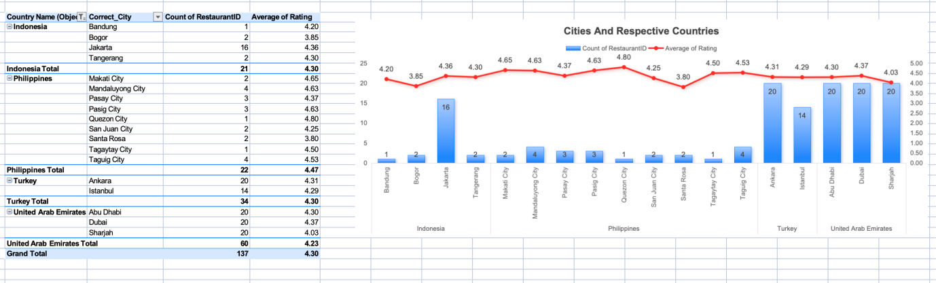

Insights:
• Several cities such as Bandung and Tagaytay show high ratings despite having very few restaurants, indicating strong untapped demand.
• Cities like Makati, Dubai, and Istanbul maintain high ratings, suggesting strong customer satisfaction and premium market potential.
• Moderate competition in cities such as Tangerang and Pasig makes them suitable for steady expansion.
• Overall, the shortlisted countries demonstrate high customer satisfaction (ratings above 4.0), indicating favorable conditions for market entry.

Recommendations:
Zomato should prioritize expansion in:
- Makati, Tagaytay (Philippines)
- Bandung, Tangerang (Indonesia)
- Istanbul (Turkey)
- Dubai & Abu Dhabi (UAE)
These cities show the best balance between high customer satisfaction and manageable competition levels.

Question 3

Question:

According to the countries you suggested, what is the current quality regarding ratings for restaurants that are open there?

Solution:

Approach:
To evaluate restaurant quality across the shortlisted countries, average restaurant ratings were used as the primary metric.
A Pivot Table was created using the cleaned dataset by grouping restaurants based on Country Name and calculating the Average Rating for each country.
Only the four previously recommended countries (Indonesia, Philippines, Turkey, and United Arab Emirates) were included in the analysis.
The results were rounded to two decimal places and visualized using a horizontal bar chart for easy comparison.

Charts & Tables:

Table / Chart Name:
Average Restaurant Rating by Country (Pivot Table & Bar Chart)

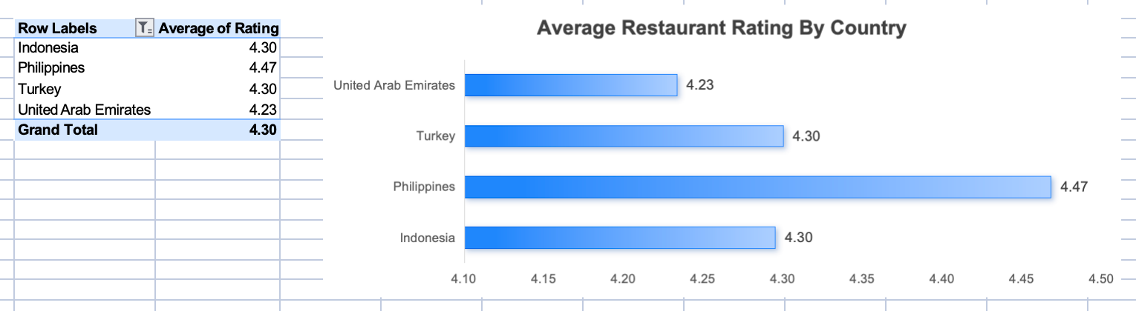

Insights:
- Philippines has the highest average rating (4.47), indicating very strong customer satisfaction.
- Indonesia and Turkey both show solid ratings (4.30), reflecting stable and competitive restaurant markets.
- United Arab Emirates maintains a good average rating (4.23), suggesting consistent service quality.
- All selected countries have ratings above 4.0, indicating favorable market conditions for expansion.

Recommendations:
Since all shortlisted countries demonstrate strong average ratings (above 4.0), they are suitable for expansion.
- Philippines can be targeted for premium or flagship launches due to its highest satisfaction levels.
- Indonesia and Turkey offer stable growth opportunities.
- United Arab Emirates presents potential for quality-focused expansion in a premium market.

Question 4

Question:

Also, what is the current expenditure on food in the suggested countries, so we can keep our financial expenditure in control?

Solution:

To evaluate food expenditure, the average cost for two (in INR) was calculated using a Pivot Table for the selected countries: Turkey, Indonesia, and Philippines.

Approach:

To determine food expenditure levels in the shortlisted countries, a Pivot Table was created using the cleaned dataset.
- The data was grouped by Country Name.
- The metric Average of Cost_for_Two (in INR) was calculated.
- Only the four recommended countries (Turkey, Indonesia, Philippines, and United Arab Emirates) were filtered for comparison.
- The results were visualized using a bar chart to clearly compare cost levels across countries.
This approach helps evaluate affordability and understand the financial implications of expansion in each market.

Charts & Tables:

Table / Chart Name:
Average Cost for Two (INR) by Country
Values:
• Turkey – ₹181
• Indonesia – ₹1,490
• Philippines – ₹2,426
• United Arab Emirates – ₹3,919
The bar chart visually compares the dining cost levels across these countries.

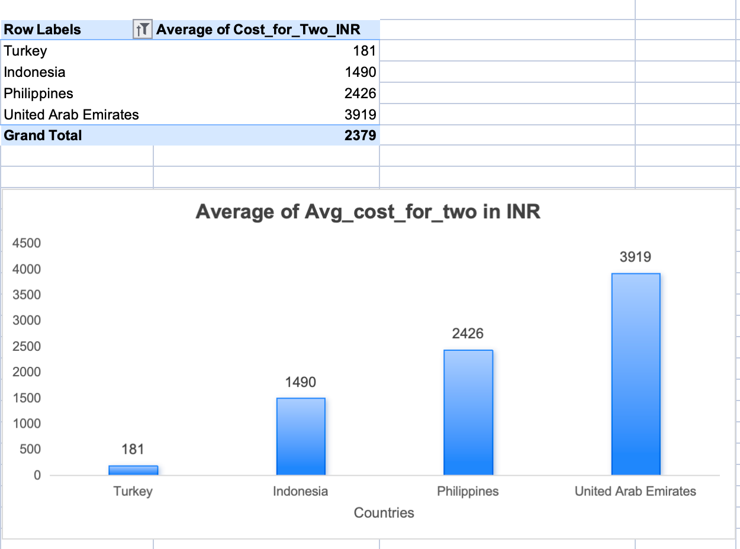

Insights:

• Turkey is the most cost-effective market.
• Indonesia falls in the mid-range pricing segment.
• Philippines reflects a moderately premium market.
• United Arab Emirates has the highest dining cost, indicating a strong premium positioning and higher operational expenditure.

Recommendations:

- UAE should be approached as a premium expansion market with careful cost planning.
- Turkey remains ideal for low-investment entry.
- Indonesia and Philippines support balanced pricing strategies.

Question 5

Question:

Come up with the names of restaurants from the recommended states that are our biggest competitors and also those that are rated in the lower brackets (i.e., 1–2 or 2–3).

Solution:

Approach:

• Restaurants were grouped by Country and City using a Pivot Table.
• Average Ratings were used as the key metric.
• Restaurants were categorized as:
- Biggest Competitors: Rating ≥ 4.8
- Lowest Rated: Rating ≤ 3.7
• This helped identify both strong competitors and weak performers in each market.

Biggest Competitors (Rating ≥ 4.8)
These restaurants have very high ratings and represent strong competition:
Turkey:
- Draft Gastro Pub (Istanbul – 4.9)
- Gaga Manjero (Ankara – 4.9)
- Meşhur Çiğ Köfteci (4.8 approx.)
Philippines:
- Ooma (Makati – 4.9)
- Spiral – Sofitel Philippine Plaza Manila (Pasay – 4.9)
- Silantro Fil-Mex (Quezon City – 4.8)
- Sambo Kojin (Mandaluyong – 4.8)
Indonesia:
- Sushi Masa (Jakarta – 4.9)
- Talaga Sampireun (Tangerang – 4.9)
United Arab Emirates:
- Tresind - Nassima Royal Hotel (4.9)
- Carnival by Tresind (4.9)
- AB’s Absolute Barbecues (4.9)
- Punjab Grill (4.9)

Lowest Rated Restaurants (Rating ≤ 3.7)
These represent weak competition and potential entry opportunities:
Turkey:
- Liva (Ankara – 3.4)
- Huqqa (Istanbul – 3.7)
- Leman Kültür (3.7)
Philippines:
- Cafe Arabelle (Santa Rosa – 3.6)
- Buffet 101 (Pasay – 3.4)
Indonesia:
- Momo Milk (Bogor – 3.7)
- Fish Streat (Jakarta – 3.7)
- Onokabe (Tangerang – 3.7)
United Arab Emirates:
- Pizza Hut (2.4)
- Red Lobster (3.2)
- Sangeetha Vegetarian Restaurant (3.6)
- Sis Burger (3.8 approx. borderline)

Charts & Tables:

Table / Chart Name:
Competitor & Low-Performing Restaurants Analysis
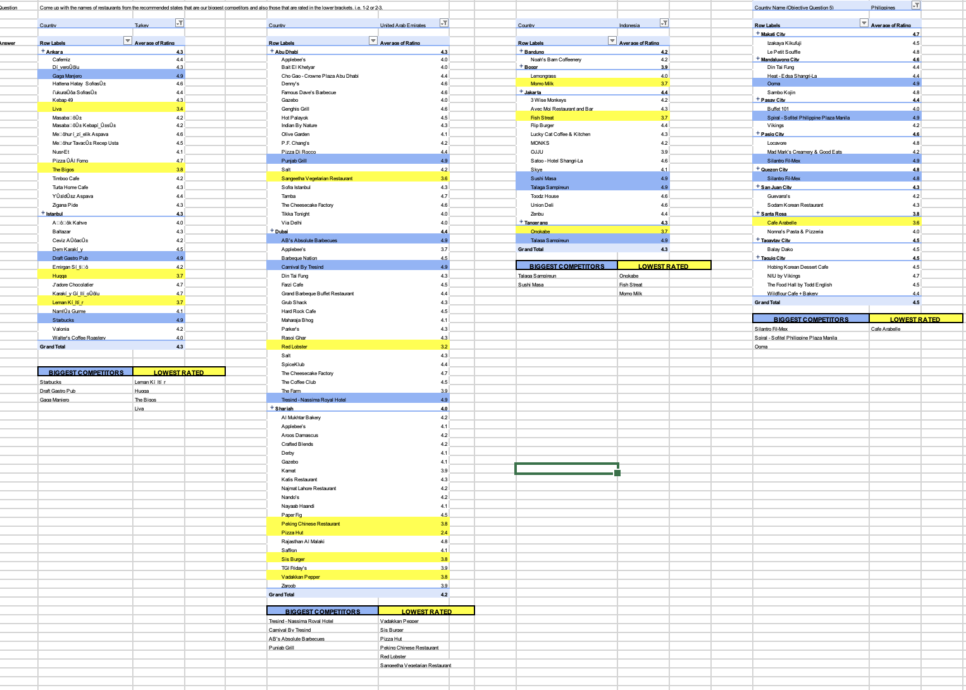

Insights:

• High-rated restaurants (≥4.8) indicate strong competitive markets in major cities.
• Low-rated restaurants (≤3.7) highlight clear gaps in service quality and customer satisfaction.
• Indonesia and UAE show a mix of strong competition and untapped opportunities.

Recommendations:

• Target low-rated markets to quickly capture demand with better quality offerings.
• Benchmark top competitors to replicate best practices in service and customer experience.
• Use a differentiation strategy (unique cuisine, better delivery, premium experience) in highly competitive cities.

Question 6

Question:
Which cuisines should we focus on in the newer restaurants to get better feedback? Does the choice of cuisines affect the restaurant ratings?

Solution:

Approach:

• A Pivot Table was created by grouping data based on Country and Cuisines.
• The Average Rating was calculated for each cuisine category.
• The analysis was focused on the recommended countries: Indonesia, Philippines, Turkey, and UAE.
• A chart was used to compare cuisine performance across countries.
• High-performing cuisines were identified based on ratings close to 4.8–4.9.

Top Performing Cuisines (High Ratings ~4.8–4.9)
Across Countries:
- Japanese / Sushi – Consistently rated around 4.9
- Sunda / Indonesian Cuisine – ~4.9 (strong local preference)
- Continental / Indian (UAE) – ~4.9
- Bar Food & World Cuisine (Turkey) – ~4.9
Philippines:
- European, Asian, Indian – 4.9
- Filipino, Mexican – 4.8–4.9
- Japanese, Korean – 4.8
Indonesia:
- Sunda, Indonesian – 4.9
- Sushi, Japanese – 4.9
- Desserts & Bakery – 4.6+
Turkey:
- Bar Food, Café – 4.9
- Pizza, Desserts – 4.7+

UAE:
- Continental, Indian – 4.9
- Indian, North Indian – 4.8–4.9

Charts & Tables:

- Table Name: Cuisine-wise Average Ratings
- Chart Name: Cuisines and their Ratings
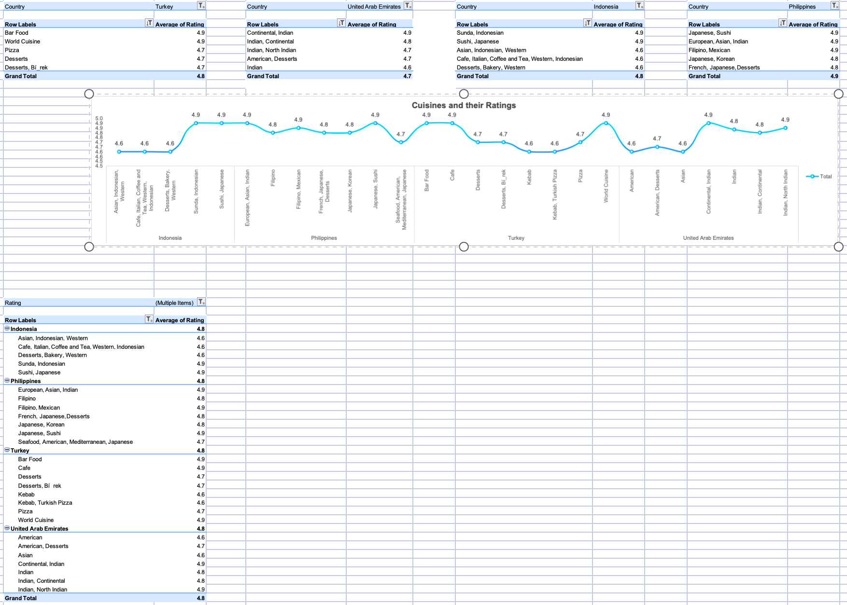

Insights:

• High-rated cuisines (~4.8–4.9) clearly show customer preference trends.
• Japanese/Sushi and local cuisines perform best across multiple countries.
• Desserts, café, and fusion cuisines consistently receive good ratings.

Recommendations:

- Focus on Japanese/Sushi cuisine as a global high-performing option.
- Include local cuisines (e.g., Sunda in Indonesia) for better acceptance.
- Introduce fusion cuisines in urban markets for variety and engagement.
- Develop dessert & café formats for consistent customer appeal.
- Avoid or improve cuisines with relatively lower ratings.

Question 7

Question:

According to our current data, should we go for online delivery and table booking? Does that affect the customer’s ratings?

Solution:

Approach:

• A Pivot Table was created using:
- Online Delivery (Yes/No)
- Table Booking (Yes/No)
• The Average Rating was calculated for each category.
• Separate comparisons were made to understand the impact of each service.
• Charts were used to visually compare rating differences.

Impact of Table Booking:
- Without Table Booking → 2.8 rating
- With Table Booking → 3.5 rating
Increase of +0.7 rating

Impact of Online Delivery:
- Without Online Delivery → 2.8 rating
- With Online Delivery → 3.3 rating
Increase of +0.5 rating

Charts & Tables:

• Table Name: Service-wise Average Rating Analysis
• Chart Name: Table Booking & Online Delivery Impact
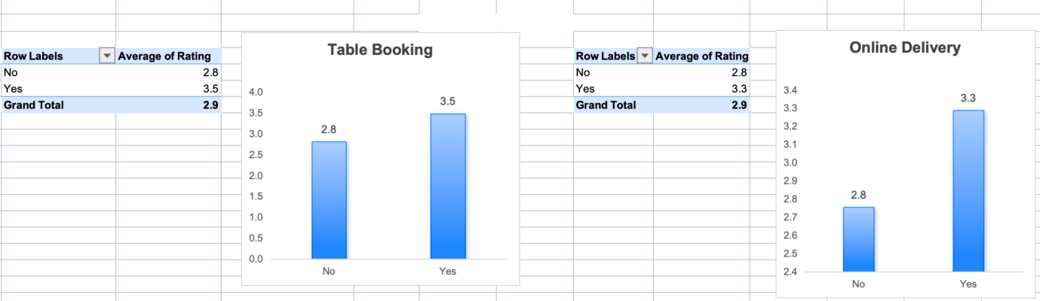

Insights:

• Restaurants with table booking have the highest rating improvement.
• Online delivery also increases ratings but slightly less than table booking.
• Lack of both services results in lowest customer satisfaction.

Recommendations:

• New restaurants should offer both online delivery and table booking.
• Prioritize table booking for higher impact on ratings.
• Use delivery services to improve customer convenience and reach.

Question 8

Question:

Should the team keep the rate of cuisines higher? Will that affect the feedback? According to our data are the rates of cuisines and ratings, correlated?

Solution:

Approach:

• The relationship between Average Cost for Two and Average Ratings was analyzed.
• The CORREL function was used to calculate the correlation coefficient.
• The analysis was performed for selected countries: Indonesia, Philippines, and Turkey.
• A scatter plot was created to visually examine the relationship between cost and ratings.

- The correlation coefficient = 0.24
- This indicates a very weak positive correlation
Interpretation:
- As price increases, ratings may increase slightly
- However, the relationship is too weak to be meaningful

Charts & Tables:

Chart Title: Correlation between Cost for Two and Ratings (Scatter Plot)

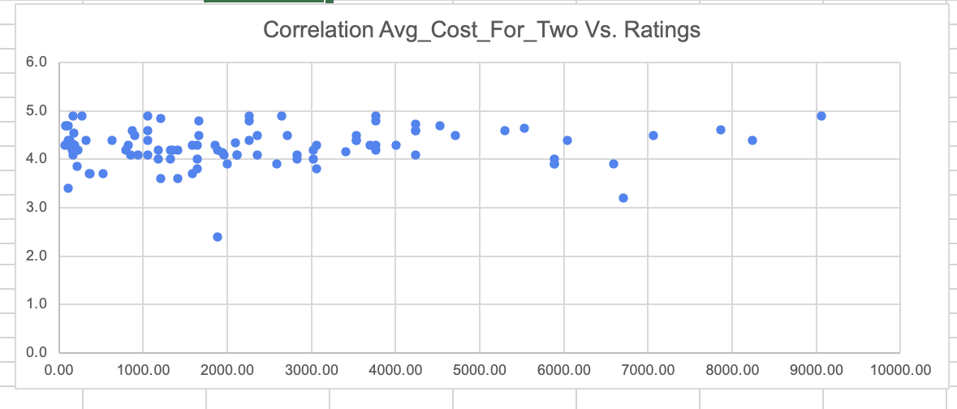

Insights:

• Ratings are not strongly influenced by price
• High-priced restaurants do not always receive higher ratings
• Customer satisfaction depends on other factors beyond pricing.

Recommendations:

• Do not increase prices with the expectation of better ratings
• Focus on:
- Food quality
- Service experience
- Ambience
• Use competitive pricing strategies based on market demand and value perception

Question 9

Question:

What is the distribution of the number of restaurants of different price ranges in all the countries?

Solution:

Approach:

• • A Pivot Table was created using:
- Country Name in Rows
- Price Range (1, 2, 3, 4) in Columns
- Count of Restaurant Names in Values
The total number of restaurants was calculated for each price range across countries.
• A Clustered Column Chart was used to visually compare the distribution of restaurants across different price ranges and countries.

Price Range Distribution:

Price Range 1 (Budget)
- Has the highest number of restaurants globally (4444 restaurants), especially in India and the United States of America.

Price Range 2 (Low-Mid Range)
- Second most common (3113 restaurants), widely present across India, UAE, UK, and USA.

Price Range 3 (Mid-Range)
- Moderate presence (1408 restaurants), commonly found in countries such as Brazil, South Africa, UAE, and Turkey.

Price Range 4 (Premium)
- Least common globally (586 restaurants), mainly concentrated in countries like USA, UK, South Africa, and UAE.

Charts & Tables:
- Table Name: Country-wise Price Range Distribution
- Chart Name: Country Wise Price Range

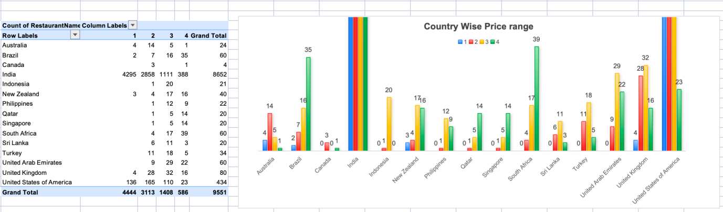

Insights:

- The majority of restaurants belong to Price Range 1 and 2, indicating strong global demand for affordable and moderately priced dining options.

- Premium restaurants (Price Range 4) are comparatively limited and concentrated mainly in developed or high-spending countries.

- Countries such as India show a very high concentration of budget-friendly restaurants.
- Developed markets like the USA, UK, and UAE have a more balanced distribution across all price ranges.

Recommendations:

• Focus primarily on budget and mid-range restaurant categories (Price Range 1 & 2) to maximize customer reach and market penetration.

• Introduce selective premium restaurant partnerships in high-spending markets such as USA, UK, and UAE.

• Align pricing strategy with local affordability, customer preferences, and market demand in each country.

Question 10

Question:

Explain your approach in brief for suggesting countries/cities in order to open new restaurants, if the objective and subjective questions would have not been given to assist you. [you have to give bullet pointers in order to answer this question]

Solution:

Approach:

- • Data Cleaning and Preparation
Cleaned the dataset by handling missing values, standardizing currency formats, and ensuring consistency in key fields such as ratings, cost, and service availability.

- • Country and City-Level Analysis
Used Pivot Tables to analyze the number of restaurants across countries and cities to understand market presence and distribution.

- • Competition Analysis
Identified countries and cities with fewer restaurants, indicating lower competition and higher potential for expansion.

- • Customer Preference Analysis (Ratings)
Evaluated average ratings across countries to identify regions with higher customer satisfaction and better acceptance of restaurant services.

- • Cost and Affordability Analysis
Analyzed Average Cost for Two to understand customer spending capacity and classify markets into budget, mid-range, and premium segments.

- • Price Range Distribution
Studied the distribution of price ranges (1–4) to determine which pricing segments dominate in each country.

- • Service Impact Analysis
Examined the effect of online delivery and table booking on ratings, and prioritized markets where these services improve customer satisfaction.

- • Cuisine Performance Analysis
Identified high-performing cuisines based on ratings to understand customer preferences in different regions.

- • Multi-Factor Evaluation
Combined key factors such as low competition, high ratings, affordable pricing, and strong service impact to shortlist the most suitable countries and cities.
- • Final Recommendation Strategy
Selected locations that offer a balance of:
Low competition
High customer satisfaction
Suitable pricing environment
Growth potential

