$
Immunomodulation by microbicidal NSAIDs for Mycobacterium tuberculosis
Xinyi Tu

Supervisors:
Mahdad Noursadeghi

iBSc Immunology, Infection & Cell Pathology
BSc infection & Immunity
BSc Immunology & Infection

Word count:

Capsule summary
Carprofen has recognised cyclooxygenase-inhibitory activity and has also been reported to exert antimycobacterial effects, but its impact on human macrophage inflammatory responses during mycobacterial stimulation remains unclear.

This study investigated whether carprofen alters pro-inflammatory mediator production and BCG growth in human monocyte-derived macrophages stimulated with LPS or infected with BCG.

Carprofen at 1–10 µg/mL was associated with lower and less variable PGE₂ levels, but did not consistently alter TNF-α or IL-6 release, and did not show a clear or reproducible restrictive effect on intracellular BCG burden in this model.

These findings suggest that carprofen can engage the COX–PGE₂ axis in human macrophages, but that the present model did not provide a sufficiently strong inducible PGE₂ response or a sufficiently definitive bacterial growth readout to test downstream cytokine or antimycobacterial effects convincingly.

Summary
Tuberculosis is characterised by both persistent mycobacterial infection and host-driven inflammatory tissue damage, creating interest in therapies that may modulate macrophage responses while also supporting bacterial control. Carprofen is a non-steroidal anti-inflammatory drug with recognised cyclooxygenase (COX)-inhibitory activity and reported antimycobacterial effects, but its immunological effects in human macrophages during mycobacterial stimulation remain unclear. This study examined whether carprofen alters inflammatory mediator production and BCG growth in human monocyte-derived macrophages (MDMs). MDMs from healthy donors were stimulated with lipopolysaccharide (LPS) or infected with Mycobacterium bovis BCG in the presence or absence of carprofen. PGE₂, TNF-α, IL-6 and IL-1β were measured by ELISA. In parallel, BCG burden was assessed by flow cytometry using integrated fluorescence measurements in intracellular and extracellular compartments. LPS induced strong TNF-α and IL-6 responses, whereas mature IL-1β remained close to the detection limit. BCG elicited a weaker and more variable cytokine response overall. In both stimulation systems, carprofen at 1–10 µg/mL was associated with lower and less variable PGE₂ levels, but did not consistently alter TNF-α or IL-6 output. In the BCG assay, integrated fluorescence increased with inoculum and showed compartment-dependent changes over time, indicating that the system could detect bacterial burden. However, any apparent effect of carprofen on BCG growth was modest, more evident extracellularly than intracellularly, and not reproducibly dose-dependent. Overall, carprofen showed limited but detectable engagement of the COX–PGE₂ axis, but this did not translate into clear downstream cytokine modulation or reproducible intracellular growth restriction under the present conditions. These findings support further work using models with stronger inducible PGE₂ responses, inflammasome-competent conditions for IL-1β assessment, and viability-based bacterial readouts such as CFU assays.

Introduction
TB is a destructive chronic inflammatory disease caused by Mycobacterium tuberculosis (Mtb) and related mycobacterial species[1]. TB most commonly affects the lungs but can affect any organ system. According to the World Health Organization (2024), TB caused an estimated 10.7 million new cases and 1.23 million deaths in 2024, making it one of the leading infectious causes of mortality[1]. In TB, immunopathology is associated with uncontrolled mycobacterial growth[2]. Prolonged antimicrobial treatment is required to effect bacterial clearance and enable the disease activity to subside through immune homeostasis[1]. In some circumstances antimicrobial therapy leads to transient paradoxical inflammation potentially as a result of greater immunoreactivity to microbial products[3]. Even with curative antimicrobial treatment, TB can result in chronic disease as result of irreversible tissue damage caused by the immunopathology of the disease giving rise to the expression post-TB lung disease as an example[4]. Consequently, there has been substantial interest in immunomdoulatory therapies that may ameliorate the pathogenesis of TB disease alongside antimicrobial treatment. To date, corticosteroids have been the mainstay of anti-inflammatory therapies in TB[5]. Corticosteroids are most commonly used in TB meningitis and pericarditis, and in paradoxical reactions. However, controlled clinical trials have revealed to have modest demonstrable therapeutic benefit in these settings[6].
The primary host-pathogen interaction in TB is thought to center on Mtb infection of macrophages[7]. Mtb is able to adapt to the phagosomal environment inside macrophages, block phagolysosomal fusion to evade canonical microbicidal clearance mechanisms of phagocytic cells[7], and to modulate its metabolic/nutrient requirement to replicate inside this compartment[8]. Hence treatment of Mtb requires antimicrobial drugs to reach and function within intracellular Mtb compartments. In addition, macrophages contribute substantially to host immune responses, particularly via innate immune microbial sensing and production/secretion of canonical pro-inflammatory cytokines including IL-1β, IL-6 and TNF-α. Each of these cytokines has been implicated in the immunopathogenesis of TB[2].
There is increasing interest in the potential role of NSAIDs in the treatment of TB[9]. By inhibiting cyclooxygenase (COX) enzymes and altering the arachidonic acid–prostaglandin pathway, they can modify the local inflammatory environment and regulate cytokine production by macrophages and other immune cells[9]. NSAIDs may also modulate macrophage activation and the balance between apoptosis and necrosis through effects on NF-κB signaling, inflammasome activity and the generation of reactive oxygen and nitrogen species. These changes have the potential to influence bacterial clearance, antigen presentation and the quality of T cell responses[10]. NSAIDs with microbicidal activity therefore represent promising candidates for therapeutic strategies that target both the pathogen and the host immune response[11, 12]. In addition, some NSAIDs have been shown to have direct antibacterial effects as well as their canonical anti-inflammatory effects[13]. Among NSAIDs, carprofen is of particular interest because its relevance in tuberculosis extends beyond its conventional anti-inflammatory properties. Previous studies have shown that carprofen exerts direct bactericidal activity against mycobacteria and can inhibit mycobacterial efflux while restricting biofilm growth[14]. Transcriptomic analyses further suggest that carprofen may disrupt membrane potential and interfere with bacterial respiration, indicating a pleiotropic mechanism of action directed at the bacillus itself. These observations make carprofen a rational candidate for further investigation as a repurposed antimycobacterial compound in TB[14].
Despite these observations, the specific immunological and microbicidal effects of NSAIDs in mycobacterial infection of human macrophages remain unknown[13]. I have sought to test the hypothesis that a selected NSAID, carprofen, will attenuate pro-inflammatory cytokine secretion and restrict intracellular mycobacterial infection in human macrophages. In these experiments, I modelled human macrophages using primary monocytes (MDM) differentiated with the macrophage-colony stimulating factor (M-CSF) and I modelled Mtb infection using the Mycobacterium bovis Bacillus Calmette Guerin (BCG) strain that can be used in biosafety containment level 2 laboratories.

Results

Pro-inflammatory mediator production in LPS-stimulated MDMs co-treated with carprofen
Monocyte-derived macrophages (MDMs) from four donors were stimulated with LPS (0, 1, 10, 100 ng/mL) in the presence or absence of carprofen (1, 10, 100 µg/mL), and secreted PGE₂, TNF-α, IL-6 and IL-1β were measured by ELISA (Figure 2). PGE₂ was detectable in unstimulated cells and showed only a modest increase across the LPS dose range in vehicle-treated conditions (Figure 2A). In the presence of 1 or 10 µg/mL carprofen, PGE₂ remained low and relatively stable across all LPS concentrations, consistent with an effect on the COX–PGE₂ axis. At 100 µg/mL, PGE₂ values were slightly higher and more variable, including in unstimulated wells, which limited interpretation at this concentration. In contrast, LPS induced clear increases in TNF-α and IL-6. TNF-α rose markedly from baseline at 1 ng/mL LPS and remained high at 10 and 100 ng/mL (Figure 2B), while IL-6 also increased with LPS, although to a lower magnitude (Figure 2C). Carprofen did not produce a clear or consistent inhibitory effect on either cytokine across the LPS dose range. At 1 and 10 µg/mL, responses largely overlapped with the vehicle control, whereas values at 100 µg/mL appeared somewhat lower at low-dose LPS but were associated with wide confidence intervals. By contrast, IL-1β remained at or close to the detection threshold under all conditions (Figure 2D), with no clear increase across the LPS dose range and no interpretable effect of carprofen. Overall, in LPS-stimulated MDMs, the clearest and most reproducible effect of carprofen was observed for PGE₂, whereas effects on TNF-α, IL-6 and IL-1β were limited or not clearly detectable.

Pro-inflammatory mediator production in BCG-stimulated MDMs co-treated with carprofen
Monocyte-derived macrophages (MDMs) from the same four donors were infected with BCG (MOI 0, 1, 10, 100) in the presence or absence of carprofen (1, 10, 100 µg/mL), and secreted PGE₂, TNF-α, IL-6 and IL-1β were measured by ELISA (Figure 3). PGE₂ levels were detectable across all conditions but showed no clear increase with BCG infection (Figure 3A). In the presence of 1 and 10 µg/mL carprofen, PGE₂ remained low and relatively stable across the MOI range, consistent with the pattern observed under LPS stimulation. As in the LPS experiments, values at 100 µg/mL were more variable and included some higher measurements, limiting interpretation at this concentration. Compared with LPS, BCG elicited a weaker and more variable cytokine response. TNF-α and IL-6 both showed modest increases at higher MOIs, although responses were not strictly dose-dependent and varied substantially between donors (Figure 3B, 3C). Carprofen did not produce a clear or consistent inhibitory effect on either cytokine. At 1 and 10 µg/mL, responses largely overlapped with vehicle controls, while apparent differences at 100 µg/mL were inconsistent and associated with wide confidence intervals. IL-1β remained at or close to the detection threshold across all conditions (Figure 3D), with only occasional values above the lower limit of detection. As in the LPS model, this limited the ability to assess any potential effect of carprofen on IL-1β production. Overall, BCG stimulation generated a relatively weak inflammatory response in this system, and although carprofen consistently maintained low PGE₂ levels, it did not produce a clear or reproducible effect on TNF-α, IL-6 or IL-1β under these conditions.

Effects of carprofen on BCG growth in macrophages
BCG integrated fluorescence increased with MOI from 1 to 100 at both 4 h and 7 d, indicating that higher inocula resulted in greater bacterial burden. At low MOI, intracellular and extracellular values were comparable, whereas at higher MOI, particularly MOI 100, extracellular integrated fluorescence showed a more pronounced increase from 4 h to 7 d compared to intracellular values. Because integrated fluorescence scales with inoculum and captures time-dependent changes in bacterial burden, these data demonstrate that the system can reliably reflect BCG growth dynamics and is therefore suitable for assessing the effects of carprofen. Across carprofen concentrations, changes in integrated fluorescence over time were more strongly influenced by MOI and compartment than by carprofen itself. At MOI 1, integrated fluorescence remained largely unchanged between 4 h and 7 d across all carprofen conditions. At MOI 10 and MOI 100, extracellular integrated fluorescence increased more clearly over time, whereas intracellular integrated fluorescence showed more limited changes. Although some differences between carprofen concentrations were observed, these were not consistent across conditions. Therefore, BCG growth in this system appears to be primarily driven by inoculum and compartment rather than by a clear dose-dependent effect of carprofen. Fold change was analysed separately for experiments 1–3 and 4–6 due to differences in post-infection treatment conditions (4 h versus 7 d carprofen exposure). In both groups, fold change remained close to 1 at MOI 1, but increased at MOI 10 and more prominently at MOI 100. Across conditions, extracellular fold change was consistently higher than intracellular fold change, indicating that increases in BCG burden over time were more evident in the extracellular compartment. Although in some cases higher carprofen concentrations were associated with lower fold change values, this pattern was not consistent across donors or experimental sets. Therefore, the effect of carprofen on BCG growth appears limited and variable.

Discussion
This study examined whether carprofen could alter inflammatory mediator production and BCG growth in human monocyte-derived macrophages. The most important point arising from the data is not simply that carprofen did not consistently change TNF-α, IL-6 or IL-1β, but that the experimental system did not generate a sufficiently strong inducible PGE₂ response to test this proposed mechanistic link convincingly. In other words, the original premise was that inhibition of COX activity, and therefore reduced PGE₂ production, might influence downstream cytokine responses and possibly bacterial control. However, under the conditions used here, that relationship could only be examined to a limited extent. The data therefore support a clear effect of carprofen at the level of the COX–PGE₂ axis, but provide only limited evidence that this translated into downstream cytokine modulation or a clear intracellular growth phenotype. This mechanistic premise was biologically reasonable. LPS activates macrophages through TLR4-associated signalling pathways, leading to NF-κB-dependent inflammatory responses. In parallel, cyclooxygenase-dependent arachidonic acid metabolism generates prostaglandins such as PGE₂, which may in turn shape subsequent inflammatory output. On that basis, it was plausible to hypothesise that inhibition of COX activity by carprofen might reduce PGE₂ and thereby alter the release of cytokines such as TNF-α, IL-6 and IL-1β. However, the present results suggest that, in this model, the link between these two layers of the response was either weak, indirect, or not sufficiently dynamic to be resolved under the chosen conditions.

The LPS experiments are central to this interpretation. In the present study, LPS clearly induced TNF-α and IL-6, showing that the macrophages mounted a robust inflammatory response and that the model was responsive. By contrast, PGE₂ increased only modestly above basal levels in vehicle-treated cells. This distinction is important. The more appropriate interpretation is therefore not that carprofen failed to inhibit a strongly induced LPS-driven PGE₂ response, but that 6 h of LPS stimulation did not generate a sufficiently pronounced PGE₂ upregulation in the first place. Under those conditions, even if carprofen was acting pharmacologically, there was only a limited inducible PGE₂ range available for inhibition. This makes the absence of a clear downstream effect on TNF-α and IL-6 much less surprising, and it also means that the experiment did not provide strong evidence either for or against the proposed mechanistic relationship between PGE₂ reduction and altered cytokine output. The IL-1β data were even more constrained. In both LPS- and BCG-stimulated conditions, mature IL-1β remained close to the detection threshold. This is biologically plausible, because LPS can provide a priming signal for pro-IL-1β transcription, but secretion of mature IL-1β generally requires an additional signal to activate the inflammasome and promote caspase-1-dependent processing and release. Since no defined second signal such as ATP or nigericin was included in this study, the model was not well suited to assessing mature IL-1β production. For this reason, the negative IL-1β result should not be overinterpreted. It is better regarded as a limitation of the model than as evidence against the possibility that PGE₂-related signalling might influence IL-1β under more appropriate inflammasome-competent conditions. At the same time, it would also be inaccurate to conclude that carprofen had no effect in this system. The most reproducible difference between conditions was observed for PGE₂. At 1 and 10 µg/mL, carprofen-associated PGE₂ levels were generally lower and flatter than vehicle controls in both the LPS and BCG models. This pattern is consistent with an effect on the COX–PGE₂ axis, which is the direct pharmacological target of the drug. However, because PGE₂ induction itself was modest in these experiments, this finding is better interpreted as limited modulation of basal or weakly induced PGE₂ production than as inhibition of a strong stimulus-driven response. This distinction matters, because it means that the study does not provide a firm basis for claiming that suppression of PGE₂ should necessarily have propagated to TNF-α, IL-6 or IL-1β in the present system. This also helps explain the apparent dissociation between PGE₂ and the cytokine readouts. TNF-α and IL-6 are not direct products of COX activity, but instead depend mainly on broader inflammatory signalling and transcriptional regulation. It is therefore entirely possible for carprofen to affect PGE₂ without producing a clear accompanying effect on TNF-α or IL-6, particularly when the PGE₂ response itself is only weakly inducible. In that sense, the present data do not show that the original hypothesis was wrong; rather, they suggest that the model was not optimal for testing it. The study was able to show that carprofen was pharmacologically active in a narrow sense, but not that this activity was sufficient to reprogramme downstream inflammatory mediator release.

The BCG experiments point in the same general direction, but in a weaker and more variable setting. Compared with LPS, BCG induced a less pronounced inflammatory response overall, with greater donor-to-donor variability. This is consistent with the fact that BCG is a particulate stimulus that requires uptake and intracellular processing, rather than a soluble agonist that rapidly triggers a strong receptor-driven response. In this narrower response window, any PGE₂-dependent modulation of cytokines would be even harder to detect. Indeed, BCG did not clearly induce PGE₂ above basal levels either, and again there was no strong evidence that lower PGE₂ was accompanied by consistent changes in TNF-α, IL-6 or IL-1β. Taken together, the ELISA results therefore suggest that the limiting factor was not simply drug inactivity, but the biological and dynamic constraints of the models used. The BCG growth data should also be interpreted in this context. In untreated cultures, integrated fluorescence increased with MOI at both 4 h and 7 d, indicating that the assay was able to detect inoculum-dependent differences in bacterial burden. At higher MOI, especially MOI 100, extracellular integrated fluorescence increased more clearly over time than intracellular integrated fluorescence. This was an important positive feature of the assay, because it showed that the system could capture biologically structured changes in BCG burden across inoculum, time and compartment. Against that background, the effect of carprofen appeared modest. Across concentrations, integrated fluorescence was influenced more strongly by MOI and compartment than by drug dose. Fold change analyses, performed separately for experiments 1–3 and 4–6 because of their different post-infection treatment conditions, showed a similar pattern: values remained close to baseline at MOI 1, increased more clearly at MOI 10 and MOI 100, and were consistently greater extracellularly than intracellularly. Although higher carprofen concentrations were sometimes associated with lower extracellular fold change, this was not stable across donors or across the two experimental sets. The most defensible interpretation is therefore that carprofen may have had a modest and compartment-dependent effect under some conditions, but that there is no strong evidence here for a clear or reproducible restriction of intracellular BCG growth.

This cautious interpretation is strengthened by the limitations of the fluorescence-based readout. Integrated fluorescence is useful for tracking relative bacterial burden, but it does not directly distinguish viable from non-viable bacteria. Changes in extracellular burden over time could therefore reflect several non-exclusive processes, including persistence of extracellular bacteria, release from infected cells, altered retention of fluorescent material, or true compartment-specific differences in bacterial handling. For that reason, the growth assay should be interpreted as measuring changes in fluorescence-derived bacterial burden rather than definitive viable bacterial replication. This is particularly important when considering any apparent reduction at higher carprofen concentrations, which should not be taken as direct proof of antimycobacterial activity in the absence of a viability-based readout. Several limitations further restrict the strength of the conclusions. The donor number was small, and inter-donor variability was substantial. Cytokine measurements were made at a single early timepoint, which may not have been optimal for capturing PGE₂ dynamics or any secondary cytokine effects. The IL-1β model lacked a defined second signal, limiting its interpretability from the outset. BCG, while practical and appropriate for this laboratory setting, does not fully reproduce the immunostimulatory behaviour of pathogenic M. tuberculosis. In the growth experiments, fluorescence-based burden measurements could not establish viability, and experiments 1–3 and 4–6 had to be analysed separately because post-infection drug exposure differed. In addition, interpretation of the 100 µg/mL condition should remain cautious until the outstanding viability observations are fully analysed. These results nevertheless suggest several clear next steps. First, if the intention is to test whether reduced PGE₂ can alter downstream cytokine responses, a model that generates a stronger inducible PGE₂ response would be needed. Second, if IL-1β is to be used as a mechanistic readout, future experiments should include a defined inflammasome-activating second signal. Third, the BCG growth assay would be strengthened by pairing integrated fluorescence with viability-based methods such as CFU measurement. Finally, increasing donor number and incorporating multiple timepoints would improve the ability to detect modest or delayed effects.

In summary, this study shows that carprofen was associated with lower and less variable PGE₂ levels in human macrophages, consistent with limited engagement of the COX–PGE₂ axis. However, the LPS and BCG models used here did not generate a sufficiently strong inducible PGE₂ response to allow the proposed mechanistic link between reduced PGE₂ and altered downstream cytokine output to be tested convincingly. Likewise, although the BCG assay captured clear inoculum- and compartment-dependent changes in bacterial burden, the effect of carprofen on BCG growth was modest, extracellularly biased and variable, with no clear evidence of reproducible intracellular growth restriction. Overall, the findings support pharmacological activity by carprofen at the level of lipid mediator biology, but do not provide strong evidence for downstream cytokine remodelling or intracellular antimycobacterial activity under the present conditions.

Materials and methods
Isolation of human PBMCs and macrophage differentiation
Peripheral blood samples (120ml) were obtained from healthy adult donors under UCL ethical approval. PBMCs were isolated by Ficoll density-gradient centrifugation and resuspended in RPMI-1640(Gibco, Cat#21875-034) supplemented with 10% heat-inactivated FBS (Sigma-Aldrich, Cat#12103C-100ML) and penicillin–streptomycin (Gibco, Cat#15070-063). Monocytes were enriched by adherence (2 h, 37 °C, 5% CO₂), washed with DPBS (Gibco, Cat#14190-094), and differentiated into monocyte-derived macrophages (MDMs) using RPMI-1640 containing 10% autologous serum and M-CSF (R&D Systems, Cat#216-MC-025). Cells were maintained in macrophage adhesion/maintenance medium as required. (Cell seeding density: 5x10⁶ PBMCs/ml)

Bacterial culture and preparation
Mycobacterium bovis bacillus Calmette–Guérin (BCG) expressing fluorescent reporters (dsRED) was cultured in Middlebrook 7H9 broth (BD Difco, Cat#2271310) supplemented with ADC enrichment (BD BBL, Cat#211887), 0.2% glycerol (Sigma-Aldrich, Cat#2025-500ML), and 0.05% Tween-80(Sigma-Aldrich, Cat#P1754-500ML) at 37 °C with shaking until mid-logarithmic phase (OD₆₀₀ ≈ 0.4-0.6). Before infection, bacterial cultures were centrifuged and washed with PBS containing 0.05% Tween-80 (PBST). Bacterial suspensions were resuspended in macrophage culture medium.

Infection of macrophages with BCG
Differentiated MDMs (day 7) were infected with BCG at multiplicities of infection (MOI) of 1, 10, or 100. Bacterial suspensions were added to macrophage cultures and incubated for 4 h at 37 °C. Following infection, extracellular bacteria were removed by washing three times with warm DPBS. Fresh antibiotic-free MDM adhesion/maintenance media were then added to each well for subsequent treatments and assays. For BCG growth assays, two experimental formats were used. In Exp 1–3, cultures were infected for 4 h, washed, and then maintained in medium alone until the 7 d timepoint. In Exp 4–6, cultures were infected for 4 h, washed, and then returned to the same treatment conditions used during infection, such that carprofen-treated wells continued to receive carprofen in medium until 7 d. Because of this difference in post-infection treatment, Exp 1–3 and Exp 4–6 were analyzed separately.

Carprofen treatment
Carprofen (stock 50mg/mL in DMSO) was diluted in macrophage culture medium to final concentrations of 0, 2, 20, and 200 µg/mL. Carprofen was prepared at 2× concentrations (0, 2, 20, 200 µg/mL) and diluted 1:1 with culture medium to achieve final concentrations of 0, 1, 10, and 100 µg/mL. Vehicle controls received equivalent DMSO volumes. Carprofen was added after the 4h infection and wash step, and cells were maintained under treatment conditions until sample collection.

Cytokine quantification by ELISA
For inflammatory readouts, MDMs were stimulated with LPS (from Escherichia coli O111: B4; Sigma-Aldrich) or infected with BCG in parallel plates. Supernatants were collected 6 h post-stimulation/infection and stored at −80 °C. IL-1β, IL-6, and TNF-α were measured using Thermo Fisher ELISA kits following manufacturer instructions; LPS served as a positive control for macrophage activation.

BCG baseline and growth quantified by flow cytometry
Baseline bacterial burden was assessed at 4 h post-infection by collecting extracellular bacteria (EC) from supernatants and intracellular bacteria (IC) after macrophage lysis (sterile water + 0.05% Tween-80). EC/IC fractions were fixed (1:1 with 8% PFA (Sigma-Aldrich, Cat#P6148-1KG), 15 min; final 4% PFA), centrifuged, resuspended in FACS buffer, and protected from light until acquisition. For growth assays, infected MDMs (± carprofen) were maintained for 7 days and EC/IC were processed identically. Samples were acquired on a BD LSR Fortessa; absolute bacterial events were quantified using CountBright counting beads (Invitrogen, cat# C36950) (25 µL/sample) and dsRED signal was detected in the PE channel.

Statistical analysis
All statistical analyses were performed using RStudio. Two-way ANOVA with carprofen and stimulus as factors. Experiments were performed using MDMs from four (ELISA) or three (BCG growth assay) independent healthy donors. Data are presented as mean ± SEM.

Acknowledgements
I would like to thank Prof Mahdad Noursadeghi’s group for hosting me for this project. All members of the lab were very welcoming and made this a supportive and enjoyable environment to work in. I am especially grateful to Ana Isabel Fernandes and Jacklyn Hyder, who helped me the most throughout this project. Their guidance, patience and constant support were invaluable.

References
1. World Health Organization. Tuberculosis. World Health Organization 2026 2026 Mar 24; Available from: http://www.who.int/news-room/fact-sheets/detail/tuberculosis.
2. Scriba, T.J., et al., Immunopathology in human tuberculosis. Science Immunology, 2024. 9(102): p. eado5951.
3. Done, M.M., et al., Corticosteroid therapy for the management of paradoxical inflammatory reaction in patients with pulmonary tuberculosis. Infection, 2020. 48(4): p. 641-645.
4. Ofori-Anyinam, B., B. Nyiro, and P. Salgame, Post-TB lung disease: pathogenesis, host-directed therapies, and the C3HeB/FeJ model for pre-clinical advances. Infection and Immunity, 2026. 94(3): p. e00523-24.
5. Tiwari, D. and A.R. Martineau, Inflammation-mediated tissue damage in pulmonary tuberculosis and host-directed therapeutic strategies. Seminars in Immunology, 2023. 65: p. 101672.
6. Schutz, C., et al., Corticosteroids as an adjunct to tuberculosis therapy. Expert Rev Respir Med, 2018. 12(10): p. 881-891.
7. Maphasa, R.E., M. Meyer, and A. Dube, The Macrophage Response to Mycobacterium tuberculosis and Opportunities for Autophagy Inducing Nanomedicines for Tuberculosis Therapy. Frontiers in Cellular and Infection Microbiology, 2021. Volume 10 - 2020.
8. Park, H.-S., et al., Mycobacterium tuberculosis Rv3463 induces mycobactericidal activity in macrophages by enhancing phagolysosomal fusion and exhibits therapeutic potential. Scientific Reports, 2019. 9(1): p. 4246.
9. Kroesen, V.M., et al., Non-Steroidal Anti-inflammatory Drugs As Host-Directed Therapy for Tuberculosis: A Systematic Review. Frontiers in Immunology, 2017. Volume 8 - 2017.
10. Cubillos-Angulo, J.M., et al., Host-directed therapies in pulmonary tuberculosis: Updates on anti-inflammatory drugs. Front Med (Lausanne), 2022. 9: p. 970408.
11. Young, C., G. Walzl, and N. Du Plessis, Therapeutic host-directed strategies to improve outcome in tuberculosis. Mucosal Immunology, 2020. 13(2): p. 190-204.
12. Kroesen, V.M., et al., A Beneficial Effect of Low-Dose Aspirin in a Murine Model of Active Tuberculosis. Frontiers in Immunology, 2018. Volume 9 - 2018.
13. Maitra, A., et al., Carprofen elicits pleiotropic mechanisms of bactericidal action with the potential to reverse antimicrobial drug resistance in tuberculosis. J Antimicrob Chemother, 2020. 75(11): p. 3194-3201.
14. Maitra, A., et al., Repurposing drugs for treatment of tuberculosis: a role for non-steroidal anti-inflammatory drugs. British Medical Bulletin, 2016. 118(1): p. 138-148.
15. Sokolowska, M., et al., Prostaglandin E2 Inhibits NLRP3 Inflammasome Activation through EP4 Receptor and Intracellular Cyclic AMP in Human Macrophages. The Journal of Immunology, 2015. 194(11): p. 5472-5487.
16. Sakai, J., et al., Lipopolysaccharide-induced NF-κB nuclear translocation is primarily dependent on MyD88, but TNFα expression requires TRIF and MyD88. Scientific Reports, 2017. 7(1): p. 1428.
17. Victoni, T., et al., Human lung and monocyte-derived macrophages differ with regard to the effects of β2-adrenoceptor agonists on cytokine release. Respiratory Research, 2017. 18(1): p. 126.

Figure 1

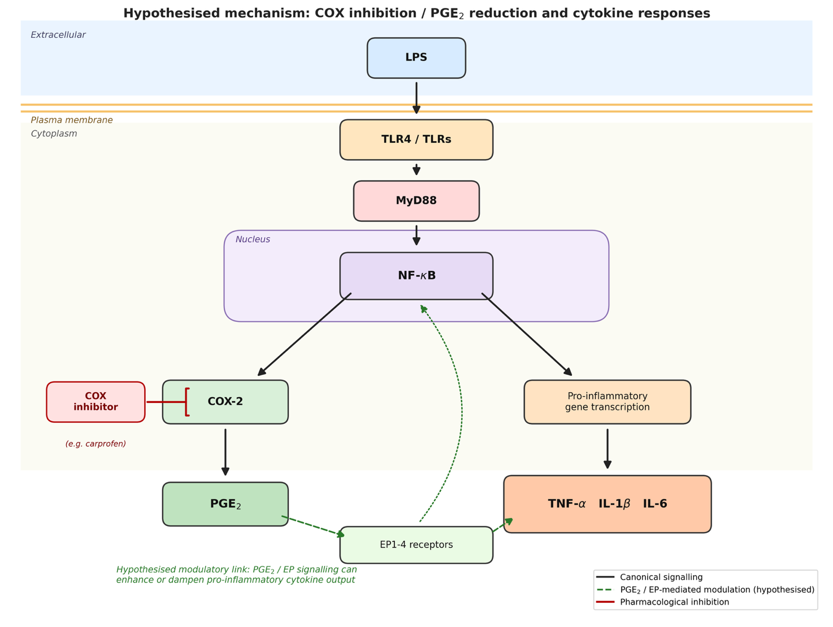

Figure 1. Proposed mechanism linking COX inhibition, PGE₂ reduction and pro-inflammatory cytokine responses.
LPS is proposed to activate TLR4/TLR signalling and downstream MyD88/NF-κB pathways in macrophages, promoting both COX-2-dependent PGE₂ production and pro-inflammatory cytokine responses. Carprofen is hypothesised to inhibit COX activity and thereby reduce PGE₂ generation. In turn, PGE₂ signalling through EP receptors may modulate downstream cytokine output, providing the mechanistic rationale tested in this study. Black arrows indicate canonical signalling, dashed green arrows indicate hypothesised modulatory links, and the red inhibitory symbol indicates pharmacological inhibition.
Figure 2
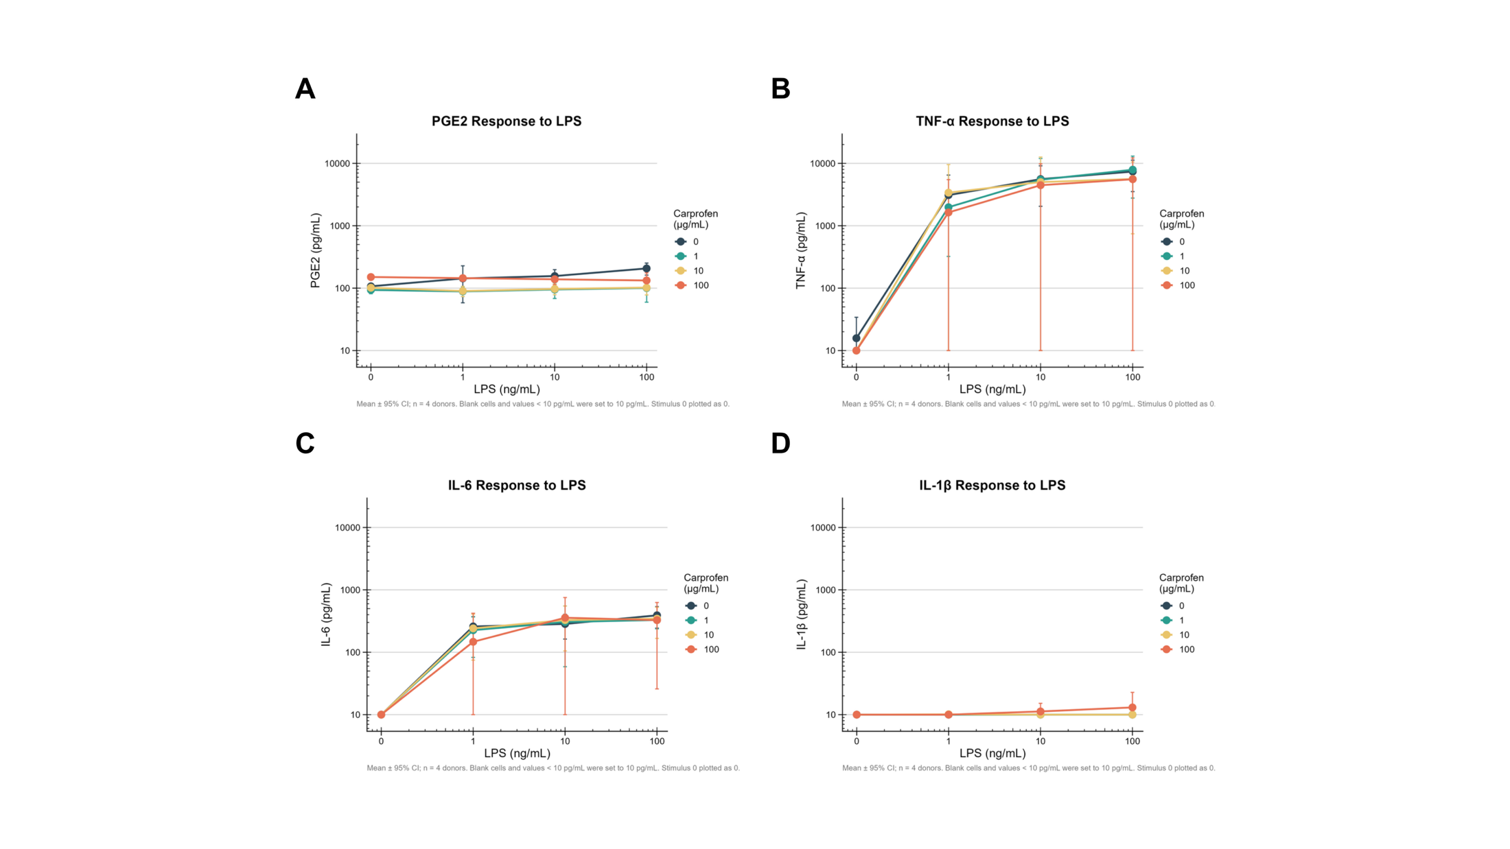

Figure 2. Effects of carprofen on mediator production in LPS-stimulated MDMs.
Human monocyte-derived macrophages (MDMs) were stimulated with LPS (0, 1, 10, 100 ng/mL) in the presence of carprofen (0, 1, 10, 100 µg/mL). Secreted levels of (A) PGE₂, (B) TNF-α, (C) IL-6 and (D) IL-1β were measured after 6 h. PGE₂ showed only a modest increase with LPS in vehicle-treated cells, but remained low and relatively stable in the presence of 1–10 µg/mL carprofen. LPS induced clear TNF-α and IL-6 responses, whereas IL-1β remained close to the detection limit across all conditions. Data are shown as mean ± 95% confidence intervals from four independent donors (n = 4). Values below 10 pg/mL were plotted at the lower detection threshold (10 pg/mL). LPS 0 was plotted as 0.1 for log-scale display.

Figure 3
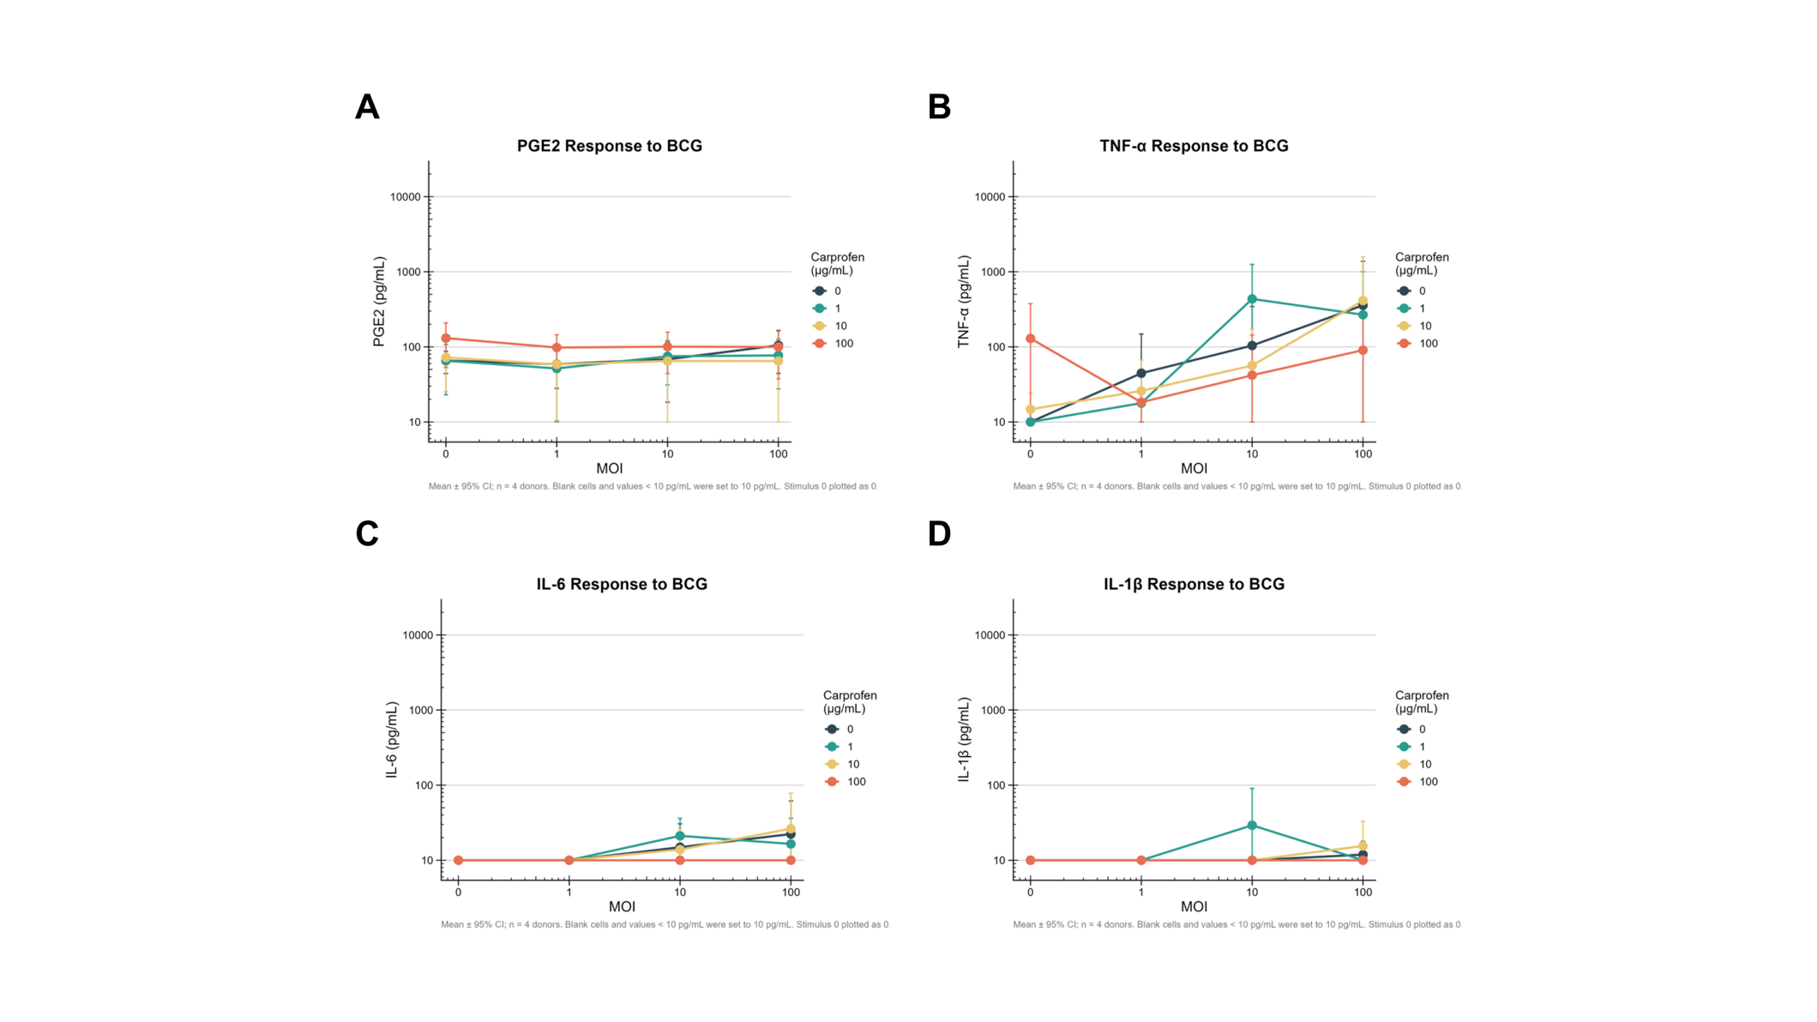
Figure 3. Effects of carprofen on mediator production in BCG-stimulated MDMs.
MDMs from four donors were infected with BCG (MOI 0, 1, 10, 100) in the presence of carprofen (0, 1, 10, 100 µg/mL). Secreted levels of (A) PGE₂, (B) TNF-α, (C) IL-6 and (D) IL-1β were measured after 6 h. BCG elicited a weaker and more variable cytokine response compared with LPS stimulation. PGE₂ remained low and relatively stable in the presence of 1–10 µg/mL carprofen, while no consistent inhibition was observed for TNF-α or IL-6. IL-1β remained close to the detection limit across all conditions. Data are shown as mean ± 95% confidence intervals (n = 4). Values below 10 pg/mL were plotted at the lower detection threshold.

Figure 4
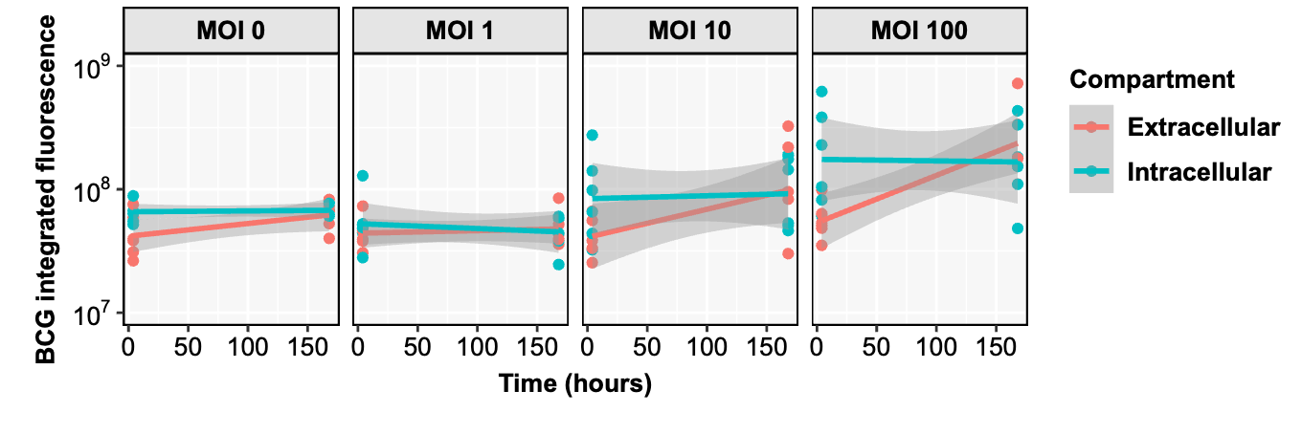

Figure 5
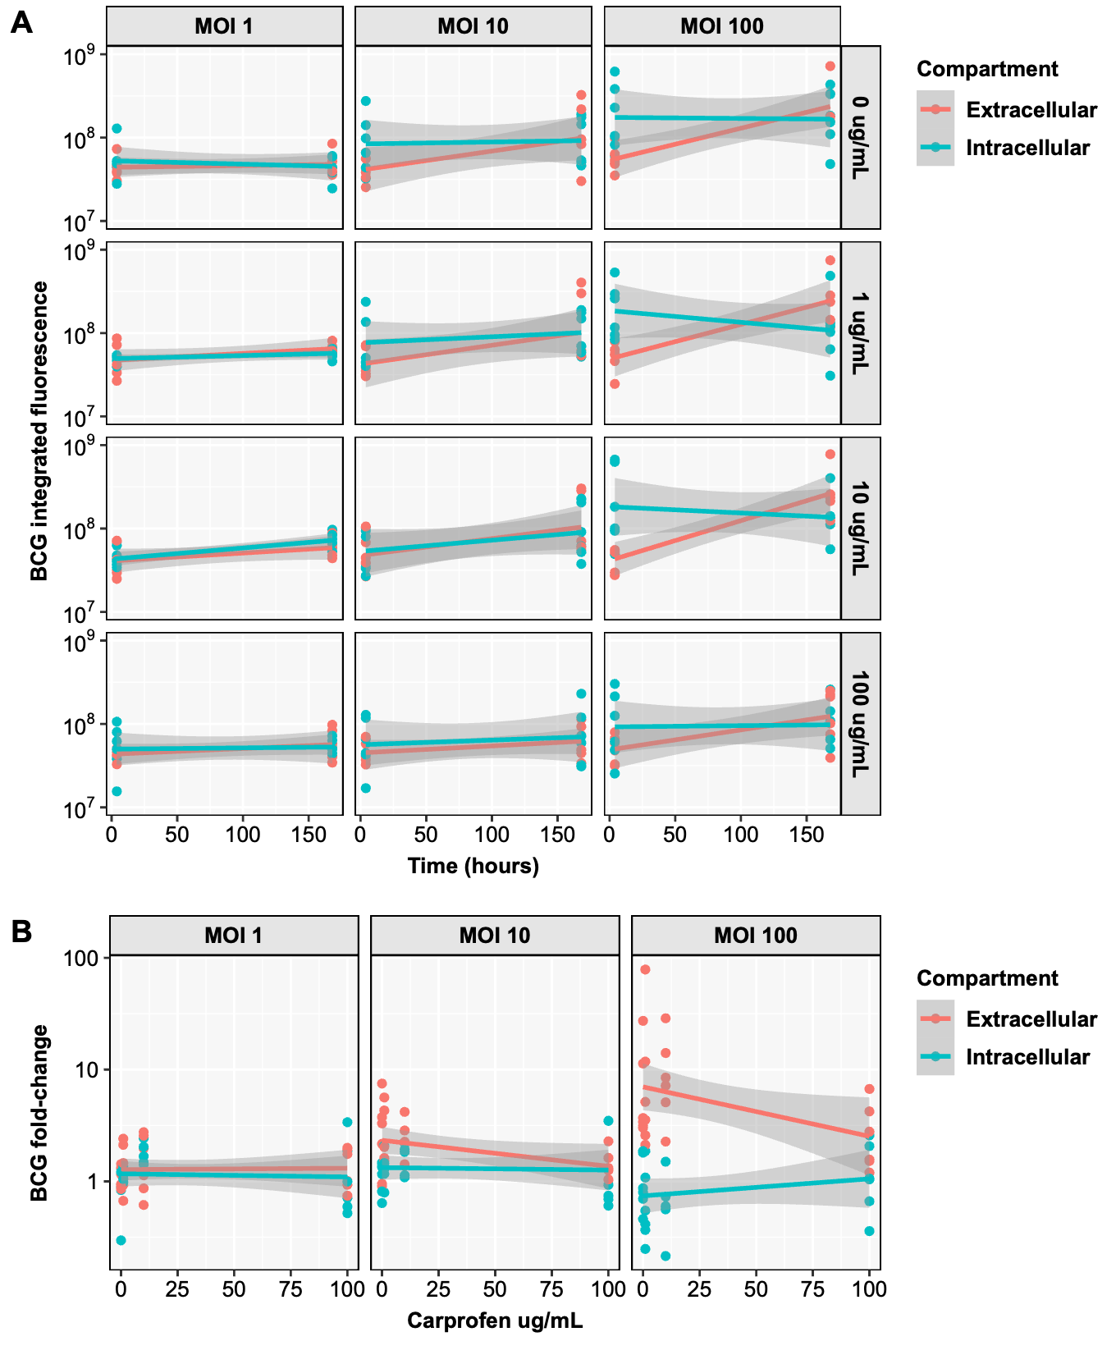
Figure 5. Compartment-specific BCG burden assessed by integrated fluorescence across time, inoculum and carprofen concentration. (A) Integrated fluorescence of BCG measured at 4 h and 7 d in extracellular and intracellular compartments, stratified by MOI (1, 10 and 100; columns) and carprofen concentration (0, 1, 10 and 100 µg/mL; rows). Points represent individual donor measurements; coloured lines indicate compartment-specific trends over time. (B) Fold change in BCG burden from 4 h to 7 d, calculated from integrated fluorescence values and plotted against carprofen concentration for each MOI. Extracellular and intracellular compartments are shown separately. Integrated fluorescence was calculated from bacterial event number and fluorescence intensity normalised to bead counts, as described in Methods. Data are shown for three independent experiments/donors.

Figure 6A

Figure 6A. Donor-level fold change in BCG burden in experiments 1–3 (4 h carprofen treatment).
BCG fold change from 4 h to 7 d (log₂ scale) is shown for total, extracellular and intracellular bacterial burden (columns) across MOI 1, 10 and 100. Rows correspond to individual donors from experiments 1–3. Colours indicate carprofen concentration (0, 1, 10 and 100 µg/mL). In experiments 1–3, cells were exposed to carprofen during the initial 4 h infection period, washed, and then maintained in medium alone until 7 d. Fold change was calculated from integrated fluorescence values as described in Methods.

Figure 6B
Figure 6B. Donor-level fold change in BCG burden in experiments 4–6 (7 d carprofen treatment). BCG fold change from 4 h to 7 d (log₂ scale) is shown for total, extracellular and intracellular bacterial burden (columns) across MOI 1, 10 and 100. Rows correspond to individual donors from experiments 4–6. Colours indicate carprofen concentration (0, 1, 10 and 100 µg/mL). In experiments 4–6, cells were exposed to carprofen during the initial 4 h infection period, washed, and then returned to the same treatment condition until 7 d, such that carprofen-treated wells continued to receive carprofen throughout the post-infection period. Fold change was calculated from integrated fluorescence values as described in Methods.

