BCG infection of MDMs

Materials
Item | Source
Human MDMs plated | Protocol 4.10 Primary Hu MDM prep
BCG-GFP/dsRed (OD₆₀₀ ~0.4-0.6s) | Protocol 65.1 BCG resuscitation and propagation
DPBS no calcium, no magnesium  (for washing cells) | Gibco (ref: 14190-094)
PBS tablets  (for washing bacteria – PBST) | Gibco (ref: 18912-014)
Tween-80 | Sigma-Aldrich (ref: P1754-500ML)
RPMI medium 1640 (1x) [+]L-Glutamine | Gibco (ref: 21875-034)
Human Serum male AB plasma | Merck (ref: H4522-100ML)
Spectrophotometer | Implen GmbH (model: OD600, Serial No: 1160)
Cuvettes | Fisher brand (ref: FB55147)
50 mL falcons | Corning (ref: 430290)

Risks & control measures

Description of key risks
- Exposure to live BCG aerosols or splashes.
- Accidental puncture or cuts from needles, lancets, pipettes, or syringes.

Summary of key control measures
- Wear gloves, lab coat, and eye protection.
- Conduct work in a BSL-2 hood.
- Use aseptic techniques. Maintain sterile tools and surfaces, disinfect work areas before and after use with 70% ethanol.
- Dispose of liquid/bacterial waste by treating it with an appropriate laboratory detergent/disinfectant before disposal.
- Dispose of biohazardous waste in yellow bin bags, zip-tied closed and sharps in sharp bins.

Reagent preparation
MDM adhesion/maintenance media w/o antibiotics – warmed to 37°C
- RPMI-1640 [+] L-glutamine
- 10% heat-inactivated type AB human serum (56°C for 30 mins)
0.05% PBS-T
- Add 500 µL Tween-80 into 1L 1X PBS
- Mix gently to avoid foaming

Methods

Day 0-6 Resuscitate and propagate BCG (Protocol 65.1)

Day 0-6 Prepare Hu MDM (Protocol 4.10)

Day 6/7 – Preparation of BCG single bacterial suspensions and infection of MDMs
- Culture human MDMs in appropriate TC plates as described in Protocol 4.
- Take the upper single bacterial suspension and measure the absorbance value at 600 nm to calculate the concentration of BCG in the suspension (concentration = 1 x OD₆₀₀ x 10⁸ CFU/mL).
- Take 2 mL of logarithmic growth phase (OD₆₀₀ ~ 0.4-0.6) BCG culture and centrifuge at 2000 x g for 1 min.
- Discard supernatant, resuspend in 1 mL PBS-T, and centrifuge at 2000 x g for 1 min.
- Discard supernatant, gently resuspend with 1 mL PBS-T, and centrifuge at 2000 x g for 1 min.
- Spin, discard supernatant and resuspend bacteria in MDM adhesion/maintenance media w/o antibiotics at the desired concentration (MOI 1).
- Aspirate media from MDM cultures and replace with bacterial inoculum.
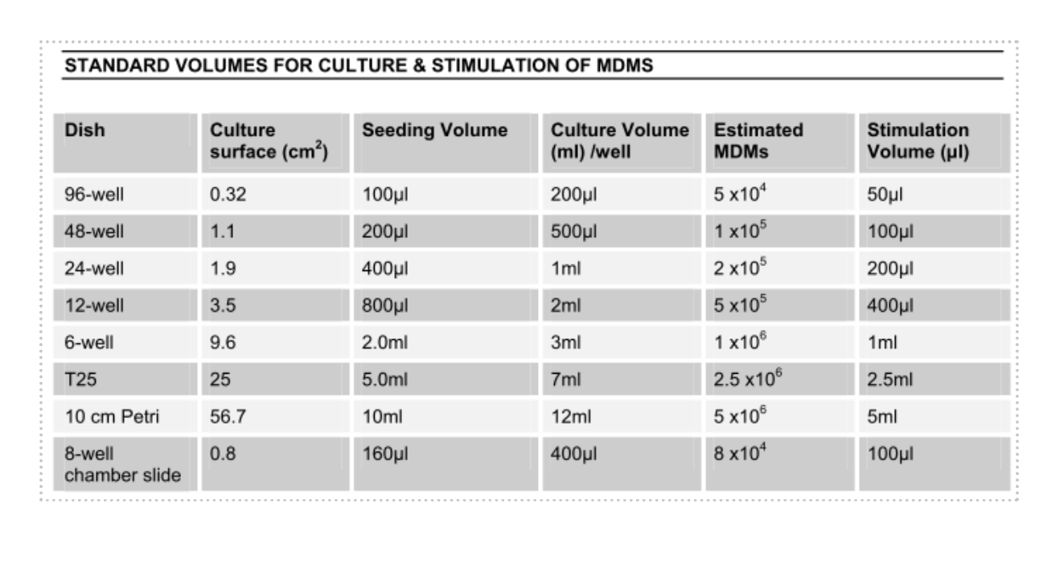
Table values are for a PBMC cell density of 1x10⁷ cells/mL. Experiments were carried out with half the cell density: 5x10⁶ cells/mL. MDM assumption should be halved.
- Incubate for 4 hours at 37 °C to allow phagocytosis.
- Remove supernatant and wash 3x with DPBS (warmed to 37°C) to remove extracellular bacteria.
- Add 500 µL of fresh MDM adhesion/maintenance media w/o antibiotics. Culture for up to 10 days for downstream assays.

