BCG growth assay

Materials
Item | Source
Infected human MDMs plated | Protocol 23.3 Primary Hu MDM prep
BCG-GFP/dsRed (OD₆₀₀ ~0.4-0.6s) | Protocol 65.1 BCG resuscitation and propagation
DPBS no calcium, no magnesium  (for washing cells) | Gibco (ref: 14190-094)
PBS tablets  (for washing bacteria – PBST) | Gibco (ref: 18912-014)
Tween-80 | Sigma-Aldrich (ref: P1754-500ML)
RPMI medium 1640 (1x) [+]L-Glutamine | Gibco (ref: 21875-034)
Human Serum male AB plasma | Merck (ref: H4522-100ML)
Spectrophotometer | Implen GmbH (model: OD600, Serial No: 1160)
Cuvettes | Fisher brand (ref: FB55147)
50 mL falcons | Corning (ref: 430290)
FACs tubes - 5 mL polystyrene round-bottom tube | Falcon (ref: 352054)
FACs tubes with filter caps- 5 mL polystyrene round-bottom tube with cell-strainer cap | BD Falcon (ref: 352235)
Paraformaldehyde | Sigma-Aldrich (ref: P6148-1KG)
H₂O | MiliQ
CountBright Counting Beads | Invitrogen (ref: C36950)
Flow Cytometer | BD LSRFortessa (5L SORP)

Risks & control measures

Description of key risks
- Exposure to live BCG aerosols or splashes.

Summary of key control measures
- Wear gloves, lab coat, and eye protection.
- Conduct work in a BSL-2 hood.
- Use aseptic techniques. Maintain sterile tools and surfaces, disinfect work areas before and after use with 70% ethanol.
- Dispose of liquid/bacterial waste by treating it with an appropriate laboratory detergent/disinfectant before disposal.
- Dispose of biohazardous waste in yellow bin bags, zip-tied closed and sharps in sharp bins.

Reagent preparation
MDM adhesion/maintenance media w/o antibiotics – warmed to 37°C
- RPMI-1640 [+] L-glutamine
- 10% heat-inactivated type AB human serum (56°C for 30 mins)
PFA 8%
- Weigh out 40 g PFA
- Add 300 mL H₂O
- Warm to 60 °C in a fume cupboard, mixing with a stir bar
- Add a few drops of concentrated NaOH until the solution clarifies
- Allow to cool to room temperature
- Add 50 mL 10x PBS
- Check pH (adjust to ~7.4 with 6 N HCl)
- Make up to 500 mL with dH₂O in a measuring cylinder
- Aliquot & store @ -20 °C
dH₂O + 0.05% Tween 80
- 25 µL Tween 80 in 50 mL dH₂O

Methods

Day 0-6 Resuscitate and propagate BCG (Protocol 65.1)

Day 1-7 Prepare Hu MDM (Protocol 4.10)

Day 7 – Preparation of BCG single bacterial suspensions and infection of MDMs (Protocol 23.3)
Day 7-11 – BCG Growth Assay
4h post-infection.
4h plates/wells
- Wash plates with warm DPBS x2 (carefully aspirate up and down 1-2x each wash; for 24 well plates, use 0.5 mL per well).
- Add 0.5 mL warm fresh media to wells.
- Leave for 2 min at RT.
- Resuspend any extracellular bacteria by pipetting up and down.
- Collect supernatants (0.5 mL) into FACs tube with an equal volume of 8% PFA (0.5 mL) for 15 min.
- Lyse adherent cells with 200 µL sterile dH₂O + 0.05% Tween for 6 min.
- Scrape well with pipette tip and collect cell lysate (200 µL) into FACs tube with an equal volume of 8% PFA (200 uL) for 15 min.
- Centrifuge at 500 x g for 2 min and resuspend in 350 µL of FACS buffer.
- Store tubes in the dark.

For downstream timepoints
96h plates/wells
- Wash plates with DPBS x2 (carefully aspirate up and down 1-2x each wash; for 24 well plates, use 0.5 mL per well).
- Add appropriate media/PBMC suspension to wells (0.5 mL per well).
- Incubate plates at 37 ºC until the endpoint of the experiment.
- At the appropriate timepoint, remove plates from the incubator.
- Resuspend the extracellular bacteria by pipetting up and down.
- Collect supernatants (0.5 mL) into FACs tube with an equal volume of 8% PFA (0.5 mL) for 15 min.
- Lyse adherent cells with 200 µL sterile dH₂O + 0.05% Tween 80 for 6 min.
- Scrape well with pipette tip and collect cell lysate (200 µL) into FACs tube with an equal volume of 8% PFA (200 µL) for 15 min.
- Centrifuge at 500 x g for 2 min and resuspend in 350 µL of FACS buffer.
- Store tubes in the dark

Run samples on flow cytometer
NB: Run 4h samples (stored) at the same time as 96h samples.
- Channels: FSC-A; counting beads (can use any channel); BCG-GFP (Blue 488 nm - FITC) or BCG-dsRED (Yellow-Green 561 nm - PE)
- Add 25 µL counting beads per sample just before running and vortex thoroughly (record batch number and bead calculation for later calculations).
- Allow the absolute counting beads to warm to room temperature. Vortex the bead suspension for 30 seconds to completely resuspend.
- Immediately after vortexing, add 25 µL of the counting bead suspension to each sample to be counted and vortex (the volume of each sample needs to be noted prior to addition of beads). Note: Any buffer appropriate for cells (e.g., flow cytometry staining buffer or other buffered saline solutions, lysis buffer, fixation buffer, permeabilisation buffer) can be used to bring the volume up to at least 300 µL. This volume is sufficient to dilute the small amount of detergent present in the beads storage buffer.
- Acquire samples (acquire 1000 events in counting bead gate).
- On the flow cytometer, set the forward scatter (FSC) threshold low enough to include the beads on the linear-forward scatter vs. the linear-side scatter plot (SSC).
- Adjust fluorescence detector voltages such that stained cells and the absolute counting beads are appropriately on scale.
- Use normal gating strategies to identify the cell population to be enumerated.
- Draw a gate on the absolute counting beads and collect at least 1,000 bead events to ensure a statistically significant determination of sample volume (e.g., Figure 1).
- Using the count statistics from these 2 gates, the concentration of the original cell sample may be determined by the equations.

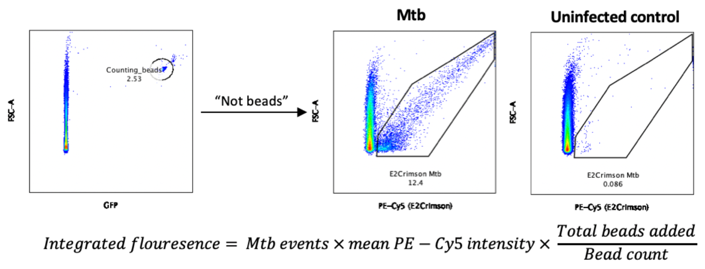
Figure 1 – Gating strategy to quantify Mtb/BCG. CountBright beads (singlets) are identified and enumerated in the counting beads channel and then excluded from further analysis (Boolean “not” gate) to ensure only fluorescent mycobacteria are quantified. The BCG population is gated by fluorescence in the FITC or PE channel (GFP and dsRED, respectively) against FSC-A using an uninfected control to confirm the gates. The total integrated fluorescence, representative of the size of the BCG population, is calculated from the product of the events within the BCG gate and their mean intensity of FITC or PE fluorescence and normalised to the number of bead events acquired. For Mtb E2Crimson, the fluorescence channel is PE-Cy5.
