# ALQ-213 Visual Studio Project Template Default Settings

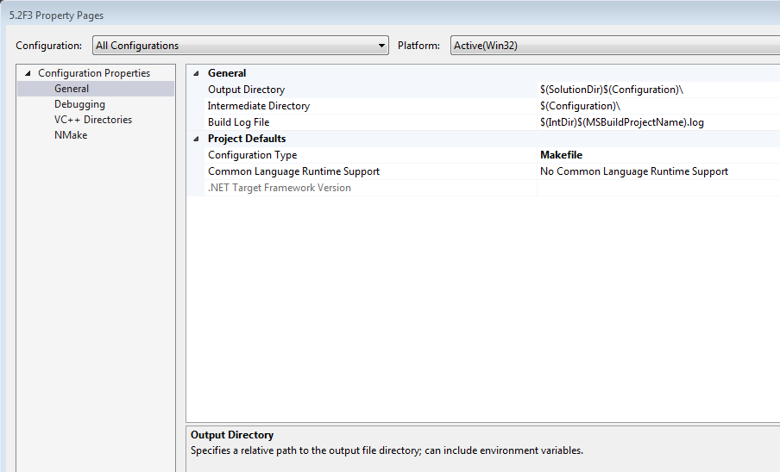

Figure : Configuration Properties | General

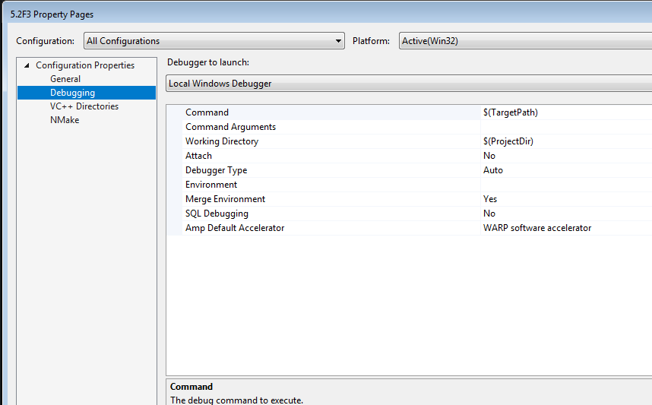

Figure : Configuration Properties | Debugging

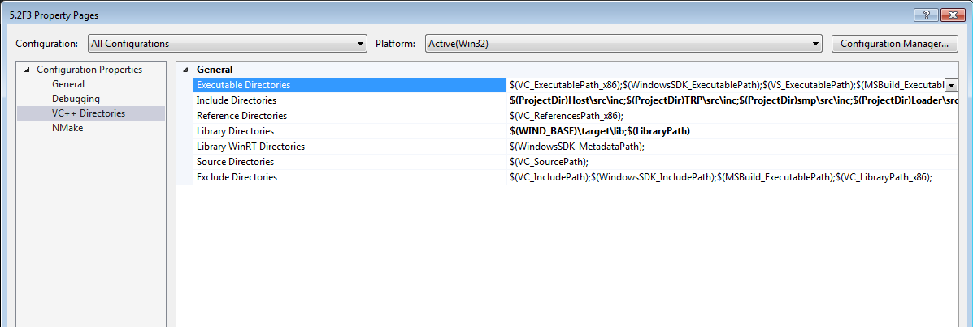

Figure : Configuration Properties | VC++ Directories

**Executable Directories**

Add:

C:\WindRiver\workbench-2.6\foundation\4.0.11\x86-win32\bin

C:\WindRiver\vxworks653-2.2\host\x86-win32\bin

C:\WindRiver

C:\WindRiver\workbench-2.6\x86-win32\bin

C:\WindRiver\gnu\3.3.2-vxworks653\x86-win32\bin

C:\ProgramData\Oracle\Java\javapath

C:\GNATPRO\6279F7~1.2\bin

C:\GNATPRO\6.2.2\bin

**Include Directories**

Add:

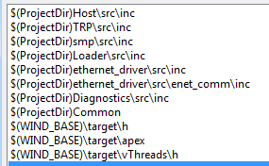

**Library Directories**

Add:

$(WIND_BASE)\target\lib

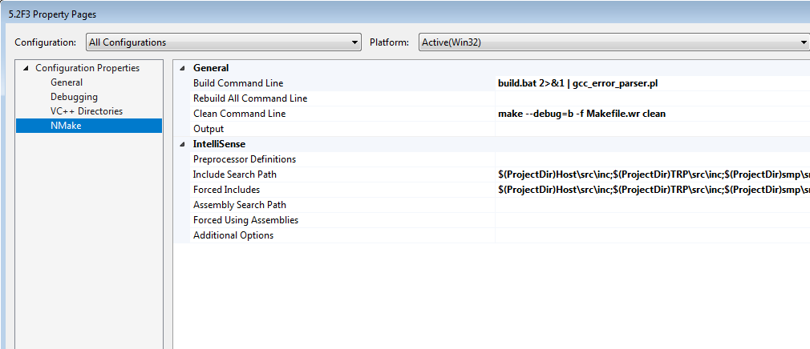

Figure : Configuration Properties | NMake

**Include Search Path**

Add:

$(ProjectDir)Host\src\inc

$(ProjectDir)TRP\src\inc

$(ProjectDir)smp\src\inc

$(ProjectDir)Loader\src\inc

$(ProjectDir)ethernet_driver\src\inc

$(ProjectDir)ethernet_driver\src\enet_comm\inc

$(ProjectDir)Diagnostics\src\inc;$(ProjectDir)Common

$(WIND_BASE)\target\h;$(WIND_BASE)\target\apex

$(WIND_BASE)\target\vThreads\h

**Forced Includes**

Add:

$(ProjectDir)Host\src\inc

$(ProjectDir)TRP\src\inc

$(ProjectDir)smp\src\inc

$(ProjectDir)Loader\src\inc

$(ProjectDir)ethernet_driver\src\inc

$(ProjectDir)ethernet_driver\src\enet_comm\inc

$(ProjectDir)Diagnostics\src\inc;$(ProjectDir)Common

$(WIND_BASE)\target\h;$(WIND_BASE)\target\apex

$(WIND_BASE)\target\vThreads\h