Code Kudos

GF Capture The Flag
October 02, 2018

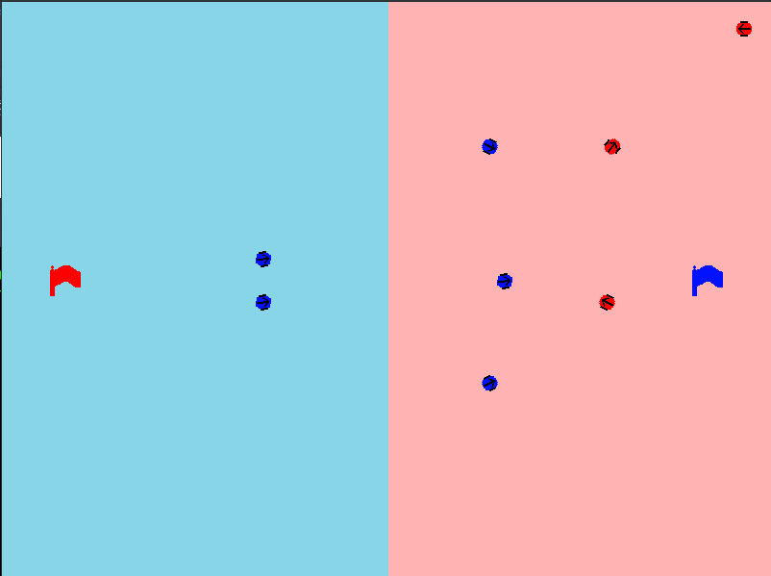

Bots vs Bots
A GameFrame built environment, GF Capture The Flag pits the blue team of autonomous bots against the Red Team of autonomous bots. The game is to program your bots then challenge other peoples bots and see which bots are most effective.

Game Rules

Territories

Gaol

Coding

Bot API

Globals

Globals.SLOW
Globals.MEDIUM
Globals.FAST

Globals.RIGHT
Globals.LEFT

Turning

self.turn_left(speed=Globals.SLOW)

self.turn_right(speed=Globals.SLOW)

self.turn_towards(x, y, speed, direction=Globals.RIGHT)

Helper functions

s

Driving

self.drive_forward(speed)

self.drive_backward()

Other objects in the room

self.red_flag

self.blue_flag

self.red_bots[]

self.blue_bots[]

Example Bots

Defensive Bot

Gaol Breaker

AttackBot

