GameFrame Tutorial Series
By Steven Tucker

Vegie Samurai
December, 2017
Updated November 2018

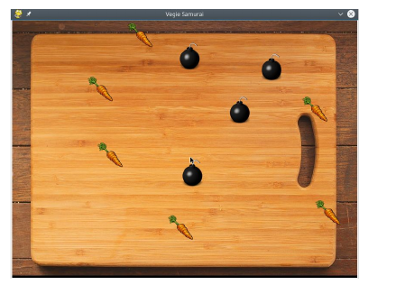

Game Description
In this tutorial we are going to build a simple game using GameFrame. The object of the game is to click on vegetables that are moving around on the screen. Click on a bomb and you lose, click on all the healthy vegies and you win!

Setting up the project
If you don’t already have GameFrame, download the Zip file from GitHub
https://github.com/tuxta/gameframe
Keep a hold of the zip file, you will reuse it every time you make a new game.

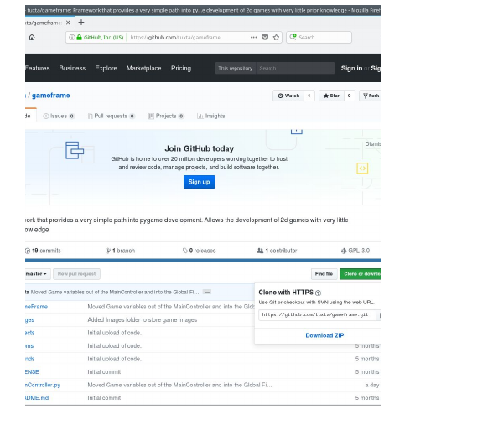

To set up a new GameFrame project, just unzip the file and rename the resulting folder to the project name, in this case we will call it “VegieSamurai”.
Inside the new VegieSamurai folder you will see some files and folders

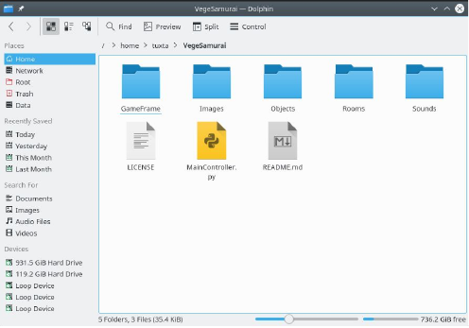
It is here that we will create and edit files to make our game. It doesn’t matter which program you use to edit the files, there are many great editors and IDE’s that you can use, though I will use (and recommend) PyCharm which is available for free at https://www.jetbrains.com/pycharm/

Launch PyCharm (or your chosen editor) and open the Vegie Samurai Folder.

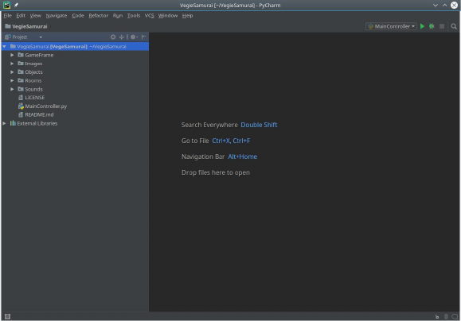

The game project is now set up and we can start working on the game.

What’s in the VegieSamurai folder?
GameFrame organises files so that the same types of files are together. This organisation makes it easier to setup and maintain a game. By keeping files of the same type together, it makes it easy to locate particular files and to create a ‘birds eye view’ of the project. The following is a description of the files and folders found in the VegieSamurai (A GameFrame Project) project folder.

GameFrame
This folder holds most of the code provided by GameFrame. When making a game, the only file in this folder that you need to edit is the Globals.py file.

Images
This folder holds all game images such as backgrounds and game characters. All graphic files that are in your game go here.

Objects
This is where you put all the individual parts (objects) of your game. For instance, you could make a player that has an image (from the Images folder) and moves across the screen if the arrow buttons are pressed. The player would be one object in the game. An enemy, wall, bouncing ball etc. could be other objects.

Rooms
Rooms are stages or levels in the game. In the Rooms folder you put each level/stage/room of your game. For instance, the first room might be a maze, and when the player reaches the end of the maze they move into the next room which is a platform game.

Sounds
This folder holds all game sounds such as gunfire and explosions. All sound files that are in your game go here.

License
The License file is not a part of the game. It lays out the rules around using and distributing GameFrame. The License is the Gnu General Public License, which basically means you can use it however you like, but you can’t stop anyone else from using it, and if you make changes to GameFrame itself (the files inside the GameFrame folder) and want to share it with other people, you can do that as well (It’s not stealing. You are allowed to do that!)

MainController.py
This is the file that is run to start the game. We don’t need to edit this file, but when we want to run the game, this is the file that is run.

README.md
This file contains a brief description of GameFrame. We do not need to edit this file. It is used to provide a description on GitHub for people who want to know what the project is about. You can delete this file if you like, but leaving it doesn’t cause any problems.

__init__.py
Inside each folder there is a file called __init__.py
It is this file that allows us to group files into different folders and still have the game know where to find everything.
Whenever we add a file to a folder, we need to add an entry to the __init__.py file in the same folder to let the rest of the program know that the new file is there.

Think Globally

Let’s get started on our VegieSamarai game.
The first file we want to edit is the Globals.py file which is in the GameFrame folder.
The Globals file holds the overall game information like the levels of the game, the window size, start level etc. The file will at first look like this ...

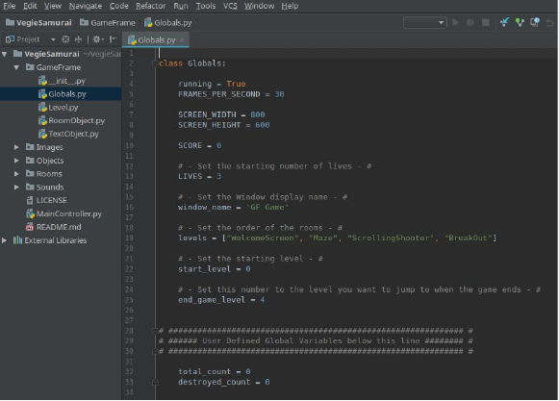

For now we only need to change 3 things
- To put the name of the game on the window, we will change the window_name variable to “Vegie Samurai”
- For this first game we will only make one level, so we will change levels to have only oneitem “VegieRoom” which will be the name of the room we make.
- Finally, because we only have one level, we will change end_game_level to 0.
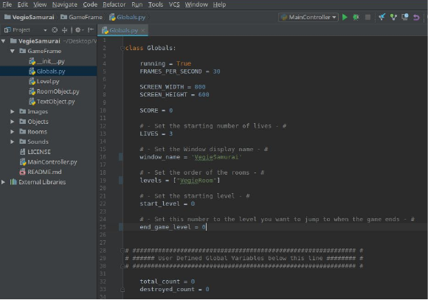

Go to your room !

A game is made up of rooms (also known as levels), and objects within each room.
Before the game will do anything at all, we need to make the first room which, in the Globals file, we called “VegieRoom”
To do this, right click on the Rooms folder and select ‘New’ -> ‘Python File’ and name it “VegieRoom”.

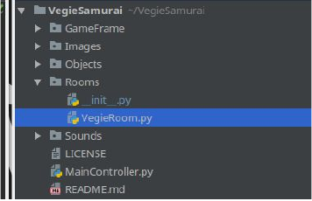

In this file we will define what our room will look like, and what objects will be in it.

To begin with, we will just make an empty room and run it to make sure everything is working. Then we will add a background image and start adding the components (objects) of the game.
To create the room, copy the following text into the VegieRoom.py file. The spaces are very important, where the text is indented, it is indented by 4 spaces.

from GameFrame import Level
class VegieRoom(Level):
def __init__(self, screen, joysticks):
Level.__init__(self, screen, joysticks)
To let GameFrame know our new file exists, we have to add an entry to the __init__.py file in the Room folder. Add the following line
from Rooms.VegieRoom import VegieRoom
Run the game by right clicking on the ‘MainController.py’ file and selecting “Run MainController”
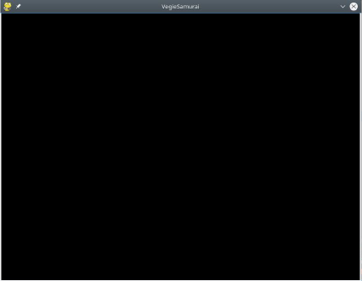

Let’s examine each line to see what it does.
Game Frame (using PyGame) looks after much of the detail of how a Level works, including a game loop, collision detection and so on. To define our own Room in GameFrame we need to access the code provided by Game Frame. To do that we write this first line of code that grants us access to the Level code in Game Frame.
from GameFrame import Level
Now we want to define our own Room. When we are defining a room or object in GameFrame, we use the word ‘class’ to state that we are setting out a new item. In this line, we use the keyword class followed by the name we want to give the room, in this case “VegieRoom”. In Brackets following the name of the new room, we state what type of GameFrame item it will be, in this case, our room is a GameFrame Level
class VegieRoom(Level):
Once we have defined the name and type of item we are making, we can then create blocks of code (known as functions) that run when certain events occur.
The first event we deal with, is the creation of the item. So when the game starts and makes this room, that is the initialization event. It is in this event that we set up the room, what its background is and what objects are in the room. The block of code that runs when the room is created is always named “__init__”
When we make a new function, it must be indented by 4 spaces, this tells Python that is it part of the class. The init function for a GameFrame Level must have 2 items named with it - self and screen.
def __init__(self, screen, joysticks):
Because our room is a GameFrame “Level”, we have to call the __init__ function of the Level class as well. Notice that this line of code is indented a further 4 spaces to show that it is part of the VegieRoom init function
Level.__init__(self, screen, joysticks)
Finally, we need to tell GameFrame where our new Room is defined, we do that by adding the following line to the __init__.py file in the Rooms folder.
from Rooms.VegieRoom import VegieRoom

Remember your background !
Now we have an empty room, we can start adding items to turn it into a game. Let’s start with adding a background image.
As our room size is 800x600 we need an image that is 800x600. When you have your image copy it to the Images folder.
Now add the following line to the __init__ function in our VegieRoom, where background.png is the name of the image you have selected. Run the game again to check the background appears
self.set_background_image('background.jpg')
GameFrame provides functions (blocks of code) that can be called upon to undertake tasks. In the GameFrame Level code there is a function called set_background_image that we just used to set the background image of the room.
When we defined VegieRoom we stated that it was a GameFrame Level object, and so it will have all the functions that GameFrame provides for a Level. So we call the VegieRoom object with the word “self” followed by a full stop followed by the function we want to use, which in this case is set_background_image. Finally we provide the name of the image (in the Image folder) that we wish to use. You will notice that the file name is in quotes. We use quotes to tell Python that we are providing a word rather than calling an object or variable in the code.
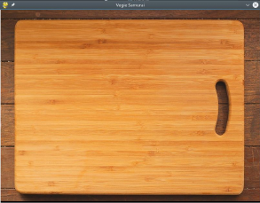

Have a Carrot doc !
We have a room and we have a background. It’s time start adding game objects.
For our first object we will put a carrot on the screen. Once we have our carrot working, we will then get it moving around the screen, then finally we will respond to mouse clicks.
First of all, create a file called Carrot.py in the Objects folder, in the same way you created the VegieRoom.py file. Just as you defined the VegieRoom class as a Level, define the Carrot Object as a RoomObject
from GameFrame import RoomObject
class Carrot(RoomObject):
The __init__ function requires 3 parameters (as well as self), room, x and y

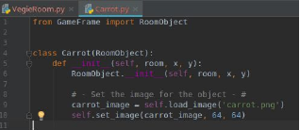

In a similar way to how you added a background image, we will set an image for our Carrot object. I will use a 64x64 image I found at ​http://www.iconninja.com/
First load the image from the Images folder, then assign the loaded image and its size to theobject
Carrot_image = self.load_image(‘carrot.png’)
self.set_image(carrot_image, 64, 64)
Now add an entry into the __init__.py file in the Object
from Objects.Carrot import Carrot

Now that the Carrot Object has been defined, lets add it to the VegieRoom.
First we need to import the Carrot code we just wrote
from Objects import Carrot
Then in the __init__ function, we will add a Carrot object
carrot_object = Carrot(self, 400, 300)
self.add_room_object(carrot_object)
Run the Game and you should now see a Carrot appear in the room

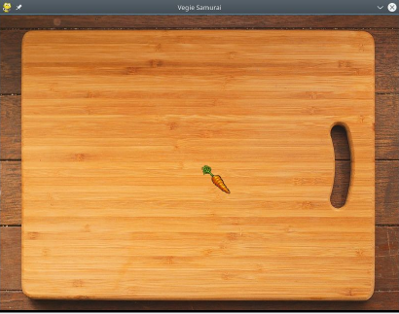

Now that the carrot is appearing in the room, we want to be able to click on the carrot to remove it from the room.
Up to this point, the only block of code we have been working with is for the initialisation of an object, which is the __init__ function. Now we are going to register our object to listen for mouse clicks, and for that event the ‘clicked’ function will be used.
First register the object for mouse events by setting the objects variable ‘handle_mouse_events’ to True
self.handle_mouse_events = True
Next we need to write the function that is called when an object is clicked.
def clicked(self, button_number):
if button_number == 1:
self.delete_object(self)
The function clicked provides a variable ‘button_number’. With this number we can check if the button clicked is the left, right or middle button. In our case we only want to react to left clicks, in which case the button_number will be equal == to 1
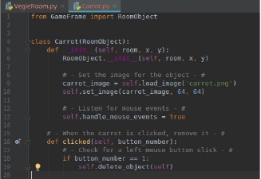
Now run the game and check that the carrot disappears when you click on it (and it doesn’t if you click anywhere else)

So now we have a Carrot on the screen that we can click, but that’s not very exciting, so let change it to a moving target.
In our VegieRoom.py file, let’s add another line after we add a carrot to the room, let’s set it in motion with the function call ‘set_direction that takes an angle and a speed.
The angle is a number between 0 and 359, the speed is a single number (how far the object moves every frame).
To make it a little more interesting, we will set the angle to a random number between 0 and 359 by using the Python function called randomint.
First we need to access the code for random number generation
import random

Then we will set the carrot in motion

carrot_obj.set_direction(random.randint(0, 359), 8)

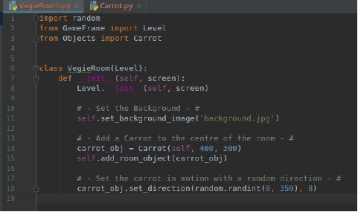

If you run the Game now you notice a problem. The Carrot does indeed start moving, but it just keeps on going straight off the screen. What we want to do is reverse the direction of the carrot whenever it reaches the edge of our screen.
Our game room uses the Cartesian coordinate system with the top left hand corner being (0, 0) and the bottom right hand corner being in our case (800, 600)

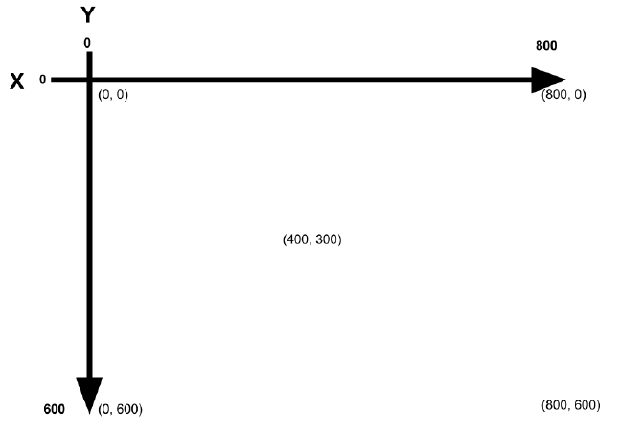

If our object reaches 0 or 800 on the X axis, we need to reverse the X direction.
Similarly, if the object reaches 0 or 600 on the Y axis, we need to reverse the X direction

When testing if our object has reached the edge of the screen, we can’t simply check the objects coordinates, because the coordinate is only the top left hand corner of the objects image. When checking if the object has reached the right side of the screen, we need to check the right edge of the screen with the right edge of the image. Luckily our object keeps this information in a variable called ‘rect’ which is the bounding rectangle of our object. The bounding rectangle has 4 sides labelled Top, Bottom, Left and Right.

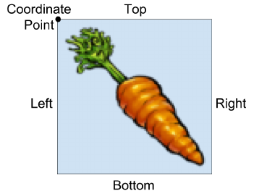

To check to see if our object image has reached the right side of the screen we could write
if self.rect.right >= 800
To make our code work with different size rooms, we can replace 800 (the screen width) with the global variable SCREEN_WIDTH. To reverse the direction of the carrot, we can multiply its speed by -1.

Add the following code to Carrot.py to keep the carrot within the room.
​# - Stay inside the room, bounce off the sides of the window sides - #
def step(self):
# - Test x position and reverse if needed - #
if self.rect.left <= 0 or self.rect.right >= Globals.SCREEN_WIDTH:
self.x_speed *= -1
self.x = self.prev_x

# - Test y position and reverse if needed - #
if self.rect.top <= 0 or self.rect.bottom >= Globals.SCREEN_HEIGHT:
self.y_speed *= -1
self.y = self.prev_y
Test the game to make sure the Carrot moves around inside the room.
Now edit VegieRoom.py to add 6 carrots (at different coordinates), by creating many instances.
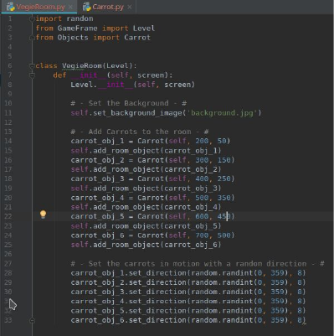

At this point you should have 6 Carrots moving around the room and bouncing back when they reach the edge of the room. Notice however, that the carrots don’t interact with each other, they simply move over each other. Let’s now handle collisions between objects. When one Carrot comes into contact with another, they should bounce off each other.
To do this we first have to ask GameFrame to inform us when a collision with another carrot occurs. In the __init__ function we register for collisions with the line

self.register_collision_object(‘Carrot’)

Then we write the code that will be run when a collision occurs. The function will be called handle_collision, and it will provide the object we are colliding with as ‘other’

def handle_collision(self, other):
self.bounce(other)

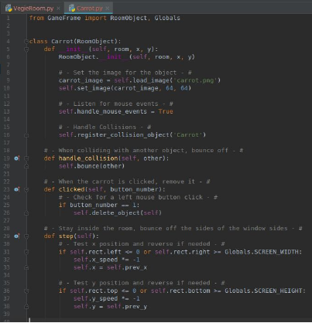

At this point we should be able to run the game, see Carrots moving around in the room and bouncing back in off the sides of the room. We should be able to click on each Carrot until the room is empty.
Our final step, to make it more of a real game, is to add bombs. When a bomb is clicked the room will end. As there is only one room, this will result in the room just restarting.
This step is actually quite easy. A bomb has all the same characteristics as a Carrot, except its image is different, and it ends the game when clicked, rather than deleting itself.
Because of this, we will simply make a copy of Carrot.py and call it Bomb.py
Don’t forget to add an entry in the __init__.py file in the Objects folder.
Now edit the Bomb.py file to change the class name, the image, and rather than call delete when clicked, set room.running to False. Also, make sure that both the Carrot class and the Bomb class register for collisions with both Carrots and Bombs
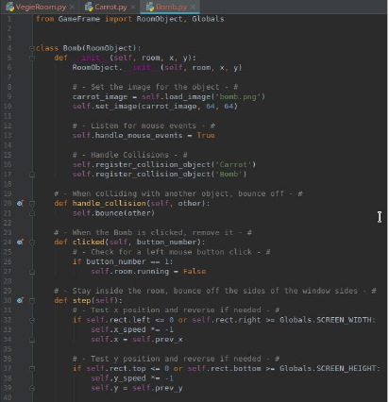

Finally, add some Bomb objects to the room. Make sure the objects aren’t overlapping when the game starts.

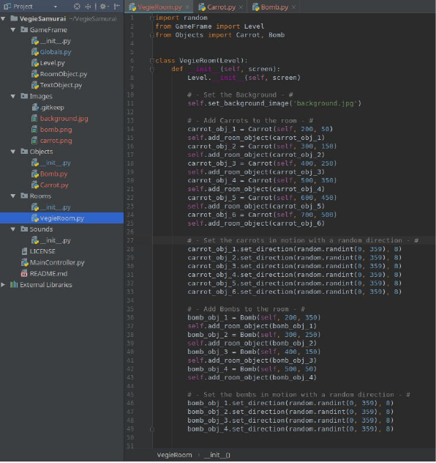

What’s next?
This tutorial showed you the main concepts behind making games with GameFrame, including how to create a Room and how to make and include objects within rooms.
There is much more that we could do with this game, such as making different types of fruit objects that have different images (such as beans, peas etc) and different speeds (different difficulty). We could add more rooms, increasing in difficulty and we could add a scoring system, and perhaps record and show high scores.
There are other features of GameFrame such as applying gravity to an object, responding to key presses, creating timers and so on. Some of these will be explored in following tutorials.
For now we have created a simple game to demonstrate the main concepts of GameFrame.
Have a go at extending the game now. Add some more Vegetable types with different speeds, and perhaps add some more rooms to progress through.
I have used http://www.iconninja.com to source the object images used in this tutorial, you could also find images at https://craftpix.net, https://www.gameart2d.com and others.

