- How should you answer these questions?
Like this
Or maybe with code
fun hello() = "world"
- Please enumerate al least 3 Java EE APIs being used at this project, also define it's main objective
CDI – Context s Dependency injection
JPA – Persiste to database
JAX-RS – Support for java ee to use REST
- Which of the following is not an application server?
- Tomcat
- Undertow
- Grizzly
- Netty
- This project defines two main profiles. Which one will be the default if -P argument is not used on Maven?

- Could you guess if this project will be supported on many application servers? Which ones? Why is this possible?
Yes, Payara Server, webLogic Server
Because we use de java EE standar without use specific apis for a specifc app Server

- If no database is configured? Will you be able to run this project? Why?

Yes, because we use de default java bd in the app server.

Development tasks
- (easy) Please include a screenshot of this project building on a regular CLI
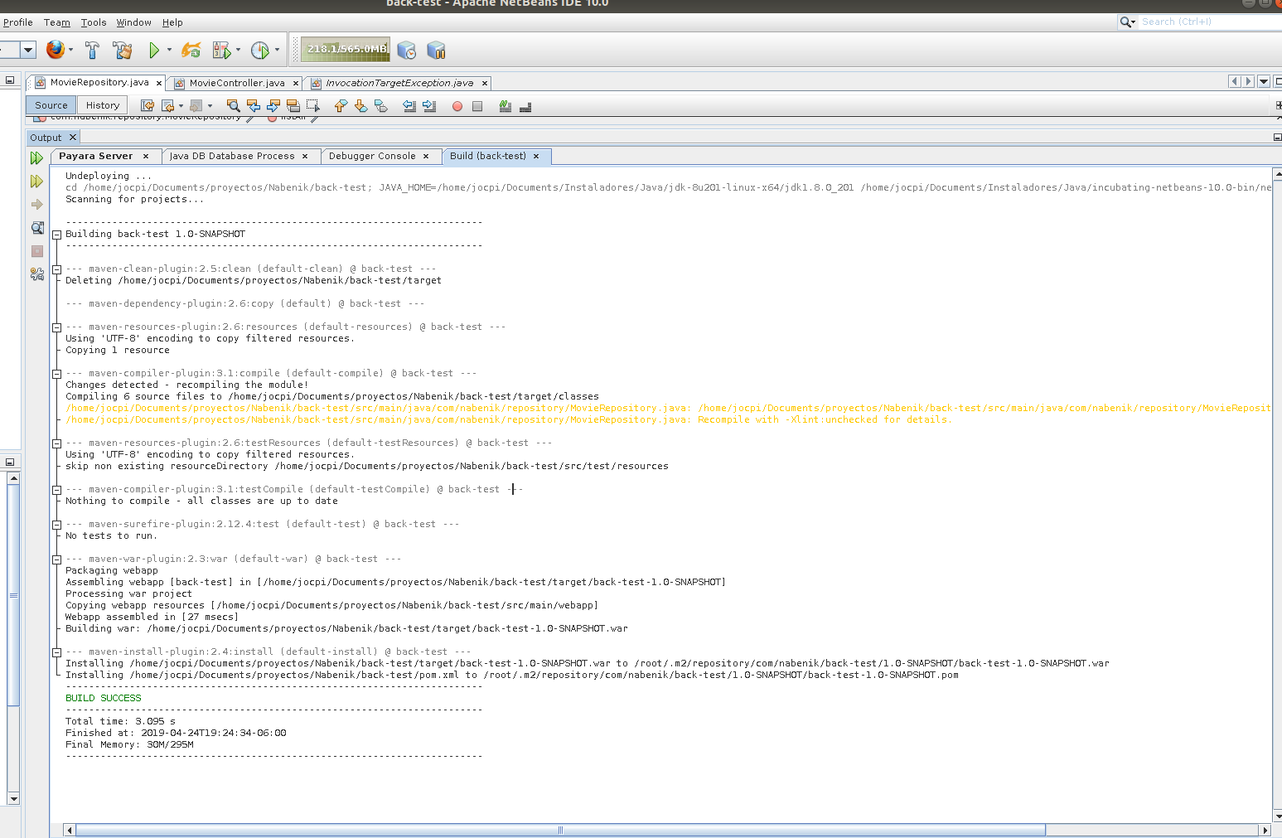
- (easy) Please include a screenshot of this project running on an IDE of your choice
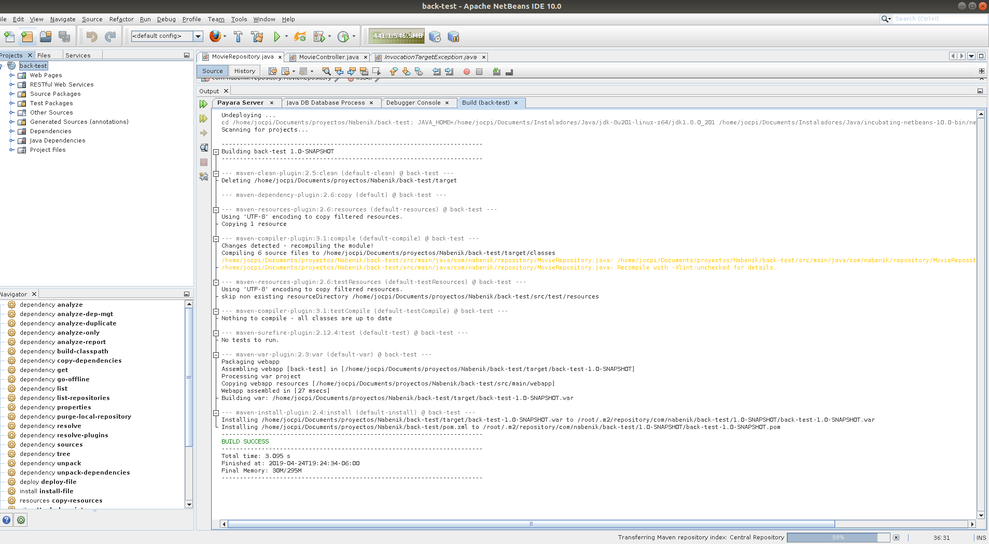
- (medium) Please deploy this project to a compatible application server, later include the screenshot of the list Movies endpoint
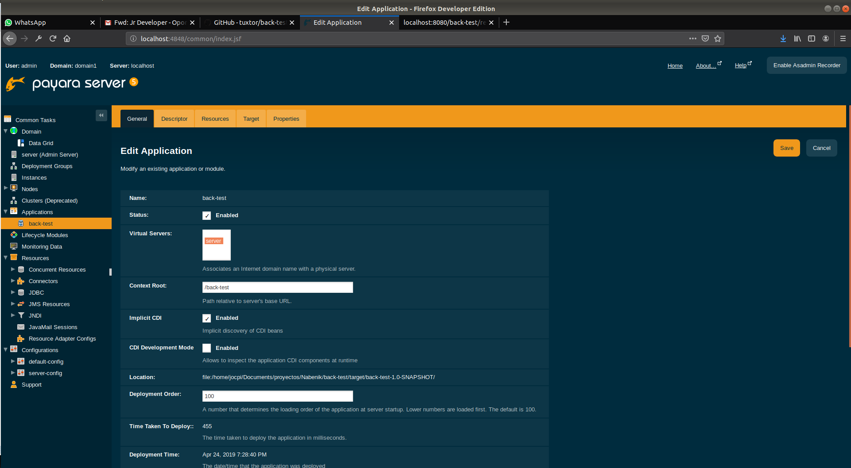


- (medium) Include a screenshot of each of the endpoint operations, if needed please also check/fix the code

@GET
public List<Movie> listAll(@QueryParam("title") String title){
if(title != null)
return movieRepository.listAll(title);
else
return movieRepository.listAll();
}
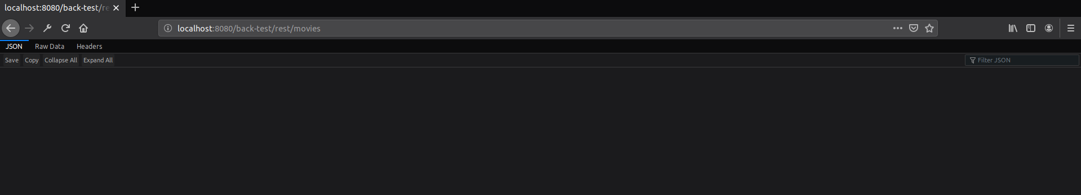
@POST
public Response create(Movie movie){
movieRepository.create(movie);
return Response.created(URI.create("/Lol")).build();
}
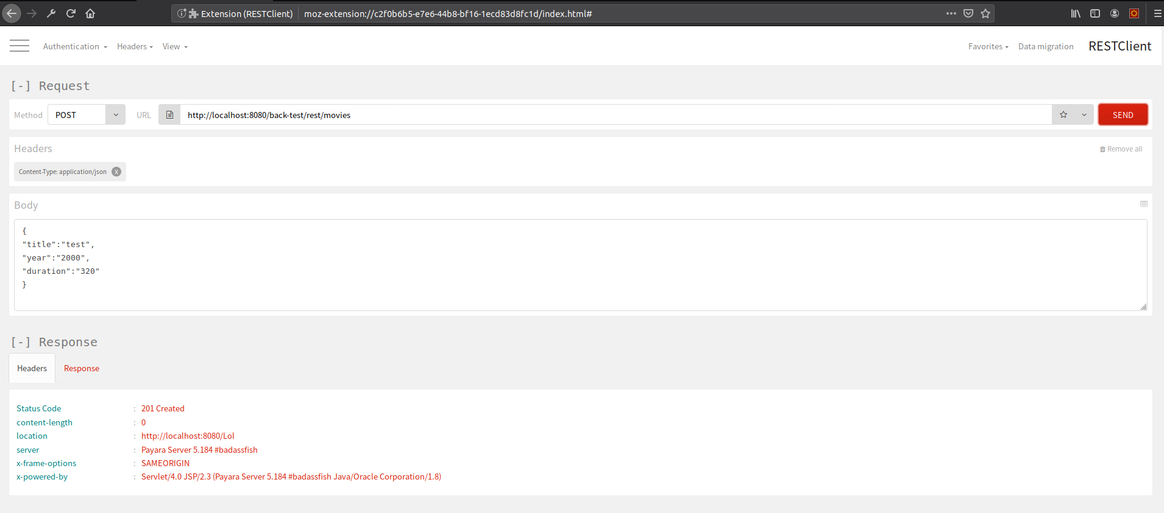

@PUT
@Path("/{id}")
public Response update(@PathParam("id") Long id, Movie movie){
movieRepository.update(movie);
return Response.created(URI.create("/Lol")).build();
}

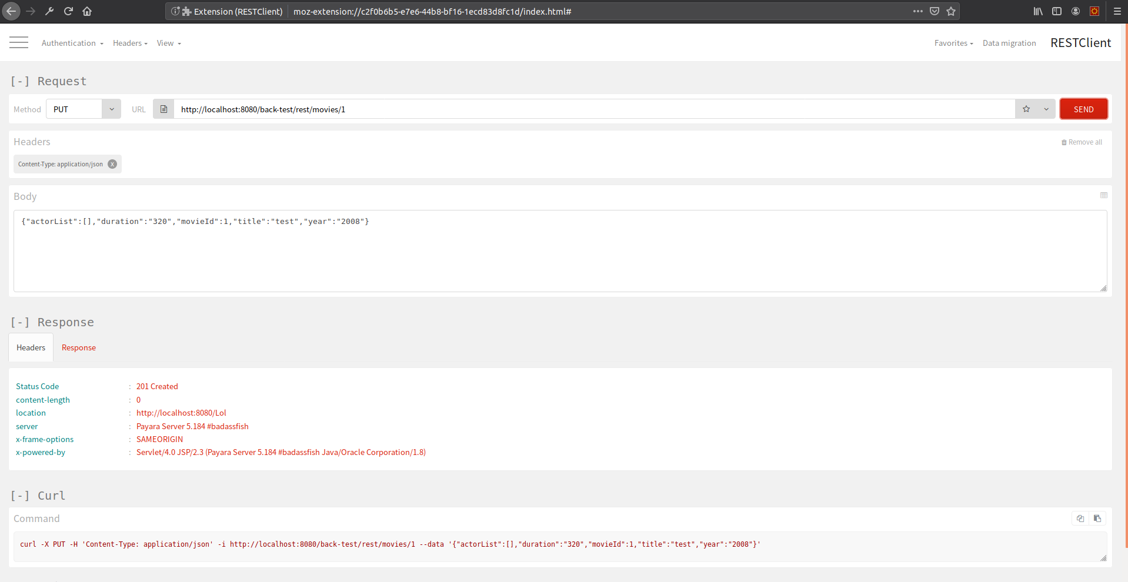

@GET
@Path("/{id}")
public Movie findById(@PathParam("id") Long id){
return movieRepository.findById(id);
}
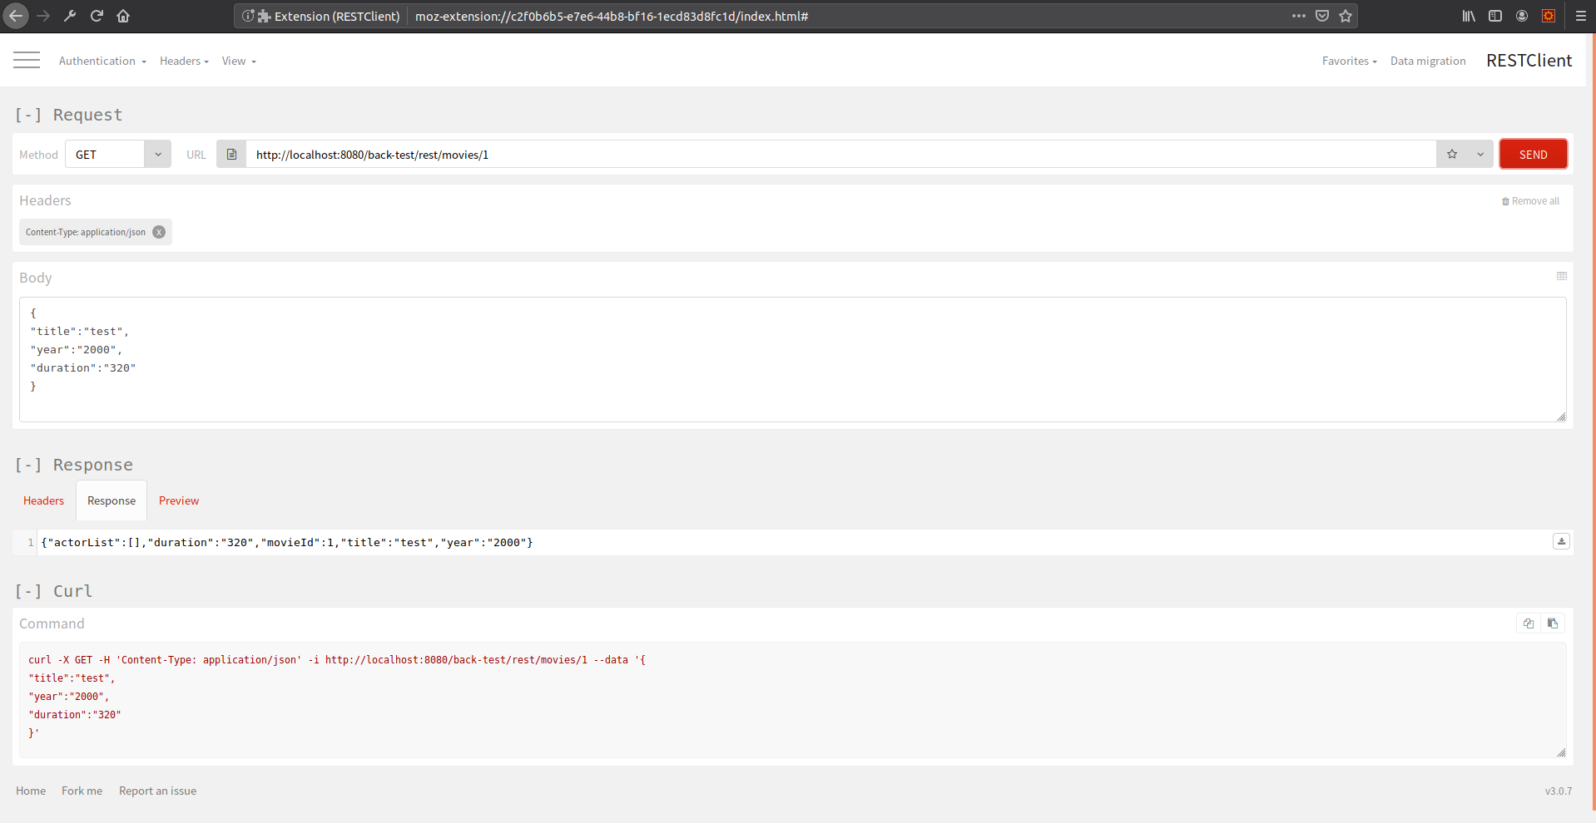
@DELETE
@Path("/{id}")
public Response delete(@PathParam("id") Long id){
Movie movie = movieRepository.findById(id);
movieRepository.delete(movie);
return Response.ok().build();
}
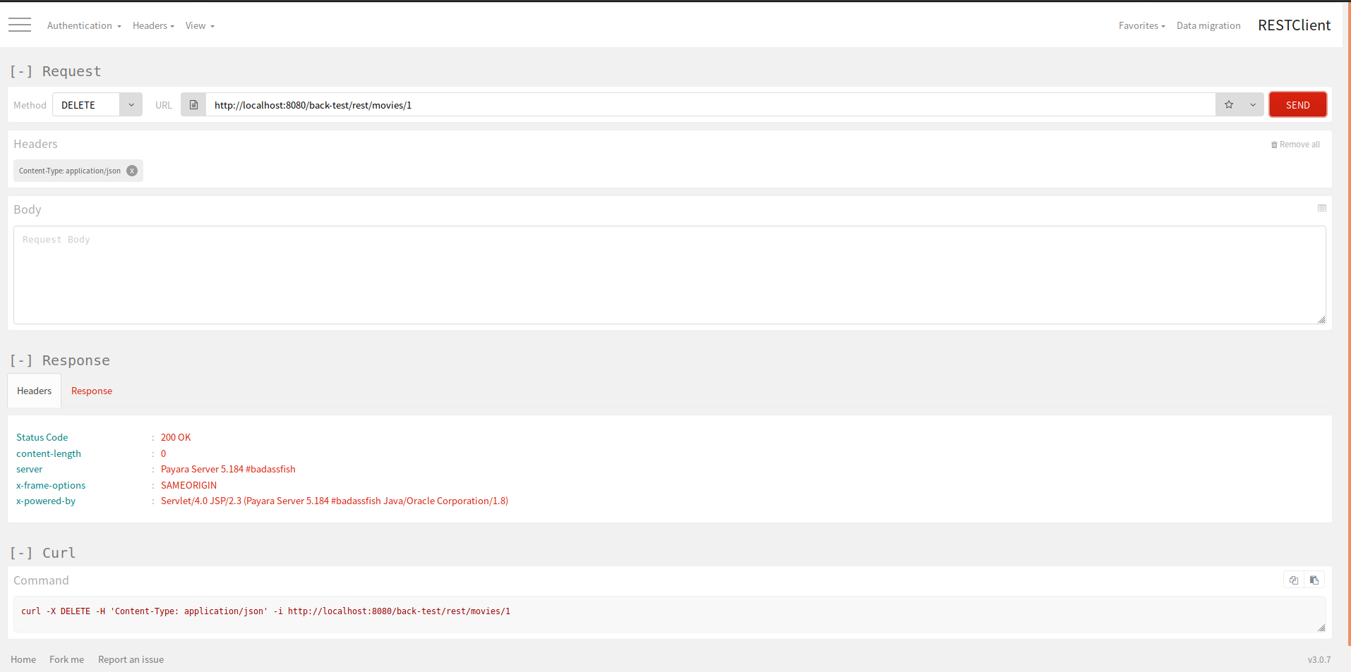
- (medium) Add support to Bean Validation for the entity Movie and validate nulls on REST layer
@Column
@NotNull
private String title;

@Column(name="year_movie")
@NotNull
private String year;

@Column
@NotNull
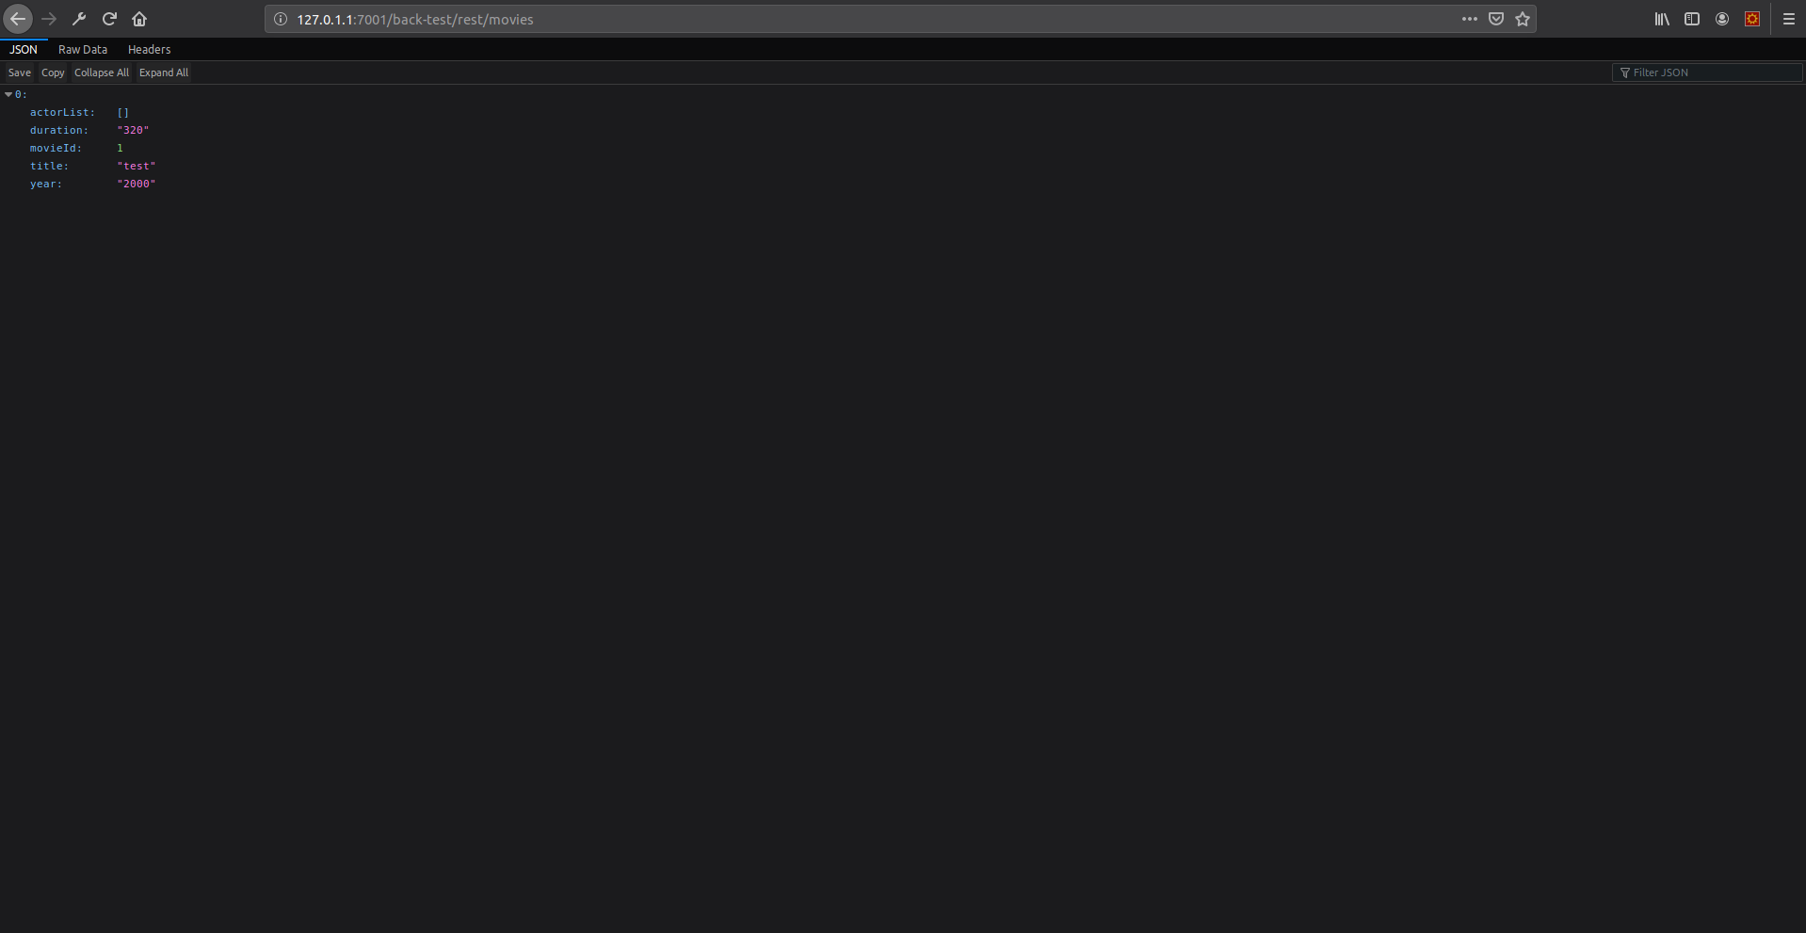
private String duration;
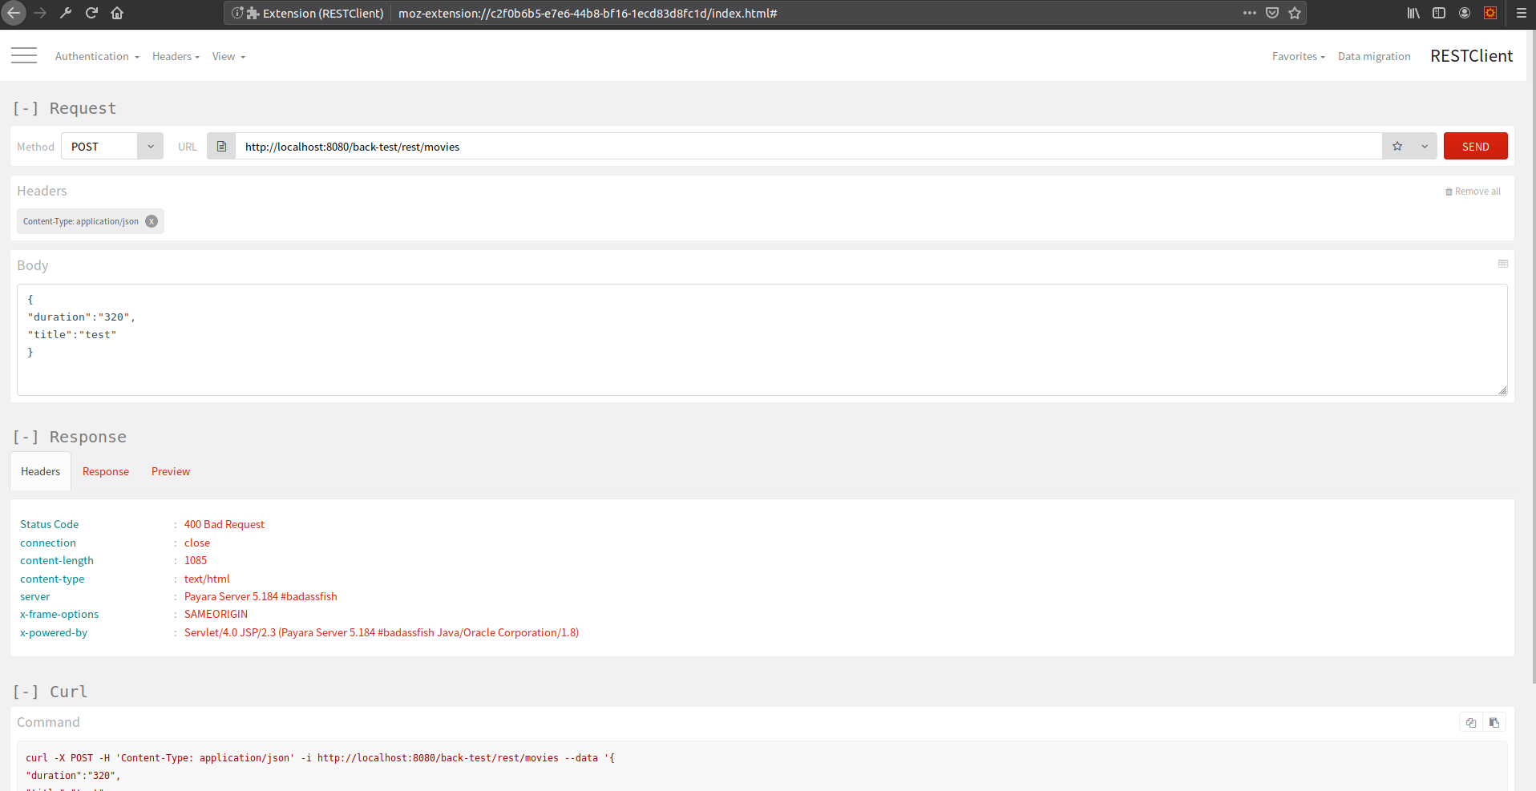

- (hard) Please identify the Integration Testing for MovieRepository, after that implement each of the non-included CRUD methods

package com.nabenik.repository;

import com.nabenik.model.Movie;

import javax.enterprise.context.RequestScoped;
import javax.enterprise.inject.Default;
import javax.inject.Inject;
import javax.persistence.EntityManager;
import javax.persistence.Query;
import java.util.List;
import javax.transaction.Transactional;

@RequestScoped
//@Default
@Transactional
public class MovieRepository {

@Inject
EntityManager em;

public Movie findById(Long id){
return em.find(Movie.class, id);
}

public void create(Movie movie){
em.persist(movie);
}

public Movie update(Movie movie){
return em.merge(movie);
}

public void delete(Movie movie){
em.remove(movie);
}

public List<Movie> listAll(String title){

String query = "SELECT m FROM Movie m " +
"where m.title LIKE :title";

Query typedQuery = em.createQuery(query)
.setParameter("title", "%".concat(title).concat("%"));

return typedQuery.getResultList();
}
public List<Movie> listAll(){

String query = "SELECT m FROM Movie m";

Query typedQuery = em.createQuery(query);

return typedQuery.getResultList();
}
}

- (hard) This project includes support for Oracle Weblogic, please include a screenshot with your modifications being tested with Weblogic
