Project Architecture

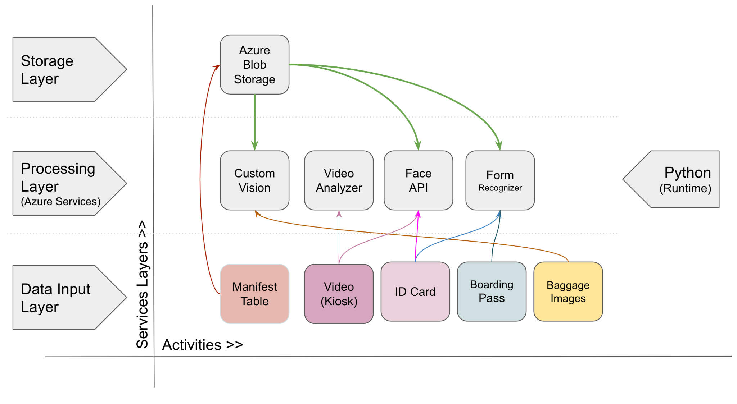

**Description**

The architecture has 3 layers: Storage, processing, and data input.

The storage layer using Azure Blob Storage to store the manifest table.

The processing layer using Custom Vision for validate Baggage Images, Video Analyzer for extra person information on video, Face API for validate person identity with video and ID card, and Form Recogizer for validate Boarding Pass.

The data input layer includes manifest table, video, id card, boarding pass, and baggage images.